for investors & friends · May 2017

**Drylab**News

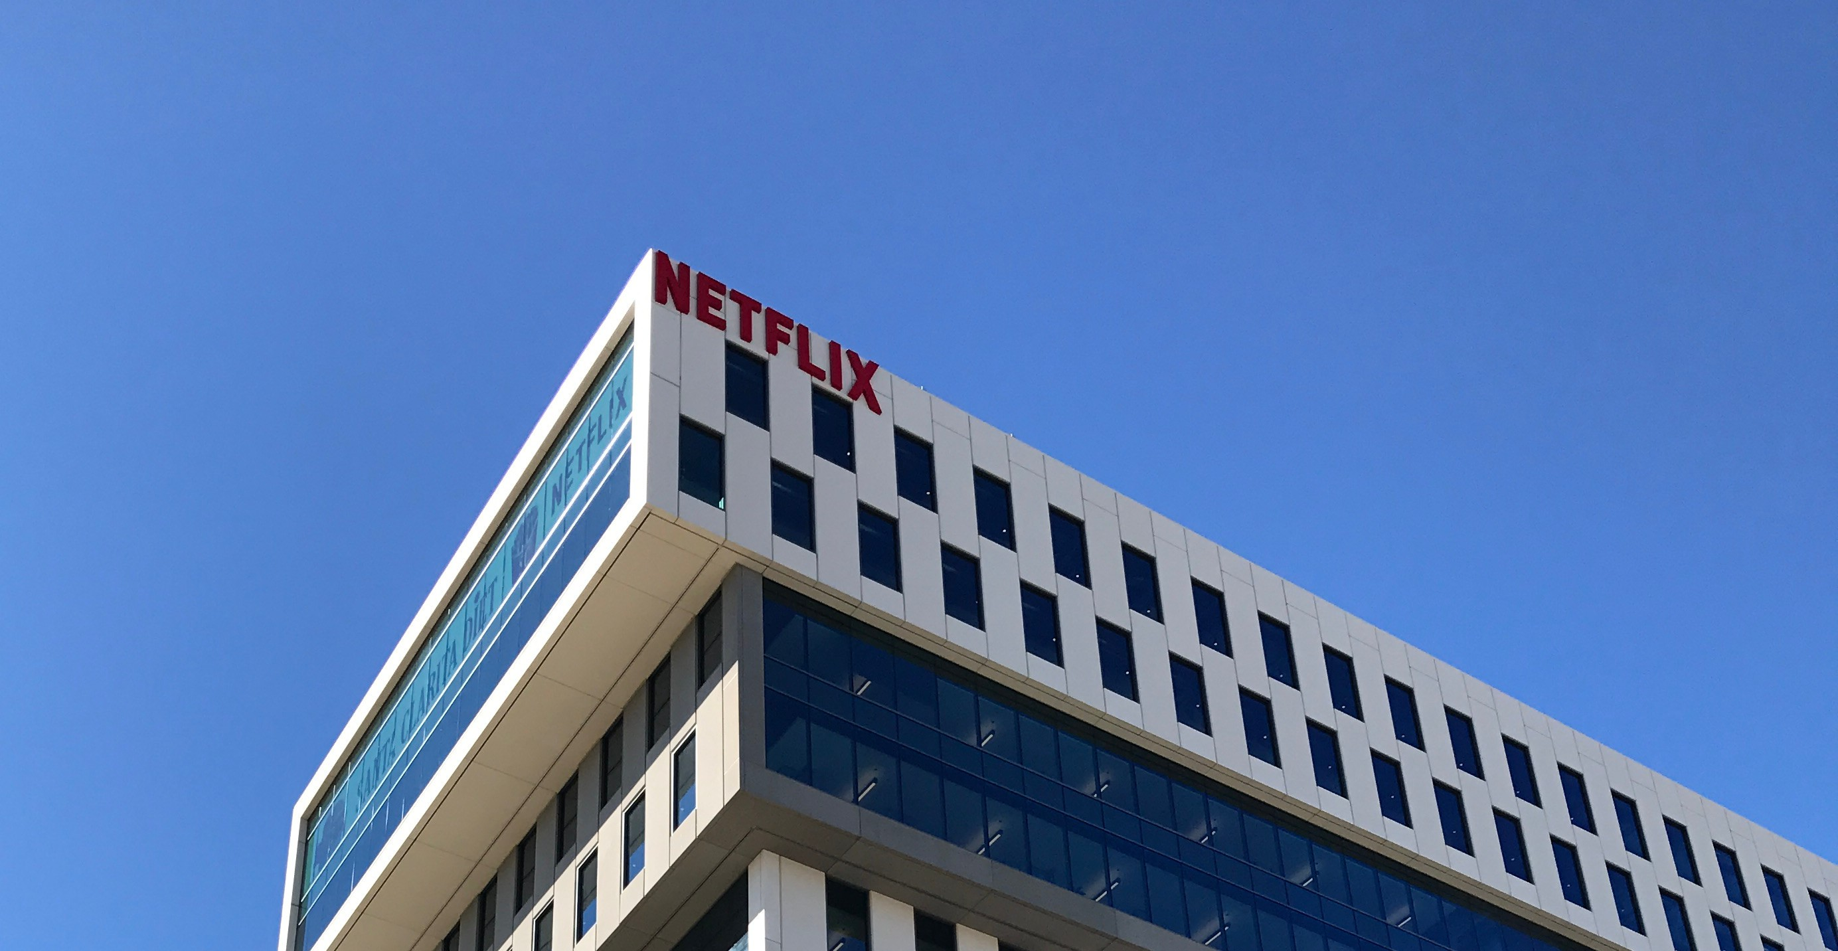

Welcome to our first newsletter of 2017! It's been a while since the last one, and a lot has happened. We promise to keep them coming every two months hereafter, and permit ourselves to make this one rather long. The big news is the beginnings of our launch in the American market, but there are also interesting updates on sales, development, mentors and (of course) the investment round that closed in January.

**New capital:** The investment round was successful. We raised 2.13 MNOK to match

the 2.05 MNOK loan from Innovation Norway. Including the development agreement with Filmlance International, the total new capital is 5 MNOK, partly tied to the successful completion of milestones. All formalities associated with this process are now finalized.

**New owners:** We would especially like to warmly welcome our new owners to the Drylab family: Unni Jacobsen, Torstein Jahr, Suzanne Bolstad, Eivind Bergene, Turid Brun, Vigdis Trondsen, Lea Blindheim, Kristine

**34**

meetings NY · SF LA · LV

Academy of Motion Picture Arts and Sciences · Alesha & Jamie Metzger · Amazon AWS · Apple · Caitlin Burns, PGA · Carlos Melcer · Chimney L.A. · Dado Valentic · Dave Stump · DIT WIT · ERA NYC · Facebook · Fancy Film · FilmLight · Geo Labelle · Google · IBM · Innovation Norway (NYC) · Innovation Norway (SF) · International Cinematographers Guild · NBC · Local 871 · Netflix · Pomfort · Radiant Images · Screening Room · Signiant · Moods of Norway · Tapad · Team Downey

Holmsen, Torstein Hansen, and Jostein Aanensen. We look forward to working with you!

**Sales:** Return customer rate is now 80%, proving value and willingness to pay. Film Factory Montreal is our first customer in Canada. Lumiere Numeriques have started using us in France. We also have new customers in Norway, and high-profile users such as Gareth Unwin, producer of Oscar- winning [The King's Speech](http://www.imdb.com/title/tt1504320/). Revenue for the first four months is 200 kNOK, compared to 339 kNOK for all of 2016. We are working on a partnership to safeguard sales in Norway while beginning to focus more on the US.

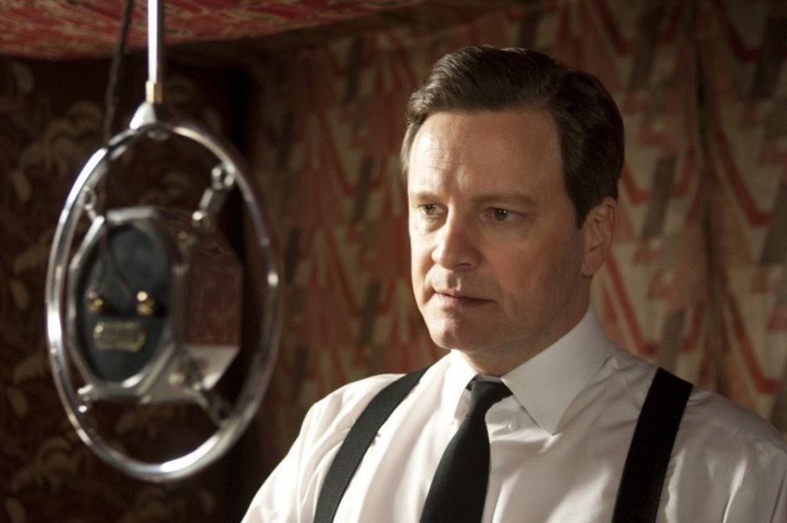

**New team members:** We've extended our organization with two permanent developers based in Łódź, the film capital of Poland. Two highly skilled interns from the University of Oslo's Entrepreneurship Program, will be working on market research until mid-June (starting in March), preparing for the US launch. Also, two computer science students are working as part-time interns during spring, on machine learning and analysis research, as well as innovative architectures based on the Swift language. We hope our interns will consider sticking around!

**New mentor:** We are honored to have Caitlin Burns joining us as a mentor. She's an

accomplished producer based in New York, an active member of the Producers Guild of America, and the collaboration has already yielded good results, including valuable contacts for our visit in Los Angeles. Oscar- winning VFX supervisor [Dave Stump](http://www.imdb.com/name/nm0003432/) joined us earlier.

**New York, St. Louis, San Francisco and Los Angeles:** Pontus and Audun did a tour of the US in February and March, meeting users, partners and potential customers. The trip was very successful, with several high points, including meetings with Netflix, the Academy of Motion Picture Arts and Sciences, the International Cinematographers Guild, Local 871 (the script supervisors' union), one of the world's leading DITs, and Apple. See the separate attachment for a more detailed summary.

**NAB:** Andreas and Audun travelled to the National Association of Broadcasters convention (NAB) in Las Vegas for three hectic days in April. NAB gathers 100,000 participants from film and TV. It's a very efficient way of meeting people in the business, and getting an updated picture of the business landscape. The most exciting meeting was with PIX System, one of our most important competitors. It was interesting to note that they regarded the indie market as bigger than their own.

Andreas was able to secure us an invitation to the DIT-WIT party, with some of the world's leading DITs in attendance. It was a great place for informal feedback on Drylab Viewer. The pattern was the same as for other users: Initial polite interest turns to real enthusiasm the moment someone is able to personally try Drylab Viewer! We also met with Pomfort and Apple about our on- going collaborations; ARRI and Teradek/

Paralinx about camera integration; Amazon, Google and IBM about cloud computing.

**WWDC and Silicon Valley:** We were very pleasantly surprised to be invited by Apple to their World Wide Developers Conference in San Jose in June, despite not having applied. It's a valuable chance to learn and make new connections. We’re also setting aside time to meet other potential partners.

**Cine Gear:** We have decided not to attend the Cine Gear expo in L.A. this year, since feedback from many users about the show were mixed, and our planned beta version of

3.0 is slightly delayed.

**Development and launch:** Development is around one month behind our original schedule. We expect the delay to decrease, with new developers on board.

The launch of Drylab 3.0 will take place at the International Broadcasters Convention in Amsterdam in September, and we are working hard to get solid feedback from pilot users before then.

**Annual General Meeting:** Drylab's AGM will be held on June 16th at 15:00. An invitation will be distributed to all owners well in advance. We hope to see you there!

**As you can see it has been a hectic spring that has given us a lot of confirmation about our product. We are now working eagerly and hard towards the US launch with Drylab 3.0, while keeping momentum in Europe with our existing system.**





[[Drylab](http://www.drylab.no/) has kindly allowed this newsletter to be redone in HTML/CSS and converted to PDF with [Prince](http://www.princexml.com/). [Navngen](http://navngen.no/) helped anonymize names in the process.]