|  |  |  |
| --- | --- | --- |
| **Guide Name** | | **Panel Head** |
|  | Dr. Pandiaraj.A | Dr.Deeban Chakkravarthy |
|  |  |  |
|  | **Faculty Advisor** | **Project Domain** |
|  | Dr. Briskilal .J | Good Health and Well being |
| M |  |  |
|  | **Student(s) Details: Name** | **Passport size photo(s)** |
|  | 1. ARNAV 2. VISHAL S HAYYAL |  |
|  |  |  |

Registration Number(s)

1.RA2111003011667

2. RA2111003011663

**Email ID(s)&Mobile Number(s)**

|  |  |
| --- | --- |
| 1: [az5430@srmist.edu.in](mailto:az5430@srmist.edu.in)  Mobile Number: 9910265902 | 2: [vh1835@srmist.edu.in](mailto:vh1835@srmist.edu.in)  Mobile Number: 6364666966 |

**Abstract Architecture Diagram**

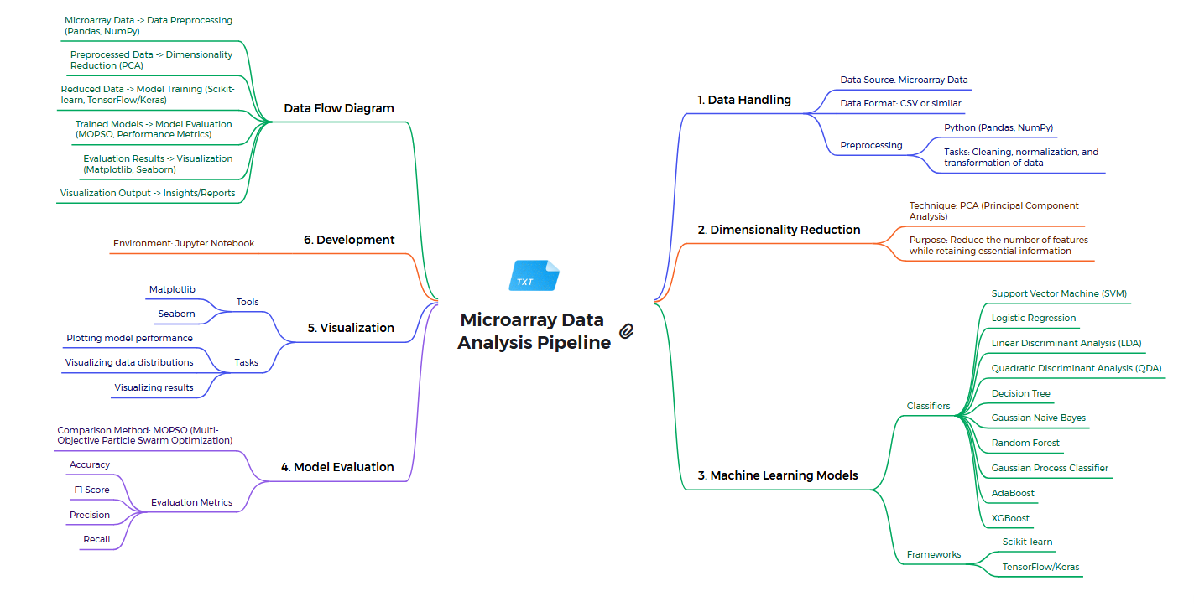

This project aims to leverage machine learning techniques to predict tumor presence from microarray gene expression data. Microarrays provide a comprehensive view of gene expression across thousands of genes, allowing for the identification of those that are differentially expressed between normal and tumor tissues. The project addresses the challenge of selecting the most relevant genes from a high-dimensional dataset with a limited number of samples. The methodology involves several key steps: data preparation, model training, and evaluation.

**Significance of the Project Conclusion**

This project uses machine learning to improve tumor classification accuracy in cancer diagnosis. By comparing algorithms, it identifies effective models for analyzing microarray gene expression data, aiding earlier and more accurate detection. The study's findings contribute to better diagnostic tools and emphasize the role of machine learning in advancing personalized medical treatments.

This research highlights the vital role of machine learning in improving tumor classification accuracy through the analysis of microarray gene expression data. By evaluating various algorithms, the project identifies models that enhance early cancer detection, providing insights for more reliable diagnostic tools. It underscores the potential of machine learning in advancing personalized medical treatments, contributing to better outcomes in cancer care.

**Conference/Journal Publication Details (Mandatory)**

Annals of R.S.C.B., ISSN:1583-6258, Vol. 25, Issue 6, 2023