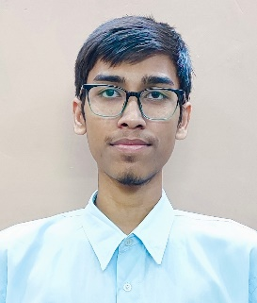



**Vishal Singh Thapa**

Delhi, India <singh.thapa.vishal@gmail.com>

+91 8130532163

[LinkedIn](https://www.linkedin.com/in/vishal-thapa-5ba6a5229/)

# EDUCATION

## Maharaja Agrasen Institute of Technology

*Bachelor of Technology - Information Technology*

9.62/10.0 CGPA (till 4th semester)

## Army Public School Delhi Cantt

## *Senior Secondary (XII)*

## 95.25%

# PROFESSIONAL EXPERIENCE

## Cod Soft

*C++ Intern*

Collaborating with the development team to design, implement tasks

creation of tasks using C++ data structures (HashMap, Arrays, Lists etc.)

Debugging technical issues and bugs to improve projects performance

# SKILLS

**Programming Languages** (C, C++)

2021 – 2025

Delhi, India

2019 – 2020

Delhi, India

08/2023 – 09/2023

**Computer Science Fundamentals** (Data Structures, Algorithms, Object-Oriented Programming, Database Management System, Operating Systems, Computer Networks, Linux)

**Frontend Web Development** (Advanced HTML/CSS, Tailwind CSS, JavaScript)

**Tools** (Git, GitHub, VS Code)

# PROJECTS

## 1.Weather Uno

W*eather Forecaster Website*

Streamline weather forecaster, showing details of weather of specific locations.

Used Open Weather API to display current weather conditions of different locations.

Tech Stack: HTML, CSS, and JavaScript, API

## 2.Modern Chair Project

Created a responsive modern chair project

Tech Stack: HTML, Tailwind CSS, Animations

## 3.Portfolio website

Created an animated and responsive portfolio website

Tech Stack: HTML, CSS

## 4.Usability club (Clone)

Created a clone of Usability Hub Website

Tech Stack: HTML, CSS

# Achievements

## Solved 400+ Questions on [LeetCode](https://leetcode.com/VST_11092001/)

## 5-star Coder at [HackerRank](https://www.hackerrank.com/profile/singh_thapa_vis1)

## Specialist at [CodeStudio](https://www.codingninjas.com/studio/profile/08a652ec-67e9-4a0a-8b69-2004f7600bcc)

## Department Rank-1 holder in 3rd Semester

## University Rank-4 holder overall