**A PROJECT REPORT ON**

**IRIS FLOWER DATASET CLASSIFICATION USING SUPPORT VECTOR MACHINE**

SUBMITTED TO THE SAVITRIBAI PHULE PUNE UNIVERSITY, PUNE

IN THE PARTIAL FULFILLMENT OF THE REQUIREMENTS

FOR THE AWARD OF THE DEGREE

OF

**BACHELOR OF ENGINEERING (COMPUTER ENGINEERING)**

##### SUBMITTED BY

**VISHAL TANAWADE 18CS055**

**SARTHAK THORAT 18CS056**

**HITESH SASWADKAR 18CS048**

**SURAJ SHIRUDE 18CS051**

**PRATIK KARHEKAR 18CS027**

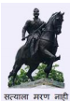

## DEPARTMENT OF COMPUTER ENGINEERING

## AISSMS COLLEGE OF ENGINEERING

PUNE 411001

## SAVITRIBAI PHULE PUNE UNIVERSITY

## 2021 -2022



**CERTIFICATE**

This is to certify that the project report entitles

“**IRIS FLOWER DATASET CLASSIFICATION USING SUPPORT VECTOR MACHINE”**

Submitted by

**VISHAL TANAWADE 18CS055**

**SARTHAK THORAT 18CS056**

**HITESH SASWADKAR 18CS048**

**SURAJ SHIRUDE 18CS051**

**PRATIK KARHEKAR 18CS027**

is a bonafide student of this institute and the work has been carried out by him/her under the supervision of **Prof. S. R. Nalamwar** and it is approved for the partial fulfillment of the requirement of Savitribai Phule Pune University, for the award of the degree of **Bachelor of Engineering** (Computer Engineering).

**Prof. S.R. Nalamwar** **Dr. D. P. Gaikwad**

Guide Head,

Department of Computer Engineering Department of Computer Engineering

Place : Pune

Date :

**ACKNOWLEDGEMENT**

We take this opportunity to thank Head Of The Department for giving us an opportunity to work on a mini-project that helped hone our technical skills to a great extent. We are immensely grateful to **Prof. S. R. Nalamwar** for their guidance, support and suggestions that helped us in making this project a success.

It has been an honor to be guided by **Prof. S. R. Nalamwar** for her terrific mentorship, and we are very thankful for all of her constructive criticism that greatly helped us in our journey towards the successful completion of the project.

We would also like to acknowledge the efforts and appreciate the departmental faculty for their efforts.

**INDEX**

Contents:

1 Introduction

1.1 Problem Statement and Objectives

2 Methodology

2.1 Data Understanding

2.2 Modeling

2.3 Implementation and Evaluation

3 Result

4 Conclusion

1. **INTRODUCTION**

Machine learning is a subfield of artificial intelligence (AI). The goal of machine learning generally is to understand the structure of data and fit that data into models that can be understood and utilized by people.

Machine learning is a growing technology which enables computers to learn automatically from past data. Machine learning uses various algorithms for building mathematical models and making predictions using historical data or information.

Currently, it is being used for various tasks such as image recognition, speech recognition, email filtering, Facebook auto-tagging, recommender system, and many more.

* 1. **PROBLEM STATEMENT**

Classify the Iris Flower Dataset using Support Vector Machine based on Sepal length , Petal length, Sepal width and Petal width.

## OBJECTIVE

* Classify Iris Flower Dataset.
* To learn about Support Vector Machine.

1. **METHODOLOGY**

* We used various libraries such as Sklearn, Pandas, Numpy, MatplotLib, etc.
* We used Support Vector Machine Model for prediction of Iris Flower type.
* We are using Jupyter Notebook to implement our project.

**2.1 Data Understanding:**

* This database contains 4 attributes Sepal length , Petal length, Sepal width and Petal width.

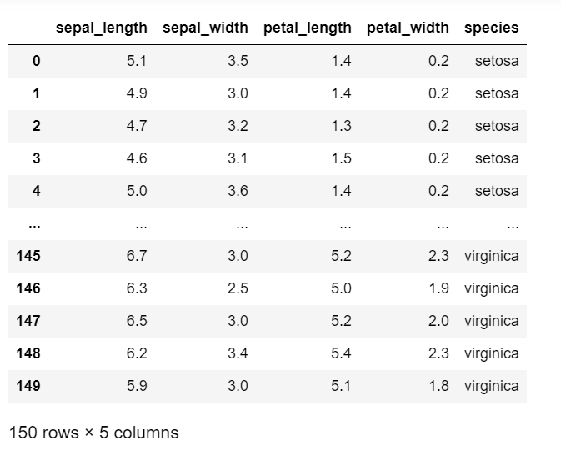

* Iris Flower contains following 3 classes:

1.Iris Versicolor

2.Iris Setosa

3.Iris Virginica.

**2.2 Modeling:**

* Standard library built-in modeling techniques are used for the project. The various stages are shown below:

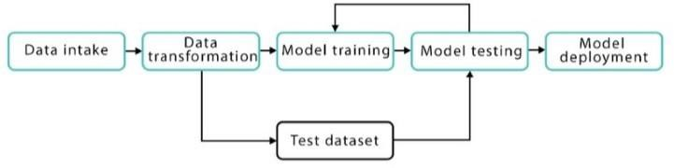

**2.3 Implementation and Evaluation:**

The project will be using jupyter notebook running Python 3.7 and ML library Scikit- learn. The standard accuracy result based on training and testing dataset is used for evaluating the different classification models.

1. **RESULT**

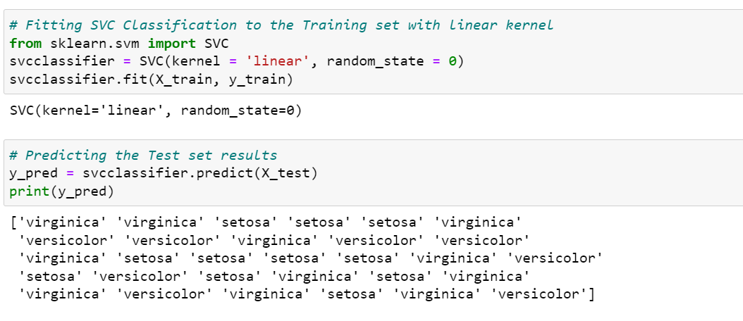

1. **CONCLUSION**

We have successfully implemented the Support Vector Machine algorithm to checking the Iris Flower type based on the dataset provided. We classify the image based on Sepal length , Petal length, Sepal width and Petal width. Using Support Vector Machine algorithm we conclude that the accuracy is around the 97%.