DATA WAREHOUSE ASSIGNMENT-1

1.IPL Cricket Tournament Star Schema Design:

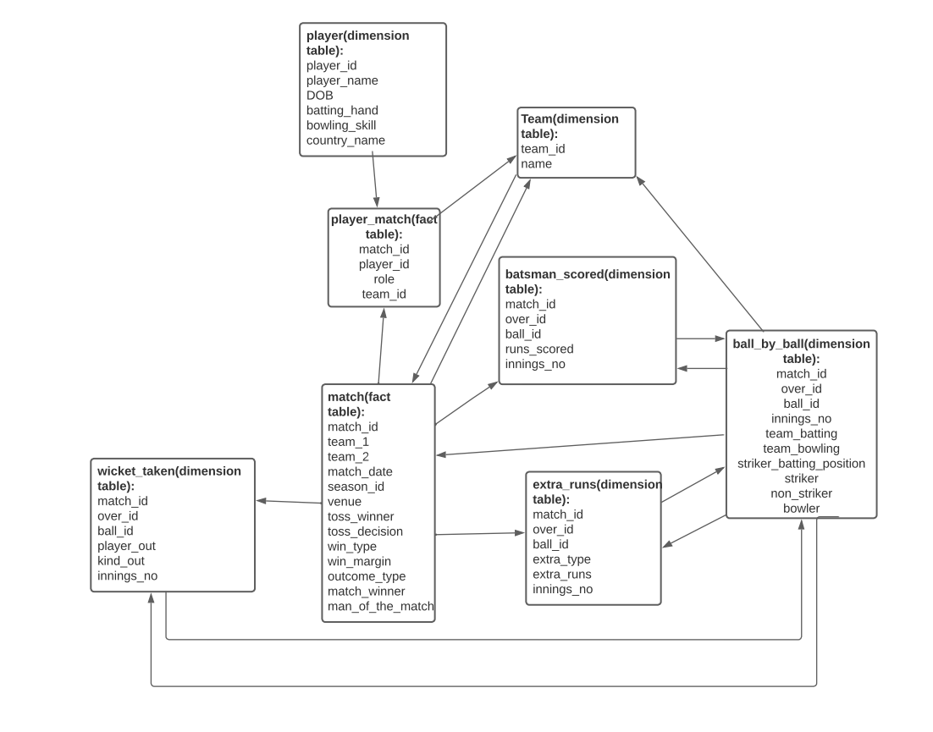

1.IPL Cricket Tournament Snowflake Schema:

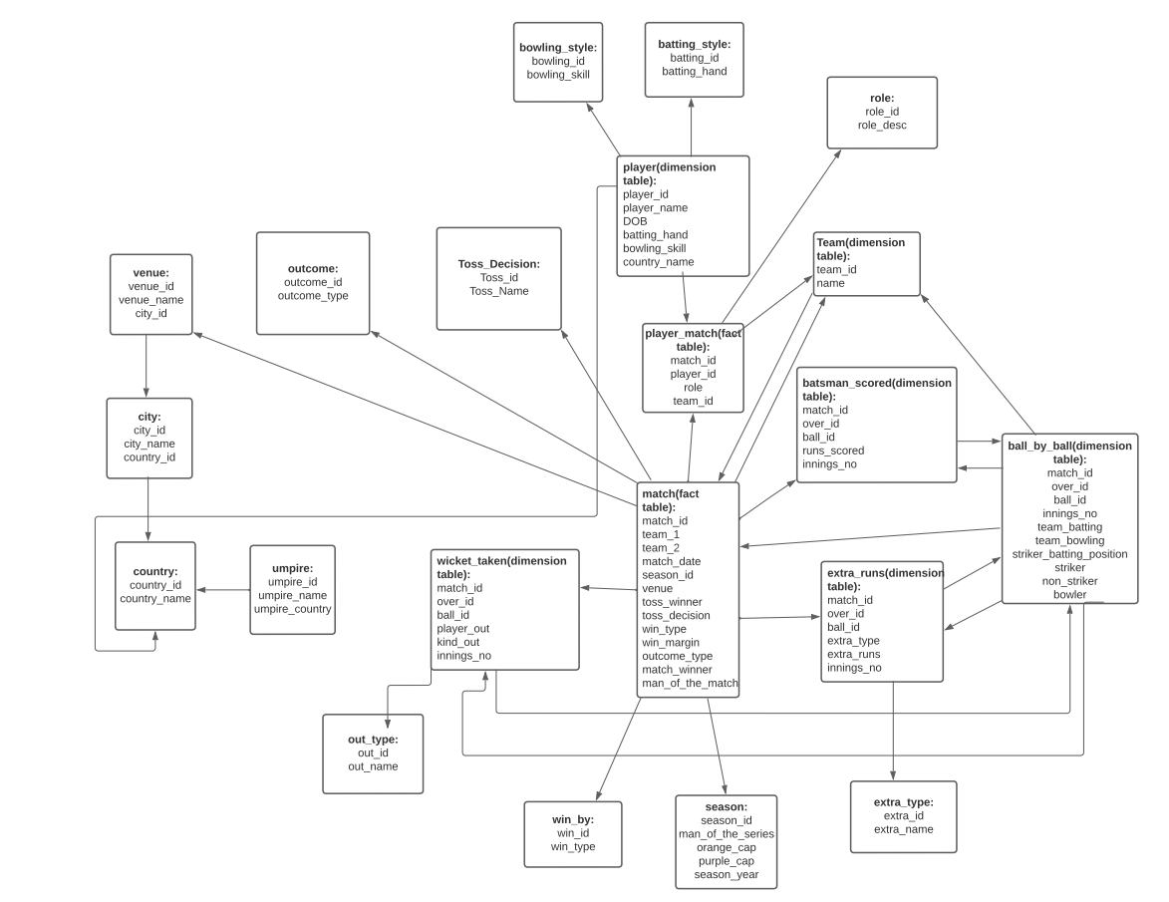

2. Food Delivery Apps like Swiggy, Zomato Star Schema Design:

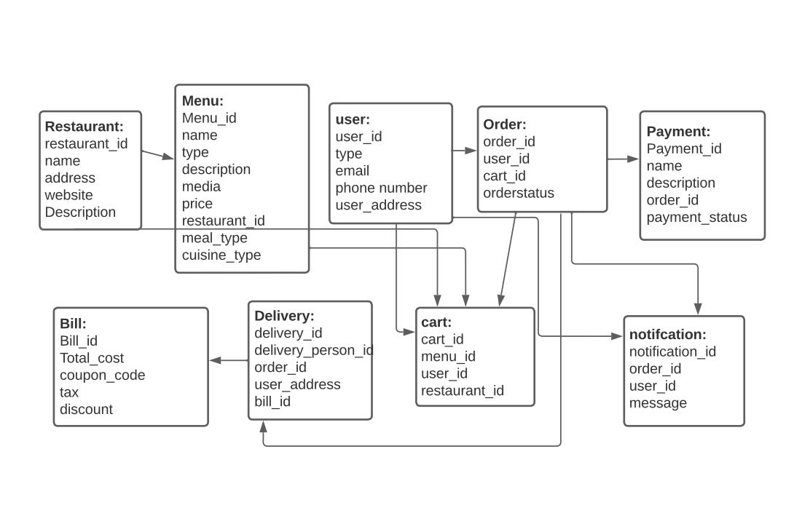

2. Food Delivery Apps like Swiggy, Zomato Snowflake Schema Design:

3. Cab Ride Services Like Uber Star Schema Design:

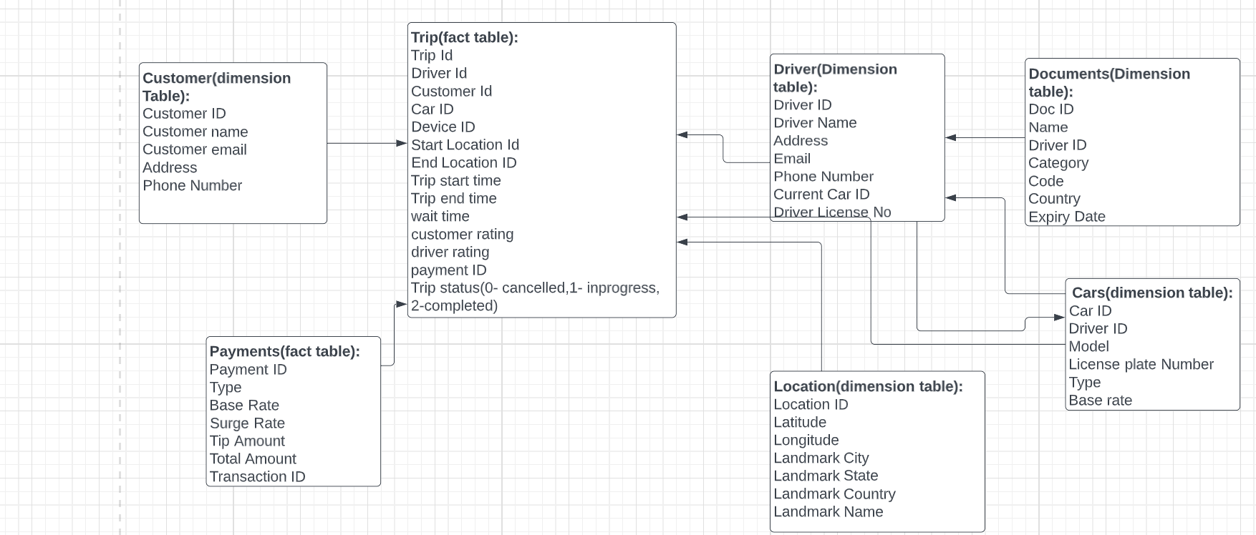

3. Cab Ride Services Like Uber Snowflake Schema Design:

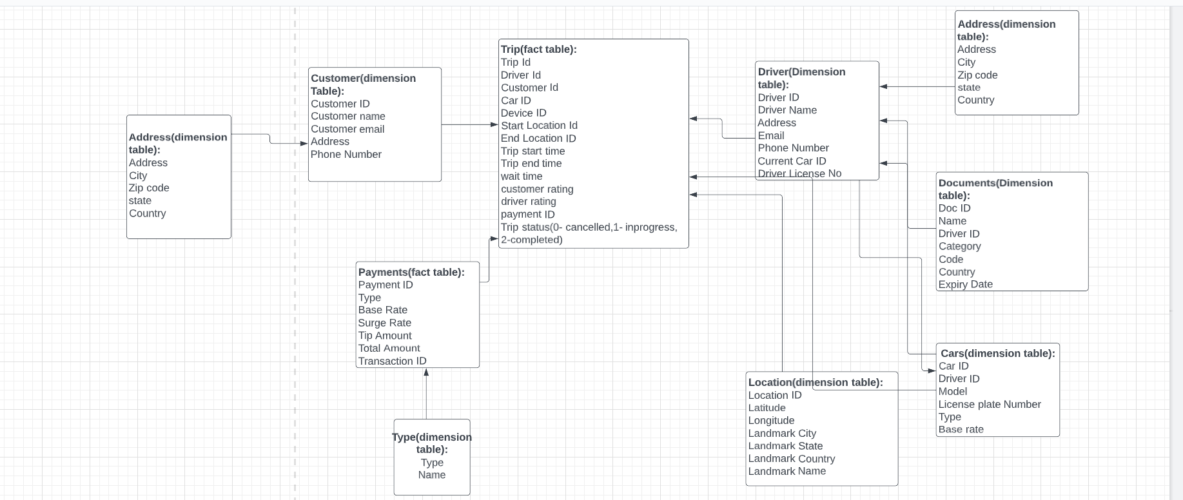

4. Restaurant Table Booking App Like Dine-out Star Schema:

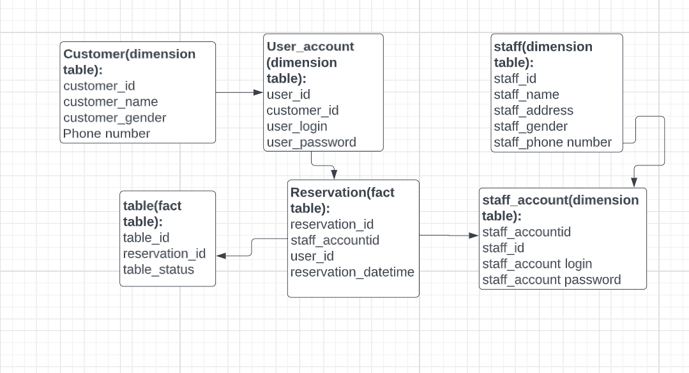

4. Restaurant Table Booking App Like Dineout Snowflake Schema:

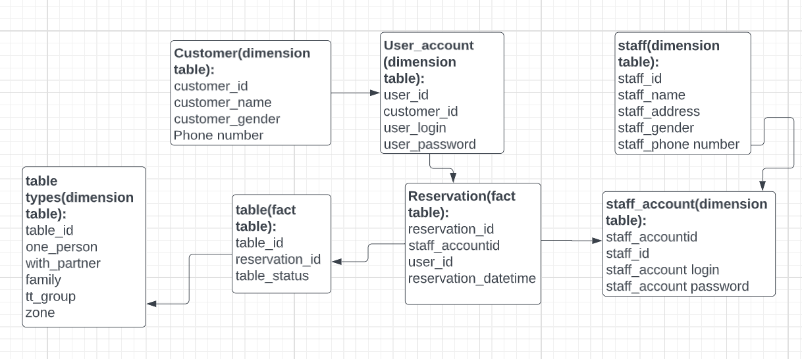

5.Covid Vaccination Application Start Schema:

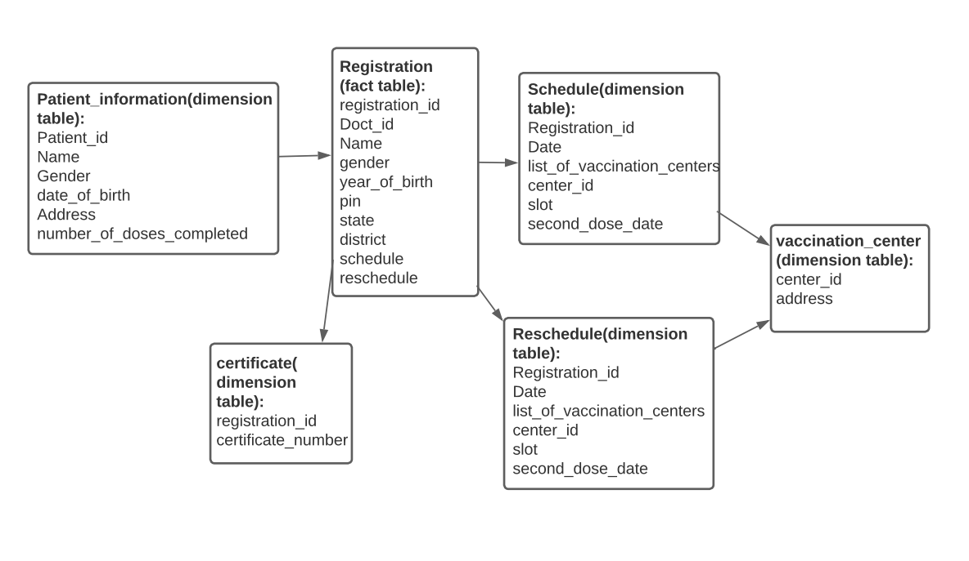

5.Covid Vaccination Application Snowflake Schema:

