Software Design Specification Template
Crop Yield Prediction System Using Machine Learning
Version 1.0
1. Introduction
1.1 Purpose
This Software Design Specification (SDS) document describes the design architecture and internal structure of the Crop Yield Prediction System Version 1.0. The system is developed to predict crop yield for Rabi and Kharif crops using supervised machine learning techniques. This document defines the analysis model, architectural design, database structure, component design, and interface design of the system. It serves as a technical reference for developers and evaluators to understand how the system is constructed and how its components interact.
1.2 Document Conventions
This document follows IEEE standards for Software Design Specification. Diagrams such as Use Case Diagrams, Class Diagrams, Activity Diagrams, and Sequence Diagrams are represented using UML conventions. All modules and components are described using formal terminology. Technical terms are defined in the Glossary section. Section numbering follows a hierarchical format for clarity.
1.3 Intended Audience and Reading Suggestions
This document is intended for developers, system designers, project supervisors, testers, and evaluation committees. Developers should focus on the Design Model section to understand the architecture and component interaction. System analysts should review the Analysis Model section to understand user behavior and workflows. Evaluators may review the Architectural Design and Database Design sections to understand system structure. It is recommended to begin with the Introduction, followed by the Analysis Model and then the Design Model.
1.4 References
This SDS is based on the previously prepared Software Requirements Specification (SRS) document for the Crop Yield Prediction System. Additional references include Scikit-learn documentation, Python programming standards, and UML modeling guidelines.
2. Analysis Model
2.1 Methodology Used
The system is developed using Object-Oriented Programming principles in Python. The development follows an incremental software process model where the system was built in stages including requirement analysis, design, implementation, and testing. The object-oriented methodology promotes modularity, reusability, and maintainability of code.
Classes such as DataPreprocessor, ModelTrainer, EnsembleModel, and Predictor encapsulate system functionality. The machine learning workflow follows supervised regression techniques, where historical data is used to train predictive models.
2.2 Use Case Diagram
The primary actors interacting with the system are:
• End User (Farmer / Researcher)
• Administrator / Developer
Main Use Cases:
• Load Dataset
• Preprocess Data
• Train Model
• Evaluate Model
• Predict Crop Yield
• View Analytical Reports
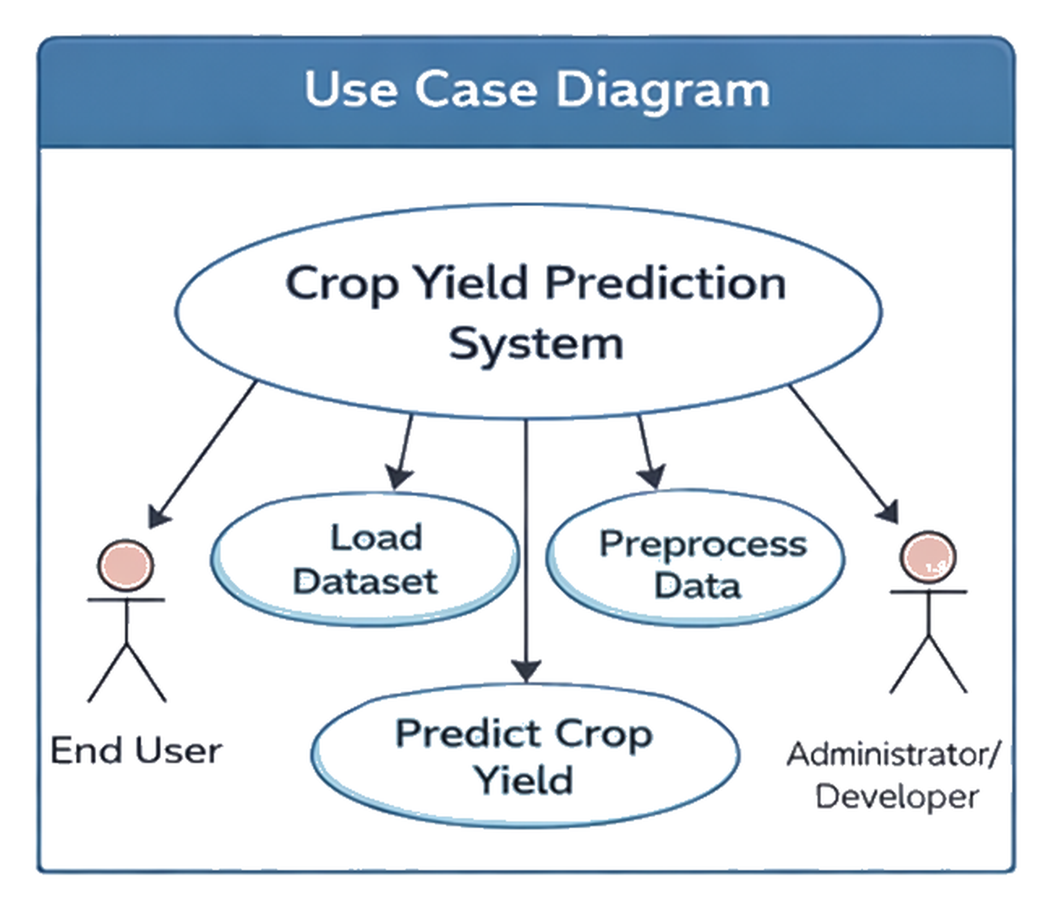
Fig.2.2 Use Case Diagram
Use Case Specification
Name of Use Case: Predict Crop Yield
Actor: End User
Precondition: Model must be trained and system must be running.
Primary Flow of Events:
The user enters crop parameters such as crop type, season, rainfall, area, fertilizer usage, and state. The system validates input data and processes it using the trained machine learning model. The predicted yield is displayed along with graphical analysis.
Alternate Flow:
If invalid input is entered, the system displays an error message and prompts the user to re-enter valid data.
Post Condition: Predicted yield value is displayed.
Use Case Termination: User exits the system.
2.3 Activity Diagram
The activity flow of the system begins with dataset loading. The system performs preprocessing steps including cleaning and encoding. After preprocessing, data is split into training and testing sets. Machine learning models are trained and evaluated. The ensemble model is applied to improve accuracy. Finally, predictions are generated and displayed.

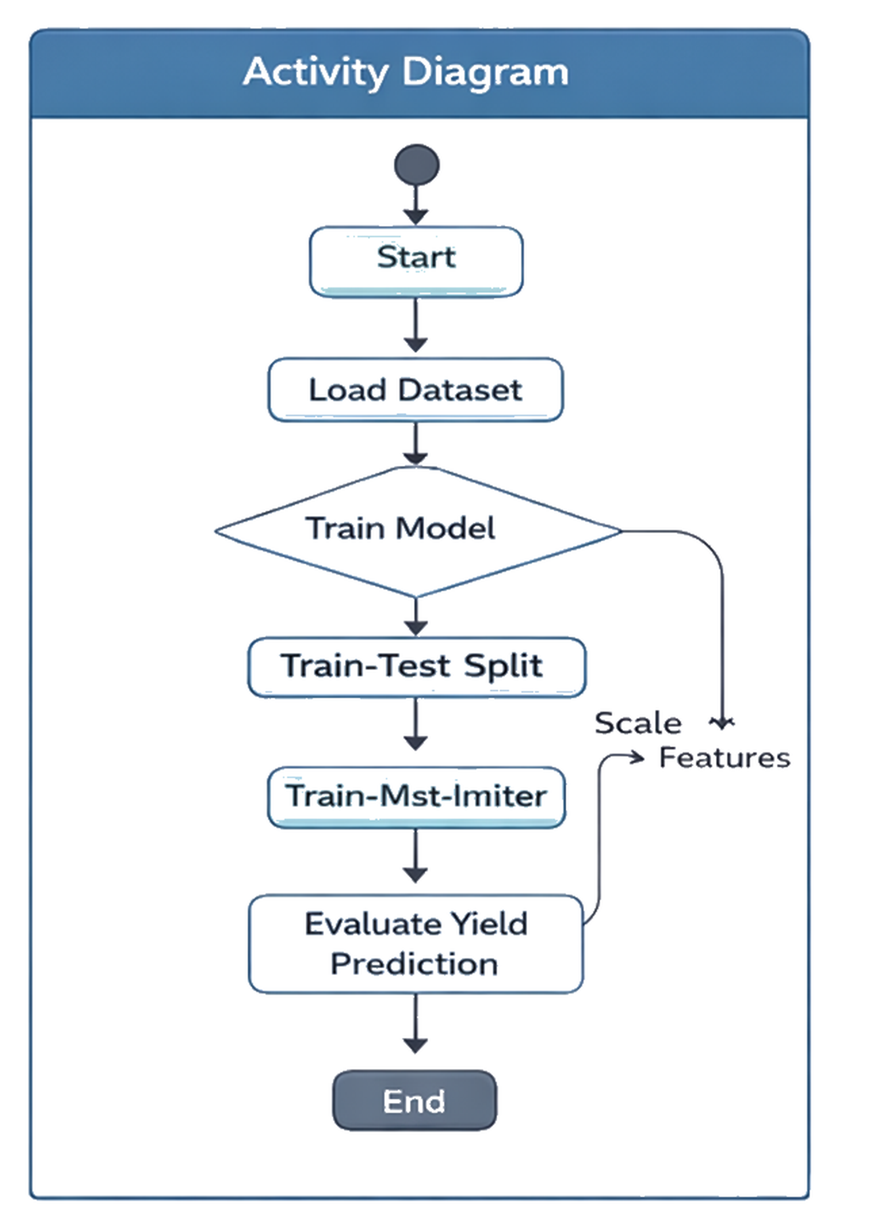
Fig.2.3 Activity Diagram

2.4 Sequence Diagram
The sequence of interaction in prediction process is as follows:
User sends input data to the Interface Module.
Interface Module forwards data to Predictor Class.
Predictor Class sends processed input to Trained Model.
Model computes prediction and returns output.
Output is displayed to the User.
This sequence ensures clear separation between user interaction and machine learning logic.
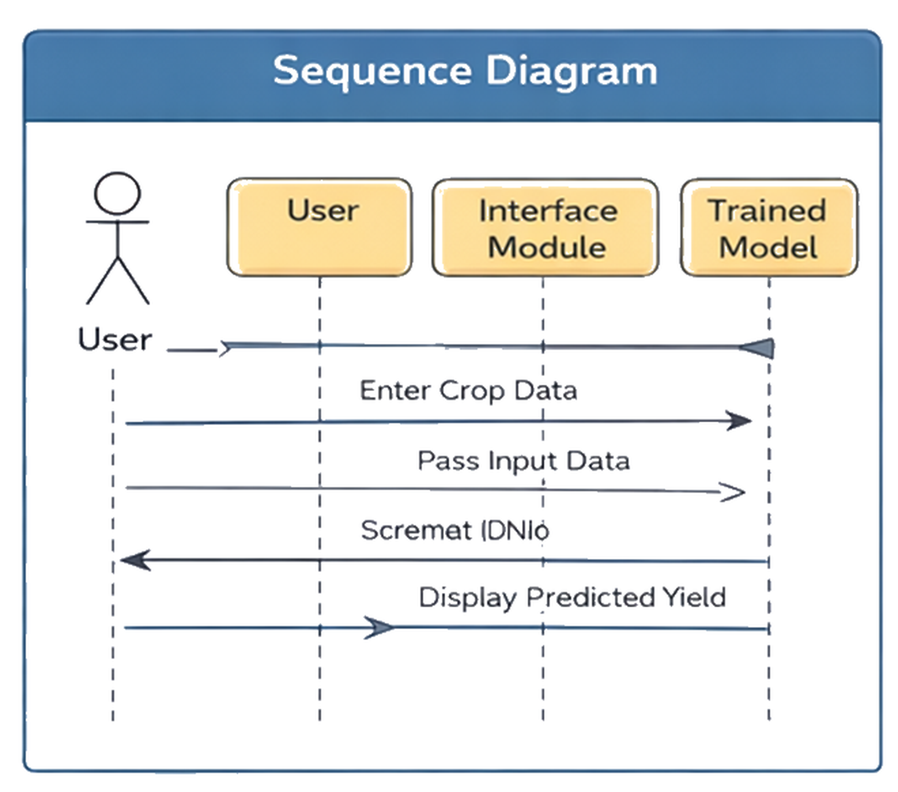
Fig.2.4 Sequence Diagram

2.5 Class Diagram
The system consists of the following major classes:
DataPreprocessor
ModelTrainer
EnsembleModel
Predictor
Visualizer

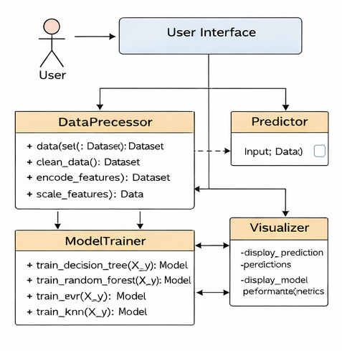
Fig.2.5 Class Diagram
The DataPreprocessor class handles cleaning, encoding, and scaling.
The ModelTrainer class trains regression models.
The EnsembleModel class combines predictions.
The Predictor class generates yield predictions.
The Visualizer class generates graphs.
Relationships:
ModelTrainer depends on DataPreprocessor.
Predictor depends on trained models.
Visualizer uses prediction results.

3. Design Model
3.1 Architectural Design
3.1.1 System Architecture Diagram
The system follows a layered architecture:
Presentation Layer → Application Layer → Machine Learning Layer → Data Layer
Presentation Layer handles user input and display.
Application Layer manages workflow control.
Machine Learning Layer performs model training and prediction.
Data Layer manages dataset storage.
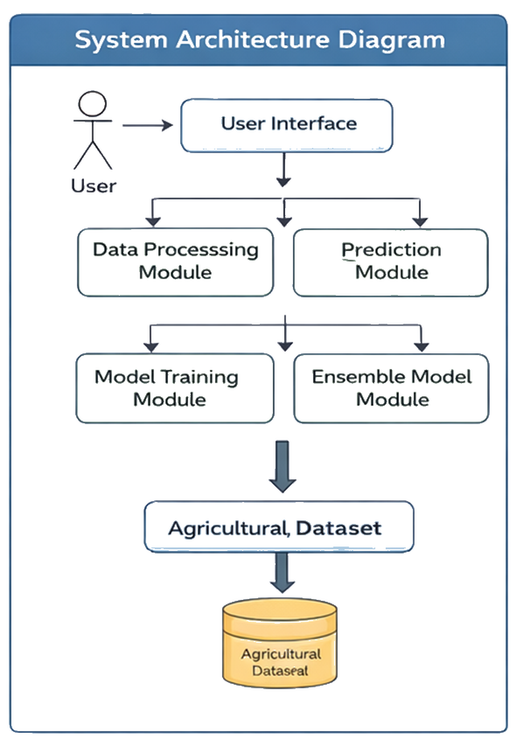
Fig.3.1.1 System Architecture Diagram
3.1.2 Description of Architectural Design
The architecture separates concerns to improve maintainability. The Presentation Layer interacts with users and passes input to the Application Layer. The Application Layer coordinates preprocessing, training, and prediction modules. The Machine Learning Layer implements regression algorithms and ensemble methods. The Data Layer stores historical agricultural data in CSV format.
3.2 Database Design
Although the system primarily uses CSV datasets, the conceptual database structure includes the following entities:
Crop
Season
State
Yield
Rainfall
Area
Fertilizer

3.2.1 Data Dictionary
Crop: Name of the crop being cultivated.
Season: Type of season (Rabi/Kharif).
State: Geographic region.
Rainfall: Annual rainfall measurement in millimeters.
Area: Cultivated land area in hectares.
Fertilizer: Quantity of fertilizer used.
Yield: Output crop yield per hectare.
Each attribute is stored as structured data in tabular format.
3.2.2 Normalization
The dataset structure follows First Normal Form (1NF) as all attributes contain atomic values. It also satisfies Second Normal Form (2NF) since non-key attributes depend entirely on the primary key. Redundant data is minimized to maintain consistency.
3.3 Component Design
3.3.1 Package Diagram
The system consists of the following packages:
data
models
utils
visualization
main
The data package handles preprocessing.
The models package contains regression algorithms.
The visualization package handles graphs.
The main module integrates all components.
3.3.2 Component Diagram
Components include:
Dataset Loader
Preprocessing Engine
Model Training Engine
Ensemble Engine
Prediction Engine
Visualization Module
These components interact sequentially to complete prediction workflow.

3.3.3 Deployment Diagram
The system is deployed on a single machine environment.
Node: Personal Computer
Artifacts: Python Interpreter, ML Libraries, Dataset File
All components execute locally without network dependency.
3.4 Interface Design
The interface includes:
Input form for crop parameters
Prediction output display
Graphical visualization of trends
In command-line implementation, user inputs are accepted via terminal. Future enhancement includes web-based GUI using Streamlit.

Appendix C1: Glossary
Machine Learning: Algorithmic technique for learning patterns from data.
Regression: Supervised learning method for predicting continuous values.
Ensemble Model: Combination of multiple models for improved accuracy.
UML: Unified Modeling Language.

