Hospital Management System
A Scalable Microservices Application
Spring Boot · Feign · Kafka · Resilience4j · JWT · React · Docker · Kubernetes

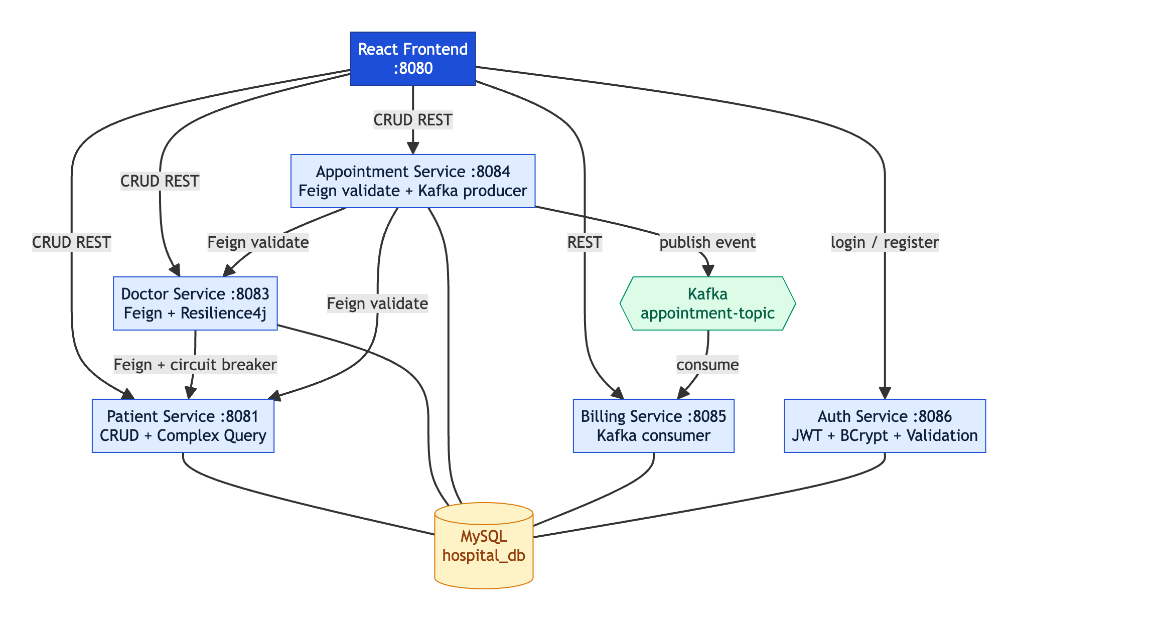
Figure 1: High-level system architecture
Group 1 — Project Documentation
Project Report & Execution Guide

Table of Contents
1. Introduction & Problem Statement
2. System Overview
3. Architecture
4. Technology Stack
5. The Microservices
6. Inter-Service Communication (Feign & Kafka)
7. Circuit Breaking with Resilience4j
8. Complex Query
9. Authentication & Validation
10. Pagination & Sorting
11. Database Design
12. Frontend (React Hooks) — with Screenshots
13. Deployment (Docker & Kubernetes)
14. How to Execute & Run the Project
15. Testing & Verification
16. Requirement → Implementation Map
17. Conclusion

1. Introduction & Problem Statement
The objective of this project is to design and develop a scalable Hospital Management System using a microservices architecture. The system incorporates CRUD operations, inter-service communication using Spring Cloud OpenFeign and Apache Kafka, circuit breaking using Resilience4j, a complex multi-criteria database query, and deployment using Docker and Kubernetes. The frontend is built using React Hooks.
Beyond the core requirements, the system also implements user authentication (JWT-based login and registration), input validation, and pagination with sorting on all list endpoints.

Key Objectives
- Design four core microservices: Patient, Doctor, Appointment, and Billing.
- Implement full CRUD operations for each service.
- Enable synchronous inter-service communication using Spring Feign Client.
- Enable asynchronous, event-driven communication using Apache Kafka.
- Apply circuit breaking to gracefully handle downstream service failures.
- Implement a complex multi-criteria query for patient search.
- Secure the application with JWT authentication and input validation.
- Containerize all services with Docker and orchestrate with Kubernetes.
- Build a responsive frontend using React Hooks.

2. System Overview
The application is composed of five backend microservices and a React frontend, supported by a shared MySQL database and an Apache Kafka message broker. Each service is independently deployable and owns its own domain logic.
Service | Port | Responsibility
patient-service | 8081 | Patient CRUD + complex multi-criteria search
doctor-service | 8083 | Doctor CRUD; calls Patient Service via Feign (circuit-broken)
appointment-service | 8084 | Appointment CRUD; Feign validation; Kafka producer
billing-service | 8085 | Consumes Kafka events and auto-generates bills
auth-service | 8086 | Register/login with JWT, BCrypt, and validation
frontend | 8080 | React Hooks single-page application (nginx)

3. Architecture
The architecture follows microservices principles: loose coupling, single responsibility, and independent deployability. Services communicate synchronously via REST/Feign and asynchronously via Kafka. The frontend is the single entry point for users.
Figure 2: Component & communication architecture

Communication Patterns
- Synchronous (Feign): doctor→patient, appointment→patient, appointment→doctor.
- Asynchronous (Kafka): appointment→billing (decoupled, event-driven).
- Resilience: the doctor→patient call is guarded by a Resilience4j circuit breaker with a fallback.

4. Technology Stack
Layer | Technology
Language / Framework | Java 17, Spring Boot 3.5
Persistence | Spring Data JPA, MySQL 8.4
Sync communication | Spring Cloud OpenFeign
Async communication | Apache Kafka 3.7 (KRaft mode)
Fault tolerance | Resilience4j Circuit Breaker
Security | Spring Security, JWT (jjwt), BCrypt
Validation | Jakarta Bean Validation
Frontend | React 18 (Hooks), Vite
Containerization | Docker, Docker Compose
Orchestration | Kubernetes (+ AWS EKS guide)

5. The Microservices

5.1 Patient Service (:8081)
Manages patient records and provides the complex multi-criteria search.
Method | Endpoint | Description
POST | /patients | Create a patient
GET | /patients?page=&size=&sort= | List patients (paginated + sortable)
GET | /patients/{id} | Get patient by ID
PUT | /patients/{id} | Update a patient
DELETE | /patients/{id} | Delete a patient
GET | /patients/search?name=&age=&department= | Multi-criteria search

5.2 Doctor Service (:8083)
Manages doctors and exposes the Feign + circuit-breaker endpoint that combines a doctor with patient data fetched from the Patient Service.
Method | Endpoint | Description
POST | /doctors | Create a doctor
GET | /doctors?page=&size=&sort= | List doctors (paginated + sortable)
GET | /doctors/{id} | Get doctor by ID
PUT | /doctors/{id} | Update a doctor
DELETE | /doctors/{id} | Delete a doctor
GET | /doctors/{doctorId}/patient/{patientId} | Doctor + patient via Feign (circuit-broken)

5.3 Appointment Service (:8084)
Books appointments. Before saving, it validates that both the patient and doctor exist (via Feign); it then publishes an event to Kafka, which the Billing Service consumes.
Method | Endpoint | Description
POST | /appointments | Book (Feign-validated, publishes Kafka event)
GET | /appointments?page=&size=&sort= | List appointments (paginated + sortable)
GET | /appointments/{id} | Get by ID
PUT | /appointments/{id} | Update
DELETE | /appointments/{id} | Delete

5.4 Billing Service (:8085)
Listens to the Kafka appointment topic and automatically generates a bill for each booked appointment. Bills are not created by a POST endpoint — they are event-driven.
Method | Endpoint | Description
GET | /bills?page=&size=&sort= | List bills (paginated + sortable)
GET | /bills/{id} | Get bill by ID
PUT | /bills/{id}/status?status= | Update a bill's status
DELETE | /bills/{id} | Delete a bill

6. Inter-Service Communication (Feign & Kafka)

6.1 Spring Cloud OpenFeign (Synchronous)
Feign provides declarative REST clients. The Doctor Service calls the Patient Service, and the Appointment Service validates both the patient and the doctor before booking.
@FeignClient(name = "patient-service", url = "http://patient-service:8081")
public interface PatientFeignClient {
@GetMapping("/patients/{id}")
PatientDto getPatientById(@PathVariable Long id);
}

6.2 Apache Kafka (Asynchronous)
When an appointment is booked, the Appointment Service publishes a JSON event to the 'appointment-topic' topic. The Billing Service (consumer group 'billing-group') consumes the event and generates a bill. This decouples billing from appointment booking.
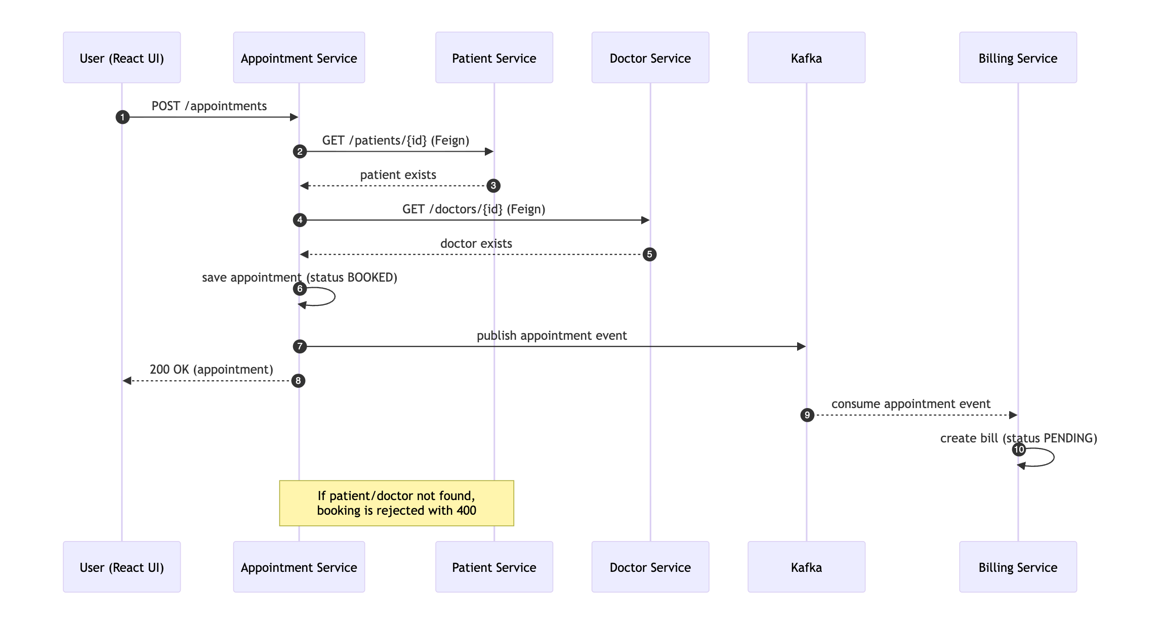
Figure 3: Appointment booking flow: Feign validation + Kafka-driven billing

7. Circuit Breaking with Resilience4j
The doctor→patient Feign call is wrapped in a Resilience4j circuit breaker. If the Patient Service is unavailable, the breaker opens and the call falls back to a placeholder response instead of failing the whole request.
@CircuitBreaker(name = "patientService", fallbackMethod = "patientServiceFallback")
public DoctorPatientResponse getDoctorWithPatient(Long doctorId, Long patientId) { ... }
Property | Value | Meaning
sliding-window-size | 10 | Calls evaluated
minimum-number-of-calls | 5 | Calls before the rate is computed
failure-rate-threshold | 50% | Opens the breaker above this rate
wait-duration-in-open-state | 10s | Time before trying half-open
permitted-calls-in-half-open | 3 | Trial calls in half-open

The breaker state can be observed via Spring Boot Actuator at /actuator/health and /actuator/circuitbreakers on the Doctor Service.

8. Complex Query
The Patient Service implements a complex, dynamic, NULL-safe multi-criteria query. A single JPQL query handles any combination of the criteria (name, age, department) — each predicate applies only when its parameter is provided.
@Query("SELECT p FROM Patient p WHERE " +
"(:name IS NULL OR p.name = :name) AND " +
"(:age IS NULL OR p.age = :age) AND " +
"(:department IS NULL OR p.department = :department)")
List<Patient> searchPatients(@Param("name") String name,
@Param("age") Integer age,
@Param("department") String department);
Note: the assignment names Oracle; this project uses MySQL. The query is standard, portable JPQL (translated by Hibernate to the target dialect), so it runs unchanged on Oracle.

9. Authentication & Validation
A dedicated auth-service handles registration and login using Spring Security, JWT, and BCrypt password hashing. The frontend is gated — users must log in or register first.

Validation Rules
- Email is mandatory, must be a valid email, and must be a @gmail.com address.
- Password must be at least 8 characters with an uppercase letter, a lowercase letter, a digit, and a special character (@$!%*?&#).
- Validation failures return HTTP 400 with per-field error messages shown next to each input.
@Pattern(regexp = "^[A-Za-z0-9._%+-]+@gmail\\.com$",
message = "Email must be a @gmail.com address")
private String email;
Passwords are stored only as BCrypt hashes in the 'users' table — never in plaintext.

10. Pagination & Sorting
Every list endpoint is paginated and sortable using Spring Data's Pageable abstraction. Clients pass page, size, and sort query parameters; the default page size is 5.
@GetMapping
public Page<Patient> getAll(@PageableDefault(size = 5, sort = "id") Pageable pageable) {
return service.getAllPatients(pageable);
}
Example: GET /patients?page=0&size=5&sort=name,asc. The frontend renders Prev/Next controls, a page indicator, and a sort dropdown on every list tab.

11. Database Design
All services share a single MySQL database (hospital_db); each service owns its own tables. The schema is generated from the JPA entities. The entity-relationship model is shown below.
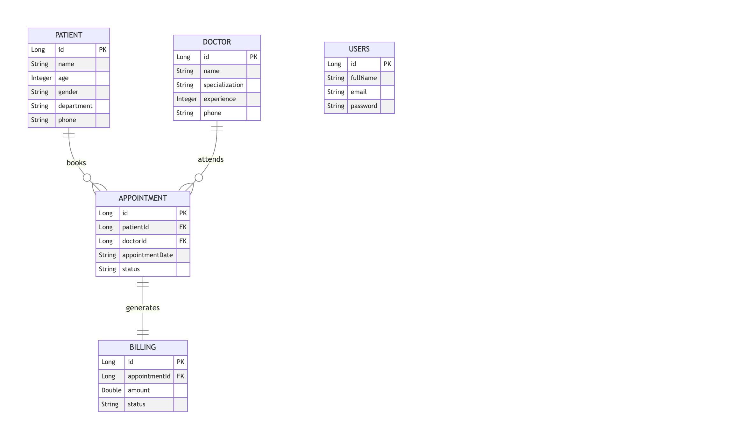
Figure 4: Entity-Relationship diagram

12. Frontend (React Hooks) — with Screenshots
The frontend is a single-page application built with React 18 Hooks (useState, useEffect, useCallback) and two custom hooks — usePaged (pagination/sort state) and useAll (full-list fetch for dropdowns). It is served by nginx in Docker on port 8080.

12.1 Login & Registration
The application is gated by a split-screen login/registration page. Registration enforces the email and password validation rules, displaying per-field errors.
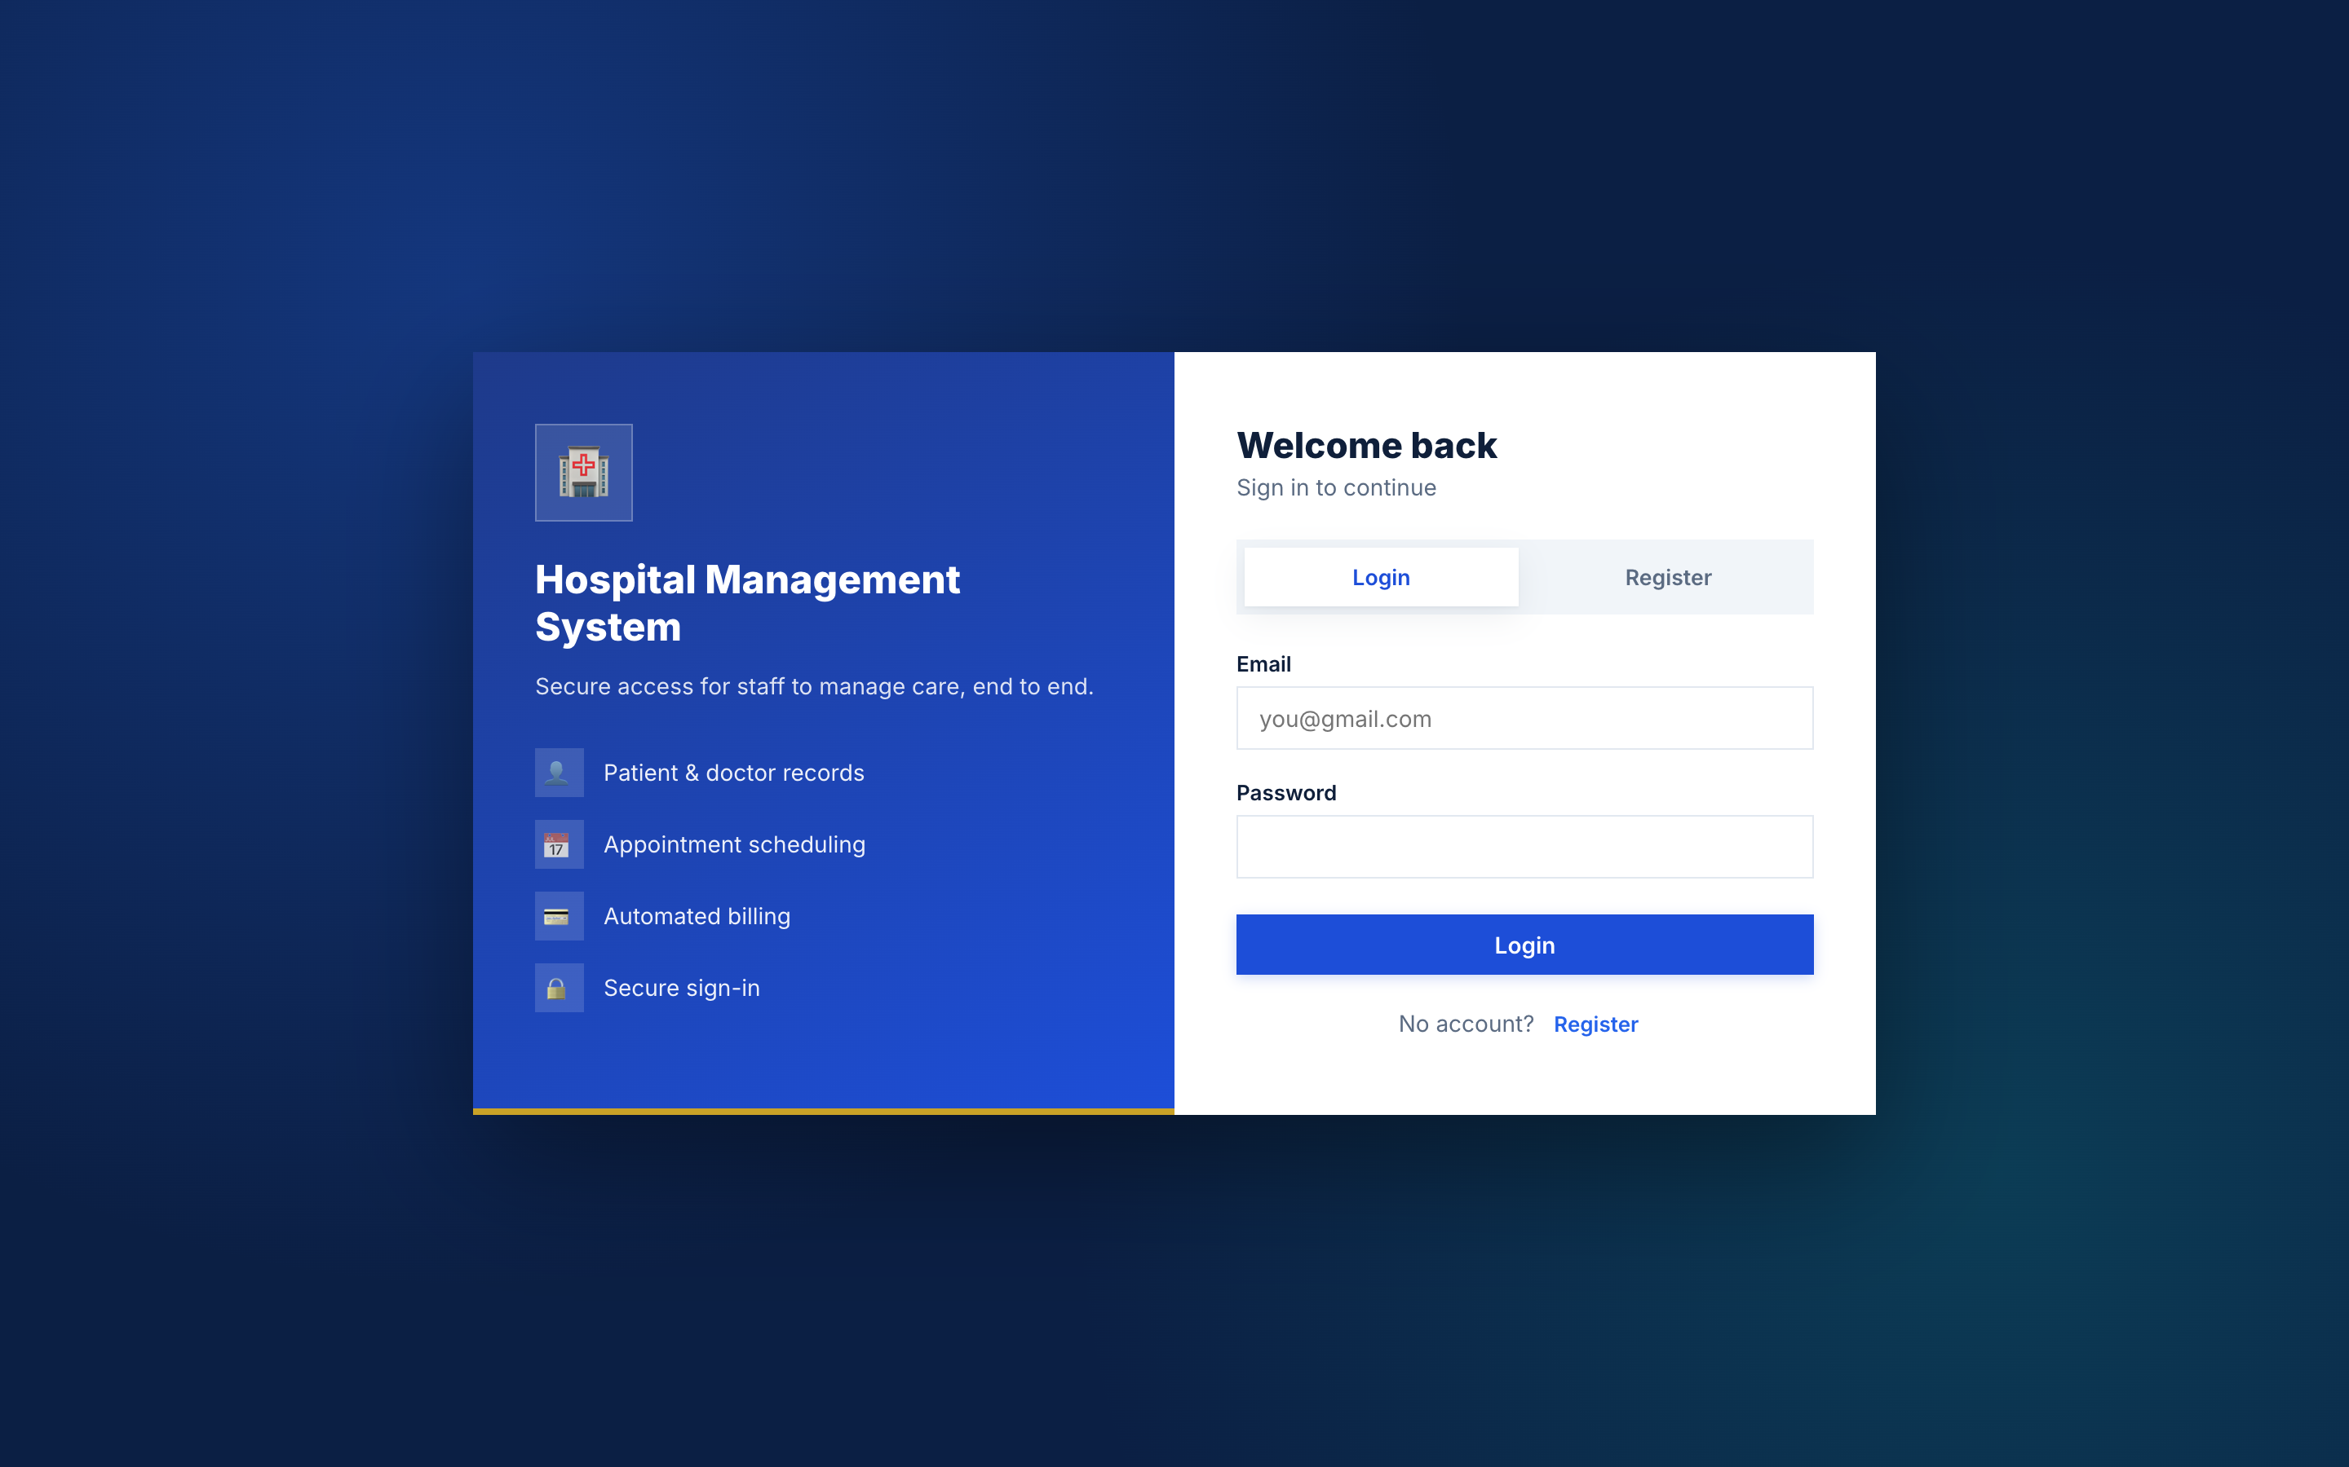
Figure 5: Login page (split-screen with branding panel)
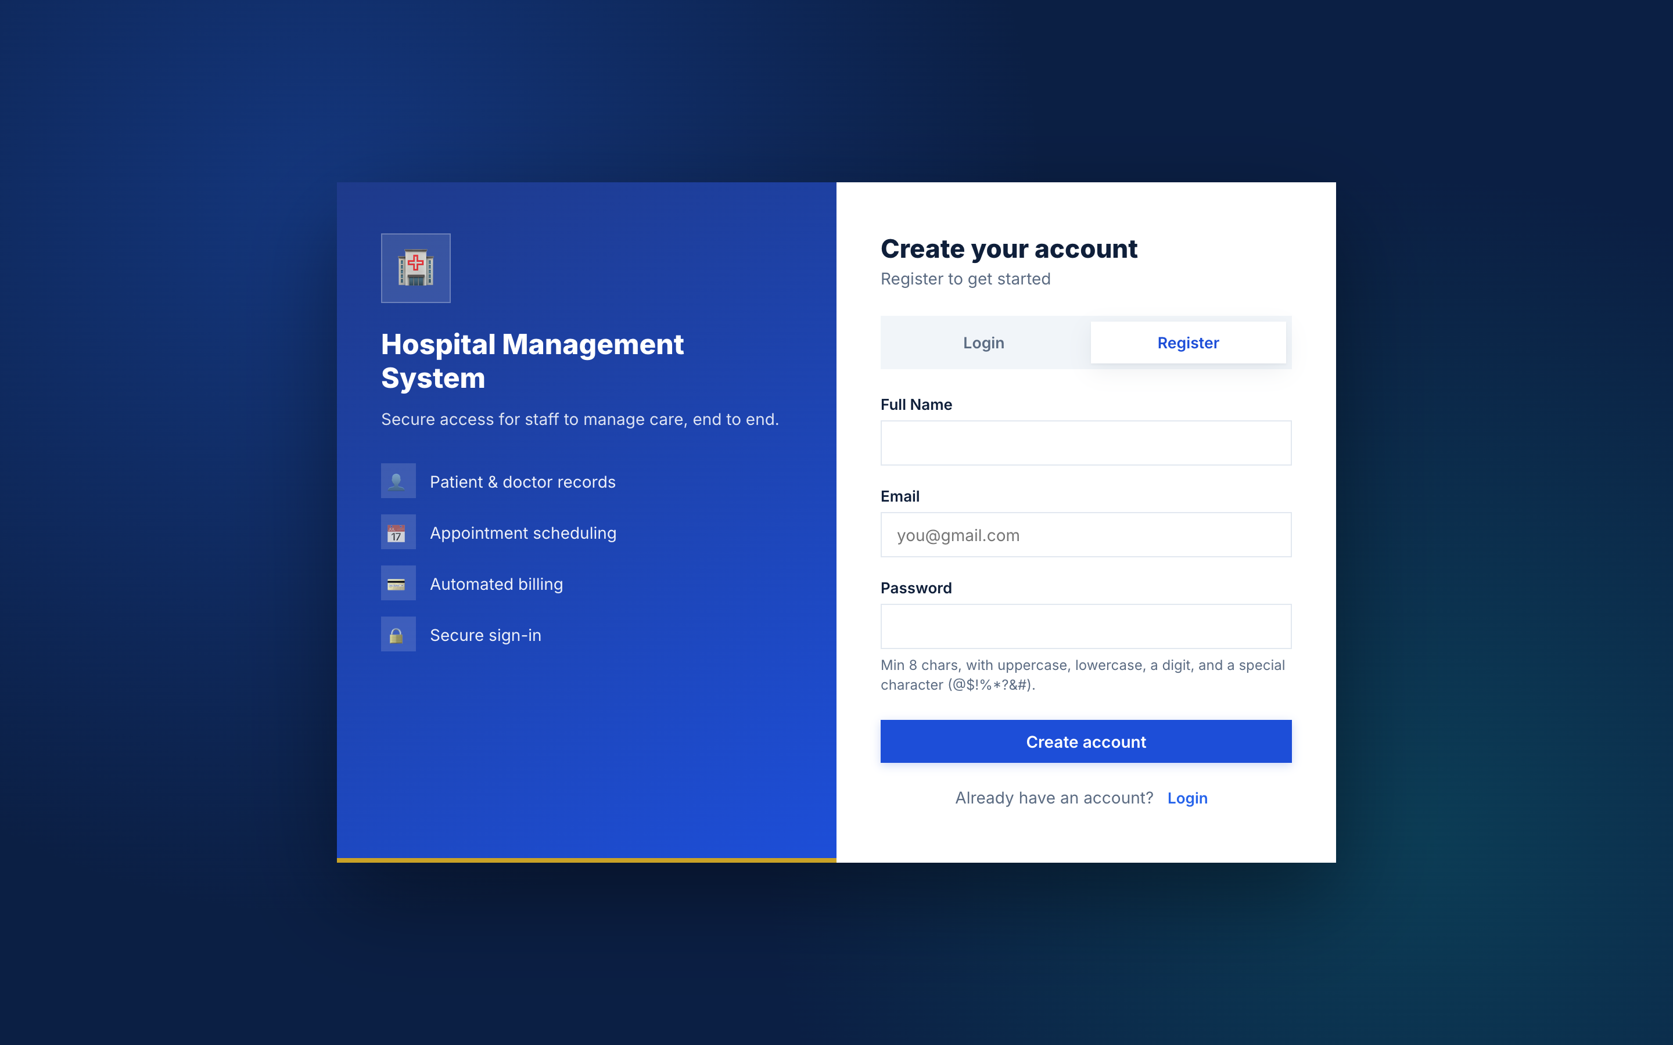
Figure 6: Registration form with validation hints

12.2 Patients
Full CRUD for patients, the complex multi-criteria search, and pagination with sorting.
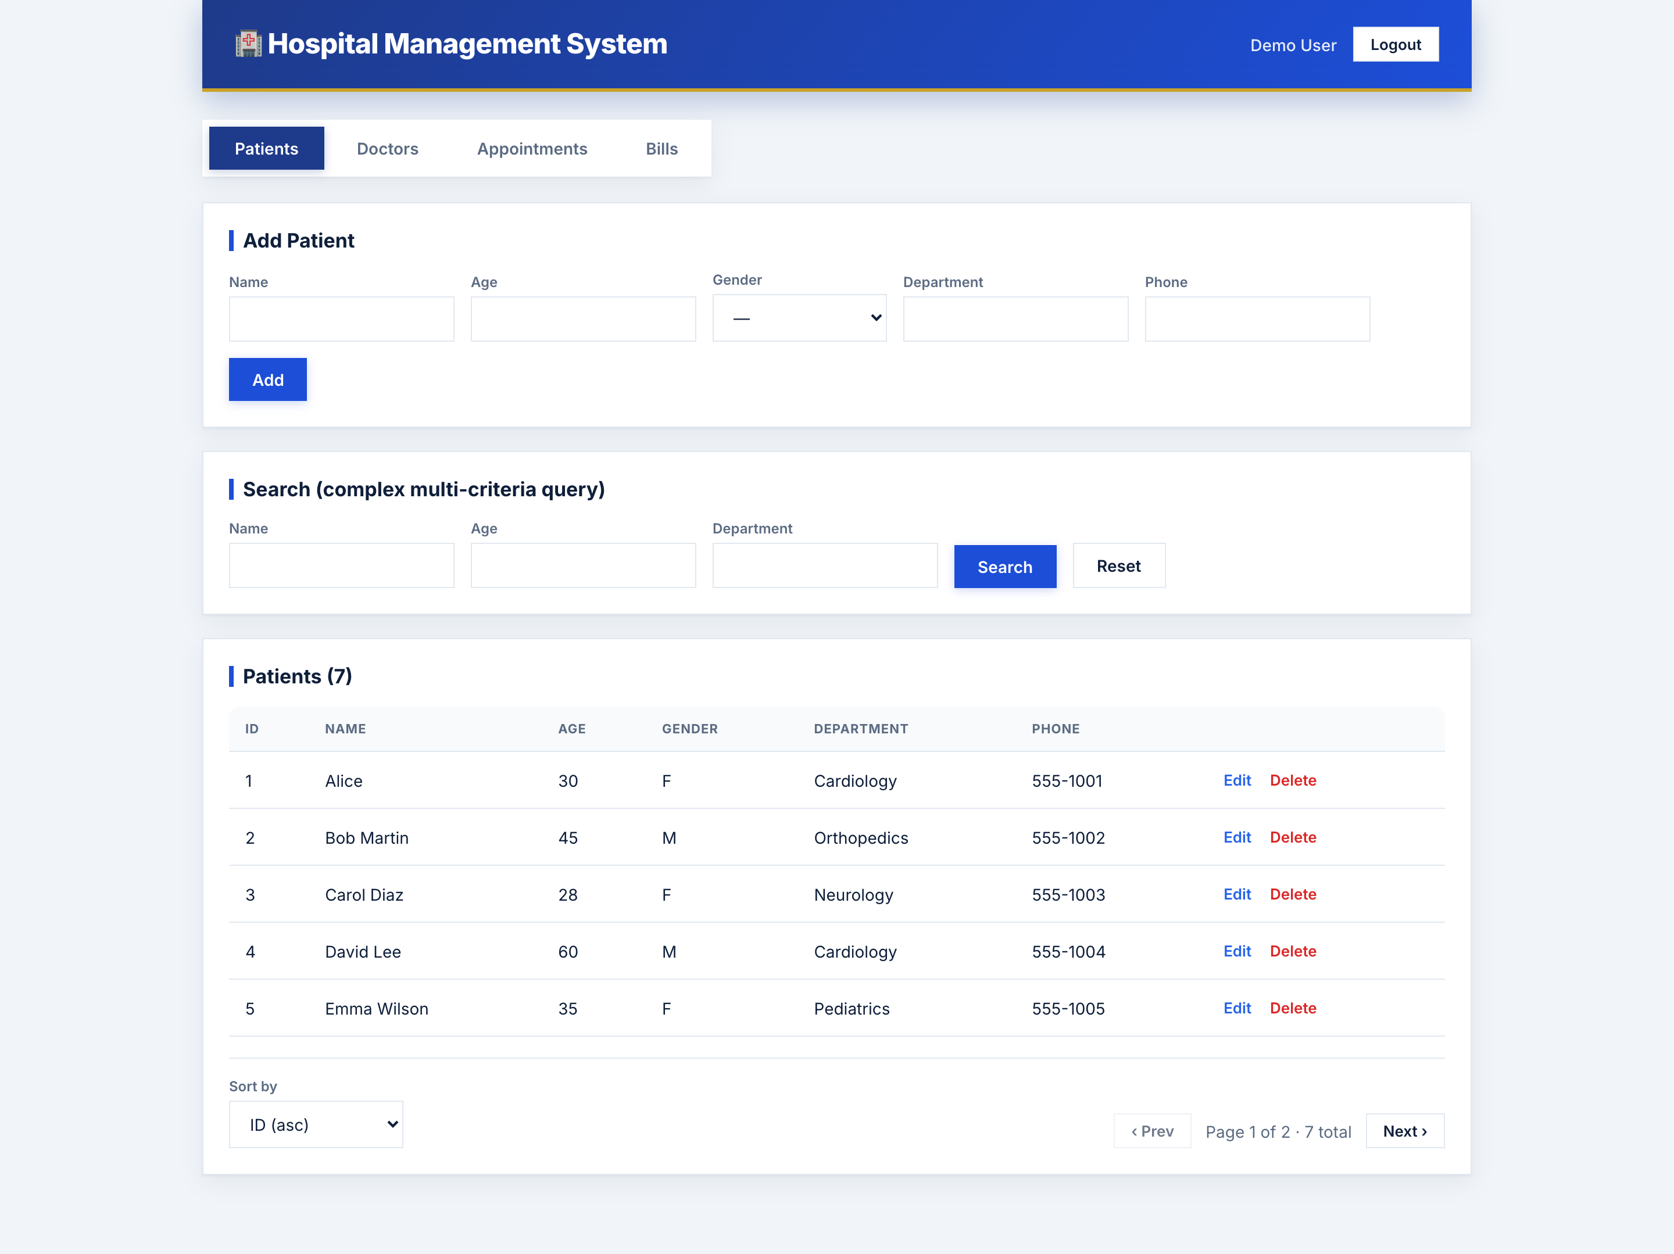
Figure 7: Patients page: add form, search, paginated & sortable table

12.3 Doctors
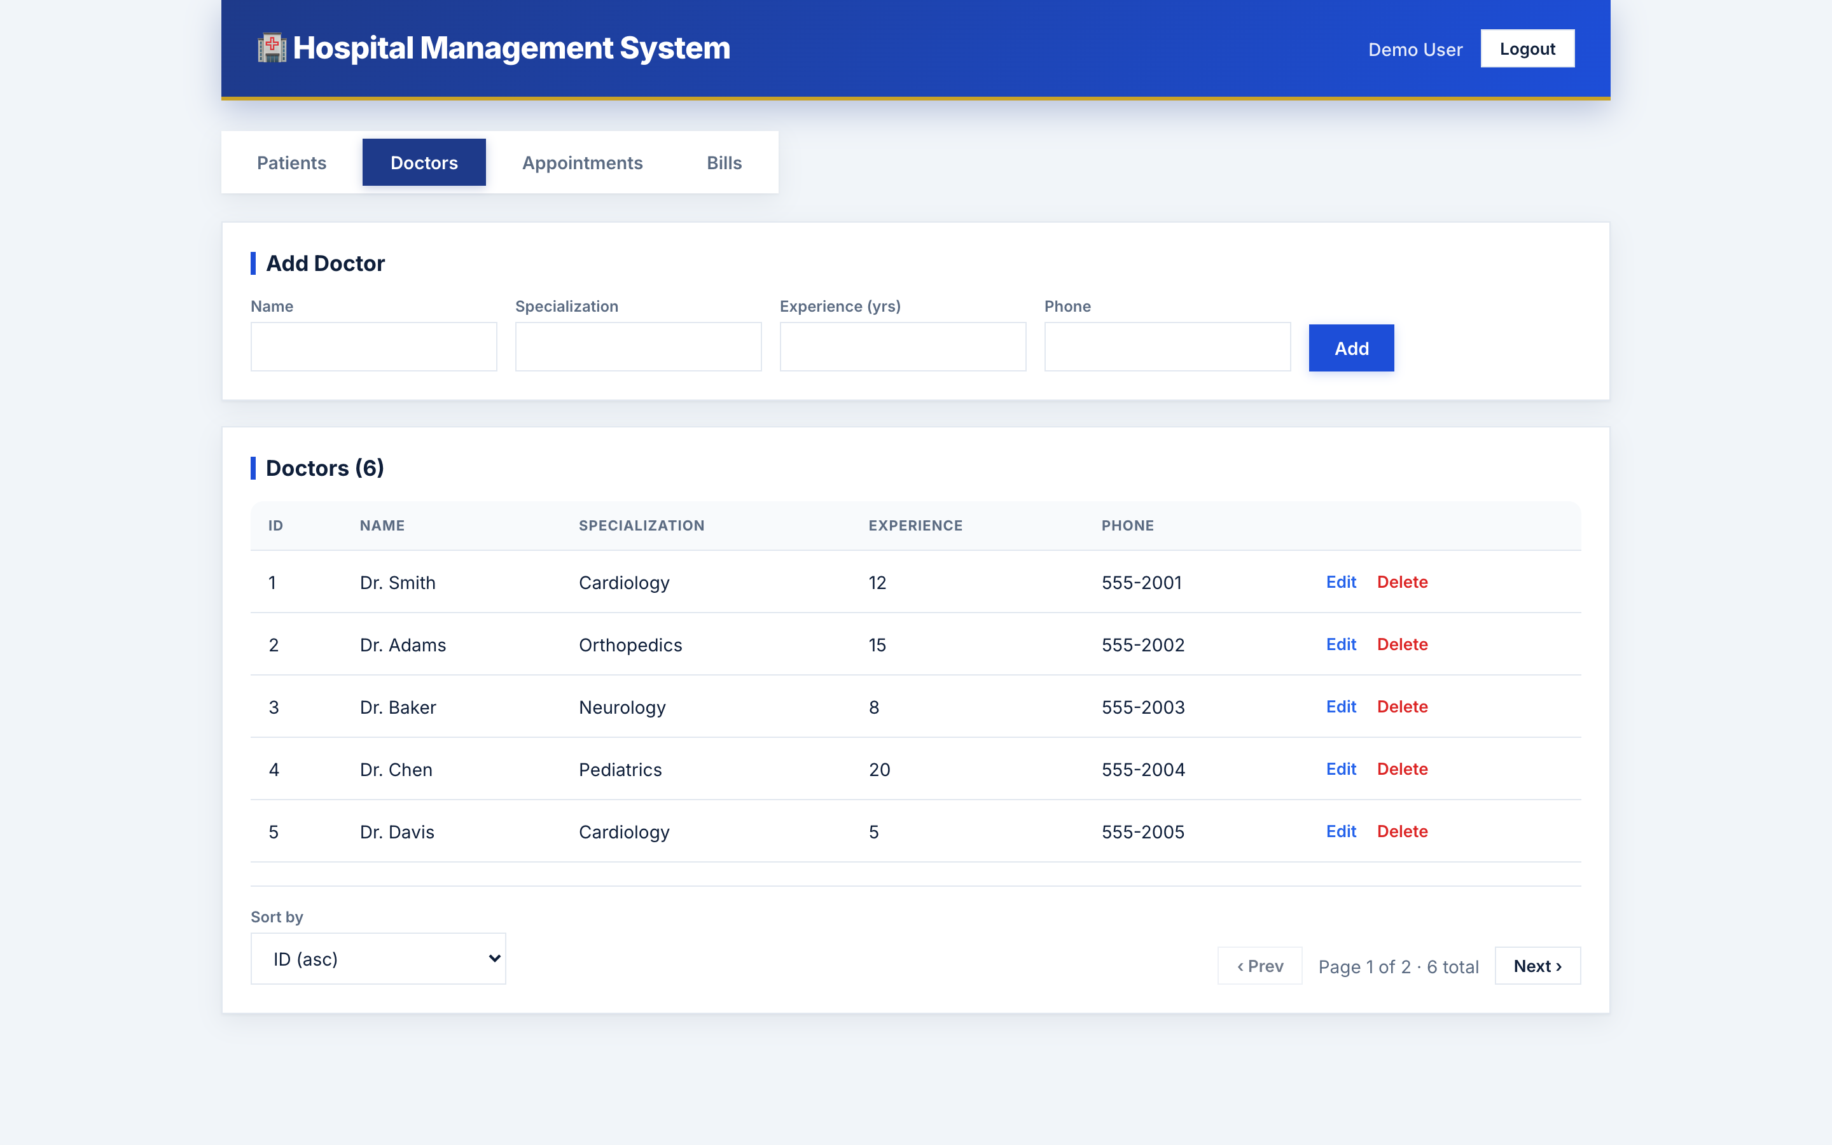
Figure 8: Doctors page: CRUD with pagination & sorting

12.4 Appointments
Booking uses patient/doctor dropdowns and is validated via Feign before saving.
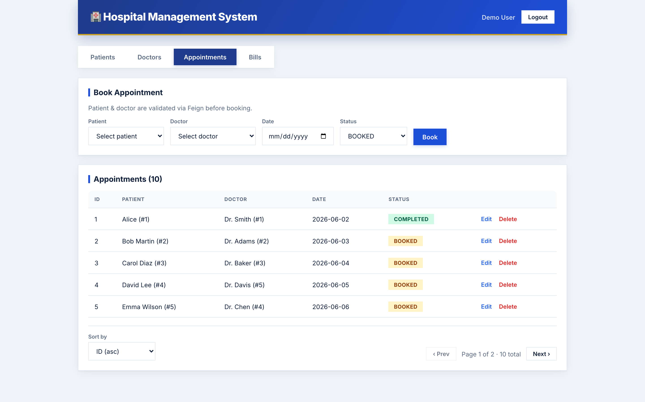
Figure 9: Appointments page: Feign-validated booking, pagination & sorting

12.5 Bills
Bills are generated automatically via Kafka when an appointment is booked. The table resolves and displays the patient and doctor names for each bill.
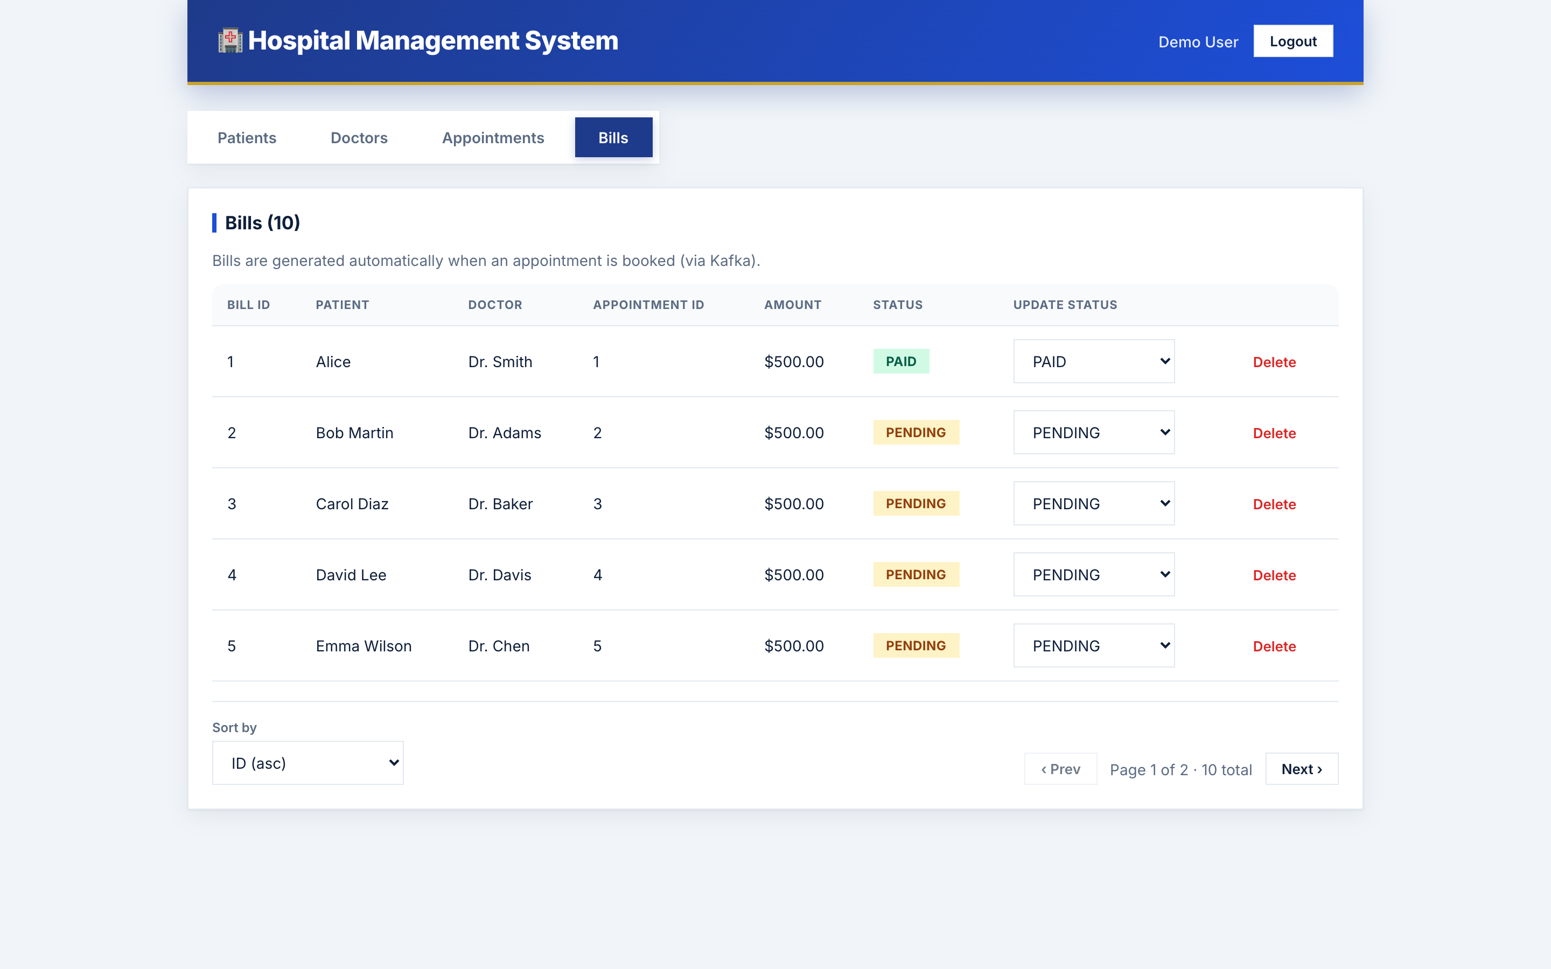
Figure 10: Bills page: Kafka-generated bills with patient/doctor names

13. Deployment (Docker & Kubernetes)
Every service and the frontend has a multi-stage Dockerfile. Docker Compose orchestrates all containers together with MySQL and Kafka. Kubernetes manifests (in the k8s/ folder) deploy the same system to a cluster, with a documented path to AWS EKS.
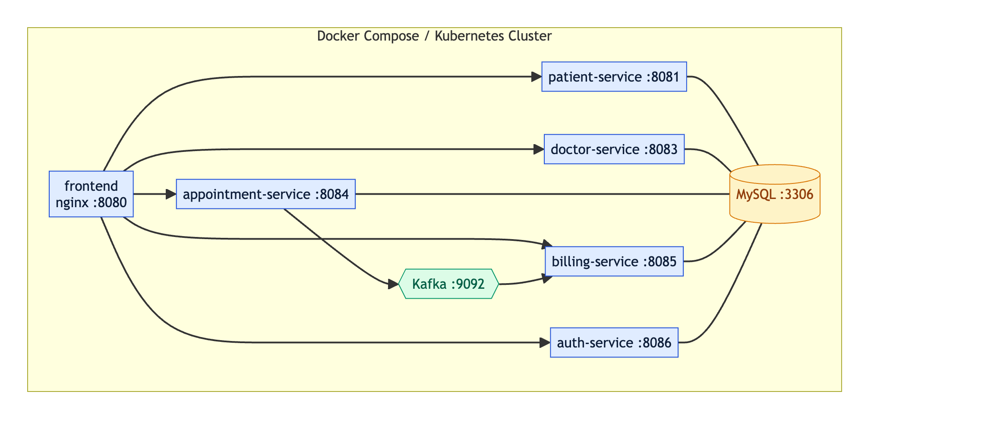
Figure 11: Containerized deployment topology

14. How to Execute & Run the Project

Prerequisites
- Docker Desktop (includes Docker Engine and Docker Compose).
- For local development only: JDK 17+ and Node.js 18+.

Run everything with Docker Compose (recommended)
From the project root, run a single command. Each service compiles inside Docker, so no manual build step is needed:
docker compose up --build
Once all containers are healthy, open the application in a browser:
What | URL
Frontend (start here) | http://localhost:8080
Patient API | http://localhost:8081/patients
Doctor API | http://localhost:8083/doctors
Appointment API | http://localhost:8084/appointments
Billing API | http://localhost:8085/bills
Auth API | http://localhost:8086/auth

First use: open the frontend, click Register, sign up with a @gmail.com email and a strong password (e.g. Test@1234), then log in.

Useful commands
docker compose up --build -d # run in the background
docker compose ps # list containers
docker compose logs -f doctor-service
docker compose down # stop everything
docker compose down -v # stop and wipe the database

Run the frontend in development mode
cd frontend
npm install
npm run dev # http://localhost:5173

Deploy to Kubernetes
kubectl apply -f k8s/
kubectl get pods -n hospital -w

15. Testing & Verification
A quick end-to-end smoke test (with the stack running):
# Create a patient and a doctor
curl -X POST localhost:8081/patients -H 'Content-Type: application/json' \
-d '{"name":"Alice","age":30,"department":"Cardiology"}'
curl -X POST localhost:8083/doctors -H 'Content-Type: application/json' \
-d '{"name":"Dr Rao","specialization":"Cardiology"}'
# Book an appointment (Feign-validated, fires Kafka)
curl -X POST localhost:8084/appointments -H 'Content-Type: application/json' \
-d '{"patientId":1,"doctorId":1,"appointmentDate":"2026-06-10"}'
# A bill is auto-generated via Kafka
curl localhost:8085/bills
# Feign validation rejects a bad reference (HTTP 400)
curl -X POST localhost:8084/appointments -H 'Content-Type: application/json' \
-d '{"patientId":999,"doctorId":1,"appointmentDate":"2026-06-10"}'

16. Requirement → Implementation Map
Requirement | Implementation
4 microservices + CRUD | patient / doctor / appointment / billing services
Spring Feign Client | PatientFeignClient, DoctorFeignClient
Kafka | AppointmentProducer → appointment-topic → BillingConsumer
Resilience4j circuit breaking | DoctorServiceImpl.getDoctorWithPatient + config
Complex multi-criteria query | PatientRepository.searchPatients
Docker | Dockerfile per service + docker-compose.yml
Kubernetes / AWS | k8s/ manifests + k8s/README.md
React Hooks frontend | frontend/
Login / Logout (JWT) | auth-service + frontend gating
Validation (gmail, password) | auth-service DTOs (Bean Validation)
Pagination + Sorting | All list endpoints + frontend controls

17. Conclusion
This project delivers a complete, scalable Hospital Management System built on microservices principles. It demonstrates synchronous and asynchronous inter-service communication, fault tolerance, a complex query, secure authentication with validation, pagination and sorting, a modern React frontend, and full containerized deployment with Docker and Kubernetes. All components have been verified end-to-end.

