ClientSync (React Full Stack)
Project Documentation

Developer Documentation December 5, 2025

Introduction
Step into the future of client and project management – a revolutionary experience awaits you with ClientSync, a state-of-the-art management dashboard intricately designed us- ing the brilliance of React.js and Tailwind CSS. Merging innovation with a user-centric approach, our platform is poised to redefine how you organize your business, manage clients, and track projects.
Crafted for modern freelancers and agencies, ClientSync seamlessly integrates robust functionality with an intuitive user interface. From visualizing revenue trends to managing complex client relationships, our platform ensures a comprehensive management journey tailored to your unique workflow.
The core of ClientSync beats with React, a dynamic and feature-rich JavaScript li- brary. Immerse yourself in a visually stunning and interactive interface, where every chart, table, and animation feels like a productivity revelation. Whether you’re on a desktop, tablet, or smartphone, our responsive design guarantees a consistent and enjoyable expe- rience across all devices.

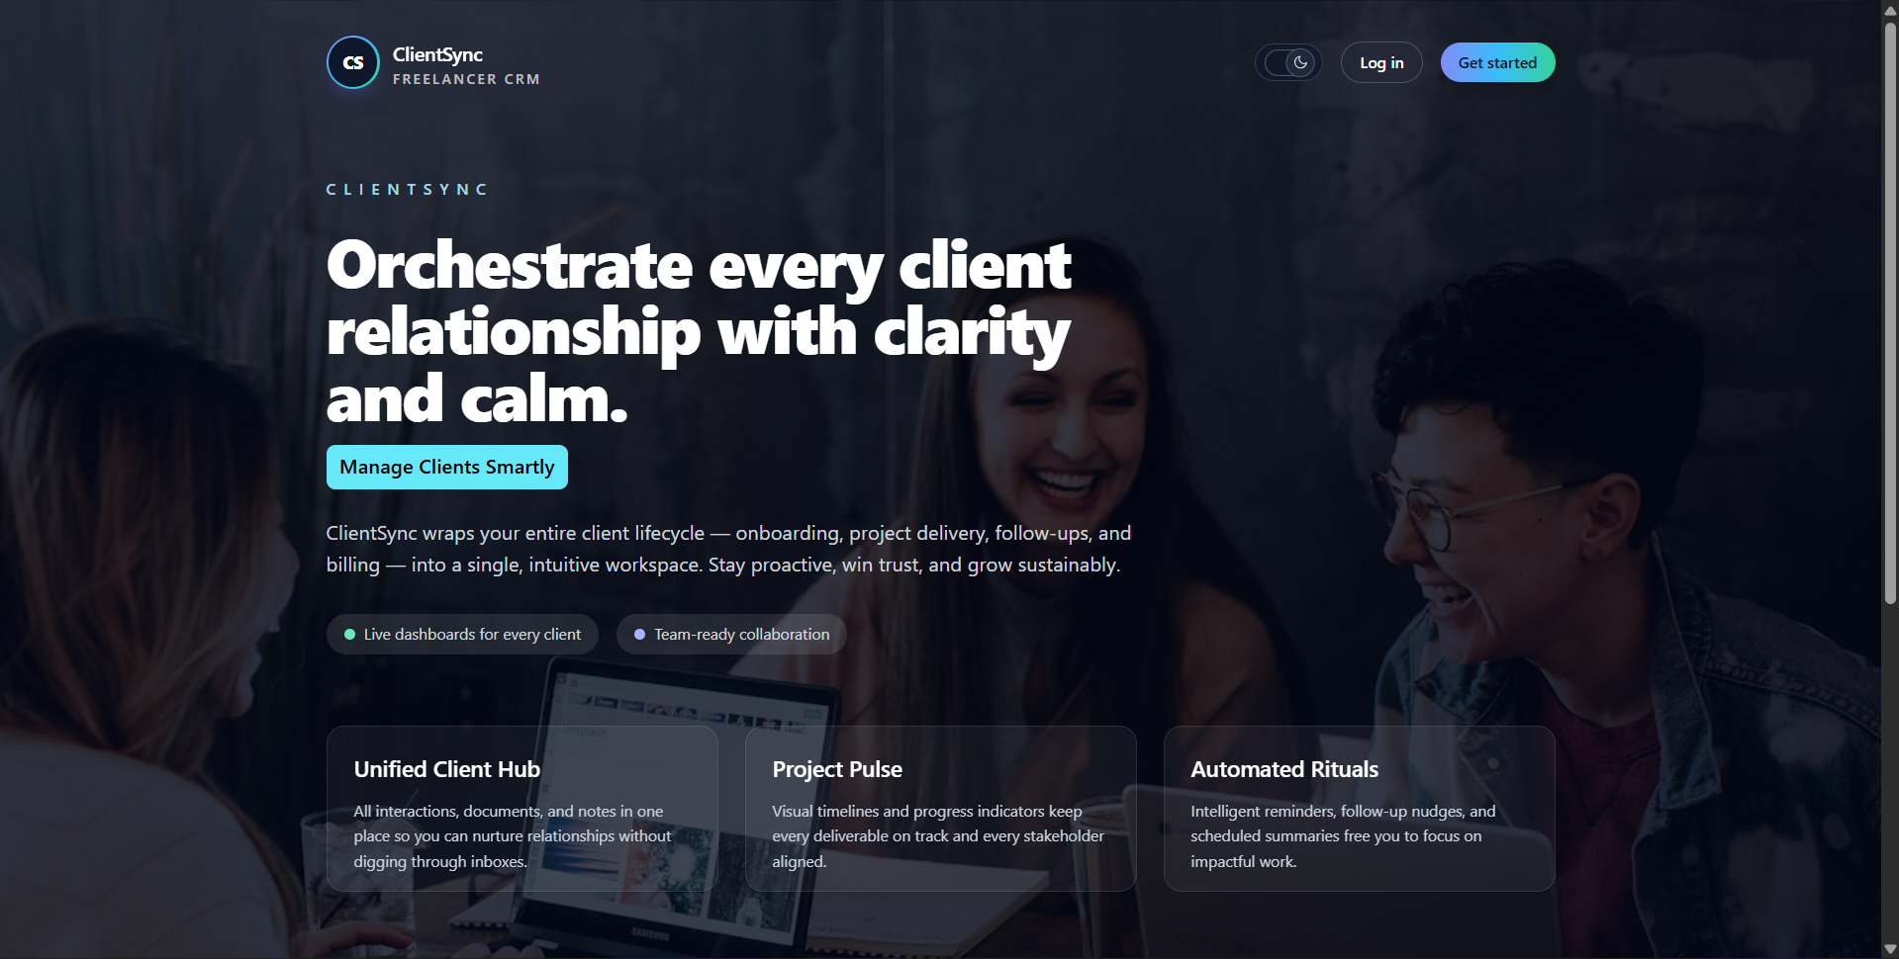

Figure 1: ClientSync Home Page Concept

Scenario-Based Intro
Imagine a typical day in the life of a freelance developer or a small agency owner. You’ve just started your day, coffee in hand, ready to tackle a list of deliverables. You open your favorite management tool, ”ClientSync.”
As you log in, ClientSync greets you with a clean, intuitive Dashboard, customized to your preferences with a sleek dark mode. The analytics overview instantly shows your active projects, total clients, and monthly revenue. You notice a pending project deadline, and with a single click, you navigate to the Projects section to update the status.
Later, a new lead contacts you. You effortlessly add them to the Clients database, assigning them a ”Active” status. With ClientSync, realized chaos turns into organized success.

Target Audience
ClientSync is tailored for a diverse community of professionals, including:
  - Freelancers: Individuals managing multiple clients and projects who need a cen- tralized hub for their business.
  - Small Agencies: Teams looking for a lightweight yet powerful tool to track client relationships and project progress.
  - Project Managers: Professionals seeking an intuitive interface to monitor deliv- erables and timelines.

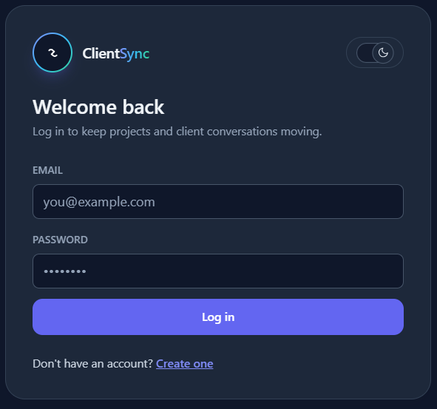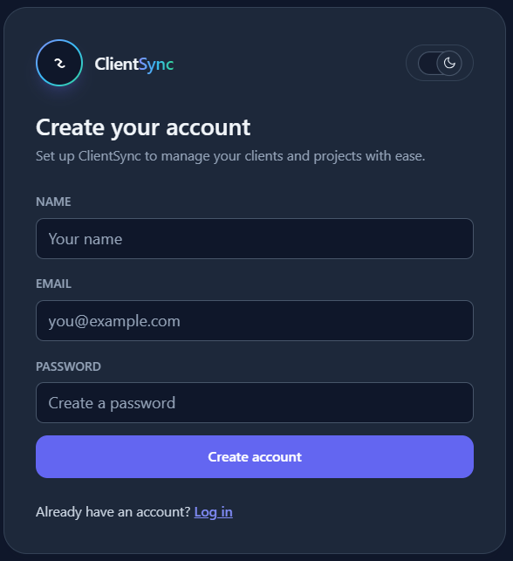

Figure 2: Login and SignUp UI

Project Goals and Objectives
The primary goal of ClientSync is to offer a seamless platform for business management, facilitating a collaborative and efficient workflow. Our objectives include:
  - User-Friendly Interface: Develop an intuitive interface that enables users to navigate, edit, and manage data effortlessly.
  - Comprehensive Management: Provide robust features for organizing clients and projects, including search options and status filtering.
  - Modern Tech Stack: Leverage cutting-edge web development technologies, such as React.js, Tailwind CSS, and Recharts, to ensure an efficient and enjoyable user experience.

Key Features
  - Dashboard & Analytics: A real-time dashboard featuring interactive charts (Recharts) to visualize revenue, client growth, and project distribution.
  - Client Management: A dedicated section to add, edit, delete, and view client details, with status tracking (Active, Inactive).
  - Project Tracking: Comprehensive project management tools allowing users to link projects to clients, set deadlines, and track budgets.
  - Secure Authentication: Protected routes ensuring that only authenticated users can access sensitive business data (Login/Register flow).
  - Dark Mode & Theming: Built-in theme support allowing users to switch between light and dark modes for visual comfort.
  - Responsive Sidebar: A fully responsive navigation system that adapts to mobile and desktop layouts.
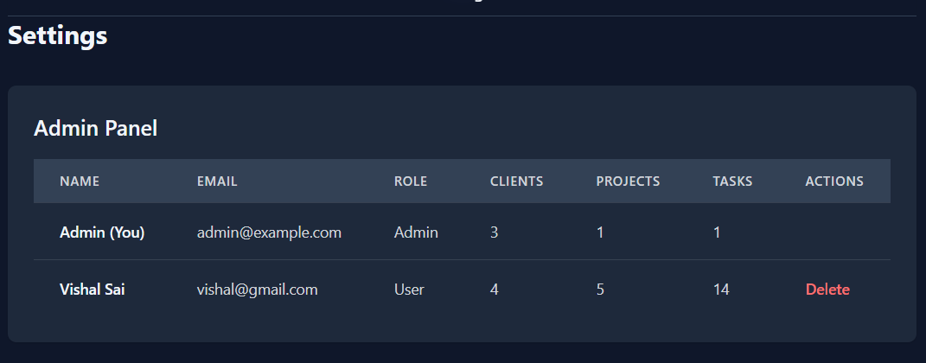
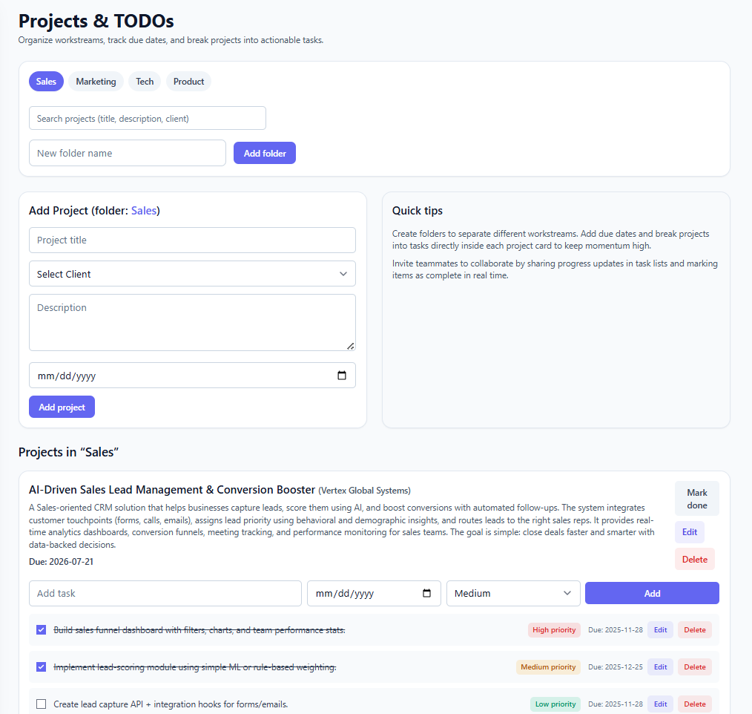
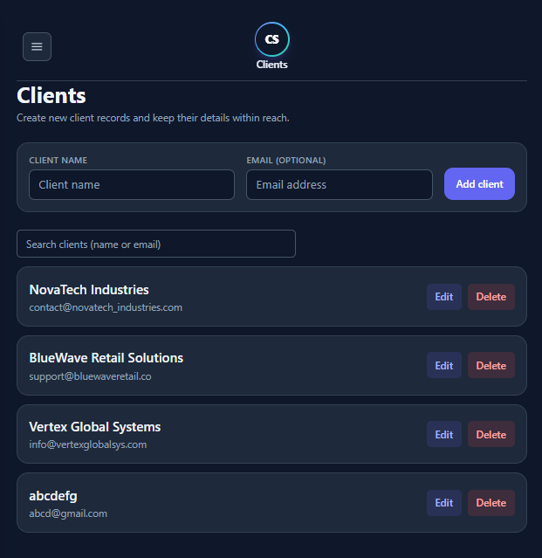
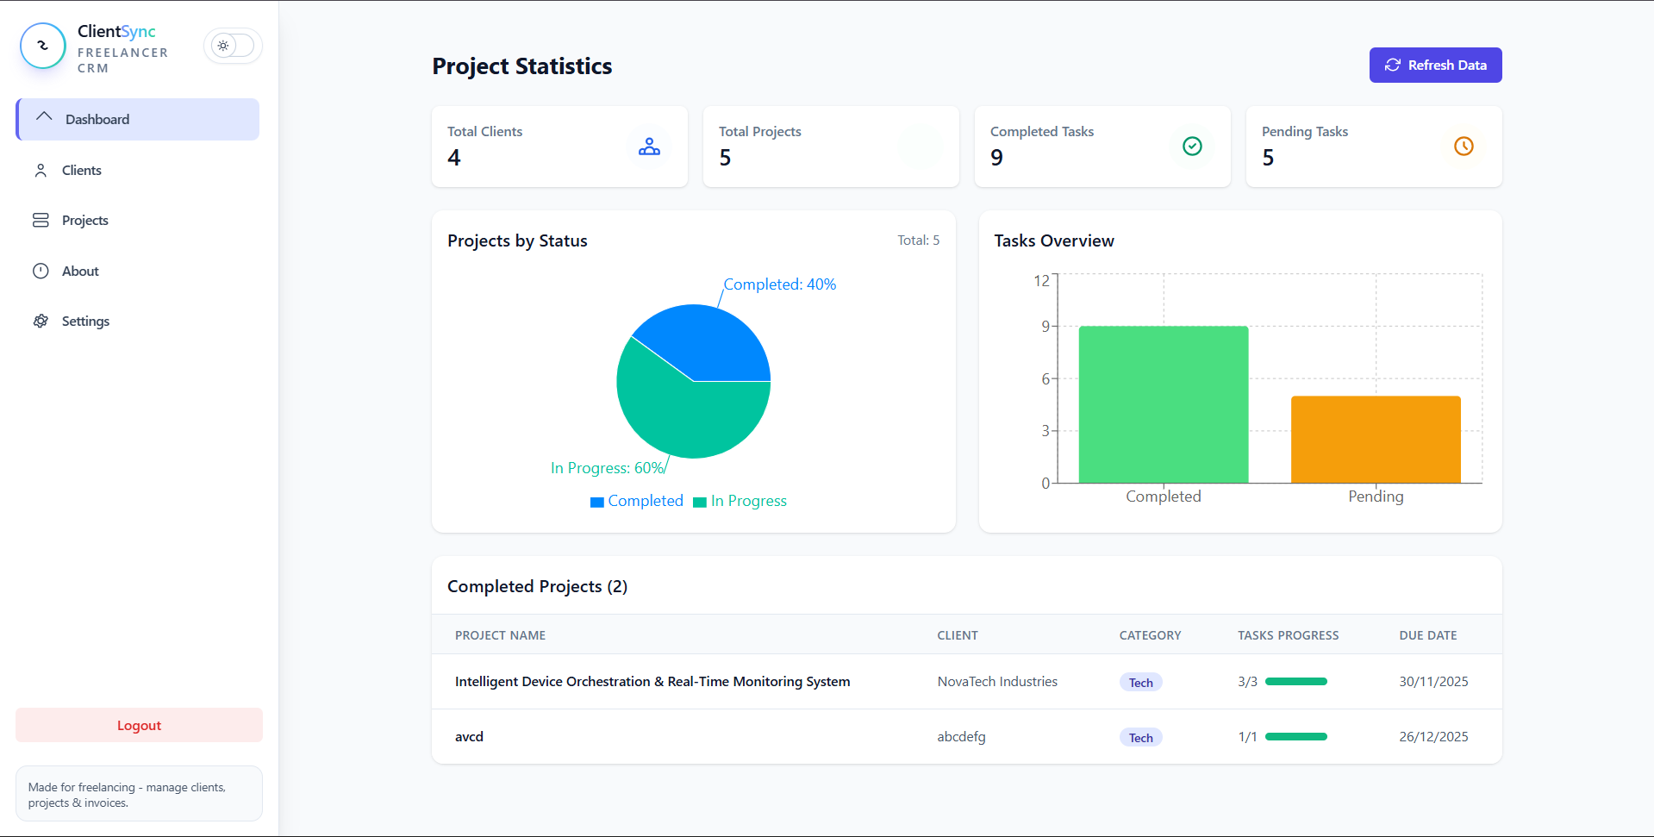
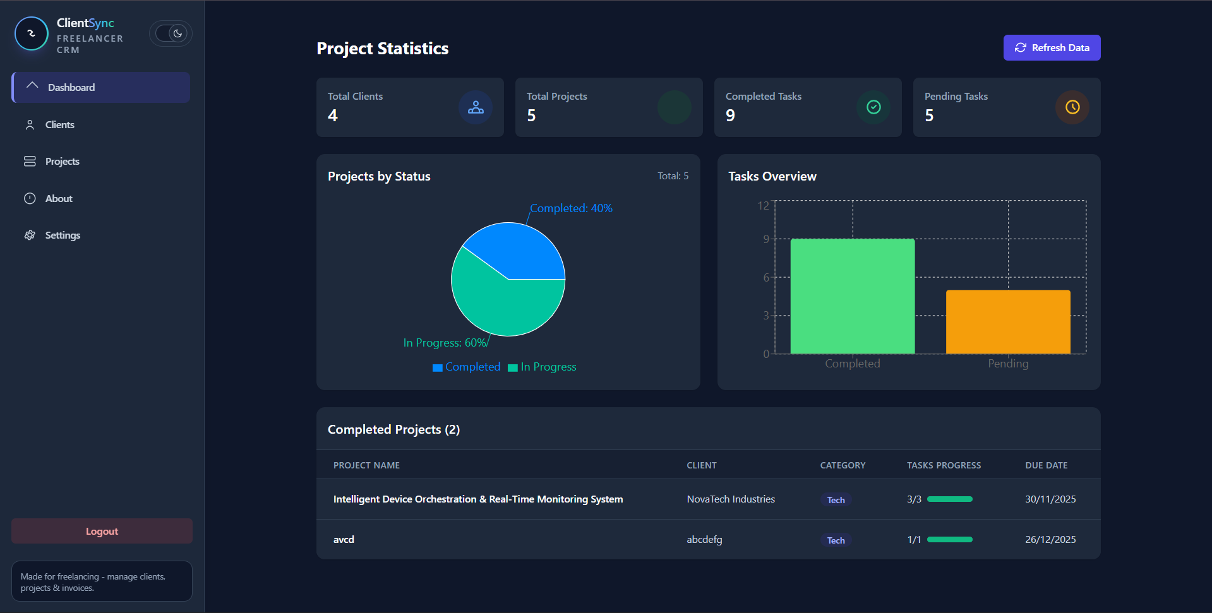
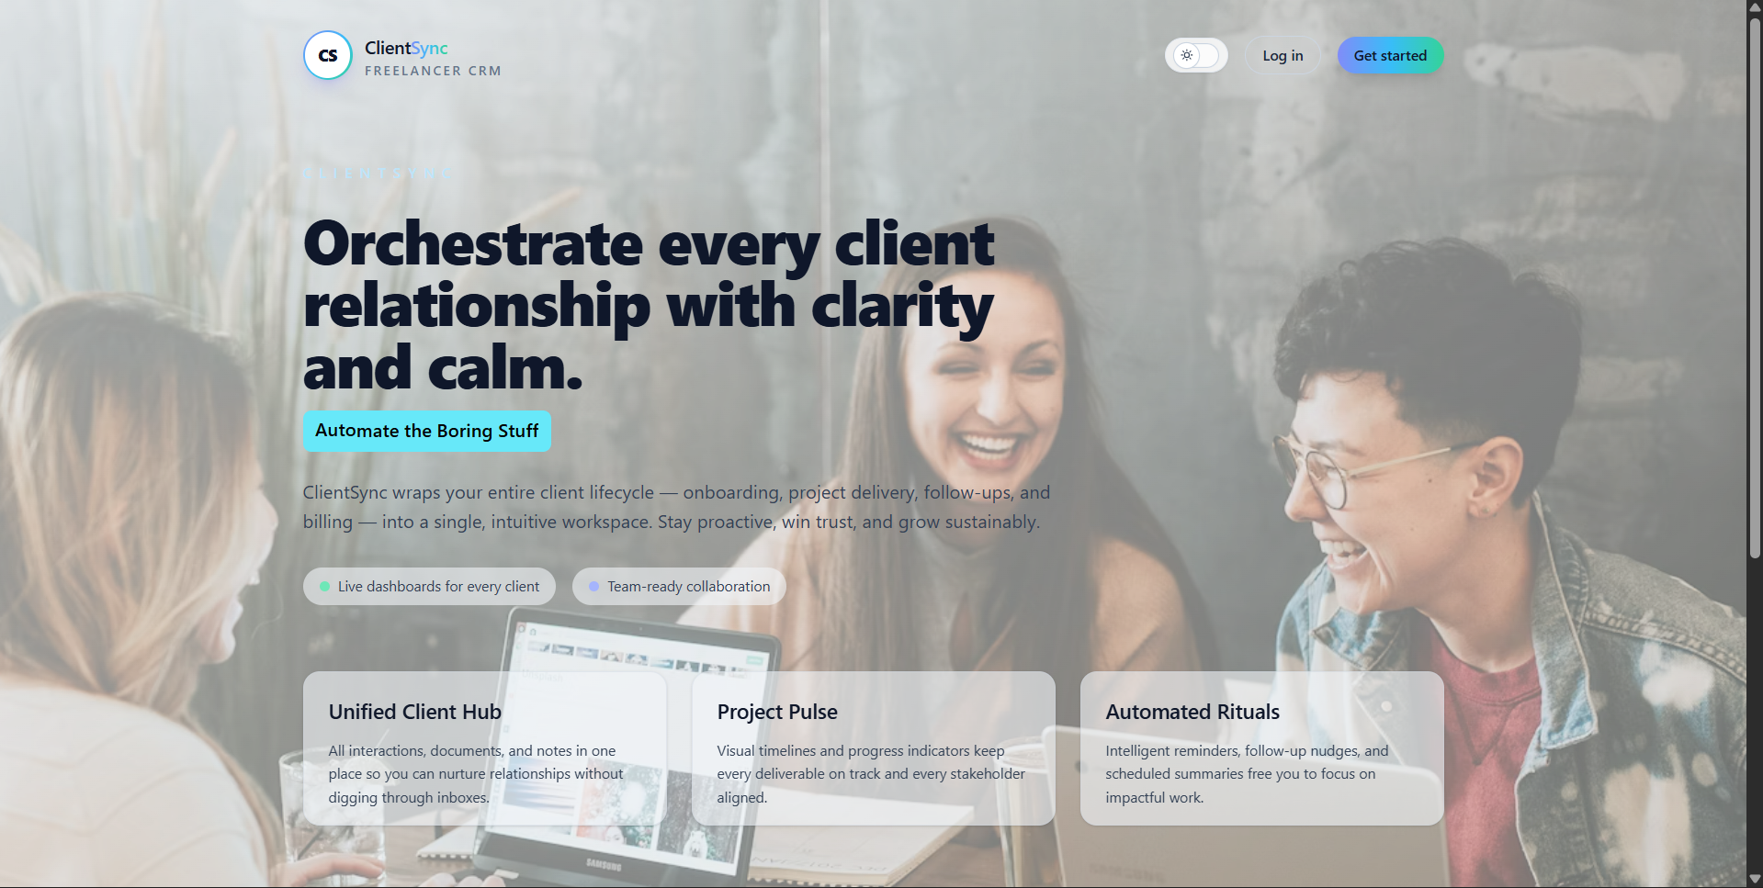

Figure 3: Projects, Clients, Dashboard Analytics and Dark Mode UI

Pre-Requisites
Here are the key prerequisites for developing this application:

Node.js and npm
Node.js is a powerful JavaScript runtime that allows you to run JavaScript on the local environment.
  - Download: https://nodejs.org/en/download/
  - Installation: Follow the official guide to install Node.js and npm.

React.js Environment
- Create a new React app:
npm create vite@ latest

- Navigate:
cd clientsync

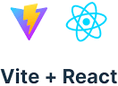



- Install Dependencies:
npm install

Version Control
  - Git: Use Git for version control to track changes and collaborate.

Project Structure
The project is organized into frontend and backend directories.
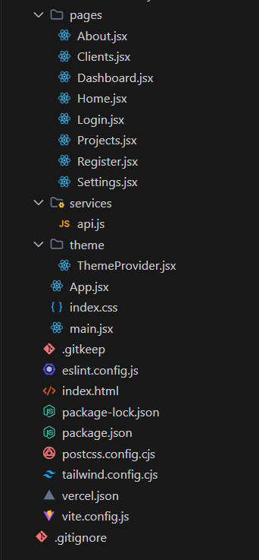
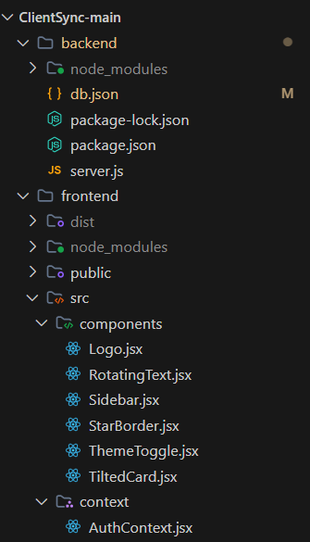

Figure 3: Project Folder Structure Diagram

frontend/
  - src/components: Reusable UI components like Sidebar, Logo, ThemeToggle.
  - src/pages: Main view components including Dashboard, Clients, Projects, Login.
  - src/context: React Context for global state management (AuthContext).
  - src/App.jsx: Main application component handling routing and layout.

backend/
  - server.js: Custom Node.js server using json-server to mock a REST API.
  - db.json: JSON database storing users, clients, and projects data.

Project Flow

Milestone 1: Project Setup and Configuration

Install Required Tools:
  - Node.js & npm
  - VS Code (Recommended IDE)

Initialize Project:
  - Set up Vite + React project.
  - Install Tailwind CSS for styling.
  - Install json-server for the backend.

Milestone 2: Web Development

Setup React Application:
  - Configure react-router-dom for navigation.
  - Set up AuthContext for user session management.

Design UI Components:
  - Create a responsive Sidebar with mobile support.
  - Implement Dashboard widgets using recharts.
  - Build forms for Login, Register, and Client/Project entry.

Implement Logic:
  - Connect frontend components to http://localhost:4000 API.
  - Implement CRUD operations for Clients and Projects.
  - Secure routes using ProtectedRoute component.

Code Description

App.jsx
  - Routes: Defines the application structure using react-router-dom.
  - Layout: Manages the Sidebar and main content area. Handles responsive toggling of the sidebar.
  - Providers: Wraps the application in ThemeProvider and AuthProvider to share state globally.

server.js (Backend)
  - Custom Server: Uses json-server to provide a full fake REST API.
  - CORS: Configured to allow requests from the frontend development server.
  - Custom Routes: Includes a custom DELETE route /users/:id that cascades deletion to related clients and projects, ensuring data integrity.

AuthContext (Context)
  - State Management: Manages the authenticated user’s state.
  - Functions: Provides login, register, and logout functions that interact with the backend and local storage.

Project Execution
After completing the code, run the full stack application:

Start Backend
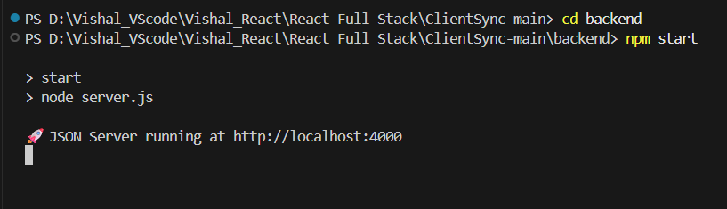

- Start Frontend
cd frontend npm run dev
# ( Runs on http :// localhost :5173)
