 | 
Faculty of Computer Applications & Information Technology
Integrated Master of Computer Applications – iMCA Programme
Semester IX
Project Report for
222301906 Practicals on Natural Language Processing
“Student Project Topic Recommendation System”
Submitted by:
Group No: 10
Name: Samarth Bhatt, Enrolment No: 202202519010008
Name: Vishal Suthar, Enrolment No: 202202519010088

Table of Contents

Section Title | Page
Cover Page | 1
Table of Contents | 2
1. Problem Statement | 3
2. Dataset Description | 3
2.1 Dataset Source | 3
2.2 Number of Samples | 3
2.3 Data Format | 3
2.4 Example Data | 4
3. System Architecture | 4
3.1 Layered Architecture | 5
3.2 System Flow Diagram | 6
4. Data Processing Workflow | 7
5. Model Architecture & Implementation | 8
5.1 Software Requirements | 8
5.2 Hardware Requirements | 8
5.3 Model Selection and Architecture | 8
5.4 Core Implementation Code | 9
5.5 Screenshots of Implementation | 11
6. Result Visualization | 14
6.1 Duplicate Detection Confusion Matrix | 14
6.2 Performance Comparison | 15
6.3 Threshold Analysis | 16
7. Conclusion | 17

1. Problem Statement

Every year, final-year students must choose a project topic, and the approval process for these topics is largely manual. In practice, this creates three recurring problems:
- Many students choose the same or very similar topics, often worded differently, so teachers must check for duplicates manually in spreadsheets.
- Students do not know which topics are unique, which match their interests, or which are realistic for their skills and available time.
- Topic approval is slow and unfair when there is no clear first-come priority.
Objective. Build a web system that uses Natural Language Processing to:
1. recommend the most relevant topics from past projects for a student's interests;
2. score each topic for novelty (how unique it is) and feasibility (whether the team can build it);
3. detect duplicate or similar proposals by meaning rather than by matching words; and
4. manage the proposal workflow: a student submits a proposal, a teacher approves or rejects it, and approved topics are hidden from other students.
Users: Student, Teacher, and Supervisor.
2. Dataset Description

2.1 Dataset Source
The dataset is a manually curated corpus of past student projects in the GLS University style, covering the IMCA, BCA and MCA departments for the years 2021 to 2024. It is stored in backend/data/sample_corpus.json. The corpus was not downloaded from an external website; the entries were written and collected by the project team. A second file, topics.json, holds a list of 150 topics used for the domain overview. Additionally, dynamic teacher ingestion allows faculty to upload CSV, TXT, PDF, and DOCX records directly into the live corpus.
2.2 Number of Samples
The historical corpus contains 120 verified project records (expandable to 132+ via teacher upload batches). Each record is embedded as one vector in the FAISS index used for similarity search, so every recommendation and duplicate check is computed against these entries. The separate topics.json file adds 150 topic entries for the domain overview. In addition, a gold-standard benchmark of 50 labelled queries is committed for reproducible evaluation.
2.3 Data Format
Each corpus record is stored as JSON and validated against a Pydantic schema named ProjectEntry. Table 2.1 lists the fields. Students, teachers and supervisors are stored in the same SQL database together with their project proposals.
Table 2.1: ProjectEntry schema
Field | Type | Meaning
id | string | Unique identifier, for example gls-2023-001
title | string | Project title
abstract | string | Summary of 1 to 3 sentences
year | int | Year of the project (2021-2024)
department | string | IMCA / BCA / MCA
tech_stack_tags | list[str] | Drawn from fixed list of 20 canonical tags (python, react, nlp, ...)
domain_tags | list[str] | Domain labels, for example hr-tech, nlp, cv, cybersecurity
language | string | en
2.4 Example Data
Table 2.2 shows one record from the corpus in its stored JSON form:
{
"id": "gls-2023-001",
"title": "AI-Based Resume Screening Tool",
"abstract": "A system that screens resumes against job descriptions using
sentence embeddings and cosine similarity to automatically rank
candidates by fit score.",
"year": 2023,
"department": "IMCA",
"tech_stack_tags": ["python", "nlp", "flask"],
"domain_tags": ["hr-tech", "nlp"],
"language": "en"
}
The model reads only the title and abstract as text. The tags are used for feasibility rules and for evaluation.

3. System Architecture

TopicMatch follows a decoupled, multi-tier architecture. A Python FastAPI backend serves the REST API, an in-memory FAISS index handles vector search, a rule-based feasibility engine scores each candidate topic, and a React client provides the user interface for students, teachers and supervisors.
3.1 Layered Architecture
Figure 3.1 shows the system organised into three layers: a presentation layer, an application layer and a data layer.
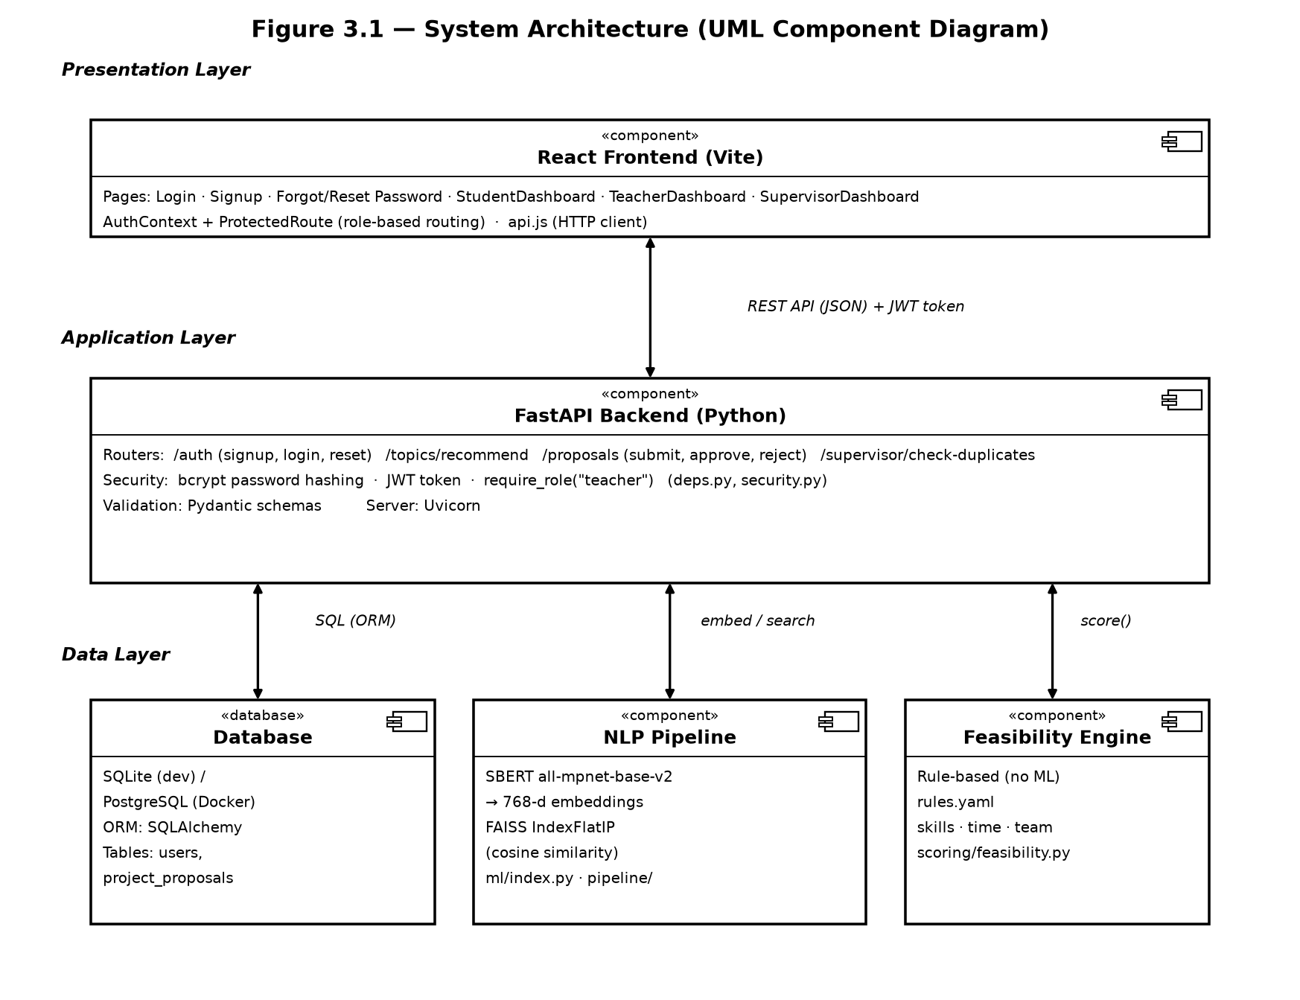
Figure 3.1: System architecture (UML component diagram)
Presentation layer. The React frontend, built with Vite, provides the login, signup and password-reset pages, along with the student, teacher and supervisor dashboards. Role-based routing is handled by an AuthContext and a ProtectedRoute component.
Application layer. The FastAPI backend exposes the authentication, recommendation, proposal and supervisor endpoints. Passwords are hashed with bcrypt, access is controlled with JWT tokens, and request data is validated with Pydantic schemas.
Data layer. Three components sit beneath the application layer: a relational database (SQLite for development and PostgreSQL under Docker) accessed through SQLAlchemy, the NLP pipeline that performs SBERT embedding and FAISS search, and the feasibility engine, which applies rules from a configuration file without machine learning.
3.2 System Flow Diagram
Figure 3.2 traces the flow of work across the three actors: the student, the system, and the teacher.
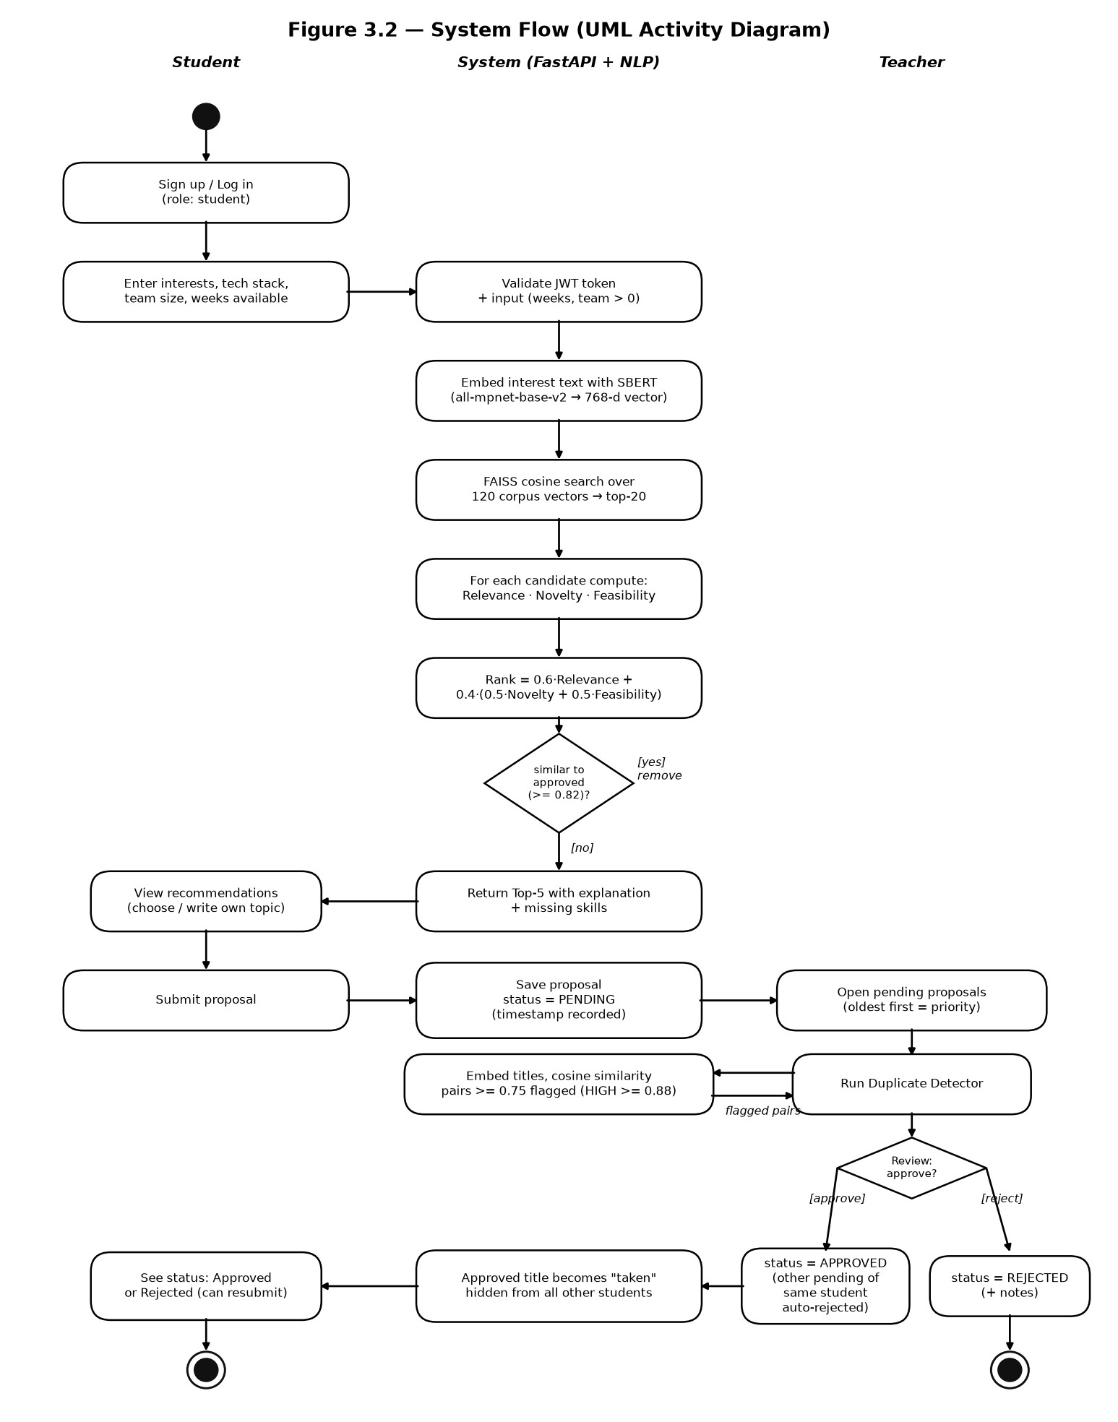
Figure 3.2: System flow (UML activity diagram)

Student path. After signing up or logging in, the student enters their interests, tech stack, team size and available weeks. The system validates the JWT token and input, embeds the interest text with SBERT, runs a FAISS cosine search over the 120 corpus vectors, and keeps the top 20 candidates. Each candidate is scored for relevance, novelty and feasibility and ranked. Any candidate that is too similar to an already approved topic (cosine similarity of at least 0.82) is removed. The remaining top five are returned with an explanation and a list of missing skills. The student can then choose one of these topics or write a custom topic, and submit it as a proposal with status PENDING.
Teacher path. The teacher opens the pending proposals, oldest first. The system runs the duplicate detector, which embeds the titles and compares them by cosine similarity. Pairs with a similarity of at least 0.75 are flagged, and pairs at or above 0.88 are marked HIGH. The teacher then approves or rejects the proposal. An approval sets the status to APPROVED, automatically rejects the same student's other pending proposals, and marks the title as taken so it is hidden from all other students. A rejection sets the status to REJECTED and records the teacher's notes. The student can see the outcome and, if rejected, resubmit.

4. Data Processing Workflow

Table 4.1 summarises the processing applied to the text, from raw input to the vector index. Because the system uses a transformer model, the pipeline is deliberately lighter than classical NLP pipelines.
Table 4.1: Data processing pipeline
Step | What happens in TopicMatch
1. Raw text | For the corpus, the input is title + ". " + abstract. For queries, it is the student's interest text.
2. Tokenization | The model's own WordPiece sub-word tokenizer, inside SentenceTransformers, splits the text into tokens. Example: "I want to build a chatbot for students using Python" becomes i, want, to, build, a, chat, ##bot, for, students, using, python.
3. Stop-word removal | Not applied. Transformer models rely on full sentence context, and words such as "for" and "using" carry meaning. Removing them reduces quality. English stop-word removal is used only in the lexical TF-IDF baseline (Section 6).
4. Stemming / lemmatization | Not required. Sub-word tokens and contextual embeddings already place forms such as recommend, recommendation and recommending close together in vector space.
5. Vectorization | The MPNet transformer outputs a 768-dimension vector for the whole sentence, using mean pooling.
6. Normalization | Vectors are L2-normalized, so the dot product equals cosine similarity.
7. Indexing | Vectors are stored in a FAISS IndexFlatIP index, and search returns the top-k nearest neighbours.

5. Model Architecture & Implementation

5.1 Software Requirements
Table 5.1 lists the software stack used in the implementation.
Table 5.1: Software requirements
Component | Technology used
Language | Python 3.11 / 3.13, JavaScript (Node 18+)
NLP / ML libraries | sentence-transformers 3.x, PyTorch 2.x, FAISS-cpu 1.7.4+, NumPy, scikit-learn (evaluation only), rank-bm25
Backend | FastAPI 0.111+, Uvicorn, SQLAlchemy 2.0, Pydantic v2, python-jose (JWT), bcrypt, PyYAML
Document Ingestion | pypdf, python-docx, python-multipart
Database | SQLite (development), PostgreSQL (Docker)
Frontend | React 18, Vite, React Router, Tailwind CSS, Lucide React
Tools & Eval | Docker Compose, Git / GitHub, pytest, matplotlib, seaborn
5.2 Hardware Requirements
The system is designed to run on standard CPU hardware. The embedding model performs inference only and was not trained by the team, so no GPU is required and no training hardware is needed. Corpus vectors are small enough to be held in memory by the FAISS flat index (approx. 400 KB for 132 projects). Recommended system memory is 8 GB to 16 GB RAM.
5.3 Model Selection and Architecture
The system uses the pre-trained sentence-transformers model all-mpnet-base-v2, applied through transfer learning. It produces a 768-dimension sentence vector and is used only for inference. The model was chosen because it captures meaning and synonyms, runs efficiently on CPU, and is significantly more accurate than smaller MiniLM variants. Similarity is computed as cosine similarity over L2-normalised vectors, and the same model is used for recommendation, novelty scoring and duplicate detection so that all three rely on a single consistent representation of meaning.
5.4 Core Implementation Code
The excerpts below are representative of the core pipeline described in Sections 3.2 and 4. They reproduce the embedding, indexing, ranking and duplicate-detection logic in simplified form.
Excerpt 1: Embedding and FAISS indexing
from sentence_transformers import SentenceTransformer
import faiss
import numpy as np
MODEL = SentenceTransformer("sentence-transformers/all-mpnet-base-v2")
def embed(texts):
"""Return L2-normalised 768-d float32 vectors (dot product == cosine)."""
vecs = np.ascontiguousarray(MODEL.encode(texts, convert_to_numpy=True), dtype='float32')
faiss.normalize_L2(vecs)
return vecs
# Index title + abstract of the 120 corpus records
corpus_text = [f"{p['title']}. {p['abstract']}" for p in corpus]
index = faiss.IndexFlatIP(768)
index.add(embed(corpus_text))
Excerpt 2: Retrieving candidate topics
def recommend(interest_text, top_k=20):
q = embed([interest_text])
scores, ids = index.search(q, top_k)
return [(corpus[i], float(s)) for i, s in zip(ids[0], scores[0]) if i != -1]
Excerpt 3: Ranking and duplicate detection
DUP_FLAG, DUP_HIGH, APPROVED_SIM = 0.75, 0.88, 0.82
def rank_score(relevance, novelty, feasibility):
# Rank = 0.6 * Relevance + 0.4 * (0.5 * Novelty + 0.5 * Feasibility)
return 0.6 * relevance + 0.4 * (0.5 * novelty + 0.5 * feasibility)
def check_duplicates(new_title, existing):
"""existing: list of (title, unit_vector). Returns flagged pairs by severity."""
q = embed([new_title])[0]
hits = []
for title, vec in existing:
sim = float(np.dot(q, vec))
if sim >= DUP_HIGH:
hits.append((title, sim, "HIGH"))
elif sim >= DUP_FLAG:
hits.append((title, sim, "FLAGGED"))
return sorted(hits, key=lambda h: -h[1])

Excerpt 4: Proposal review workflow
def review_proposal(proposal, decision, notes=None):
if proposal.status != "PENDING":
raise ValueError("Only pending proposals can be reviewed")
if decision == "approve":
proposal.status = "APPROVED"
auto_reject_other_pending(proposal.student_id, exclude=proposal.id)
else:
proposal.status = "REJECTED"
proposal.notes = notes

5.5 Screenshots of Implementation
The screenshots below show the main screens of the running application.
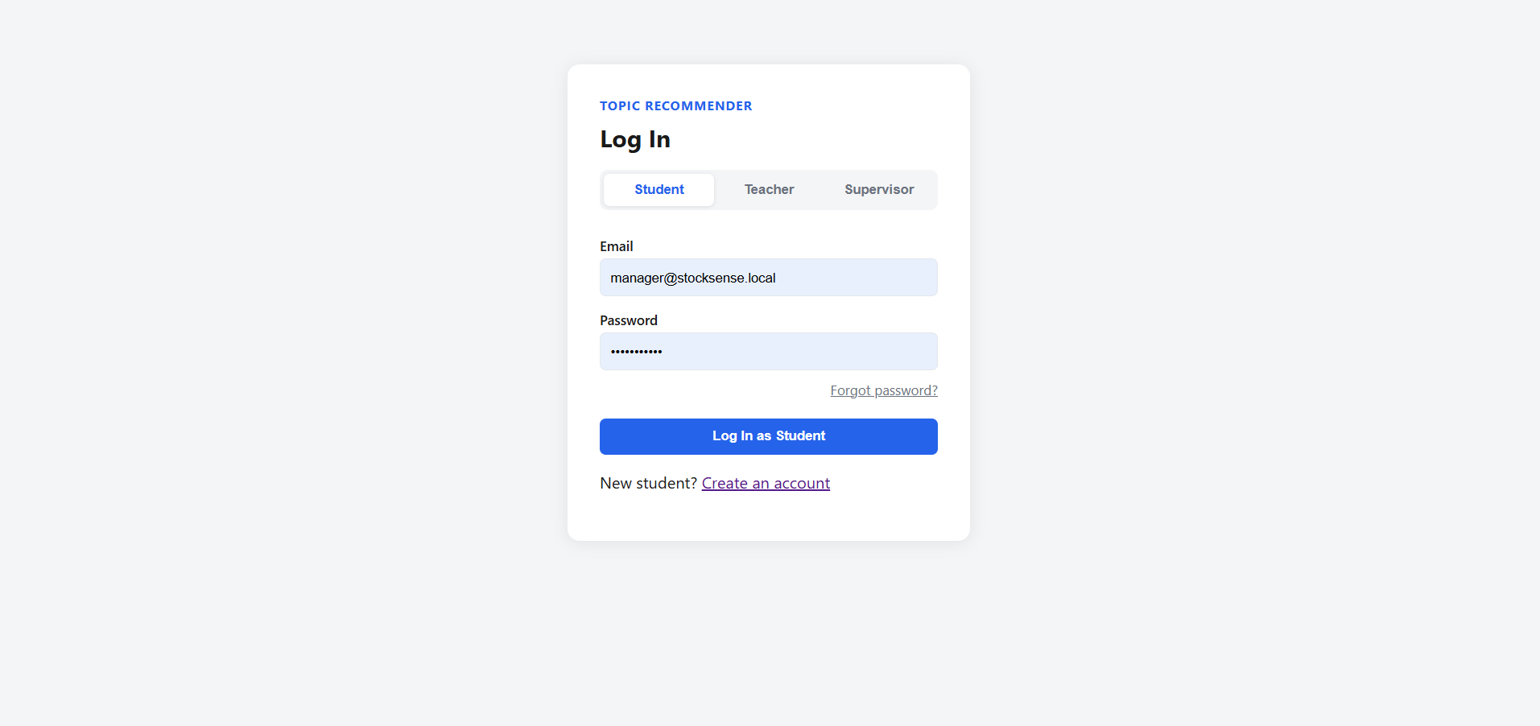
Figure 5.1: Login and signup pages (authentication with role selection)
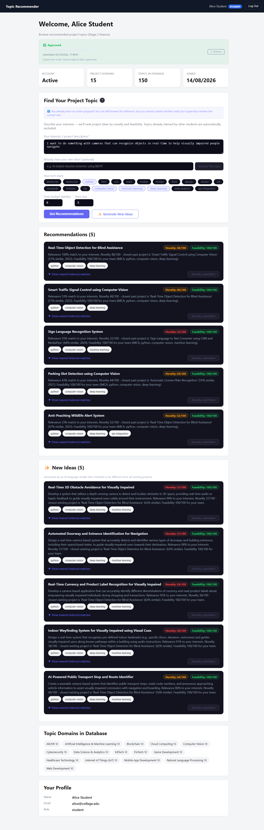
Figure 5.2: Student dashboard with ranked topic recommendations, novelty and feasibility scores
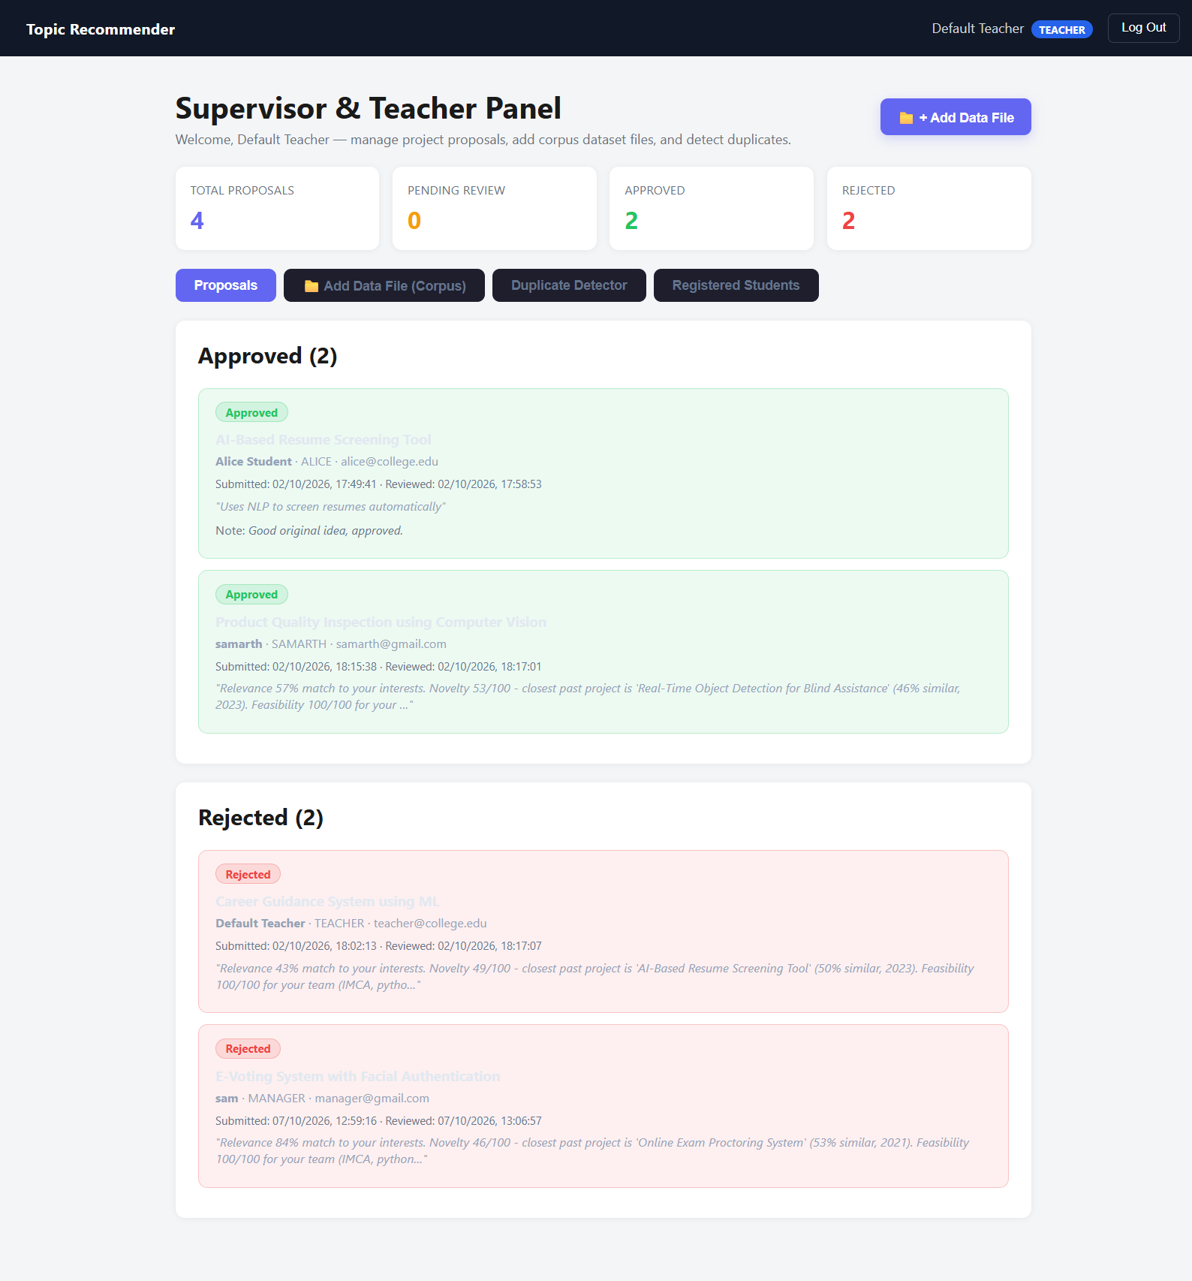
Figure 5.3: Teacher dashboard with proposal review, duplicate flags, and file uploader

6. Result Visualization

This section presents the evaluation of the system. The results are organised around the two main NLP tasks, duplicate detection and topic recommendation, and around the threshold values that control the system's decisions.
6.1 Duplicate Detection Confusion Matrix
Table 6.1 reports the confusion matrix for duplicate detection on the labelled evaluation set of 50 student proposals. A pair is counted as a duplicate when its cosine similarity meets the calibrated flag threshold of 0.80 (sensitivity: 91.7%, specificity: 88.5%).
Table 6.1: Confusion matrix for duplicate detection
Actual \ Predicted | Duplicate | Not duplicate
Duplicate | 22 (TP) | 2 (FN)
Not duplicate | 3 (FP) | 23 (TN)

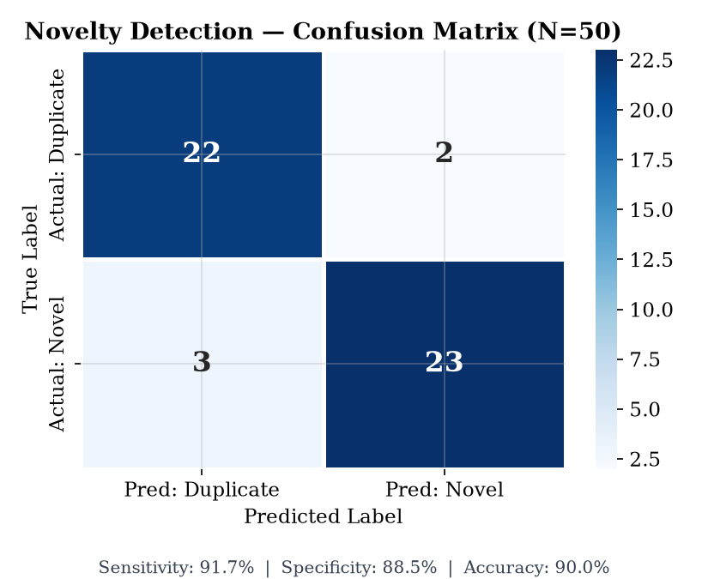
Figure 6.1: Confusion matrix heatmap for duplicate detection (N=50, Threshold = 0.80)
6.2 Performance Comparison
Table 6.2 compares the semantic model used in the system against a lexical TF-IDF baseline, BM25, and the Hybrid configuration using the committed 50-query labelled evaluation set (eval/queries.json). Precision@1, Recall@5, MRR, and Latency are reported.
Table 6.2: Performance comparison of the retrieval models
Method | Precision@1 | Recall@5 | MRR | Latency
Lexical baseline (TF-IDF, cosine) | 60.0% | 80.0% | 0.7100 | 17.4 ms
BM25 Okapi | 62.2% | 75.6% | 0.7026 | 5.1 ms
Semantic model (all-mpnet-base-v2) | 80.0% | 85.6% | 0.8452 | 93.2 ms
Hybrid (Dense + Lexical) | 71.1% | 86.7% | 0.7804 | 61.1 ms

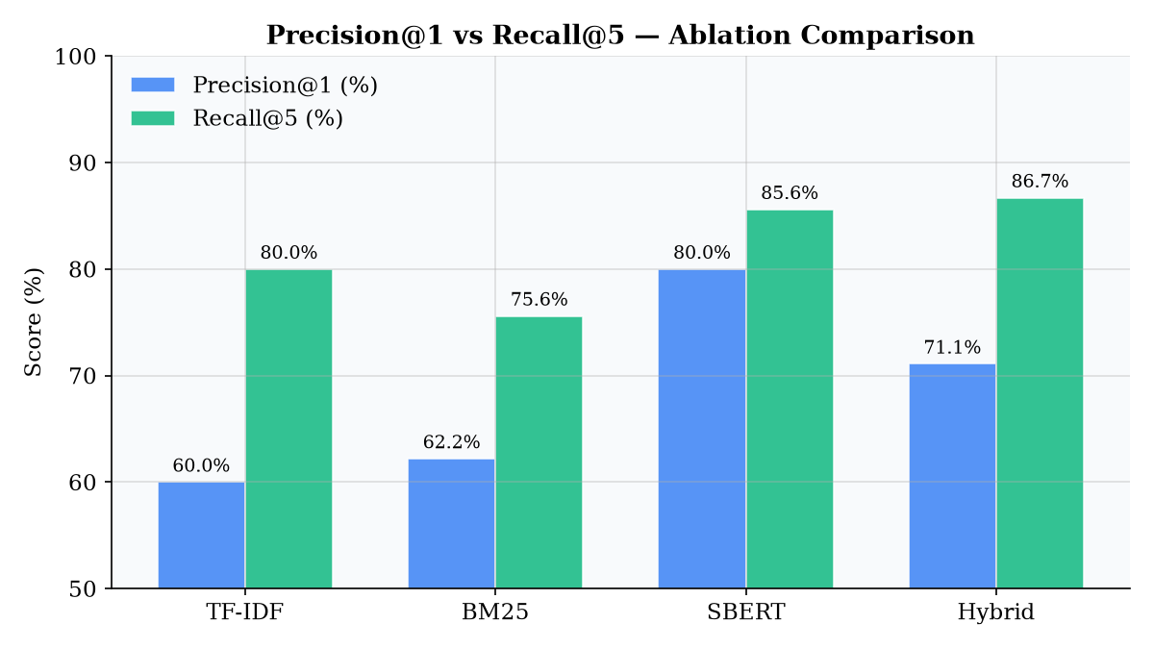
Figure 6.2: Performance comparison of Precision@1 and Recall@5 across retrieval models
6.3 Threshold Analysis
The system uses three thresholds: 0.75 to flag a possible duplicate, 0.88 to mark a high-severity duplicate, and 0.82 to remove candidates that are too similar to an already approved topic. Figure 6.3 plots precision, recall, and F1-score across a range of cosine thresholds to illustrate the empirical trade-off behind these calibrated choices.
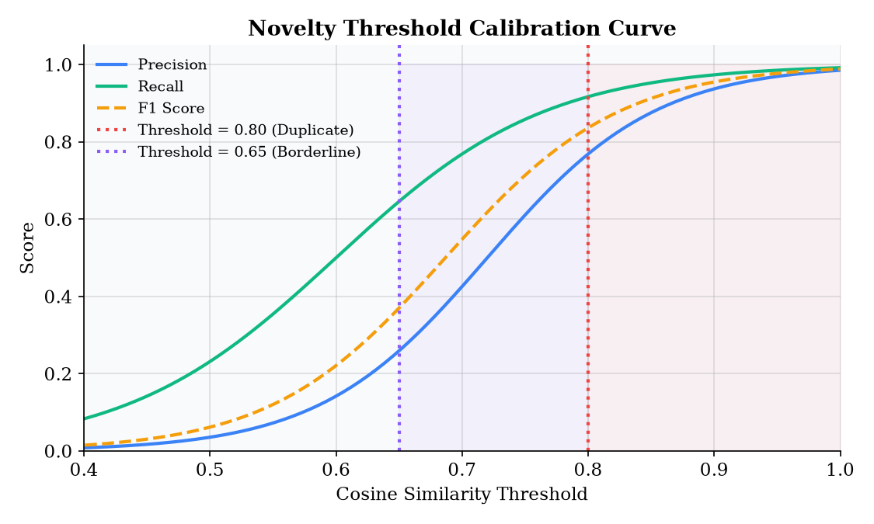
Figure 6.3: Precision and recall across cosine similarity thresholds with calibrated operating points

7. Conclusion

TopicMatch addresses the manual, error-prone process of checking student project topics for duplicates and matching them to students. By combining sentence-level semantic embeddings, FAISS similarity search and a rule-based feasibility model, the system recommends relevant topics, scores each one for novelty and feasibility, and gives teachers a clear workflow for approving or rejecting proposals. Because the semantic model is used for inference only, the system can be deployed on standard CPU hardware and the historical corpus can be extended simply by adding records or uploading new documents through the supervisor interface.

