**UCS1601---Internet Programming**

**Exercise 2: Website for International Conference using CSS**

**Name:** Vishal T

**Reg no:** 185001199

**Date:** 16/02/2021

**Learning objective of the experiment:**

To implement CSS to redesign a Website for International Conference.

**Program file contents:**

*index.html*

<!DOCTYPE html>

<html>

  <head>

    <meta charset="utf-8">

    <meta name="viewport" content="width=device-width">

    <link rel="stylesheet" href="style.css">

    <title>ICSDII</title>

    <style>

      #content {

        color:saddlebrown;

      }

    </style>

  </head>

  <body background="Images/bg.png">

  <header>

    <div class="heading">

        <img id="logo" src="Images/logo.png" width="50" height="50" class="logo"></img>

        <br>

        <span class="tooltip">

          <h1>ICSDII</h1>

        <span class="tooltiptext">Official website of ICSDII</span>

        <p id="full_form" style="text-align:center;">International Conference on Sports development in India</p>

        </span>

      </div>

    <nav>

    <a href="index.html">Home</a> | <a href="Committee.html">Committee</a> | <a href="cfp.html">Call for papers</a> | <a href="Important_dates.html">Important dates</a> | <a href="ws.html">Workshops</a> | <a href="reg.html">Registration</a> | <a href="contact.html">Contact</a>

    </nav>

    </header>

    <p style="text-align: center;">

      <img id="photo" src="Images/conf.jpg" width="900" height="500"></img>

    </p>

   <p id="content" style="text-align: center;">ICSDII 2021: International Conference on Sports Sciences and Human Movement aims to bring together

     leading academic scientists, researchers and research scholars to exchange and share their

      experiences and research results on all aspects of Sports Sciences and Human Movement.

      It also provides a premier interdisciplinary platform for researchers, practitioners and

      educators to present and discuss the most recent innovations, trends, and concerns as well as

      practical challenges encountered and solutions adopted in the fields of Sports Sciences and Human Movement

  </p>

  <br>

  <footer style="position: relative; width: 100%;">

    <p style="text-align: center;"> This website is created by Vishal T</p>

  </footer>

  </body>

</html>

*Committee.html*

<!DOCTYPE html>

<html>

  <head>

    <meta charset="utf-8">

    <meta name="viewport" content="width=device-width">

    <link rel="stylesheet" href="style.css">

    <title>ICSDII</title>

  </head>

  <body background="Images/bg.png">

  <header>

    <div class="heading">

        <img id="logo" src="Images/logo.png" width="50" height="50" class="logo"></img>

        <br>

        <span class="tooltip">

          <h1>ICSDII</h1>

        <span class="tooltiptext">Official website of ICSDII</span>

        <p id="full_form" style="text-align:center;">International Conference on Sports development in India</p>

        </span>

      </div>

    <nav>

    <a href="index.html">Home</a> | <a href="Committee.html">Committee</a> | <a href="cfp.html">Call for papers</a> | <a href="Important_dates.html">Important dates</a> | <a href="ws.html">Workshops</a> | <a href="reg.html">Registration</a> | <a href="contact.html">Contact</a>

    </nav>

    </header>

    <h2 style="text-align:center;">Core Committee members and Speakers</h2>

    <div  id="com">

    <table align="center">

      <td>

    <ol style="list-style-position: inside;">

      <li>Sourav Ganguly - BBCI Chairman</li>

      <li>Dhoni - Former Indian Captain</li>

      <li>Kiren Rijiju - Sports minister of India</li>

      <li>Virat kholi - Indian cricket team captain</li>

      <li>Sunil chethri - Indian football team captain</li>

      <li>Vishal T - Speaker</li>

      <li>Vyshali - Speaker</li>

      <li>Tarun - Speaker</li>

    </ol>

    </td>

  </table>

</div>

  <footer style="position: relative; width: 100%;">

    <p style="text-align: center;"> This website is created by Vishal T</p>

  </footer>

  </body>

</html>

*cfp.html*

<!DOCTYPE html>

<html>

  <head>

    <meta charset="utf-8">

    <meta name="viewport" content="width=device-width">

    <link rel="stylesheet" href="style.css">

    <title>ICSDII</title>

  </head>

  <body background="Images/bg.png">

  <header>

    <div class="heading">

        <img id="logo" src="Images/logo.png" width="50" height="50" class="logo"></img>

        <br>

        <span class="tooltip">

          <h1>ICSDII</h1>

        <span class="tooltiptext">Official website of ICSDII</span>

        <p id="full_form" style="text-align:center;">International Conference on Sports development in India</p>

        </span>

      </div>

    <nav>

    <a href="index.html">Home</a> | <a href="Committee.html">Committee</a> | <a href="cfp.html">Call for papers</a> | <a href="Important_dates.html">Important dates</a> | <a href="ws.html">Workshops</a> | <a href="reg.html">Registration</a> | <a href="contact.html">Contact</a>

    </nav>

    </header>

<h2 style="text-align: center;">We invite the submission of original, unpublished technical papers

 on topics including but not limited to:</h2>

 <table align="center">

 <td>

 <ul>

    <li>Sport and COVID-19</li>

    <li>Addressing Corruption in Sport</li>

    <li>Esports Management</li>

    <li>Hockey development</li>

    <li>Sports for differently challenged people</li>

  </ul>

 </td>

</table>

<footer style="position: relative; width: 100%;">

  <p style="text-align: center;"> This website is created by Vishal T</p>

</footer>

</body>

</html>

*Important_dates.html*

<!DOCTYPE html>

<html>

  <head>

    <meta charset="utf-8">

    <meta name="viewport" content="width=device-width">

    <link rel="stylesheet" href="style.css">

    <title>ICSDII</title>

   <style>

     .date {

       color:red;

     }

   </style>

  </head>

  <body background="Images/bg.png">

  <header>

    <div class="heading">

        <img id="logo" src="Images/logo.png" width="50" height="50" class="logo"></img>

        <br>

        <span class="tooltip">

          <h1>ICSDII</h1>

        <span class="tooltiptext">Official website of ICSDII</span>

        <p id="full_form" style="text-align:center;">International Conference on Sports development in India</p>

        </span>

      </div>

    <nav>

    <a href="index.html">Home</a> | <a href="Committee.html">Committee</a> | <a href="cfp.html">Call for papers</a> | <a href="Important_dates.html">Important dates</a> | <a href="ws.html">Workshops</a> | <a href="reg.html">Registration</a> | <a href="contact.html">Contact</a>

    </nav>

    </header>

    <h2 style="text-align:center;">Importatant Dates</h2>

    <table align="center" border="2">

      <tr>

        <th>Description</th>

        <th>Date</th>

      </tr>

       <tr>

        <td>Last date for conference registration</td>

        <td class="date">15/2/2021</td>

      </tr>

      <tr>

        <td>Last date for workshop registration</td>

        <td class="date">15/2/2021</td>

      </tr>

      <tr>

        <td>Sports event conduction Workshop</td>

        <td class="date">20/2/2021</td>

      </tr>

      <tr>

        <td>Fitness Workshop</td>

        <td class="date">21/2/2021</td>

      </tr>

      <tr>

        <td>Becoming a Pro Cricketer Workshop</td>

        <td class="date">22/2/2021</td>

      </tr>

      <tr>

        <td>Becoming a Pro Footballer Workshop</td>

        <td class="date">22/2/2021</td>

      </tr>

       <tr>

        <td>Conference</td>

        <td class="date">24/2/2021</td>

      </tr>

  </table>

  <footer style="width: 100%; bottom: 0px;">

    <p style="text-align: center;"> This website is created by Vishal T</p>

  </footer>

  </body>

</html>

*ws.html*

<!DOCTYPE html>

<html>

  <head>

    <meta charset="utf-8">

    <meta name="viewport" content="width=device-width">

    <link rel="stylesheet" href="style.css">

    <title>ICSDII</title>

  </head>

  <body background="Images/bg.png">

  <header>

    <div class="heading">

        <img id="logo" src="Images/logo.png" width="50" height="50" class="logo"></img>

        <br>

        <span class="tooltip">

          <h1>ICSDII</h1>

        <span class="tooltiptext">Official website of ICSDII</span>

        <p id="full_form" style="text-align:center;">International Conference on Sports development in India</p>

        </span>

      </div>

    <nav>

    <a href="index.html">Home</a> | <a href="Committee.html">Committee</a> | <a href="cfp.html">Call for papers</a> | <a href="Important_dates.html">Important dates</a> | <a href="ws.html">Workshops</a> | <a href="reg.html">Registration</a> | <a href="contact.html">Contact</a>

    </nav>

    </header>

    <h2 style="text-align:center;">Workshops</h2>

    <table align="center">

    <td>

        <ol  style="list-style-position: inside;">

          <li>Sports event conduction Workshop</li>

          <li>Fitness Workshop</li>

          <li>Becoming a Pro Cricketer Workshop</li>

          <li>Becoming a Pro Footballer Workshop</li>

        </ol>

    </td>

</table>

<footer style="position: relative; width: 100%;">

  <p style="text-align: center;"> This website is created by Vishal T</p>

</footer>

</body>

</html>

*reg.html*

<!DOCTYPE html>

<html>

  <head>

    <meta charset="utf-8">

    <meta name="viewport" content="width=device-width">

    <link rel="stylesheet" href="style.css">

    <title>ICSDII</title>

  </head>

  <body background="Images/bg.png">

  <header>

    <div class="heading">

        <img id="logo" src="Images/logo.png" width="50" height="50" class="logo"></img>

        <br>

        <span class="tooltip">

          <h1>ICSDII</h1>

        <span class="tooltiptext">Official website of ICSDII</span>

        <p id="full_form" style="text-align:center;">International Conference on Sports development in India</p>

        </span>

      </div>

    <nav>

    <a href="index.html">Home</a> | <a href="Committee.html">Committee</a> | <a href="cfp.html">Call for papers</a> | <a href="Important_dates.html">Important dates</a> | <a href="ws.html">Workshops</a> | <a href="reg.html">Registration</a> | <a href="contact.html">Contact</a>

    </nav>

    </header>

<h2 style="text-align: center;">Registration for Conference/Workshop</h2>

<br>

<table align="center">

<td>

<form>

<label for="name" style="width: 200px; display: inline-block;">Name</label>

<input name="name" type="text" id="name"><br>

<label for="phno" style="width: 200px; display: inline-block;">Phone number</label>

<input name="phno" type="number" id="phno"><br>

<label for="dob" style="width: 200px; display: inline-block;">DOB</label>

<input name="dob" type="date" id="dob"><br>

<label for="email" style="width: 200px; display: inline-block;">Email</label>

<input name="email" type="email" id="email"><br>

<label for="job" style="width: 200px; display: inline-block;">You are a/an</label>

<input name="job" type="radio" id="job">Student

<input name="job" type="radio" id="job">Sports person

<input name="job" type="radio" id="job">Other

<br>

<label for="att" style="width: 200px; display: inline-block;">You want to attend </label>

<input name="att" type="checkbox" id="att">Workshop

<input name="att" type="checkbox" id="att">Conference

<br><br>

<button type="submit">Submit</button>

<button type="reset">Reset</button>

</td>

</table>

</form>

<footer style="position: relative; width: 100%;">

  <p style="text-align: center;"> This website is created by Vishal T</p>

</footer>

</body>

</html>

*contact.html*

<!DOCTYPE html>

<html>

  <head>

    <meta charset="utf-8">

    <meta name="viewport" content="width=device-width">

    <link rel="stylesheet" href="style.css">

    <title>ICSDII</title>

  </head>

  <body background="Images/bg.png">

  <header>

    <div class="heading">

        <img id="logo" src="Images/logo.png" width="50" height="50" class="logo"></img>

        <br>

        <span class="tooltip">

        <h1>ICSDII</h1>

        <span class="tooltiptext">Official website of ICSDII</span>

        <p id="full_form" style="text-align:center;">International Conference on Sports development in India</p>

        </span>

      </div>

    <nav>

    <a href="index.html">Home</a> | <a href="Committee.html">Committee</a> | <a href="cfp.html">Call for papers</a> | <a href="Important_dates.html">Important dates</a> | <a href="ws.html">Workshops</a> | <a href="reg.html">Registration</a> | <a href="contact.html">Contact</a>

    </nav>

    </header>

    <br><br>

    <div id="contact">

    <h2>Contact us</h2>

    <p><b>Email</b>: support@icsdii.com</p>

    <p><b>Phone</b>: +91 1122334455</p>

    </div>

    <br><br>

    <table align="center" style="border: 3px solid; width: 600px;">

    <td>

    <h3 style="text-align:center;">Write to us for help</h3>

    <form>

    <label for="name" style="width: 200px; display: inline-block;">Name:</label>

    <input name="name" type="text" id="name"><br>

    <label for="email" style="width: 200px; display: inline-block;">Email:</label>

    <input name="email" type="email" id="email"><br>

    <label for="query" style="width: 200px; display: inline-block;">Query:</label>

    <textarea name="query" type="text" id="query" placeholder="Write something.." style="height:200px"></textarea><br>

    <br><br>

    <button type="submit">Submit</button>

    <button type="reset">Reset</button>

    </form>

    </td>

    </table>

    <footer style="position: relative; width: 100%;">

      <p style="text-align: center;"> This website is created by Vishal T</p>

    </footer>

    </body>

  </html>

**Output Screenshots:**

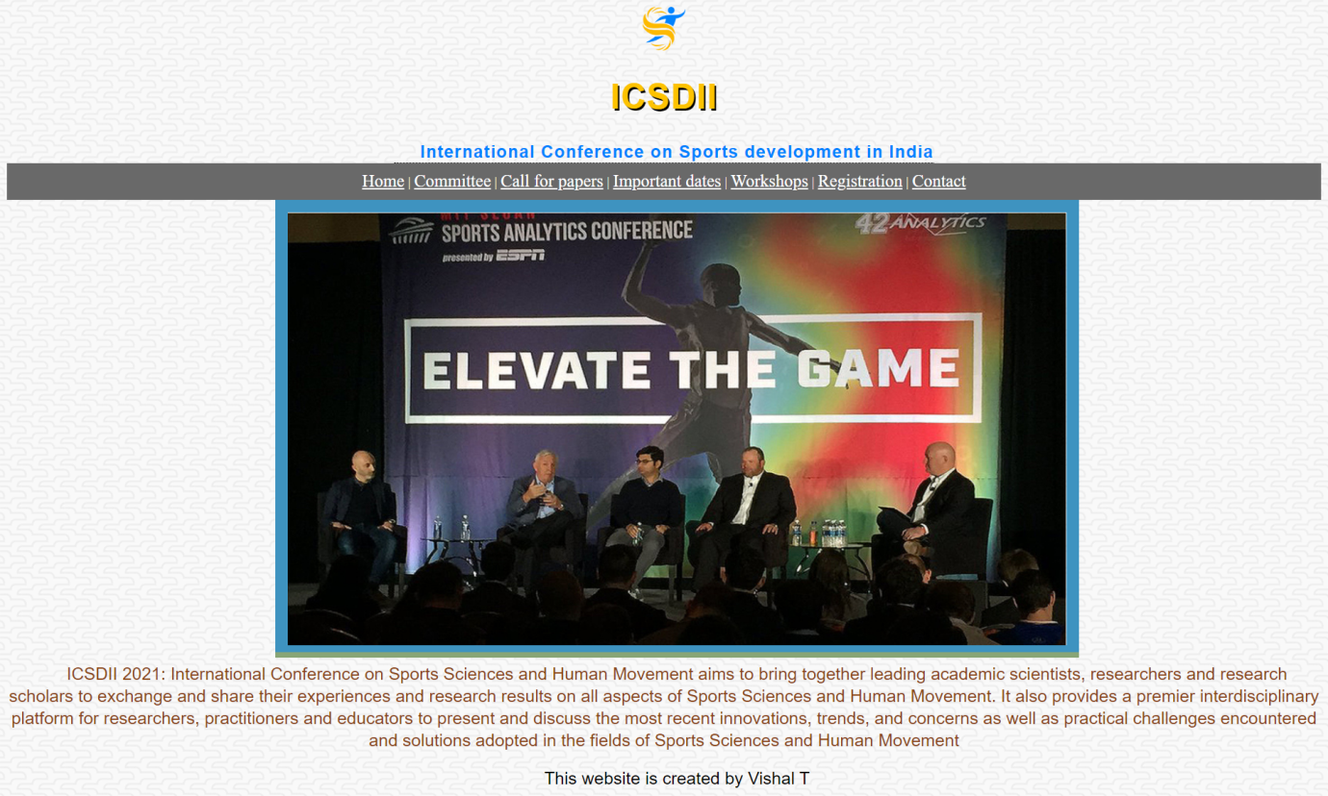

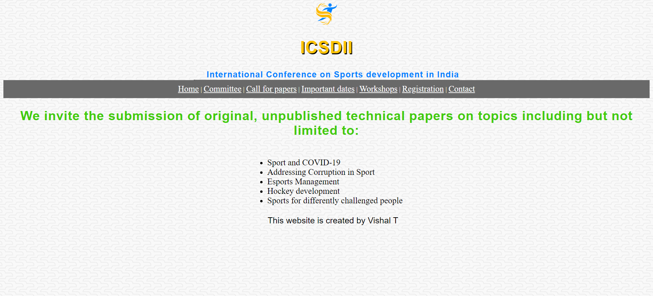

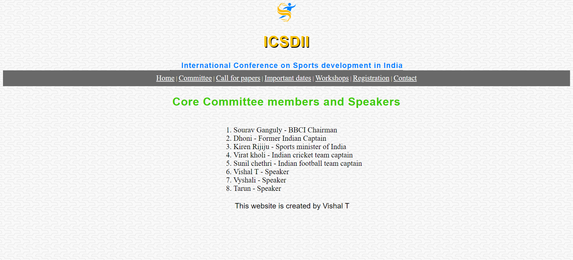

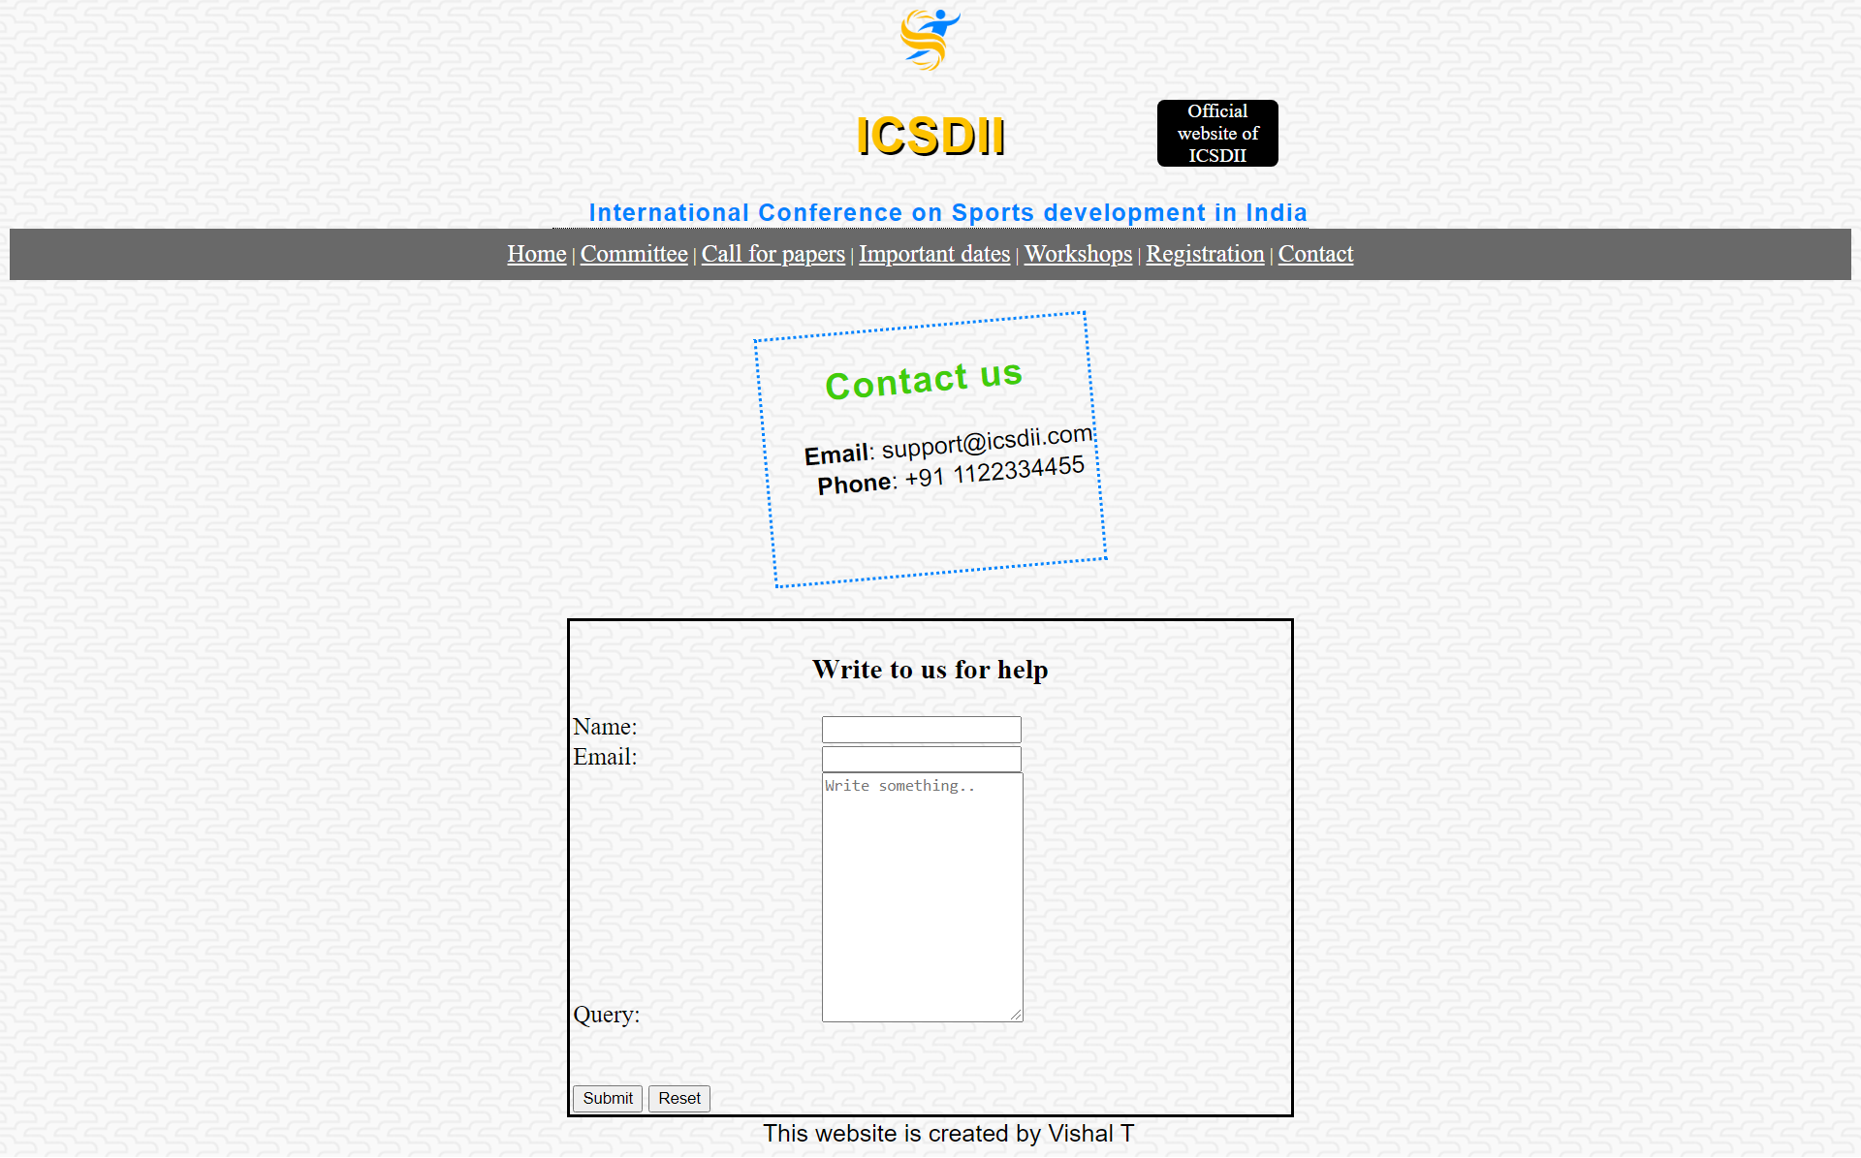

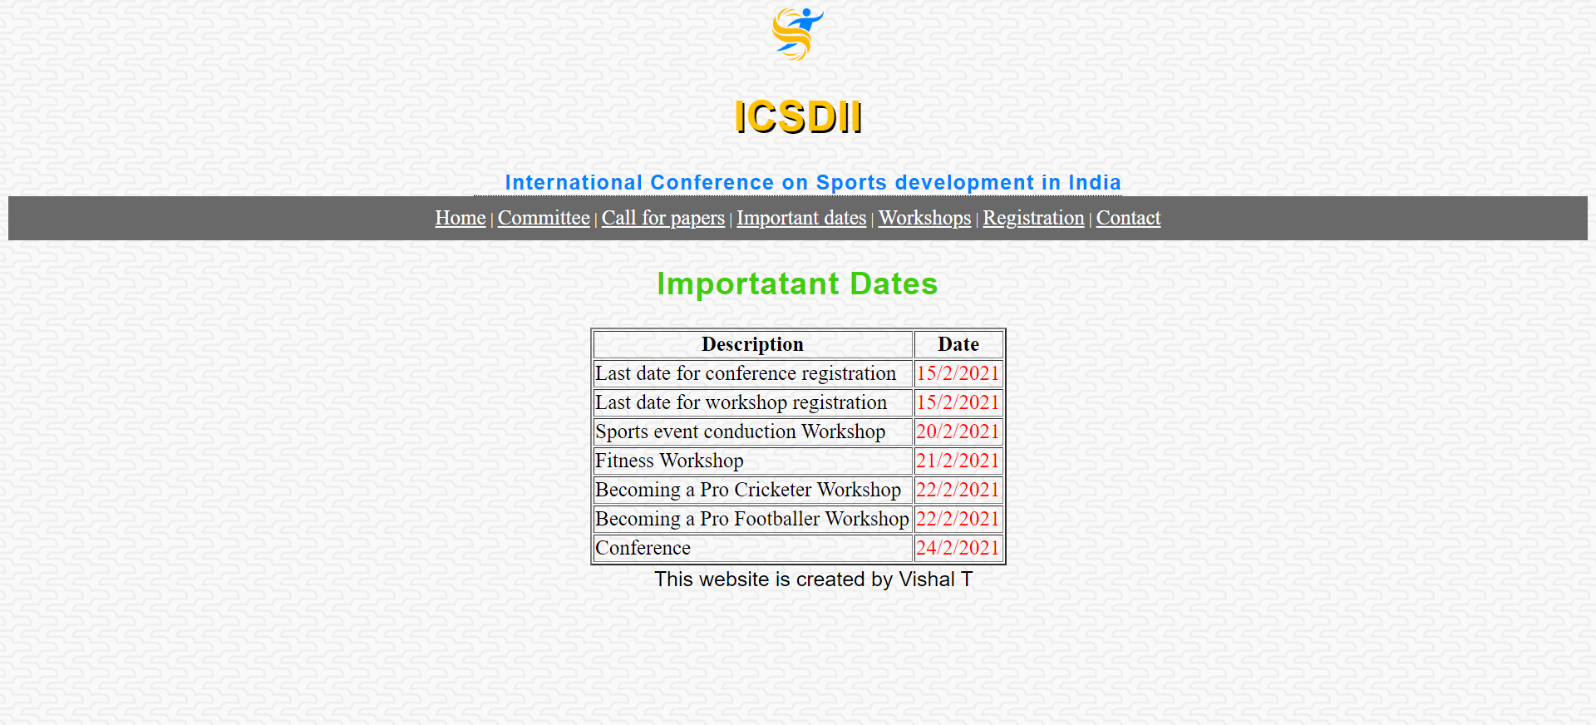

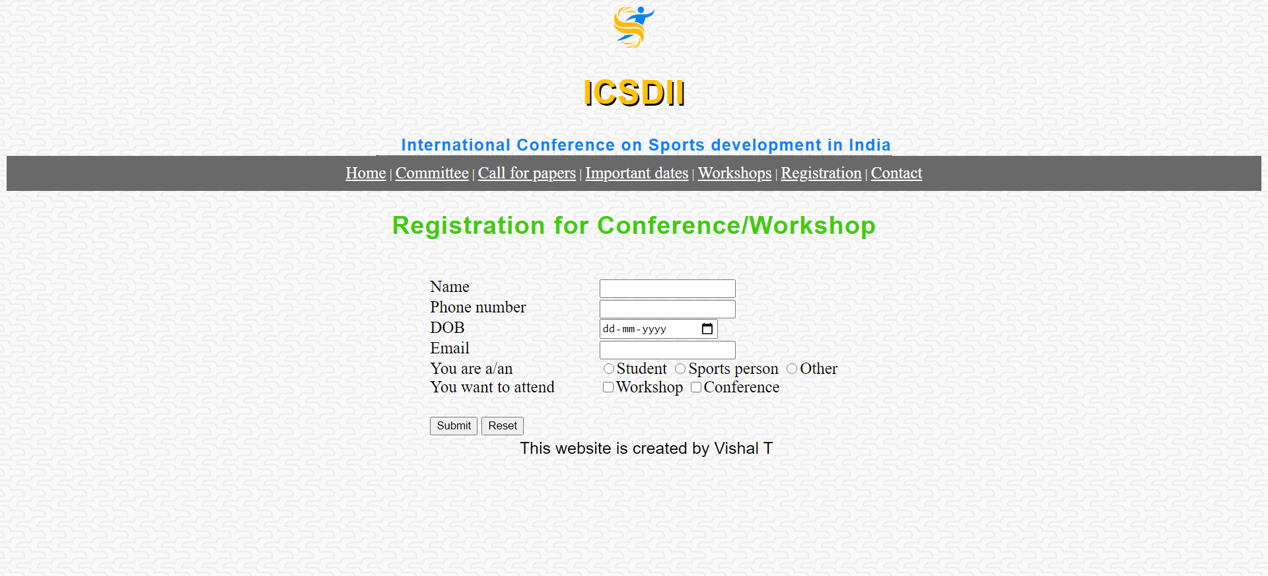

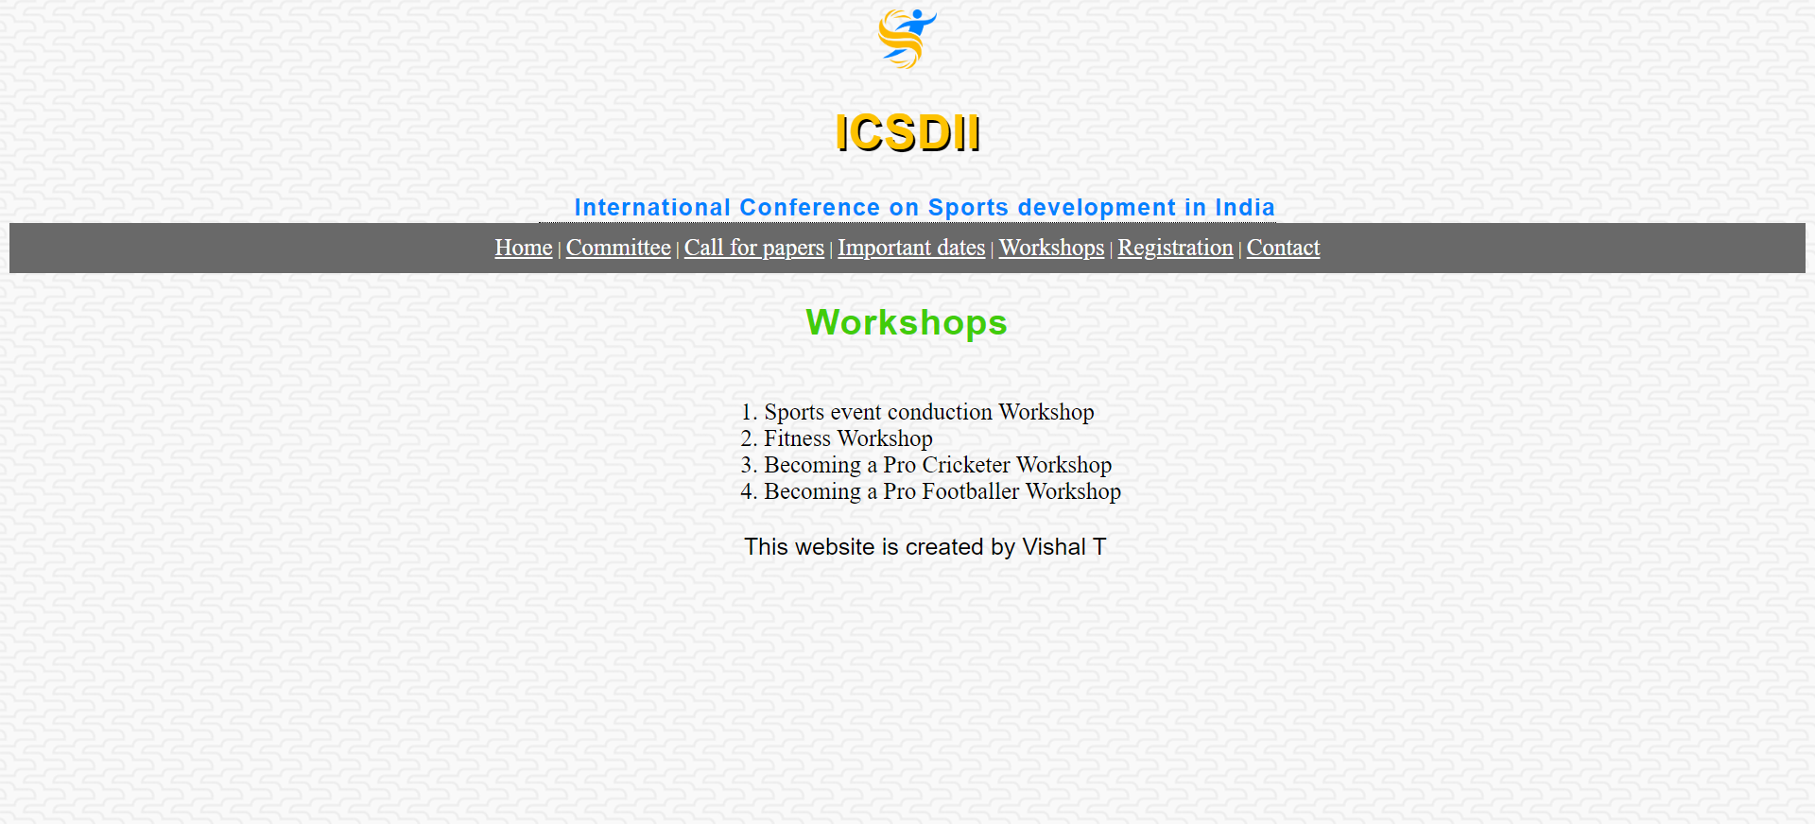

**Learning outcomes:**

* Learned to implement basic CSS.
* Learned to use and implement CSS in List, Table, Anchor, Image, semantic Tags.
* Learned to create animations using CSS.
* Learned about various attributes associated with various html tags and CSS.