**UCS1601---Internet Programming**

## Exercise 3: JavaScript event handling mechanisms, DOM

**Name:** Vishal T

**Reg no:** 185001199

**Date:** 04/03/2021

**Learning objective of the experiment:**

* To generate a registration form for a hospital to register new patient details.
* Write a JS program to develop a memory matching game.

**Program file contents:**

**Registration form**

*index.html*

<!DOCTYPE html>

<html>

  <head>

    <meta charset="utf-8">

    <meta name="viewport" content="width=device-width">

    <link rel="stylesheet" href="style.css">

    <script src="script.js"></script>

    <title>Hospital reg_form</title>

  </head>

  <body background="Images/bg.png" onload="startTime()" style="height: 120%;">

  <div id="container">

  <header>

    <div class="heading">

         <p id="clock" style="text-align: right;"></p>

        <img id="logo" src="Images/hospital.png" width="70" height="50" class="logo" style="display:inline-block;"></img>

        <br>

          <h1>Hospital Management System</h1>

      </div>

    </header>

<h2 id="form_title">New patient Registration</h2>

<br>

<table align="center">

<td>

<form id="myform">

<label for="name">Name</label>

<input name="name" type="text" id="name" onfocus="focusFunction(this)" onblur="blurFunction(this)" oninvalid="nInvalidFunc()" required><br>

<br>

<label for="add">Address</label>

<textarea id="add" name="add" rows="4" cols="50" onfocus="focusFunction(this)" onblur="blurFunction(this)" onselect="selectFunc()"></textarea><br><br>

<label for="age">Age</label>

<input name="age" type="number" id="age" onfocus="focusFunction(this)" onblur="blurFunction(this)" onkeypress="okpFunc()"><br>

<label for="dob">DOB</label>

<input name="dob" type="date" id="dob" onfocus="focusFunction(this)" onblur="blurFunction(this)"><br>

<label for="sex">Gender</label>

<input name="sex" type="radio" value="Male" id="sex1">Male

<input name="sex" type="radio" value="Female" id="sex2">Female

<input name="sex" type="radio" value="Others" id="sex3">Others

<br>

<label for="ms">Marital Status</label>

<input name="ms" type="radio" value="Married" id="ms1" onchange="msFunc(this)">Married

<input name="ms" type="radio" value="Unmarried" id="ms2" onchange="msFunc(this)">Unmarried

<br>

<label for="phno">Contact number</label>

<input name="phno" type="tel" id="phno" maxlength="10" onfocus="focusFunction(this)" onblur="blurFunction(this)" oninvalid="phInvalidFunc()" required><br>

<br>

<label for="addic">Addictions(if any)</label>

<textarea id="addic" rows="4" cols="30"></textarea>

  <p id="addic1" draggable="true" style="border: 1px solid black;display: inline-block;">Smoking</p>

  <p id="addic2" draggable="true" style="border: 1px solid black;display: inline-block;">Drinking</p>

  <br>

<button type="submit" onclick="submitFunc()">Submit</button>

<button type="reset" onclick="resetFunc()">Reset</button>

</td>

</table>

</form>

  <div id="footer">

  <footer>

    <p style="text-align: center;"> This website is created by Vishal T</p>

  </footer>

  </div>

</div>

</body>

</html>

display.html

<!DOCTYPE html>

<html>

  <head>

    <meta charset="utf-8">

    <meta name="viewport" content="width=device-width">

    <link rel="stylesheet" href="style.css">

    <script src="script.js"></script>

    <title>Hospital reg_form</title>

    <style>

      table, th, td {

        border: 1px solid black;

      }

    </style>

    <script>

       function init() {

        // Retrieving the text input's value which was stored into localStorage

        var myname = localStorage.getItem("name");

        var myadd = localStorage.getItem("add");

        var myage = localStorage.getItem("age");

        var mydob = localStorage.getItem("dob");

        var mygen = localStorage.getItem("sex");

        var myms = localStorage.getItem("ms");

        var myphno = localStorage.getItem("phno");

        var myaddic = localStorage.getItem("addic");

        // Writing the value in the document

        document.getElementById("myname").innerHTML= myname;

        document.getElementById("myadd").innerHTML= myadd;

        document.getElementById("myage").innerHTML= myage;

        document.getElementById("mydob").innerHTML= mydob;

        document.getElementById("mygen").innerHTML= mygen;

        document.getElementById("myms").innerHTML= myms;

        document.getElementById("mycontact").innerHTML= myphno;

        document.getElementById("myaddic").innerHTML= myaddic;

    }

    </script>

  </head>

  <body background="Images/bg.png" onload="startTime();init()" style="height: 120%;">

  <div id="container">

  <header>

    <div class="heading">

         <p id="clock" style="text-align: right;"></p>

        <img id="logo" src="Images/hospital.png" width="70" height="50" class="logo" style="display:inline-block;"></img>

        <br>

          <h1>Hospital Management System</h1>

      </div>

    </header>

<table align="center">

  <caption>Patient's Details</caption>s

  <tr>

    <td>Name</td>

    <td id="myname"></td>

  </tr>

  <tr>

    <td>Address</td>

    <td id="myadd"></td>

  </tr>

  <tr>

    <td>Age</td>

    <td id="myage"></td>

  </tr>

  <tr>

    <td>DOB</td>

    <td id="mydob"></td>

  </tr>

  <tr>

    <td>Gender</td>

    <td id="mygen"></td>

  </tr>

  <tr>

    <td>Martital Status</td>

    <td id="myms"></td>

  </tr>

  <tr>

    <td>Contact Number</td>

    <td id="mycontact"></td>

  </tr>

  <tr>

    <td>Addictions</td>

    <td id="myaddic"></td>

  </tr>

</table>

<div id="footer">

  <footer>

    <p style="text-align: center;"> This website is created by Vishal T</p>

  </footer>

  </div>

</div>

</body>

</html>

script.js

//Name

function focusFunction(elemt)

{

    elemt.style.background="#61b3ff";

}

function blurFunction(elemt) {

    elemt.style.background="#a9ff88";

  }

function nInvalidFunc() {

    alert("Name is required");

}

//address

function selectFunc(){

    alert("Text selected!");

}

//Age

function okpFunc(){

    document.getElementById("age").style.color="red";

}

//Gender

function genValue(){

        var ele = document.getElementsByName("sex");

        for(i = 0; i < ele.length; i++) {

            if(ele[i].checked)

            {

                return ele[i].value;

            }

}

}

//Marital Status

function msFunc(elemt){

    if(elemt.id=="ms1"){

        alert("You are married");

    }

    else{

        alert("You are Unmarried");

    }

}

function msValue(){

    var ms = document.getElementsByName("ms");

    for(i = 0; i < ms.length; i++) {

        if(ms[i].checked)

        {

            return ms[i].value;

        }

}

}

//phno

function phInvalidFunc() {

    alert("Contact Number is required");

}

//Addiction

document.addEventListener('dragstart', function (event) {

    event.dataTransfer.setData('text/plain', event.target.innerHTML);

  });

//Clock

function startTime() {

    var today = new Date();

    var h = today.getHours();

    var m = today.getMinutes();

    var s = today.getSeconds();

    m = checkTime(m);

    s = checkTime(s);

    document.getElementById('clock').innerHTML =

    h + ":" + m + ":" + s;

    var t = setTimeout(startTime, 500);

  }

  function checkTime(i) {

    if (i < 10) {i = "0" + i};  // add zero in front of numbers < 10

    return i;

  }

//Submit

function submitFunc(){

    var name= document.getElementById("name").value;

    localStorage.setItem("name", name);

    var add= document.getElementById("add").value;

    localStorage.setItem("add", add);

    var age= document.getElementById("age").value;

    localStorage.setItem("age", age);

    var dob= document.getElementById("dob").value;

    localStorage.setItem("dob", dob);

    var sex= genValue();

    localStorage.setItem("sex", sex);

    var ms= msValue();

    localStorage.setItem("ms", ms);

    var phno= document.getElementById("phno").value;

    localStorage.setItem("phno", phno);

    var addic=document.getElementById("addic").value;

    localStorage.setItem("addic", addic);

    window.open("display.html");

}

//Reset

function resetFunc(){

    alert("The Form has been reset");

}

style.css

#form_title,caption{

  color:#41cc0a;

  text-align: center;

  font-family: 'Courier New', Courier, monospace;

  font-size: 30px;

  font-style: italic;

  font-weight: bold;

}

h1 {

  color:#fdc200;

  font-family:Arial, Helvetica, sans-serif;

  font-size: 40px;

  letter-spacing: 1px;

  text-shadow: 2px 2px black ;

}

.heading {

      margin: auto;

      text-align:center;

}

label{

  color:black;

  font-family:Arial, sans-serif;

  width: 200px;

  display: inline-block;

}

p{

  color:black;

  font-family:Arial, sans-serif;

  font-size: 20px;

  line-height: 26px;

  margin: 0;

}

table{

  font-size:20px;

}

html,

body {

   margin:0;

   padding:0;

   height:100%;

}

#container {

  min-height:100%;

  position:relative;

}

#footer {

  position:absolute;

  bottom:0;

  width:100%;

  height:40px;   /* Height of the footer */

  background:#6cf;

}

td{

  color:black;

  font-family:Arial, sans-serif;

  font-size: 20px;

}

**Memory Game:**

index.html

<!DOCTYPE html>

<html lang="en" dir="ltr">

<head>

  <meta charset="UTF-8">

  <title>Memory Game</title>

  <link rel="stylesheet" href="style.css"></link>

  <script src="script.js" charset="utf-8"></script>

</head>

<body>

  <h1>Memory Game</h1>

  <div style="text-align: center;">

  <h3>Level:<span id="level">1</span></h3>

  <h3>Score:<span id="result"></span></h3>

  <h3>Timer:<span id="time">60</span></h3>

  </div>

  <div class="grid" id="grid" style="margin: auto;">

  </div>

  <div style="text-align: center;">

    <input type="button" id="mixBut" value="Start" onclick="Start_Stop()">

  </div>

</body>

</html>

script.js

function start_game(){

    //card options

    const cardArray = [

      {

        name: 'fries',

        img: 'images/fries.png'

      },

      {

        name: 'cheeseburger',

        img: 'images/cheeseburger.png'

      },

      {

        name: 'ice-cream',

        img: 'images/ice-cream.png'

      },

      {

        name: 'pizza',

        img: 'images/pizza.png'

      },

      {

        name: 'milkshake',

        img: 'images/milkshake.png'

      },

      {

        name: 'hotdog',

        img: 'images/hotdog.png'

      },

      {

        name: 'fries',

        img: 'images/fries.png'

      },

      {

        name: 'cheeseburger',

        img: 'images/cheeseburger.png'

      },

      {

        name: 'ice-cream',

        img: 'images/ice-cream.png'

      },

      {

        name: 'pizza',

        img: 'images/pizza.png'

      },

      {

        name: 'milkshake',

        img: 'images/milkshake.png'

      },

      {

        name: 'hotdog',

        img: 'images/hotdog.png'

      }

    ]

    cardArray.sort(() => 0.5 - Math.random())

    const grid = document.querySelector('.grid')

    const resultDisplay = document.querySelector('#result')

    var score=0;

    let cardsChosen = []

    let cardsChosenId = []

    let cardsWon = []

    //create your board

    function createBoard() {

      for (let i = 0; i < cardArray.length; i++) {

        const card = document.createElement('img')

        card.setAttribute('src', 'images/blank.png')

        card.setAttribute('data-id', i)

        card.addEventListener('click', flipCard)

        grid.appendChild(card)

      }

    }

    //check for matches

    function checkForMatch() {

      const cards = document.querySelectorAll('img')

      const optionOneId = cardsChosenId[0]

      const optionTwoId = cardsChosenId[1]

      if(optionOneId == optionTwoId) {

        cards[optionOneId].setAttribute('src', 'images/blank.png')

        cards[optionTwoId].setAttribute('src', 'images/blank.png')

        alert('You have clicked the same image!')

      }

      else if (cardsChosen[0] === cardsChosen[1]) {

        alert('You found a match')

        score=score+1;

        resultDisplay.textContent=score;

        cards[optionOneId].setAttribute('src', 'images/white.png')

        cards[optionTwoId].setAttribute('src', 'images/white.png')

        cards[optionOneId].removeEventListener('click', flipCard)

        cards[optionTwoId].removeEventListener('click', flipCard)

        cardsWon.push(cardsChosen)

      } else {

        cards[optionOneId].setAttribute('src', 'images/blank.png')

        cards[optionTwoId].setAttribute('src', 'images/blank.png')

        alert('Sorry, try again')

      }

      cardsChosen = []

      cardsChosenId = []

      resultDisplay.textContent = cardsWon.length

      if  (cardsWon.length === cardArray.length/2) {

        alert('Congratulations! You won 1st level and going to next');

        level++;

        if(level==1){

          level_time=60;

        }

        else if(level==2){

          level_time=40;

        }

        else{

          level_time=25;

        }

        document.getElementById("level").innerHTML=level;

        document.getElementById("time").innerHTML=level_time;

        Start_Stop();

        reset_game();

      }

    }

    //flip your card

    function flipCard() {

      let cardId = this.getAttribute('data-id')

      cardsChosen.push(cardArray[cardId].name)

      cardsChosenId.push(cardId)

      this.setAttribute('src', cardArray[cardId].img)

      if (cardsChosen.length ===2) {

        setTimeout(checkForMatch, 500)

      }

    }

    createBoard()

  }

  function reset_game(){

    document.getElementById("grid").innerHTML=" ";

  }

  var myTimer;

  var level=1;

  var level_time=60;

  function clock() {

    myTimer = setInterval(myClock, 1000);

    if(level==1){

      var c = 60;

    }

    else if(level==2){

      var c = 40;

    }

    else{

      var c = 25;

    }

    function myClock() {

      document.getElementById("time").innerHTML = --c;

      if (c == 0) {

        clearInterval(myTimer);

        alert("Reached zero. Game Over!!!!!");

        location.reload();

      }

    }

  }

function Start_Stop(){

    var but= document.getElementById("mixBut");

    if(but.value=="Start"){

      start_game();

      clock();

      but.value="Stop";

      //code

    }

    else{

      clearInterval(myTimer);

      reset_game();

      but.value="Start"

    }

}

style.css

h1{

  color: blue;

  text-decoration: underline;

  text-align: center;

}

input{

  margin: 20px;

  font-size: 30px;

}

.grid {

    display: flex;

    flex-wrap: wrap;

    width: 400px;

    height: 300px;

  }

**Output Screenshots:**

**Registration form**

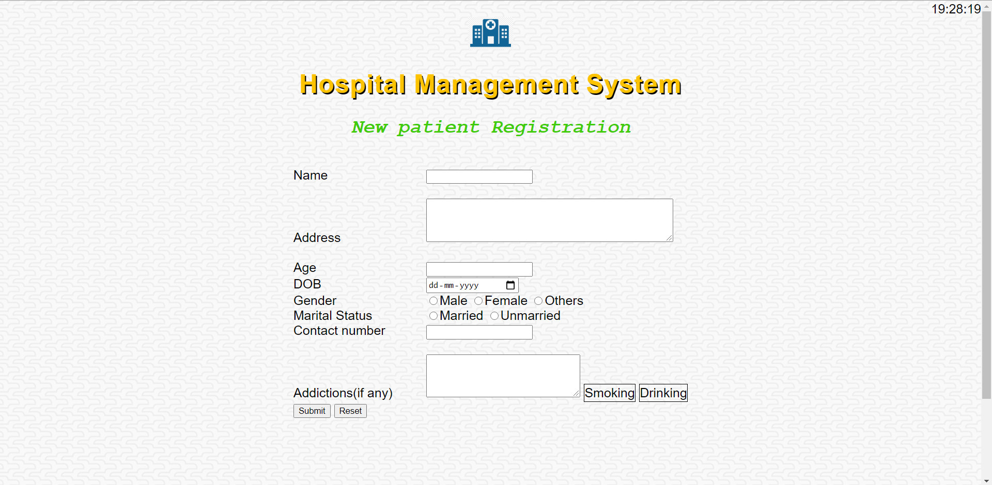

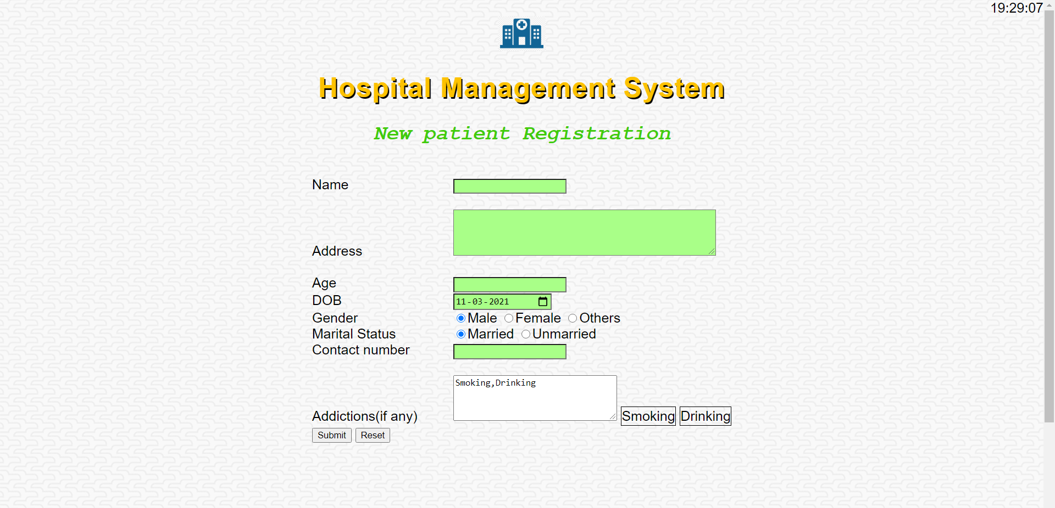

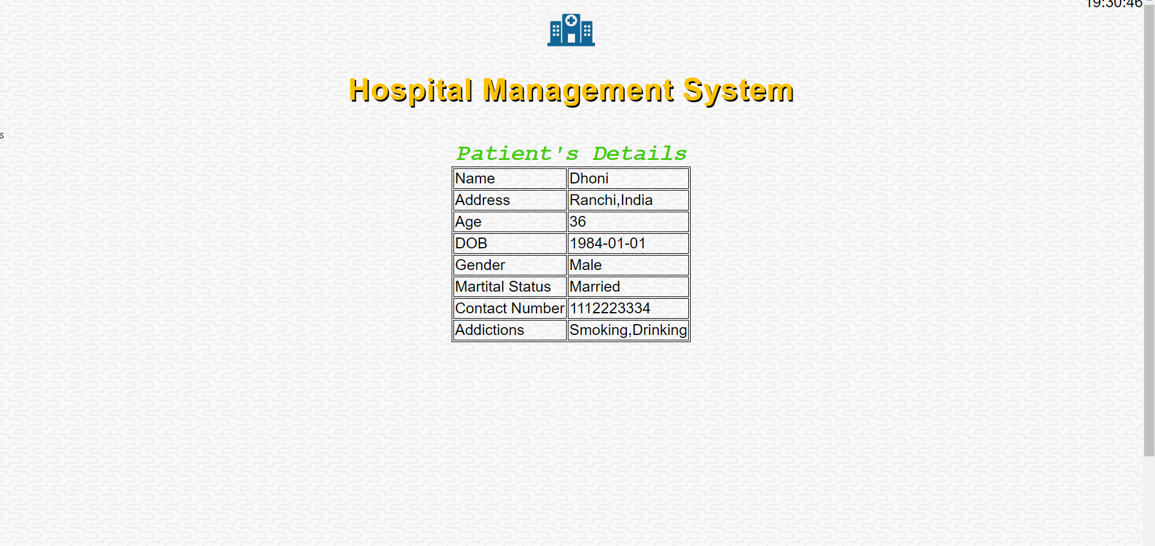

**Memory Game:**

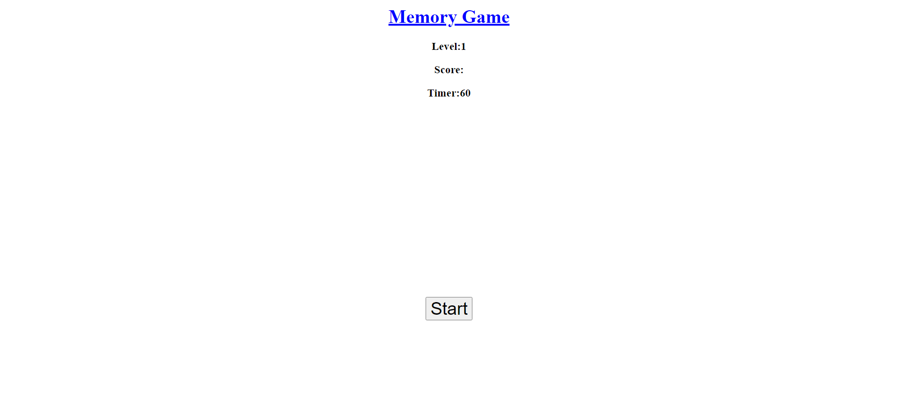

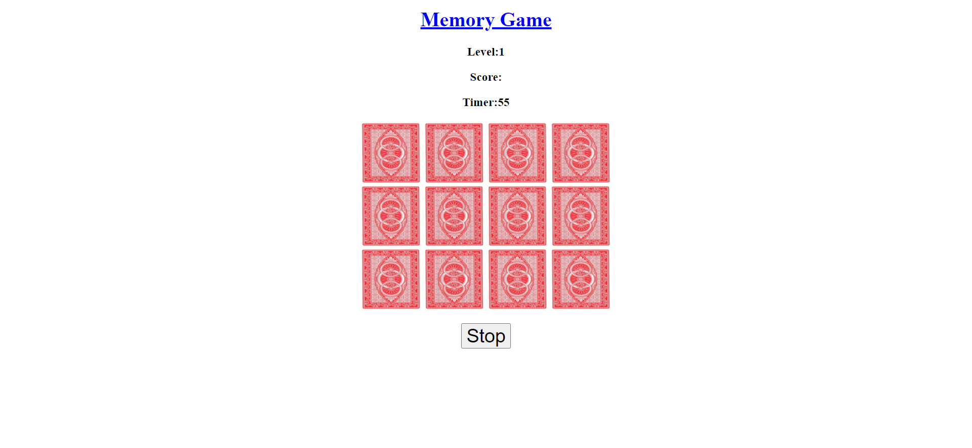

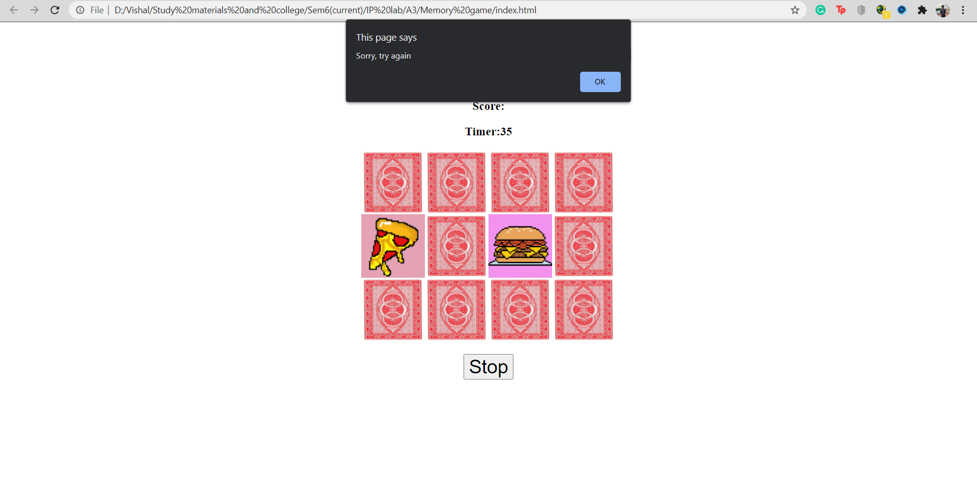

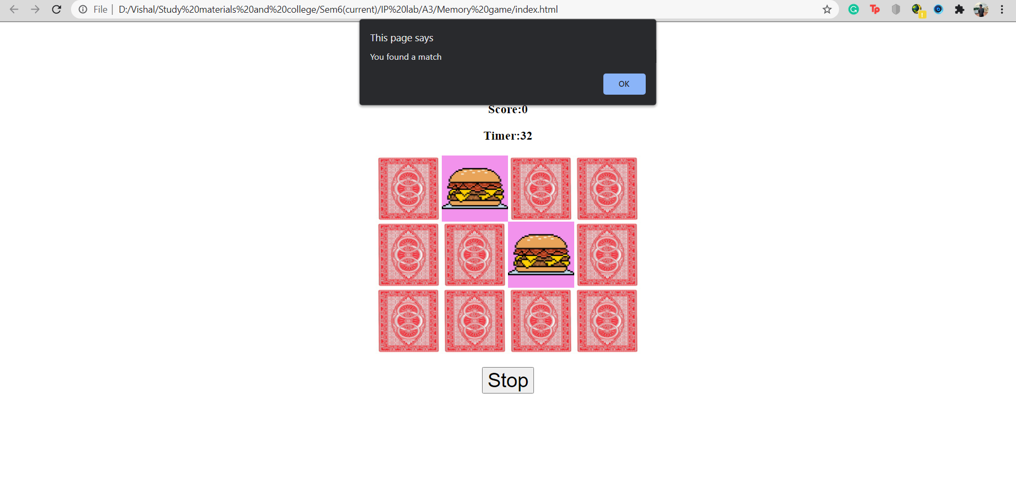

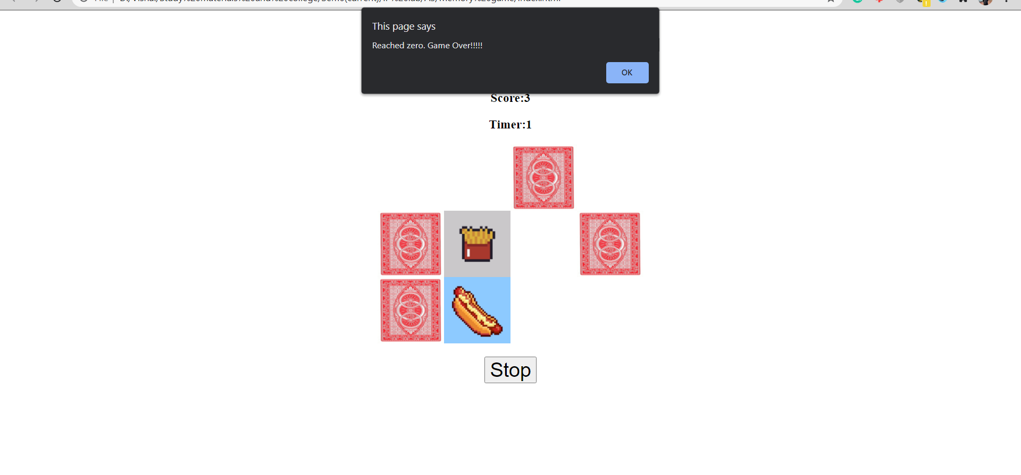

**Learning outcomes:**

* Learned to implement basic Javascript.
* Learned to use and implement various Javascript inbuilt functions.
* Learned to create and use user defined functions in Javascript.
* Learned to use Javascript for calculation, manipulation and validation of data.