***ASSIGNMENT 6***

***UCS 1601 – INTERNET PROGRAMMING***

**NAME: Vishal T**

**REG NUMBER: 185001199**

**DATE: 20/04/2021**

**Exercise 6: Autocomplete Feature using AJAX**

**SPECIFICATIONS:**

Develop an AJAX program that implements the Autocomplete feature for filling the country names as given below:



For Example, when N is entered all the names of the country starting with “N” should be listed in drop-down list for user’s easy selection. When “Na” is typed only “Namibia” and “Nauru” should be listed for selection. Use Servlet for server side scripting. Use MySQL database to store the countries names.

**HTML CODE:**

**index.html**

<!DOCTYPE html>

<html lang=en>

<head>

<meta charset ="utf-8">

<meta name="viewport" content="width=device-width, initial- scale=1,shrink-to-fit=no">

<title>Select Country</title>

<style>

body{

    text-align: center;

    justify-content: center;

    align-content:center;

    background-color: #fff34ee5

}

h1{

    text-align:center;

    font-size: 50px;

    color: rgb(0, 0, 0);

    margin-top:120px;

}

#selection{

    border: 4px dotted rgb(0, 0, 0);

    border-radius: 10px;

    text-align: center;

    justify-content: center;

    margin:auto;

    max-width: 650px;

    min-height: 200px;

    align-content:center;

}

#selection label{

    margin-top: 90px;

}

#selection input{

    margin-top: 90px;

    min-width: 400px;

}

</style>

</head>

<body>

<h1>Select the Country</h1>

<br><br><br>

<div id="selection">

<label for="country" style="color: rgb(0, 0, 0); font-size:30px;">Country &emsp;&nbsp;</label>

<input type="text" id="country" list="countries" onkeyup="getCountry()" /><datalist id ="countries">

</datalist>

</div>

<script>

function fetch(country){

var request = new XMLHttpRequest();

var URL = "country?country="+country;

request.onreadystatechange = function(){

    if(this.readyState == 4 && this.status == 200) {

    var val = request.responseText;

    console.log(val);

    document.getElementById("countries").innerHTML = val;

    }

};

request.open('GET', URL, true);

request.send();

}

function getCountry(){

var country = document.getElementById("country").value;

fetch(country);

}

</script>

</body>

</html>

**SERVLET CODE:**

**country.java**

import java.io.*;

import jakarta.servlet.*;

import jakarta.servlet.http.*;

import java.sql.*;

public class country extends HttpServlet{

public void doGet(HttpServletRequest request, HttpServletResponse response)

throws ServletException, IOException

{

    String JDBC_DRIVER = "com.mysql.jdbc.Driver";

    String DB_URL= "jdbc:mysql://localhost:3306/a6";

    String USER ="root";

    String PASS="db@321v";

try{

    response.setContentType("text/html");

    PrintWriter pw = response.getWriter();

    Connection conn = DriverManager.getConnection(DB_URL,USER,PASS);

    String country_name = request.getParameter("country");

    String search = "Select name from country_list where name like '"+country_name+"%' ;";

    Statement stmt = conn.createStatement();

    ResultSet rs = stmt.executeQuery(search);

while(rs.next()){

    String country = rs.getString("name");

    pw.println("<option name='"+country+"'>"+country+"</option>");

}

}catch(Exception E){

    E.printStackTrace();

}

}

}

**logout.java:**

import jakarta.servlet.*;

import jakarta.servlet.http.*;

import java.util.*;

import java.lang.*;

import java.io.*;

public class logout extends HttpServlet{

  public void doGet(HttpServletRequest request, HttpServletResponse response)throws ServletException, IOException{

    response.setContentType("text/html");

    PrintWriter pw = response.getWriter();

    pw.println("<html><head><meta charset='utf-8'><meta name='viewport' content='width=device-width, initial-scale=1, shrink-to-fit=no'>");

    pw.println("<title>Welcome</title>");

    pw.println("<style>h1{color:black; margin-left:auto; margin-right:auto; text-align:center; font-size: 1em; font-weight: bold;}</style></head>");

    pw.print("<body><h1>");

    HttpSession session = request.getSession(false);

    String user = (String)session.getAttribute("name");

    session.invalidate();

    pw.print("<center>....... Sucessfully Logged Out "+user+" ...........<center>");

    pw.print("</body></html>");

    pw.close();

  }

}

**XML CODE:**

**web.xml**

<web-app>

<servlet>

<servlet-name>Country</servlet-name>

<servlet-class>country</servlet-class>

</servlet>

<servlet-mapping>

<servlet-name>Country</servlet-name>

<url-pattern>/country</url-pattern>

</servlet-mapping>

</web-app>

**SNAPSHOTS:**

1. index

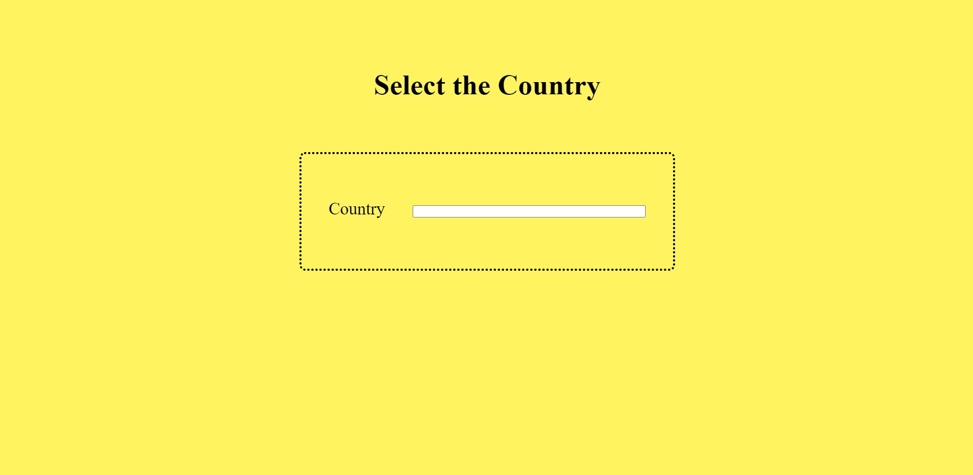

2. Getting suggestions

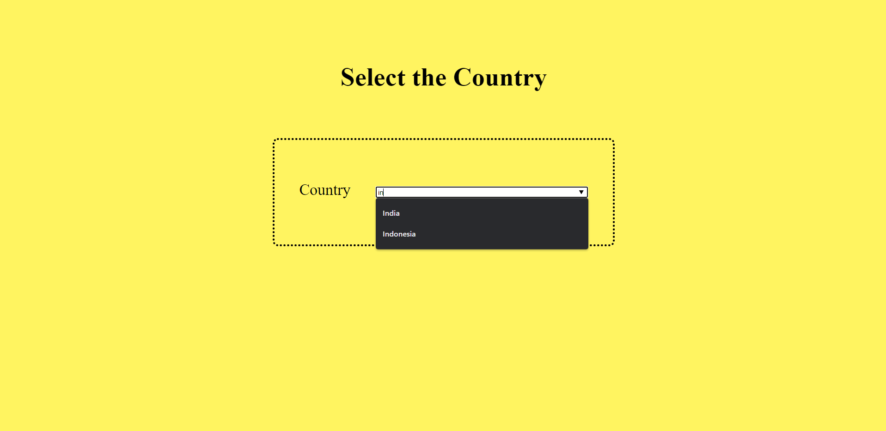

3. Database content

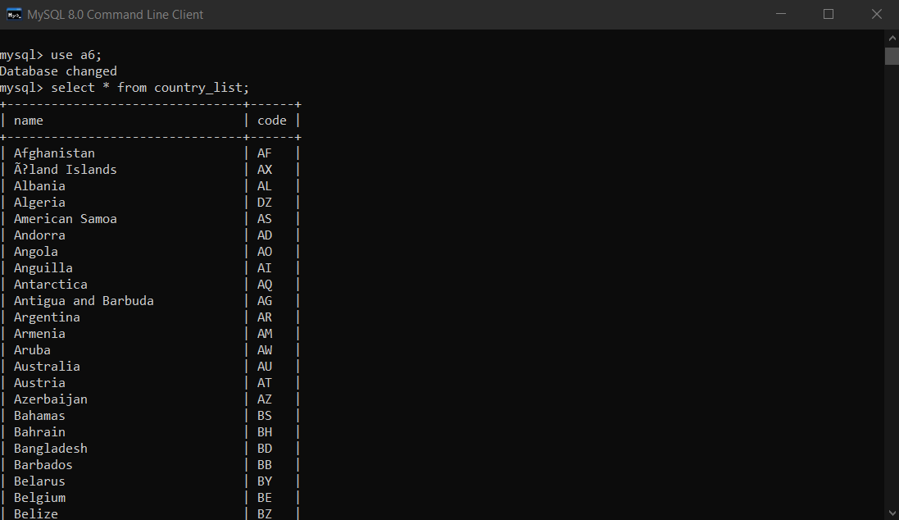

**Learning outcome:**

* Learned to implement Ajax with MySql in java servlets.
* Learned to create a suggestion list using Ajax.
* Learned about the working and functionality of Ajax.