***DATE : 28/04/2021***

**ASSIGNMENT 8**

**UCS 1601 – INTERNET PROGRAMMING**

**NAME** : Vishal T

**REGISTER NUMBER** : 18 5001 199

**Exercise 8: Programs using Node.js**

***SPECIFICATIONS:***

1. a. Write a Node.js program that reads all the greetings from the file greetings.txt, asks the user "What is your name?", then prints a random greeting followed by the given name. Make sure to check for the case where the file doesn’t exist! For example, if the greeting is "Hey", then the program will print "Hey, Joe" to the console, then pick some other greeting and do the same until finished. Use Non-blocking I/O.
2. b. Write a Node.js program that reads all the greetings as before. When all the greetings are loaded, it creates a server listening on port number 8080. On request, it checks for whether there is a name value in the query string. If there isn’t, the value of query.name will be undefined.

In other words, if you access http://localhost:8080/?name=Mike, then your browser should just display something like "Hello, Mike" when the page loads.

**greetings.txt**

Hello

Hey

Hi

What's up

Welcome

***CODE:***

***greet.js***

var fs = require("fs");

var readline = require("readline");

var rl = readline.createInterface({

  input: process.stdin,

  output: process.stdout

});

if(!fs.existsSync("greetings.txt")) {

  console.log("File not found");

  rl.close();

}

else {

  var greetingsFile = fs.readFileSync("greetings.txt");

  var greetings_string = greetingsFile.toString();

    var greetings = greetings_string.split("\n");

    rl.question("What is your name? ", function(name) {

       for(var i = 0; i < 1; i++) {

            var n = Math.floor(Math.random() * greetings.length);

          console.log(name+','+greetings[n]);

        }

        rl.close();

});

}

***greetser.js***

var http = require("http");

var fs = require("fs");

var url = require("url");

var greetings;

fs.readFile("greetings.txt", function(err, body) {

  if (err === null) {

    greetings = body.toString().split("\n");

    var server = http.createServer(function(req, res) {

      res.writeHead(200);

      var query = url.parse(req.url, true).query;

      var name = query.name;

      var greeting = greetings[Math.floor(Math.random() * greetings.length)];

      if (name) {

        res.end(greeting + ", " + name);

      } else {

        res.end(greeting);

      }

    });

    server.listen(8080);

  } else {

    console.log(err);

  }

});

***greetings.txt***

Hello

Hey

Hi

What's up

Welcome

***OUTPUT:***

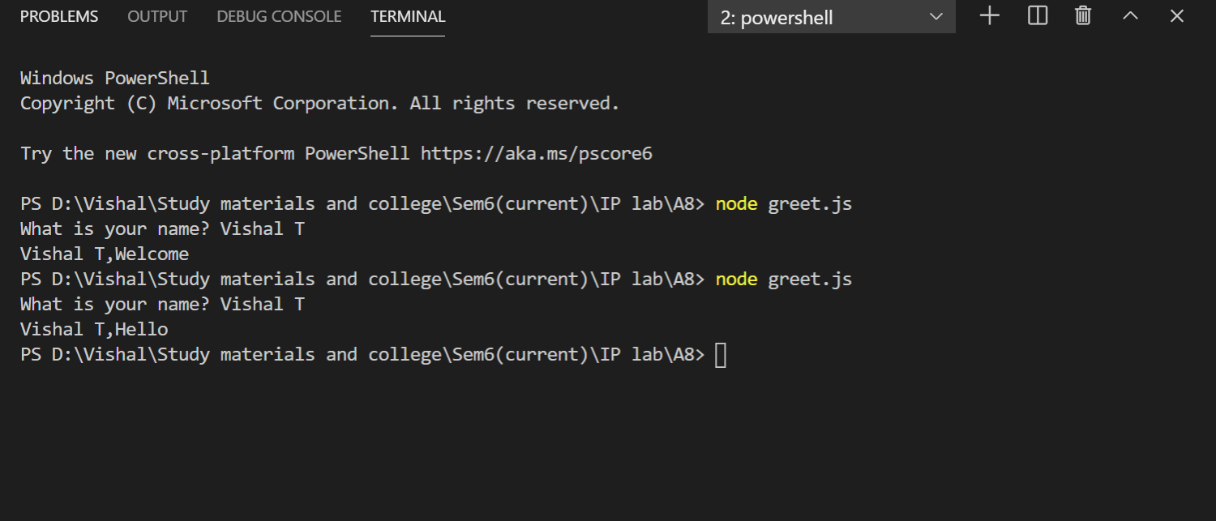

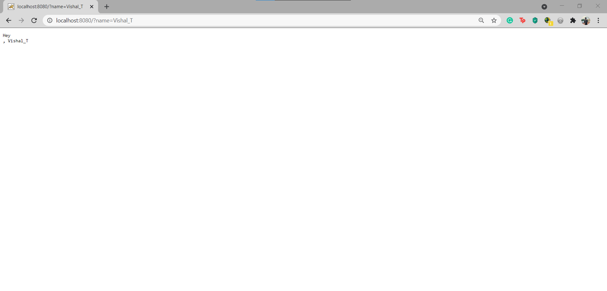

**Learning outcome:**

* Learned to implement javascript program in nodejs environment.
* Learned to read a file using fs module.
* Learned to create a server in nodejs environment.