Assessment (Week 4)

Student’s Full Name : Vishal Guddeti
Course Title : INFO 531 - Data Warehousing and Analytics in the Cloud
Term name and year : Summer 2024
Submission Week : Week 6- Assignment 4
Instructor’s Name : Dr.Nayem Rahman
Date of Submission : 28 August 2024

Question and Answers:

Q1. Create your Azure free account
Go to the address https://azure.microsoft.com/en-us/free/students/ and create a free Azure account using your university email address. Note that you do NOT need a credit card to create the account. If you find yourself entering your credit card information know that you are doing it wrong.

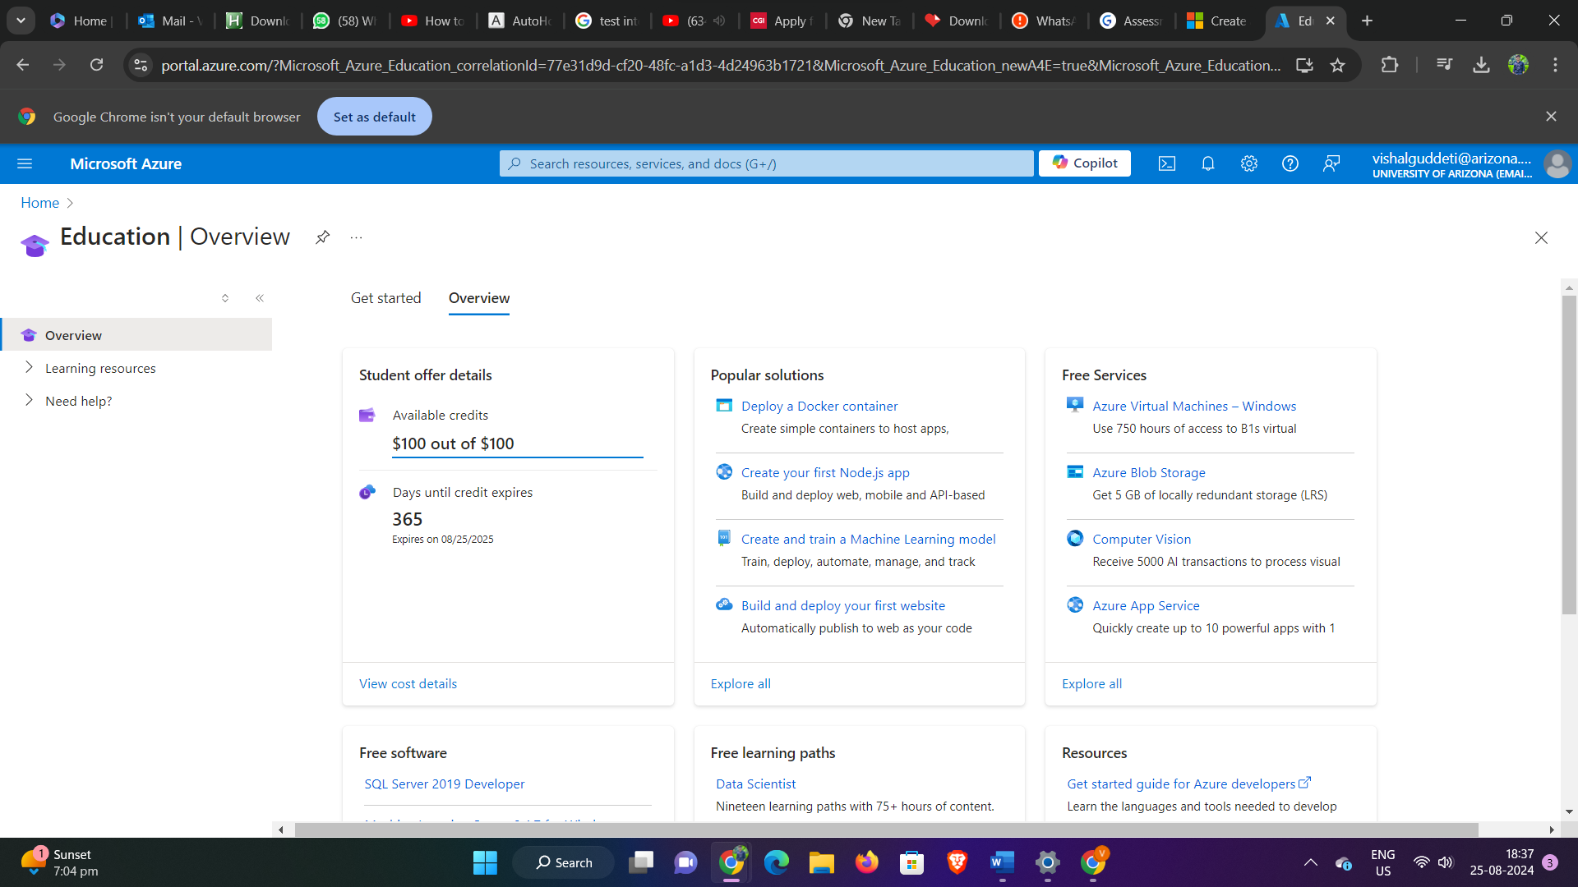

Q2. Create a container in Azure Storage, and to upload and download block blobs in that container.
Follow the instructions here to create a container in Azure Storage, and to upload and download block blobs in that container. https://learn.microsoft.com/en-us/azure/storage/blobs/storage-quickstart-blobs-portal Assumption: You already have an account using your university email address. Go to the portal and login.
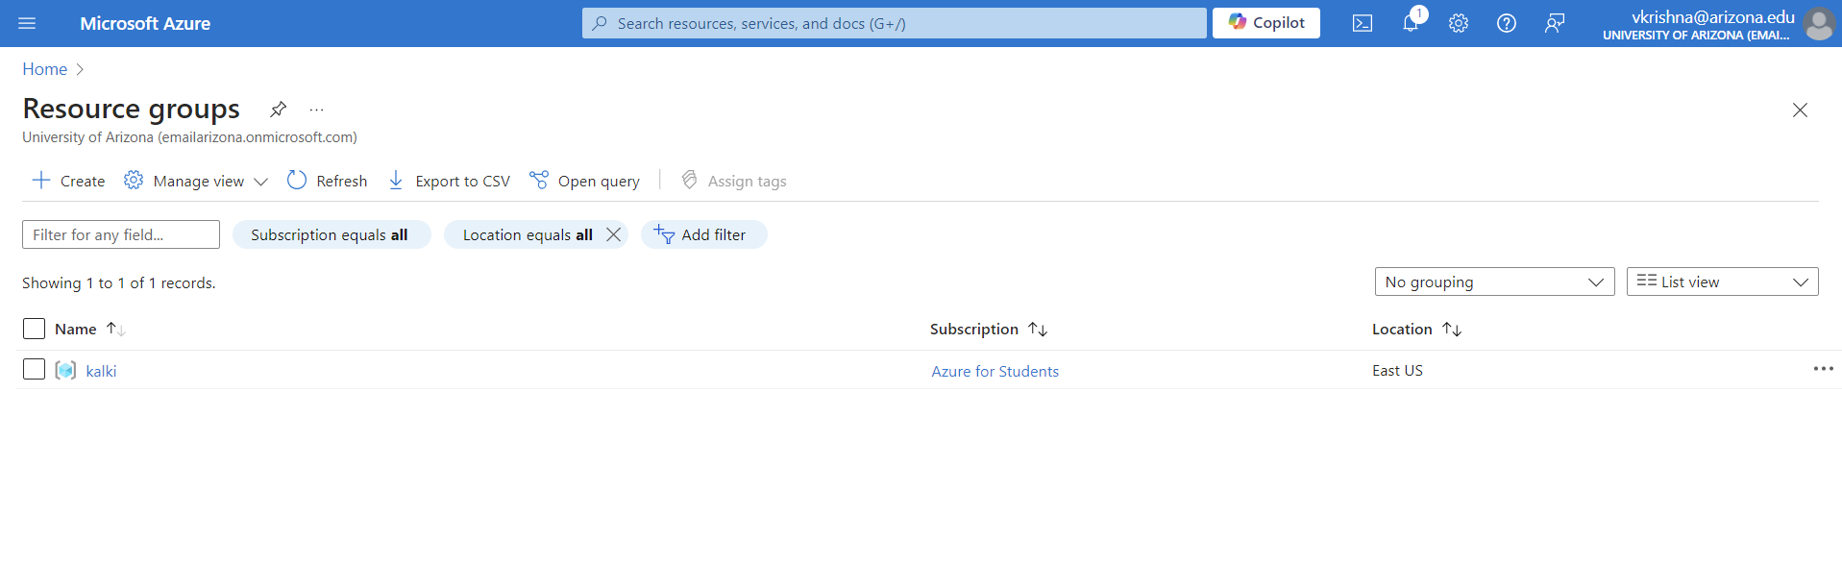
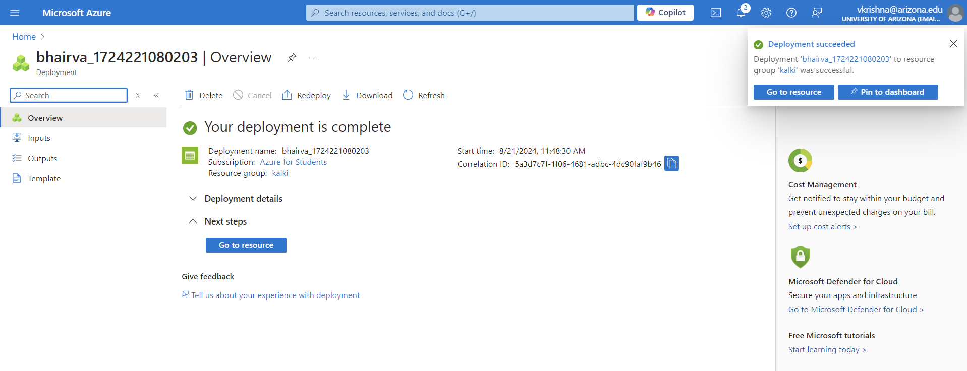
Q3. Create a SQL database on Azure
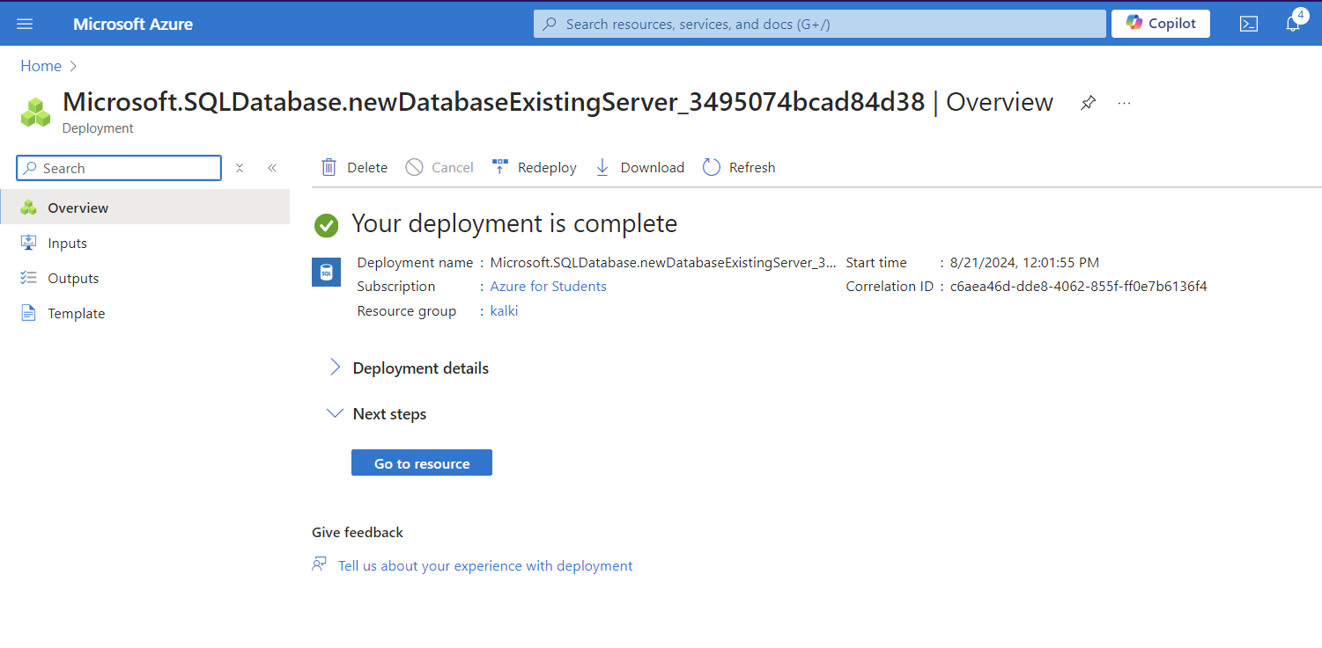
Q4. Summarize SQL database creation in Azure
Write in one or two paragraphs what you have done and learned by creating a single database - Azure SQL Database – in Azure Portal.
In creating an Azure SQL Database, I started by setting up a resource group to organize related
resources. Then, I created a storage container to manage data storage needs. Following that, I set up
a server, providing the necessary credentials to securely access the SQL database. This process
highlighted the importance of structuring resources effectively in Azure and ensuring proper security
configurations are in place for database access.
Q5. Query the SQL database in Azure
Query the database you created in Azure. You can use the Query editor (preview) in the Azure portal to connect to the database and query data. Run the following query in the query editor of the database on the Azure portal and take a screenshot of the result of the query. SELECT TOP 10 pc.Name as CategoryName, p.name as ProductName FROM SalesLT.ProductCategory pc JOIN SalesLT.Product p ON pc.productcategoryid = p.productcategoryid;
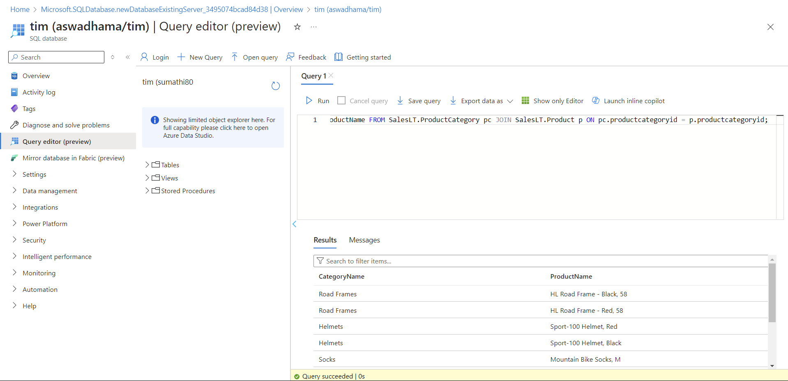

Q6. Describe the SQL database "SalesLT" on Azure.
Analyze data in the tables in the SalesLT database schema using the Azure Query editor. Identify the primary key (PK) columns, and different data types, and observe the relationships among these tables. Write at least one paragraph.
Using the Azure Query Editor to explore the SalesLT database schema helped me understand how the database is structured. I found that each table has a primary key (PK) column, which uniquely identifies each record. For example, in the `SalesLT.Customer` table, the primary key is `CustomerID`. The tables use a variety of data types, like integers for IDs, strings for names and descriptions, and datetime fields for dates and times. I also noticed how the tables are connected through relationships. For instance, the `SalesLT.SalesOrderHeader` table has a `CustomerID` column that links back to the `SalesLT.Customer` table, showing the connection between customers and their orders. These relationships help keep the data consistent and ensure everything is properly organized across the database. Overall, this exercise gave me a better understanding of how the data is stored and connected within the database.
Q7. Clean up resources in Azure
When you're finished using these resources, delete the resource group you created, which will also delete the blob storage, server and single database within it. Show the screenshot that you deleted the resource group.
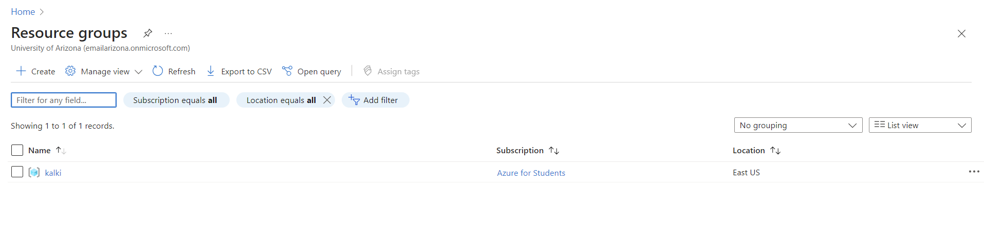
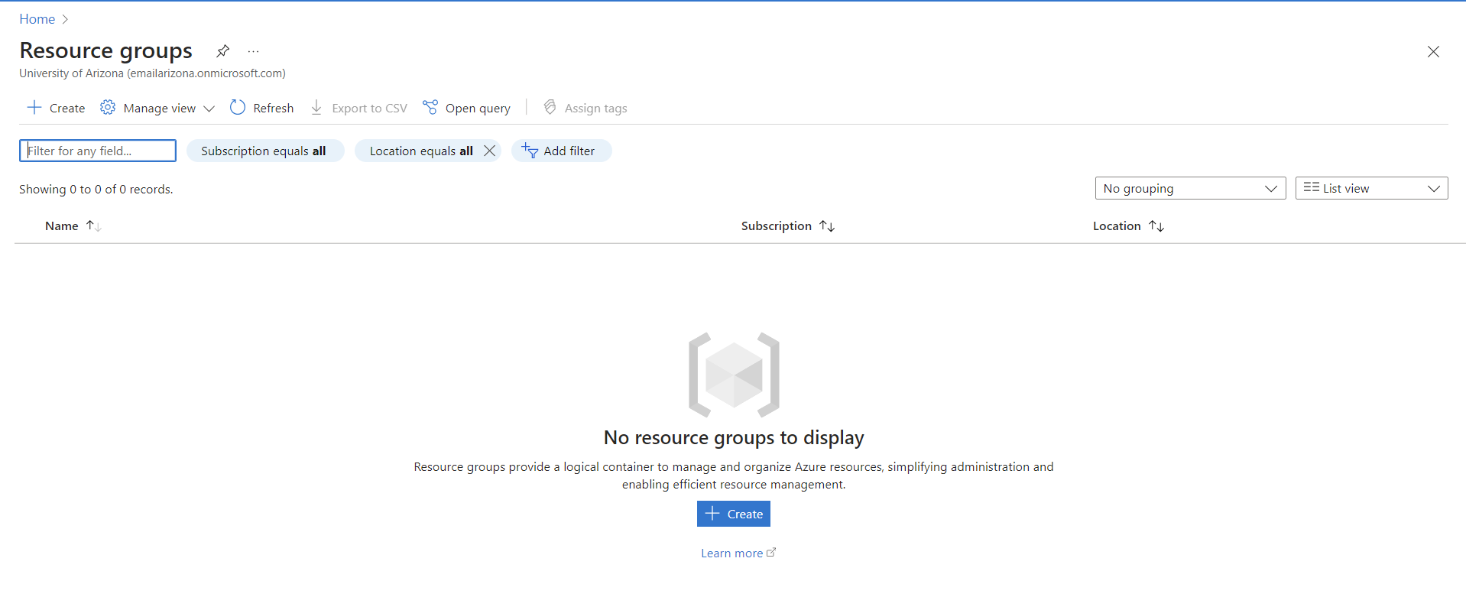
Q8. Summarize the article on "Understanding Data Store Models" . Link --> https://learn.microsoft.com/en-us/azure/architecture/guide/technology-choices/data-store-overview
The article "Navigating Data Storage Models" provides valuable insights into selecting the right data storage solution for diverse application needs. It highlights the importance of considering variables like data organization, query requirements, and scalability to inform decision-making processes effectively. Various data storage models, including relational databases, NoSQL databases, file-based storage, and in-memory data stores, are explored, each offering unique strengths and applications.
Moreover, the article emphasizes understanding the CAP theorem—consistency, availability, and partition tolerance—to empower readers in making informed choices within the Azure ecosystem. Data storage models are categorized into relational databases, non-relational databases, data warehouses, data lakes, and object storage.
Relational databases, such as SQL Server, are characterized by tabular structures with predefined schemas and relationships, optimized primarily for transactional workloads featuring ACID properties. Conversely, non-relational databases like Cosmos DB offer flexible schemas and horizontal scaling capabilities, accommodating semi-structured or unstructured data formats such as documents, keyvalue pairs, wide-column, and graphs.
Additionally, specialized solutions like data warehouses, exemplified by Azure Synapse Analytics, are designed for analytical tasks with features like columnar storage and parallel processing, serving as central repositories for business intelligence activities. Data lakes, such as Azure Data Lake Storage, store vast volumes of raw data in their native formats, awaiting processing for subsequent analysis.
Object storage solutions, typified by Azure Blob Storage, excel in storing extensive amounts of unstructured data like images, videos, and log files, accessible through REST APIs. Crucial factors for selecting a data storage solution include data structure, workload types, scalability, and consistency and availability requirements. Given the inherent trade-offs involved in data storage models, understanding specific use cases is paramount for making informed decisions.

Q9. Summarize the article on "Understanding the differences between NoSQL and relational databases". Link --> https://learn.microsoft.com/en-us/azure/cosmos-db/relational-nosql
The article "Exploring NoSQL vs. Relational Databases" offers a comprehensive comparison between two prominent database types: NoSQL and relational databases. It elucidates that relational database, such as SQL Server and Oracle, adhere to structured, tabular formats characterized by predefined schemas and relational connections, governed by ACID principles. Conversely, NoSQL databases like MongoDB and Cassandra are recognized for their flexibility and scalability, often accommodating schema-less or semi structured data.
Key disparities outlined in the article encompass data modelling, scalability options, and consistency models. Relational databases excel in managing intricate queries, ensuring robust consistency, and facilitating transactions. In contrast, NoSQL databases are celebrated for their simplicity in design, horizontal scalability, and expedited queries for expansive data sets. NoSQL databases encompass diverse types such as document, key-value, wide-column, and graph databases, whereas relational databases organize data into tables.
Moreover, the article underscores that NoSQL databases lack a declarative query language akin to SQL, focusing queries on collections of documents rather than relational entities. Relational databases adhere to ACID properties to guarantee reliability, while NoSQL databases conform to the BASE model (Basically Available, Soft state, Eventual consistency). The adaptability of schemas, scalability approaches, and agility in meeting application requirements are highlighted as NoSQL databases' strengths, juxtaposed with the upfront schema design prerequisites and vertical scaling on costly servers associated with relational databases. Ultimately, the selection between NoSQL and relational databases hinges on the specific use case and data requisites, with NoSQL presenting superior scalability and flexibility, while relational databases offer robust consistency and support for intricate queries.
Q10. Summarize the article on "Understanding Azure Cosmos DB". Link --> https://learn.microsoft.com/en-us/azure/cosmos-db/introduction
The article discussing "Understanding Azure Cosmos DB" presents a user-friendly exploration of Azure's widely adaptable and globally dispersed database service, Cosmos DB. It introduces pivotal aspects such as global distribution, enabling users to deploy databases across multiple regions, thereby enhancing performance and accessibility. Highlighting Cosmos DB's versatility, the article underscores its support for diverse data models, encompassing document, key-value, graph, and column-family structures, effectively catering to a myriad of application requirements. It introduces the notion of containers for data storage, accompanied by insights into automatic indexing and scaling functionalities. Additionally, it briefly addresses consistency models, affording users the flexibility to opt between strong and eventual consistency, aligning with their specific application needs. Essentially, the article stands as an essential resource for users aiming to grasp the core principles and functionalities of Azure Cosmos DB for constructing contemporary and scalable applications.
Azure Cosmos DB emerges as Microsoft's globally distributed, schema-agnostic database service, furnishing horizontally scalable capabilities to manage extensive data and traffic proficiently. Supporting a diverse array of data models, including document, key-value, wide-column, and graph structures, Cosmos DB offers configurable consistency levels such as strong, bounded-staleness, session, consistent prefix, and eventual, ensuring tailored performance. Guaranteeing swift singledigit millisecond response times at the 99th percentile, Cosmos DB facilitates automatic indexing of data, eliminating the need for manual schema or index management. The service provides userfriendly SQL and JavaScript query APIs, supplemented by SDKs for prevalent languages, and features multi-homing capabilities for ensuring high availability and low latency access from any location.
With data replication across multiple Azure regions, Cosmos DB ensures high availability, seamlessly managing scaling, failovers, and redundancy. Its applications span diverse sectors, encompassing web, mobile, gaming, and IoT domains, necessitating a responsive, always-on database service. Furthermore, backends for AI and machine learning applications can leverage Cosmos DB's schemaless architecture and expedited query capabilities, accentuating its versatility and applicability across a broad spectrum of use cases.

Q11. Summarize the article on "Azure Cosmos DB API for MongoDB". Link --> https://learn.microsoft.com/en-us/azure/cosmos-db/mongodb/mongodb-introduction
The article on "Leveraging Azure Cosmos DB API for MongoDB" provides insight into how developers can seamlessly interact with MongoDB databases using Azure Cosmos DB. It emphasizes the effortless migration process, allowing existing MongoDB applications to transition to Azure Cosmos DB without requiring code modifications. Key features like automatic scaling, global distribution, and multi-region failover for improved availability and low-latency access are highlighted. The article also explains the mapping of MongoDB entities to Cosmos DB's data model, emphasizing its support for multiple data models. Essentially, it acts as a developer guide for harnessing Azure Cosmos DB's MongoDB API for a globally distributed and highly scalable database solution.
Azure Cosmos DB, Microsoft's globally distributed, multi-model database service, offers support for various APIs, including the MongoDB API, ensuring compatibility with MongoDB client drivers and tools. The MongoDB API enables seamless interaction between existing MongoDB applications and Azure Cosmos DB, leveraging features such as global distribution, automatic sharding, availability SLAs, encryption at rest, and backups.
The MongoDB API integrates smoothly with popular MongoDB client drivers like Node.js, Python, Java, and .NET. Developers can utilize their existing MongoDB application code and tools with minor configuration adjustments to connect to Cosmos DB. Cosmos DB ensures wire protocol level compatibility with MongoDB server versions 3.2, 3.6, 4.0, and 4.2, supporting most CRUD operations, indexing, aggregation, and other commands.
While offering a straightforward migration path, the MongoDB API may not support certain MongoDB features such as multi-document ACID transactions due to Cosmos DB's native support for single-document level transactions. Other unsupported features include server-side JavaScript execution and mapReduce aggregations. Nonetheless, the MongoDB API streamlines the process for MongoDB apps to leverage the scalability, availability, global distribution, and other benefits of Cosmos DB, with wire protocol compatibility aimed at minimizing code adjustments.

Q12. Summarize the article on "Nodes and tables in Azure Database for PostgreSQL – Hyperscale". Link --> https://learn.microsoft.com/en-us/azure/postgresql/hyperscale/concepts-nodes
The article discussing "Nodes and Tables in Azure Database for PostgreSQL – Hyperscale" delves into the core concepts of the Hyperscale deployment option within Azure's PostgreSQL database service. It introduces two crucial components: coordinator nodes, responsible for query management, and worker nodes, handling data storage and processing. The article emphasizes the distribution of tables across these nodes, facilitated by a sharding mechanism that horizontally partitions tables for parallel processing, ultimately enhancing performance and scalability. In simpler terms, it provides insights into the architecture enabling the efficient management of large-scale PostgreSQL databases in a distributed and scalable manner.
Azure's PostgreSQL database service - Hyperscale employs a distributed architecture with multiple nodes to ensure scalability. Tables are distributed across nodes using a hash distribution algorithm. Nodes are dynamically added or removed from a Hyperscale server group based on workload demands to optimize performance.
Each node serves as a coordinator, executing queries and transactions while holding a subset of the data. Queries are parallelized across nodes to improve processing efficiency. Tables are distributed using a hash distribution key, where the distribution column determines which node stores specific rows of a table.
Choosing the appropriate distribution key is vital for optimizing performance, as it facilitates the co-location of related data on the same nodes. Distribution keys can be set at the database or table level, with tables inheriting the database distribution key by default if not specified.
Hyperscale aims to co-locate joined tables on the same nodes, reducing data movement for queries. The distribution strategy should align with common join operations. Additionally, replica tables are created on nodes to ensure redundancy and high availability. In case of node failure, replicas on other nodes ensure continued access to the data.

Q13. Summarize the article on "Overview - Azure Database for PostgreSQL - Flexible Server". Link --> https://learn.microsoft.com/en-us/azure/postgresql/flexible-server/overview
The "Azure Database for PostgreSQL - Flexible Server Overview" article introduces a dynamic Azure service tailored for deploying and managing PostgreSQL databases via a flexible server configuration. It highlights essential features such as flexibility, security, and performance, demonstrating Azure's streamlined management experience with automated backups, scalable options, and intelligent performance tuning.
The article explores the flexible server deployment model, covering server configuration, storage, and networking aspects, while also addressing secure database connections and access control management. Overall, it offers a comprehensive understanding of Azure's PostgreSQL - Flexible Server, emphasizing its adaptability and robust management capabilities within the Azure cloud environment.
Azure's Database for PostgreSQL - Flexible Server is a fully managed database service designed specifically for running and scaling PostgreSQL databases in Azure. It provides built-in high availability, automatic backups, security features, and automated maintenance tasks.
Flexible Server allows for independent scaling of compute and storage resources, enabling users to adjust vCores and storage capacity as needed through the Azure portal. The service offers automatic backups with point-in-time restore capabilities for up to 35 days, with configurable backup retention and storage in geo-redundant storage.
Security features include VNet service endpoints, private IP addresses, and enforcement of TLS connections. Authentication and authorization can be managed using Azure AD and RBAC. Monitoring and alerting capabilities are available through Azure Monitor, VM insights, and logs, with Query Store facilitating query performance monitoring.
Maintenance tasks include automatic minor version upgrades, security patches, and Azure-initiated maintenance events, ensuring minimal planned maintenance downtime. Flexible Server supports PostgreSQL versions 11, 12, and 13, along with various extensions like PostGIS and pg_cron.
Pricing is based on vCore compute tiers, provisioned storage amounts, and backup retention days, allowing for cost optimization through appropriate resource scaling based on usage requirements.

Q14. Summarize the article on "Azure Database for PostgreSQL - Single Server". Link--> https://learn.microsoft.com/en-us/azure/postgresql/single-server/concepts-servers
The "Azure Database for PostgreSQL - Single Server" article offers a comprehensive guide to deploying and managing PostgreSQL databases in a single-server configuration on Azure. It covers foundational concepts such as server configuration, storage considerations, and networking aspects in detail. The article underscores the importance of understanding server parameters to achieve optimal performance and addresses critical topics like server security, including firewall rules and authentication methods for securing database connections.
Overall, it serves as a detailed resource for users aiming to efficiently deploy, configure, and secure PostgreSQL databases within the Azure environment.
Azure Database for PostgreSQL provides a fully managed PostgreSQL database service on Azure, with the single-server deployment option offering a highly available PostgreSQL database server managed entirely by Azure. Users can choose from different service tiers such as Basic, General Purpose, and Memory Optimized, each offering varying levels of vCores, memory, storage, and backup retention days. Pricing follows a pay-as-you-go model based on the selected tier and provisioned compute.
Azure handles various tasks such as patching, backups, upgrades, and ensuring high availability, thereby relieving users from managing the underlying infrastructure. Databases within the server are accessible through a connection string and can be administered using tools like psql or PgAdmin, with data stored in Azure storage featuring three locally redundant copies.
Security features include firewall rules, SSL connections, Azure AD integration, auditing, and threat detection. Backups support point-in-time restore, and the service guarantees high availability with a 99.99% uptime SLA. Scaling can be achieved by changing service tiers, and read replicas can be created for read-heavy workloads.
Additionally, the service provides monitoring and alerting capabilities, offering metrics for resource usage, connections, storage, and performance that users can visualize for troubleshooting purposes.

Q15. Summarize the article on "What is Azure Database for PostgreSQL?". Link --> https://learn.microsoft.com/en-us/azure/postgresql/single-server/overview
The "Azure Database for PostgreSQL: An Overview" article acts as a beginner's guide to Azure's service aimed at deploying and managing PostgreSQL databases within a single-server framework. It outlines core features like high availability, security, and scalability, emphasizing Azure's user-friendly management interface. The article delves into the architecture of a PostgreSQL single-server deployment, discussing server configuration, storage, networking, and methods for secure database access and access control management. Overall, it provides a comprehensive overview for users looking to understand the basics of Azure Database for PostgreSQL, facilitating the deployment and maintenance of PostgreSQL databases in the Azure cloud environment.
Azure Database for PostgreSQL is a relational database service in Azure that utilizes the open-source PostgreSQL database engine. It is a fully managed service handling critical functions such as patching, backups, monitoring, and security. The service ensures built-in high availability, intelligent performance tuning, and security features, aiming to achieve 99.99% availability. Database servers operate on Azure virtual machines with SSD-based local storage for enhanced performance, with compute and storage resources capable of independent scaling.
Azure Database for PostgreSQL supports various features, including JSON, spatial indexes, PostGIS, and stored procedures, and it remains compatible with PostgreSQL community editions. The service offers three pricing tiers - Basic, General Purpose, and Memory Optimized - each varying in vCores, memory, storage size, and advanced features. Key benefits highlighted include no infrastructure management, high availability, elastic scaling, intelligent performance tuning, security features, and enterprise-grade SLAs. Use cases mentioned range from modern cloud-native apps to the migration of on-prem apps, periodic analytics, and hybrid scenarios extending on-prem PostgreSQL deployments.

Q16. Summarize the article on "Azure Database for MySQL - Flexible Server". Link --> https://learn.microsoft.com/en-us/azure/mysql/flexible-server/overview
The article on "Azure Database for MySQL - Flexible Server" introduces a robust and dynamic service on the Azure platform tailored for deploying and managing MySQL databases. It highlights key features such as flexibility, security, and performance, emphasizing Azure's streamlined management experience. The article extensively covers the flexible server deployment model, providing insights into server configuration, storage, and networking aspects. It also details secure database connections and access control management. Notably, it highlights the architectural flexibility of the server, allowing users to customize parameters and utilize features like automatic and manual backups based on their specific needs. Overall, the article serves as a valuable guide for those seeking a versatile and customizable solution for MySQL databases within the Azure cloud.
Azure Database for MySQL - Flexible Server is a fully managed database service known for its flexibility and customization options, built on the MySQL community edition. Users can tailor compute and storage, backup retention, server version, high availability, and network isolation, providing more control compared to other Azure MySQL offerings. The service ensures rapid provisioning and auto-scaling of compute and storage, with high availability through zone-redundant deployments. Automated backups with point-in-time restore capabilities enhance data protection for up to 35 days.
Security features such as SSL/TLS connectivity, firewall rules, and virtual network integration contribute to a secure database environment. Monitoring and alerting capabilities are included for effective performance tracking. Users can stop and start the server, optimizing costs based on usage patterns. Various pricing tiers are available based on factors like vCores, storage type/amount, and high availability. The service supports MySQL versions 5.7 and 8.0, seamlessly integrating with other Azure services for enhanced security, monitoring, and deployment capabilities.

Q17. Summarize the article on "Azure Database for MySQL Single Server". Link --> https://learn.microsoft.com/en-us/azure/mysql/single-server/single-server-overview
The article on "Azure Database for MySQL Single Server" provides an accessible introduction to the Azure service, enabling users to deploy and manage MySQL databases in a single-server setup. It highlights key features such as high availability, security, and scalability, showcasing Azure's simplified database management with automated backups, scaling options, and performance tuning. The article comprehensively covers the components of a MySQL single-server deployment, elucidating server configuration, data storage, and networking aspects. Additionally, it details secure database connections and access control through firewall rules and authentication methods. Overall, the article serves as a helpful guide for individuals seeking a foundational understanding of deploying and maintaining MySQL databases in Azure's cloud environment.
Azure Database for MySQL Single Server is a fully managed database service powered by the MySQL community edition database engine, handling critical database management functions like patching, backups, upgrades, and high availability.
The service offers built-in high availability at no additional cost, utilizing SSD storage with automatic replication to a secondary server. Users can easily scale compute and storage resources up or down without application downtime, with computing resources scaling up to 32 vCores and storage up to 16TB.
Security features include SSL/TLS connectivity, firewall rules, virtual network service endpoints, and encryption at rest using Azure Storage Service Encryption. Azure guarantees an availability SLA of 99.99% for single servers, with additional capabilities such as point-in-time restore, georestore, and geo-replication for enhanced continuity. Monitoring and alerting are available through Azure Monitor, tracking various metrics such as storage, connections, queries, and cache hits. Automatic backups are enabled by default, with configurable backup retention ranging from 7 to 35 days. Users can also set up scheduled backups. Supported MySQL versions include 5.6, 5.7, and 8.0, and migration to Azure Database for MySQL is simplified through the Azure Database Migration service.

