Data Sets:

* causes-of-death-in-children
* child-deaths-by-age
* child-deaths-from-malaria-number
* neonatal-deaths-by-cause

**Problem Statement:**

Welcome to our Analysis !

First we analyzed the leading cause of death across the globe.

**Our Key Findings:**

* Lower respiratory infections
* Diarrheal diseases
* Neonatal preterm birth defects
* Congenital birth defects
* Malaria etc.

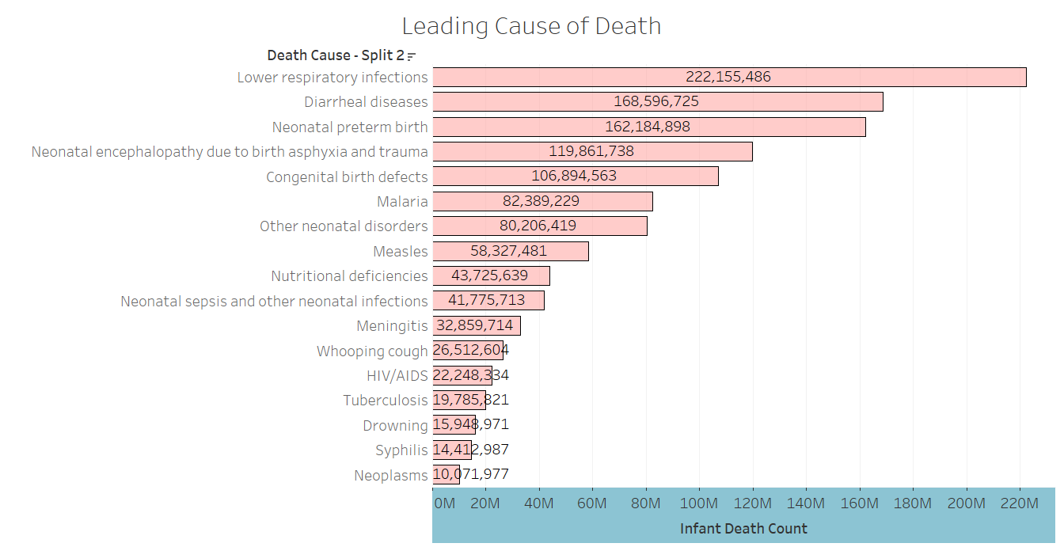

We also analyzed the leading cause of death nationally in United States

**Our Key Findings:**

* Neonatal preterm birth defects
* Congenital birth defects
* Lower respiratory infections
* Diarrheal diseases

We can observe lower rates in Malaria and Lower respiratory infections due to hygiene standards maintained in US.

But death cause like Neonatal preterm births and Congenital birth defects do not seem to reduce

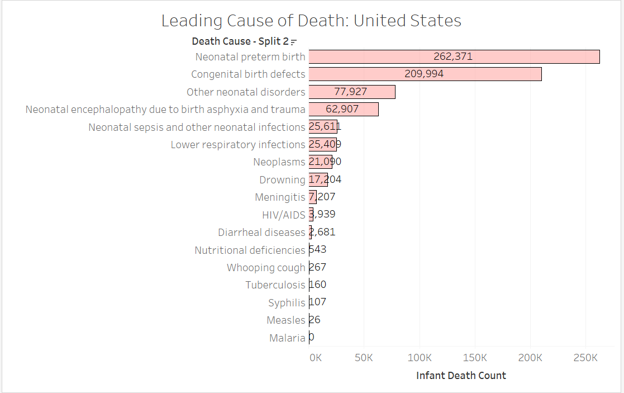

The lack of reduction in death causes like Neonatal preterm births and Congenital birth defects in the United States could be influenced by several factors:

Improved Detection and Reporting: With advancements in medical technology and healthcare infrastructure, there might be better detection and reporting of such conditions, leading to apparent increases in reported cases over time.

* **Changes in Diagnostic Criteria:** Changes in diagnostic criteria or classification systems over the years could also contribute to the observed trends. What might have been classified differently in the past could now be categorized under Neonatal preterm births and congenital birth defects.
* **Demographic Changes**: Shifts in demographics, such as changes in birth rates or maternal age, can impact the prevalence of certain conditions. For example, an increase in the average maternal age could be associated with a higher incidence of congenital birth defects.
* **Access to Healthcare:** Disparities in access to healthcare services, particularly among marginalized or underserved populations, can affect the detection and management of conditions related to neonatal health and congenital defects.
* **Environmental Factors:** Environmental factors, including exposure to toxins or pollutants, maternal health during pregnancy, and lifestyle factors, can influence the occurrence of congenital defects and preterm births.
* **Genetic Predisposition:** Some congenital defects have a genetic basis, and changes in the prevalence of certain genetic traits within the population could impact the frequency of these conditions over time.

Understanding these factors and conducting further research into the underlying causes can help inform public health policies and interventions aimed at reducing the incidence of neonatal preterm births and congenital defects.

Next we visualized globally effected areas with respect to infant deaths and found out that many densely populated countries.

Our Key findings (highly effected countries):

* China (Effected with highly with Respiratory, Diarrhea and Malaria due to high population and bad hygienic condition due to bad infrastructure development)
* India (Effected with highly with Respiratory, Diarrhea and Malaria due to high population and bad hygienic condition due to bad infrastructure development)
* Ethiopia
* Nigeria
* United States (National)

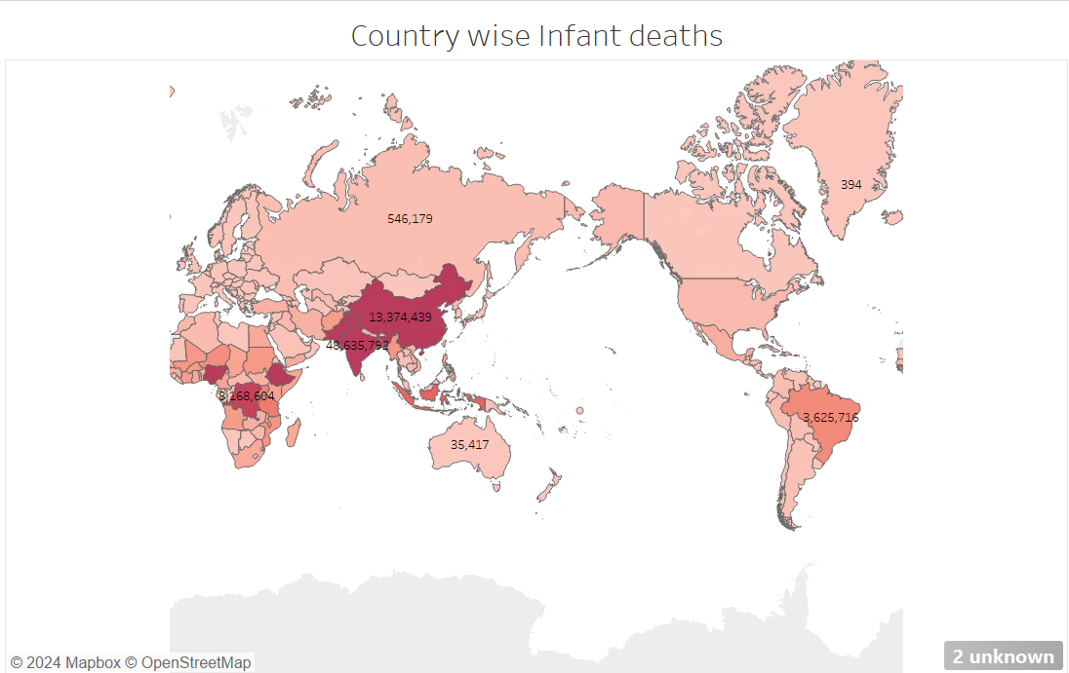

To analyze further we discovered leading cause of infant death in the World.

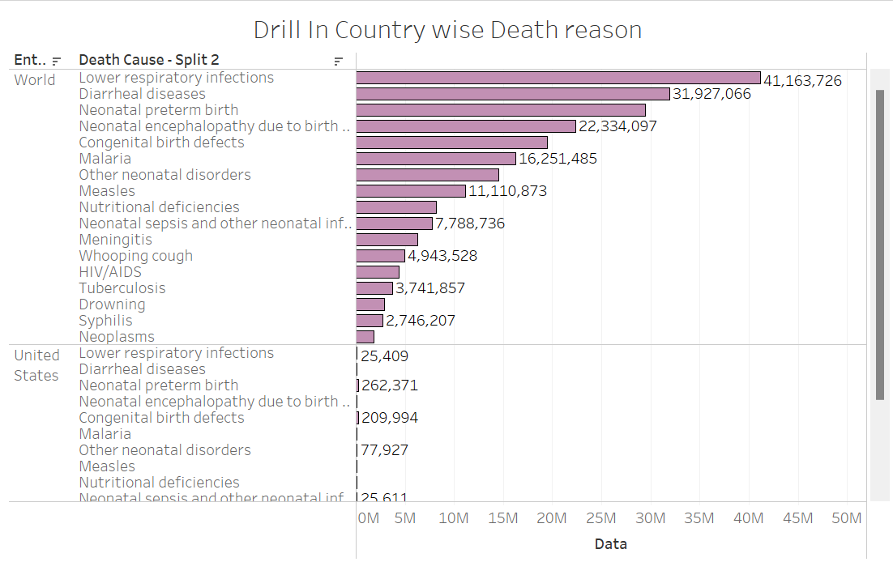

Age wise death:

Indicating highest deaths for infants and the next one being senior citizens who are above 70 years of age.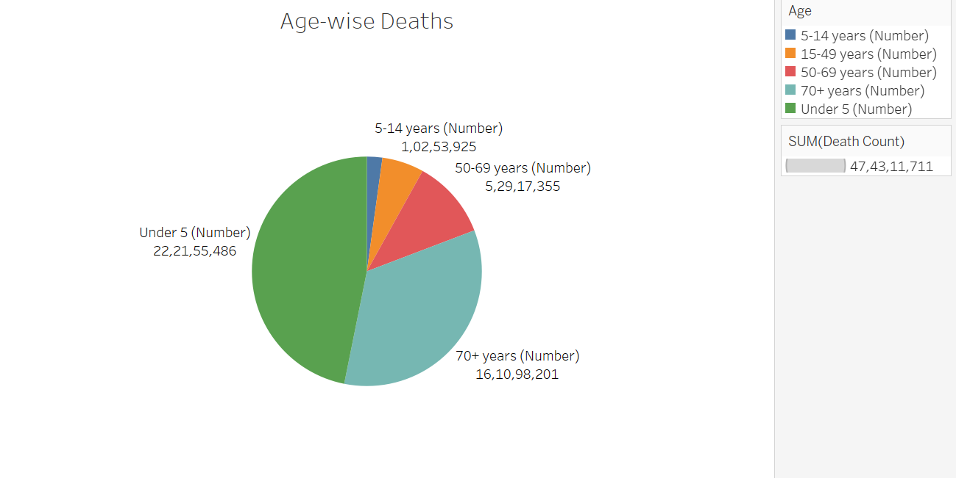

Let’s dive into trend of diseases in United States:

Congenital birth defects and neonatal defects do not seem to reduce drastically.

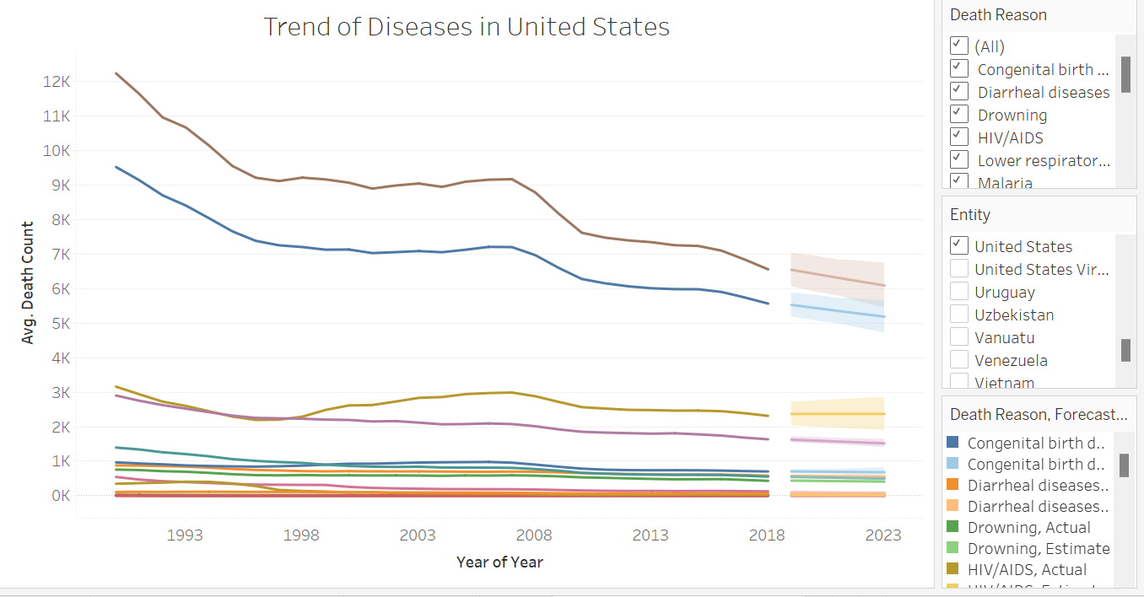

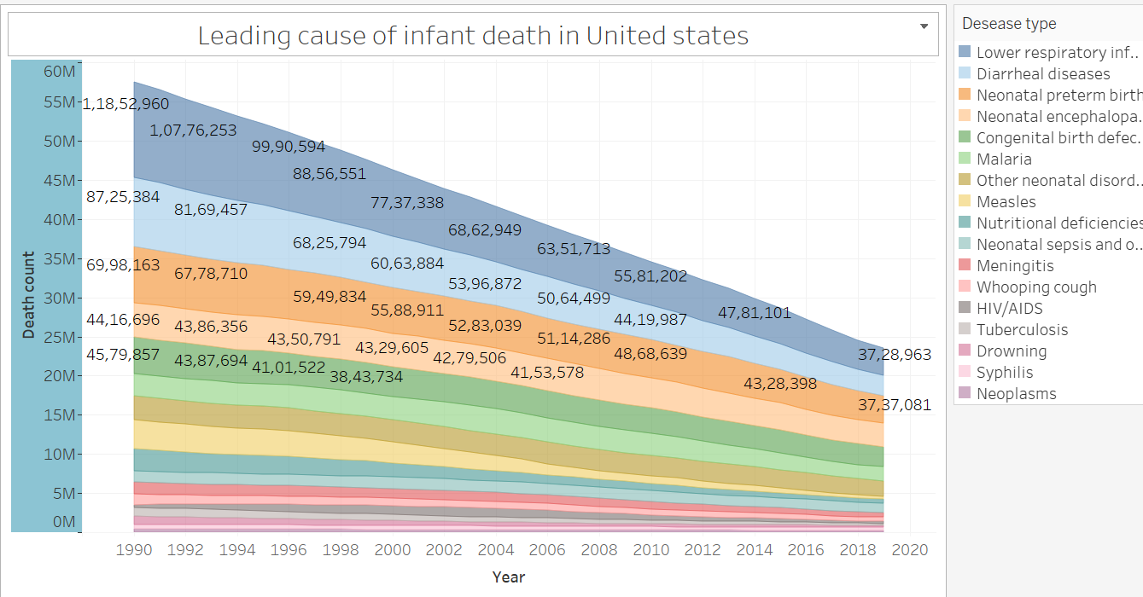

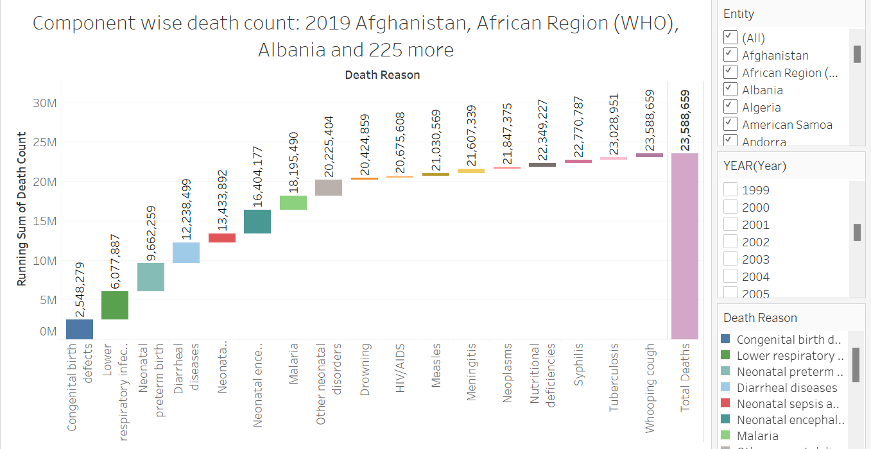 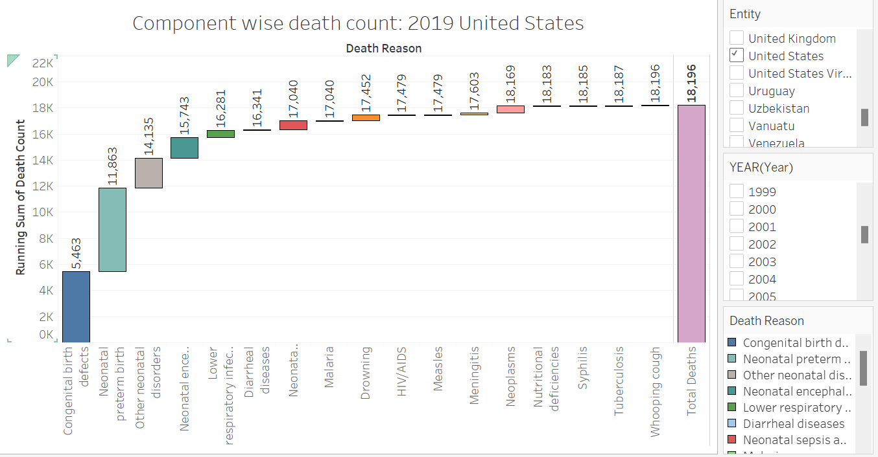

Lets dive into statisitcs

Time Series for United States Congential

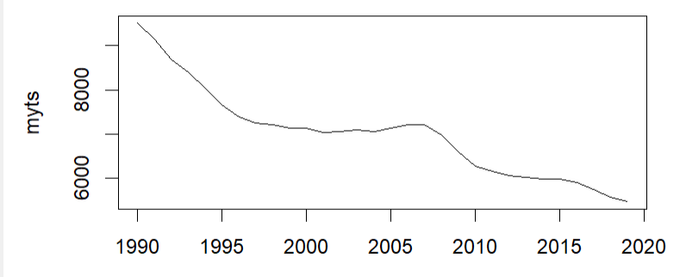

Acf to compare death of infants in time lags to current time period

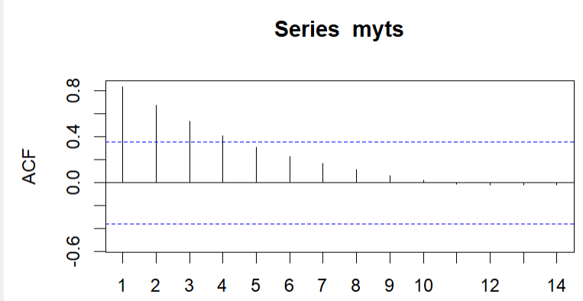

This suggests a reducing trend in data with reducing correlation.

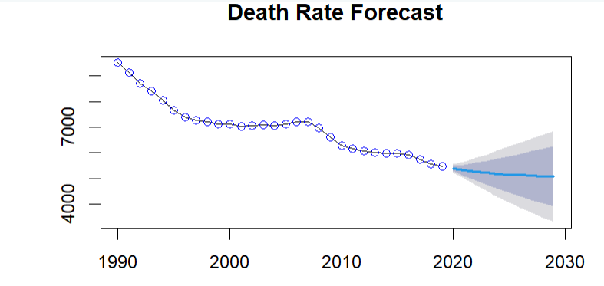

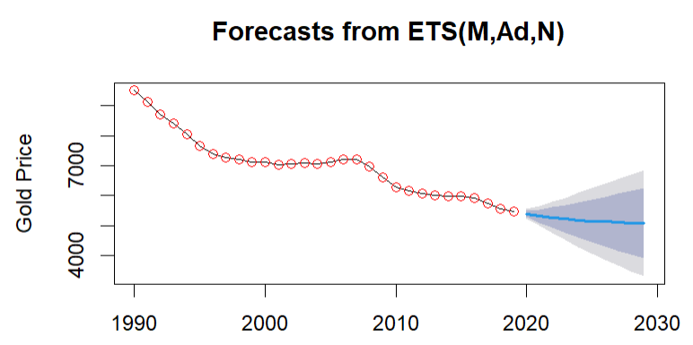

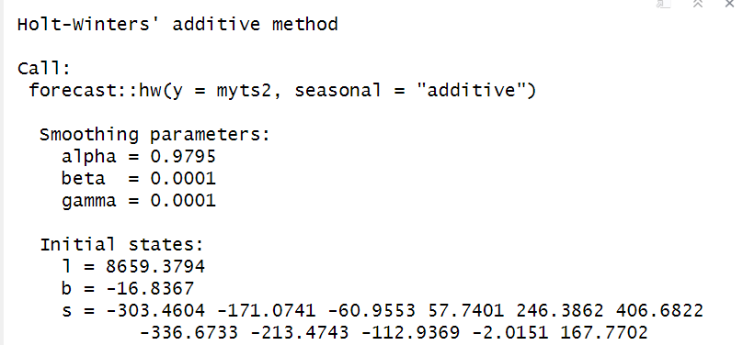

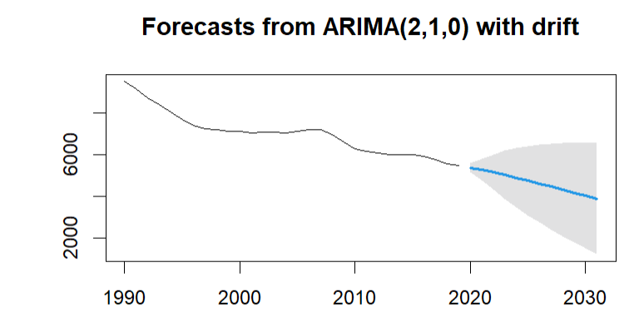

**CRITICAL POINTS FOR PURPLE HATS (CAUSE OF DEATHS IN CHILDREN)**

**MAIN CAUSES OF INFANT DEATH**

Lower respiratory infections: 222,155,486 deaths

Diarrheal diseases: 168,596,725 deaths

Neonatal preterm birth: 162,184,898 deaths

Neonatal encephalopathy due to birth asphyxia and trauma: 119,861,738 deaths

Congenital birth defects: 106,894,563 deaths

Malaria: 82,389,229 deaths

Other neonatal disorders: 80,206,419 deaths

Measles: 58,327,481 deaths

Nutritional deficiencies: 43,725,639 deaths

Neonatal sepsis and other neonatal infections: 41,775,713 deaths

**Trend Line Analysis Keywords:**

1. **Lower respiratory infections**: Decrease, successful interventions, healthcare, vaccination, global health initiatives.
2. **Diarrheal diseases**: Fluctuating trends, generally decreasing, clean water, sanitation facilities, public health measures.
3. **Neonatal preterm birth**: Stable, slight decreases, complexities, maternal and neonatal care improvements.
4. **Neonatal encephalopathy due to birth asphyxia and trauma**: Decreasing trend, better birth practices, neonatal care, areas for improvement.
5. **Congenital birth defects**: Varying trends, genetic counseling, prenatal care, better detection, prevention strategies.
6. **Malaria**: Significant downward trend, global efforts, mosquito control, antimalarial medications.
7. **Other neonatal disorders**: Decreasing trend, healthcare practices improvement, neonatal intensive care.
8. **Measles**: Downward trend, widespread vaccination, vaccination coverage.
9. **Nutritional deficiencies**: Declining trend, addressing malnutrition, food security.
10. **Neonatal sepsis and other neonatal infections**: Decreasing trend, better hygiene, neonatal care practices.

**Correlation Analysis Keywords:**

1. **Infectious diseases correlation**: Strong positive correlations, lower respiratory infections, diarrheal diseases, poor sanitation, low vaccination rates.
2. **Negative correlations**: Interventions, different effects, targeted healthcare strategies.
3. **Unrelated causes correlation**: No significant correlation, congenital birth defects, infectious diseases, different origins.
4. **Neonatal conditions correlation**: Strong correlation, preterm birth, neonatal encephalopathy, other neonatal disorders, common risk factors, neonatal health.

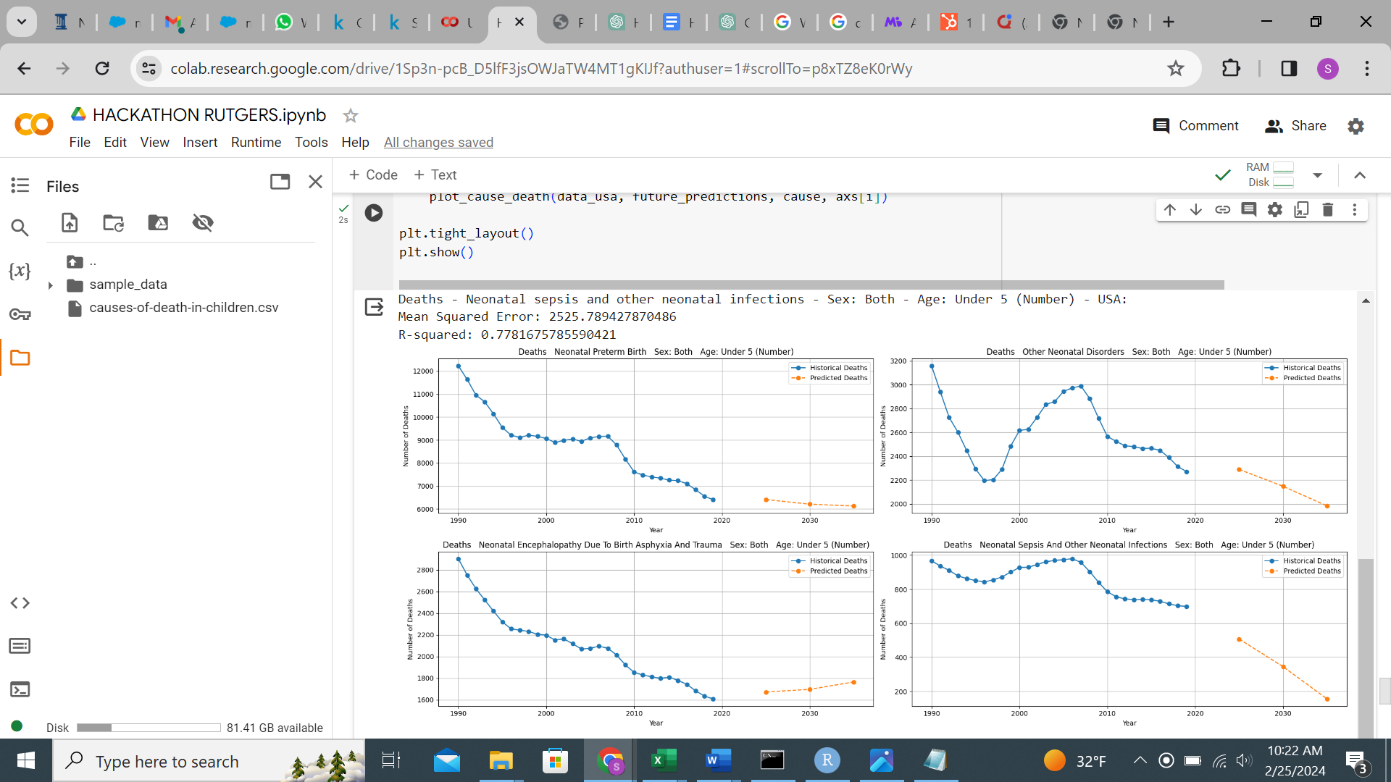

Reasons of prenatal birth deaths :

1. **Limited Access to Healthcare**: Many of these countries have insufficient access to quality prenatal and postnatal care. This lack of access increases the risk of preterm births and decreases the survival rates of preterm infants due to inadequate care and monitoring during pregnancy.
2. **Poverty**: Economic challenges contribute significantly to the high rates of preterm birth deaths. Poverty can affect maternal nutrition, leading to undernourished women who are more likely to have preterm births. It also limits access to healthcare services and proper living conditions.
3. **Inadequate Maternal Nutrition**: Proper maternal nutrition is crucial for fetal health. Malnutrition or undernutrition can lead to poor fetal growth and development, increasing the likelihood of preterm birth and subsequent health issues.
4. **Infections and Chronic Conditions**: High rates of infections, including malaria, HIV/AIDS, and other infectious diseases, can increase the risk of preterm birth. Additionally, untreated chronic conditions like diabetes and hypertension can lead to complications resulting in preterm deliveries.
5. **Lack of Education**: Lower levels of female education in these countries can contribute to higher rates of preterm births. Education often leads to better health practices, including seeking prenatal care and following medical advice during pregnancy.
6. **Cultural and Social Factors**: Cultural practices, lack of family planning, and limited knowledge about reproductive health can lead to higher rates of adolescent pregnancies, which are at a higher risk of resulting in preterm births.
7. **Political Instability and Conflict**: In countries experiencing conflict or political instability, health infrastructure is often compromised, leading to decreased access to healthcare services and an increase in preterm birth rates.

**To prevent infant mortalities effectively, combining practical solutions endorsed by the World Health Organization (WHO) and insights from global health data is crucial. Here's a detailed plan outlining strategies to improve infant survival rates, focusing on the importance of raising awareness and implementing key health interventions:**

**Quality Antenatal and Postnatal Care:** High coverage of quality antenatal care and postnatal care for both mother and baby is essential. Skilled care at birth and immediately after birth can significantly reduce neonatal deaths. Encouraging women to attend all recommended antenatal appointments and ensuring skilled birth attendants are present at deliveries are critical steps.

**Midwife-Led Continuity of Care (MLCC):** Women who receive care from professional midwives educated and regulated to international standards are significantly less likely to experience pre-term birth and lose their baby. MLCC involves a midwife or a team of midwives providing care throughout pregnancy, childbirth, and the postnatal period, with medical support available if necessary.

**Essential Newborn Care:** All newborns should receive thermal protection (e.g., skin-to-skin contact), hygienic umbilical cord and skin care, early and exclusive breastfeeding, and assessment for signs of serious health problems. Preventive treatments such as immunization (e.g., BCG and Hepatitis B vaccines), vitamin K, and ocular prophylaxis should be administered.

**Care for Low-Birth-Weight and Preterm Babies:** Special attention is required for low-birth-weight and preterm babies, including proper thermal care and feeding support. Identifying these babies early, either at the healthcare facility or through home visits, is vital for providing necessary care.

**Education and Awareness:** Raising awareness among parents about the danger signs in newborns and the importance of timely medical care is crucial. Families should be informed about the need for birth registration and adherence to vaccination schedules.

**Nutritional Support:** Addressing malnutrition is key to reducing infant mortality. Adequate nutrition for both mother and baby, including support for breastfeeding, can prevent malnutrition and its associated risks.

**Improving Healthcare Access:** Reducing barriers to accessing healthcare services, including geographical, financial, and cultural barriers, is essential for early detection and treatment of conditions that can lead to neonatal deaths.

**Strengthening Healthcare Systems:** Enhancing the quality of care in healthcare facilities, ensuring the availability of essential medicines and supplies, and training healthcare workers are vital for improving neonatal survival rates.

**Intersectoral Collaboration:** Collaboration across sectors, including education, transportation, water and sanitation, and law enforcement, is necessary to address the broader determinants of health and prevent injuries among older children.

**Implementing these strategies requires commitment from governments, healthcare providers, communities, and international organizations. It's also important to tailor interventions to the specific needs and contexts of different regions, especially in low- and middle-income countries where the majority of newborn deaths occur.**

# Load the dplyr package

library(dplyr)

# Assuming Cause_of_Death2 is your data frame containing the data

Cause_of_Death2 <- read_excel("C:/Rutgers/Hackathon/Rutgers/Transformed Data/Cause of Death2.xlsx")

# Filter the data

filtered_data <- Cause_of_Death2 %>%

filter(Entity == "United States" & Death_Reason == "Congenital birth defects")

# View the filtered data

View(filtered_data)

```

```{R}

# Load the dplyr package

library(dplyr)

# Assuming filtered_data is your filtered data frame

# Drop the columns

filtered_data <- filtered_data %>%

select(-Entity, -Death_Reason)

# View the modified data

View(filtered_data)

```

```{R}

# Assuming 'child_death' is your time series data

child_death <- as.numeric(filtered_data$Death_Count)

myts <- ts(child_death, start=c(1990, 1), end=c(2019, 1), frequency=1)

plot(myts)

```

```{r}

Acf(myts)

```

```{R}

# Perform Holt-Winters forecasting using the forecast function

fit <- forecast(myts, h = 10) # Adjust 'h' as needed for the forecast horizon

# Plot the forecasted values with title

plot(fit, main = "Death Rate Forecast")

# Add data point values

points(myts, col = "blue")

```

```{R}

# Create the time series object with frequency 1 (annual)

myts2 <- ts(child_death, start = c(1990, 1), end = c(2019, 1), frequency = 1)

# Perform Holt-Winters forecasting

HW_forecast <- forecast::forecast(myts2)

# Plot the forecast

plot(HW_forecast, xlab = "Year", ylab = "Gold Price")

# Add data point values

points(myts, col = "red")

```

```{r}

hw_add$model

```

```{R}

adf_test <- adf.test(myts2)

print(adf_test)

```

```{R}

ndiffs(myts2)

timeseriesdiff1 <- diff(TS_win, differences=1)

plot(timeseriesdiff1)

```

```{R}

tsdisplay(timeseriesdiff1)

```

```{R}

auto_fit <- auto.arima(myts2, trace=TRUE, stepwise = FALSE,approximation = FALSE)

auto_fit

```

```{R}

coefficients <- coef(auto_fit)

print(coefficients)

summary(auto_fit)

auto_fit1yr <- plot(forecast(auto_fit,h=12,level=c(99)))

```