1st Session Assignment

1. Install Jupyter notebook and run the first program and share the screenshot of the output.

Anaconda Navigator Screen where you can see Jupyter Notebook

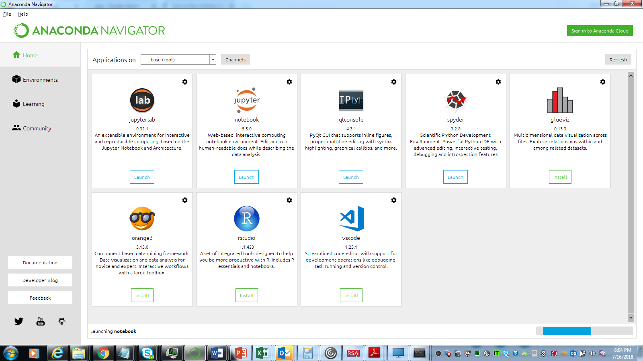

Jupyter Note Book Screen - First Program 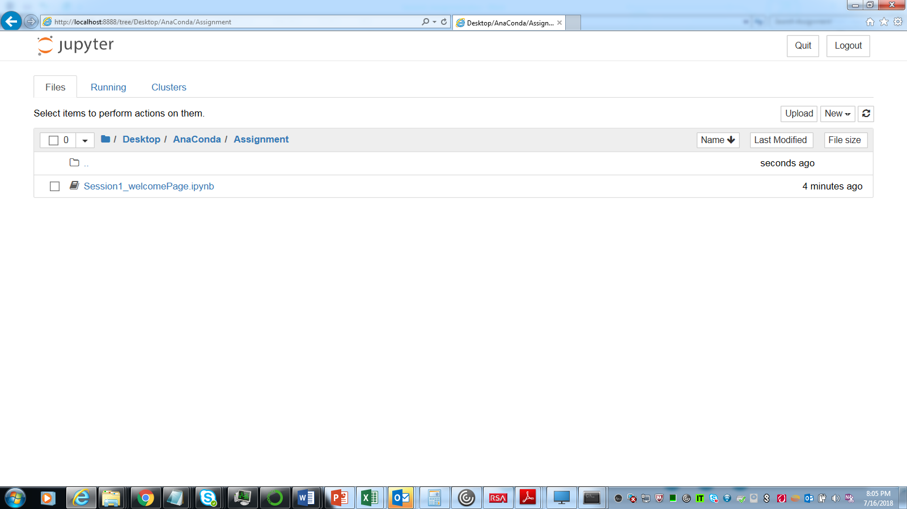

First Program code with output

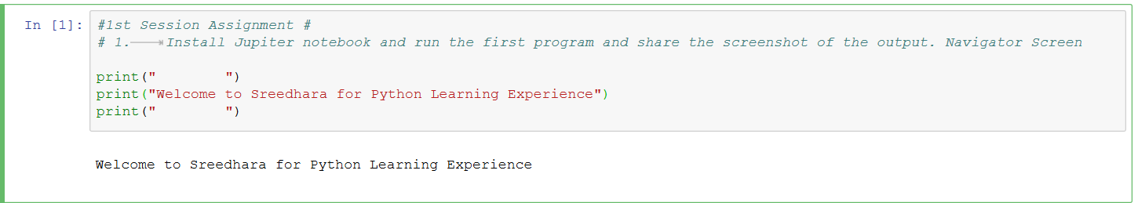

1. Write a program which will find all such numbers which are divisible by 7 but are not multiple of 5, between 2000 and 3200 (both included). The numbers obtained should be printed in a comma-separated sequence on a single line.

Code Screenshot

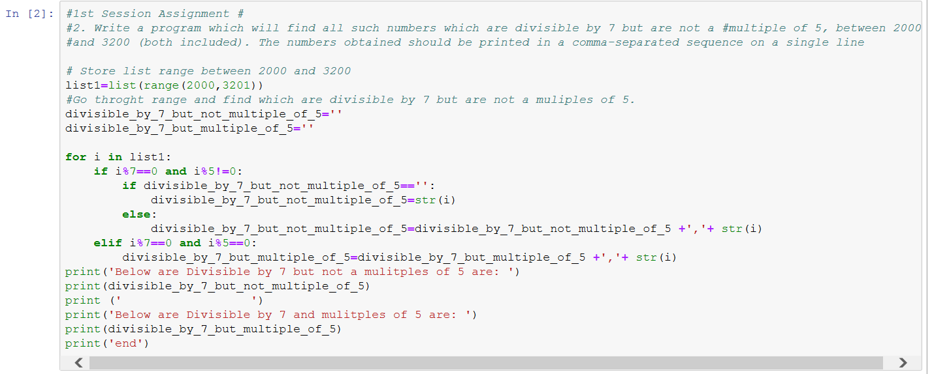

Program Output Screenshot

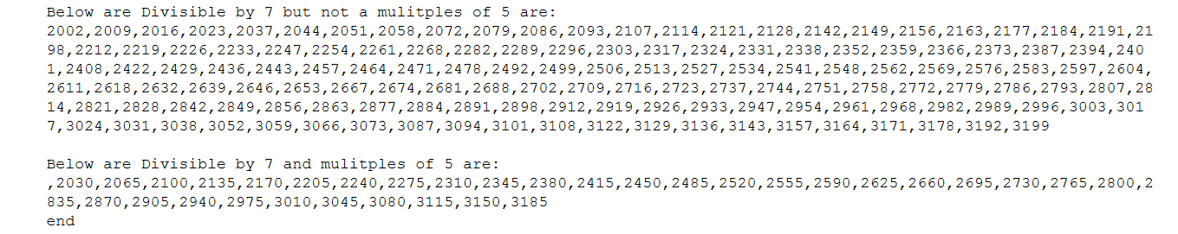

1. Write a Python program to accept the user's first and last name and then getting them printed in the the reverse order with a space between first name and last name.

Code Screen Shot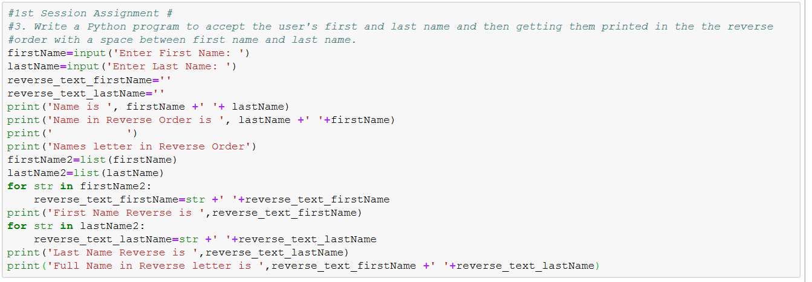

Program Output

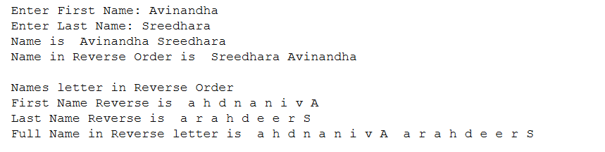

1. Write a Python program to find the volume of a sphere with diameter 12 cm. Formula: V=4/3 \* π \* r 3

Program Screenshot

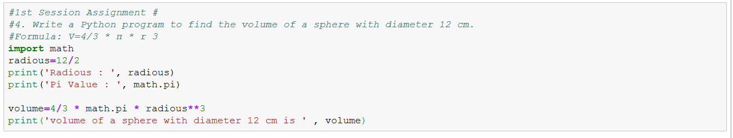

Program output Screenshot

