E-COMMERCE REST API
API DESIGN & REQUIREMENTS DOCUMENT
Internship – Week 1 Deliverable

Prepared for Backend API Planning and Implementation

Document Version | 1.0
API Version | v1
Date | September 2026
Technology Direction | REST API • OpenAPI 3.x • JWT

Executive Summary
This document defines the requirements and proposed REST API design for a simple e-commerce system. The API is organized around Users, Products, Orders, Order Items, and Inventory. Customers can register, authenticate, browse products, place orders, view their orders, and cancel eligible orders. Administrators can manage products, inventory, and operational order information. The design uses REST conventions, API versioning, JWT-based authentication, role-based authorization, input validation, standardized error responses, and an OpenAPI 3.x specification approach. The document is intended to act as a clear blueprint for backend implementation and testing.

1. Project Overview
The proposed system is a backend API for a simple online store. A web or mobile client communicates with the backend over HTTP/HTTPS. The backend exposes versioned REST endpoints and uses a database to persist users, products, orders, and inventory. Business rules ensure that orders can only be created when sufficient stock is available and that users can access only the information permitted by their role.

2. Objectives
- Define clear functional and non-functional requirements before implementation.
- Design a consistent REST API for users, products, orders, and inventory.
- Document HTTP methods, request inputs, responses, authentication, and error conditions.
- Apply common API standards such as resource-oriented URLs, JSON responses, versioning, and OpenAPI.
- Provide diagrams that explain architecture, authentication, and order processing.
- Provide a practical roadmap that another developer can follow during backend implementation.

3. Scope
In scope:
- Customer registration and authentication.
- User profile retrieval and update.
- Product listing, product details, and administrator CRUD operations.
- Order creation, retrieval, and cancellation of eligible orders.
- Inventory viewing and stock updates by administrators.
- Validation, authorization, error handling, and security requirements.
- OpenAPI/Swagger-oriented API documentation.
Out of scope for this first version:
- Payment gateway integration.
- Shipping carrier integration and live delivery tracking.
- Product reviews and ratings.
- Discount/coupon engine.
- Multi-vendor marketplace functionality.
- Advanced recommendation or analytics systems.

4. Stakeholders and Roles
Role | Responsibilities
Customer | Register, login, browse products, place orders, view own orders, manage profile, cancel eligible orders.
Admin | Manage products, manage inventory, review/manage operational order information, and maintain the system.
API / Backend | Authenticate requests, validate input, enforce authorization, calculate totals, check stock, persist data, and return standardized responses.

5. Main Resources
Resource | Purpose | Key Fields
User | Stores customer and administrator accounts. | id, name, email, passwordHash, role, createdAt
Product | Represents an item available for sale. | id, name, description, price, category, createdAt, updatedAt
Order | Represents a purchase made by a customer. | id, userId, totalAmount, status, createdAt
Order Item | Represents a product and quantity inside an order. | id, orderId, productId, quantity, unitPrice
Inventory | Tracks current stock for products. | id, productId, quantity, updatedAt

6. Functional Requirements
ID | Requirement | Actor
FR-01 | Allow customers to register with name, email, and password. | Customer
FR-02 | Allow registered users to authenticate using email and password. | Customer/Admin
FR-03 | Allow authenticated users to view their profile. | Customer/Admin
FR-04 | Allow authenticated users to update permitted profile information. | Customer/Admin
FR-05 | Allow clients to list available products. | Public
FR-06 | Allow clients to view a specific product. | Public
FR-07 | Allow administrators to create products. | Admin
FR-08 | Allow administrators to update products. | Admin
FR-09 | Allow administrators to delete products. | Admin
FR-10 | Allow authenticated customers to create orders. | Customer
FR-11 | Verify that requested products exist before creating an order. | System
FR-12 | Verify sufficient inventory before creating an order. | System
FR-13 | Calculate the order total from product prices and quantities. | System
FR-14 | Allow customers to list their own orders. | Customer
FR-15 | Allow customers to view an individual order they own. | Customer
FR-16 | Allow customers to cancel orders that are still eligible for cancellation. | Customer
FR-17 | Allow administrators to view inventory. | Admin
FR-18 | Allow administrators to add/update stock quantities. | Admin
FR-19 | Reduce inventory after a successful order. | System
FR-20 | Return standardized errors for invalid, unauthorized, or failed requests. | System

7. Business Rules
- Email addresses must be unique within the user system.
- Passwords must be stored as secure hashes and must never be returned in API responses.
- Only authenticated users may create orders or access protected user/order information.
- Only administrators may create, update, or delete products.
- Only administrators may change inventory quantities.
- An order cannot be created when a requested product does not exist.
- An order cannot be created when requested quantity exceeds available stock.
- Order total is calculated using the applicable product unit price multiplied by requested quantity.
- Inventory is reduced only when order creation succeeds.
- Customers may access only their own orders.
- Orders that have been shipped or delivered cannot be cancelled by customers.
- A successful resource creation should return HTTP 201 where applicable.

8. Non-Functional Requirements
Area | Requirement
Security | Use HTTPS, JWT authentication, password hashing, role-based authorization, validation, and safe error messages.
Performance | Use pagination for product/order lists and efficient database queries.
Reliability | Prevent partial updates where order creation and inventory changes could become inconsistent.
Scalability | Use /api/v1 versioning and modular resource-based services so future features can be added.
Maintainability | Use consistent naming, response formats, validation rules, and OpenAPI documentation.
Availability | Backend should handle expected failures gracefully and return useful status codes.

9. System Architecture
The client communicates with a versioned REST API. The API authenticates requests, applies business rules, and communicates with the persistence layer. Products are publicly readable, while management operations and inventory changes require administrator authorization.
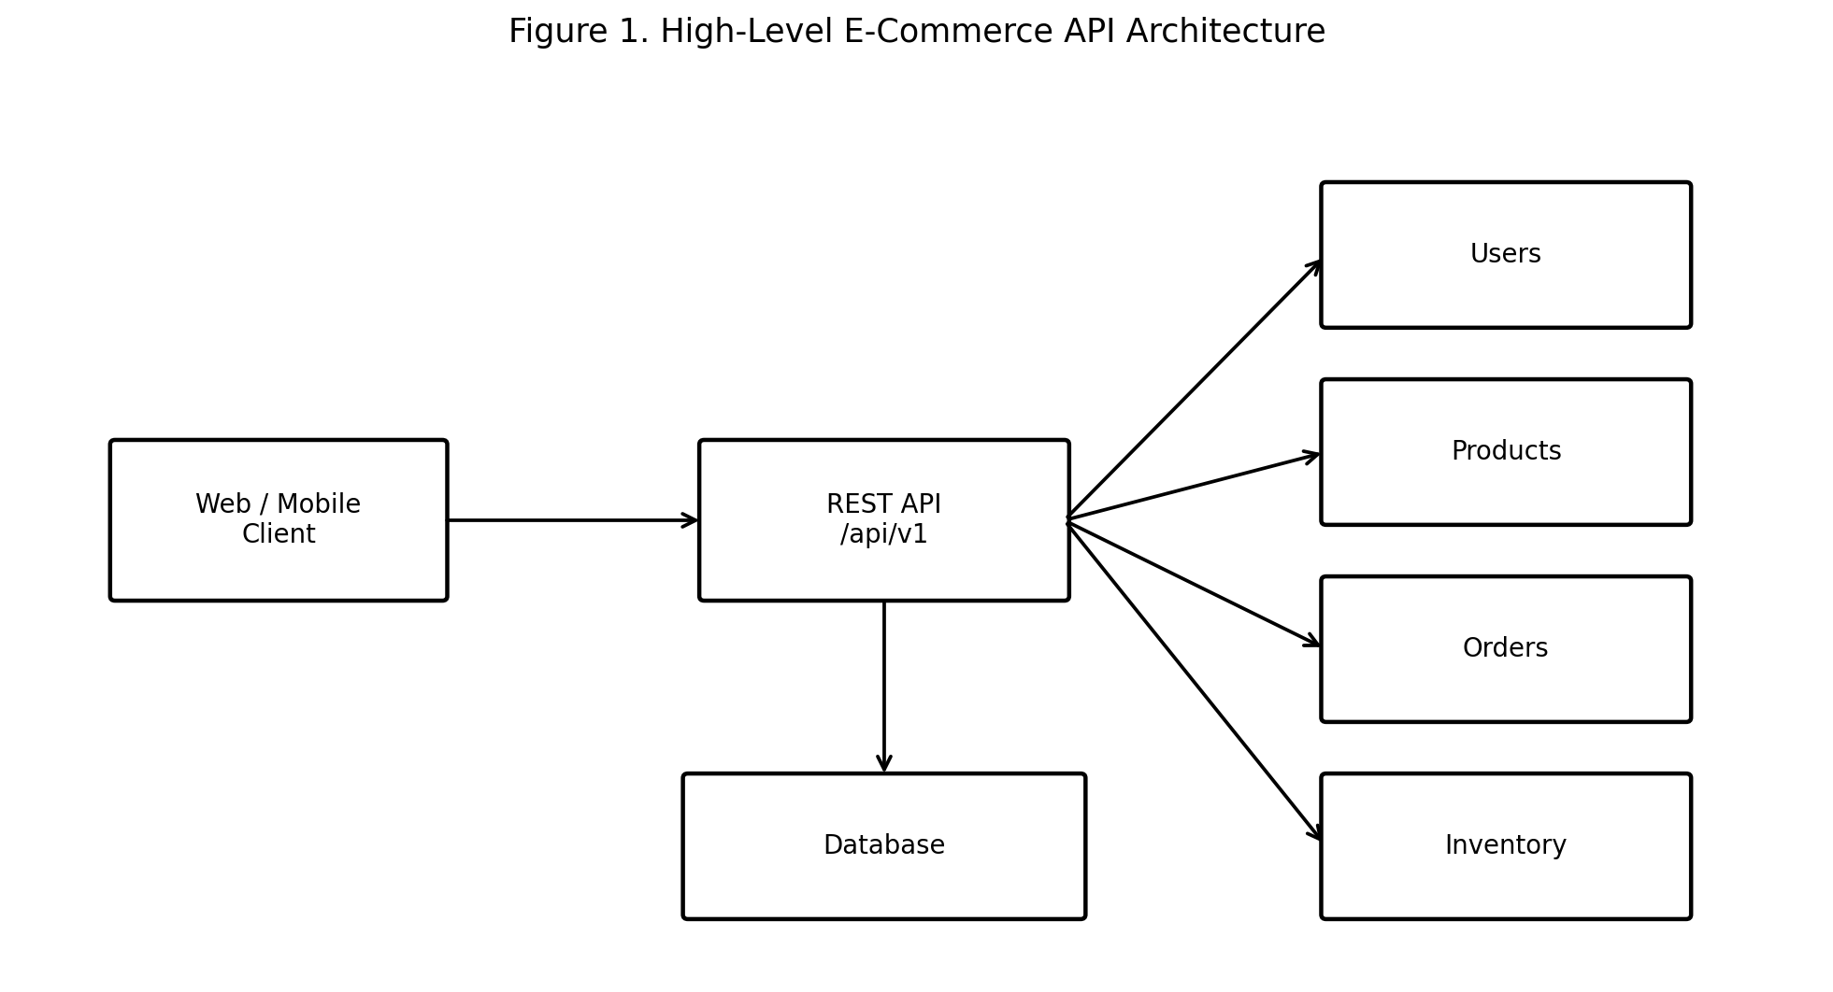

10. Authentication and Authorization
JWT bearer authentication is proposed for protected endpoints. A user first authenticates through the login endpoint. On successful authentication, the API returns an access token. The client then sends the token in the Authorization header for protected requests.
Example header:
Authorization: Bearer <JWT_ACCESS_TOKEN>
Access Level | Examples
Public | Register, login, list products, view product details
Authenticated Customer | Profile, create order, list own orders, view own order, cancel eligible order
Admin | Product CRUD, inventory management, operational order management

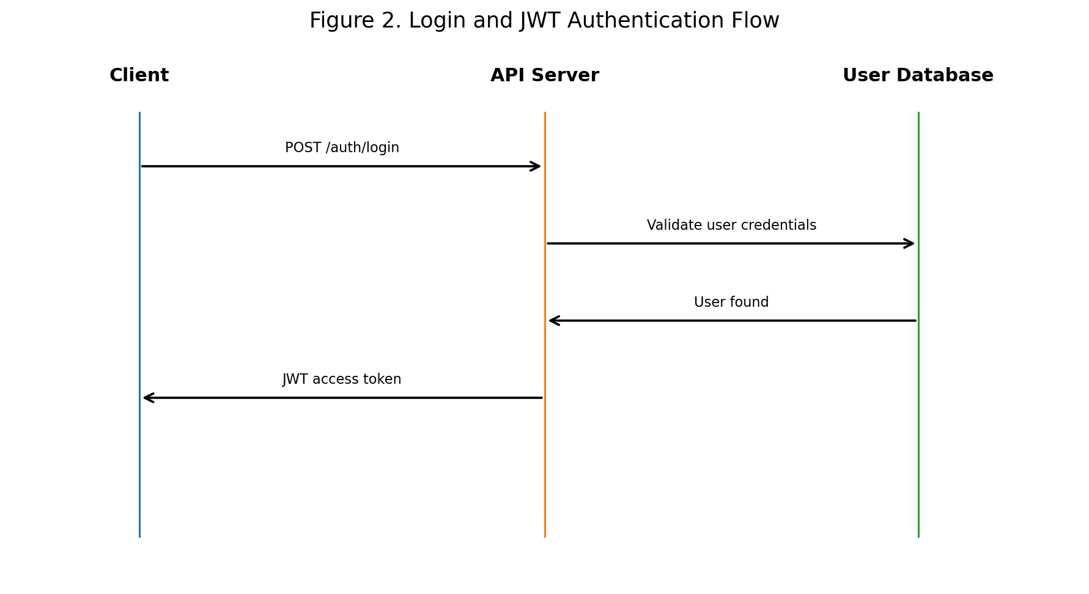

11. API Standards and Conventions
- Base path: /api/v1
- Content type: application/json
- Resource names use plural nouns, e.g. /products and /orders.
- Path parameters use identifiers such as {productId}.
- HTTP status codes communicate the result of each request.
- Authentication uses Authorization: Bearer <token> for protected endpoints.
- Pagination is recommended for collection endpoints.
- Timestamps should use ISO 8601 format.
- API responses should not expose password hashes, secrets, or internal stack traces.

12. API Endpoint Overview
Method | Endpoint | Purpose | Auth | Role
POST | /api/v1/users/register | Register a user | No | Public
POST | /api/v1/auth/login | Authenticate and issue JWT | No | Public
GET | /api/v1/users/me | Get current user profile | Yes | User
PUT | /api/v1/users/me | Update current user profile | Yes | User
GET | /api/v1/products | List products | No | Public
GET | /api/v1/products/{productId} | Get product details | No | Public
POST | /api/v1/products | Create product | Yes | Admin
PUT | /api/v1/products/{productId} | Update product | Yes | Admin
DELETE | /api/v1/products/{productId} | Delete product | Yes | Admin
GET | /api/v1/orders | List current user's orders | Yes | Customer
POST | /api/v1/orders | Create an order | Yes | Customer
GET | /api/v1/orders/{orderId} | Get one order | Yes | Customer
POST | /api/v1/orders/{orderId}/cancel | Cancel eligible order | Yes | Customer
GET | /api/v1/inventory | List inventory | Yes | Admin
GET | /api/v1/inventory/{productId} | Get stock for product | Yes | Admin
PUT | /api/v1/inventory/{productId} | Update stock | Yes | Admin

13. Detailed API Specifications

13.1 Register User
Endpoint: POST /api/v1/users/register
Authentication: No
Request:
{
"name": "Vishal",
"email": "vishal@example.com",
"password": "StrongPassword123"
}
Success response:
{
"id": 101,
"name": "Vishal",
"email": "vishal@example.com",
"role": "CUSTOMER"
}
Common errors: 400 validation error; 409 email already exists

13.2 Login
Endpoint: POST /api/v1/auth/login
Authentication: No
Request:
{
"email": "vishal@example.com",
"password": "StrongPassword123"
}
Success response:
{
"accessToken": "<JWT_TOKEN>",
"tokenType": "Bearer",
"expiresIn": 3600
}
Common errors: 400 invalid request; 401 invalid credentials

13.3 Get Products
Endpoint: GET /api/v1/products?page=1&limit=20
Authentication: No
Request:
Query parameters: page (integer, default 1), limit (integer, default 20, max 100)
Success response:
{
"items": [
{
"id": 501,
"name": "Wireless Mouse",
"price": 799,
"category": "Electronics"
}
],
"page": 1,
"limit": 20,
"total": 1
}
Common errors: 400 invalid pagination

13.4 Get Product
Endpoint: GET /api/v1/products/{productId}
Authentication: No
Request:
Path parameter: productId (integer/string identifier)
Success response:
{
"id": 501,
"name": "Wireless Mouse",
"description": "Bluetooth wireless mouse",
"price": 799,
"category": "Electronics"
}
Common errors: 400 invalid ID; 404 product not found

13.5 Create Product
Endpoint: POST /api/v1/products
Authentication: Yes – Admin
Request:
{
"name": "Wireless Mouse",
"description": "Bluetooth wireless mouse",
"price": 799,
"category": "Electronics"
}
Success response:
{
"id": 501,
"name": "Wireless Mouse",
"description": "Bluetooth wireless mouse",
"price": 799,
"category": "Electronics"
}
Common errors: 400 validation error; 401 unauthorized; 403 forbidden

13.6 Update Product
Endpoint: PUT /api/v1/products/{productId}
Authentication: Yes – Admin
Request:
{
"name": "Wireless Mouse Pro",
"description": "Updated description",
"price": 999,
"category": "Electronics"
}
Success response:
{
"id": 501,
"name": "Wireless Mouse Pro",
"price": 999,
"category": "Electronics"
}
Common errors: 400 validation error; 401 unauthorized; 403 forbidden; 404 not found

13.7 Delete Product
Endpoint: DELETE /api/v1/products/{productId}
Authentication: Yes – Admin
Request:
Path parameter: productId
Success response:
No response body on success
Common errors: 401 unauthorized; 403 forbidden; 404 not found; 409 product referenced by active order

13.8 Create Order
Endpoint: POST /api/v1/orders
Authentication: Yes – Customer
Request:
{
"items": [
{
"productId": 501,
"quantity": 2
}
]
}
Success response:
{
"id": 1001,
"userId": 101,
"items": [
{
"productId": 501,
"quantity": 2,
"unitPrice": 799
}
],
"totalAmount": 1598,
"status": "PENDING"
}
Common errors: 400 validation error; 401 unauthorized; 404 product not found; 409 insufficient stock

13.9 List Orders
Endpoint: GET /api/v1/orders
Authentication: Yes – Customer
Request:
Optional query parameters: page, limit, status
Success response:
{
"items": [
{
"id": 1001,
"totalAmount": 1598,
"status": "PENDING"
}
],
"page": 1,
"limit": 20,
"total": 1
}
Common errors: 401 unauthorized; 400 invalid query

13.10 Get Order
Endpoint: GET /api/v1/orders/{orderId}
Authentication: Yes – Customer
Request:
Path parameter: orderId
Success response:
{
"id": 1001,
"userId": 101,
"totalAmount": 1598,
"status": "PENDING"
}
Common errors: 401 unauthorized; 403 not owner; 404 order not found

13.11 Cancel Order
Endpoint: POST /api/v1/orders/{orderId}/cancel
Authentication: Yes – Customer
Request:
Path parameter: orderId
Success response:
{
"id": 1001,
"status": "CANCELLED"
}
Common errors: 401 unauthorized; 403 not owner; 404 not found; 409 order cannot be cancelled

13.12 List Inventory
Endpoint: GET /api/v1/inventory
Authentication: Yes – Admin
Request:
Optional query parameters: page, limit, lowStockOnly
Success response:
{
"items": [
{
"productId": 501,
"quantity": 50
}
],
"page": 1,
"limit": 20,
"total": 1
}
Common errors: 401 unauthorized; 403 forbidden

13.13 Get Inventory
Endpoint: GET /api/v1/inventory/{productId}
Authentication: Yes – Admin
Request:
Path parameter: productId
Success response:
{
"productId": 501,
"quantity": 50,
"updatedAt": "2026-09-01T10:00:00Z"
}
Common errors: 401 unauthorized; 403 forbidden; 404 inventory not found

13.14 Update Inventory
Endpoint: PUT /api/v1/inventory/{productId}
Authentication: Yes – Admin
Request:
{
"quantity": 100
}
Success response:
{
"productId": 501,
"quantity": 100,
"updatedAt": "2026-09-01T10:00:00Z"
}
Common errors: 400 quantity invalid; 401 unauthorized; 403 forbidden; 404 product not found

14. Order Processing Flow
When a customer submits an order, the API validates the JWT, validates the request body, confirms that each product exists, checks inventory, calculates the total, creates the order and order items, and updates stock. These database changes should be handled transactionally so that a failed order does not incorrectly reduce stock.
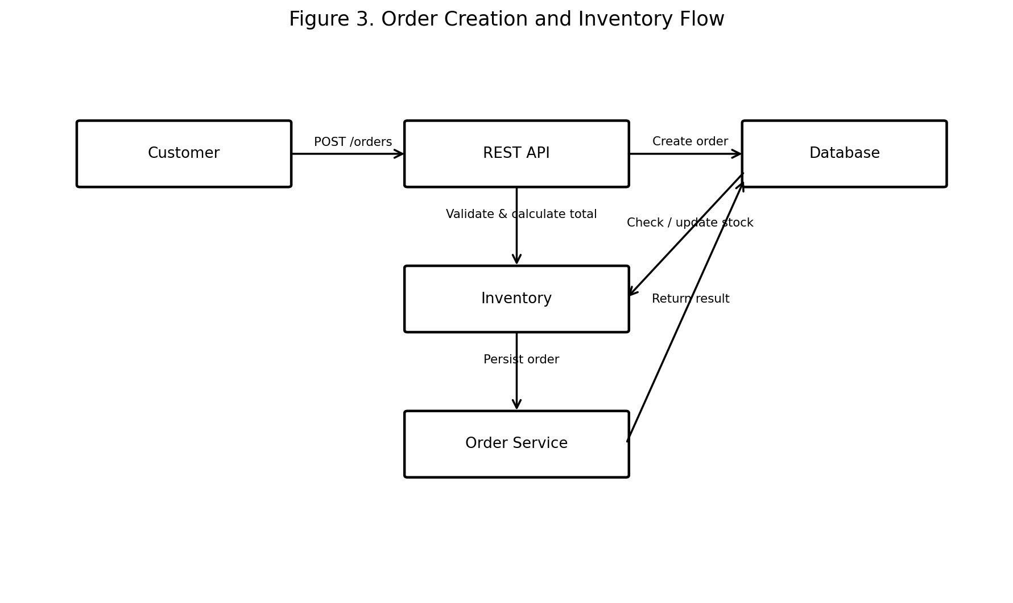

15. Input Validation
Input | Validation Rule
User name | Required; 2–100 characters.
Email | Required; valid email format; unique.
Password | Required; minimum 8 characters; never returned in responses.
Product name | Required; 1–100 characters.
Product price | Required; numeric; greater than 0.
Product category | Required; controlled string or validated category.
Product ID / Order ID | Required path identifier; valid format.
Order quantity | Required integer; must be greater than 0.
Inventory quantity | Required integer; must be 0 or greater.
Pagination limit | Positive integer; maximum 100.

16. Error Handling
All error responses should follow a consistent structure:
{
"success": false,
"error": {
"code": "PRODUCT_NOT_FOUND",
"message": "Product with the specified ID was not found."
}
}
HTTP Status | Meaning | Typical Use
200 | OK | Successful read/update request.
201 | Created | Successful resource creation.
204 | No Content | Successful deletion with no response body.
400 | Bad Request | Malformed request or invalid input.
401 | Unauthorized | Missing or invalid authentication.
403 | Forbidden | Authenticated but insufficient permissions.
404 | Not Found | Requested resource does not exist.
409 | Conflict | Business conflict such as insufficient stock or invalid state transition.
422 | Unprocessable Entity | Optional choice for semantically invalid fields if the implementation uses it.
500 | Internal Server Error | Unexpected backend failure; do not expose stack traces.

17. Security Considerations
- Use HTTPS for all production API traffic.
- Hash passwords with a strong password-hashing algorithm; never store plaintext passwords.
- Use short-lived JWT access tokens and validate signature, expiry, and relevant claims.
- Enforce role-based authorization on administrator endpoints.
- Validate and sanitize all client-provided input.
- Use parameterized database queries or an ORM to reduce injection risks.
- Do not expose passwords, tokens, database credentials, stack traces, or internal identifiers unnecessarily.
- Apply rate limiting and brute-force protection to authentication endpoints.
- Configure CORS according to the actual frontend origins instead of allowing unrestricted production access.
- Log security-relevant events without logging passwords or access tokens.

18. Data Relationships
Relationship | Description
User → Orders | One user can create many orders; each order belongs to one user.
Order → Order Items | One order contains one or more order items.
Product → Order Items | A product can appear in many order items.
Product → Inventory | Each product has one inventory record in the simple design.

Logical relationship:
USER 1 ───< ORDER 1 ───< ORDER_ITEM >─── 1 PRODUCT 1 ─── 1 INVENTORY

19. OpenAPI / Swagger Specification
The API should be represented using OpenAPI 3.x so that the contract can be imported into Swagger UI, Swagger Editor, Postman, or other API tooling. The following excerpt shows the structure of the specification; the endpoint tables in this document define the complete planned contract.
openapi: 3.0.3
info:
title: E-Commerce API
version: 1.0.0
description: REST API for a simple e-commerce system
servers:
- url: https://api.example.com/api/v1
paths:
/users/register:
post:
summary: Register a user
/auth/login:
post:
summary: Authenticate and issue a JWT
/products:
get:
summary: List products
post:
summary: Create a product
security:
- bearerAuth: []
/products/{productId}:
get:
summary: Get product details
put:
summary: Update a product
security:
- bearerAuth: []
delete:
summary: Delete a product
security:
- bearerAuth: []
/orders:
get:
summary: List current user's orders
security:
- bearerAuth: []
post:
summary: Create an order
security:
- bearerAuth: []
/orders/{orderId}:
get:
summary: Get an order
security:
- bearerAuth: []
/orders/{orderId}/cancel:
post:
summary: Cancel an eligible order
security:
- bearerAuth: []
/inventory:
get:
summary: List inventory
security:
- bearerAuth: []
/inventory/{productId}:
get:
summary: Get inventory for a product
security:
- bearerAuth: []
put:
summary: Update inventory
security:
- bearerAuth: []
components:
securitySchemes:
bearerAuth:
type: http
scheme: bearer
bearerFormat: JWT

20. Implementation Roadmap
Phase | Workstream | Planned Work
Phase 1 | Project setup | Initialize Node.js/Express project, environment configuration, linting, and folder structure.
Phase 2 | Database | Create User, Product, Order, OrderItem, and Inventory models plus relationships.
Phase 3 | Authentication | Implement registration, password hashing, login, JWT generation, and authentication middleware.
Phase 4 | Product APIs | Implement product listing, details, creation, update, and deletion with validation and authorization.
Phase 5 | Inventory APIs | Implement stock retrieval and administrator stock updates.
Phase 6 | Order APIs | Implement order creation, stock checks, totals, persistence, cancellation, and transaction handling.
Phase 7 | Error & Security | Add centralized error middleware, validation, rate limiting, CORS configuration, and secure logging.
Phase 8 | Testing | Write unit/integration tests and test endpoints using Postman or an equivalent client.
Phase 9 | API Documentation | Publish OpenAPI/Swagger documentation and keep it synchronized with the implementation.
Phase 10 | Deployment | Deploy the API with environment variables, HTTPS, monitoring, and database backups.

21. Acceptance Criteria
- All required resources and endpoints are documented before backend implementation.
- Public, authenticated, and admin-only operations are clearly distinguished.
- Requests and responses use consistent JSON structures.
- Validation and expected error codes are documented.
- Order creation checks inventory and updates stock consistently.
- The API contract is representable in OpenAPI 3.x.
- Diagrams clearly explain architecture and key flows.
- The document can be used as a handoff specification for implementation and testing.

22. Conclusion
The proposed e-commerce API provides a structured foundation for backend implementation. The design focuses on a small but complete resource model, conventional REST endpoints, JWT authentication, role-based access, input validation, predictable errors, and clear order/inventory behavior. By defining the contract first, implementation and testing can proceed with fewer assumptions and less rework.

Appendix A – Quick Endpoint Checklist
Resource | CRUD / Action Coverage
Users | Register, login, read current profile, update current profile
Products | Create, read list, read one, update, delete
Orders | Create, read list, read one, cancel eligible order
Inventory | Read list, read one, update stock

Appendix B – Complete OpenAPI 3.0.3 Specification
This appendix provides the complete machine-readable API contract for the proposed e-commerce API. OpenAPI is a language-independent standard for describing HTTP APIs and can be used by documentation, testing, and code-generation tools. This document uses OpenAPI 3.0.3 for broad tooling compatibility.
openapi: 3.0.3
info:
title: E-Commerce REST API
version: 1.0.0
description: |
REST API for a simple e-commerce system.
Supports users, authentication, products, orders, and inventory.
servers:
- url: https://api.example.com/api/v1
description: Production server
- url: http://localhost:3000/api/v1
description: Local development server
tags:
- name: Authentication
- name: Users
- name: Products
- name: Orders
- name: Inventory
paths:
/users/register:
post:
tags: [Users]
summary: Register a new user
operationId: registerUser
requestBody:
required: true
content:
application/json:
schema:
$ref: '#/components/schemas/RegisterRequest'
responses:
'201':
description: User created successfully
content:
application/json:
schema:
$ref: '#/components/schemas/User'
'400':
$ref: '#/components/responses/ValidationError'
'409':
description: Email already exists
/auth/login:
post:
tags: [Authentication]
summary: Authenticate a user
operationId: login
requestBody:
required: true
content:
application/json:
schema:
$ref: '#/components/schemas/LoginRequest'
responses:
'200':
description: Authentication successful
content:
application/json:
schema:
$ref: '#/components/schemas/LoginResponse'
'400':
$ref: '#/components/responses/ValidationError'
'401':
$ref: '#/components/responses/Unauthorized'
/users/me:
get:
tags: [Users]
summary: Get current user's profile
operationId: getCurrentUser
security:
- bearerAuth: []
responses:
'200':
description: Current user
content:
application/json:
schema:
$ref: '#/components/schemas/User'
'401':
$ref: '#/components/responses/Unauthorized'
put:
tags: [Users]
summary: Update current user's profile
operationId: updateCurrentUser
security:
- bearerAuth: []
requestBody:
required: true
content:
application/json:
schema:
$ref: '#/components/schemas/UserUpdateRequest'
responses:
'200':
description: Profile updated
content:
application/json:
schema:
$ref: '#/components/schemas/User'
'400':
$ref: '#/components/responses/ValidationError'
'401':
$ref: '#/components/responses/Unauthorized'
/products:
get:
tags: [Products]
summary: List products
operationId: listProducts
parameters:
- $ref: '#/components/parameters/Page'
- $ref: '#/components/parameters/Limit'
- name: category
in: query
schema:
type: string
description: Optional product category filter
responses:
'200':
description: Product list
content:
application/json:
schema:
$ref: '#/components/schemas/ProductListResponse'
'400':
$ref: '#/components/responses/ValidationError'
post:
tags: [Products]
summary: Create a product
operationId: createProduct
security:
- bearerAuth: []
requestBody:
required: true
content:
application/json:
schema:
$ref: '#/components/schemas/ProductRequest'
responses:
'201':
description: Product created
content:
application/json:
schema:
$ref: '#/components/schemas/Product'
'400':
$ref: '#/components/responses/ValidationError'
'401':
$ref: '#/components/responses/Unauthorized'
'403':
$ref: '#/components/responses/Forbidden'
/products/{productId}:
parameters:
- $ref: '#/components/parameters/ProductId'
get:
tags: [Products]
summary: Get product details
operationId: getProduct
responses:
'200':
description: Product details
content:
application/json:
schema:
$ref: '#/components/schemas/Product'
'404':
$ref: '#/components/responses/NotFound'
put:
tags: [Products]
summary: Update a product
operationId: updateProduct
security:
- bearerAuth: []
requestBody:
required: true
content:
application/json:
schema:
$ref: '#/components/schemas/ProductRequest'
responses:
'200':
description: Product updated
content:
application/json:
schema:
$ref: '#/components/schemas/Product'
'400':
$ref: '#/components/responses/ValidationError'
'401':
$ref: '#/components/responses/Unauthorized'
'403':
$ref: '#/components/responses/Forbidden'
'404':
$ref: '#/components/responses/NotFound'
delete:
tags: [Products]
summary: Delete a product
operationId: deleteProduct
security:
- bearerAuth: []
responses:
'204':
description: Product deleted
'401':
$ref: '#/components/responses/Unauthorized'
'403':
$ref: '#/components/responses/Forbidden'
'404':
$ref: '#/components/responses/NotFound'
'409':
description: Product cannot be deleted because of an active business dependency
/orders:
get:
tags: [Orders]
summary: List current user's orders
operationId: listOrders
security:
- bearerAuth: []
parameters:
- $ref: '#/components/parameters/Page'
- $ref: '#/components/parameters/Limit'
- name: status
in: query
schema:
$ref: '#/components/schemas/OrderStatus'
responses:
'200':
description: Order list
content:
application/json:
schema:
$ref: '#/components/schemas/OrderListResponse'
'401':
$ref: '#/components/responses/Unauthorized'
post:
tags: [Orders]
summary: Create an order
operationId: createOrder
security:
- bearerAuth: []
requestBody:
required: true
content:
application/json:
schema:
$ref: '#/components/schemas/CreateOrderRequest'
responses:
'201':
description: Order created
content:
application/json:
schema:
$ref: '#/components/schemas/Order'
'400':
$ref: '#/components/responses/ValidationError'
'401':
$ref: '#/components/responses/Unauthorized'
'404':
description: Product not found
'409':
description: Insufficient stock or order business conflict
/orders/{orderId}:
parameters:
- $ref: '#/components/parameters/OrderId'
get:
tags: [Orders]
summary: Get an order
operationId: getOrder
security:
- bearerAuth: []
responses:
'200':
description: Order details
content:
application/json:
schema:
$ref: '#/components/schemas/Order'
'401':
$ref: '#/components/responses/Unauthorized'
'403':
$ref: '#/components/responses/Forbidden'
'404':
$ref: '#/components/responses/NotFound'
/orders/{orderId}/cancel:
parameters:
- $ref: '#/components/parameters/OrderId'
post:
tags: [Orders]
summary: Cancel an eligible order
operationId: cancelOrder
security:
- bearerAuth: []
responses:
'200':
description: Order cancelled
content:
application/json:
schema:
$ref: '#/components/schemas/Order'
'401':
$ref: '#/components/responses/Unauthorized'
'403':
$ref: '#/components/responses/Forbidden'
'404':
$ref: '#/components/responses/NotFound'
'409':
description: Order is not eligible for cancellation
/inventory:
get:
tags: [Inventory]
summary: List inventory
operationId: listInventory
security:
- bearerAuth: []
parameters:
- $ref: '#/components/parameters/Page'
- $ref: '#/components/parameters/Limit'
- name: lowStockOnly
in: query
schema:
type: boolean
default: false
responses:
'200':
description: Inventory list
content:
application/json:
schema:
$ref: '#/components/schemas/InventoryListResponse'
'401':
$ref: '#/components/responses/Unauthorized'
'403':
$ref: '#/components/responses/Forbidden'
/inventory/{productId}:
parameters:
- $ref: '#/components/parameters/ProductId'
get:
tags: [Inventory]
summary: Get inventory for a product
operationId: getInventory
security:
- bearerAuth: []
responses:
'200':
description: Inventory record
content:
application/json:
schema:
$ref: '#/components/schemas/Inventory'
'401':
$ref: '#/components/responses/Unauthorized'
'403':
$ref: '#/components/responses/Forbidden'
'404':
$ref: '#/components/responses/NotFound'
put:
tags: [Inventory]
summary: Update inventory quantity
operationId: updateInventory
security:
- bearerAuth: []
requestBody:
required: true
content:
application/json:
schema:
$ref: '#/components/schemas/InventoryUpdateRequest'
responses:
'200':
description: Inventory updated
content:
application/json:
schema:
$ref: '#/components/schemas/Inventory'
'400':
$ref: '#/components/responses/ValidationError'
'401':
$ref: '#/components/responses/Unauthorized'
'403':
$ref: '#/components/responses/Forbidden'
'404':
$ref: '#/components/responses/NotFound'
components:
securitySchemes:
bearerAuth:
type: http
scheme: bearer
bearerFormat: JWT
description: JWT access token issued by POST /auth/login
parameters:
Page:
name: page
in: query
description: Page number
required: false
schema:
type: integer
minimum: 1
default: 1
Limit:
name: limit
in: query
description: Number of records per page
required: false
schema:
type: integer
minimum: 1
maximum: 100
default: 20
ProductId:
name: productId
in: path
required: true
schema:
type: integer
minimum: 1
OrderId:
name: orderId
in: path
required: true
schema:
type: integer
minimum: 1
responses:
ValidationError:
description: Request validation failed
content:
application/json:
schema:
$ref: '#/components/schemas/ErrorResponse'
Unauthorized:
description: Authentication is missing or invalid
content:
application/json:
schema:
$ref: '#/components/schemas/ErrorResponse'
Forbidden:
description: Authenticated user lacks required permissions
content:
application/json:
schema:
$ref: '#/components/schemas/ErrorResponse'
NotFound:
description: Resource not found
content:
application/json:
schema:
$ref: '#/components/schemas/ErrorResponse'
schemas:
RegisterRequest:
type: object
required: [name, email, password]
properties:
name:
type: string
minLength: 2
maxLength: 100
email:
type: string
format: email
password:
type: string
minLength: 8
writeOnly: true
LoginRequest:
type: object
required: [email, password]
properties:
email:
type: string
format: email
password:
type: string
writeOnly: true
LoginResponse:
type: object
properties:
accessToken:
type: string
tokenType:
type: string
example: Bearer
expiresIn:
type: integer
example: 3600
User:
type: object
properties:
id:
type: integer
name:
type: string
email:
type: string
format: email
role:
type: string
enum: [CUSTOMER, ADMIN]
createdAt:
type: string
format: date-time
UserUpdateRequest:
type: object
properties:
name:
type: string
minLength: 2
maxLength: 100
email:
type: string
format: email
Product:
type: object
properties:
id:
type: integer
name:
type: string
description:
type: string
price:
type: number
format: double
minimum: 0
category:
type: string
createdAt:
type: string
format: date-time
updatedAt:
type: string
format: date-time
ProductRequest:
type: object
required: [name, price, category]
properties:
name:
type: string
minLength: 1
maxLength: 100
description:
type: string
maxLength: 1000
price:
type: number
format: double
exclusiveMinimum: 0
category:
type: string
minLength: 1
maxLength: 100
ProductListResponse:
type: object
properties:
items:
type: array
items:
$ref: '#/components/schemas/Product'
page:
type: integer
limit:
type: integer
total:
type: integer
CreateOrderRequest:
type: object
required: [items]
properties:
items:
type: array
minItems: 1
items:
$ref: '#/components/schemas/OrderItemRequest'
OrderItemRequest:
type: object
required: [productId, quantity]
properties:
productId:
type: integer
minimum: 1
quantity:
type: integer
minimum: 1
OrderItem:
type: object
properties:
id:
type: integer
productId:
type: integer
quantity:
type: integer
unitPrice:
type: number
format: double
OrderStatus:
type: string
enum: [PENDING, CONFIRMED, SHIPPED, DELIVERED, CANCELLED]
Order:
type: object
properties:
id:
type: integer
userId:
type: integer
items:
type: array
items:
$ref: '#/components/schemas/OrderItem'
totalAmount:
type: number
format: double
status:
$ref: '#/components/schemas/OrderStatus'
createdAt:
type: string
format: date-time
OrderListResponse:
type: object
properties:
items:
type: array
items:
$ref: '#/components/schemas/Order'
page:
type: integer
limit:
type: integer
total:
type: integer
Inventory:
type: object
properties:
id:
type: integer
productId:
type: integer
quantity:
type: integer
minimum: 0
updatedAt:
type: string
format: date-time
InventoryUpdateRequest:
type: object
required: [quantity]
properties:
quantity:
type: integer
minimum: 0
InventoryListResponse:
type: object
properties:
items:
type: array
items:
$ref: '#/components/schemas/Inventory'
page:
type: integer
limit:
type: integer
total:
type: integer
ErrorResponse:
type: object
required: [success, error]
properties:
success:
type: boolean
example: false
error:
type: object
properties:
code:
type: string
example: PRODUCT_NOT_FOUND
message:
type: string
example: Product with the specified ID was not found.

Appendix C – How to Use the OpenAPI Specification
Copy the YAML specification above into an OpenAPI-compatible editor such as Swagger Editor. The editor can render the documented paths, request bodies, responses, schemas, and bearer authentication as interactive API documentation. The OpenAPI Initiative describes OAS as a language-independent interface description for HTTP APIs and notes that OpenAPI definitions can support documentation, code generation, and testing workflows.
For the internship submission, this document therefore contains both the human-readable API design and the machine-readable OpenAPI contract. During implementation, the OpenAPI file should be kept synchronized with the actual backend behavior.

