Advanced Encryption Standard (AES) Algorithm to Encrypt Data

Module Substitute_Byte :-
In this module, each byte (ai,j) in the state array is replaced with a SubByte S(ai,j) using an S-Box. (ai,j) has 8 bits in which the first 4 bits give the row no. To look up in the S-Box while the next 4 bits give the column no. to look up in the S-Box.

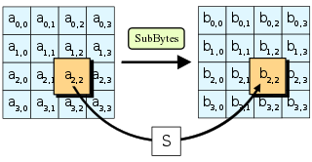

Module Shift_Rows :-
The ShiftRows step operates on the rows of the state ,the bytes in the first row is left unchanged. Each byte of the second row is shifted one to the left. Similarly, the third and fourth rows are shifted by offsets of two and three respectively.

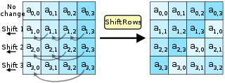

Module Mix_Columns :-
In thi module we multiply the state array with matrix A,

where, 01 :- no change
02 :- perform left shift
03 :- perform XOR of left shift and initial
02 | 03 | 01 | 01
01 | 02 | 03 | 01
01 | 01 | 02 | 03
03 | 01 | 01 | 02

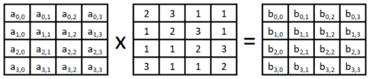

Module Round_Call :-
In this module,
- first we call the Key_Generate module.
- After that we call the Substitute_Byte module with input as plain text
- then on it’s output we call the Shift_Rows module.
- Then we call the Mix_Columns module on output of the Shift_Rows module.
- At last we XOR the output of the Mix_Columns module and the key generated(4 words/128 bits).

Module Round_Call_Last :-
In this module,
- first we call the Key_Generate module.
- After that we call the Substitute_Byte module with input as plain text
- then on it’s output we call the Shift_Rows module.
- At last we XOR the output of the Shift_Rows module and the key generated(4 words/128 bits).

Module S_Box :-
In this we calculate the S-box value using the table,
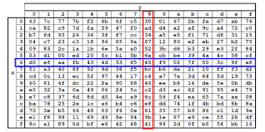

Module Key_Generate:

In module Key_Generate we have to expand the key given as input by the user. Each key given as input consists of 4 words. Since we have 10 rounds and 1 pre-round and each round requires 4 words so we need 44 words for our whole encryption process. These 44 words have to be produced from the words given as input by the user.

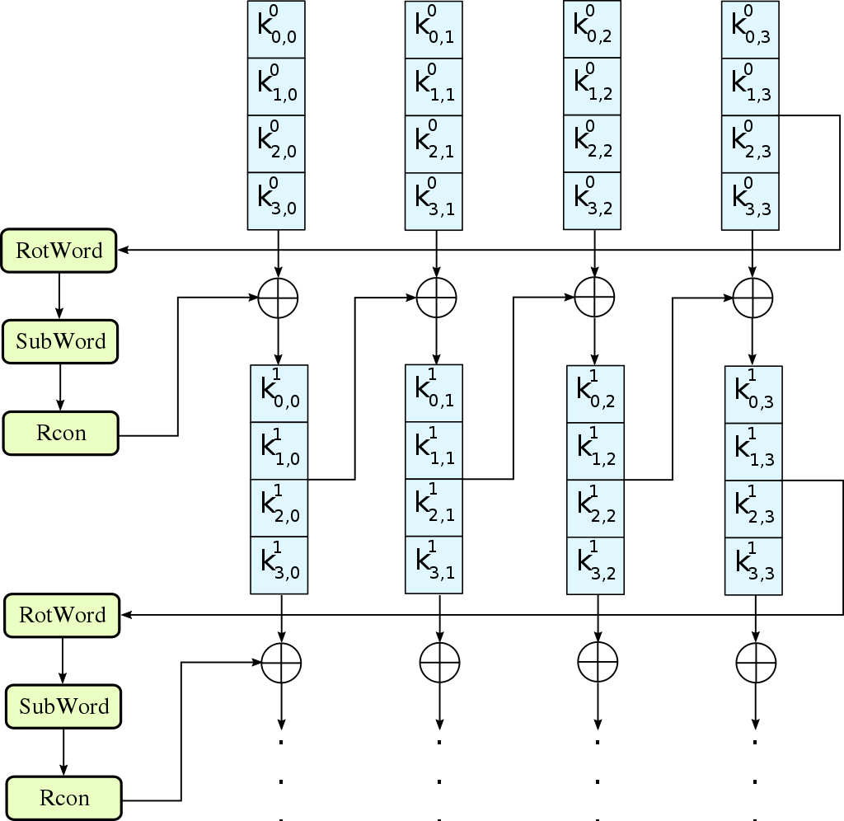

In Key_Generate first we have to generate rcout value using the rc value in hexadecimal. We pass rc value to roundconst module which returns output in rcout.

Then we have to rotate the words by one byte left circular shift.

RotateWord(b0,b1,b2,b3)=(b1,b2,b3,b0)

Then we substitute the values of the above 4 bytes from the sbox and store it in temp.

Now for finding the output we use the below formula to find the next words.

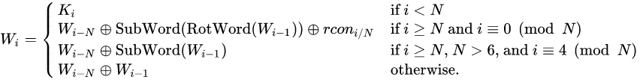

Module roundconst:

This module calculates round constant value using input rc and returns rcout as output according to the following table.

rc | rcout
0 | 01
1 | 02
2 | 04
3 | 08
4 | 10
5 | 20
6 | 40
7 | 80
8 | 1B
9 | 36

Module AES_Encrypt:

This module takes the input data and input key from the user. First it takes XOR of the input data and the key. Then it calls the module Round_Call 9 times. For the last round we call the module Round_Call_Last which encrypts the input data.

