The second synopsis of the project entitled

SyncBag

Submitted in partial fulfillment of the requirements for the degree of

Master’s of Computer Application

*submitted by*

**Salil Sethi**

**(Roll No.: 2011CSC1076)**

*supervised by*

**S. Jaswinder Singh**

Reader

Department of Computer Science & Engineering

Guru Nanak Dev University

Amritsar

*co-supervised by*

**Mrs. Sukhpreet Kaur**

Department of Computer Science & Engineering

Guru Nanak Dev University

Amritsar

2016

DEPARTMENT OF COMPUTER SCIENCE & ENGINEERING

GURU NANAK DEV UNIVERSITY

AMRITSAR(INDIA)

Contents

1. **Revisiting the Problem 4**
   1. Introduction........................................................................................................................4
   2. Problem Definition..............................................................................................................4
   3. Project Plan Adherence.......................................................................................................4
   4. Progress so far.....................................................................................................................4
2. **Detailed Analysis 6**2.1 Problem Details....................................................................................................................6  
   2.2 Inputs, Outputs and Constraints..........................................................................................6  
   2.3 Assumptions.........................................................................................................................8
3. **Design 9**
   1. Database Design.................................................................................................................9
   2. Process Design....................................................................................................................11
   3. Interface Design..................................................................................................................12
   4. Module Design....................................................................................................................14
   5. Report Design......................................................................................................................15
4. **Annexures 16**

4.1 First Synopsis.......................................................................................................................16

List Of Figures

1.3 A gantt chart for Project Plan...................................................................................................24  
3.1 ER-Diagram...............................................................................................................................25  
3.2.1 Level 0 DFD of G-Cloud..........................................................................................................26  
3.2.2 Level 1 DFD of login to cloud server.......................................................................................26   
3.2.3 Level 1 DFD of auto sync mobile data....................................................................................27  
3.2.4 Level 1 DFD of fetching file from cloud..................................................................................27  
3.2.5 Level 1 DFD of pushing file to cloud.......................................................................................28  
4.1 A gantt chart for Project Plan....................................................................................................28  
4.2 A graphical illustration of Agile Model......................................................................................29

Chapter 1

Revisiting the Problem

* 1. Introduction

As described in the first synopsis, SyncBag lets you access your music, photos, documents and more from whatever android device you’re on. It’s easy to set up and use. It acts as a data syncing center for contacts, documents, photos, messages and other data in the memory card of android phone. The app also allows users to wirelessly back up their data which previously a user use to do by manually copying data from phone to pc.

* 1. Problem Definition

SyncBag puts your content on all devices. It does everything automatically like when you buy a new device, you don’t have to copy all the content on it all over again, you just have to install and login through the app and rest it takes care of everything for u. It does so by storing data on remote computer servers for download to multiple android devices and personal computer.

* 1. Project Plan Adherence

As per the plan i had completed with the language learning. I have started working on the project and designing part is completed. Now, i am up for coding. Refer to the **figure 1.3** representing project plan in the form of gantt chart.

* 1. Your Progress so far

I am now in the coding phase, and have completed with the user signup, user login, user home,admin login, admin home, register new device, manage devices screens/webpages for the Web part. And for Android App part i have completed with the user signup, user login, settings, manage devices.

Chapter2

Detailed Analysis   
  
  
2.1 Problem Details

Mobile phones have became a crucial part of our lives these days or we could say a basic necessity of life as they provide us with various features like, easy way of communication, internet access & social media etc. Similarly, the mobile data has became a crucial part of our lives. By mobile data we mean documents, photos, music, etc. So, for ease of access to their device data from anywhere in the world using browser or whatever android device they are on, we have SyncBag.

2.2 Inputs, Outputs and Constraints

User login

|  |  |  |
| --- | --- | --- |
| Inputs | Datatype | Validations/Constraints |
| Username | Varchar(100) | Yes/Required |
| Password | Varchar(100) | Yes/Required |

Output:-

1. If username and password are entered correctly then user login successfully.

2. If username and password do not match then the error message appears.

User Signup

|  |  |  |
| --- | --- | --- |
| Inputs | Datatype | Validations/Constraints |
| Username | Varchar(100) | No/Required |
| Full name | Varchar(100) | No/Required |
| Password | Varchar(100) | No/Required |
| Confirm password | Varchar(100) | Yes/Required |
| Phone number | Varchar(50) | No/Required |
| Security question | Varchar(250) | No/Required |
| Security answer | Varchar(250) | No/Required |
| Email | Varchar(100) | Yes/Required |
| Profile photo | Varchar(100) | No/Required |

Output:-

1. If all the fields are entered correctly then user signed up successfully.

2. If any field having required field validate is left empty then error message appears.

3. If duplicate username is added then the error message appears.

User Forgot Password

|  |  |
| --- | --- |
| Inputs | Outputs |
| Username | Field is must |
| Security Question | Fetched Automatically |
| Security Answer | Field is must |

Output:-

1. If all the fields are entered correctly then user is provided with the password.

2. If any field having required field validate is left empty then error message appears.

3. If any input entered is incorrect then the error message appears.

User Change Password

|  |  |
| --- | --- |
| Inputs | Outputs |
| Username | Fetched automatically |
| Old password | Field is must |
| New password | Field is must |
| Confirm password | Field is must / Password do not match |

Output:-

1. If old, new and confirm password entered correctly then password will be changed successfully.

2. If old password do not match then error message appears.

3. If any field is left empty then error message appears.

4. If new password and confirm password do not match then error message appears.

2.3 Assumptions

For this project to execute, there are some conditions and assumptions to be made for the users to keep in mind. Some requirements are very important which can’t be rejected.

1. Internet Connecton: It is assumed that the devices using this project should internet connection, it can either be the Wi-Fi or the Mobile data. Only using internet, the user can backup/restore their data like music,videos,images, contacts, calllogs, messages.

2. Internet Speed: It is assumed that the speed of the Internet is high for high speed backup and restore feature.

3. GPS Toggle Button: The device used by the user should also have the GPS toggle button, nothing but the feature which tracks the location of the user and gets the direction where the user has to travel. This button is must for the user to track the location. So it is assumed that this project will also run without GPS feature if the user doesn’t need to find the current location.

Chapter 3

Design

3.1 Database Design

Admin table

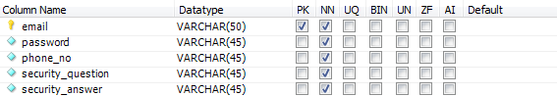

User table

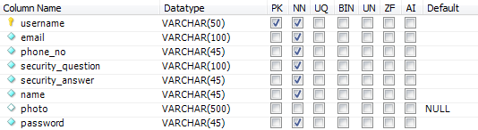

Device table

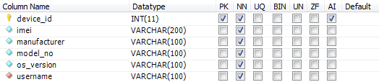

Calllog table

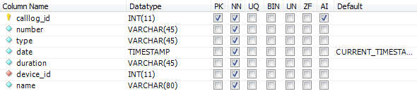

Messages table

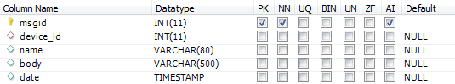

Contacts table

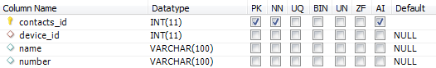

Music table

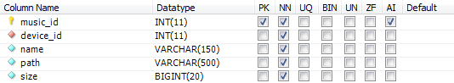

Videos table

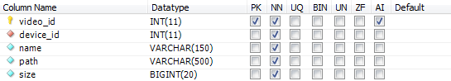

Images table

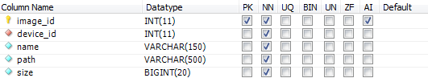

Location table

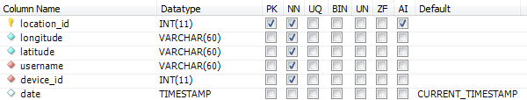

Refer to the figure 3.1 representing ER-Diagram.

3.2 Process Design

**Level 0** : G-Cloud

Refer to the figure 3.2.1 representing level 0 DFD of G-Cloud.

**Level 1** : Login to Cloud Server

Refer to the figure 3.2.2 representing level 1 DFD of login to cloud server.

**Level 1** : Auto Sync Mobile Data

Refer to the figure 3.2.3 representing level 1 DFD of auto sync mobile data.

**Level 1** : Fetching file from Cloud

Refer to the figure 3.2.4 representing level 1 DFD of fetching file from cloud.

**Level 1** : Pushing file to Cloud

Refer to the figure 3.2.5 representing level 1 DFD of pushing file to cloud.

3.3 Interface Design

SyncBag has 2 interfaces through which a user interacts with it. One is the Android Mobile App and the other is the Web Interface.

For web part :

1. user signup page

|  |  |
| --- | --- |
| **User Signup** | |
| Name |  |
| Username |  |
| Password |  |
| Email |  |
| Phone no |  |
| Photo |  |
| Security Question |  |
| Security Answer |  |
|  | Signup |

1. user login page

|  |  |
| --- | --- |
| **User Login** | |
| Username |  |
| Password |  |
|  | Login |
|  | Forgot Password? |

1. a user homepage where the user could perform various activities like :

* Register device manually;

|  |  |
| --- | --- |
| **Register New Device** | |
| IMEI |  |
| Manufacturer |  |
| Model No |  |
| OS Version |  |
|  | ADD |

* manage registered devices, where user can edit or delete the registered device, also can view the content of registered devices such as contacts, calllogs, messages, music, videos, images;

|  |  |  |  |  |  |  |  |
| --- | --- | --- | --- | --- | --- | --- | --- |
| **IMEI No** | **Manufacturer** | **Model No** | **OS Version** | **Device** | **Edit** | **Remove** | **View** |
| 359301058205518 | Moto | XT1022 | 5.1 | DeviceIcon | Edit | Remove | View |
| 352302078517823 | Samsung | SMG531F | 5.1.1 | DeviceIcon | Edit | Remove | View |

.

For app part :

1. user signup activity

|  |  |
| --- | --- |
| **User Signup** | |
| Name |  |
| Username |  |
| Password |  |
| Email |  |
| Phone no |  |
| Photo |  |
| Security Question |  |
| Security Answer |  |
|  | Signup |

1. user login activity

|  |  |
| --- | --- |
| **User Login** | |
| Username |  |
| Password |  |
|  | Login |
|  | Signup |

1. user home activity where the user could perform various activities like :

* manage registered devices;

|  |  |  |
| --- | --- | --- |
| **DeviceIcon** | **Manufacturer** |  |
| **Model no** | **OS** |
| DeviceIcon | Moto |  |
| XT1022 | 5.1 |

* can change settings for taking backup for the device;

|  |  |
| --- | --- |
| Last sync on | |
| 18/11/2016 | |
| Location | On/off |
| Contacts | On/off |
| Calllog | On/off |
| Messages | On/off |
| Music | On/off |
| Videos | On/off |
| Images | On/off |

* can restore whatever they want, to their current device by simply selecting items to restore;

|  |
| --- |
| Location |
| Contacts |
| Calllog |
| Messages |
| Music |
| Videos |
| Images |
| **RESTORE** |

3.4 Module Design

User module :

For web part :-

* User can register their device manually;
* User can view their registered devices;
* User can edit or delete the registered device;
* User can access the data of their registered device, i.e. they can view contacts, calllogs, messages, music, videos, images.

For app part :-

* User can view their registered devices;
* User can take backup for the device;
* User can restore backup to the device;
  1. Report Design

1. The report is documented according to the development of the project.
2. This contains the inputs, output of the project from which the programmer can get ideas of improvement.
3. This report has the details about the ER Diagrams, Data Flow Diagrams which concludes the database design and the process flow design of the project.
4. This report contains all the required things for the fulfillment of the project. This project is fully developed according to this design only.
5. The music table contains all the music files uniquely identified by device id; similarly for images, videos, messages, contacts, calllogs, and locations we have tables containing details for each device entry.
6. The user table holds all the registered user details as username,password, email, phone no,security question, security answer, name, photo.
7. The device table holds the details of all the registered devices as imei no, manufacturer, model no, os version uniquely identified by device id for each user.

Chapter 4

Annexures   
  
4.1 First Synopsis

The Problem

Introduction

Mobile phones have became a crucial part of our lives these days or we could say a basic necessity of life as they provide us with various features like, easy way of communication, internet access & social media etc. Similarly, the mobile data has became a crucial part of our lives. By mobile data we mean documents, photos, music, etc. So, for ease of access to their device data from anywhere in the world using browser or whatever android device they are on, we have SyncBag.

SyncBag lets you access your music, photos, documents and more from whatever android device you’re on. It’s easy to set up and use. It acts as a data syncing center for contacts, documents, photos, messages and other data in the memory card of android phone. The app also allows users to wirelessly back up their data which previously a user use to do by manually copying data from phone to pc.

Problem Definition

SyncBag puts your content on all devices. It does everything automatically like when you buy a new device, you don’t have to copy all the content on it all over again, you just have to install and login through the app and rest it takes care of everything for u. It does so by storing data on remote computer servers for download to multiple android devices and personal computer.

Brief Analysis

We will be using Java and Android as front end and MySQL as back end. SyncBag has 2 interfaces through which a user interacts with it. One is the Android Mobile App and the other is the Web Interface. The various features are as follows:

* Creating Cloud Server
* Managing users on the cloud
* Managing devices (Mobiles/Tablets) per user
* Creating cloud client for Android
* Creating background service for cloud sync.
* Creating web interface for cloud
* Creating auto backup module for contacts.
* Creating auto backup module for sms.
* Creating auto backup module for sdcard content.
* Accessing devices data from anywhere in the world using browser.
* Searching contacts in the web interface
* Reading/Searching sms data in web interface
* Downloading content of sdcard in web interface.
* Finding location of the phone using web interface.

Project Plan  
  
  
Project Plan includes the following steps:  
a) Research & Planning  
b) Learning Language  
c) Project Discussion & Finalization  
d) Coding & Testing  
e) Final Submission  
  
Refer to the figure 4.1 representing project plan in the form of gantt chart.

Resourses Needed

HARDWARE REQUIREMENTS

Hardware requirements include that hardware which is required for its working. It includes:

* Computer 1.5 Ghz or faster : The minimum processor required for smooth execution of the softwares.
* RAM 2GB or more : The minimum RAM required for smoother execution of the softwares, as Android Studio(IDE) takes minimum of 800MB, AVD takes minimum of 1GB, and their are some more applications to be used like Browser, Netbeans(IDE),etc.
* Disk space 2GB or more : The minimum disk space required for installation of the softwares like Android studio, Netbeans, MySQL Workbench.
* High Speed Internet Connection(DSL/Cable) : High speed internet connection is required as our project requires a internet connection.
* Any Smartphone with Android API 2.3 or higher : An android phone is required for testing and presenting the application.

SOFTWARE REQUIREMENTS

The technical specifications of requirements for the software are as follows:

* Any Operating System (Windows, Linux, MAC) : An Operating System is required.
* Java Development Kit (JDK) : Java Development Kit is required for IDEs; Android studio, Netbeans.
* Eclipse/Android Studio (IDE) : An IDE is required for application development i.e. the platform where the project is coded.
* Android SDK (Android software development kit) : Android software development kit is required.
* Android API (2.3) : An API specifies how software components should interact and APIs are used when programming graphical user interface (GUI) components. In our case we require Android API (2.3) or higher.
* AVD (Android Virtual Device) plugin for Testing Application on desktop.
* Any web browser(Chrome , Firefox , etc) for testing webpages of the project and accessing internet.

Analysis   
  
Model Used : Agile Model

Agile SDLC model is a combination of iterative and incremental process models with focus on process adaptability and customer satisfaction by rapid delivery of working software product.Agile Methods break the product into small incremental builds. These builds are provided in iterations. Each iteration typically lasts from about one to three weeks. Every iteration involves cross functional teams working simultaneously on various areas like planning, requirements analysis, design, coding, unit testing, and acceptance testing.At the end of the iteration a working product is displayed to the customer and important stakeholders.

Agile model believes that every project needs to be handled differently and the existing methods need to be tailored to best suit the project requirements. In agile the tasks are divided to time boxes (small time frames) to deliver specific features for a release. Iterative approach is taken and working software build is delivered after each iteration. Each build is incremental in terms of features; the final build holds all the features required by the customer.Figure-4.2, illustrates the Agile Model.

Agile thought process had started early in the software development and started becoming popular with time due to its flexibility and adaptability. The most popular agile methods include Rational Unified Process (1994), Scrum (1995), Crystal Clear, Extreme Programming (1996), Adaptive Software Development, Feature Driven Development, and Dynamic Systems Development Method (DSDM) (1995). These are now collectively referred to as agile methodologies, after the Agile Manifesto was published in 2001.

Following are the Agile Manifesto principles:

Individuals and interactions - in agile development, self-organization and motivation are important, as are interactions like co-location and pair programming.

Working software - Demo working software is considered the best means of communication with the customer to understand their requirement, instead of just depending on documentation.

Customer collaboration - As the requirements cannot be gathered completely in the beginning of the project due to various factors, continuous customer interaction is very important to get proper product requirements.

Responding to change - agile development is focused on quick responses to change and continuous development.

**Advantages of Agile model:**

a. Customer satisfaction by rapid, continuous delivery of useful software.

b. People and interactions are emphasized rather than process and tools. Customers, developers and testers constantly interact with each other.

c. Working software is delivered frequently (weeks rather than months).

d. Face-to-face conversation is the best form of communication.

e. Close, daily cooperation between business people and developers.

f. Continuous attention to technical excellence and good design.

g. Regular adaptation to changing circumstances.

Training Organization

VMM Education’s journey started in January 2005 with a vision of bringing computer education of global standard to the holy city of Amritsar. To turn this dream into reality we create a talent pool of bright young minds who would power the engines of growth of the global economy. Today seven years later VMM Education or VMM, as it is popularly known, is the largest and the most trusted computer centre of the region, with annual turn out of more than 1000 students. The reason for the success of VMM is simply the “Hard work” that our team has put in these seven years.

**VMM Education:**

VMM Education provides world class training in global technologies such as .Net and Linux, while keeping our syllabus up to date with the current industry standard. We have managed to successfully train more than 7000 engineers who are currently working in Global Multinationals like TCS, Tech Mahindra, Infosys, CSC etc.

VMM is today the favorite choice of students of various engineering college for pursuing their six months or six weeks industrial training .A unique “industry-endorsed curriculum,” crafted by professionals of VMM which enhances the job-readiness and employability of learners and equips them for the IT Industry.

To provide IT education which can match with the global IT standards, VMM also undertakes industrial projects from UK & USA under the banner of Venus Software Solutions like im4schools.co.uk and many more. This allows our students to work on the live projects and make projects for the industry. Some of our products include Point of sale software for Super Markets with barcode reader support, Finger print attendance Management System that works for schools, colleges and other institutes, Remote LAN Controller which is used to view remote desktops on LAN or WAN.

VMM has the world class computer labs that are equipped with the latest Hardware and software so that the students can do practical without any hindrance.We continuously upgrade our hardware and software’s every 6 months.

Attendance of students is one of the major features of VMM, students are required to record their day to day attendance using Biometric Finger-print Recognition device. This allows us to provide accurate attendance of students to their parents and college during their training time.

**Some Key learning solutions for Individuals include the following:**

**Foundation course**

This course includes two languages C and C++ that allows us to build a strong foundation of programming for the beginner and First year & Second year engineering graduates.

**Six Weeks Industrial training**

This training program which is of 42 working days allows the 3rd year engineering graduates to get hands on experience on either of the following technologies VB.Net ,C#.Net & SQL. This training is pretty intensive as the students are required to spend 4-8 hours at the institute learning any one of the above languages along with developing a project by working in team. This allows students to learn how to work as team member and also gets hands on training on the latest technology.

**Six Months Industrial Training**

Doing your six months industrial training at VMM is a very special experience for any engineering graduate as it allows the students to nurture his / her of knowledge by working on Technologies like ASP.Net, Silverlight, AJAX etc. The candidate is required to spend almost whole day at institute doing their Lab practical or attending their tutorial lecture and developing a project which they can submit in their college as a part of dissertation.

**7 Months Project Training**

This program is for the final year BCA students who can learn latest technologies like VB.Net, C#.Net, ASP.Net and make their project.

**Individual Skill enhancement programs**

Apart from above training program VMM provides a bouquet of courses in windows application development using VB.Net/C#.Net, Web Development using ASP.Net .

Our Department

**DCSE (Department of Computer Science)**

Our department(DCSE) also known as Maharaja Ranjit Singh Bhawan is one of the oldest building, having a good infrastructure. The department offers two courses : MCA (TYC) and MCA (FYIC). Syllabus for the new classes are well revised and updated according to the needs.

Our department has a good faculty, ready to help in any situation. They take a personal approach to provide the highest quality education to the students, teaching each and every concept very well. Their dedication is toward helping students understand the topic, rather than cramming it.

In addition to the main library, there is a separate department library where students can issue books anytime to learn or to refer any topic according to their desire. Also, there are five computer labs at present working to provide practical knowledge to all the students, in programming, networking and other hardware specializations. Our department is very much helpful in every way and we appreciate this warm, friendly atmosphere of the department.

Progress so far

As a trainee in the last semester of my degree MCA [FYIC], I am now in the analysis phase, knowing all the requirements for the project, studying the causes and the effects of the project very well and learning the language to know how to code/program a given module in an efficient manner.

Analysis is the core part of the SDLC (Software Development Life Cycle), during which the major requirements are discussed so that a proper cut-out can be designed before the start of the programming. Without knowing what to prepare or what to program, or not having the proper design of the project is not a desirable act.

Figure 1.3 : Gantt Chart for Project Plan

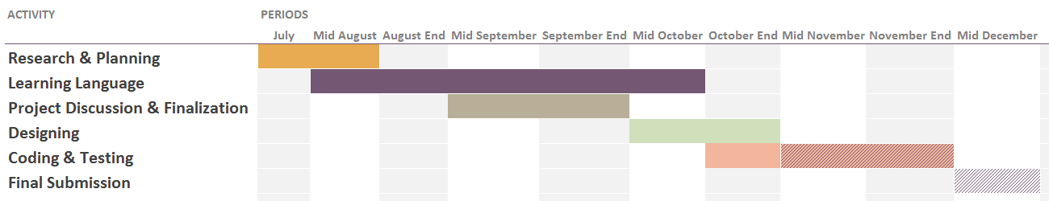

Figure 3.1 : ER-diagram

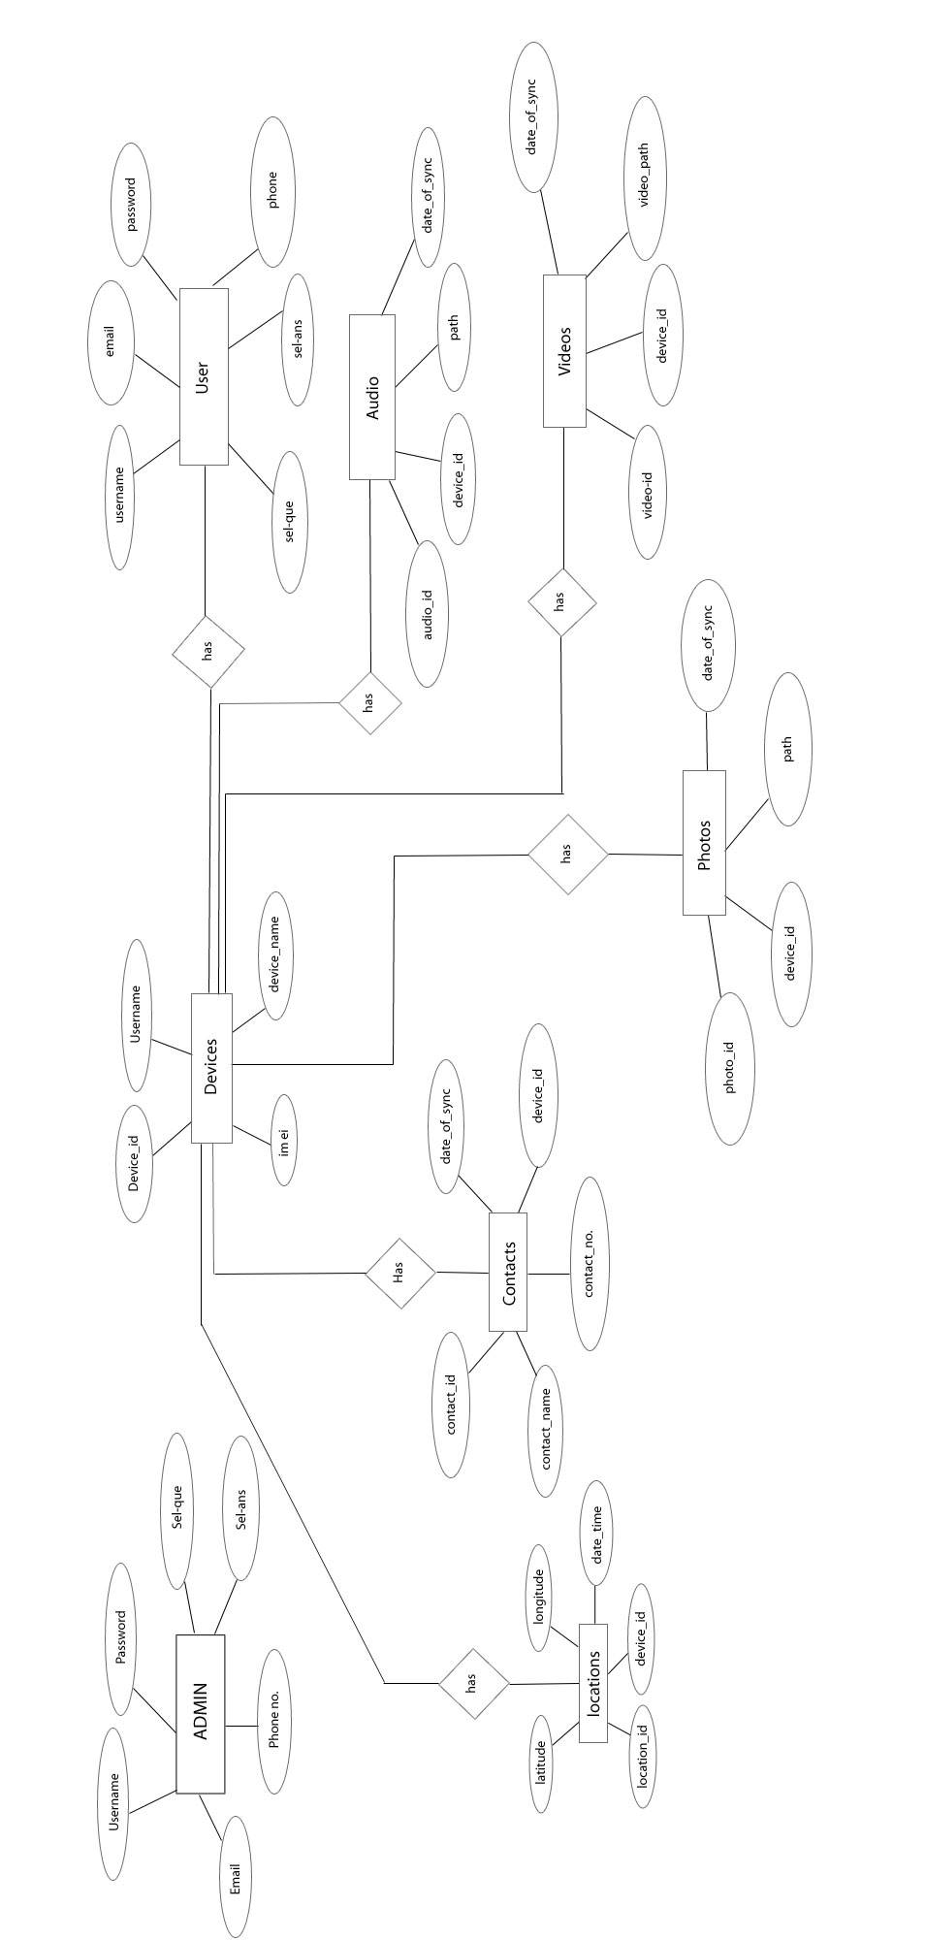

Figure 3.2.1 : Level 0 DFD of G-Cloud

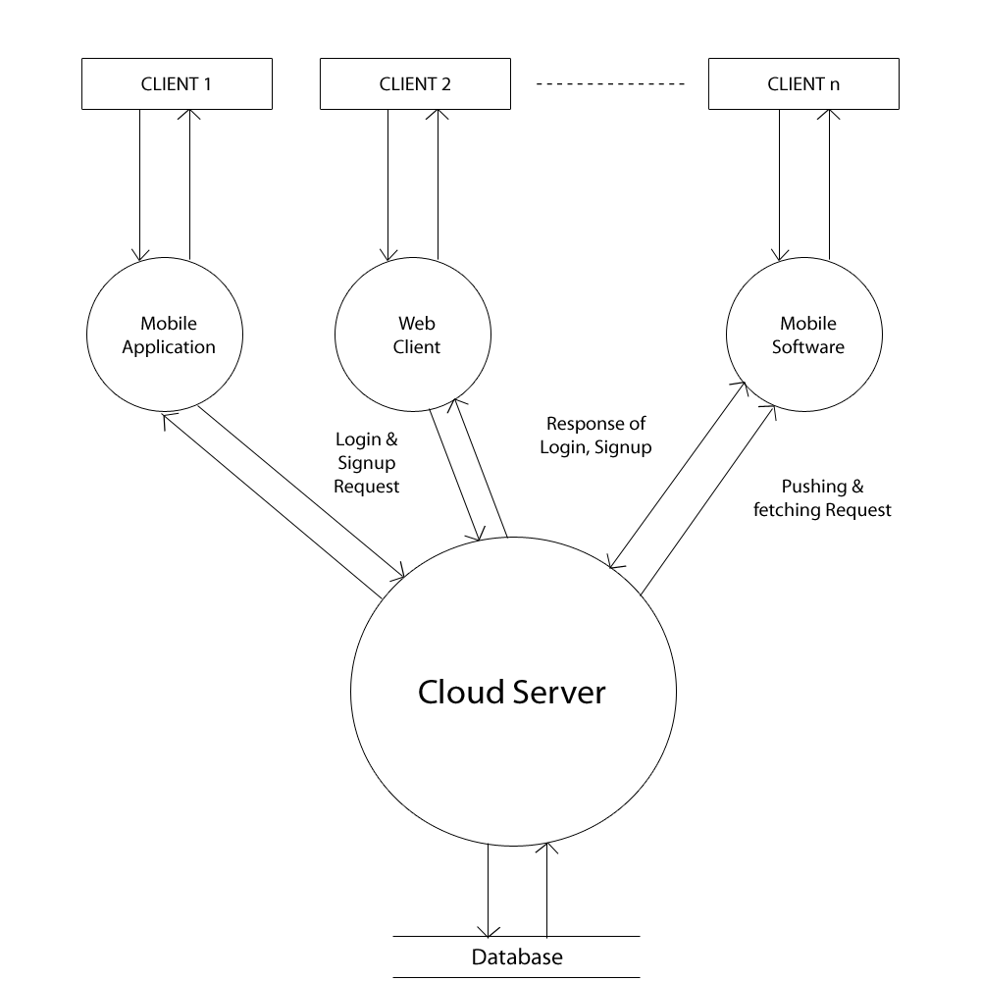

Figure 3.2.2 : Level 1 DFD of login to cloud server

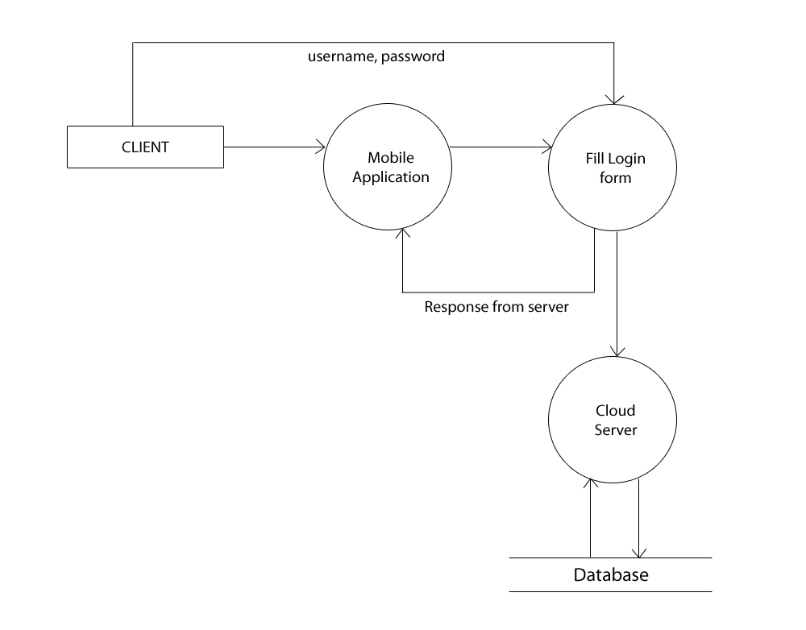

Figure 3.2.3 : Level 1 DFD of auto sync mobile data

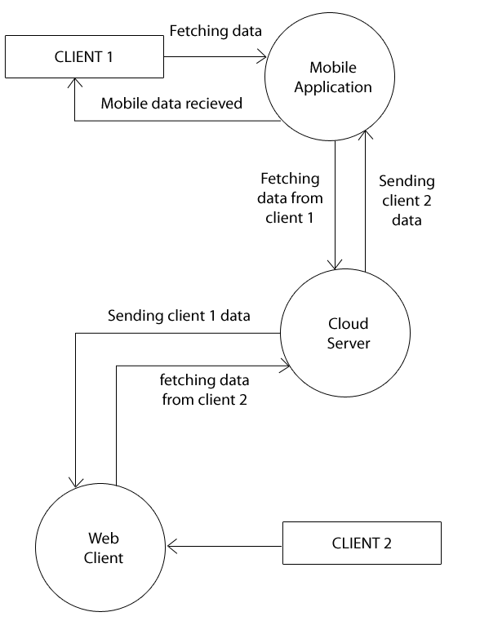

Figure 3.2.4 : Level 1 DFD of fetching file from cloud

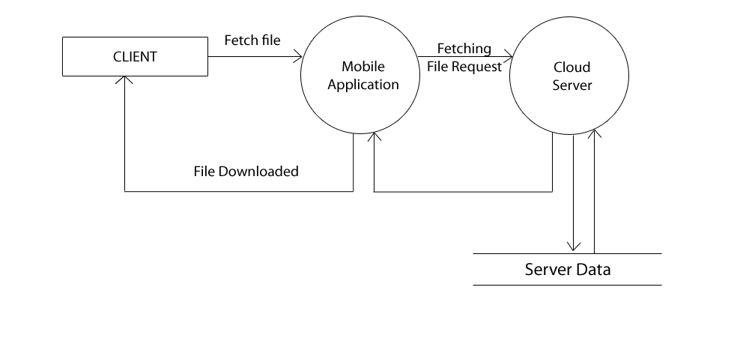

Figure 3.2.5 : Level 1 DFD of pushing file to cloud

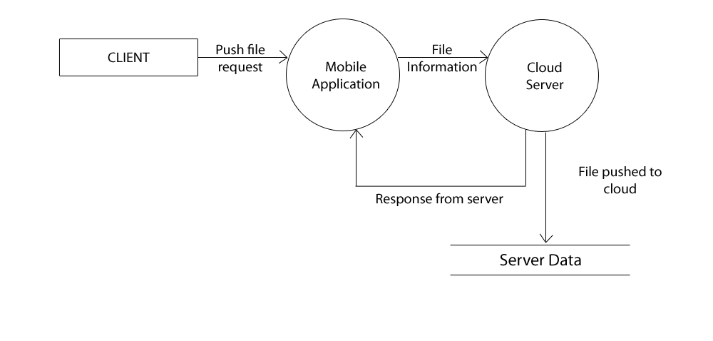

Figure 4.1 : Gantt Chart for Project Plan



Figure 4.2 : A graphical illustration of Agile Model

