Hidden Groundwater Contamination Patterns in Tamil Nadu Using Python
CGWB groundwater data | Tamil Nadu | 433 records | 25 districts | 2020–2023 acquisition years

Project Overview
Identify unusual groundwater measurements and prioritize follow-up testing using evidence from sampled locations.

Key Findings
- pH: 431/433 samples (99.54%) within 6.5–8.5; 2 below.
- Hardness: Dharmapuri median ~640 mg/L vs Kanyakumari ~120 mg/L.
- EC–TDS: r ≈ 1.00 across 143 paired measurements; requires validation.
- Data gaps: TDS missing in 290 records; uranium in 291; only 4 records in 2023.

Monitoring Decision
Verify unusual readings, prioritize repeat testing at affected sampling sites, and improve chemical and yearly coverage. Acquisition years may not equal sampling years; results do not establish district-wide safety.

Visualization 1 — Groundwater pH Distribution
Objective: Identify pH measurements outside the 6.5–8.5 reference range.
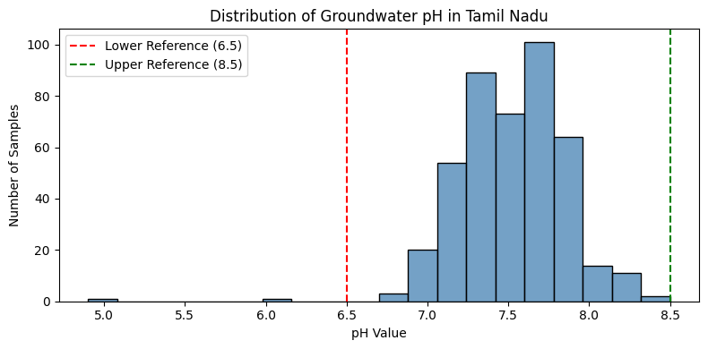
Interpretation: Median pH 7.50 (range 4.90–8.50); 431/433 samples (99.54%) within range, 2 (0.46%) below, none above.
Key Insight: Only two recorded samples fall outside the selected pH range.
Business Insight: Retest the two low-pH locations; continue routine monitoring elsewhere.

Visualization 2 — TDS Distribution
Objective: Identify unusually high TDS measurements and assess data coverage.
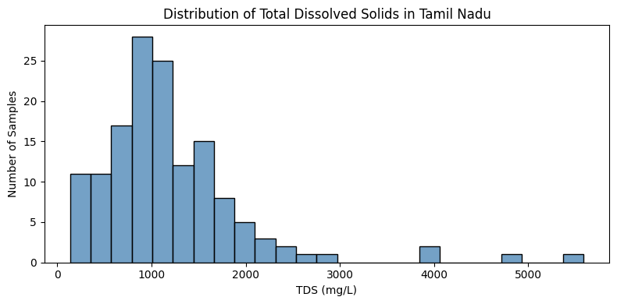
Interpretation: TDS measured in 143/433 samples (33.0%); median 1,036 mg/L, mean ~1,190 mg/L, maximum 5,588 mg/L. Distribution is right-skewed.
Key Insight: A few samples have substantially elevated TDS; 290 records (67.0%) lack measurements.
Business Insight: Retest high-TDS locations and expand TDS sampling before drawing district-wide conclusions.

Visualization 3 — Uranium Distribution
Objective: Identify unusually elevated uranium readings and measurement gaps.
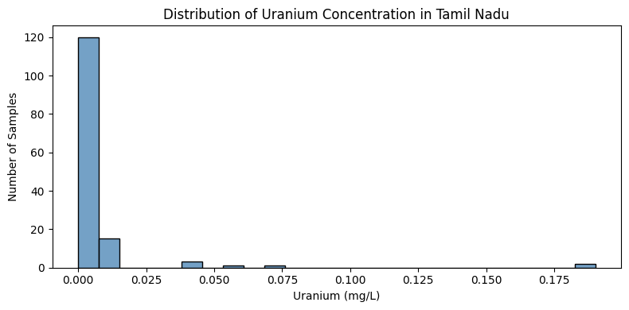
Interpretation: Uranium measured in 142/433 records (32.8%); maximum 0.19 mg/L; skewness 6.63.
Key Insight: A few readings are unusually high; 291 records (67.2%) have no uranium result.
Business Insight: Verify the highest readings and expand uranium sampling before assessing risks.

Visualization 4 — Groundwater Sample Count by District
Objective: Assess district-level monitoring coverage.
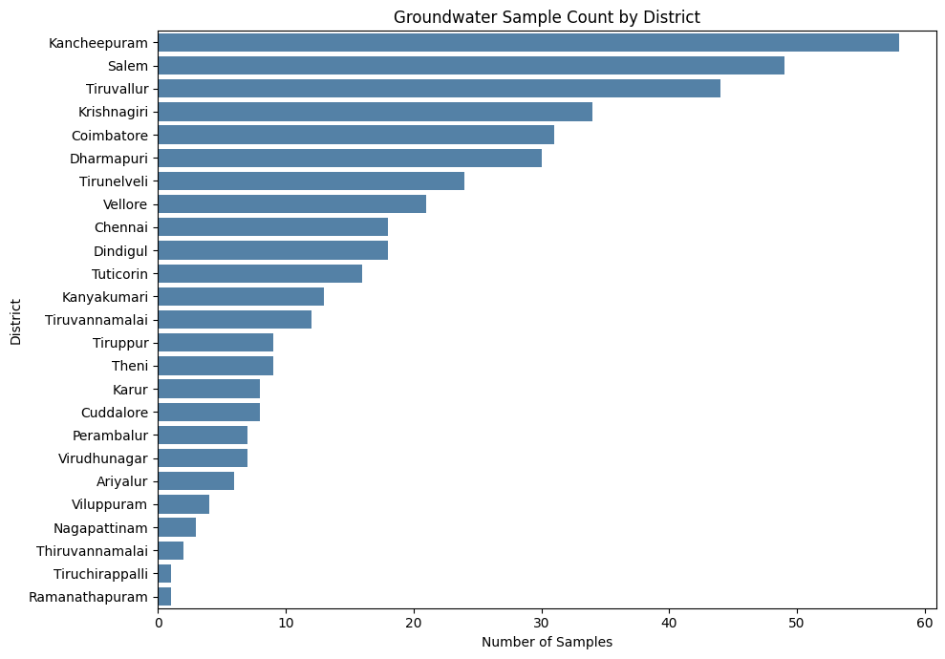
Interpretation: 433 records span 25 districts (17.3 per district on average). Kancheepuram has the most; Ramanathapuram and Tiruchirappalli have comparatively few.
Key Insight: Unequal sample coverage weakens direct district comparisons.
Business Insight: Increase sampling in underrepresented districts and set consistent coverage targets.

Visualization 5 — pH Category Distribution
Objective: Quantify results within and outside pH 6.5–8.5.
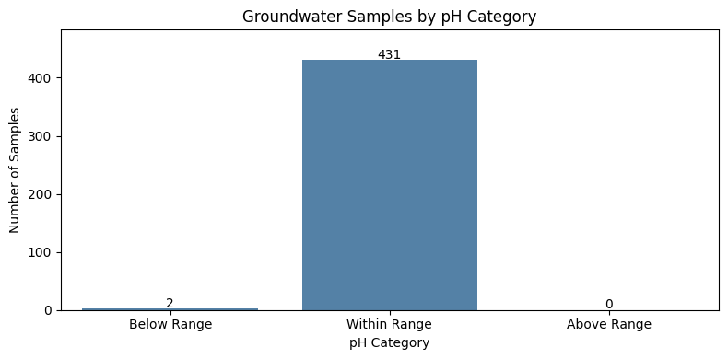
Interpretation: 431/433 (99.54%) within range; 2 (0.46%) below; none above.
Key Insight: Only two sampled locations need low-pH follow-up.
Business Insight: Retest those two locations; assess other chemicals before judging water suitability.

Visualization 6 — District-wise Median Hardness
Objective: Locate districts with relatively high recorded hardness.
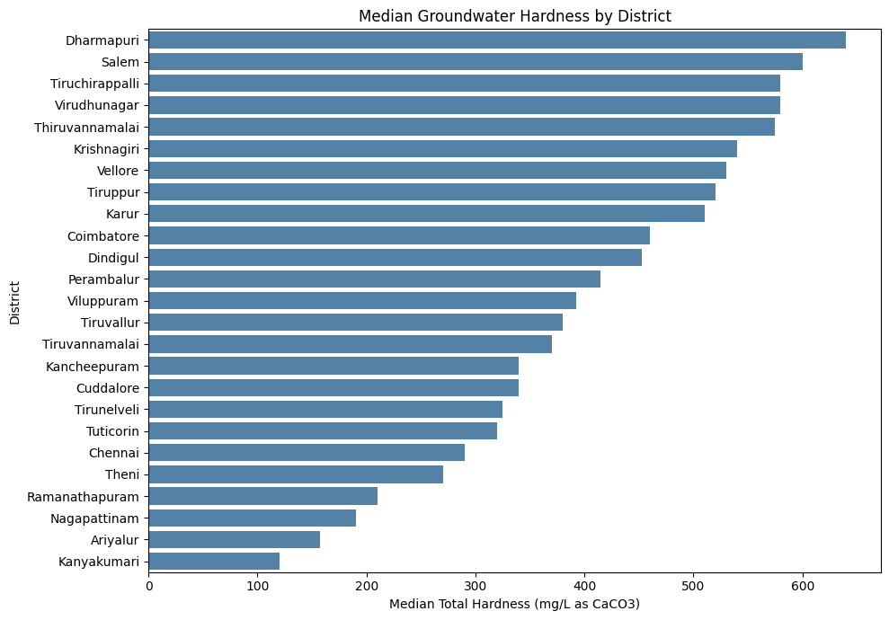
Interpretation: Dharmapuri median ~640 mg/L; Salem ~600 mg/L; Kanyakumari ~120 mg/L. Dharmapuri is ~5.3 times Kanyakumari.
Key Insight: Large differences exist between sampled district medians.
Business Insight: Prioritize repeat hardness tests at relevant Dharmapuri and Salem sites.

Visualization 7 — Electrical Conductivity vs TDS
Objective: Assess whether EC can support TDS screening.
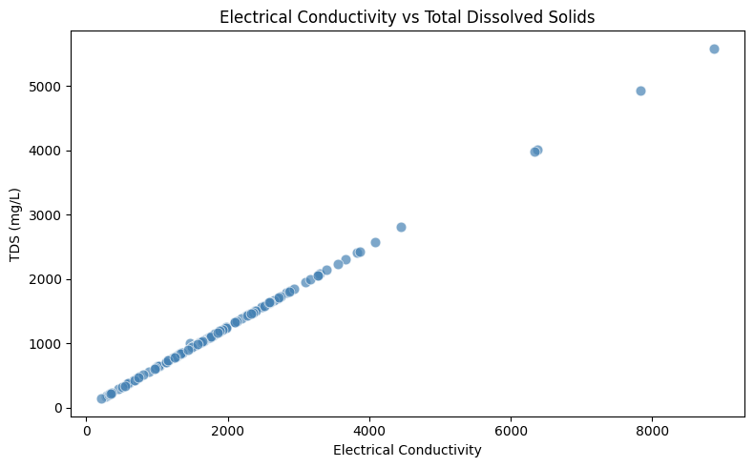
Interpretation: EC and TDS correlate at approximately r = 1.00 across 143 paired records.
Key Insight: Higher EC tracks higher TDS in the measured subset.
Business Insight: Use EC to prioritize confirmatory TDS tests, after further validation.

Visualization 8 — Year-wise Median Hardness
Objective: Compare hardness across data acquisition years.
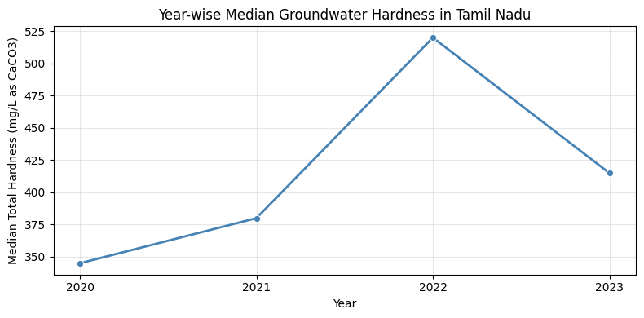
Interpretation: Median hardness: 2020 ~345, 2021 ~380, 2022 ~520, 2023 ~415 mg/L. Year 2023 has only 4 records.
Key Insight: 2022 is highest in this dataset; uneven coverage prevents trend claims.
Business Insight: Repeat sampling at elevated sites and standardize annual monitoring.

Visualization 9 — District-wise Median Uranium
Objective: Compare uranium measurements where district data exist.
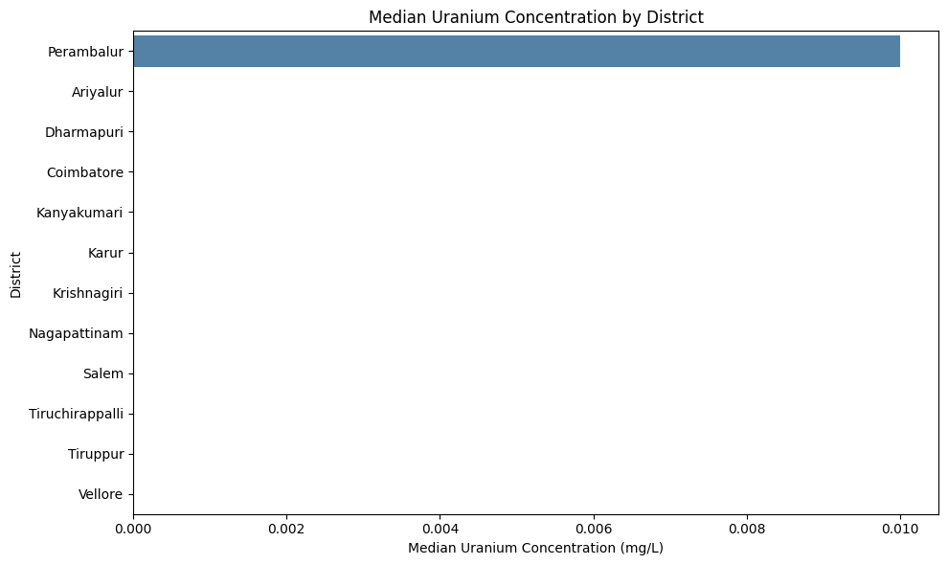
Interpretation: Perambalur has the highest district median (~0.010 mg/L) among 12 districts with uranium measurements.
Key Insight: Coverage is limited; district medians do not establish contamination.
Business Insight: Verify elevated sites and expand uranium testing in unmeasured districts.

Visualization 10 — Chemical Correlation Heatmap
Objective: Identify associations that can guide chemical follow-up tests.
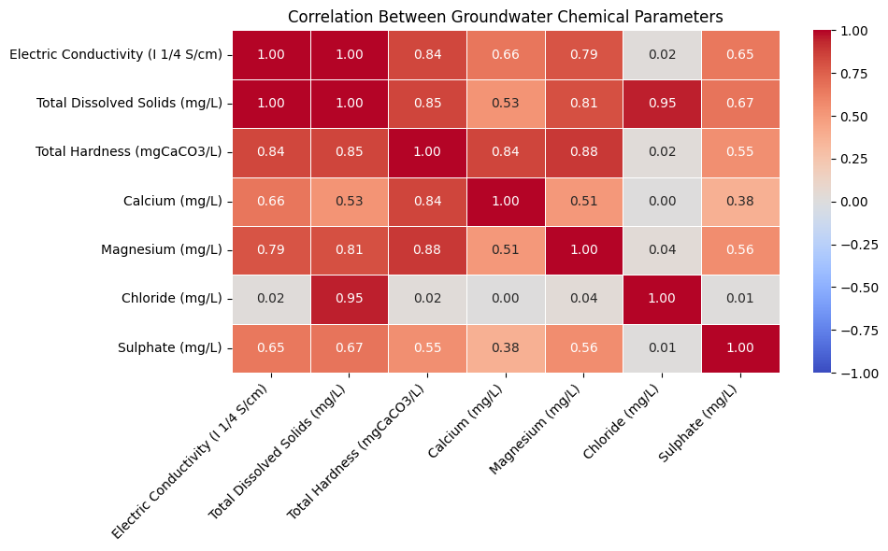
Interpretation: EC–TDS ~1.00; TDS–Chloride ~0.95; Hardness–Magnesium ~0.88; Hardness–Calcium ~0.84.
Key Insight: Dissolved solids and hardness-related chemicals are strongly associated in available pairs.
Business Insight: Use EC for initial screening and test calcium/magnesium at high-hardness sites.

Visualization 11 — District Chemical Profile Heatmap
Objective: Compare relative chemical patterns by district.
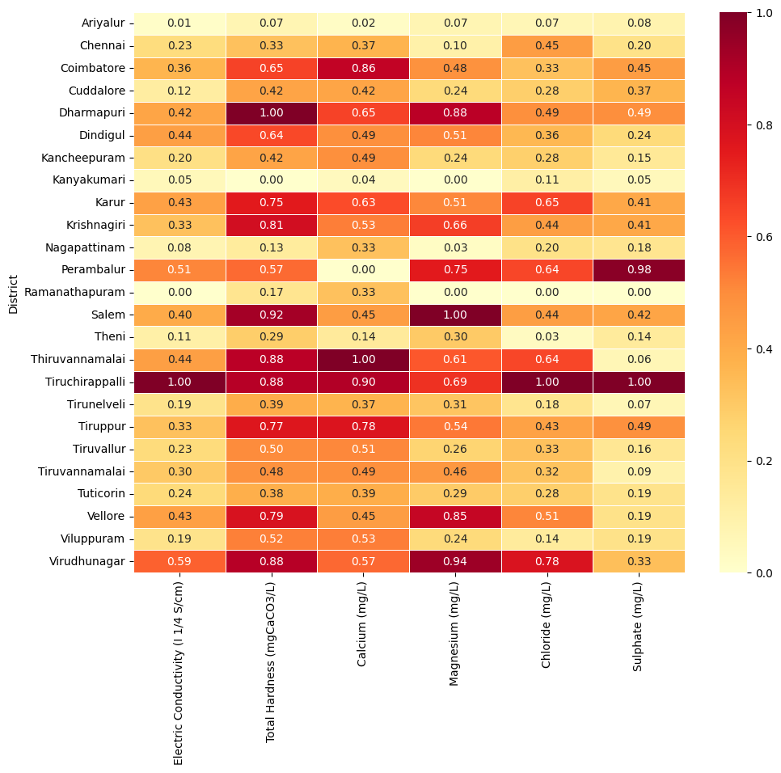
Interpretation: Normalized 0–1 profiles show relatively high EC, chloride and sulphate in Tiruchirappalli; calcium and magnesium in Salem; sulphate in Perambalur.
Key Insight: Monitoring priorities differ by chemical and district; normalization is not a safety threshold.
Business Insight: Target these parameters for confirmation using original concentrations.

Visualization 12 — District × Year Median Hardness Heatmap
Objective: Identify district-year combinations with elevated recorded hardness.
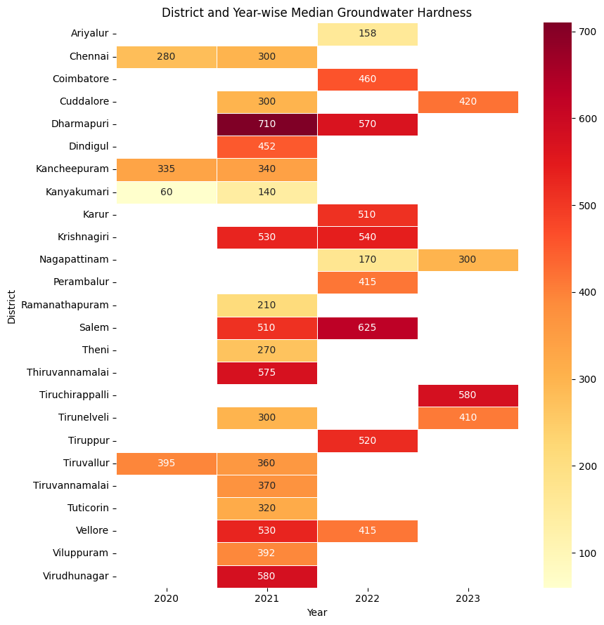
Interpretation: Dharmapuri 2021 ~710 mg/L; Salem 2022 ~625; Tiruchirappalli 2023 ~580; Kanyakumari 2020 ~60.
Key Insight: Coverage varies by year; 2023 has only 4 records overall.
Business Insight: Retest elevated sites and collect comparable samples across years.

Final Conclusion & Future Enhancements

Conclusion
Across 433 records from 25 districts, 431 samples (99.54%) fall within the selected pH range. Recorded median hardness differs from ~120 mg/L in Kanyakumari to ~640 mg/L in Dharmapuri. EC and TDS are strongly associated (r ≈ 1.00, 143 pairs), but roughly 67% of records lack TDS or uranium results and only four records are available for 2023.
Decision: Verify unusual readings, prioritize testing at affected sampled sites, and improve chemical and yearly coverage. These results do not establish district-wide water safety.

Future Enhancements
- Expand TDS and uranium testing and balance district coverage.
- Capture verified sampling dates and repeat measurements consistently.
- Add GIS mapping to identify location-specific monitoring gaps.
- Build an interactive monitoring dashboard; consider forecasting only after adequate historical data are available.

