INDUSTRIAL TRAINING REPORT

**On**

**Gloom**

**Submitted by**

**Mrinmay Bala**

**Vishal Singh**

**Snehil**

Department of Computer Engineering & Applications

**Institute of Engineering & Technology**



**GLA University**

**Mathura- 281406, INDIA**

**2020**

**Gloom**

Submitted for the partial fulfillment of

Bachelor of Computer Science

**Submitted To: Submitted By:**



**Synopsis**

**Student Information:**

|  |  |
| --- | --- |
| Name: Mrinmay Bala | University Roll. No. 181500396 |
|  | Email: mrinmay.bala_cs18@gla.ac.in |
|  |  |
| Name: Vishal Singh | University Roll. No. 181500806 |
|  | Email: vishal.singh_cs18@gla.ac.in |
|  |  |
| Name: Snehil | University Roll. No. 181500716 |
|  | Email: snehil.gla_cs18@gla.ac.in |

**Project Information:**

|  |  |
| --- | --- |
| Title Of Project/Training/Task | Gloom |
| Role & Responsibility | Designing characters , environment , activites , scoring and progression |
| Technical Details | Hardware Requirements:  Requires a 64-bit processor and operating system  OS: Windows 10 64bit  Processor: Intel Core i5 or AMD equivalent  Memory: 8 GB RAM  Graphics: NVIDIA GTX 660 or AMD Radeon HD 7950 or Intel HD 630  Network: Broadband Internet connection  Storage: 2 GB  Software Requirements:  Unity Game Development  Adobe Illustrator  Adobe Photoshop  Visual Studio |
| Training Implementation Details | Fully Implemented |

**Summary of the Work:**

|  |
| --- |
| The objective of the project is to make the students enrolled in the course get a high end idea on the topic “Game development” . As a player proceeds further their main goal of the project is to clear a certain area filled with both dynamic and static obstacle in addition to gathering collectibles.  It uses Unity engine as the main game development software in order to build and run the game . Moreover along with Unity engine , Visual Studio is used to script the game using the language C sharp . For the environment ,designing and character building , Adobe photoshop and illustrator have been used .  The basic steps included creating the player , designing the environment , making a movable background , adding movement to the main player, generating obstacles and creating a start menu that acts as a link in between player and the project . |

**Acknowledgements**

This project is an acknowledgement to the intensity drive and technical competence of many persons who have contributed to it.

I express my heartiest gratitude and deepest thanks to EDU CBA , the head organisation of unity 2D environment analyst of the world renowned game “Shovel Knight” for its proper guidance, suggestions and helping me in completing the project.

I am very grateful to the Staff and Faculty Members of our college.

I am highly grateful to my parents who have been the source of money and encouragement during the course of my work.

Thanking You:

EDU CBA

**Abstract**

The proposed game will be a computer game version of a 2D basic side-scroller platformer game . Players will be able to play the Gloom game in the single player style known as hot seat, where users take turns at the same computer. The game will allow from two to six players to play but the turn will have to be individual . The game will not deal with in artificial intelligence and will solely be intended for competitive single player use in order to break high scores . Due to the nature of the game, the graphics will be in two done in 2D and offer a layout and feel similar to that of the platformer game .

The main menu will be the user’s guide to the game where users will be able to change the in-game settings as per there comfort .

Users will also be able to toggle full screen and will be able to change graphics and resolution of the game.

**Contents**

|  |  |
| --- | --- |
| Certificate | i |
| Synopsis | ii |
| Acknowledgments | iii |
| Abstract | iv |
| 1. **Introduction** | **1** |
| 1.1 Motivation and Overview | 1 |
| 1.2 Objective | 2 |
| 1. **Software Requirement Analysis** | **3** |
| 2.1 Define the problem ………………………………………………….. | 3 |
| 2.2 Define the modules and their functionalities (SRS) ……………..………………………………… | 4 |
| 1. **Software Design** | **13** |
| 3.1 Data model and description | 13 |
| 3.2 Model diagrams | 14 |
| 1. **Testing** | **17** |
| 4.1 Importance | 17 |
| 4.2 Test Cases | 19 |
| 1. **Implementation and User Interface** | **20** |
| 5.1 Sample outputs | 20 |
| 5.2 User interface | 21 |
| **References/Bibliography** | **22** |
| 1. **Appendices** | **23** |

**1.1 Motivation and Overview**

The objective of “Zathura : A World Unknown” is to create an entertaining-competitive environment for the players as well as giving them new challenges as they progress into the game further. Objective of the game is to attain maximum points making your way further in the game before health of the player runs out .

The software used to create the game is Unity engine combined with C sharp’s object oriented programming. Adobe illustrator and Adobe photoshop were used to create the player , obstacles and the environment in the game. The first step was to create the ghost player using Adobe illustrator and the the environment was created using Adobe Photoshop . For the surroundings, Unity provides inbuilt terrains which are used in the project. On the other hand, we also used Unity’s component: Box collider and Rigidbody component and moreover sprite animations have been used in order to animate the player . The objective of these components was to provide physics in our game such as adding force, gravity and collision with other objects. We also used Visual studio for adding scripts into the project for the movement of the player, and a script for the obstacles to repeat themselves and also added a time cycle in the game which shifts between day and night.

After the scene of game of setup and complete , a new scene was used in order to create the start menu , containing Play button , Quit button and Settings button . These buttons then linked to their respective roles and screen overlays were created using the Canvas and Panel UI in Unity .

The motivation behind the project is to create a competitive multiplayer gaming platform for E-Sports because there has been a drastic rise in gaming in India. Since most of the competitive games are not from India , it mostly benefits other countries because of lack of involvement in this field in our country . This project focuses on making the involvement of people in the field of gaming to increase . Not much 2D games have been included in E Sports . This project aims to make its way through to the top category in 2D games like the world renowned game “Hollow Knight”.

**1.2 Objective**

The objective of this project is to develop a game that can be published on online platforms such as Google Playstore and to be represented in Game Jams that are held all around the world . Moreover it can also be used to check decision making skills of the players indulged in this project . Collecting maximum points , trying to avoid obstacles , when a player moves forward , it checks the thinking process of a player and many other games based on this objective have been used by scientists and psychologists all around the globe . Some games and projects like these are even a part of college and school curriculum in countries like U.K.

**2.1 Define the problem**

As our country is developing at a rapid rate in the field of technology , lots of foreign companies are investing in different tech fields in our country . One of these foreign fields , E-sports is also making its way in India through many games , like Player Unknown Battle Grounds , Fortnite and Counter Strike Global Offensive .

But most of these games are platform bound and are overpriced on the platforms they are being sold on like Steam . Gloom aims to provide users a 2D platformer game , that is not platform bound and is very cheap . Platform bound games have a lots of restrictions and a majority of people don’t have access to heavy gaming laptops .

The graphics requirements of Gloom are very low as compared to other games available in market and moreover user can change graphics according to their system capability .

On the other hand , it will be available for android and players with low RAM devices won’t experience lag and frame drops like in the case of other heavy graphics games .

While sharing games , the files are mostly larger in size and can’t be shared on platforms like Whatsapp , but Gloom can be shared on these platforms as it is small in size and can be shared in a .zip (highly compressed) format .

Disk usage of Gloom is very low as compared to other heavy end games amd wont occupy much of space resulting in smooth gameplay .

Many people in India don’t have access to laptops with graphics card but Gloom can be played by the help of integrated graphics card that is already present in the system .

**2.2 Modules and their functions**

1. **Product perspective**

Gloom is aimed toward game players who like retro platformers. The

product is independent and mostly self-contained. Player in the game is like a complete controllable unit , all of whose internal designs belong to the project group and have been created using other software. However the project process contains development of interfaces to make the controller engine available for testing and publishing. This means when the game will be published after building and running , the main ‘player’ will be the centre of the game and players will be able to play the game by changing controls as per their requirements .

1. **System interfaces**

Gloom to be developed is a standalone game that is going to be integrated within a unity menu in the beginning , showing the main software used for development . All components must execute on Windows , Mac OS and Linux .

1. **User interfaces**

The user interface of the game is going to be achieved by using the unity build engine which lets the user directly interact with the game . Moreover, Gloom has the option in settings to change the controls that makes it much more user friendly .

1. **Hardware interfaces**

There is no constraint on which kind of hardware must be used. There are common hardware devices that are enough to interact with the game.

These are

• monitor screen: Screen provides visual information to user.

• keyboard: Keyboard provides user to communicate with other users

• mouse: Mouse is the main tool for playing King game

• speaker: Speaker provides audio information to us .

1. **Software interfaces**

The required software for Gloom gaming project are :

* Adobe Photoshop
* Unity game development
* Visual Studio code

1. **Product Functions**

User Functions **:**

* Play button : After clicking on this button, user will be taken to next scene where the game is to be played
* Options button : Users can change settings related to the game by selecting this option .

a) Volume button : Users can drag this option in order to change the volume

b) Graphics button : Users can change the graphics by using this drop down button

c) Resolution button : Users can change the in-game resolution by using this button

* Quit button : Users can end the game by selecting this button.
* Escape key : In order to pause or resume the game users can use this key.
* Menu button : Users can use this button to go back to the menu scene
* Resume button : Users can use this button in order to resume the paused game . Alternative to this button is the ‘Escape key’ .
* Up arrow key : Users can use this button to navigate the player upwards .
* Down arrow key : Users can use this button to navigate the player downwards

1. **User Characteristics**

All game players from all over the world will be a potential user for the product. There is no age limit. The only constraint for the users is being familiar with the rules of the games.

1. **Constraints**

The number of users is restricted to one because of the player’s capacity. Moreover the high score is not stored , it is only displayed .

1. **Usability**

The player’s controlling and using will be very easy and user friendly .Users of the game will not have to waste their time learning the game as it is

easy to use . The player usage will be very easy for newcomers as well.

1. **Reliability**

The project will be played using the Unity build and run engine so there will be no source of error as they have already been dealt with in the unity editor by the editor itself .

1. **Availability**

The project files will be available in the used disk drive so there will be no risk of availability until the files are deleted by the user .

1. **Security**

Gloom uses the unity game build and run engine to run the game which is highly secured and the data of a specific is not shared at any level

1. **Portability**

Gloom can be shared in between systems via mail , pen drives or other data sharing devices and there is no restrictions because the file size is very small . It can be shared as a whole folder or the best way to share Gloom is to compress it and share the .zip file to reduce the risk of the file being infected in its way of sharing .

1. **Maintainability**

Design of Gloom is flexible. Whenever a new functionality is needed for

application, it will be easy to integrate because the design contains a layered structure and the changes can be implemented easily .

**3.1 Data model and description**

* **Data description :**

The project will include a main menu , pause menu , options menu, ghost animated player character and an animated background .

* **Data objects and relationships :**

Animated character will be the topmost layer object over other objects in the play scene . When a player joins and selects the play button then he will be removed from the main menu lobby scene and will be transferred to the play game lobby scene.

Obstacle object is a prefab and will respawn randomly on the screen with the help of spawner script .

Background object is the bottom layer of the scene and is displayed again and again in a loop in order to make it look animated . Background object contains 2 sub parts for the loop to take place .

**3.2 Model Diagrams**

**ER Diagram :**

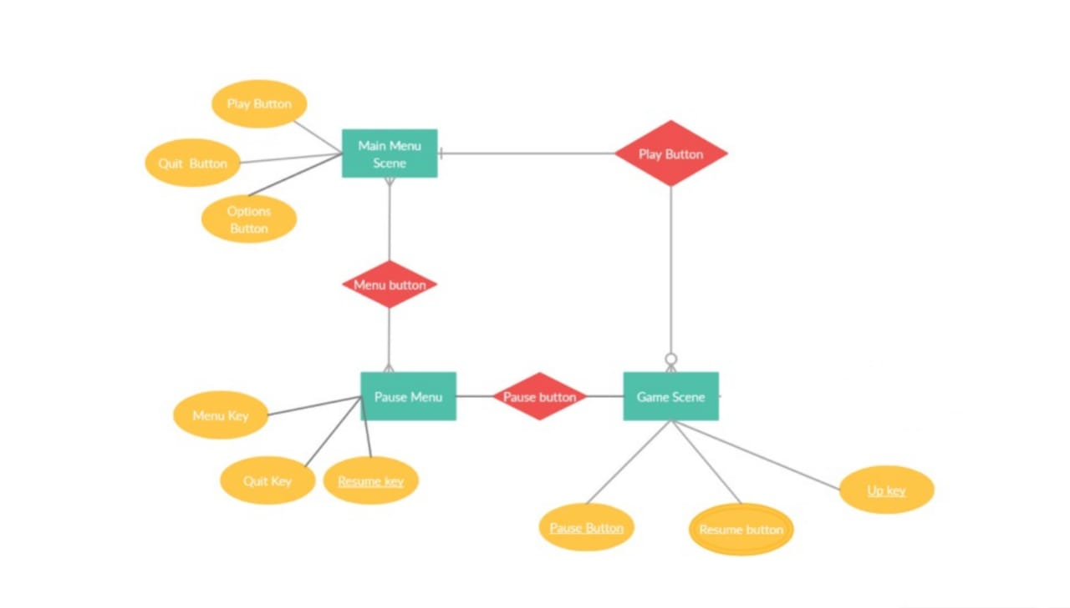

**Use case diagram** :

Play

Add/Remove scene components

Play game

Change volume

Edit/update

scripts

Customer

Delete/block users

Change resolution , graphics

**Handle the pause menu**

Pause the game

Quit

**Use case diagram synopsis :**

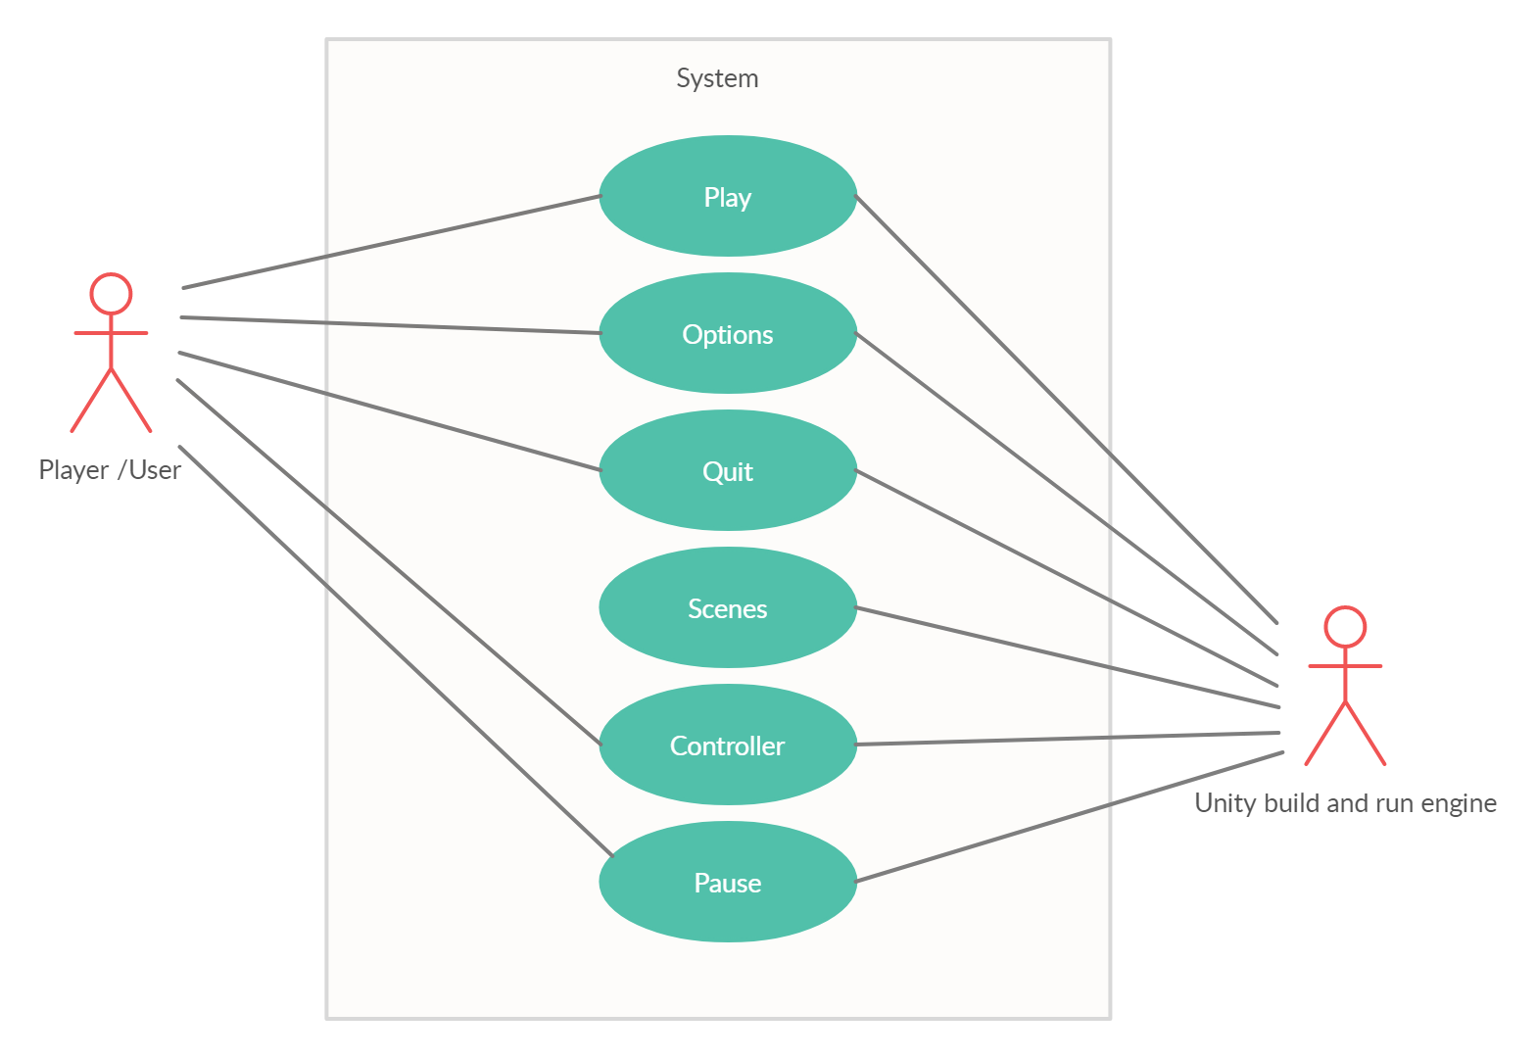

**4.1 Importance**

The increasing visibility of software as a system element and the attendant “cost” associated with a software failure are forces for well planned, through testing. It is not to expand 40% of total project effort on testing.

Detect can be caused by a flow in the application software or by a flow in the application specification. A structured approach to testing should use both dynamic and static testing rules:-

4.1.1 Testing Rules

* Test early and test often.
* Integrate the application development and testing life cycles, you will get better results.
* Develop a comprehensive test plan; it forms the basic for the testing methodology.
* Use both static and dynamic testing.
* Define your expected results.

Understands the business reason behind the application. You will get a better application

* Use multiple levels and types of testing.
* Review and aspect the work, it will lower costs.

Don’t let your programmer check their own work; they will miss their own errors.

**4.2 Test Cases:**

|  |  |  |
| --- | --- | --- |
| **S.No.** | **Description** | **Status** |
| **1.** | Change the resolution to custom resolution  Users can not use a custom resolution and can only select the options from the drop down button .  Output:Resolution won’t be changed to custom | Fail |
| **2.** | Change the graphics to extreme or ultra  Users can not change the graphics to very high and can only select from the options given in the graphics drop down button .  Output: Option not available | Fail |
| **3.** | Options menu can not be opened from the pause menu  Users can only access the options menu from the main menu and not from the pause menu within the game .  Output: Option not available | Fail |
| **4.** | Change the volume of the game  Users can change the volume of the game by using the volume slider button in the options menu .  Output: Volume is altered | Success |
| **5.** | Change the predefined controls of the game  Users can not change the predefined controls of the game or can not add custom controls to the game .  Output: Controls won’t be altered | Fail |
| **6.** | Change the in-game boundaries  Users can not change the in-game boundaries of the game as they are predefined by the admin.  Output: No change in the in-game boundaries | Fail |
| **7.** | Change the main menu  Users can not bring change to the main menu like many 2D games as it is predefined and can only be altered by the admin .  Output: Main menu will remain the same | Fail |
| **8.** | Quit the game by pausing it  Users can quit the game by pausing the game using the quit button in the pause menu .  Output: Game will exit. | Success |
| **9.** | Return to main menu by pausing the game  Users can return to the main menu by pausing the game and selecting the menu button from the pause menu .  Options: User returns to main menu . | Success |

**5.2 User interface :**

* **Main Menu**: Main menu will be opened in 1920*1080 resolution and it will have the option for users to make the game full screen or minimize it .
* **Options Menu** : This option will be available on the main menu and will have all the necessary options to bring in-game changes .
* **Buttons :** Main menu , options menu and the game scene are all comprised of buttons that have been assigned specific tasks to perform .
* **Health panel :** The game scene will have a health panel in the corner left of the screen that will be automatically set to 3 .
* **Score panel :** The game scene will have a score panel in the corner right of the screen that will initially be set to 0 and will increase gradually as the player moves forward .
* **Pause Menu :** The pause menu will open when the user triggers the pause button ie. ‘Escape’ and will be comprised of buttons like other scenes.

**References**

**1.Book References :**

* Unity 3D guide : A guide to unity by Henson Creighton Ryan
* Head first C Sharp : A book by Andrew Stellman

**2.Web references :**

* <https://assetstore.unity.com/>
* <https://learn.unity.com/project/ruby-s-2d-rpg>
* <https://learn.unity.com/>

**6.1 Appendix 1:** **Video Game and Console History Chart**

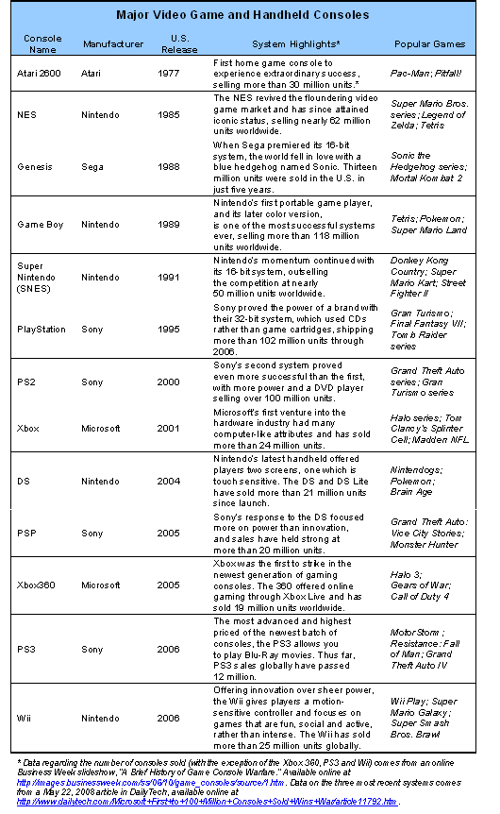

**6.2 Appendix 2: Regression analysis**

The findings regarding the relationship between frequency, social context and civic qualities of gaming experiences and life civic outcomes were derived using regression analysis. This statistical technique allows us to pinpoint whether a relationship between different gaming experiences and civic and political outcomes exists after controlling for factors such as income, race, gender and parent involvement—all individual characteristics that have been previously found to be important predictors of civic and political engagement.

