Design Document for project on “Dictionary of IIT Mandi birds and animals"

**by Vishal Anand, Yash Agrawal, Tirupati Mishra, Vedant Agrawal and Parimal Kumar**

**13th November 2016**

**1 The computational problem**

* 1. **Problem statement:**

The user specifies the serial no. (rank) / letter / name of any species (bird / animal) from the Dictionary of IIT Mandi birds and animals. The program must contain the names and description of local birds and animals of IIT Mandi and nearby areas and print the same.

1. 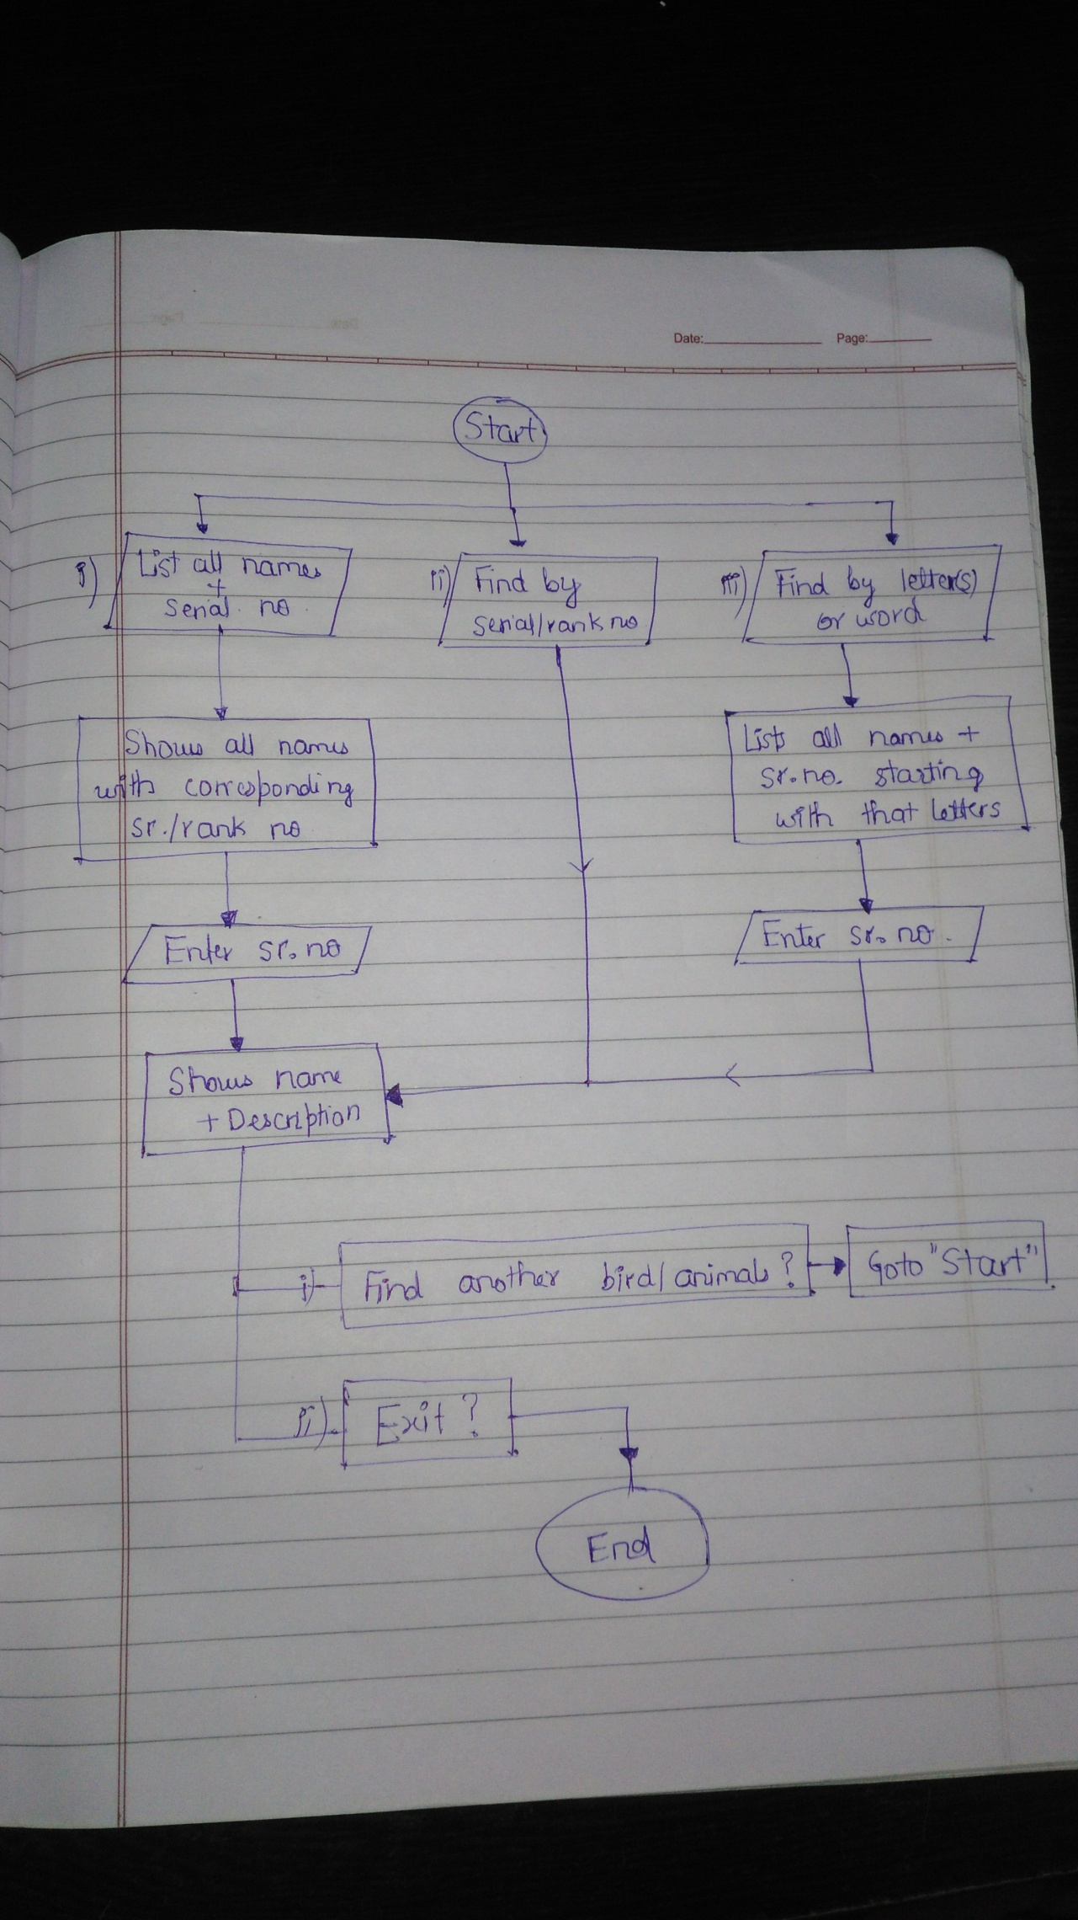**Our Solution**

ExceptionalHandling:

1. Shows error message on typing invalid integer or character input: typing integer in place of character or vice-versa, entering name of species which is not present in the dictionary.
2. Asks the user again for the correct input for any incorrect input.

The program will be user friendly, in the sense of proper exceptional handling and the alignment of texts.

Data:

struct dict{

int sr_no[];

char name[][];

char *desc[];

}Dictionary;

**Components**

**f1** int optionInput()

-displayingoptionsand taking input at the starting of the program

**f2** void printDescriptionSrNo( int sr_no )

-printing the name of the bird/animal chosen by the user and its description

**f3** void findByLetter( char search[] )

-printing the names of the species by comparing the starting letters/word given by the user.

**f4** void openReadMeTXT()

-showing the readme.txt in terminal

**f5** void exitProgram()

-exiting the program in a nice fashion

**f6** int main()

**f7** readme.txt

**f8** dictionary_bird_animals.txt

void showAllList()

void showCategory()

void printDescriptionName( char name[] )

**Responsibilities and Timeline**

Responsibilities:

1. Tirupati Mishra: **f2,f8**
2. Vishal Anand: **f3,f6,f8**
3. Yash Agrawal : **f3,f5,f8**
4. Vedant Agrawal: **f1,f4,f8**
5. Parimal Kumar : **f7,f8**

Timeline:

1. Milestone1: f5 to be ready by 15/11/2016
2. Milestone2: f1,f4,f7 to be ready by 19/11/2016
3. Milestone3: f2 to be ready be 21/11/2016
4. Milestone4: f3,f6,f8 to be ready by 24/11/2016

* * * * *

* * *

*