Design Document for project on “Dictionary of IIT Mandi birds and animals"

**by Vishal Anand, Yash Agrawal, Tirupati Mishra, Vedant Agrawal and Parimal Kumar**

**30th November 2016**

**1 The computational problem**

* 1. **Problem statement:**

The user specifies the serial no / letter / name of any species (bird / animal) from the Dictionary of IIT Mandi birds and animals. The program must contain the names and description of local birds and animals of IIT Mandi and nearby areas and print the same.

1. **Our Solution**

ExceptionalHandling:

1. Shows error message on typing invalid integer or character input: typing integer in place of character or vice-versa, entering name of species which is not present in the dictionary.
2. Asks the user again for the correct input for any incorrect input.

The program will be user friendly, in the sense of proper exceptional handling and the alignment of texts.

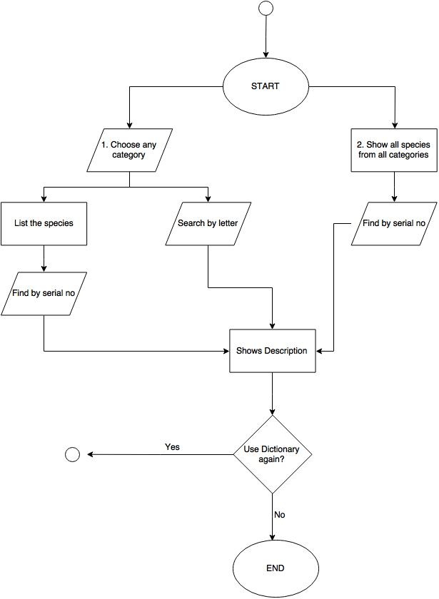

Data:

typedef struct dict{

char sr_no[4];

char category[20];

char name[30];

char *des;

}Dictionary;

**Components**

**f1** void ucase(char s[])

**f2** int optionInput()

**f3** int showCategory()

**f4** void printSelectedCategory(int i,int max_species,char *allCat[])

**f5** void printSelectedCategorySpecies(int cat_sno, char *allCat[], int max_species)

**f6** int printByLetter(int cat_sno, char *allCat[], int max_species)

**f7** void showAllList()

**f8** helpMe()

**f9** int main()

**f10 “**start.c”

**f11** “end.c”

**f12** “help.txt”

**f13** “readme.txt”

**f14** “animals.txt”

**f15** printPic()

**f16** int printByLetterAll(int max_species)

**Responsibilities and Timeline**

Responsibilities:

1. Tirupati Mishra: f2, f7
2. Vishal Anand: f5, f6, f9, f16
3. Yash Agrawal : f10, f11, f4, f15 + Designing
4. Vedant Agrawal: f3, f14, f12
5. Parimal Kumar : f1, f8, f12, f13

Timeline:

1. Milestone1: f1, f2, f3 to be ready by 24/11/2016
2. Milestone2: f13, f14, f7 to be ready by 27/11/2016
3. Milestone3: f4, f5, f6, f10, f11 to be ready by 29/11/2016
4. Milestone4: f12, f8, f9, f15 to be ready by 30/11/2016
5. Milestone4: f16 to be ready by 01/12/2016

**References**

<http://stackoverflow.com/questions/27447195/how-to-use-delay-function-in-c-using-codeblocks-13-12mingw>

<http://stackoverflow.com/questions/2347770/how-do-you-clear-console-screen-in-c>

**Corrections/Lessons learnt:**

Lessons Learnt: Team Work, manage to complete the task before the deadline, more interaction with the group members and the instructor.

Corrections: Added functions/files- f1, f3, f4, f5, f7, f8, f15, start.c, end.c, help.txt

Removed functions- void printDescriptionSrNo(int sr_no)

void openReadMeTXT()

void exitProgram()

* * * * *