IC260 – Signals and Systems
Assignment 3
Vishal Anand
B16040

Brief explantion for implementing the Fourier Transform in computer and generating the graph:

X(e^{jw)} = ∑ x[n]e^{-jwn}

Taking input the array x[n] (from keyboard in Part1 and from sound file in Part2) and the array n (in Part1). On expanding the complex exponential term in terms of cos and sin, we get

X(e^{jw}) = ∑ x[n] {cos(wn) -jsin(wn)}
= ∑ {x[n_{i}] * cos(wn_{i})} -j ∑ {x[n_{i}] * sin(wn_{i}) }
= A(w) -j B(w)

| X(e^{jw}) | = sqrt(A² + B²)

φ = Tan⁻¹ (B / A)

Now we calculate these values for each value of w in the range (0, 10) with an interval of 0.02
At last we obtain the array w, | X(e^{jw}) | and φ .

Fig1 shows the answer to part1 when the x axis ranges from -1 to 3 and the x[n] = {1, 4, -6, 2, 8}
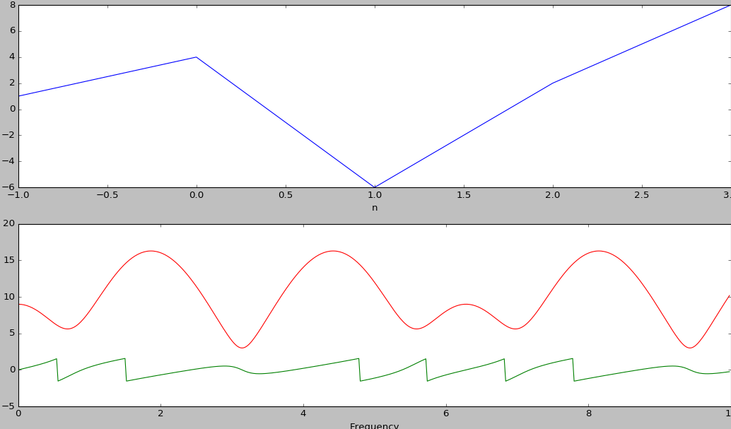
The red graph shows the Magnitude plot, the green one shows the phase plot and the blue one is the input signal.

The Fig2 shows the answer to part2. Each row specifies a bird sound signals (Blue), the red one is the Magnitude and green one is the phase plot of its Fourier Transform.

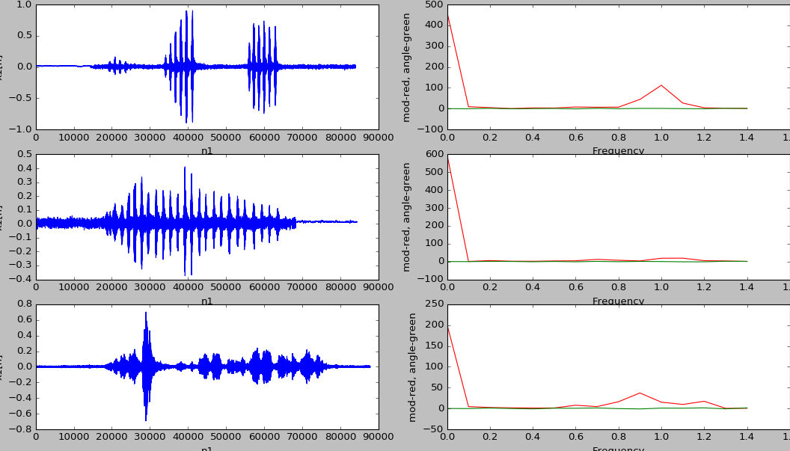
Here we can see that all the three bird songs has different Magnitude graph (Red) and hence from this they all can be differentiated.

