CS 207
APPLIED DATABASE PRACTICUM
PROJECT REPORT

TITLE OF THE PROJECT
CODE-MANIACS

Group Members:

- Vishal Anand (B16040)
- Yash Agrawal (B16120)
- Aashish Kumar (B16001)
- Aman Khandelwal (B16007)

Project Statement:

CodeManiac is a not-for-profit educational initiative. It is a global programming community that fosters learning and friendly competition, built on inspiration from the world’s largest competitive programming platforms. We have also built a large community of problem curators.

CodeManiac is created as a platform to help programmers make it big in the world of algorithms, computer programming and programming contests. We intend to help from novice programmers to expert programmers. We have our problems divided on the basis of the percentage accuracy, so that user can select a problem according to his expertise. We have our ranking system on the basis of problems solved by user which enhances healthy competition among users.

With the rise in demand of solving wide range practical problems using Computer Science and Technology, there is an utmost need for one to develop the knowledge of Logical and Computational Thinking, Data Structure and Algorithm. Not only this, one needs to know how to apply these theories in practice.
In Indian school education system, there is no well introduction to students about programming and that is the reason, Indians can’t perform well in IOI(International Olympiad in Informatics), ACM-ICPC(ACM International Collegiate Programming Contest), so to develop enthusiasm among students of our country about programming, we want to serve as great platform.
CodeManiac provides the user with a platform which utter this need. There will be many problems available on the website divided according to the accuracy level.

ER Model:
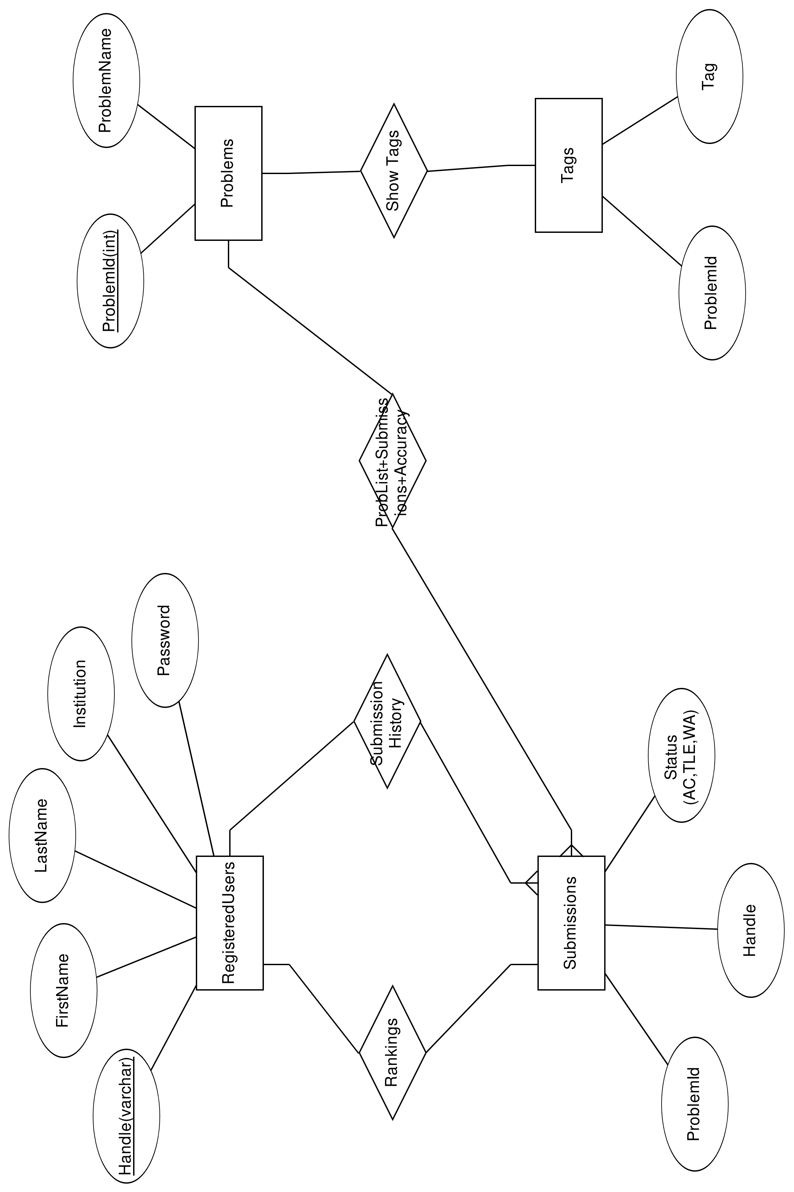
Relational Schema:
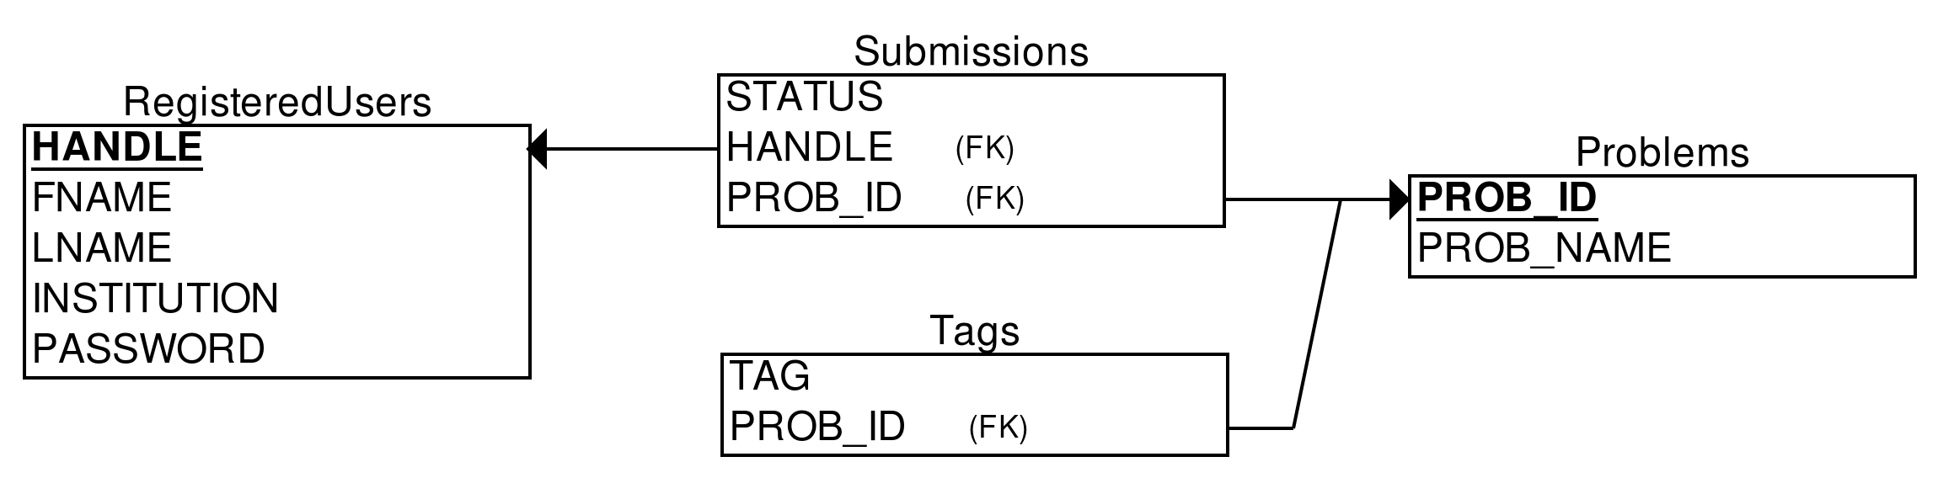

Intended User Groups:
This document is intended for everyone who wants to be good at competitive programming and peform well in various coding international competitons.
- School students
- University students
- Professionals
- Job asipiring candidates in programming sector

Features
Code-Maniac can be used by several users at the same time. The platform is designed to help users , improve their programming skills , learning new algorthims and develops a competitive environment among the users. Users can access it via browser.
The CodeManiac platform is centered around an online judge system, which serves for the automatic assessment of user-submitted programs. Some of its most important features include:
- supports programming languages and compilers, like C++ .
- a rapidly growing problem-set of about 1000 tasks available for practice 24hours/day in English.
- a flexible testing system, supporting dynamic interaction with submitted programs and highly customisable output of assessment results. Users get verdict like AC(Accepted solution), WA(Wrong Answer), TLE(Time Limit Exceeded).
- Every problem has associated accuracy(number of successful submissions/number of submissions) and accuracy and users can sort problems according to their accuracy.
- Every user has its own associated statistics in which there is count of his AC’s, WA’s and TLE’s and also submission history.
Users can easily find editorials for problems too.

Functions
The interactive user interface provides user to-
- signup and introduction to website
- login next time and continue poblem solving
- search for users, problems and tags related to problem
- Submit the solution for the problems
Also in guest mode(user not logged in)
- Problems are visible to the person
- Person can’t make submission for problem.
Front-End Design:
The front end of the website Code-Maniac is built using HTML (Hyper Text MarkUp Language), CSS (Cascading Style Sheets).
Few SQL Queries:
- SELECT * FROM RegisteredUsers WHERE HANDLE='$handle'
- INSERT INTO RegisteredUsers VALUES('$fname', '$lname', '$handle', '$institution', '$password')
- SELECT * FROM RegisteredUsers WHERE HANDLE='$handle' AND PASSWORD='$password'
- SELECT * FROM Submissions WHERE HANDLE='$handle' AND STATUS='<AC/WA/TLE>'
- SELECT * FROM Submissions S, Problems P WHERE S.PROB_ID = P.PROB_ID AND STATUS=’AC’ AND HANDLE=’$handle’
- SELECT * FROM Submissions where HANDLE='$handle' and STATUS='AC' and PROB_ID=$prob_id
- SELECT * FROM Tags WHERE PROB_ID=$prob_id and TAG='$tag'
- INSERT INTO Tags VALUES($prob_id, '$tag')
- DELETE FROM Tags WHERE PROB_ID=$prob_id and TAG='$tag'
- UPDATE RegisteredUsers SET HANDLE='$handle', FNAME='$fname', LNAME='$lname', INSTITUTION='$institution' WHERE HANDLE='$old_handle'
- UPDATE Submissions SET HANDLE='$handle' WHERE HANDLE='$old_handle'
Complex Queries:
- SELECT DISTINCT(HANDLE) USER_HANDLE, COUNT(STATUS) AC FROM Submissions WHERE STATUS=’AC’ GROUP BY HANDLE ORDER BY AC DESC
- $count = mysqli_num_rows(mysqli_query($conn,"SELECT * FROM Problems"));
SELECT * FROM Problems ORDER BY RAND() LIMIT $count

Performance Checks:
RegisteredUsers: 1009
Submissions: 10859
Average query time: 0.005 seconds
Work planned but could not do:
- Sorting the problems on the basis of Total Submissions, Accuracy.
- Open previously submitted code.

Experience of doing mini-project:
- Got to learn new technologies/languages (HTML,CSS,PHP), relational database (MYSQL), connection between the website (front-end) and the database via back-end (php). Many more essential things like how to execute terminal commands and .cpp code using php.

