1. Key KPIs in Streamlit dashboards.
- Total Candidates
- Placement Rate (%)
- Job Acceptance Rate (%)
- Average Interview Score
- Average Skills Match %
- Offer Dropout Rate
- High-Risk Candidate Percentage

The below output is for overall combined(Male+Female and Fresher+Junior+Senior Experienced category)
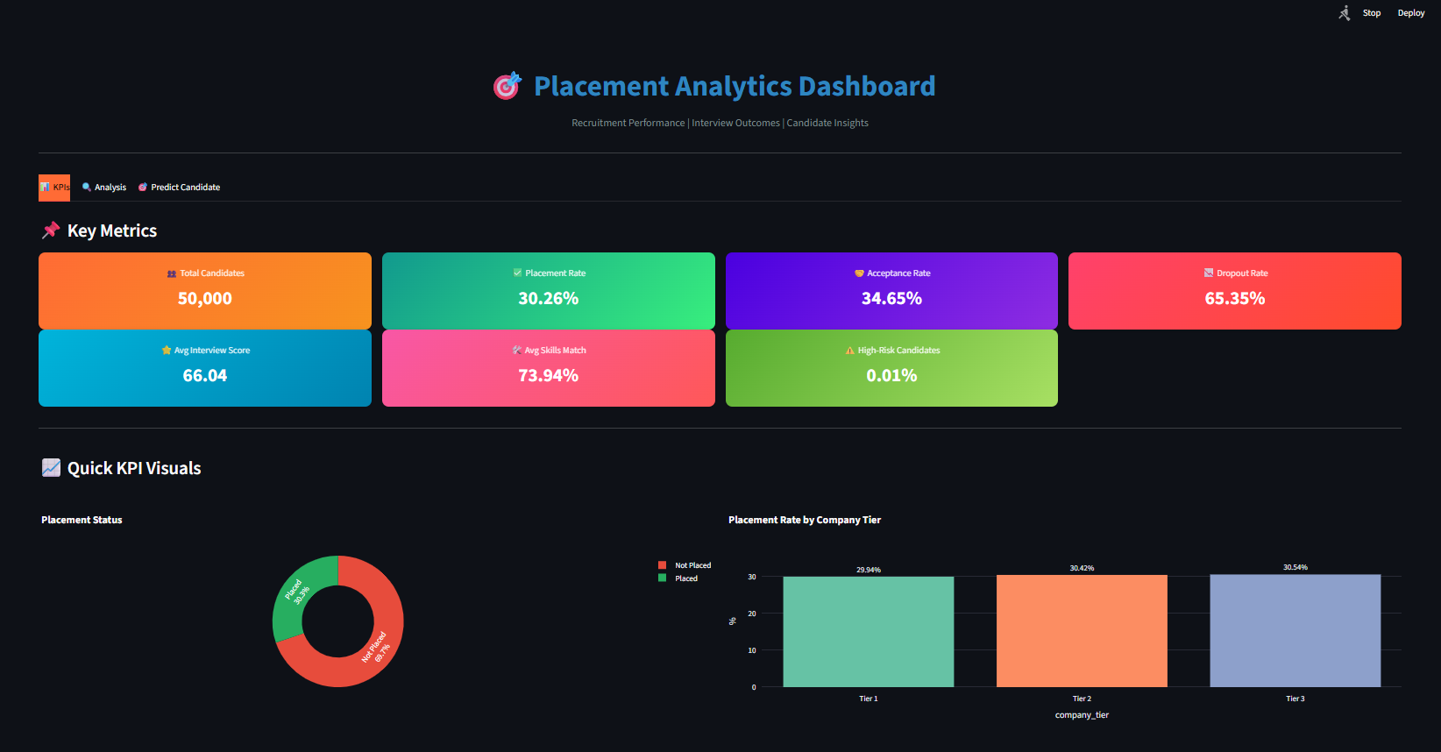
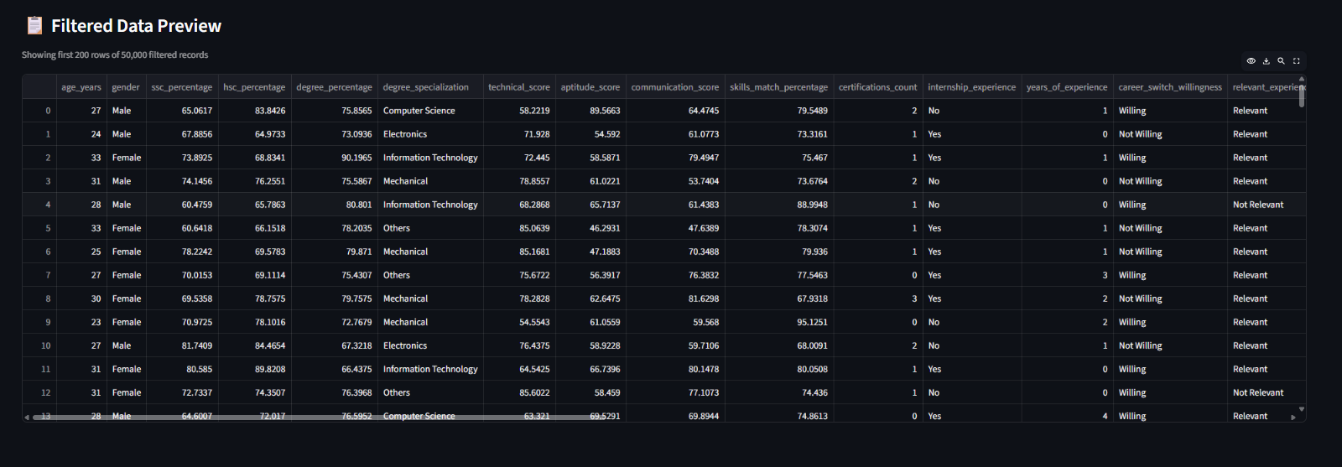

2. (EDA & ML Analytics):

Candidate Performance Analysis
- Academic scores vs placement outcome
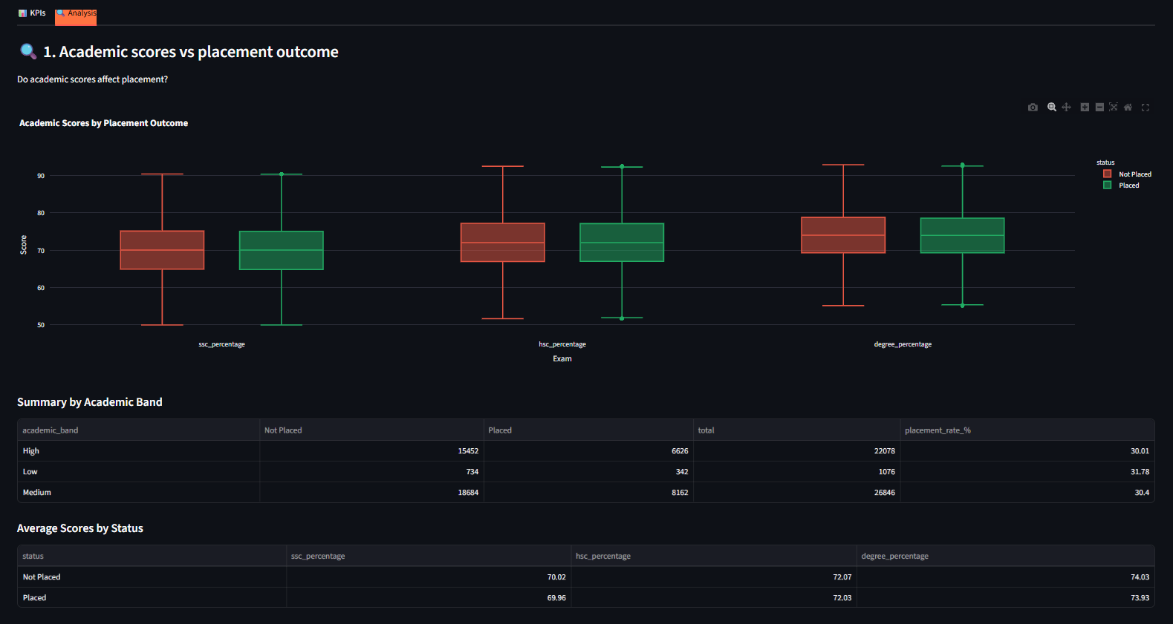
- Skills match vs interview performance
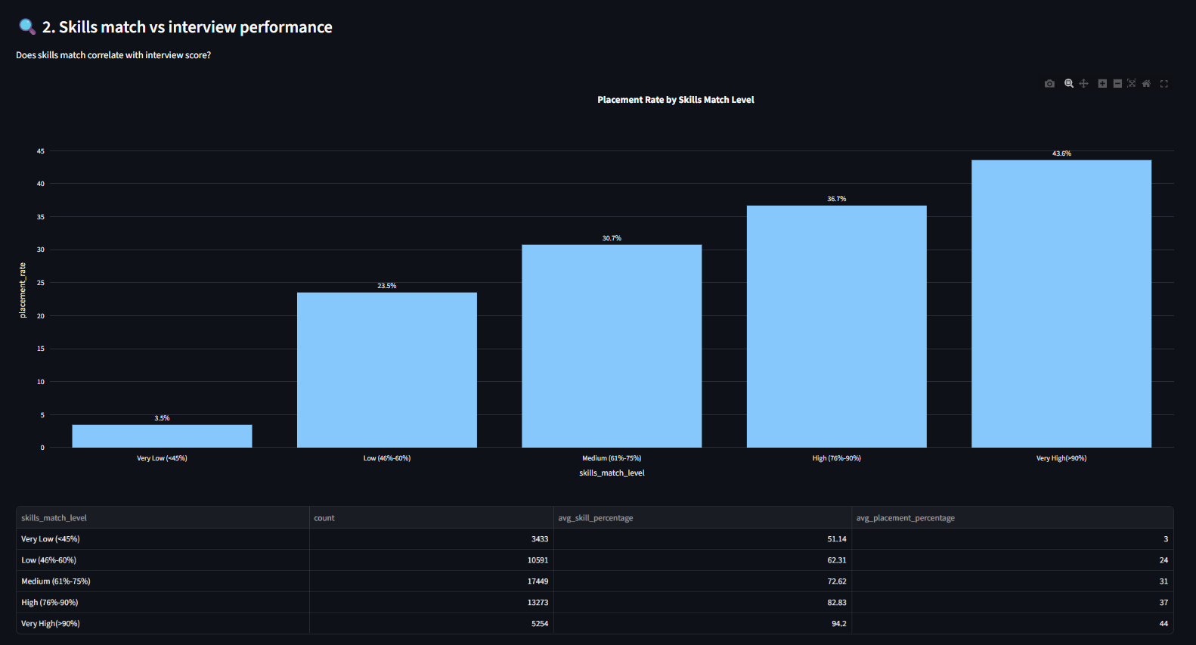
- Certification impact on job acceptance
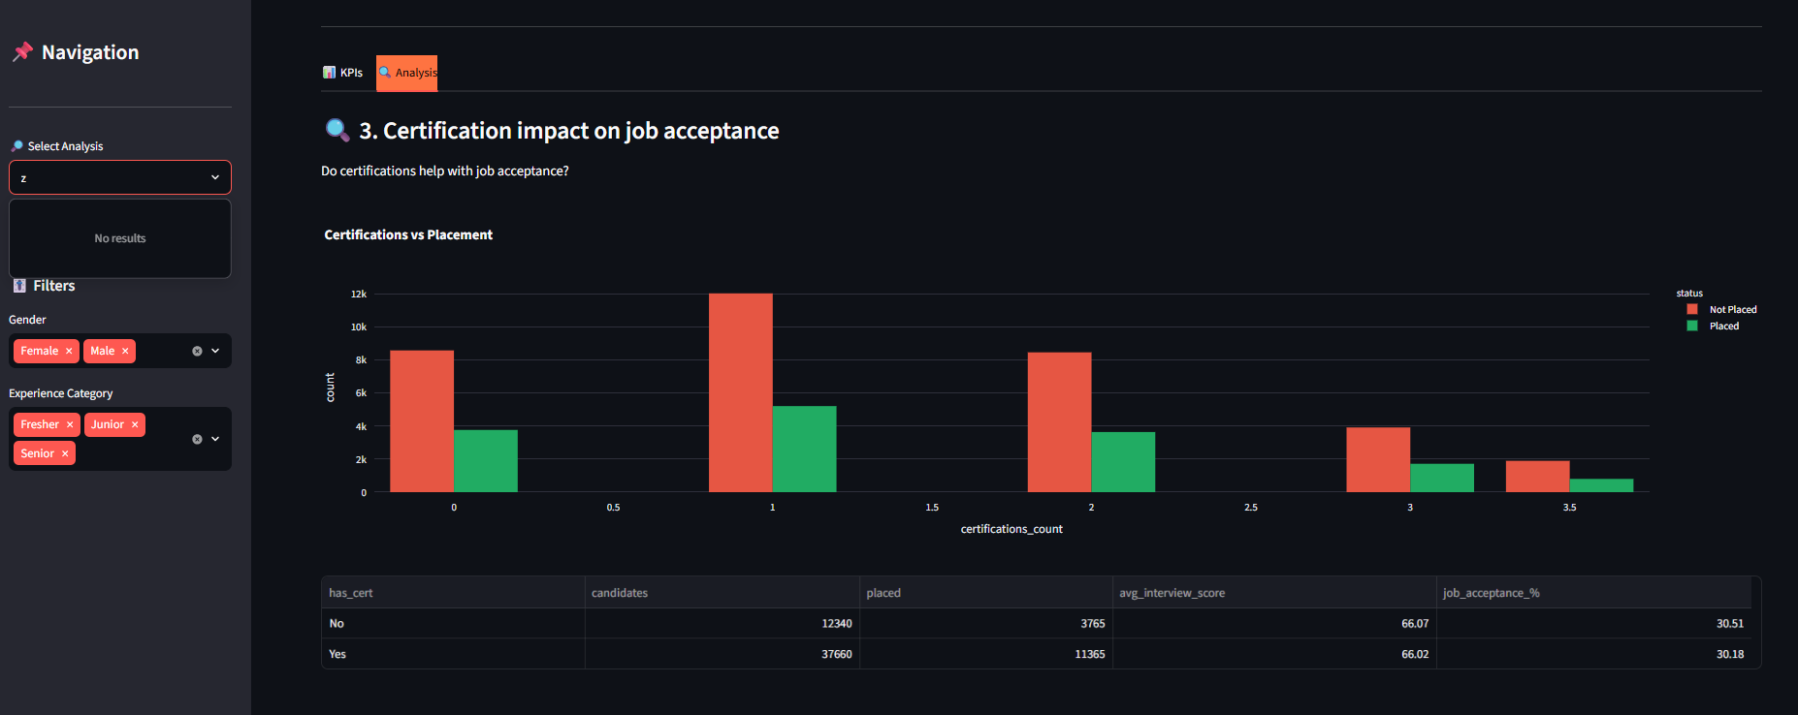

Placement & Acceptance Analysis
- Acceptance rate by company tier
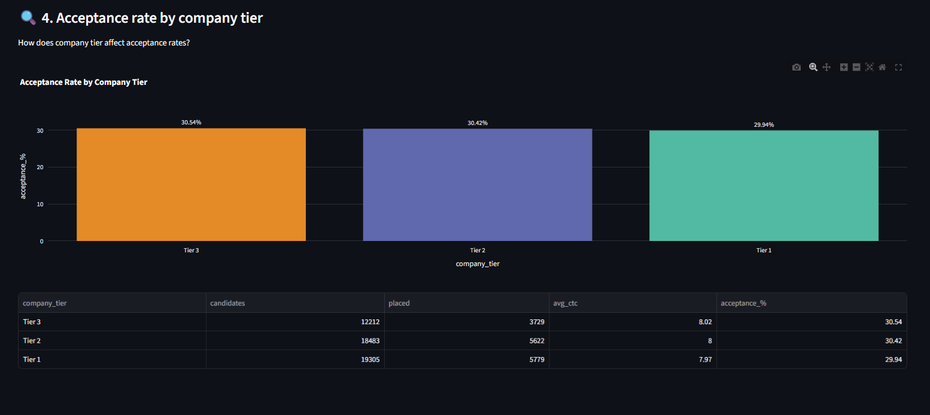
- Experience vs placement success
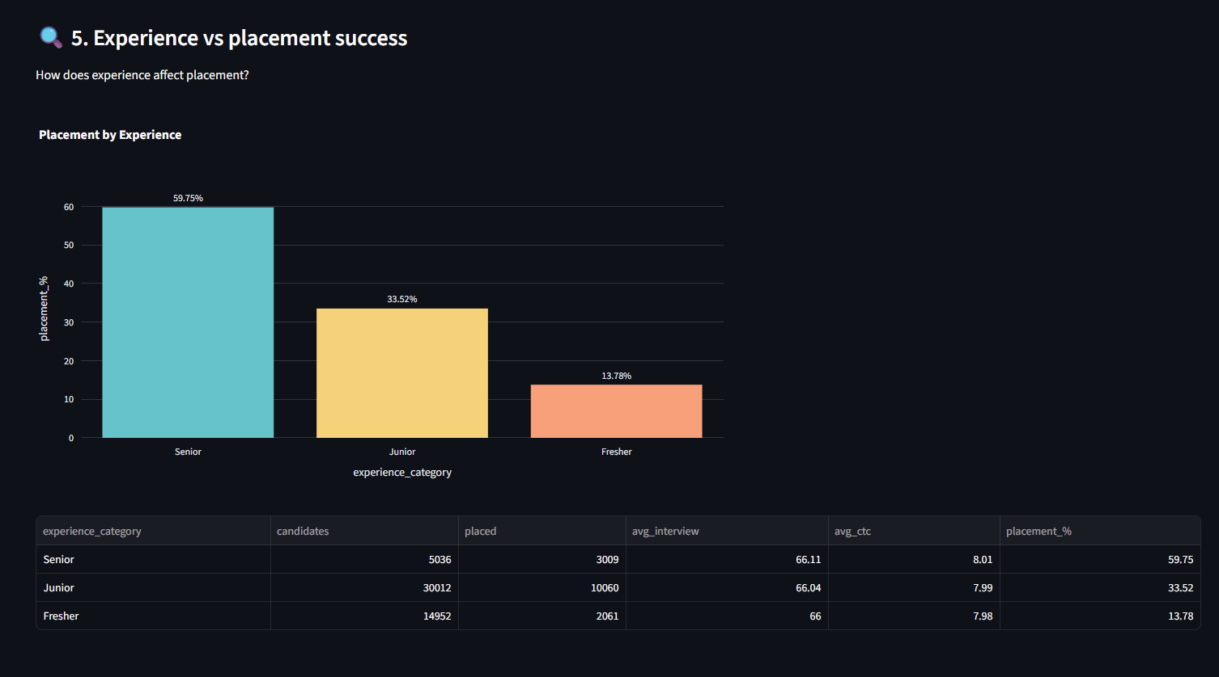

Interview & Evaluation Analysis
- Interview score vs placement probability
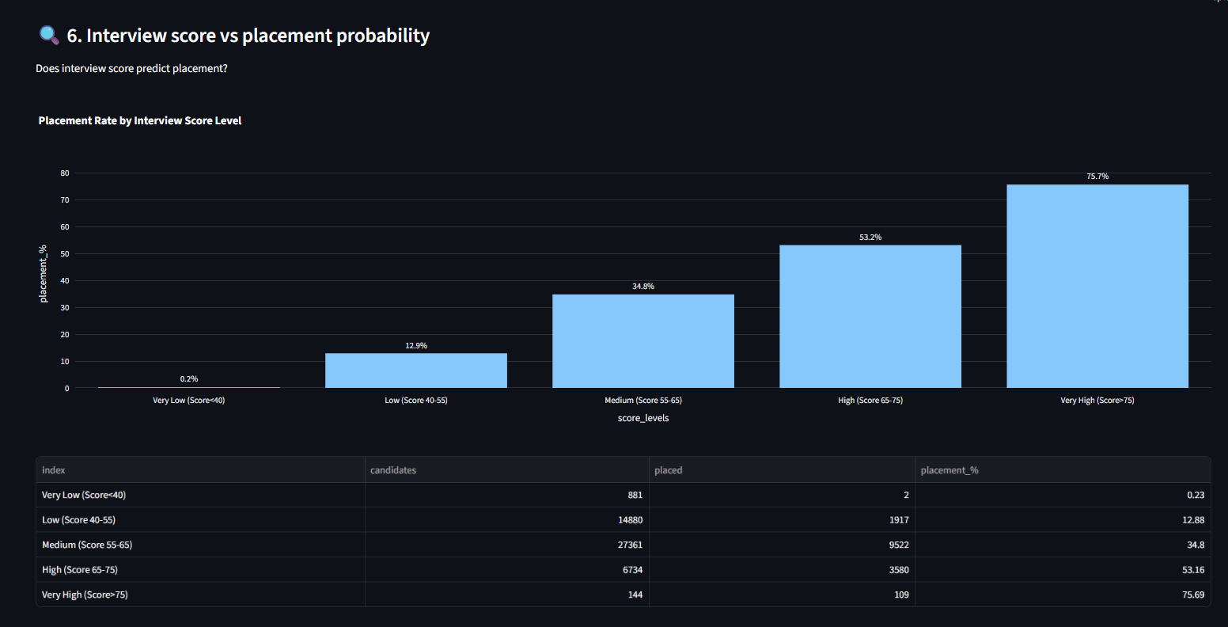
- Employability test score analysis
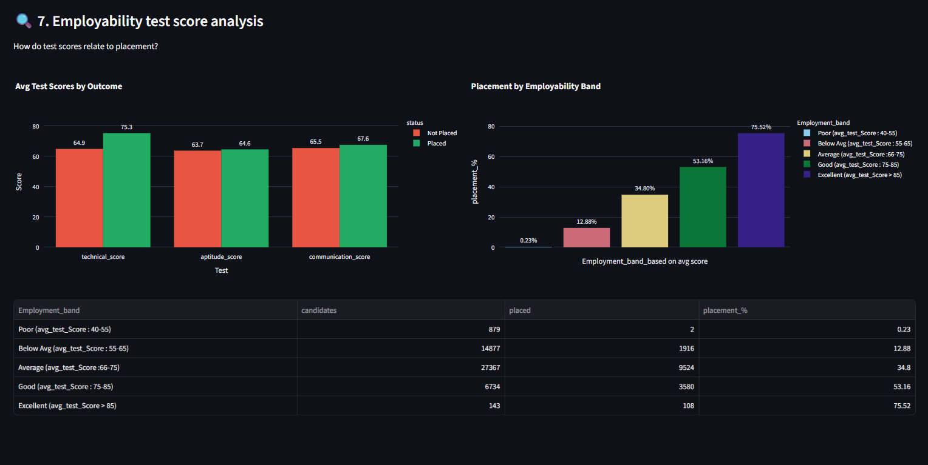
Canditate prediction:

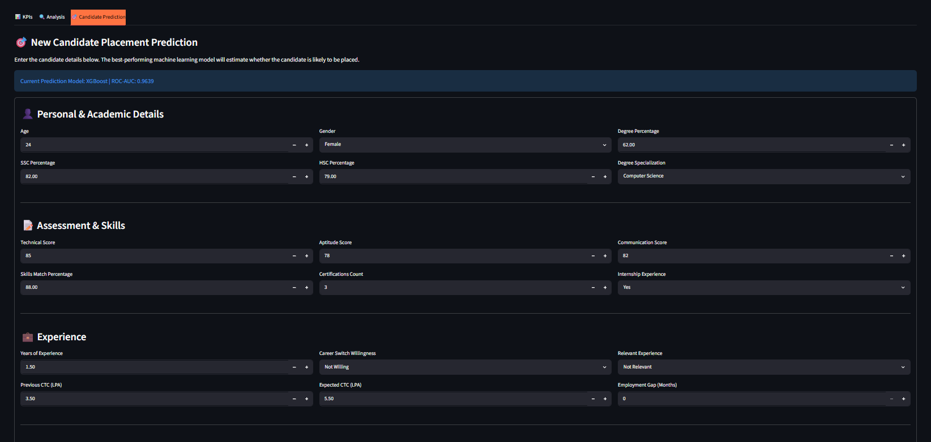
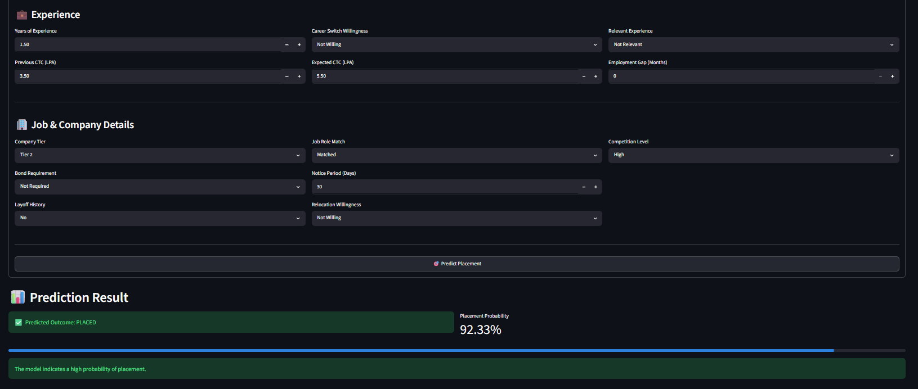
_________________________________________________________________________
KPI Comparison output:
Male: Fresher, Junior, Senior
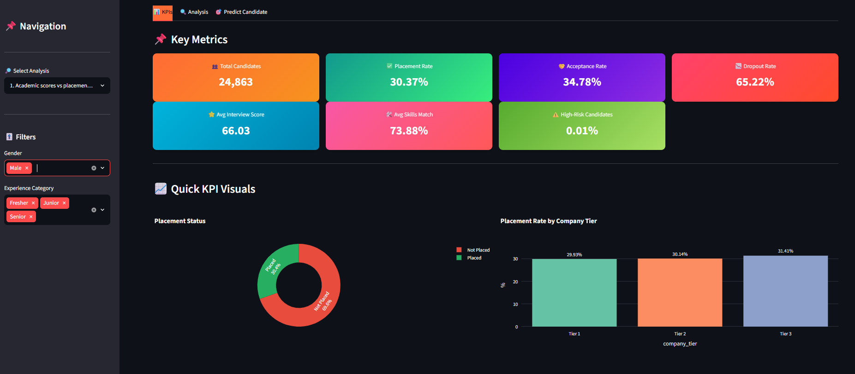
Male:Fresher:
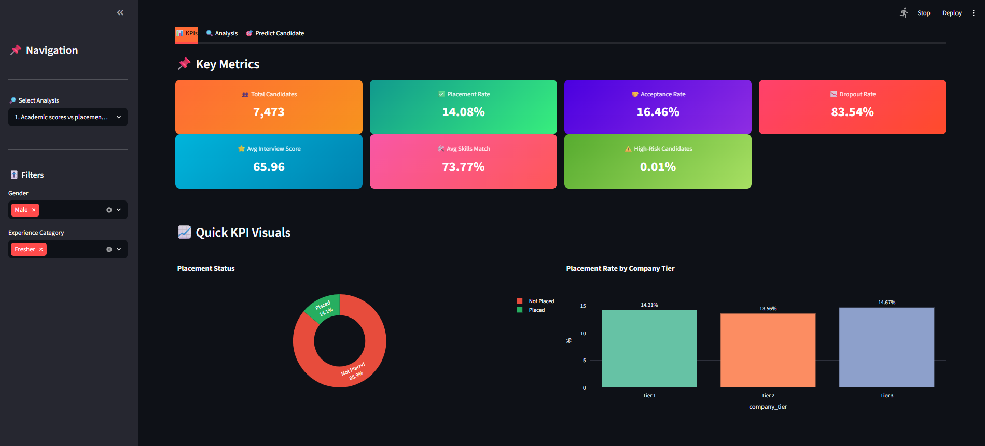
Male:Junior
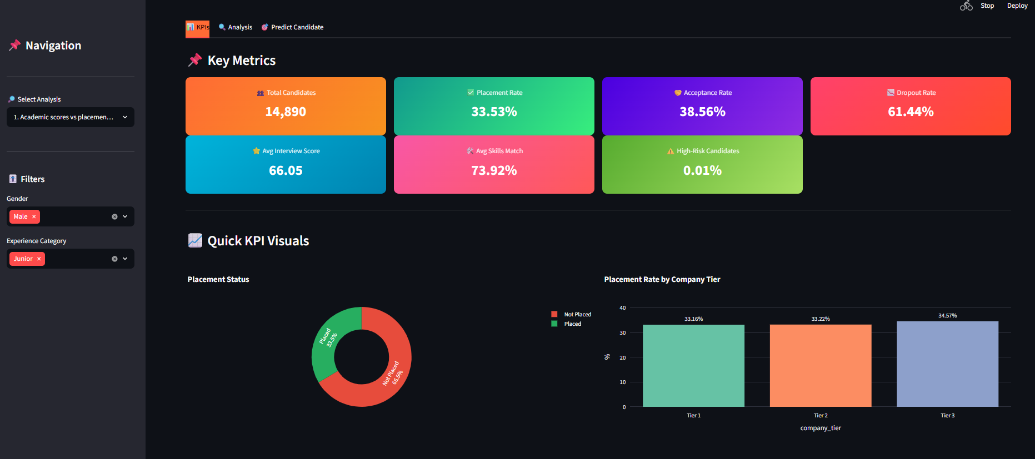
Male:Senior
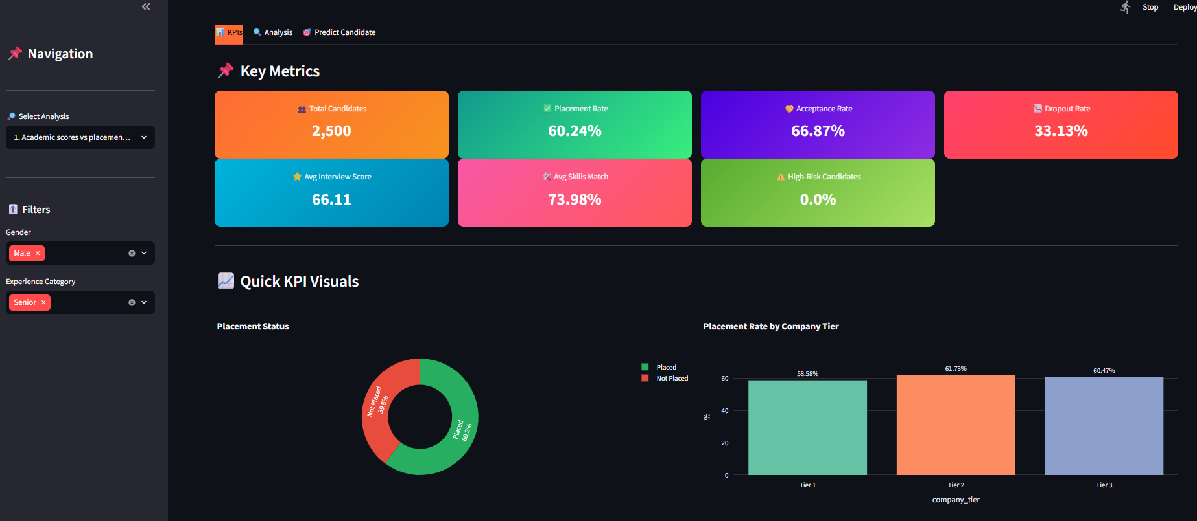
______________________________________________________________________
Female: Fresher, Junior, senior
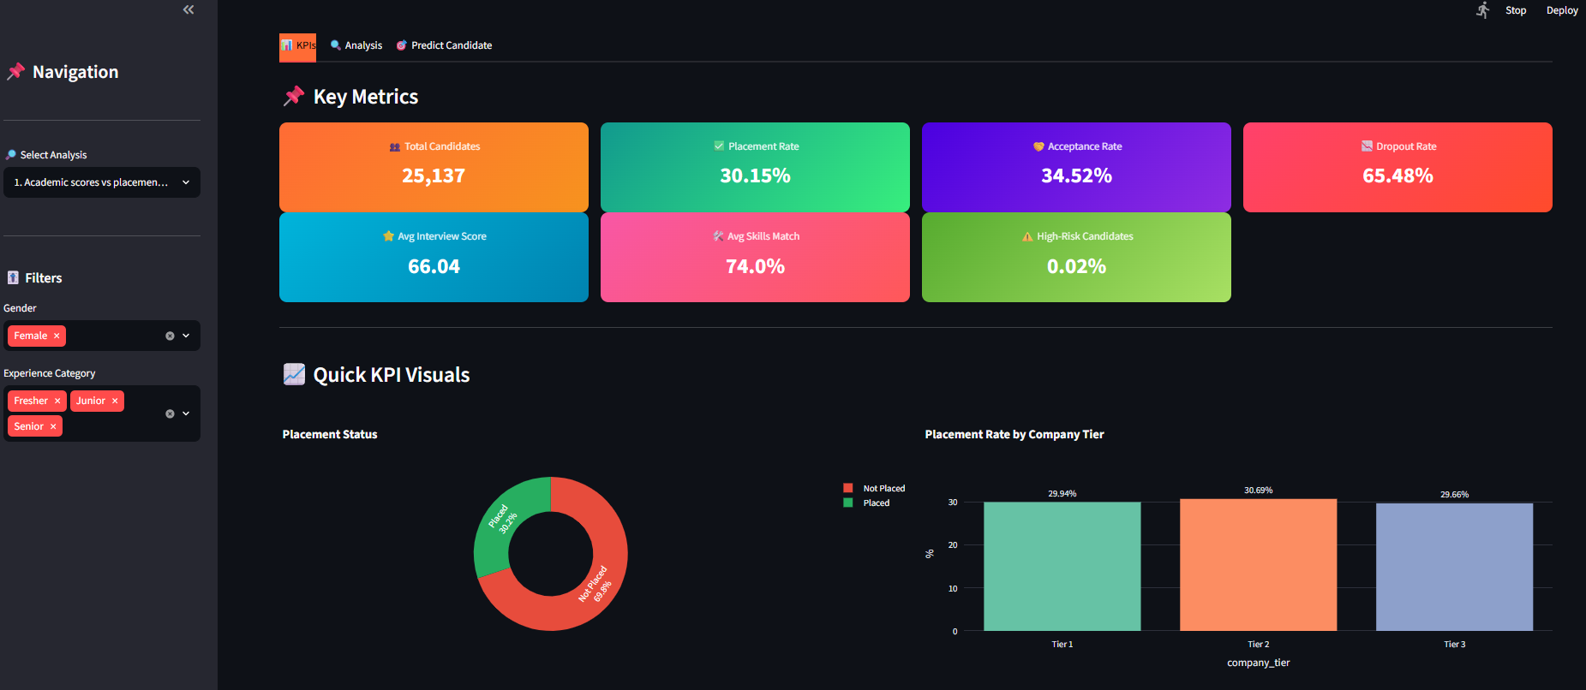

Female Fresher KPI:
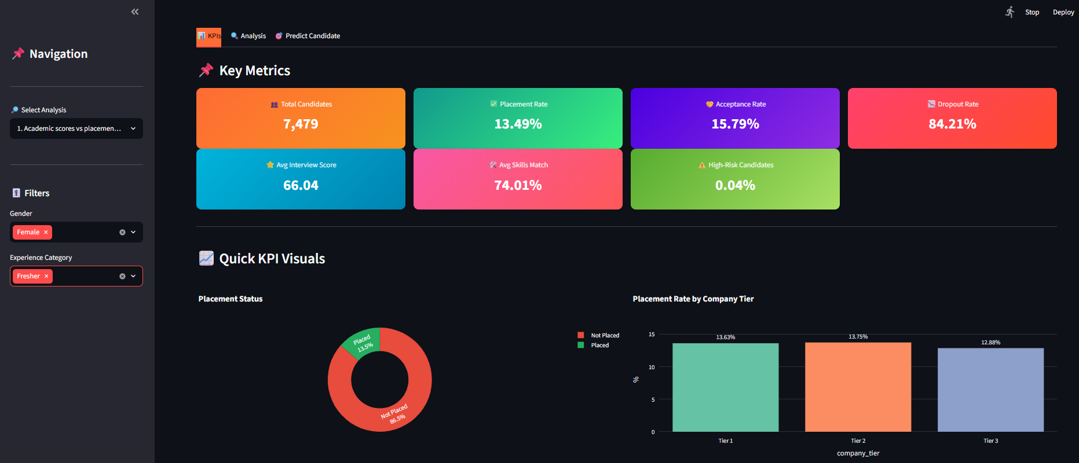
Female: Junior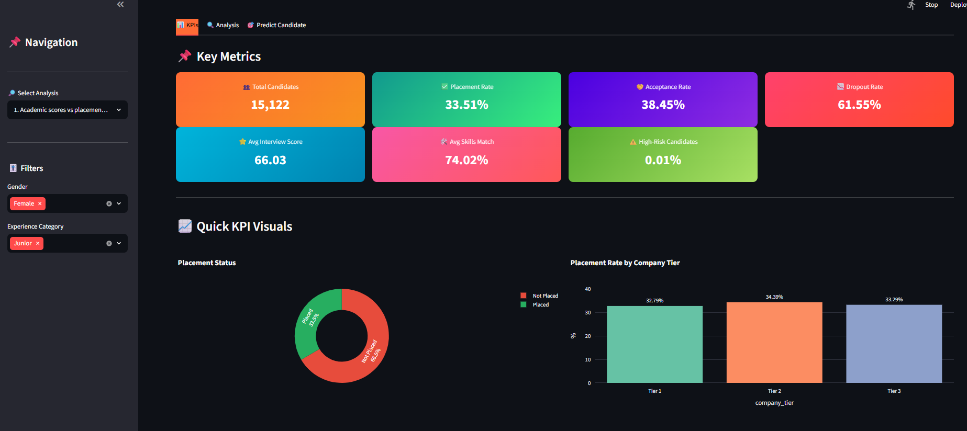

Female :Senior:
