**Go on this site :** [**https://getcomposer.org/**](https://getcomposer.org/)

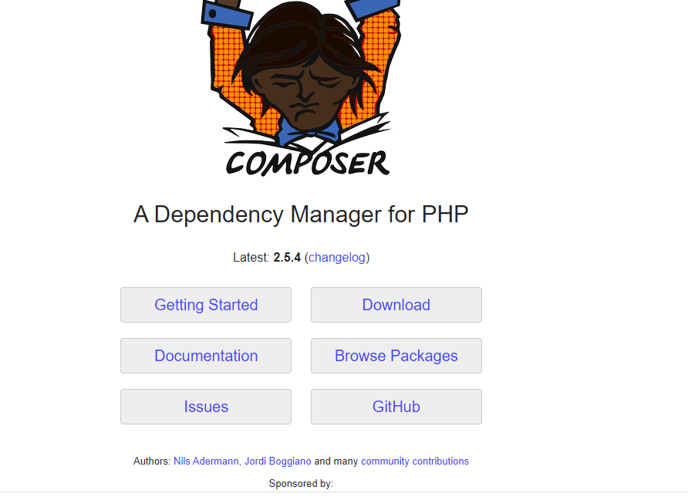

**Click On Download .**

**Steps for Installation :**

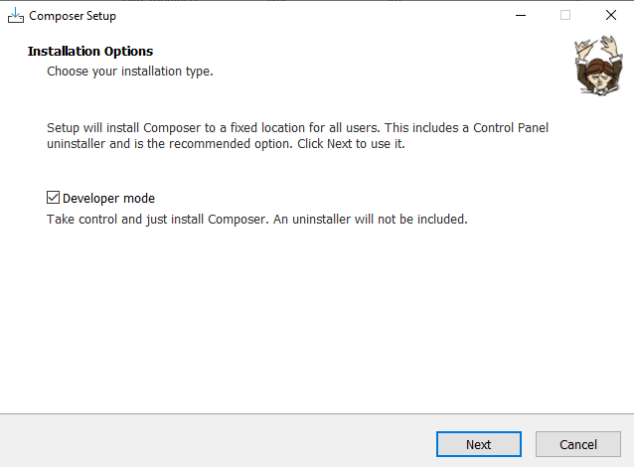

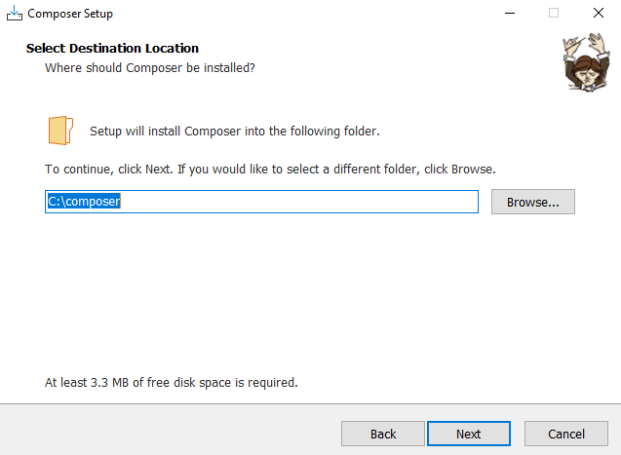

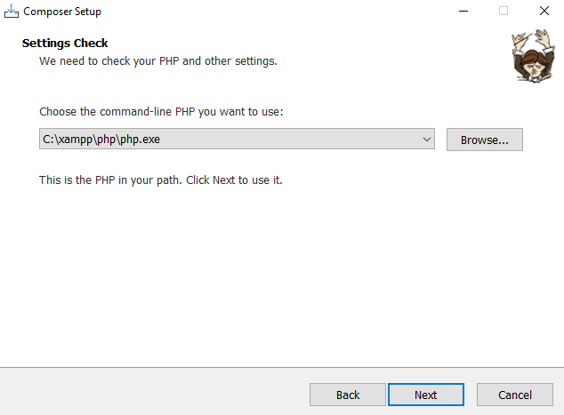

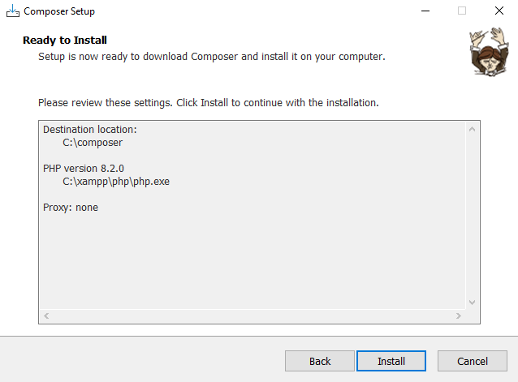

**Click on Install :**

**After installation**

**Open Command Prompt & Type :- composer**

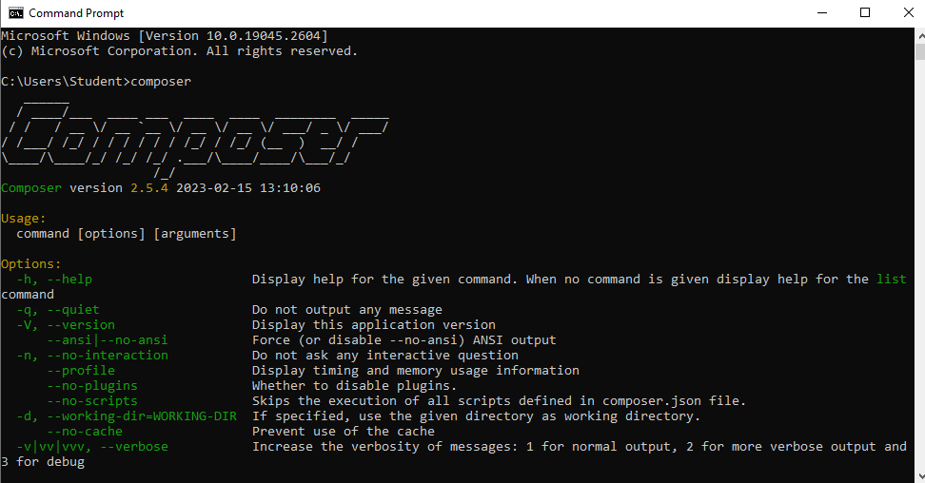

**After Getting this type of Screen**

**Paste this command :- composer global require laravel/installer**

**AFTER ALL YOU WILL GET YOUR PROJECT IN XAMPP>HTDOCS>YOUR PROJECT**

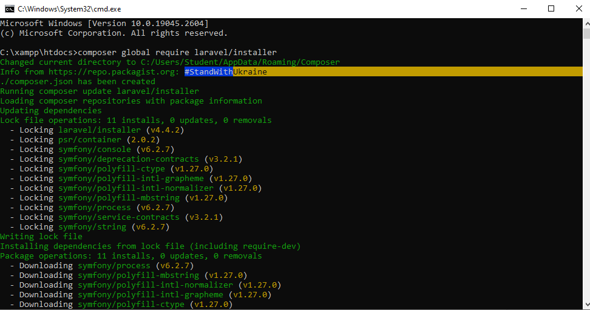

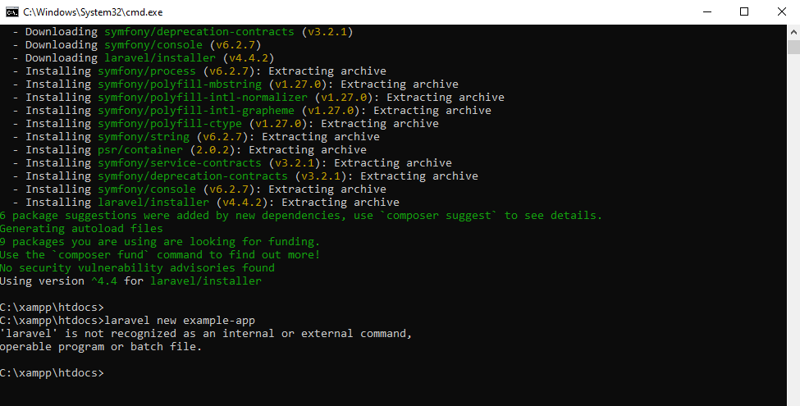

**GO ON DRIVE WHERE YOU INSTALL COMPOSER**

* **OPEN XAMPP > HTDOCS >**

**Open cmd via search bar**

**TYPE COMMAND FOR NEW PROJECT :- composer create-project laravel/laravel example-app**