Naan-Mudhalvan Phase 5 Assessment

Course Name : Internet of Things

Project Title : Traffic Management System

Team Name is : Techtronz

Team Members :

|  |  |  |
| --- | --- | --- |
| Name | Register number | Naan-Mudhalvan ID |
| Sanjesh R | 721221106089 | au721221106089 |
| Sivabalvigneshan P | 721221106097 | au721221106097 |
| Sri Krishnan N | 721221106103 | au721221106103 |
| Vishal S | 721221106120 | au721221106120 |

**Introduction:**

Traffic control is crucial in city planning. Growing urban populations and more cars on the road bring issues like traffic jams, accidents, pollution, and time wastage. To tackle these problems, cities and transport authorities are turning to the Internet of Things (IoT).

IoT links everyday objects to the internet, letting them collect and share data. In traffic management, IoT can revolutionize how cities watch, analyse, and improve their transportation systems.

IoT sensors and devices are placed around the city, like on roads, traffic lights, and vehicles. They collect real-time data on traffic, vehicle movements, and the environment. Advanced software and analytics process this data, helping authorities make smart decisions to enhance traffic flow, safety, and overall transportation.

This transformation could create smarter and more responsive transportation, reducing traffic and improving safety, cutting pollution, and enhancing the quality of city life. In this IoT traffic management intro, we'll explore the components, benefits, and challenges of using IoT in traffic control, along with examples from real cities.

**Objectives :**

The primary Objectives of this project are to develop the smart traffic Management system using IOT technology. To improve traffic flow , safety and efficiency in urban areas. This project aims to achieve the following goals;

1. **Real-time Traffic Monitoring**: It is used to improve to collect the real time data on traffic condition, vehicle movements, and environment factors in a city

2. **Data Analysis:** Process to collect the data using software and analytics tools to gain insights into patterns, and potential issues

3. **Traffic Optimization**: Use the analysed data to make informed decisions and take proactive measures to optimize traffic flow and reduce congestion.

4. **Safety Enhancement**: Improve road safety by alerting drivers about potential hazards and providing alternate routes in case of accidents or emergencies.

5. **Mobile Application:** Develop a user-friendly mobile application that provides real-time traffic updates, navigation assistance, and alerts to users.

6. **Code Implementation**: Develop the necessary software and code to facilitate data communication, analysis, and user interaction.

**IoT Sensor Input:**

1.**Traffic cameras**: To capture real-time images and videos of road conditions.

2.**GPS modules**: To track the movement and location of vehicles.

**Mobile App Development:**

The mobile app will be designed for both Android and iOS platforms and will offer the following features:

1. **Real-time traffic updates**: Users can access real-time traffic conditions in their area.

2. **Navigation assistance**: The app provides turn-by-turn directions to help users navigate through traffic.

3. **Traffic alerts**: Users receive alerts about accidents, road closures, and alternative routes.

4. **User-generated reports**: Users can report accidents, road hazards, or other incidents.

5. **Historical data**: Users can access historical traffic data and trends.

**Code Implementation:**

In our project traffic management using IoT, we use React native for front end and Django for backend. In React native java code is used for login page , home page , user identification etc; likewise, python is used for full backend process.

Through this we can get the accurate Traffic and Drive Safely enjoy your journey.

* The Below Image Shows our Project Simulation for **TRAFFIC MANAGEMNET** . The Software used for this simulation is **WOWKI.**

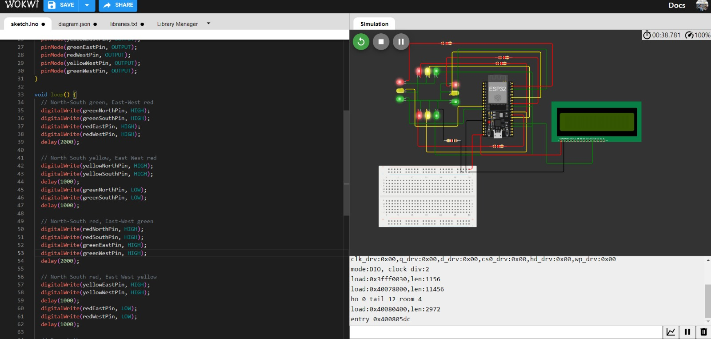

**SIMULATED OUTPUT FOR TRAFFIC MANAGEMENT USING WOWKi SOFTWARE**

* **After Making the Mobile App for Traffic Management , the App look like;**

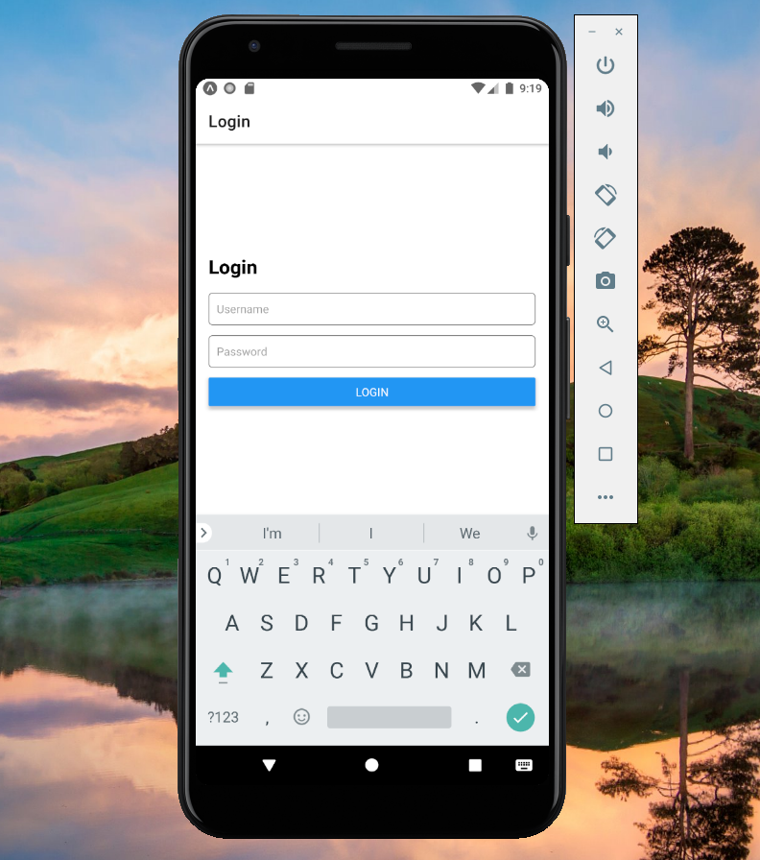

**LOGIN PAGE**

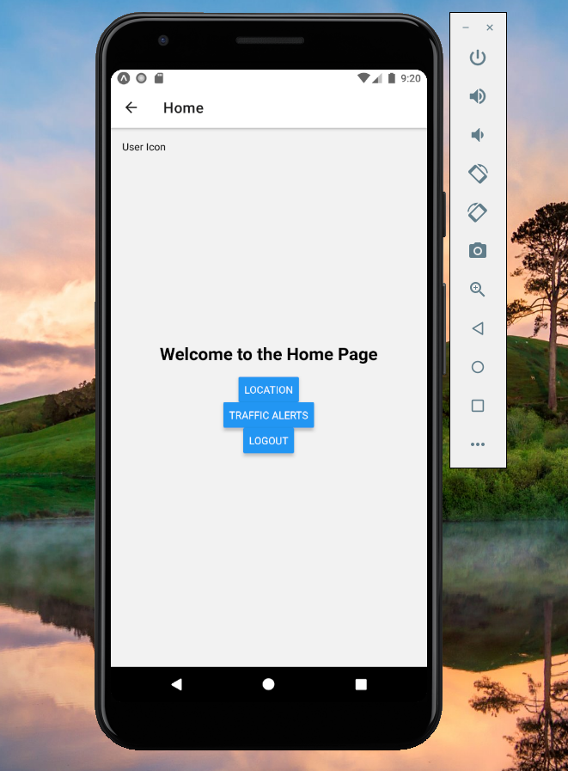

**HOME PAGE**

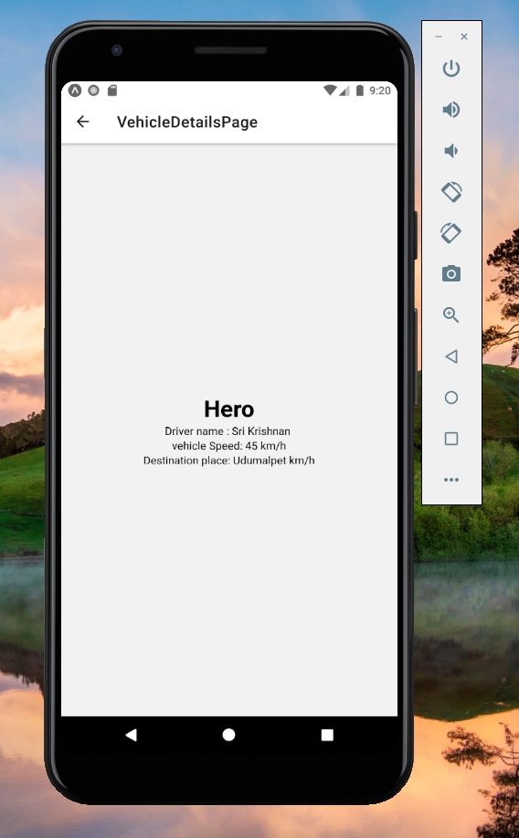

**VEHICLE INFORMATION { PERSON DETAIL }**

* The coding used in our project is :

// App.js

import React from 'react';

import { NavigationContainer } from '@react-navigation/native';

import { createNativeStackNavigator } from '@react-navigation/native-stack';

import LoginScreen from './login';

import Home from './Home';

import TrafficConditionPage from './TrafficConditionPage';

import VehicleDetailsPage from './VehicleDetailsPage';

const Stack = createNativeStackNavigator();

function App() {

return (

<NavigationContainer>

<Stack.Navigator initialRouteName="Login">

<Stack.Screen name="Login" component={LoginScreen} />

<Stack.Screen name="Home" component={Home} />

<Stack.Screen name="VehicleDetailsPage" component={VehicleDetailsPage} />

<Stack.Screen name="TrafficConditionPage" component={TrafficConditionPage} />

</Stack.Navigator>

</NavigationContainer>

);

}

export default App;

// Home.js

import React from 'react';

import { View, Text, StyleSheet, Button, TouchableOpacity } from 'react-native';

const Home = ({ navigation }) => {

const handleLogout = () => {

// Implement a logout function and navigate to the login page here

// Example: navigation.navigate('Login');

};

const handleLocationPress = () => {

navigation.navigate('VehicleDetailsPage');

};

const handleTrafficAlertsPress = () => {

navigation.navigate('TrafficConditionPage');

};

const handleUserIconPress = () => {

// Handle the user icon press to open the dashboard

// Example: navigation.navigate('Dashboard');

// Make sure you have a 'Dashboard' defined in your navigation stack.

};

return (

<View style={styles.container}>

<TouchableOpacity style={styles.userIcon} onPress={handleUserIconPress}>

{/* You can use an icon library or custom icon here */}

<Text>User Icon</Text>

</TouchableOpacity>

<Text style={styles.title}>Welcome to the Home Page</Text>

<Button title="Location" onPress={handleLocationPress} />

<Button title="Traffic Alerts" onPress={handleTrafficAlertsPress} />

<Button title="Logout" onPress={handleLogout} />

</View>

);

};

const styles = StyleSheet.create({

container: {

flex: 1,

justifyContent: 'center',

alignItems: 'center',

},

title: {

fontSize: 24,

fontWeight: 'bold',

marginBottom: 16,

},

userIcon: {

position: 'absolute',

top: 16,

left: 16,

},

});

export default Home;

// VehicleDetailsPage.js

import React, { useState, useEffect } from 'react';

import { View, Text, StyleSheet } from 'react-native';

const VehicleDetailsPage = () => {

const [vehicleDetails, setVehicleDetails] = useState({

vehicleName: 'Your Vehicle',

driverName: 'Ramesh',

speed: 45,

Destinationplace: 'coimbatore',

});

return (

<View style={styles.container}>

<Text style={styles.title}>{vehicleDetails.vehicleName}</Text>

<Text>Driver name: {vehicleDetails.driverName}</Text>

<Text>Vehicle Speed: {vehicleDetails.speed} km/h</Text>

<Text>Destination Place: {vehicleDetails.Destinationplace}</Text>

</View>

);

};

const styles = StyleSheet.create({

container: {

flex: 1,

justifyContent: 'center',

alignItems: 'center',

},

title: {

fontSize: 30,

fontWeight: 'bold',

textAlign: 'center',

},

});

export default VehicleDetailsPage;

// TrafficConditionPage.js

import React from 'react';

import { View, Text, StyleSheet } from 'react-native';

const TrafficConditionPage = () => {

// You can fetch traffic condition data and store it in state here

return (

<View style={styles.container}>

<Text style={styles.title}>Traffic Condition</Text>

{/* List the traffic condition details here */}

</View>

);

};

const styles = StyleSheet.create({

container: {

flex: 1,

justifyContent: 'center',

alignItems: 'center',

},

title: {

fontSize: 24,

fontWeight: 'bold',

marginBottom: 16,

},

});

export default TrafficConditionPage;

// login.js (Unchanged)

* The above given code is the combination of all code used in our project.
* **Next , to show how the real-time traffic monitoring system can assist commuters in making optimal route decisions and improving traffic flow.**

**1. Real-time Traffic Updates**: Data from traffic cameras, GPS devices, road sensors, and mobile apps is used to create real-time traffic updates for commuters through apps, navigation systems, and road signs.

**2. Route Optimization**: Commuters use real-time traffic info to find the quickest route, and navigation apps like Google Maps and Waze adapt directions for smoother travel.

**3. Incident Detection**: The system promptly detects and reports accidents, road closures, construction, and weather conditions. Commuters receive real-time alerts to adjust their routes and avoid delays.

**4**. **Dynamic Re-routing**: Navigation apps can dynamically re-route drivers using real-time traffic data. When unexpected traffic jams occur on the current route, the app suggests faster alternatives, saving time and spreading traffic evenly, reducing congestion.

**5. Public Transportation Integration**: Real-time traffic monitoring systems can also integrate data from public transportation services like buses and trains. Commuters can access information about public transit schedules and delays, making it easier to combine different modes of transportation for their daily commute.

**6. Traffic Signal Coordination**: In some cities, traffic signal systems are synchronized with real-time traffic data. This allows traffic lights to adjust their timing to accommodate traffic flow, reducing congestion and optimizing the movement of vehicles.

**7. Data for Traffic Management Agencies**: These systems provide vital data to traffic agencies for informed decisions on maintenance, infrastructure, and incident response, enhancing traffic flow.

**8. Improved Safety**: Real-time traffic monitoring can enhance commuter safety by providing information about road hazards and accidents. Drivers can take precautions and avoid risky situations, reducing the likelihood of accidents and improving overall road safety.

**9. Eco-Friendly Commuting**: By choosing less congested routes, commuters can reduce their fuel consumption and emissions, contributing to a more eco-friendly and sustainable transportation system.

**CONCLUSION:**

In conclusion, a real-time traffic monitoring system serves as a valuable tool for both commuters and traffic management authorities. It enables commuters to make optimal route decisions, avoid congestion, and stay informed about traffic incidents in real-time. This leads to shorter travel times, improved safety, and reduced environmental impact. Simultaneously, traffic management agencies can utilize the system's data to make informed decisions and implement measures to enhance traffic flow and overall road network efficiency. By empowering individuals and organizations with up-to-the-minute traffic information, these systems play a pivotal role in creating a more efficient, safer, and sustainable transportation system.