New York State Education Department
New York State Library
Division of Library Development

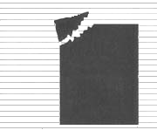 | Division of Library Development Online Grant System  Conservation/Preservation Admin Tasks Manual

Cultural Education Center
Division of Library Development
Albany NY 12203
(518) 474-7890

Stefanie Husak
April 28, 2008
Table of Contents

How to Login to Division of Library Development Online Grant System………………….….3

How to View Grant Submissions…………………………………………………………….…4
Admin reviewer tasks……………………………………………………………….…..5
Admin approver tasks……………………………………………………………….…..7

How to Search for Grant Applications……………………………………………………....…10
View search results……………………………………………….………………....….11

How to Send Correction Request………………………………………………………………12
Unlock application for correction………………………………………………………13

How to assign reviewers to a grant………………………………………………………....…..14
View reviewer ratings and comments for a grant………………………………..…......15

How to view all independent Reviewers……………………………………………..……...…16
Edit Reviewer information……………………………………………………..….…...16
Add a new Reviewer to the system………………………………………………...…..17
Send Reviewers a request for participation……………………………………..….......18
Send Reviewers their assignments for this fiscal year………………………….……...18

How to view Application available and Due dates………………………………………..…..19
Add/Edit an Available and Due date………………………………………………..…20

How to Login to NYSDS LDAP Admin Account…………………….….…………..….…...21
Creating a new user account……………………………………………………...…...22
Updating account entitlements (permissions)……………………………………..….25

How to get additional help……………………………………………………………………28

How to Login to Division of Library Development Online Grant System

- The URL to the system is https://eservices.nysed.gov/ldgrants To login to the Division of Library Development Online Grant System you must have an NYSDS LDAP username and password. If you do not have a NYSDS username and password, you must contact Library Development staff to create your account.
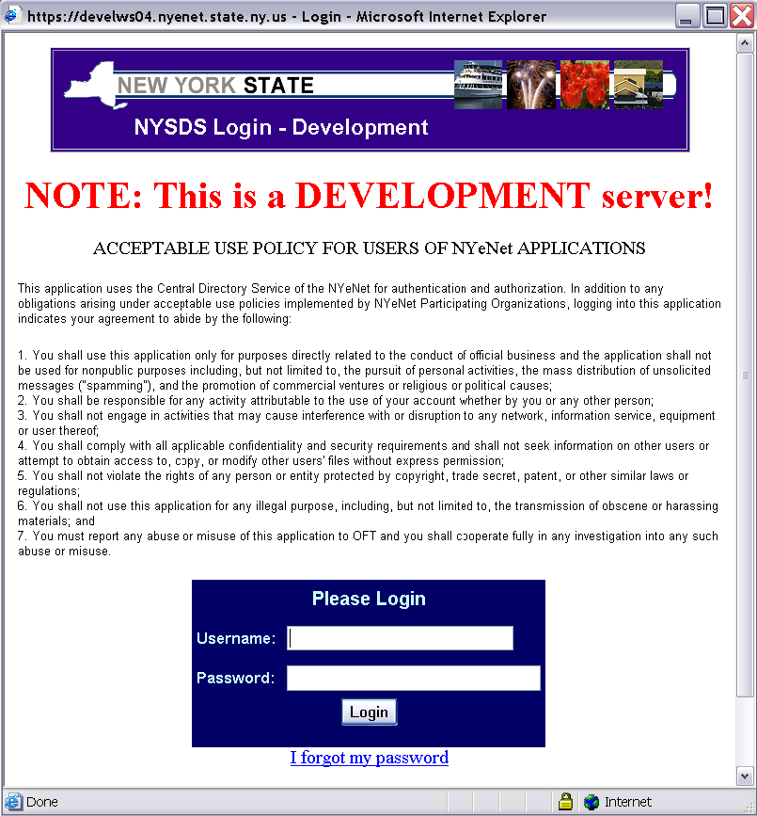

- Enter your username and password and click the Login button. The username for SED staff is usually the same as your Groupwise username. After successfully logging in, you will be able to access the grant programs you are qualified to review or approve.

- The first time you login, you will be asked to change your password and answer security questions that will be used in case you forget your password in the future. . Password requirements are:
  - Must be at least 8 characters long; one of which must be a numeric character
  - Cannot be the same as your username or default password

- If you forget your password, use the ‘I forgot my password’ link to provide the answers to your security questions and reset your password. If you need additional help logging into the system contact LibDevGrants@nysed.gov
How to View Grant Submissions

- The grant program Home page lists all submitted Statutory/Coordinated/Discretionary Aid grants ready for review or approval.

- The heading “New Submissions” and “Final Report Submissions” include all initial/final grant applications and the date the grant was last submitted.

- The heading “Waiting on Final Submissions” include all initial grants that have been approved, but a final application has not yet been submitted.

- The heading “Grants Closed this Fiscal Year” includes all grants denied and those that already have initial and final approvals.

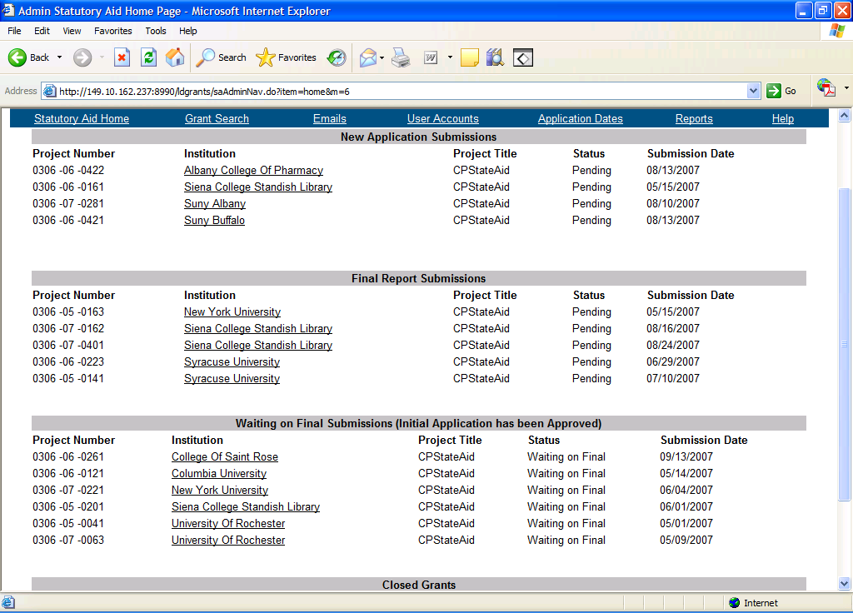

- Grants that have a Status of “Pending” are ready to be reviewed, and grants that have a status of “Complete” are ready to be approved.

- Click on the Institution Name link to go to the “Check Application Status” page where the grant application can be reviewed, and grant award amounts can be approved.
Admin Reviewer Tasks

- All new grants submitted are listed on the grant program Home page. Each grant having a status of Pending is waiting to be reviewed. Each grant with a status of Complete is waiting to be approved.

- The top portion of the Check Status Page lists information about the grant, including the project number, institution, dates submitted and the user that submitted the application. Also listed are any admin approvals for this grant application.

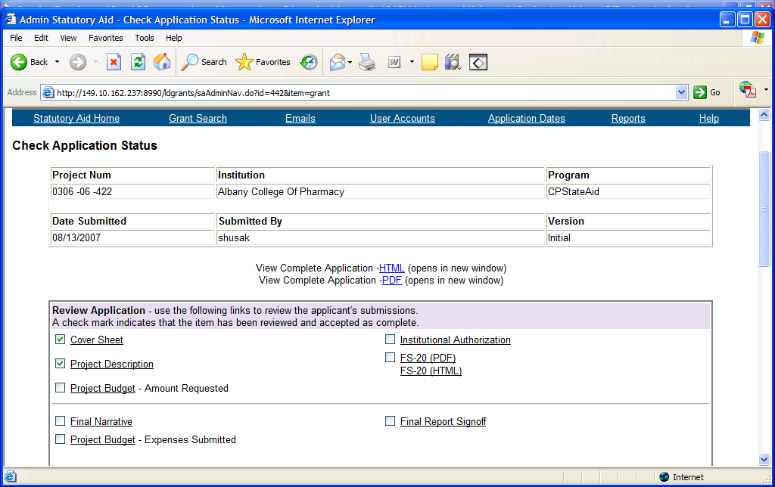

- The box labeled Review Application contains links to all parts of the initial and final grant application.

- After each item has been reviewed and found to be satisfactory, place a check mark in the box next to the item. Then save the reviewed items by clicking button “Save Review”.
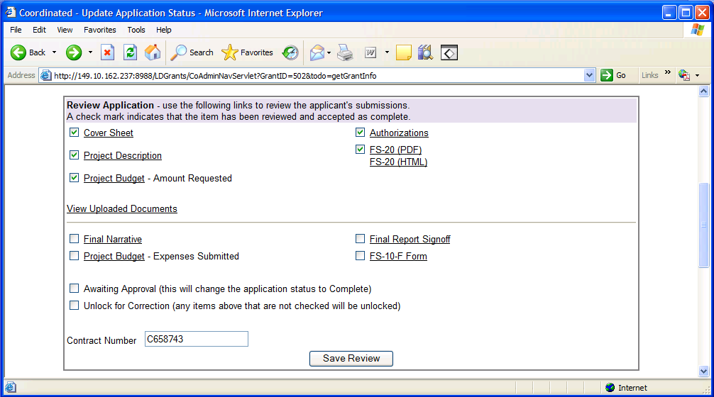

- If all portions of the initial or final application have been reviewed, check the box “Awaiting Approval” to change the status of this grant to Complete and click button “Save Review”.

- If the application needs to be unlocked for a correction, then check the box “Unlock for Correction” and click button “Save Review”. Any application item that does not have a check mark will be unlocked for the applicant to edit.

- To view admin comments for this grant, click the link labeled “Add, Edit, Email Comments”. This is located in the Administrative Tasks box along with information on assigning reviewers and viewing reviewer scores.

- To write a comment and submit it to the Preservation Officer (or Project Manager for Discretionary) for this grant, see the help manual section on How to Send Correction Request.

Admin approver tasks

- All new grants submitted are listed on the grant program Home page. Each grant with a status of Pending is waiting to be reviewed. Each grant with a status of Complete is waiting to be approved.

- The top portion of the Check Status Page lists information about the grant, including the project number, institution, dates submitted and the user that submitted the application. Also listed are admin approvals for this grant application.

- The box labeled Review Application contains links to all parts of the initial and final grant application.

- To view admin comments for this grant, click the link labeled “Add, Edit, Email Comment” located in the Administrative Tasks box.

- To write a comment and submit it to the Preservation Officer for this grant (or Project Manager for Discretionary), see the help manual section on How to Send Correction Request.

- The box labeled Approve Application contains a link to “Approve Budget Amounts” for this application. Click on the link to approve initial and final budget amounts.

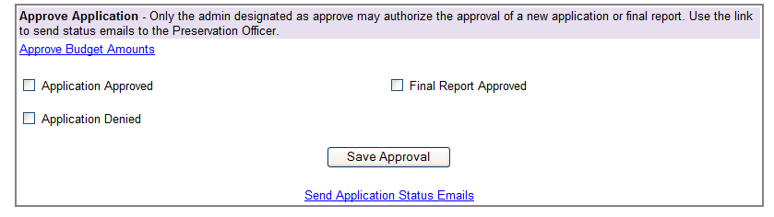

- The Project Budget menu contains links to each of the 5 expense categories, Personal Services, Employee Benefits, Contracted Services, Supplies Materials and Equipment, and Other Expenses.

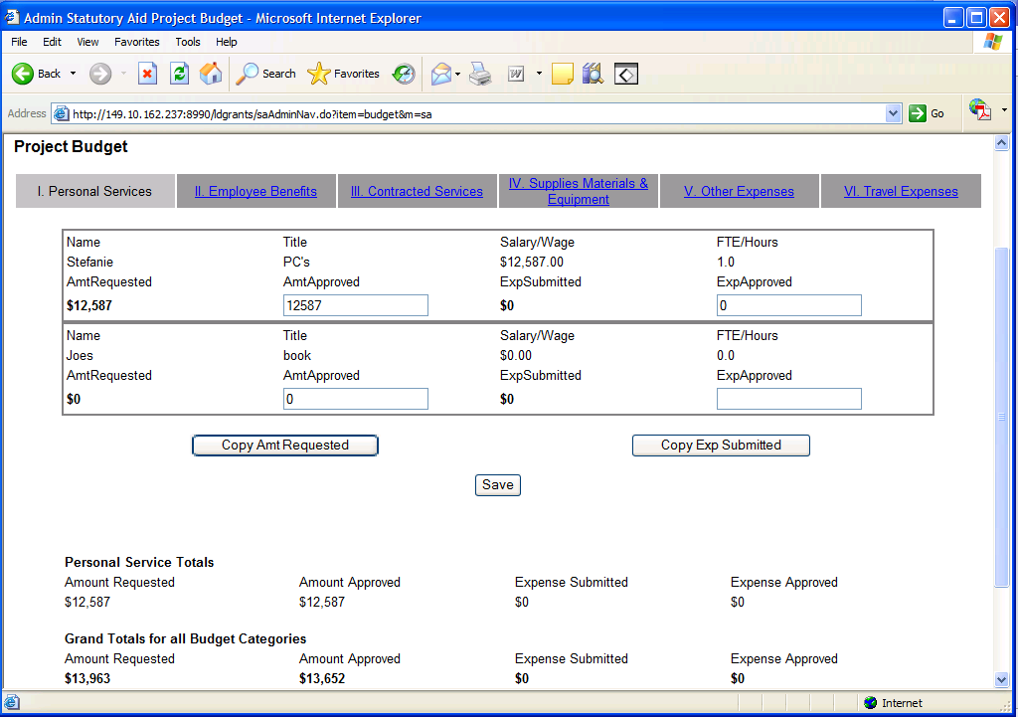

- For each expense record, type in the amount approved or expenses approved for this grant and click the Save button at the bottom of the screen.

- Approved budget amounts can be automatically entered by clicking on the button Accept Amount Requested or the button Accept Expense Submitted. The system will save the amount requested or expense submitted as the amount approved or expense approved.

- Click the link Back to Application Checklist to return to the Check Application Status page and complete the approval process.

- On the Check Application Status page in the Approve Application section, check the box next to Initial Application Approved or Final Application Approved and click the Save Approval button.

- Deny Grant Application – to deny the application, check the box next to Application Denied and click the Save Approval button. The application will be locked for editing and submitting.

- To Send a Status Email message click on the link for Grant Application Status Email and then choose the type of email you need to send, either Initial or Final Approval or Application Denial.

- Once you click the confirmation button, the email will be sent to the Preservation Officer (or Project Manager for Discretionary).

How to Search for Grant Applications

- From the grant program Home page, click on the menu link labeled "Grant Search". This will bring you to the search page.

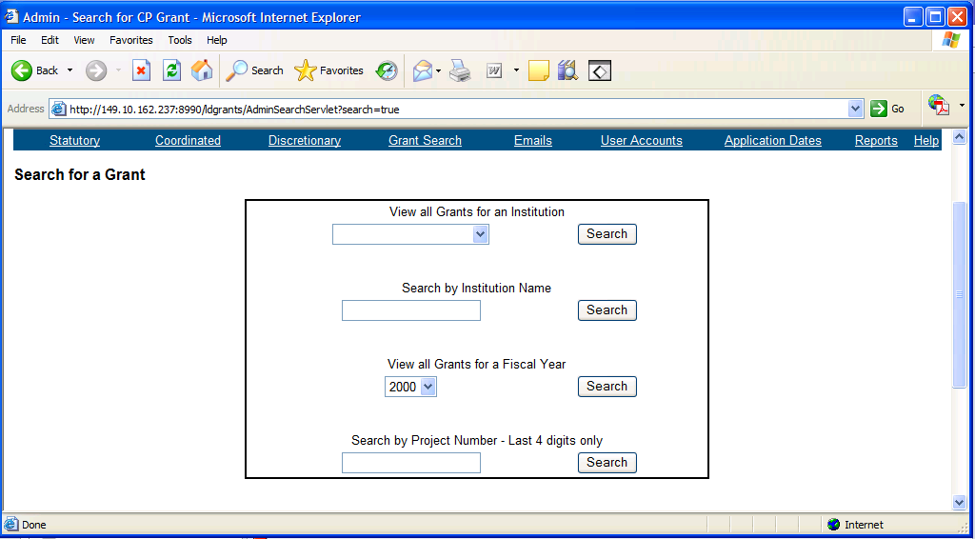

- There are three options for performing a grant search:

  - Search by an Institution - will return all grant applications for that institution
  - Search by Fiscal Year - will return all grant applications for that fiscal year
  - Search by Project Number - will return the selected grant application
  - Only enter the last 4 digits of the project number. The fund code and fiscal year code do NOT need to be entered

- Statutory and Coordinated grants have a drop down box listing all eligible institutions. To search for Discretionary grants by institution, you must type in the name of the institution. For example, type ‘Troy’ to find grants for Troy Public Library.

- The search results will display in a table, and clicking on the project number of a particular grant will return all the information associated with that grant application, including project narratives, project budget, application submissions and approvals.

- Once you have clicked on the project number of the grant to view, you also have the option of viewing the grant application in PDF format, which can be printed or saved to your desktop.

Viewing Search Results

- Click on the project number of the grant you wish to view.

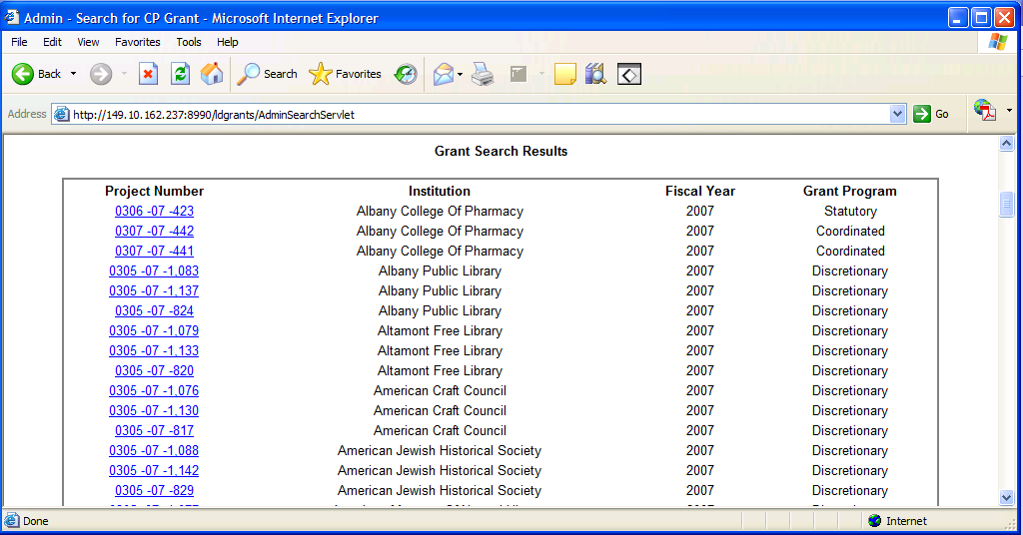

- Click on the link for PDF format to download a PDF version of this grant application. The PDF format can be used to print the complete application, or to save to a desktop.

How to Send Correction Request

- From the Application Check Status page for the given grant application, scroll to the Corrections Requested box. Type in the new comment pertaining to this grant application and click the button Save Correction.

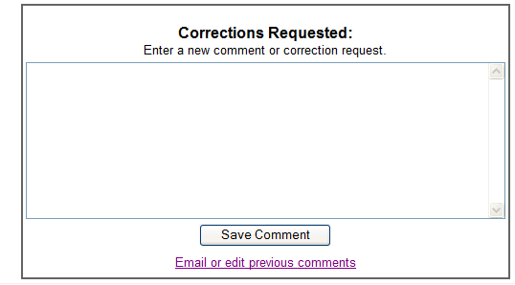

- The comment will be saved to the database and can be edited or emailed by clicking the link Email or Edit previous comments.

- The link will display all comments for this grant. Click on Delete to delete comment, or Send Correction Email to send this comment in an email to the Preservation Officer (or Project Manager for Discretionary Grants).

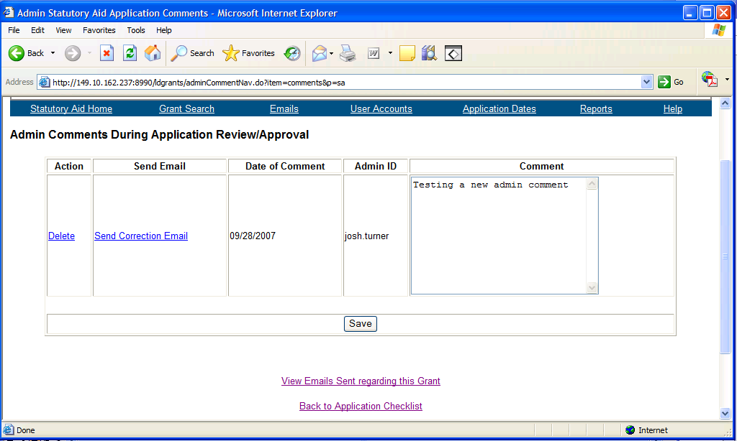

- The comments may be edited and saved by clicking the Save button below the comments.

- If you are requesting that the applicant edit their grant application, you must also unlock the portion of the application they need to edit.

- From the Review Application section, check the box “Unlock for Correction” and click button “Save Review”. Any application item (Coversheet, Project Budget, etc.) that does not have a check mark will be unlocked for the applicant to edit.

How to assign reviewers to a grant

- From the grant program Home page, choose a grant project that has been submitted. On the Check Status page, click on the link to Assign Reviewers located in the Administrative Tasks box.

- The top portion of the Assign Reviewers page has links to Cognos reports about the reviewers, including Reviewer Contact information, Reviewer availability and Reviewer assignments.

- The middle section of the Assign Reviewers page has a chart listing all reviewers who have filled out a participation form indicating that they are willing to review this grant program for this fiscal year. It has the maximum number of grants they are willing to review, along with the number of grants assigned to them so far. If the reviewer has been assigned more grants than they requested, a warning message will be displayed.

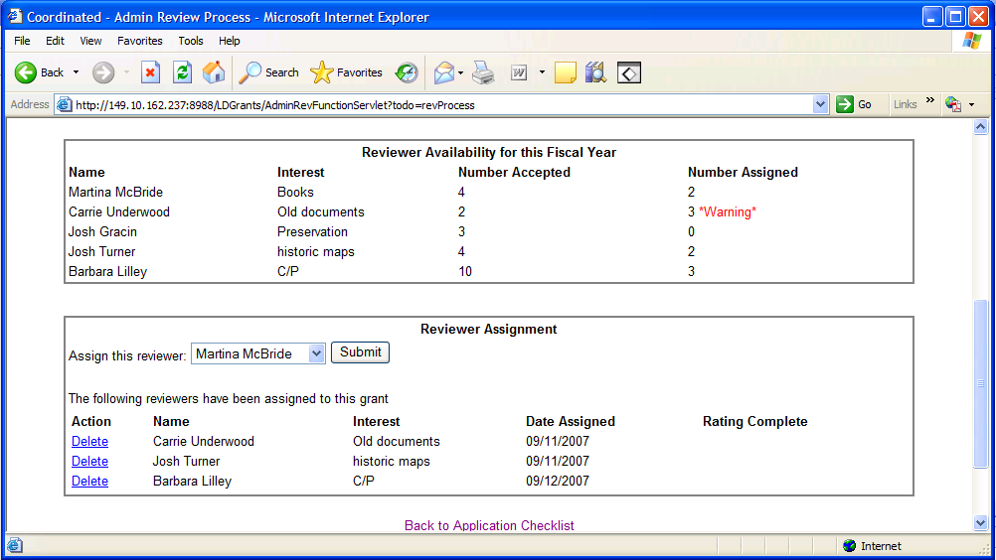

- The bottom portion of the page has a dropdown list of reviewers that agreed to review this grant program for this fiscal year. You can choose the reviewer you want to assign to this grant and click Submit button.

- The names of reviewers that have been assigned to this grant are listed, along with the date of assignment, and whether the reviewer’s rating has been completed. To delete an assignment, click the Delete link next to the assignment record. If this reviewer has already filled out a rating form or comments for this grant, you can NOT delete this grant assignment.
View reviewer ratings and comments for a grant

- From the grant program Home page, choose a grant project that has been submitted. On the Check Status page, click on the link to View Reviewer Ratings located in the Administrative Tasks box.

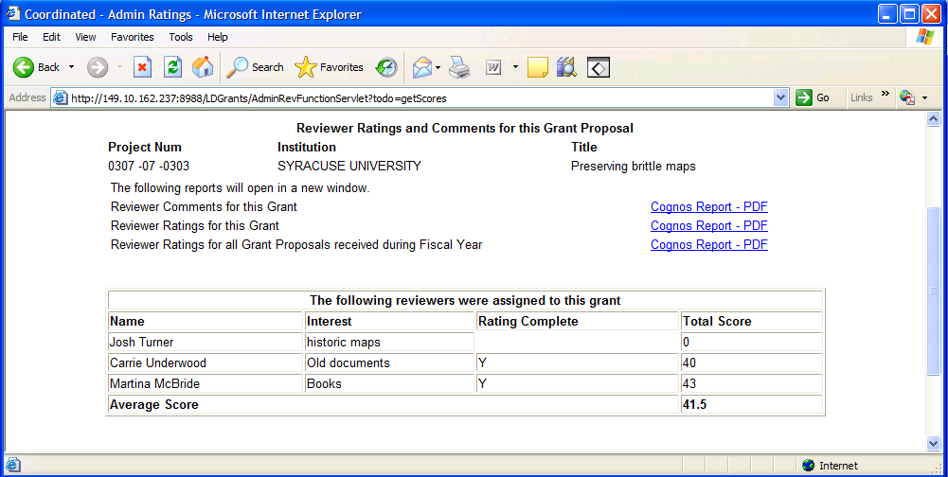

- The top portion of the View Ratings page has links to Cognos reports regarding the ratings for this grant. There is a report containing comments made by the three reviewers, a report with the ratings given to this grant proposal by the three reviewers, and a report with all ratings given for grants that were received this fiscal year. The ratings and comments are only available after the reviewer has submitted them.

- The bottom portion of the View Ratings page lists each reviewer assigned to this grant, and whether they have submitted their rating. If they have submitted the rating, you will see the total score they assigned the grant, and and average score based on all reviewer scores.

How to view all independent Reviewers

- Click on the top menu link labeled “Reviewers” to view a list of all Reviewers in the database along with their interest and affiliation. Active reviewers will be marked Y and inactive reviewers will be marked N. Inactive reviewers will not receive mass mailings.

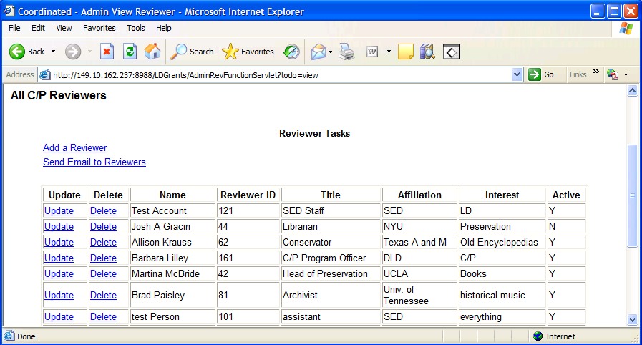

- To update a Reviewer’s information use the Update link next to the reviewer record. To delete a reviewer use the Delete link next to the reviewer record. You may NOT delete a reviewer that already has been assigned to a grant or has filled out a request for participation form. In those cases the reviewer should be updated and Active status set to No.

- Edit Reviewer information

- Click the link “Update” next to the reviewer record that you need to edit. All information on this reviewer will be displayed and you can update as necessary. Click the Save button to commit the changes.

- A valid email address is needed for each reviewer so that they can receive notifications sent out by the system. An NYSDS LDAP user name is needed for each reviewer so that they may login to the system. And if the Reviewer’s active status is set to No, they will not be receiving any email notifications.
Add a new Reviewer to the system

- Click on the top menu link labeled “Reviewers” and then choose Add a reviewer. Adding a new reviewer is a 2 part process that requires first creating a new NYSDS LDAP account so the reviewer can login to the system, and then adding the Reviewer’s contact information to our database.

- Use the link to OFT’s NYSDS Delegated Admin system to create an LDAP account for the reviewer. Detailed instructions on this process can be found in this help manual under “Creating a new user account”.

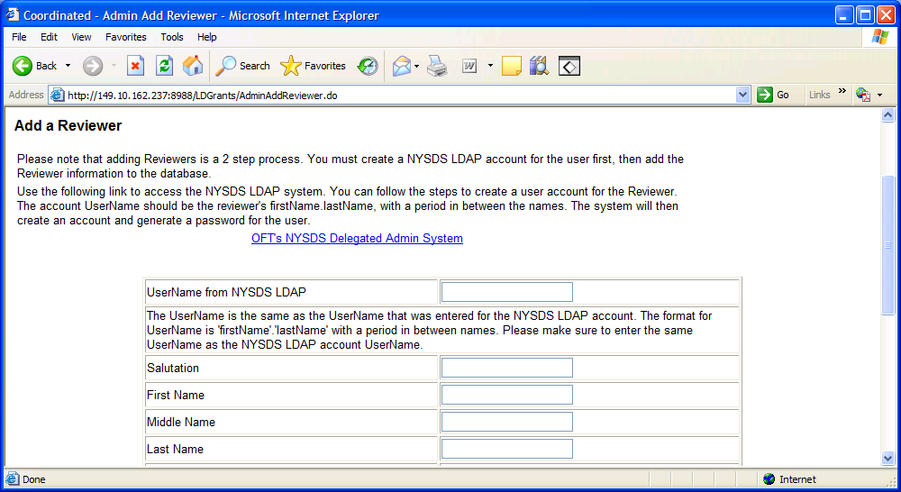

- After you have created the reviewer’s LDAP account, you can fill in the reviewer information including name, address, and email. Email address is required so the reviewer can receive notifications sent out by the system.

- The Active status is set to Yes for each new reviewer added to the system. Active means that the reviewer will receive email notifications regarding filling out a request for participation and assignment emails.

Send email to reviewers

- Click the top menu link labeled “Reviewers” to get a listing of all reviewers in the database, and then “Send email to Reviewers” to view the options for sending mass mailings to reviewers.

Request for Participation Email

- To send a Request for Participation email, click the Send Request button. This will send an email to all active reviewers asking them to login to the system and create a new participation record for the new fiscal year. On the participation form they can choose the maximum number of grants they are willing to review for a given grant program.

Reviewer Assignment Email

- To send a Reviewer Assignment Email, choose the fiscal year you are sending the assignments for and then click the button Send Assignments. You will see a list of all reviewers that have been assigned grants for the selected fiscal year, along with the project numbers of the grants they were assigned.

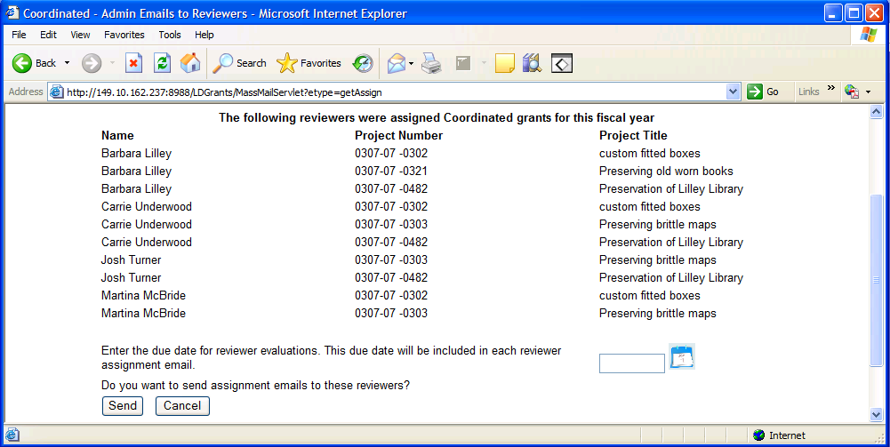

- Type in a due date or select a date using the Calendar icon. This date will be included in the Assignment email, and the reviewer will be instructed to submit all rating sheets by this due date.

- Click Send button to confirm sending the Assignment email to all Reviewers that have been assigned grants this fiscal year.

How to view Application available and Due dates

- Click on the top menu link labeled “Application Dates” to view a list of all the application available and due date records.

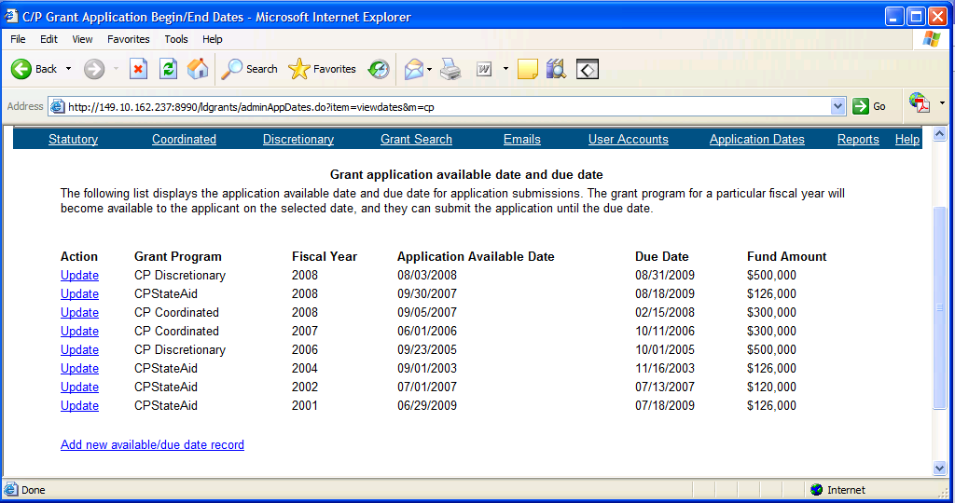

- For each grant program and fiscal year the application available date is the date that users may begin filling out a grant application. And the due date is the last day they may submit the application.

- Click the link “Update” next to the record you need to update, or click the link on the bottom to add a new record for available and due dates. NOTE: You can only have 1 record per grant program and fiscal year. (For example, you can only have 1 record for Coordinated grants for 2007 with only 1 available and due date).

Add/Edit an Available and Due date record

- Click on the “Application Dates” page to view all the application available and due date records. If the grant program and fiscal year record you need does NOT already exist, then click the Add Record link at the bottom of the page.

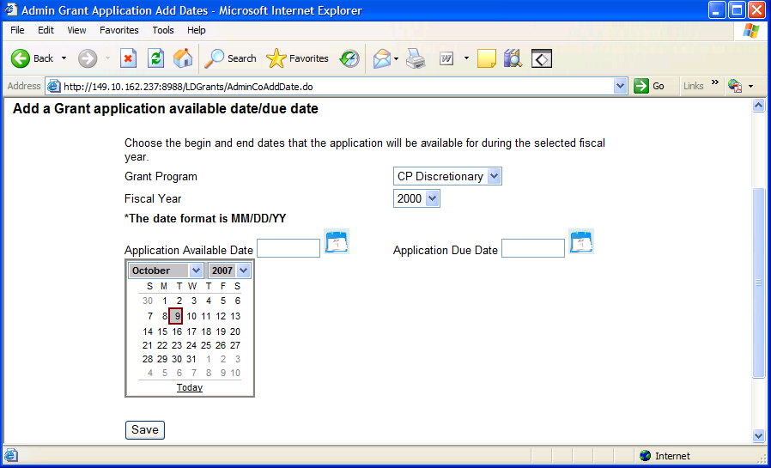

- All fields on the Add date page are required. Choose a grant program, fiscal year, and type in the Available and Due dates in the text boxes. Or you can use the Calendar icon to choose each date. Click the Save button to add the record to the database.

- If you need to change an application date record that is already listed on the Application Dates page, click the Update link next to the record.

- All fields on the Update date page are required. You must choose a grant program, fiscal year, available date and due date. Note that by changing the available and due dates you are impacting the time period that users may create new applications or submit existing ones.

How to Login to NYSDS LDAP Admin Account

- Click on the menu linked labeled LDAP accounts. The page will display the information required to create or update a NYSDS (New York State Directory Services) LDAP account.

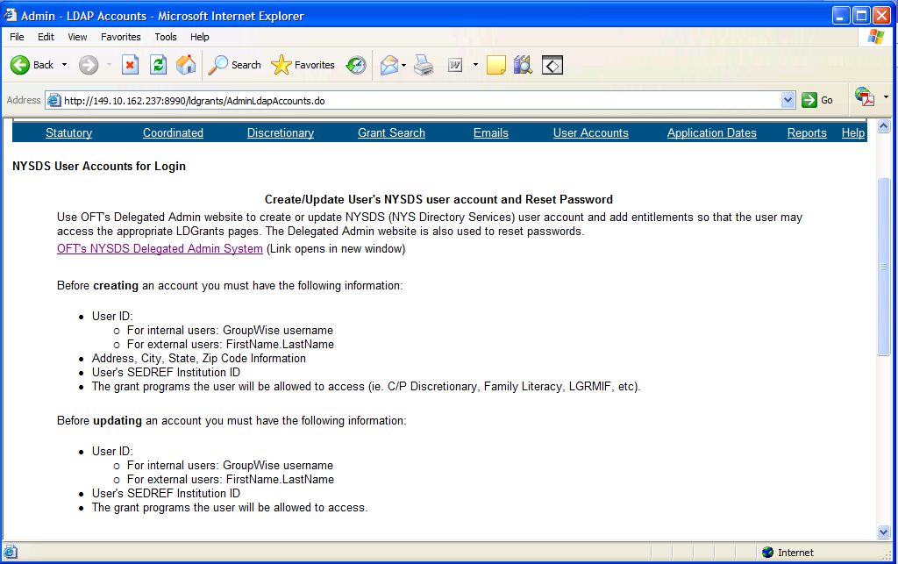

- The bottom of the page has a table containing SEDREF Institution ID numbers for the Big 11 libraries. Make note of the Institution ID corresponding to the user’s account you wish to update.

- If you have all the required information for the user, you can click on the link to go to OFT’s NYSDS Delegated Admin System. This will take you to the NYSDS login page. You will need to type in your Delegated Admin username and password to login to NYSDS. In most cases, this is not the same username and password that you use to login to LDGrants.

Note: Please remember to logout of the NYSDS Delegated Admin system once you are finished. The logout button is the last button on the menu options on the left of the screen.

Creating a new user account

- Follow the directions above to login to your NYSDS LDAP Admin account.

- Once in the NYSDS Delegated Admin system, click on the link Search to search for the user you wish to create an account for. This is to check if the user already has an account, or if the username is already taken.

- Type in the username you wish to use for the new user. Internal SED staff should have the same username as their GroupWise Email username (ex. shusak). The naming convention for external users is firstName.lastName, with a period in between the first and last names (ex. jane.doe) .

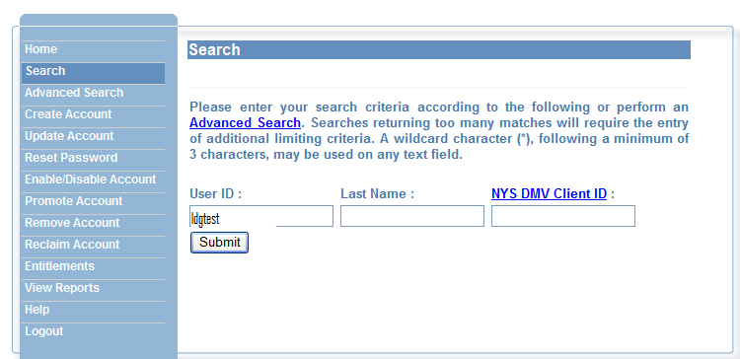

- If there are no results returned, then you can proceed to create an account for this user. If the username already exists in NYSDS, verify that this is the username you need (matches the person you need an account for). If it is the same person, then they already have an account, and you only need to add entitlements. Otherwise you can proceed to create an account for the user, and when asked for a username, just add a number to the end of the username to make it unique (ex. john.jones1).

- On the NYSDS Admin Home page, click the link Create Account. For Step 1 you must enter the user’s first and last name, email, organizational unit (NYS Education Dept), and account level. The account level should default to 1 for a regular user, do not use account level 2.

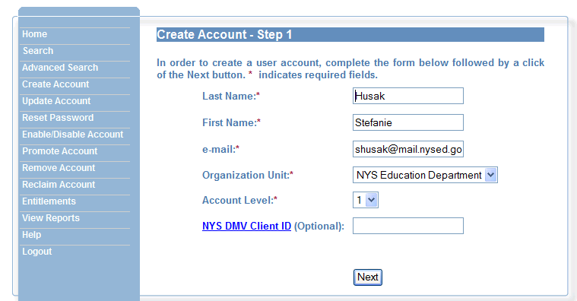

- For Step 2, enter the user’s phone number, street, city, state, and zip code.

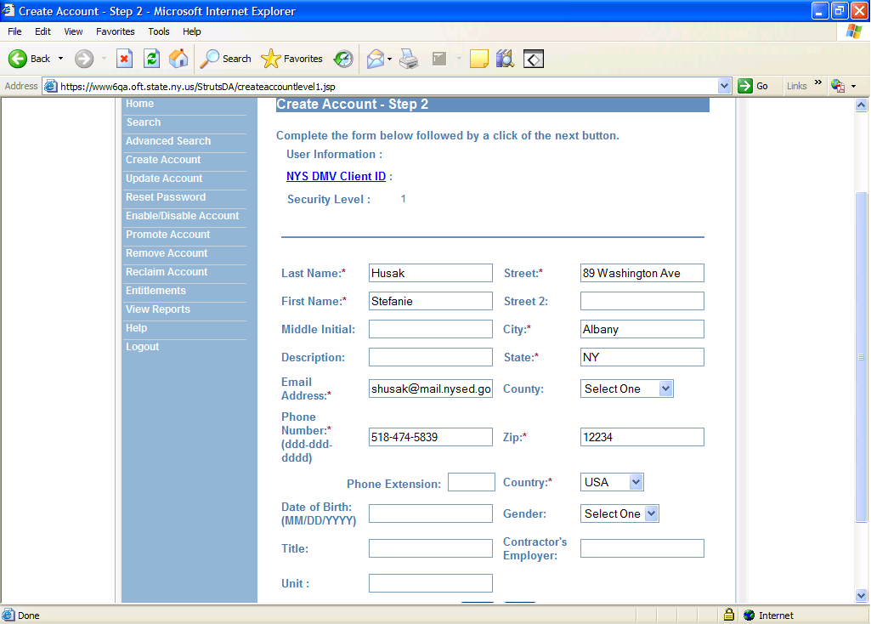

- For Step 3, the system will automatically generate a username and password. Write down the password, you need to send the password to the user so they may login to LDGrants.

- Change the system generated username to the username you searched for in the steps above. Again, for internal SED employees, the username is their GroupWise Email username. For external users the username is firstName.lastName with a period between the first and last name. Once you have the username and password written down, click Create.

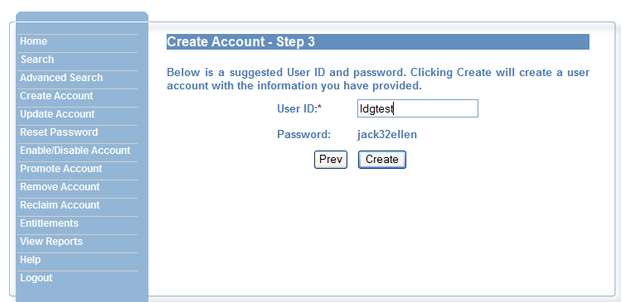

- The screen will display a message notifying if the account was created successfully. You still need to update entitlements (permissions) for the account to access LDGrants, and then notify the user of their new account username and password. The user will have the opportunity to change their password the first time they login.

Updating account entitlements (permissions)

Updating entitlements involves granting permissions to the user account so they may access LDGrants. This is where you designate the user as an applicant or admin, assign the SEDREF Institution ID, and grant read/edit/submit or review/approve permissions.

- Follow the directions above to login to your NYSDS LDAP Admin account.

- Once in the Delegated Admin System, click on the link for Entitlements, enter the account username in the text box provided and click Submit button.
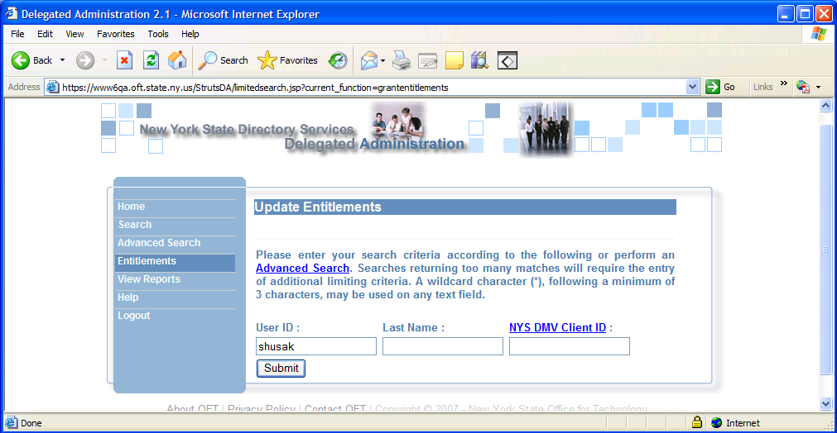

- If the account was found, the search results display with the name and address information for this account. Click on the link to Update Entitlements for this user at the top of the page.
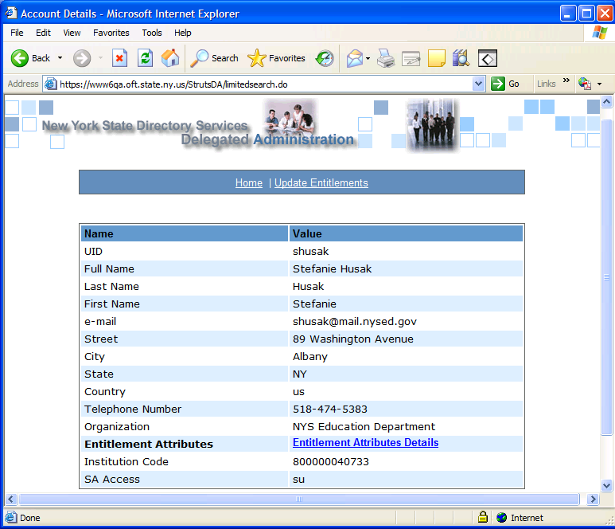

- On the entitlement page, enter the user’s SEDREF Institution ID in the attribute box “Institution Code”. Enter their permissions for Coordinated Aid, Statutory Aid, etc. in the appropriate attribute box, “SA Access” or “CO Access”. The permissions include:
re – for read only access to applications
ed – for read and edit access to applications
su – for read, edit, submit access to applications

- The permissions can also be granted for Coordinated and Discretionary grants in the attribute box “CO Access” and “DI Access”.

- If the Access attribute boxes are left empty, the user will not have any access to that particular grant program.

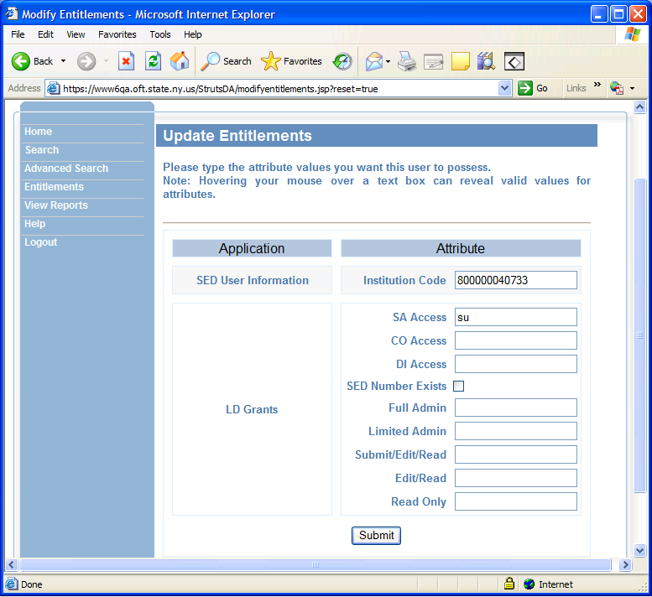

- If the user is an admin, then type in the grant program they have access to. Full Admin can approve grants and Limited Admin can review grants. The grant programs for Admin attribute boxes include:
stat – for Statutory Aid grant administrators
coor – for Coordinated grant administrators
disc – for Discretionary grant administrators
- The admin attribute can administer more than 1 grant program by separating the grant programs with commas (ex. stat,coor).

- If this account is for a Reviewer, then add an attribute to the Reviewer textbox. The reviewer attributes are stat, coor, and disc, which allow the Reviewer to review Statutory, Coordinated or Discretionary applications. The reviewer can review more than 1 grant program by seperating the grant programs with commas.

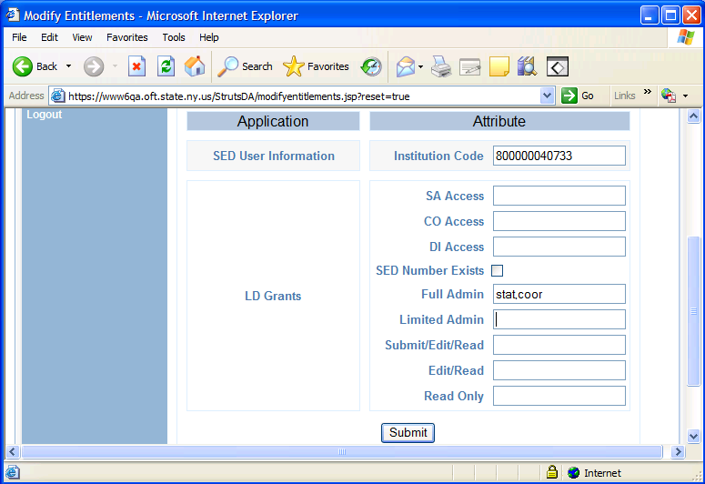

- Click the Submit button to save the entitlements for this user. A message will display if the save was successful.

Note: Remember to logout of the NYSDS Delegated Admin System when you are finished.

How to get additional help

- Use the top menu link labeled ‘Help’ to access the Guidelines and Instructions documents for Statutory, Coordinated, and Discretionary Aid. There are links to the Admin User Manuals, and also to the applicant user manuals.

- For questions or concerns regarding the Conservation/Preservation program, such as funding or eligible expenses, contact the Conservation/Preservation Program Officer Barbara Lilley at barbara.lilley@nysed.gov

- For questions or to report error messages while using the Division of Library Development Online Grant System, contact the system administrator at stefanie.husak@nysed.gov or 518-474-5839. Please provide the full error message you encountered, or attach a screenshot of the page you were working on. To get a screenshot of the page, hold the Ctrl key and press Print Screen on your keyboard. Then just paste the image into Microsoft Word and send it as an email attachment.

