New York State Education Department
New York State Library
Division of Library Development

Public Library Construction Grant Program –
PLS Reviewer Module

Cultural Education Center
Division of Library Development
Albany NY 12203
(518) 474-7890

June 13, 2011
Table of Contents

How to Login to Division of Library Development Online Grant System..……………..3

How to set a Due Date for member applications…………………………………………4

How to search for applications by fiscal year, member name…………………………….5

How to view applications submitted by Members.…………………...……………………6
How to view/edit Member’s Application Form, Narratives, etc…………………...7
How to unlock a Member’s application……………………………………………8
How to fill out an Evaluation Form for each member application………………...9
How to set the ‘Amount Recommended’ for a member application………………9

How to submit member applications to Library Development…………………………..11

How to Login to Division of Library Development Online Grant System

- The URL to the system is https://eservices.nysed.gov/ldgrants To login to the Division of Library Development Online Grant System you must have an NYSDS username and password. If you do not have a NYSDS username and password, contact Library Development staff to create your account. Your username and password will be sent via email.
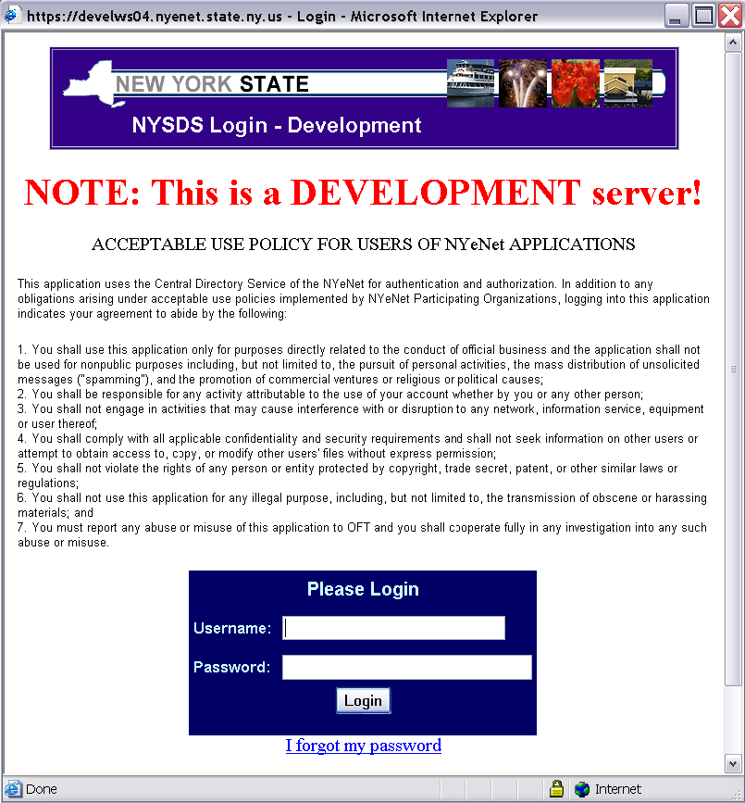

- Enter your username and password and click the Login button. Your username is usually your firstName.lastName (with a period in between first and last names).

- The first time you login to the system, you may be asked to change your password and set up security questions. These questions will be used in case you later forget your password. Password requirements are:
- Must be at least 8 characters long; one of which must be a numeric character
- Cannot be the same as your username or default password

- If you forgot your password, click the link ‘I forgot my password’ and answer your security questions in order to reset your password. If you don’t remember the answers to the security questions, please contact LibDevGrants@nysed.gov to reset your password.

- Click on the link for “Construction – Library System Reviewer” to access the PLS reviewer module.

How to set a Due Date for member applications

- From the top menu bar in the Construction Reviewer module, click the ‘Due Dates’ link.

- The table will list a row for each fiscal year, containing the PLS name, PLS due date, Library Development due date, the system allocation, and the system’s amount recommended so far for the given fiscal year.
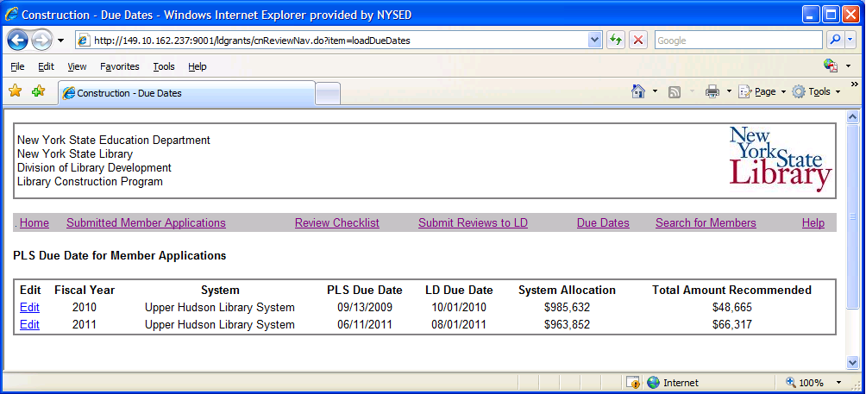

- Click on the ‘Edit’ link for a due date record. Enter the due date for member applications. This due date will be visible on the member’s checklist page. The due date must be in MM/DD/YYYY format. Click on the ‘Save’ button to save the PLS due date.

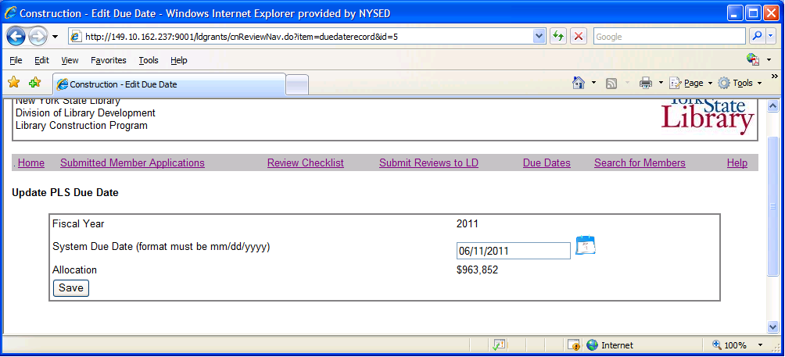

How to search for applications by fiscal year, member name

- From the top menu bar in the Construction Reviewer module, click the link ‘Search for Members’.

- Select a fiscal year OR member library name to view matching member applications (both submitted and non-submitted applications). If a member library is not listed in the ‘Member’ drop down list, contact Linda Todd in Library Development to have the member library added to your evaluation list.

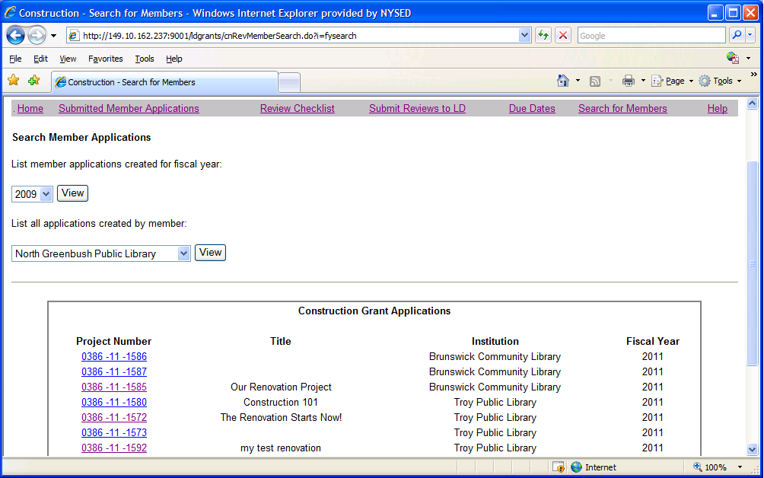

- Click on the Project Number link to access the Checklist for the given application. From the Checklist, you can view all portions of the application, including Application Form, Narratives, Budget, Attachments, etc.

How to view applications submitted by members

- From the top menu bar in the Construction Reviewer module, click the link ‘Submitted Member Applications’.

- Select a Fiscal Year, and click the View button. The table will list all applications submitted by member libraries for the given fiscal year. Click on a Project Number link to access the Checklist for the given application.

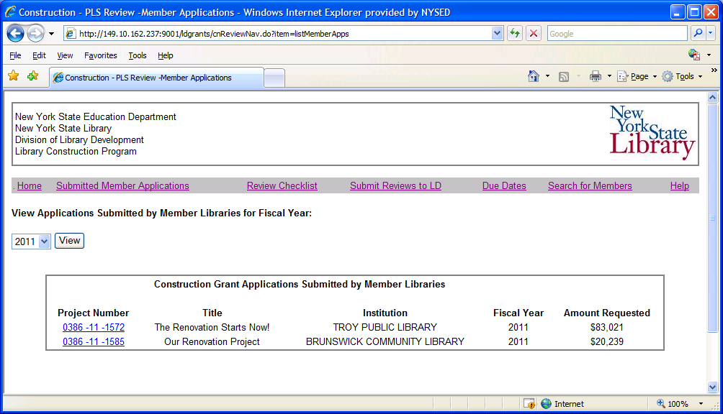

- The Checklist page for each application has links to all portions of the application, including Application Form, Narratives, Budget, Attachments, and all Documents/Approvals that need to be attached or mailed.

- Three copies of the FS-20 Form with original signatures in blue ink and 1 copy of the Payee Information Form with original signature in blue ink must be mailed to the PLS by each applicant. The PLS will mail FS-20’s and Payee Forms of approved projects to Library Development.

- The following documents are required to be electronically attached to the application: Assurances, Certificate of Available Funds to Finance Project, Short/Full Environmental Assessment Form, Smart Growth Form, Pre-Construction Building Photographs.

- The following documents must be electronically attached to the application only if the project meets the criteria given: SHPO Approval, Office of Facilities Management Approval, Certificate of 10 year minimum lease. See the online system instructions to determine if your project requires these additional documents.

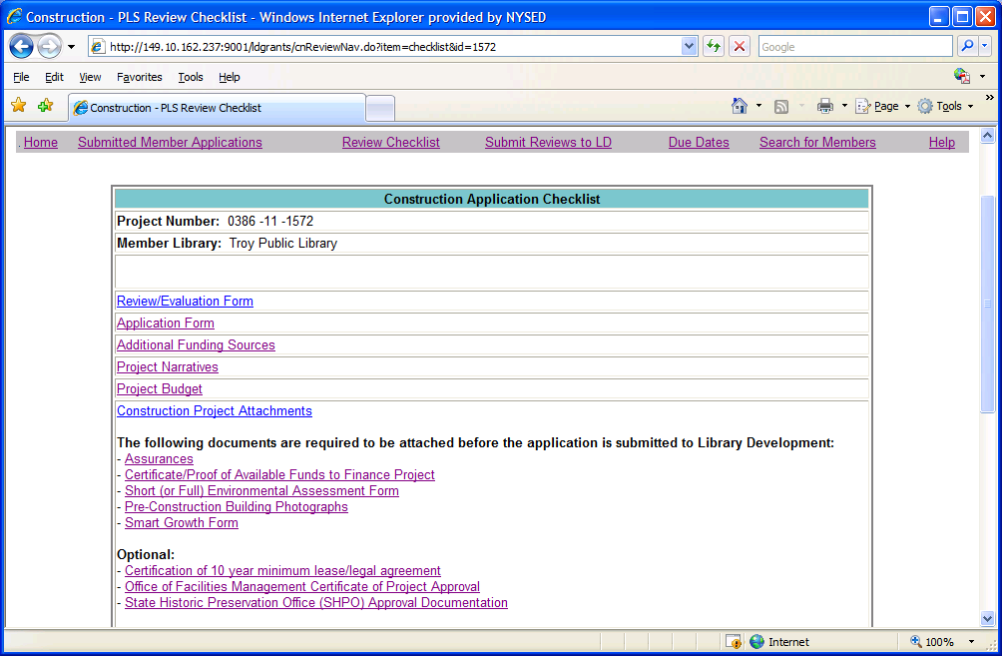

- To Edit a member’s Application Form, Narratives, Budget, Attachments, click on the appropriate link on the Checklist page. After the PLS submits a member application to Library Development, the PLS will no longer be able to edit the application.

- The bottom of the Checklist page has links to Save to your desktop or Print the completed Application Form, Narrative, and Budget in HTML and PDF formats.

How to unlock a member’s application

- Once a member submits an application to their PLS, the member is locked from editing the Application Form, Narratives, Budget, etc. The PLS can edit the application for the member. Or, the PLS can unlock the application, and allow the member to edit.

- Once the PLS submits an application to Library Development, both the member and the PLS are locked from editing the Application Form, Narratives, Budget, etc. The PLS will no longer have the ability to unlock the application.

- To unlock an application for the member: scroll to the bottom of the application Checklist page. (See the instructions above on how to view submitted member applications & access the Checklist). Click the link for ‘unlock application’.

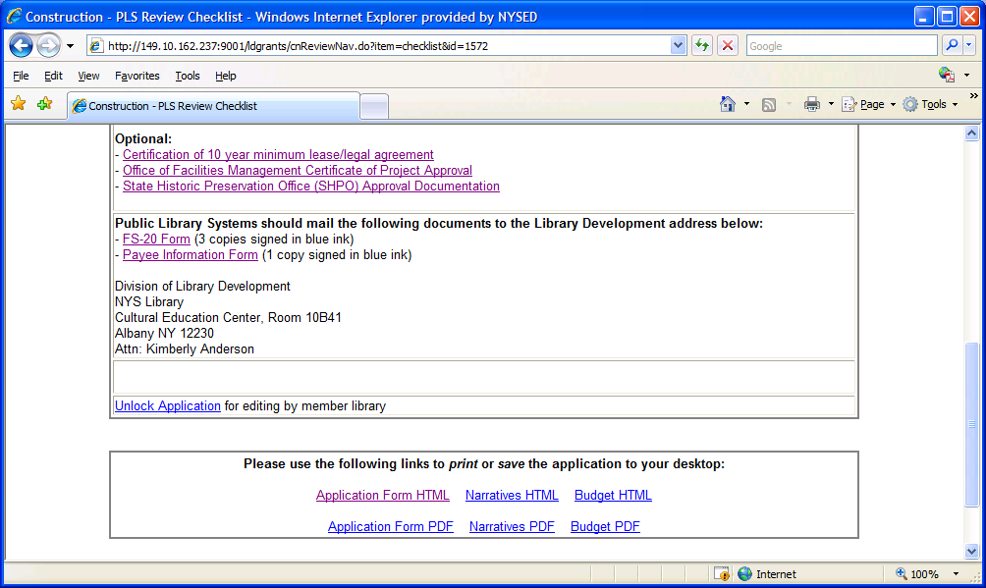

How to fill out the Evaluation Form for member applications
How to set the ‘Amount Recommended’ for member applications

- From the application Checklist page, click the link for ‘review/evaluation form’. (See the instructions above on how to view submitted member applications & access the Checklist.)

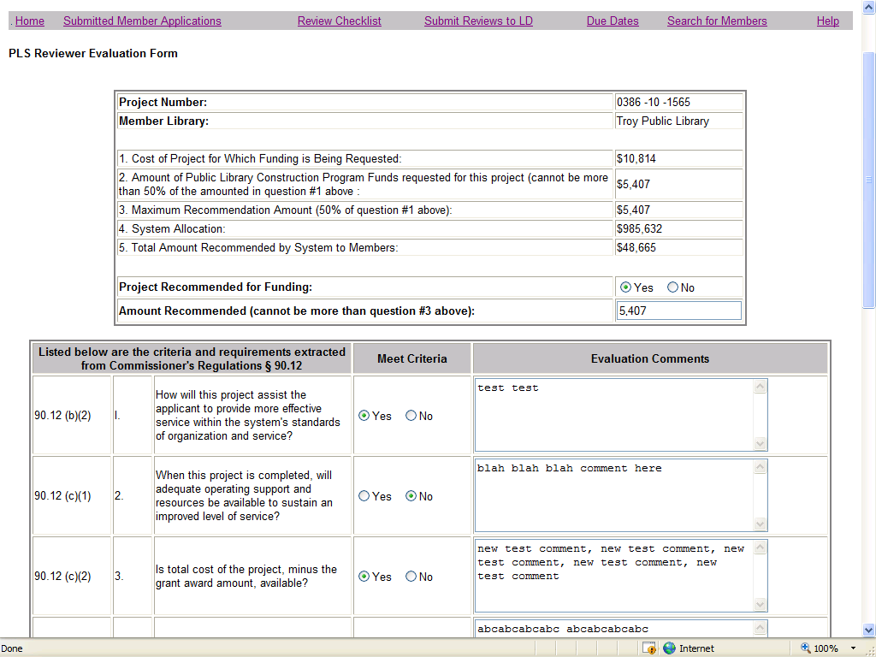

- The evaluation form has a series of yes/no questions and textboxes for comments. Use the Save button at the bottom of the form to save all data entries. The evaluation form comments will be visible to Library Development, but Not visible to member libraries.

- The top of the evaluation form contains monetary figures related to the cost/recommendation amounts for this project. The figures include the cost of the project, the amount of funds requested for the project, the 50% maximum recommendation amount, and the PLS’s allocation for the given fiscal year.

- Line number 5 contains the total amount of money the PLS has recommended so far (a running total of the Amount Recommended for all members for the given fiscal year). An error message will display if the Total Recommended by System exceeds the System’s Allocation.

- The ‘Amount Recommended’ field is the amount the PLS recommends. This amount cannot exceed Line 3 ‘Maximum Recommendation Amount’.

- Once the PLS submits the member application to Library Development, the PLS will be locked out of editing the Evaluation Form and Amount Recommended.

- To view a listing of all member applications, along with the Amount Recommended for each, see the section on ‘How to submit member applications to Library Development’.

How to submit member applications to Library Development

- From the top menu bar in the Construction Reviewer module, click the link ‘Submit Reviews to LD’.

- Select a Fiscal Year from the drop down list, and click View. The table will list all member applications submitted to the PLS.

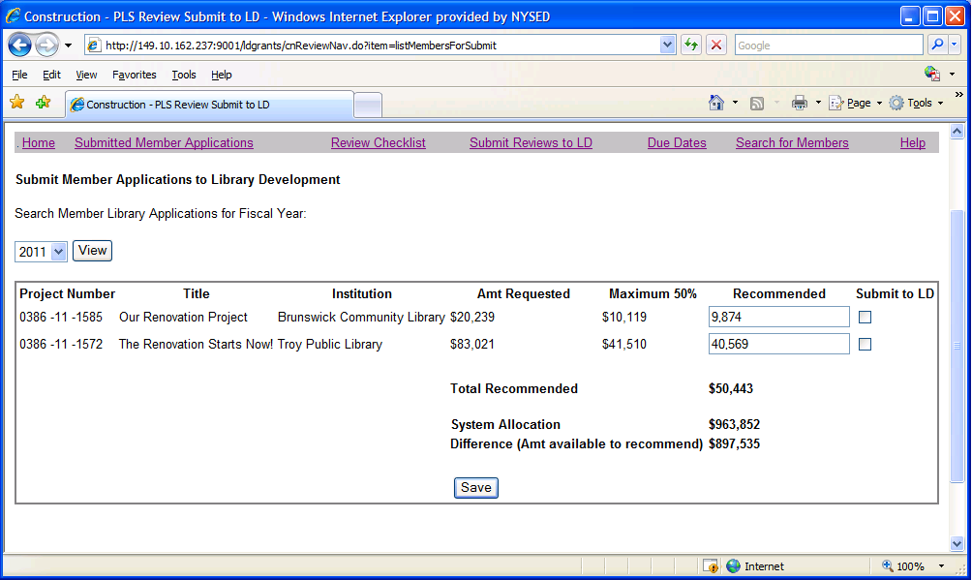

- The amount requested for the project, and the maximum recommendation amount are listed. The amount recommended for each application is copied over from the Evaluation Form. The PLS can also edit the amount recommended on this screen. To Save a new Recommended Amount, click the Save button at the bottom of the screen. The calculations of the ‘Total Recommended Amt’ and the ‘Amt available to recommend’ will refresh after the Save button is clicked.

- To submit an application to Library Development, click the checkbox in the ‘Submit to LD’ column, and click the Save button. You can submit one or multiple applications at a time.

- NOTE: after you click the ‘Submit to LD’ checkbox, and click the Save button to save your changes, both the PLS and member will be locked out of editing the application. The PLS cannot edit the Amount Recommended for any application submitted to LD.

