New York State Education Department
New York State Library
Division of Library Development

Public Library Construction Application
Online Grant System User Manual

Cultural Education Center
Division of Library Development
Albany NY 12203
(518) 474-7890

June 13, 2011
Table of Contents

How to Login to Division of Library Development Online Grant System..……………..3
How to login if you forgot your password……………………………………….3

How to Create a new application……………….…………………...……………………4

How to Access an application………………….…………………………….………….5

How to use the Checklist…………………………………………………………………6

How to update the Application Form……………………………………………………..8

How to update the Narratives………………….……………...…………………………10

How to attach documents to the application………………………………………….....11

How to update the Project Budget………………………………………..……………..12

How to update Additional Fund Sources………………………………………..…….…13

Federal/State Project Forms
How to submit the FS 20 and Payee Info…. …………………………………….14

How to Submit the Application………………………………………………………..…15

Help ………………………..……………….……………………………………….…..16

How to Login to Division of Library Development Online Grant System

- The URL to the system is https://eservices.nysed.gov/ldgrants To login to the Division of Library Development Online Grant System you must have an NYSDS username and password. If you do not have a NYSDS username and password, you must contact Library Development staff to create your account. Your username and password will be sent via email.
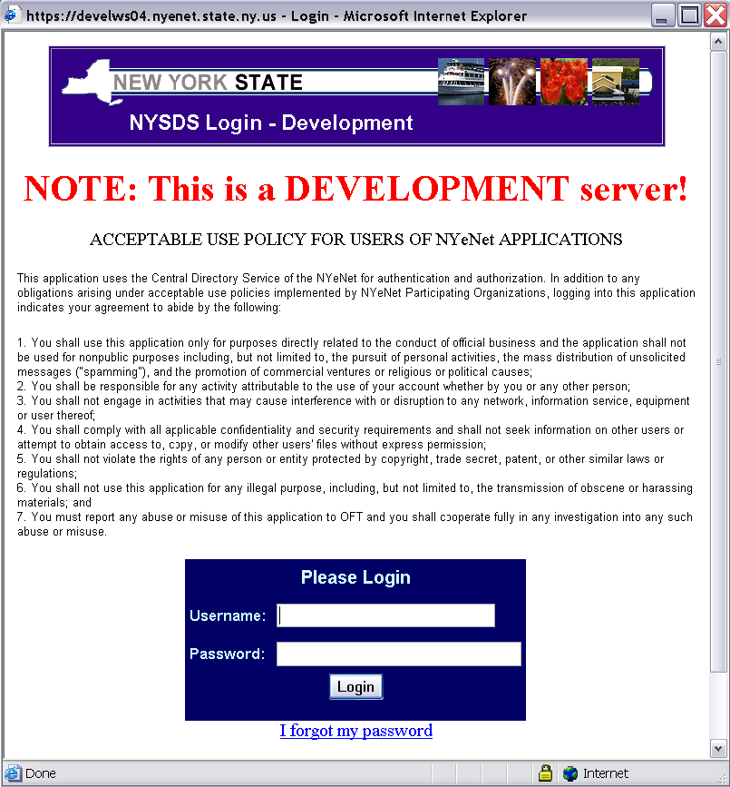

- Enter your username and password and click the Login button. Your username is usually your firstName.lastName (with a period in between first and last names).

- The first time you login to the system, you may be asked to change your password and set up security questions. These questions will be used in case you later forget your password. Password requirements are:
  - Must be at least 8 characters long; one of which must be a numeric character
  - Cannot be the same as your username or default password

- If you forgot your password, click the link ‘I forgot my password’ and answer your security questions in order to reset your password. If you don’t remember the answers to the security questions, please contact LibDevGrants@nysed.gov to reset your password.

- Click on the link for the grant program you wish to work on. The grant programs include Public Library Construction, Conservation/Preservation, Adult/Family Literacy, Local Govt Records Management Improvement Fund.
How to Create a new Application

- The Construction Home Page lists all construction grant applications that the institution has started.

- To create a new application, you can use the link “Start a new Application”. The system will only allow you to create a new application during the new application time period, and will state which fiscal year the new application is for.

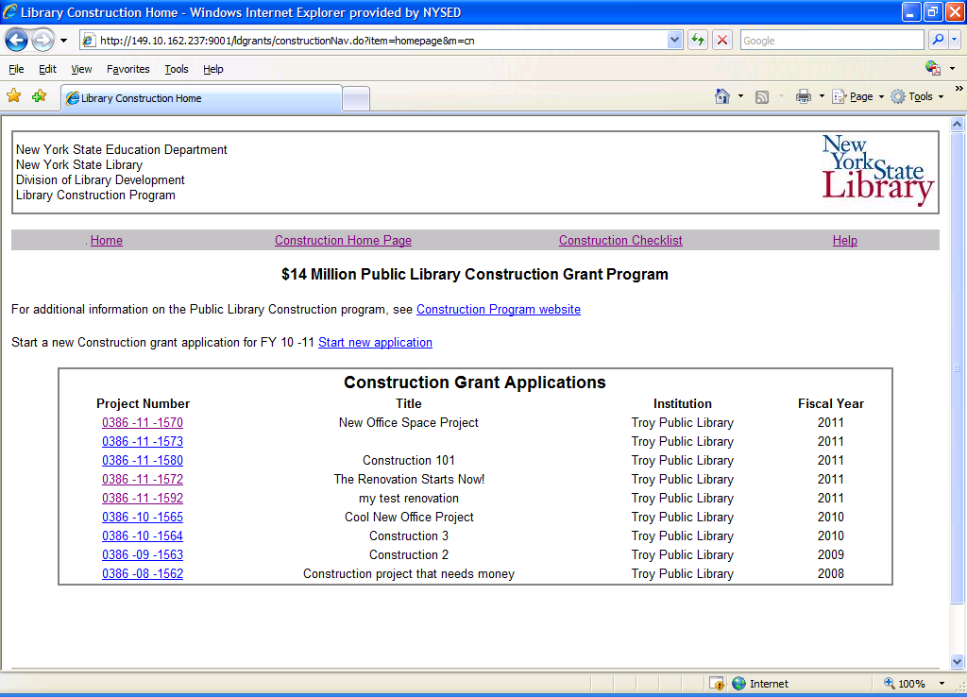

- The application must be submitted to your Public Library System by the due date listed on the Checklist page. You will not be able to submit after the due date.

- Once a new blank application is created, you will be redirected to the Checklist page and can complete the application.
How to access an application

- The Construction Home page lists all construction grants that the institution has started.

- Click on the project number link for the grant application you wish to work on. This will bring you to the Checklist page.

- You must choose a grant application project number in order to use the top menu link to access the Checklist.

How to use the Checklist

- The checklist has links to ALL application items. This includes the Application Form, Additional Funding, Narratives, Budget, etc. These items are all completed online.

- The FS-20 links to an HTML or PDF document. Three copies of the FS-20 must be signed in blue ink and mailed to your Public Library System at the time you submit your application. One copy of the Payee Info Form must be signed in blue ink and mailed to your PLS.

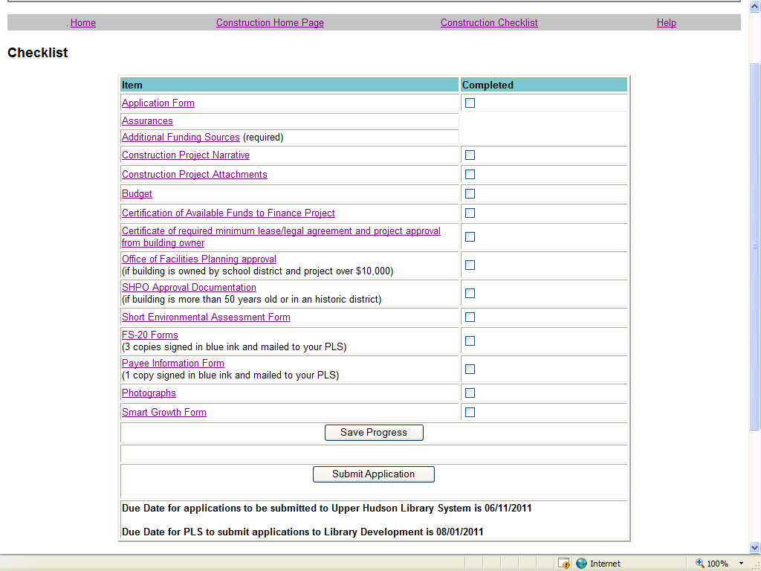

- Use the links on the Checklist page or the top menu bar to navigate the application.

- If you have completed a section, you may check off the box next to the item and click Save Progress.

- The application due date is located on the Checklist page. You cannot submit the application after the due date. If the due date has passed, a warning message will be written on the Checklist page.

- The applications are submitted by clicking on the Submit button. You will be asked to confirm submission of the application and then redirected to the Home page. The Project Manager will receive an automatically generated email indicating that the application was submitted. You will NOT be able to edit the application once you have submitted it. Please see the section on Submitting an Application.

- The bottom portion of the Checklist contains links to view application items in a single HTML or PDF document. Both links open in a new window, and the document can be printed or saved to your desktop. There are HTML/PDF versions of the Application Form, Narratives, and Budget.

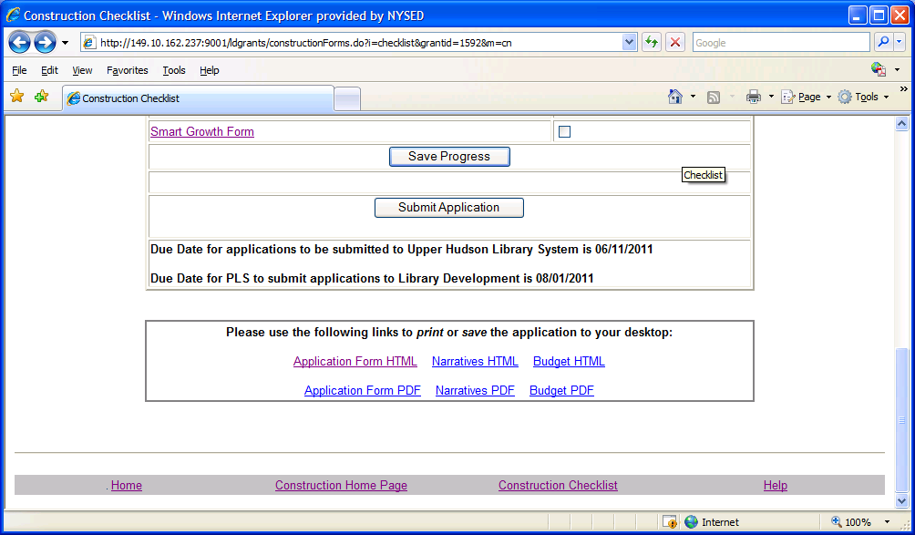

How to update the Application Form

- The Application Form contains information on the institution, building, Project Manager, project/building details, and timeline. The Institution information is supplied by an internal SED database, and cannot be modified by applicants. If the information for your institution is not correct, please contact Library Development staff with the updated data.
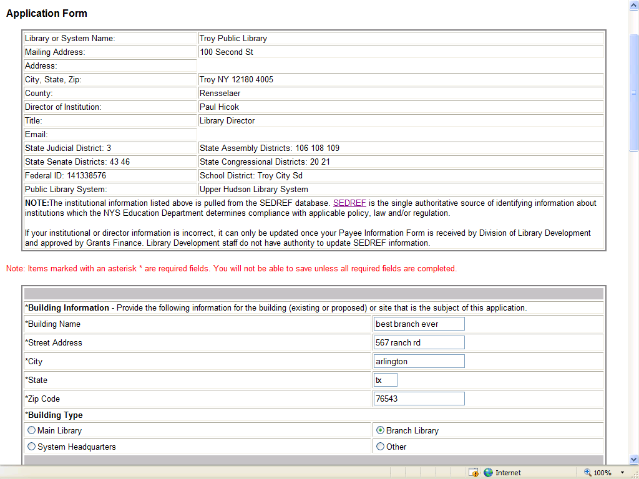

- All fields on the Application Form that are marked with an asterisk (*) are required. If you try to ‘Save’ the Application Form without filling in all required fields, you will see an error message.

- The bottom of the Application Form details the 3 additional forms that may be required depending on the answers you provided on the Application Form.
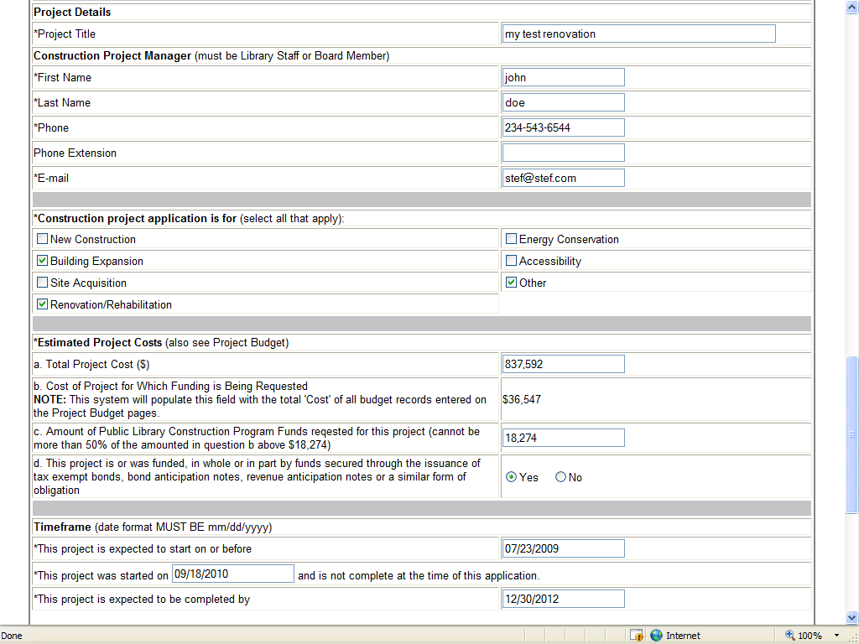

How to update Project Narratives

- If you have permissions to edit the application, you can type the narrative in the text area or copy and paste from a Microsoft Word document. Click the Save button before moving on to the next narrative.

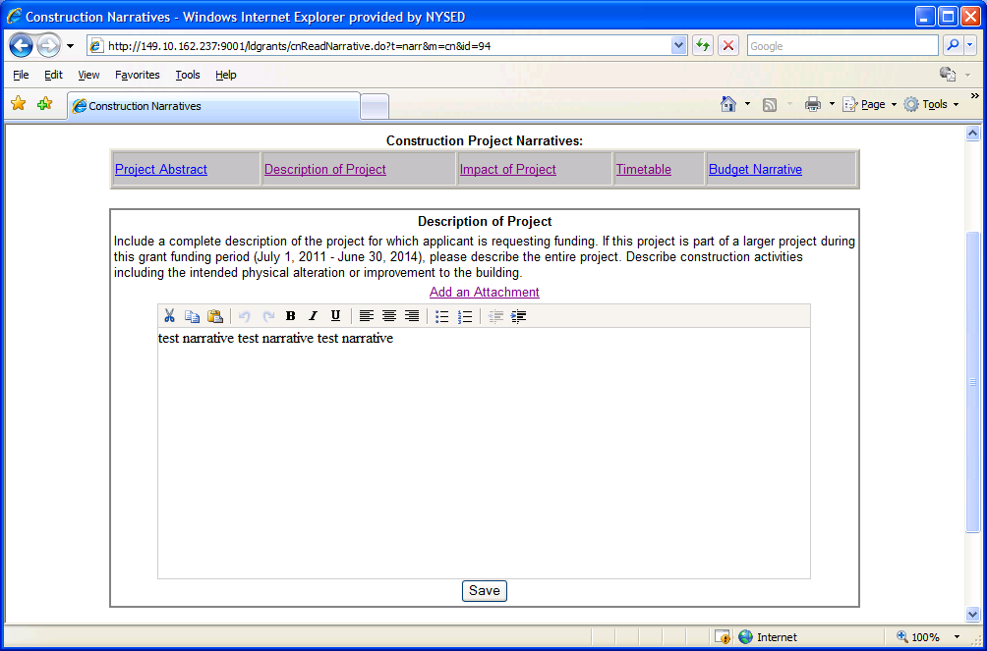

- The word editor at the top of the text area is only accessible if you have Javascript enabled. If your browser does not have Javascript enabled, you will NOT see the word editor, but can still type and save your narrative.

- To enable Javascript: From your browser click Tools -> Internet Options ->Security tab -> Custom Level button -> Scroll down to Active scripting and choose the Enable option.

- The first narrative, ‘Project Abstract’, is limited to 150 characters (including spaces). The database will not save any text after 150 characters.
How to attach documents to the application

- The Attachments link lists all documents that have been attached to this application. Click the link ‘Delete’ next to a document to remove the document from this application. You will be asked to confirm the deletion first. Click the document name link to open or save the document on your desktop. You must have the appropriate software to open the document type, for example you must have Microsoft Excel in order to open an .xls document.

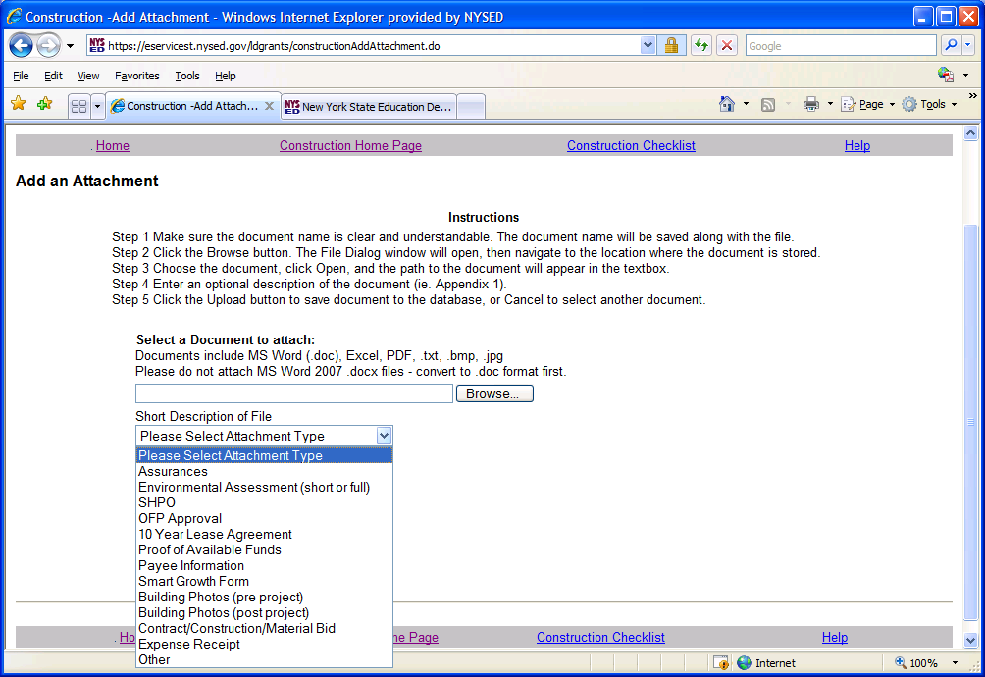

- Use the link at the bottom of the page to Add a Document to the application. You may add Microsoft Word and Excel 2003 files, PDF, picture files such as .jpg, .png, .bmp.

- On the Add Document page, click the Browse button to open a File window, and then navigate to the document you want to attach and click OK.

- Note: The name you see on the document will be the name saved to the database so please use a meaningful name for your document.

- You must select an option from the ‘Short Description of File’ list (SHPO, Assurances, OFP Approval, etc) then click Upload button to save the document to the application.

How to update the Project Budget

- The link to Project Budget displays the three expense categories for the Project Budget. The expense categories are accessible using the tabbed links. The instructions for each expense category are listed at the top of the page.

- To start the Project Budget, click the ‘Add’ button. All fields must be completed before saving the budget record. Add one record at a time, fill it in, and Save. If you add multiple records at once, you must fill out all records in order to Save.

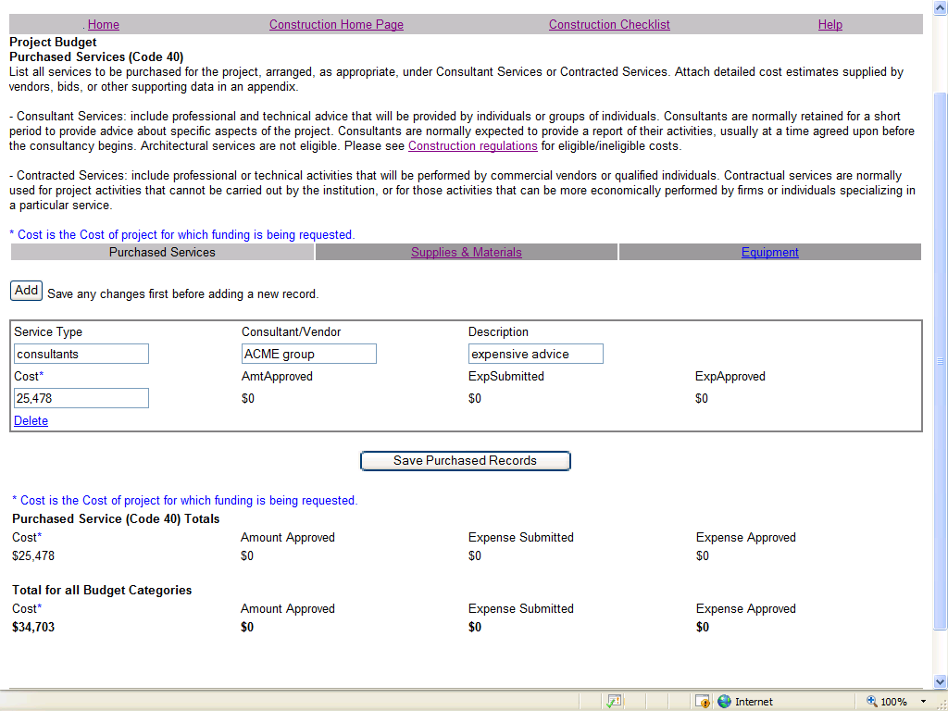

- Enter all of the information requested for that budget record, and click the Save Record button at the bottom of the form. If you have not entered all required information, an error message will warn you to enter all data before the form can be saved.

- If you need to delete an individual budget record, click the Delete link next to the record, and you will be asked to confirm deletion.

- The bottom of the page has the total cost for a given budget category. There is also a Grand Total section with the total across all budget categories.

How to update the Additional Funding Sources

- The link to ‘Additional Sources of Funding’ must be completed after you complete the Application Form.

- Click the ‘Add’ button to add a blank funding record. You must add a new funding record for each of the funding sources that contribute to this construction project.

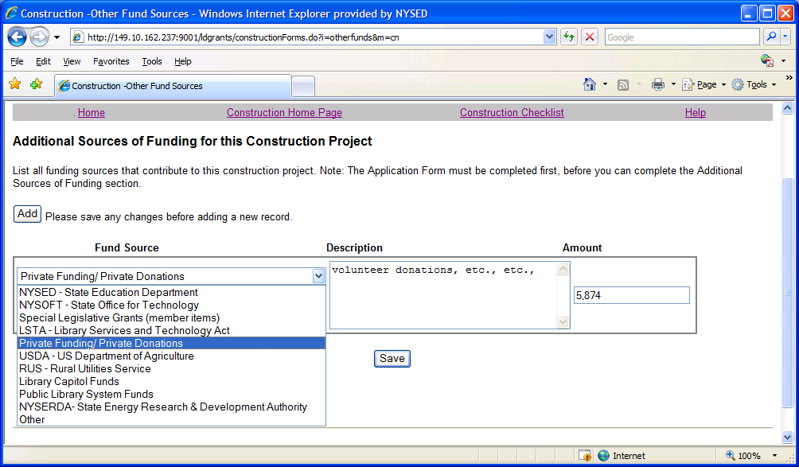

- For each funding record, select the Fund Source from the list provided (NYSED, NYSOFT, Special Leg Grants, LSTA, etc). Provide a brief description, and fund amount, then click the Save button.

- Add one record at a time, fill out all fields, and Save. If you ‘Add’ multiple records at once, you must fill out all fields in each record in order to Save.
How to submit the FS-20, and Payee Info Forms

- Three copies of the FS-20 form must be signed in blue ink and mailed to your Public Library System. The Library System will forward all approved FS-20’s to the Division of Library Development.

- One copy of the Payee Info Form must be signed in blue ink and mailed to your Public Library System. The Library System will forward all approved Payee Info Forms to the Division of Library Development.

- Library Systems must mail FS-20’s and Payee Info Forms to:

Division of Library Development
NYS Library
Cultural Education Center, Room 10B41
Albany NY 12230
Attn: Kimberly Anderson

How to Submit the Application

- Only the user account with Submit privileges may submit the application. Using the Application Checklist, if all portions of the application have been completed, click the Submit button.

- You will be directed to a confirmation page, where you can confirm application submission to your Public Library System.

- If you have not filled out the Application Form, Narratives, Budget, or attached required documents, error messages will instruct you to complete missing portions of the application. You will not be able to Submit until all required portions of the application are completed.

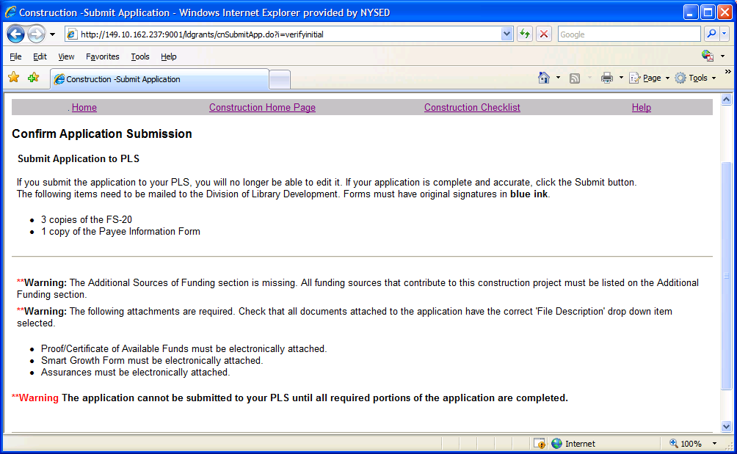

- Once the application has been submitted to your Public Library System, you will be redirected to the Home page. You will not be able to edit the application after it has been submitted.

- The Project Manager for the grant application will receive an email notification informing them that the grant application has been submitted to the Public Library System.

Help

- Click the menu bar link titled Help to access the help options.

- There are links Construction Guidelines and Instructions document, and further information on the LD website.

- To report error messages, or problems regarding the Division of Library Development Online Grant System, contact LibDevGrants@nysed.gov. Please include any error message you received, along with a description of the steps you completed just prior to receiving the error message.

If you have questions about the construction grant program or application procedure, please contact your public library system.

Library systems should contact Linda Todd marylinda.todd@nysed.gov with questions about the application deadlines, requirements and materials.

