New York State Education Department
New York State Library
Division of Library Development

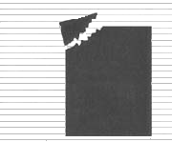 | Division of Library Development Online Grant System  Conservation/ Preservation Statutory and Coordinated Aid Applicant  User Manual

Cultural Education Center
Division of Library Development
Albany NY 12203
(518) 474-7890

Stefanie Husak
October 5, 2007
Table of Contents

How to Login to Division of Library Development Online Grant System..………………..3
How to login if you forgot your password………………………………………….3

How to Create a C/P application……………….…………………...………………………4

How to Access a C/P application………………….…………………………….………….5

How to use the Checklist……………………………………………………………………6

How to update the Cover Sheet……………………………………………………………..8

How to update Project Narratives……………..……………...……………………………9

How to attach Documents to the application……………………………………………....10

How to update the Project Budget………………………………………..………………..12

How to update the Final Report Narrative………………………………………..……..…14

Authorizations
How to Submit an Institutional Authorization………………………….…………15
How to Submit a Final Report Signoff…………………………………….……...16
How to Submit a Cooperative Agreement Form………………………………….17

Federal/State Project Forms
How to submit the FS 20, FS-10-F, FS-10-A…………………………………….18

How to Submit the Application………………………………………………………..…19

Status of the Application
How to view Application submissions/approvals……………………………......20
How to view Admin comments…………………………………………..……....20
How to view Reviewer comments/scores……………………………………..…20
How to view Award Amounts…………………………………………………...20

Help with the C/P application……………….……………………………………….…..21

How to Login to Division of Library Development Online Grant System

- The URL to the system is https://eservices.nysed.gov/ldgrants To login to the Division of Library Development Online Grant System you must have an NYSDS username and password. If you do not have a NYSDS username and password, you must contact Library Development staff to create your account. Your username and password will be sent via email.
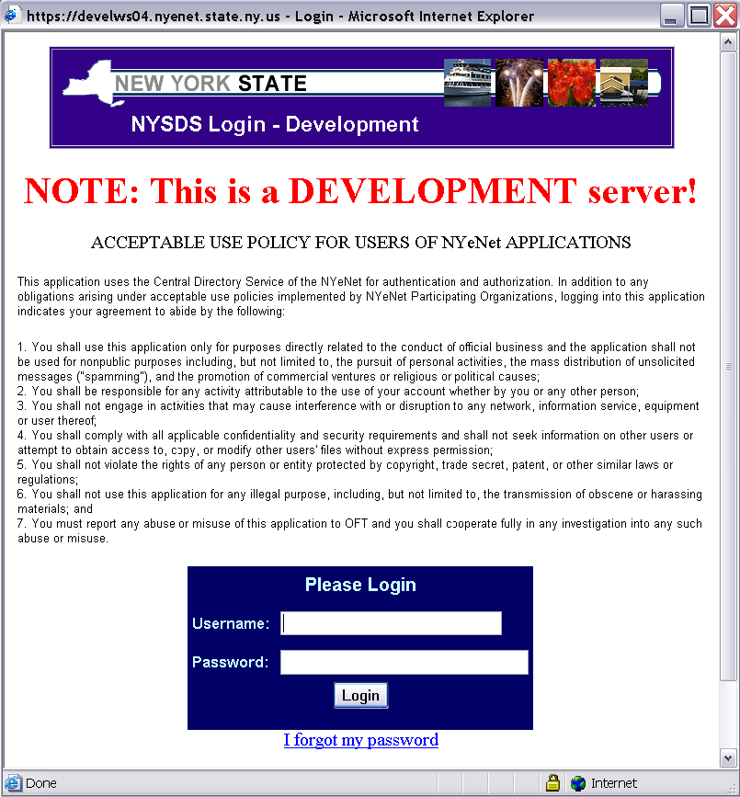

- Enter your username and password and click the Login button. Your username is usually your firstName.lastName (with a period in between first and last names).

- The first time you login to the system, you may be asked to change your password and set up security questions. These questions will be used in case you later forget your password. Password requirements are:
  - Must be at least 8 characters long; one of which must be a numeric character
  - Cannot be the same as your username or default password

- If you forgot your password, click the link ‘I forgot my password’ and answer your security questions in order to reset your password. If you don’t remember the answers to the security questions, please contact LibDevGrants@nysed.gov to reset your password.

- Click on the link for the grant program you wish to work on. The grant programs include Conservation/Preservation Statutory Application and Conservation/Preservation Coordinated Application.
How to Create a C/P Application

- The Coordinated Home page and Statutory Home Page lists all grants that the institution has applied for in the first section. The second section contains grant applications in which the institution is a participating Library.

- To create a new C/P application, you can use the link “Create a new Application”. The system will only allow you to create a new application during the new application time period, and will highlight which fiscal year the new application is for.

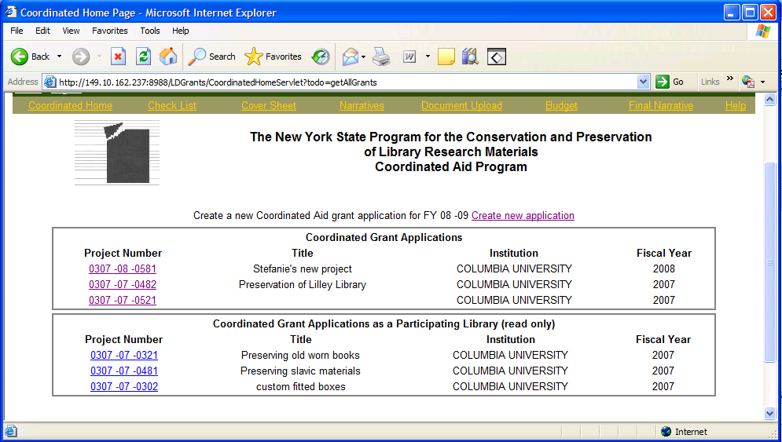

- You may only create 1 new Statutory Aid application per fiscal year, but you can create more than 1 Coordinated Aid application per fiscal year. The applications must be submitted by the due date listed on the Checklist page. You will not be able to submit after the due date.

- Once a new blank application is created, you will be redirected to the Checklist page and can complete the application
How to access a C/P application

- The Coordinated Home page and Statutory Home page lists all grants that the institution has applied for in the first section. The second section contains grant applications in which the institution is a participating Library. Grant applications for participating Libraries are read-only with the exception of the Cooperative Agreement Form.

- Click on the project number link for the grant application you wish to work on. This will bring you to the Checklist page.

- You must choose a grant application project number in order to use the top menu links to access the Cover Sheet, Narratives, Budget…etc.

How to use the Checklist

- The checklists for the Application and Final Report have links to all items that must be completed for the application. This includes the Cover Sheet, Narratives, Budget, Institutional Authorization, Final Narrative, and Final Signoff. These items are all completed online.

- The FS20 includes links to the HTML or PDF document. Three copies of this document must be signed and mailed to the Division of Library Development at the time you submit your application. Three copies of the FS-10-F also must be signed and mailed in at the time you complete the Final Report. The FS-10-A should be completed and mailed in if you have any amendments to your approved budget. For Statutory projects ONLY: you may complete the FS-10-A budget amendments directly on the Project Budget page.

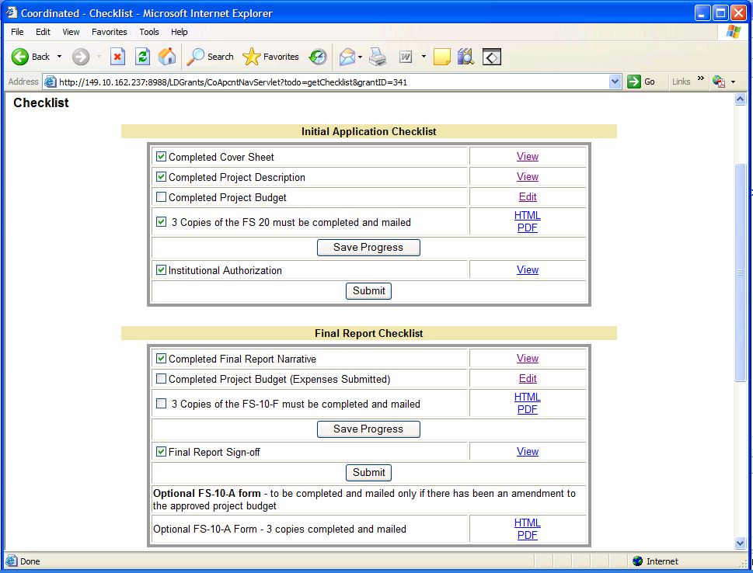

- Use the links on the Checklist page or the top menu bar to navigate the application.

- If you have completed a section, you may check off the box next to the item and click Save Progress.

- The application due date is located on the Checklist page. You cannot submit the application after the due date. If the due date has passed, a warning message will be written on the Checklist page.

- The applications are submitted by clicking on the Submit button. You will be asked to confirm submission of the application and then redirected to the Home page. The Preservation Officer will receive an automatically generated email indicating that the application was submitted. You will NOT be able to edit the application once you have submitted it. Please see the section on Submitting an Application.

- The bottom portion of the Checklist contains links to view all application items in a single HTML or PDF document. Both links open in a new window, and the PDF document can be printed or saved to your desktop.

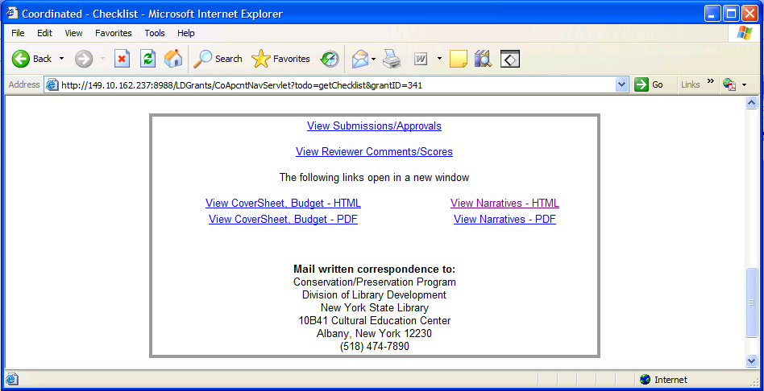

- The link to View Application Submissions/Approvals will take you to a page displaying information on when the application was submitted, the outcome of the Library Development Application Review process, and any administrative comments that were made.

- For Coordinated ONLY: the link to View Reviewer Comments/Scores will provide comments made by reviewers and the average scores for each rating category given to this grant application. The information is only accessible after the application has been approved/denied by the Program Officer.
How to update the Cover Sheet

- The cover sheet contains information on the sponsoring institution, the Project Manager, and Participating Institutions. The Institution information is supplied by an internal SED database, and cannot be modified by applicants. If the information for your institution is not correct, please contact Library Development staff with the updated data.
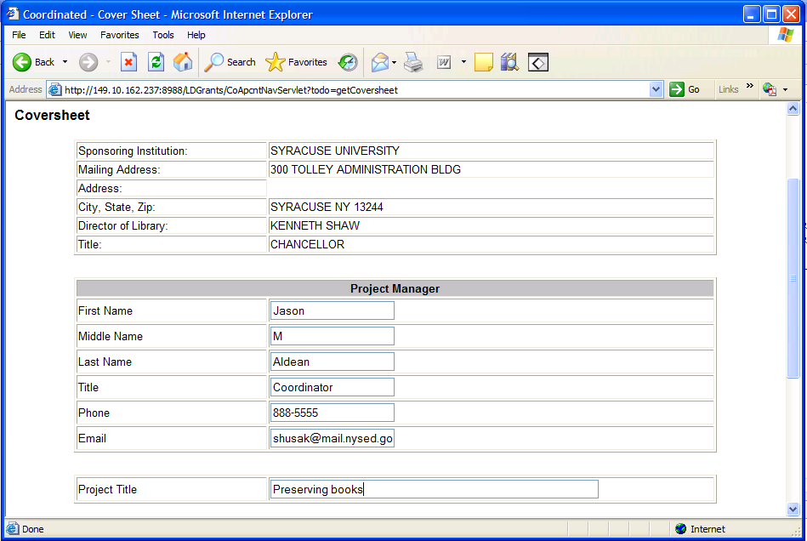
- For Statutory ONLY: type the Summary Description in the text area or copy and paste from a Microsoft Word document. Click Save button to save work to the database.

- For Coordinated ONLY: Enter the information for the Project Manager, including name, title, and contact information. Also enter the title for this grant project.

- For Coordinated ONLY: Specify the participating Libraries for this grant using the drop-down boxes at the bottom of the Cover Sheet page. Click the Save button at the bottom of the screen to save information to the database.
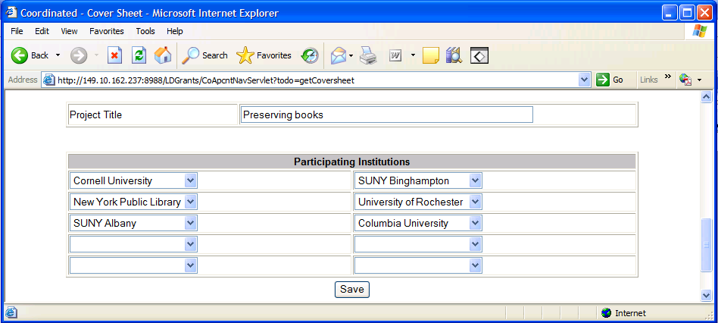
How to update Project Narratives

- The top menu Narratives link will display the first project description narrative. Each of the remaining Narratives is accessible using the menu of narrative links on the left-hand side of the screen.

- If you have permissions to edit the project description, you can type the narrative in the text area or copy and paste from a Microsoft Word document. Click the Save button before moving on to the next narrative.

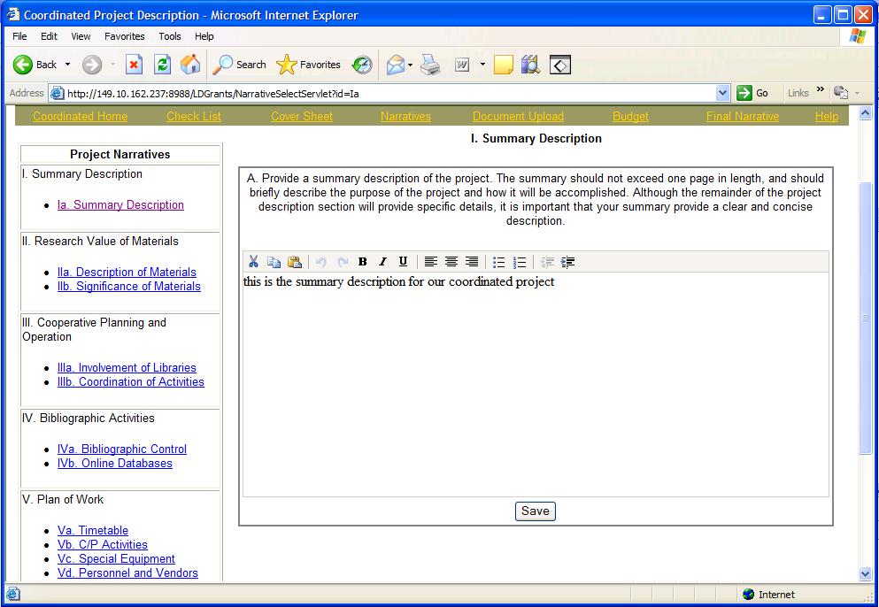

- The word editor at the top of the text area is only accessible if you have Javascript enabled. If your browser does not have Javascript enabled, you will NOT see the word editor, but can still type and save your narrative.

- To enable Javascript: From your browser click Tools -> Internet Options ->Security tab -> Custom Level button -> Scroll down to Active scripting and choose the Enable option.

- If you do not have permissions to edit a project narrative, or the application has already been submitted, you will have read-only access to the narratives.
How to attach Documents to the application

- Only Coordinated applicants may attach documents. The top menu link ‘Document Upload’ will display all the documents that have been attached to this grant application.

- Click the link ‘Delete’ next to a document to remove the document from this application. You will be asked to confirm the deletion first. Click the document name link to open or save the document on your desktop. You must have the appropriate software to open the document type, for example you must have Microsoft Excel in order to open an .xls document.

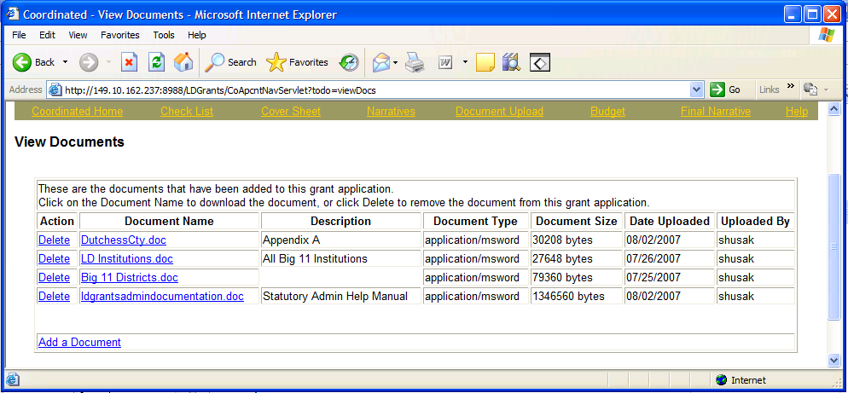

- Use the link at the bottom of the page to Add a Document to the application.

- You may add Microsoft Word, Excel files, text documents, or picture files such as .jpg, .png, .bmp.

- On the Add Document page, click the Browse button to open a File window, and then navigate to the document you want to attach and click OK.

- Note: The name you see on the document will be the name saved to the database so please use a meaningful name for your document.

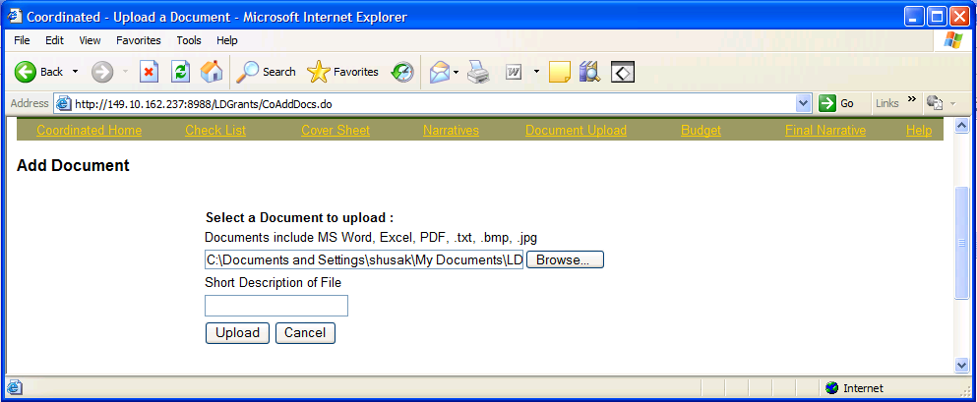

- You can optionally enter a short description of the document, and then click Upload button to save the document to the application. You will receive a message if your document was uploaded successfully. Click the Cancel button to reset the form without uploading.

How to update the Project Budget

- The link to Project Budget displays the first of five expense categories for the Project Budget. The expense categories are accessible using the tabbed links.

- The instructions for each expense category are listed at the top of the page, right above the expense category tabs. Detailed information on claiming expenses can be found in the Guidelines and Instructions document on the Help page.

- For each expense category you wish to claim, click the Add Record link next to the year you need to claim the expense. For Coordinated ONLY: you can add budget records for the current fiscal year, or 2 years out.

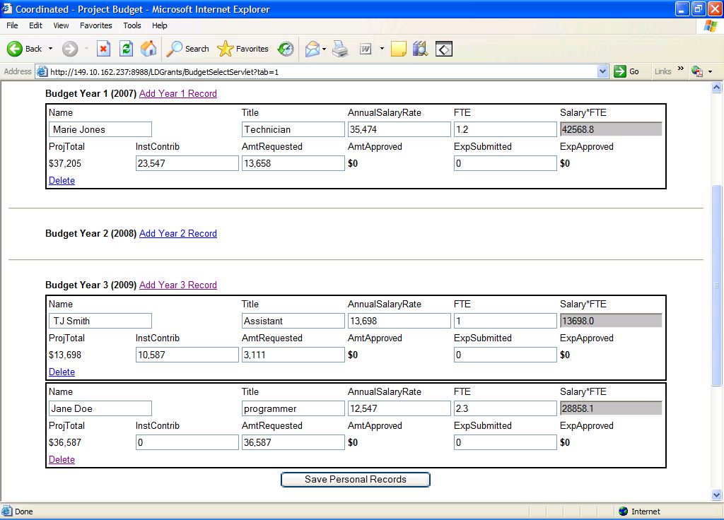

- Enter all of the information requested for that budget record, and click the Save Record button at the bottom of the form. The Project Total for each record is computed after you save the Institutional Contribution and Amount Requested for the given record.

- If you have not entered all required information, an error message will warn you to enter all data before the form can be saved.

- If you need to delete an individual budget record, click the Delete link next to the record, and you will be asked to confirm deletion.

- The bottom of the page has the total amount requested across all years for a given budget category. There is also a Grand Total section with the total across all years for all budget categories.

- After you submit the application, you cannot update the project budget records. You may only update the expenses submitted after the project completion. Click the Save Record button at the bottom of the form to save the information.

How to update the Final Report Narrative

- The top menu link Final Narrative will display the Final Report Narrative that must be completed after your application has been submitted.

- If you have permissions to edit the application, you can type the narrative in the text area or copy and paste from a Microsoft Word document. Click Save button to save changes to the database.

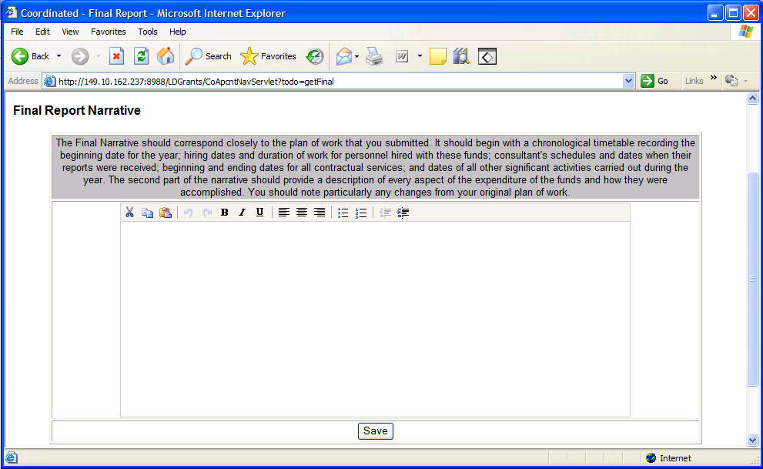

- The word editor at the top of the text area is only accessible if you have Javascript enabled. If your browser does not have Javascript enabled, you will NOT see the word editor, but can still type and save your narrative.

- To enable Javascript: From your browser click Tools -> Internet Options ->Security tab -> Custom Level button -> Scroll down to Active Scripting and choose the Enable option.

- If you do not have permissions to edit the application, or the final report has already been submitted, you will have read-only access to the final report narrative.
How to Submit an Institutional Authorization

- The online institutional authorization is completed once the application is ready to be submitted. The institutional authorization is accessible from the link on the Checklist page.

- Check the box next to the Preservation Officer and Library Director to acknowledge the authorization statement and click the Save button.

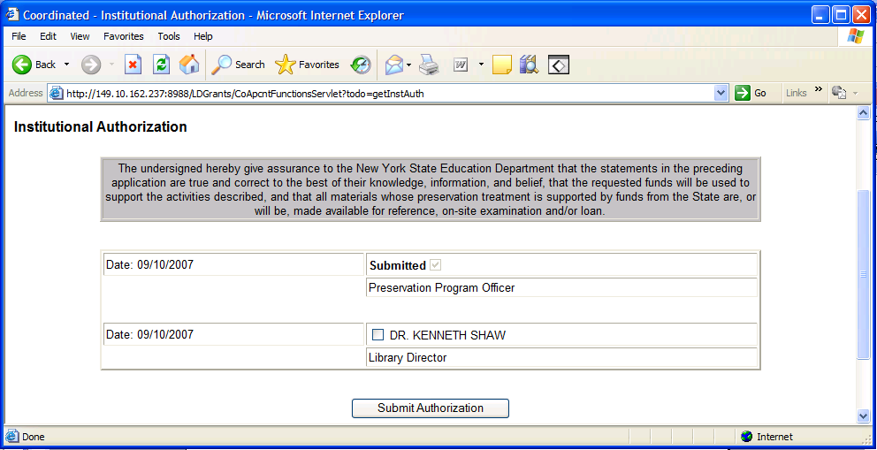

- The name and timestamp will be saved to the database indicating that the individual has completed the authorization.

- Note: Failure to complete the Institutional Authorization may result in delay of reviewing the grant application.

How to Submit a Final Report Signoff

- The online final report signoff is completed once the final report is ready to be submitted. The final signoff is accessible from the link on the Checklist page.

- Check the box next to the Library Director to acknowledge the authorization statement and click the Save button.

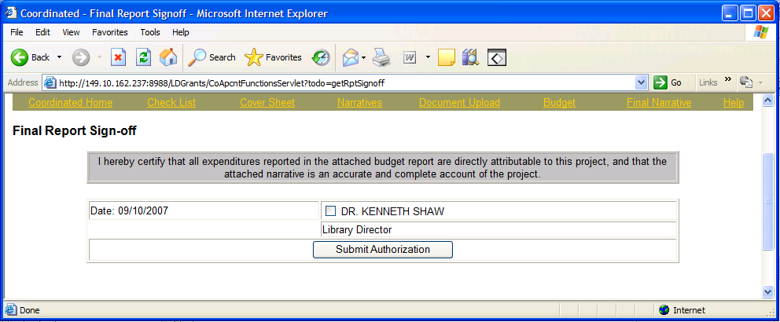

- The name and timestamp will be saved to the database indicating that the individual has completed the authorization.

- Note: Failure to complete the Final Report Signoff may result in delay of reviewing the grant application.

How to Submit a Cooperative Agreement Form

- The online Cooperative Agreement Form is completed by each participating Library of a Coordinated grant application. The participating Library must login to the Online Grant System, and chose one of the participating grant Applications. The top menu link Cooperative Agreement will display the form.

- Check the box next to the Preservation Officer and Library Director to acknowledge the authorization statement and click the Save button.

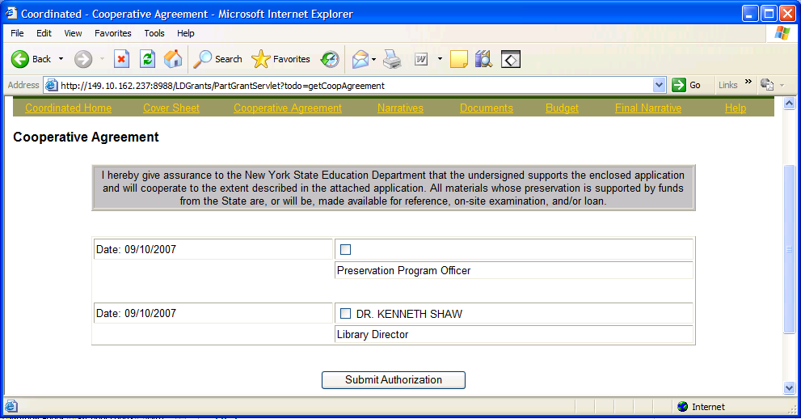

- The name and timestamp will be saved to the database indicating that the individual has completed the authorization.

- Note: Failure to complete the Cooperative Agreement by each of the participating Libraries may result in delay of reviewing the grant application.

How to submit the FS20, FS-10-A and FS-10-F

- The FS20 form must be signed and mailed to the Division of Library Development. The FS20 form is located under the Application Items on the Checklist page.

- Click the link to open an HTML or PDF FS20 document. The document will open in a new window.

- Print and sign in blue ink three copies of the FS20 form and mail the forms to the Division of Library Development address specified on the form.
--------------------------------------------------------------------------------------------------------------

- The FS-10-A form is optional and only needs to be completed if there is an amendment to your approved budget. The links to HTML and PDF versions of the FS-10-A form are located under the Final Report items of the Checklist page.

- Note: The Coordinated FS-10-A form must be signed and mailed in to the Division of Library Development if needed. The Statutory Aid application FS-10-A can be completed online. For Statutory Aid, the FS-10-A amendment link is located on the Project Budget page.

- For Coordinated ONLY: The FS-10-A form needs to be printed, and the reason for amending the budget must be clearly written. Sign in blue ink and mail the FS-10-A form to the Division of Library Development address specified on the form.

--------------------------------------------------------------------------------------------------------

- The FS-10-F form must also be signed and mailed to the Division of Library Development for Coordinated projects only. The HTML and PDF versions of the form are located as part of the Final Report items on the Checklist page.

- Print and sign in blue ink three copies of the FS-10-F form and mail the forms to the Division of Library Development address specified on the form.

How to Submit the Application

- Only the user account with Submit privileges may submit the application. Using the Application Checklist, if all portions of the application have been completed, click the Submit button to submit that portion of the application.

- You will be directed to a confirmation page, where you can confirm application submission.

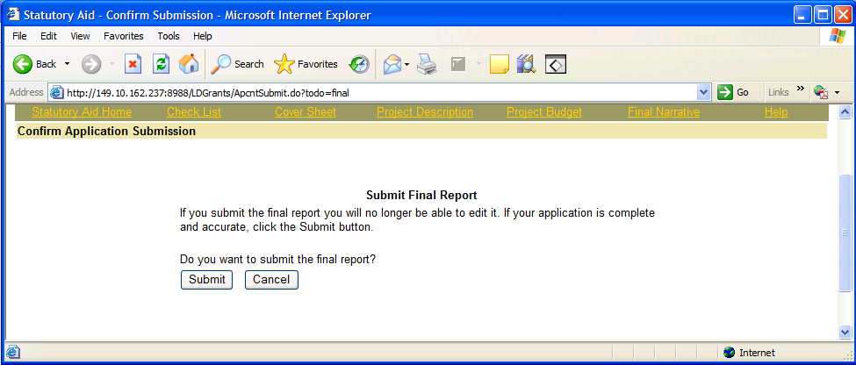

- Once the application has been submitted, you will be redirected to the Home page. You will not be able to edit portions of the application that have been submitted.

- The Preservation Officer for the grant application will receive an email notification informing them that the grant application has been submitted to the Division of Library Development.

Status of the Application

- The bottom of the Checklist page contains a link to view application submissions/approvals. This will display when the application was submitted, and when the Library Development Administrator has reviewed or approved the application.

- Any comments made by the Library Development Administrators will be displayed.

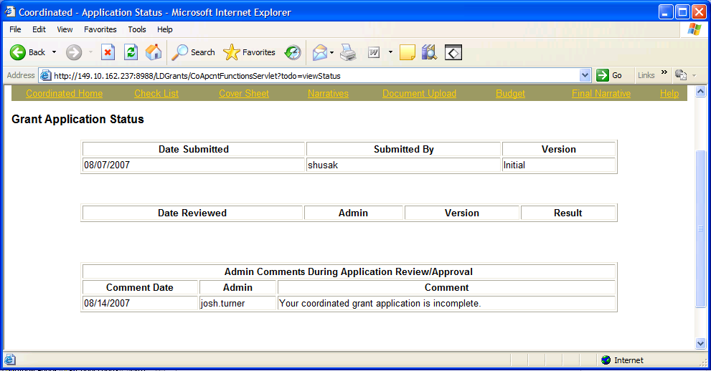

- The Preservation Officer for the grant application will receive email notifications when the application is submitted, and once reviewed by the Program Officer.

- The award amount is listed on the Project Budget pages, under the Grand Totals section on each budget page. The Amount approved and the Expenses approved are listed by expense category and a grand total for the grant application. The information is also available by accessing the View Budget link on the checklist page.

- For Coordinated ONLY: The bottom of the checklist page also contains a link to View Reviewer Comments/Scores. The page lists comments that reviewers have made regarding the application. It has the average score given to each of the rating categories.

- Reviewer Comments/Scores are only available after the application has been approved/denied by the Conservation/Preservation Program Officer.

Help with the C/P application

- Click the menu bar link titled Help to access the C/P help options.

- There are links to both HTML and PDF versions of this Applicant User Manual which has instructions on using the Online Grant System. There is also a link to the Coordinated and Statutory Aid Guidelines and Instructions document which details the types of expenditures that qualify for the grant program.

- To report error messages, problems, login issues, or questions regarding the Division of Library Development Online Grant System, contact LibDevGrants@nysed.gov or 518-474-5839. Please include any error message you received, along with a description of the steps you completed just prior to receiving the error message.

- For questions regarding the Coordinated and Statutory Aid application process, eligible projects, funding, etc., please contact the Conservation/Preservation Program Officer, Barbara Lilley, at barbara.lilley@nysed.gov.

