New York State Education Department
New York State Library
Division of Library Development

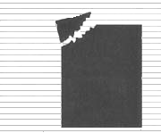 | Division of Library Development Online Grant System  Conservation/ Preservation Discretionary Aid Applicant  User Manual

Cultural Education Center
Division of Library Development
Albany NY 12203
(518) 474-7890

Stefanie Husak
December 12, 2008
Table of Contents

How to Login to Division of Library Development Online Grant System..…………………..3
How to obtain a user account and password for the system…………………………..4

How to Create a Discretionary Aid application……………………...…………………..……5

How to Access a Discretionary Aid application………………………………….………..….6

How to use the Checklist…………………………………………………………………..…7

How to update the Cover Sheet…………………………………………………………..…...9

How to specify Participating Institutions……………………………………………………11

How to update Project Description Narratives………………...……………………………12

How to attach Documents to the application……………………………………………......13

How to update the Project Budget………………………………………..…………………15

How to update the Final Report Narrative………………………………………..……..…..17

Authorizations
How to Submit an Institutional Authorization or Final Signoff……….……….…...18
How to Submit a Cooperative Agreement or Microform Guidelines.………….…..19

Federal/State Forms
How to submit the FS10, FS-10-F, FS-10-A, Payee Information Form..………….20

How to Submit the Application………………………………………………………..……21

Status of the Application
How to view Application submissions/approvals………………………………......22
How to view Reviewer comments/scores………………………………………..…22
How to view Award Amounts……………………………………………………...22

Help with the Discretionary Aid application…………………………………………...…..23
How to Login to Division of Library Development Online Grant System

- The URL to the system is https://eservices.nysed.gov/ldgrants To login to the Division of Library Development Online Grant System you must have an NYSDS username and password. If you do not have a NYSDS username and password, you must follow the directions on the next page regarding creating your account. Your username and password will be sent via email.
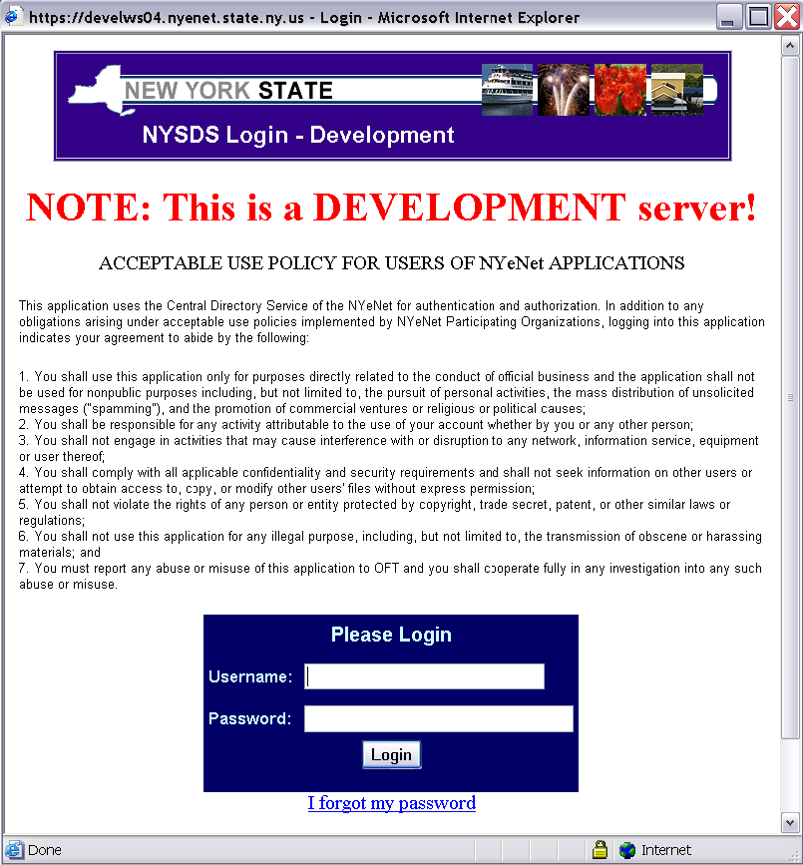

- Enter your username and password and click the Login button. Your username is usually your firstName.lastName (with a period in between first and last names).

- The first time you login to the system, you may be asked to change your password and set up security questions. These questions will be used in case you later forget your password. Password requirements are:
  - Must be at least 8 characters long; one of which must be a numeric character
  - Cannot be the same as your username or default password

- If you forgot your password, click the link ‘I forgot my password’ and answer your security questions in order to reset your password. If you don’t remember the answers to the security questions, please contact LibDevGrants@nysed.gov to reset your password.

- Click on the link for the grant program you wish to work on. The grant program currently accessible is Conservation/Preservation Discretionary Aid application.
How to obtain a user account and password for the system

- If you do not have an NYSDS user name and password, you must register for an account. The URL for registration is http://eservices.nysed.gov/ldgrants/ldgext/discRegister.jsp

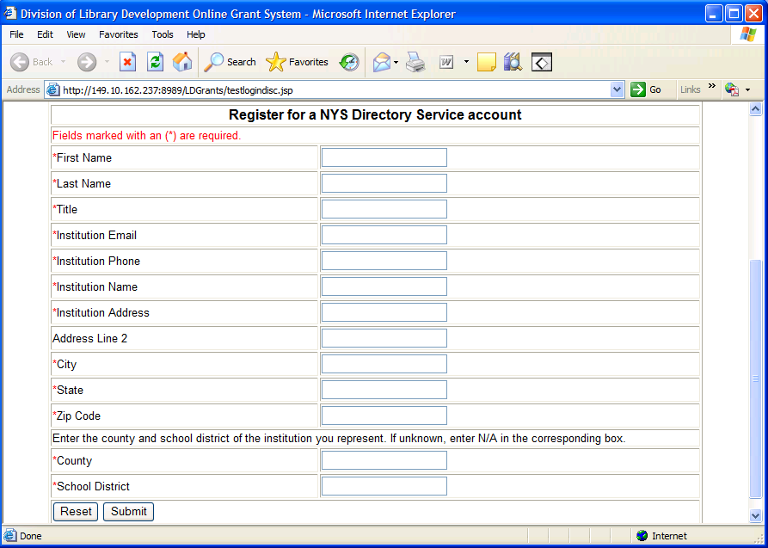

- Enter all required information, including name, title, institution address, and contact information. Then click the Submit button.

- The new user account will be tied to the institution you represent. It will allow you access to the Online Grant System so that you may submit grant applications on behalf of your institution.

- The information will be submitted to the Division of Library Development. You will receive your account username and password within 48 hours.

- The new username and password will be emailed to the Institution Email address you entered on the Registration form. Please be sure the email address provided is correct, otherwise receipt of your new account will be delayed.

How to Create a Discretionary Aid Application

- The first section of the Discretionary Aid Home page lists all grants that the institution has created. The second section contains grant applications in which the institution is a participating institution.

- To create a new Discretionary application, click the link “Create new Application”. You may only create a new application during the new application time period, and can only create 1 new Discretionary application per fiscal year.

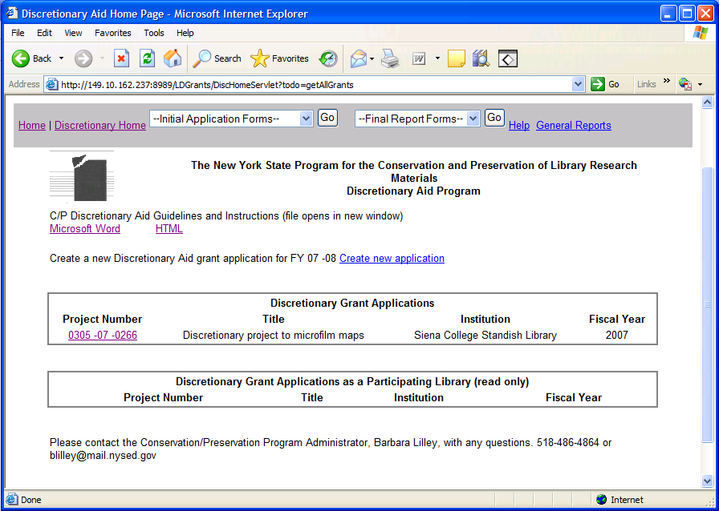

- Once a new blank Discretionary application is created, you will be redirected to the Checklist page and can begin filling out the application.

- The applications must be submitted by the due date listed on the Checklist page. You will not be able to submit after the due date.

How to Access a Discretionary Aid application

- The first section of the Discretionary Aid Home page lists all grants that the institution has created. The second section contains grant applications in which the institution is a participating institution. Participating institution grant applications are read-only with the exception of the Cooperative Agreement Form.

- Click on the project number link for the grant application you wish to work on. This will bring you to the Checklist page.

- You must choose a grant application project number in order to use the drop-down menu options to access the Initial Application Forms and Final Report Forms.

How to use the Checklist

- The checklists for the Initial Application and Final Report have links to all required items for the application. This includes the Cover Sheet, Project Narrative, Budget, Institutional Authorization, Final Report Narrative, and Final Signoff. These items are all completed online.

- Three copies of the FS 10 must be signed and mailed to the Division of Library Development at the time you submit your application. Three (3) copies of the FS-10-F must be signed and mailed in at the time you complete the Final Report, only after an award is made. The FS-10-A should be completed and mailed in if you have amendments to your approved budget. These forms are NOT completed online; they must be printed and mailed to the Division of Library Development.
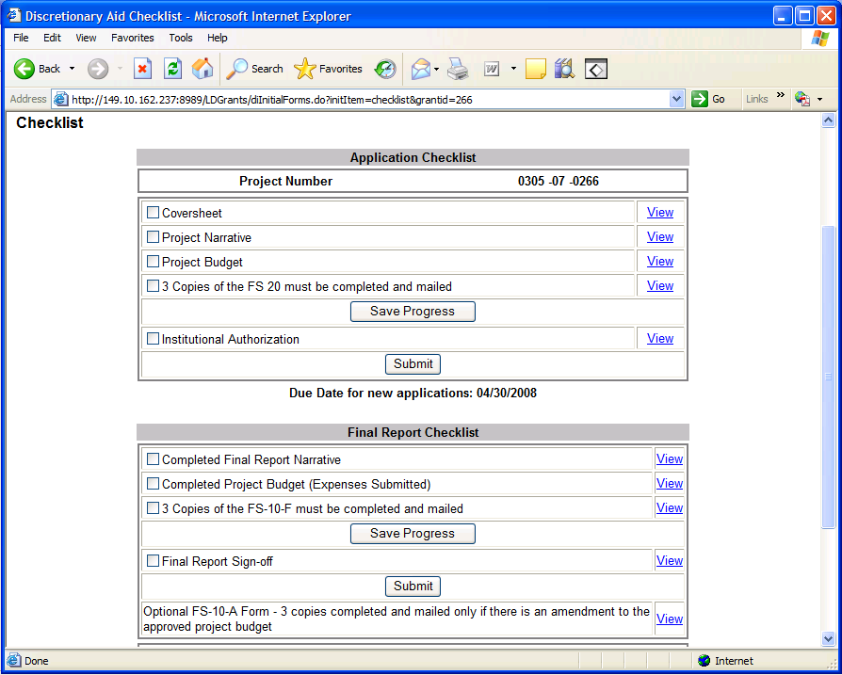

- Use the links on the Checklist page or the drop-down boxes on the top menu bar to navigate the application.

- If you have completed a section, you may check off the box next to the item and click Save Progress.

- The Discretionary application due date is located on the Checklist page. You cannot submit the application after the due date. If the due date has passed, a warning message will appear on the Checklist page.

- The application is submitted by clicking on the Submit button. A warning message will display if you have not filled out the required Project Narratives. You will be asked to confirm submission of the application. The Project Manager will receive an automatically generated email indicating that the application was submitted. You will NOT be able to edit the application once you have submitted it. Please see the section on Submitting an Application.

- The bottom portion of the Checklist contains links to view application items in HTML or PDF formats. Both links open in a new window, and the PDF document can be printed or saved to your desktop.

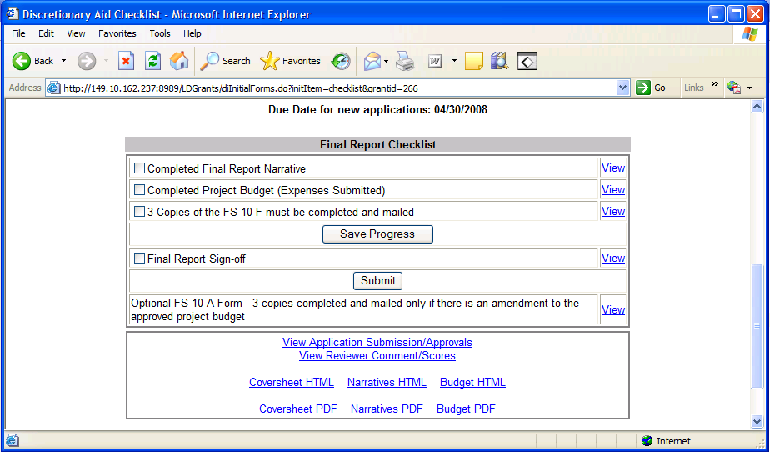

- The link to View Application Submissions/Approvals will display information on when the application was submitted, the outcome of the Library Development Application Review process, and any administrative comments.

- The link to View Reviewer Comments/Scores will display comments made by reviewers and the average scores for each rating category given to this grant application. The information is only accessible after the application has been approved/denied by the Program Officer.
How to update the Cover Sheet

- The cover sheet contains information on the Institution, the Project Manager, and Participating Institutions. The Institution information is supplied by an internal SEDREF database, and cannot be modified by applicants. If the information for your institution is not correct, please include the correct information when you mail in the Payee Information Form. The Payee Information Form will be sent to the Grants Finance office for approval, and only Grants Finance has the authority to update Institution and Director information.

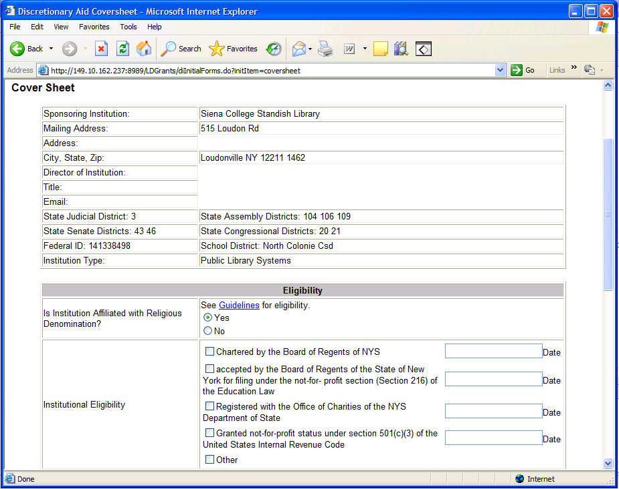

- Enter the eligibility information including religious affiliation, and institutional eligibility. Refer to the C/P Discretionary Program Guidelines for eligibility requirements.

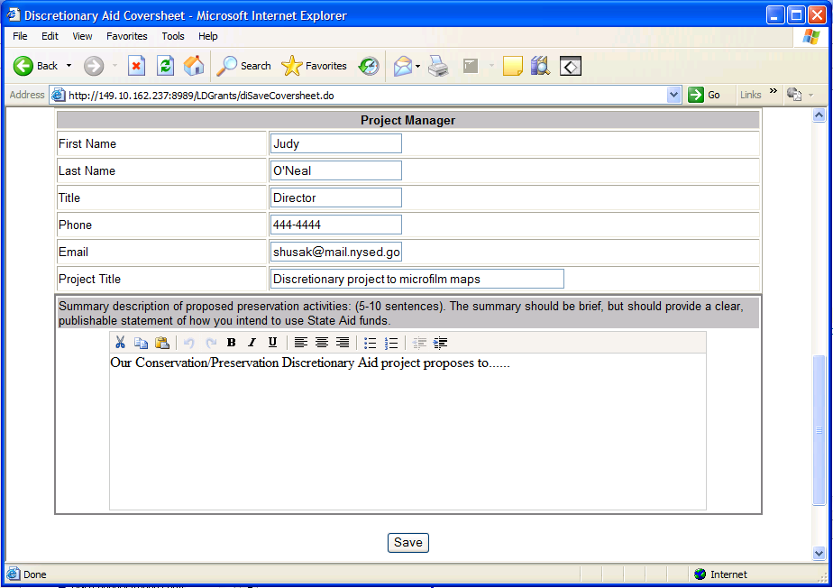

- Enter the information about the Project Manager, including name, title, and contact information. Also enter the title for this grant project. Enter a brief summary description of the proposed project in the bottom section of the coversheet. Then click the Save button to save all changes.

- To specify participating institutions cooperating in this grant project, click the link Participating Institutions located at the bottom of the Coversheet page.
How to specify Participating Institutions

To specify participating institutions cooperating in this grant project, click the link Participating Institutions located at the bottom of the Coversheet page.

Each Participating Institution added to the grant project will have read-only access to the online grant application. Each Participating Institution must complete a Cooperative Agreement Form.

To search for an institution, type in the institution name and click the search button. A list of matching institution names will display.

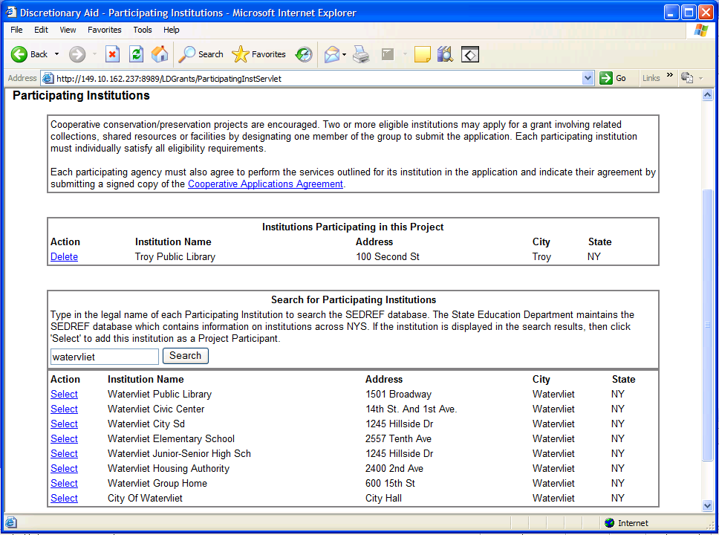

If the participating institution is not listed in the search results, try searching another name. If the participating institution is not stored in the SED reference file, contact Library Development staff to add the institution to the SED reference file.

If the participating institution is listed in the search results, click Select link, and the institution will be listed as a participant in this grant project.

Additional Participating Institutions may be added by searching again, or existing participants deleted by using the Delete link for the corresponding institution.
Updating Project Description Narratives

- From the top menu bar, choose Project Narratives in the Initial Application Forms drop-down box. This will display the first project narrative. Use the links on the left-hand side to access the remaining 17 narratives.

- The instructions for each narrative are listed above the text area. Type the narrative in the text area or copy and paste from a Microsoft Word document. Click the Save button before moving on to the next narrative.

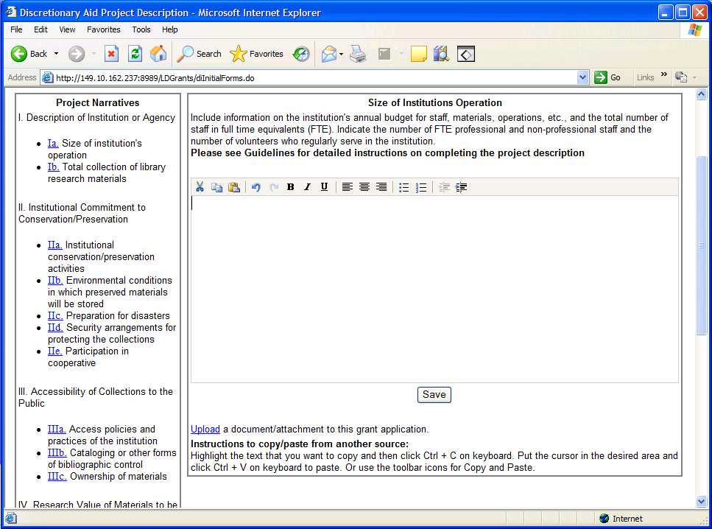

- The word editor at the top of the text area is only accessible if you have Javascript enabled. If your browser does not have Javascript enabled, you will NOT see the word editor, but can still type and save your narrative.

- To enable Javascript: From your browser click Tools -> Internet Options ->Security tab -> Custom Level button -> Scroll down to Active scripting and choose the Enable option.

- Once the application has been submitted, you will have read-only access to the narratives.
Attaching Documents to the application

- The top menu bar link ‘Upload/Attachments’ in the Initial Application Forms drop-down will display all the documents that have been uploaded to this grant application.

- Click the link ‘Delete’ next to a document to remove the document from this application. You will be asked to confirm the deletion first. Click the document name link to open or save the document on your desktop. You must have the appropriate software to open the document type, for example you must have Microsoft Excel in order to open an .xls document.

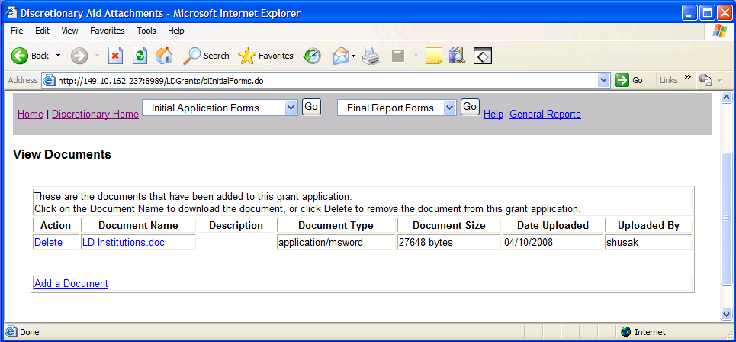

- Use the link at the bottom of the page to Add a Document to the application. You may add Microsoft Word, Excel files, text documents, pdf’s or picture files such as .jpg, .png, .bmp.

- On the Add Document page, click the Browse button to open a File window, and then navigate to the document on your own computer that you want to attach and click OK.

- Note: The name you see on the document will be the name saved to the database so please use a meaningful name for your document.

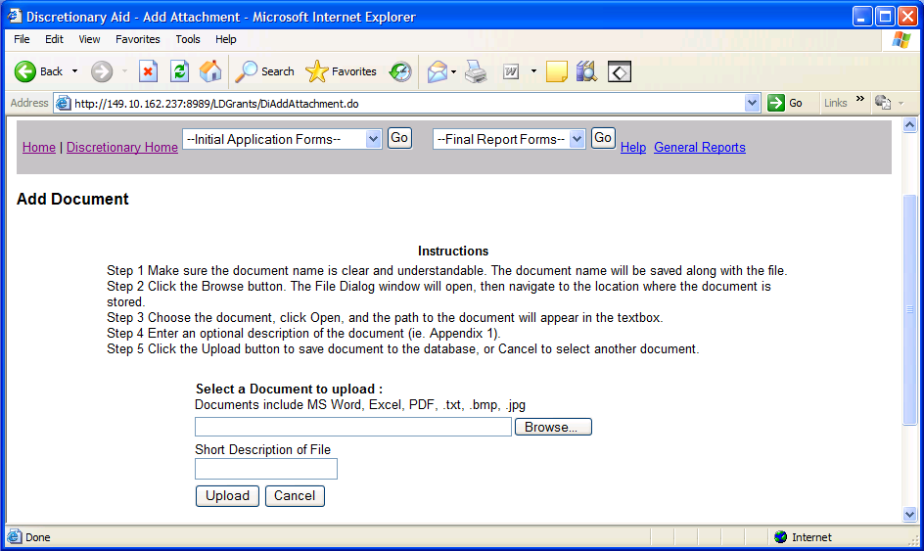

- Another option is to enter a short description of the document, and then click Upload button to save the document to the application. Click the Cancel button to reset the form without uploading.
Project Budget

- The link to Project Budget in the Initial Application Forms drop-down displays the first of five expense categories for the Project Budget. The expense categories are accessible using the tabbed links.

- The instructions for each expense category are listed at the top of the page, right above the expense category tabs. Detailed information on expenses can be found in the Guidelines and Instructions document on the Help page.

- For each expense category you wish to claim, click the Add button to add a blank record.

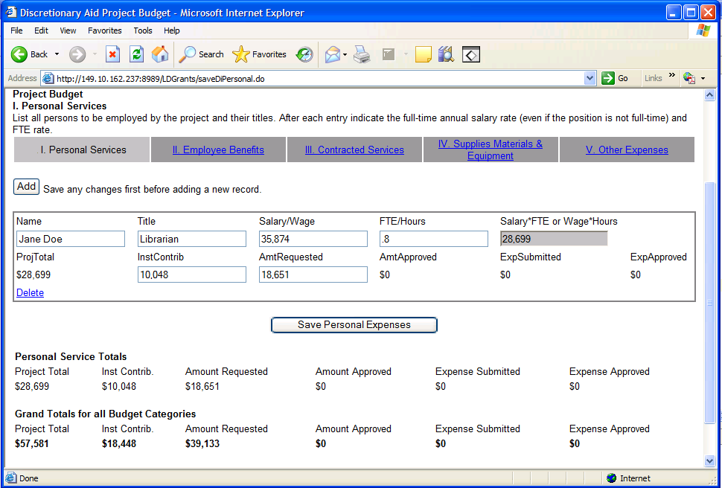

- Enter the required information for each budget record, and click the Save button at the bottom of the page. The gray text boxes are calculation boxes only – they are not saved to the database.

- If you have not entered all required data, an error message will warn you to enter all data before the form can be saved.

- If you need to delete an individual budget record, click the Delete link next to the record, and you will be asked to confirm deletion.

- The bottom of the page has the total amount requested for a given budget category. The Grand Total section has totals for all budget categories of the grant application.

- After you submit the application, you cannot update the project budget records. If your grant project is approved, you will need to complete a Final Report at the conclusion of the project. One portion of the Final Report is the Budget Expenses. On the Budget Expense form, enter the expenses submitted for each of the budget records.

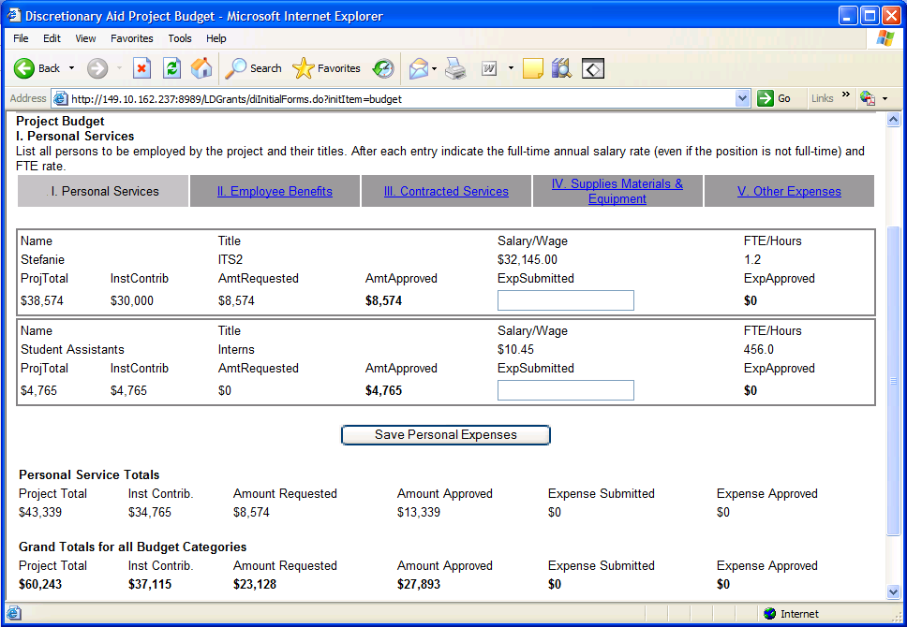

Once the Project Budget pages are filled out, you may access the FS-10 form. The FS-10 form will be pre-filled with the information you save on the Project Budget pages.

Please check the FS-10 form to make sure it is correct. This form will only show the funds you are requesting from the state

.
Final Report Narrative

- The top menu bar link Final Narrative in the Initial Application Forms drop-down will display the Final Report Narrative. If your application is approved, the final report must be completed at the conclusion of the project.

- Type the narrative in the text area or copy and paste from a Microsoft Word document. Click Save button to save changes to the database.

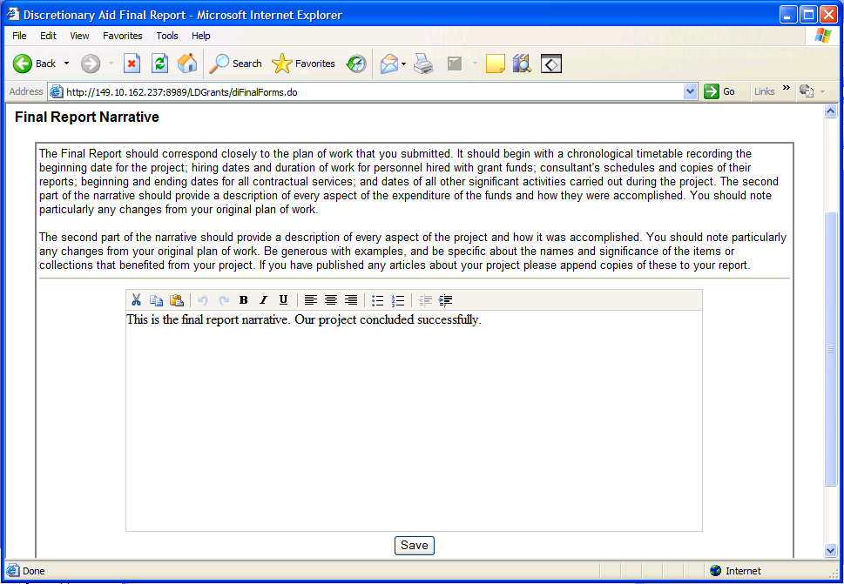

- The word editor at the top of the text area is only accessible if you have Javascript enabled. If your browser does not have Javascript enabled, you will NOT see the word editor, but can still type and save your narrative.

- To enable Javascript: From your browser click Tools -> Internet Options ->Security tab -> Custom Level button -> Scroll down to Active Scripting and choose the Enable option.

- If the final report has already been submitted, you will have read-only access to the final report narrative.
How to Submit an Institutional Authorization and Final Signoff

- The Institutional Authorization and Final Signoff are accessible using the links on the Checklist page. The Institutional Authorization is required with the initial application; the Final Signoff is required with the Final Report Narrative.

- Print out either the HTML form, or the PDF version of the form, then sign and date.

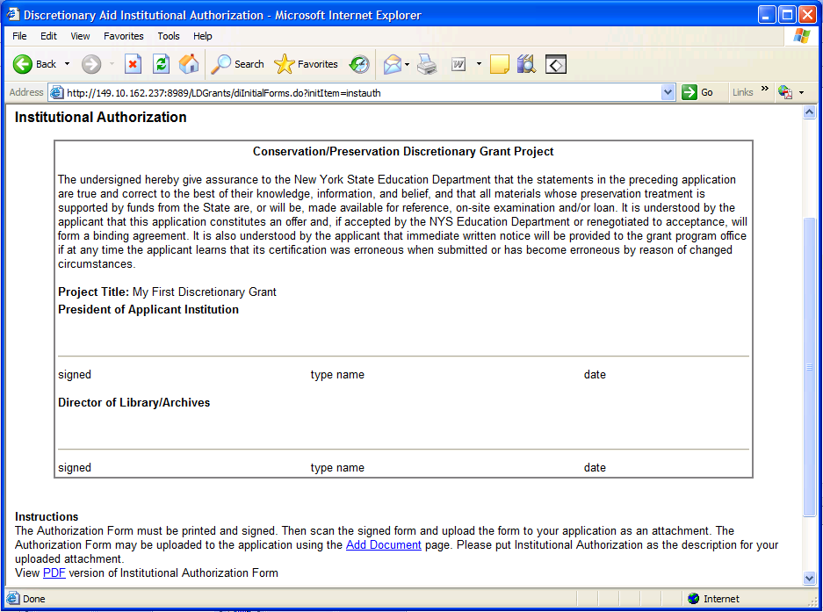

- Scan the Institutional Authorization form or Final Signoff form, and save the scanned image on your desktop. Then upload the image to the grant application using the ‘Add Document’ link. Please see the instructions on How to attach Documents to the Application.

- Note: Failure to complete the Institutional Authorization or Final Signoff may result in delay of reviewing the grant application.
How to Submit a Cooperative Agreement or Microform Guidelines

- The Cooperative Agreement and Microform Guidelines forms are accessible using the links on the top menu bar Initial Application Forms drop-down box. The Cooperative Agreement must be signed by each participating institution of the project. The Microform Guidelines must be signed for Microform projects.

- Print out either the HTML form, or the PDF version of the form, then sign and date.

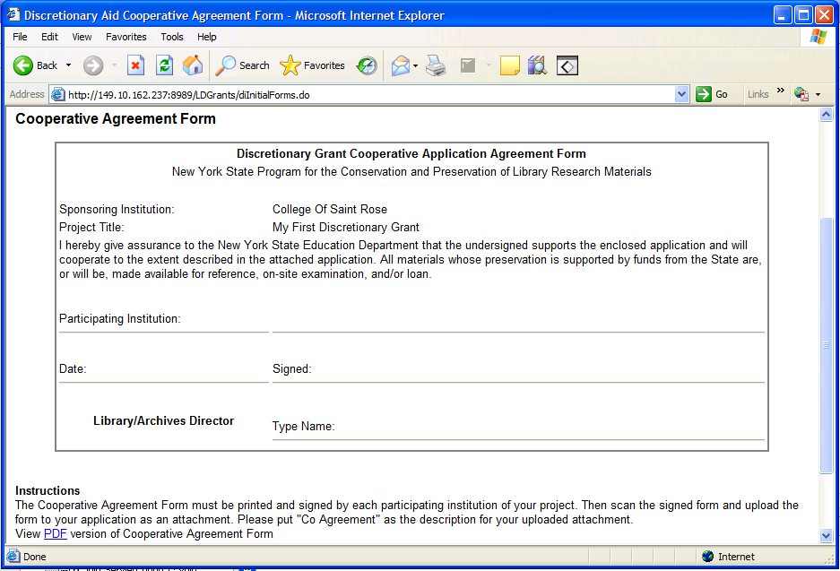

- Scan the Cooperative Agreement or Microform Guidelines form, and save the scanned image on your desktop. Then upload the image to the grant application using the ‘Add Document’ link. Please see the instructions on How to attach Documents to the Application.

- Note: Failure to complete the Cooperative Agreement or Microform Guidelines may result in delay of reviewing the grant application.
How to submit the FS10, FS-10-F, FS-10-A, Payee Information Form

- The FS10 form must be signed and mailed to the Division of Library Development when submitting your initial application. The FS10 form is located using the FS Forms link of the Initial Application Forms drop-down box.

- Please make sure the FS-10 form is correct. The data on the FS-10 form comes from the data you entered on your Project Budget pages. The form will only show the amounts you are requesting from the state.

- Print and sign in blue ink three copies of the FS10 form and mail the forms to the Division of Library Development address specified on the form.

---------------------------------------------------------------------------------------------------------------------

- The Payee Information Form must be signed and mailed to the Division of Library Development when submitting your initial application. The form is located using the Payee Information Form link of the Initial Application Forms drop-down box.

- Print and sign in blue ink 1 copy of the Payee Information Form and mail the form to the Division of Library Development address specified on the form.

---------------------------------------------------------------------------------------------------------------------

- The FS-10-A form is optional and only needs to be completed if there is an amendment to your approved budget. The FS-10-A form is located using the FS Forms link of the Initial Application Forms drop-down box.

- Print three copies of the HTML or PDF version of the form, and clearly write the reason for amending the budget, and the budget amounts. Sign in blue ink and mail the FS-10-A forms to the Division of Library Development address specified on the form.

--------------------------------------------------------------------------------------------------------------------

- The FS-10-F form must be signed and mailed to the Division of Library Development when submitting your Final Report. The FS20 form is located using the FS Forms link of the Initial Application Forms drop-down box.

- Print and sign in blue ink three copies of the HTML or PDF version of the FS-10-F form. Mail the forms to the Division of Library Development address specified on the form.

How to Submit the Application

- On the Checklist page, click the Submit button to submit either the Initial Application, or Final Report.

- Warning messages will display if you have not filled out all required project narratives. Please complete all narratives before submitting application. Then confirm application submission by clicking the Submit button.

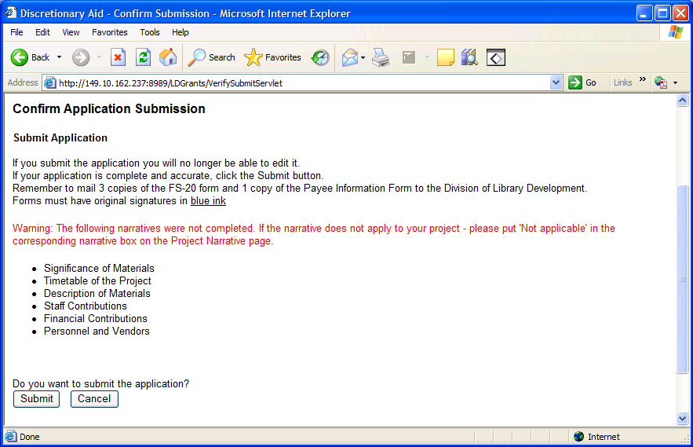

- Once the application is submitted, you will be redirected to the Discretionary Aid Home page. You cannot edit the submitted application.

- The Project Manager of the grant project will receive an email notification that the grant application has been submitted to the Division of Library Development.

- Remember to mail the FS-10 Form and Payee Information Form during Initial Application submission. The FS-10-F Form must be mailed during Final Report submission.
Status of the Application

- The bottom of the Checklist page contains a link to view application submissions/approvals. Data includes the date application was submitted, and date the Library Development Administrator reviewed or approved the application. Also displays comments made by the Library Development Administrators.

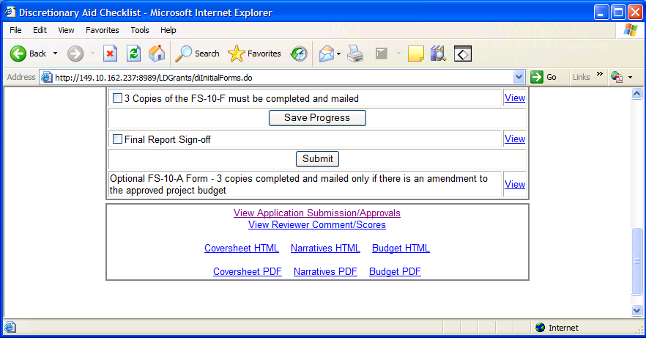

- The bottom of the Checklist page also contains a link to View Reviewer Comments/Scores. Data includes comments that reviewers made regarding the application and the average score for each of the rating categories.

- Reviewer Comments/Scores are only available after the application has been approved/denied by the Conservation/Preservation Program Officer.

- The award amount is listed on the Project Budget pages, under the Grand Totals section on each budget page. The Amount approved and the Expenses approved are listed by expense category and a grand total for the grant application.

- The Project Manager will receive an award email once approval has been made by the Division of Library Development.

Help with the Discretionary Aid application

- Click the menu bar link titled Help to access the Discretionary Aid help options.

- There are links to both HTML and PDF versions of this Applicant User Manual which has instructions on using the Division of Library Development Online Grant System. Also contains link to the Discretionary Aid Guidelines and Instructions document which details the types of expenditures that qualify for the grant program.

- To report error messages, problems, login issues, or questions regarding the Division of Library Development Online Grant System, contact LibDevGrants@nysed.gov. Please include any error message you received, along with a description of the steps you completed just prior to receiving the error message.

- For questions regarding the Discretionary Aid application process, eligible projects, funding, etc., please contact the Conservation/Preservation Program Officer, Barbara Lilley, at barbara.lilley@nysed.gov.

