New York State Education Department
New York State Library
Division of Library Development

Adult/Family Literacy Applicant User Manual

Cultural Education Center
Division of Library Development
Albany NY 12203
(518) 474-7890

Stefanie Husak
January 2, 2009
Table of Contents

How to Login to Division of Library Development Online Grant System..…………………..3
How to obtain a user account and password for the system…………………………..4

How to Create an Adult/Family Literacy Application………………...…………………..……5

How to Access a Literacy application…………………………………………….………..….6

How to use the Checklist…………………………………………………………………..…7

How to update the Cover Page…………………………………………………………..…...9

How to specify Participating Institutions……………………………………………………11

How to update Application Narratives………………….……...……………………………12

How to attach Documents to the application……………………………………………......13

How to update the Project Budget………………………………………..…………………15

How to update the Interim Narrative/Final Report Narrative……………………..……..…..17

How to Submit Authorization/Sign-off Forms………………………..……….……….…...18

Federal/State Forms
How to submit the FS10, FS-10-F, FS-10-A…………………………..………….19

How to Submit the Application………………………………………………………..……20

Status of the Application
How to view Application submissions/approvals………………………………......21
How to view Award Amounts……………………………………………………...21

Help with the Literacy application……………………………………………………...…..22
How to Login to Division of Library Development Online Grant System

- The URL to the system is https://eservices.nysed.gov/ldgrants To login to the Division of Library Development Online Grant System you must have an NYSDS username and password. If you do not have a NYSDS username and password, you must follow the directions on the next page regarding creating your account. Your username and password will be sent via email.
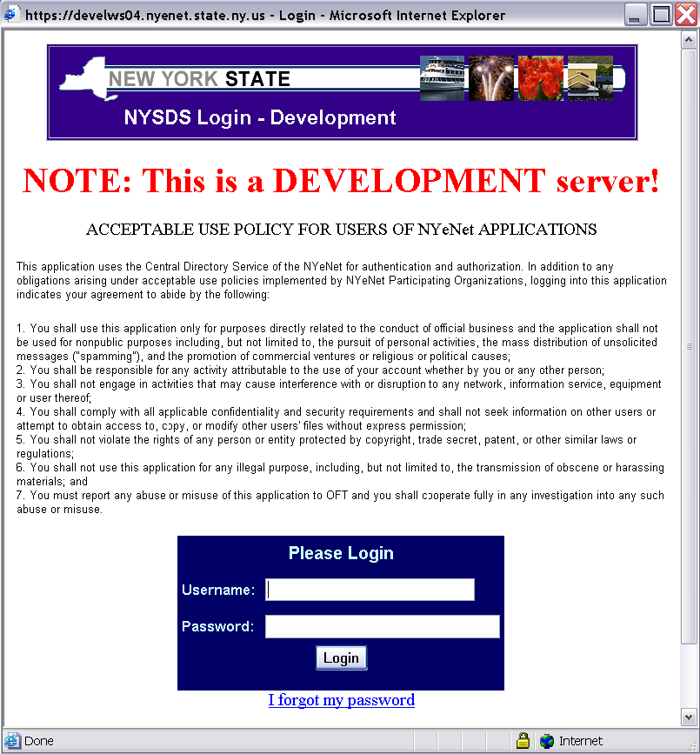

- Enter your username and password and click the Login button. Your username is usually your firstName.lastName (with a period in between first and last names).

- The first time you login to the system, you may be asked to change your password and set up security questions. These questions will be used in case you later forget your password. Password requirements are:
  - Must be at least 8 characters long; one of which must be a numeric character
  - Cannot be the same as your username or default password

- If you forgot your password, click the link ‘I forgot my password’ and answer your security questions in order to reset your password. If you don’t remember the answers to the security questions, please contact LibDevGrants@nysed.gov to reset your password.

- Click on the link for the grant program you wish to work on (either Adult Literacy or Family Literacy).
How to obtain a user account and password for the system

- If you do not have an NYSDS user name and password, you must register for an account. The URL for registration is http://eservices.nysed.gov/ldgrants/ldgext/litRegistration.do

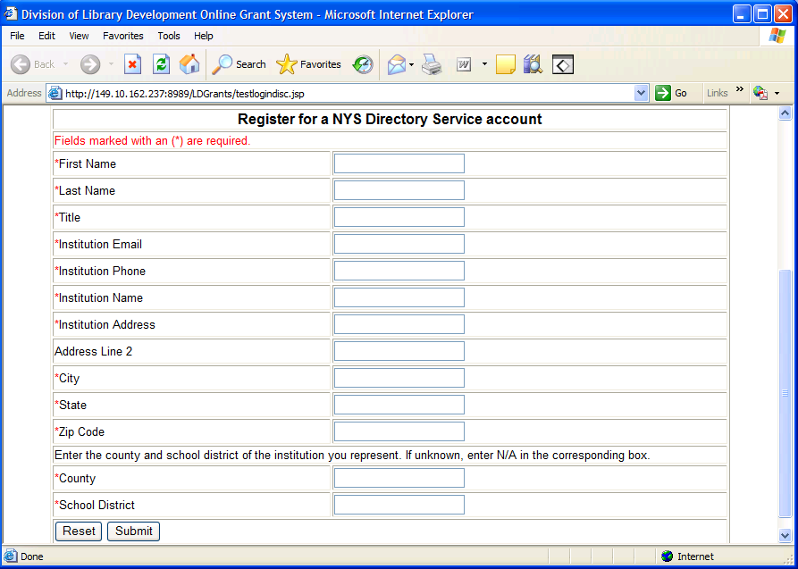

- Enter all required information, including name, title, institution address, and contact information. Then click the Submit button.

- The new user account will be tied to the institution you represent. It will allow you access to the Online Grant System so that you may submit grant applications on behalf of your institution.

- The information will be submitted to the Division of Library Development. You will receive your account username and password within 48 hours.

- The new username and password will be emailed to the Institution Email address you entered on the Registration form. Please be sure the email address provided is correct, otherwise receipt of your new account will be delayed.

How to Create a Literacy Application

- The first section of the Adult Literacy or Family Literacy Home page lists all grant applications that the institution has created. The second section contains grant applications in which the institution is a participating institution.

- To create a new Literacy application, click the link “Create new application”. You may only create a new application during the new application time period, and can only create 1 new Adult Literacy and 1 new Family Literacy application per fiscal year.

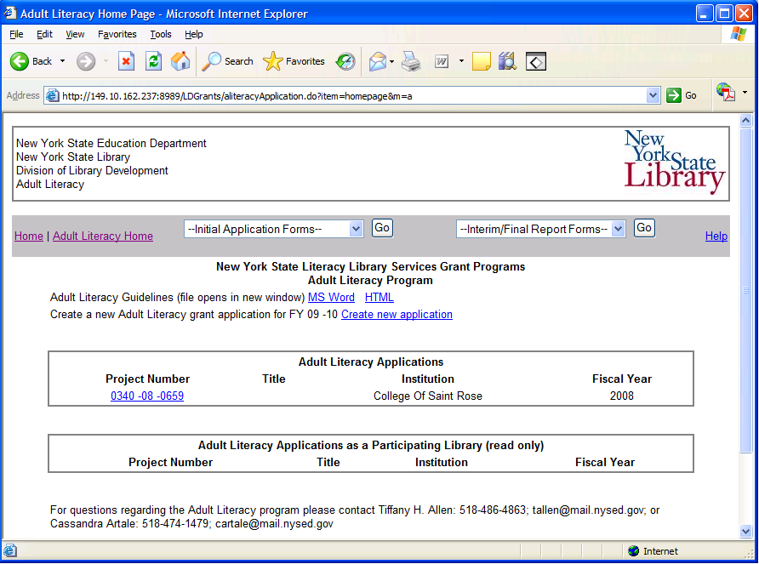

- Once a new Adult or Family Literacy application is created, you will be redirected to the Checklist page and can begin filling out the application.

- The applications must be submitted by the due date listed on the Checklist page. You will not be able to submit after the due date.

How to Access a Literacy application

- The first section of the Adult or Family Litearcy Home page lists all grants that the institution has created. The second section contains grant applications in which the institution is a participating institution. Participating institution grant applications are read-only.

- Click on the project number link for the grant application you wish to work on. This will bring you to the Checklist page.

- You must choose a grant application project number in order to use the drop-down menu options to access the Initial Application Forms and Final Report Forms.

How to use the Checklist

- The checklists for the Initial Application, Interim Report and Final Report have links to all required items for the application. This includes the Cover Sheet, Project Narrative, Budget, Final Report Narrative. These items are all completed online.

- Three (3) copies of the FS 10 must be signed and mailed to the Division of Library Development at the time you submit your application. Three (3) copies of the FS-10-F must be signed and mailed in at the time you complete the Final Report, only after an award is made. The FS-10-A should be completed and mailed in if you have amendments to your approved budget. These forms are NOT completed online; they must be printed and mailed to the Division of Library Development.
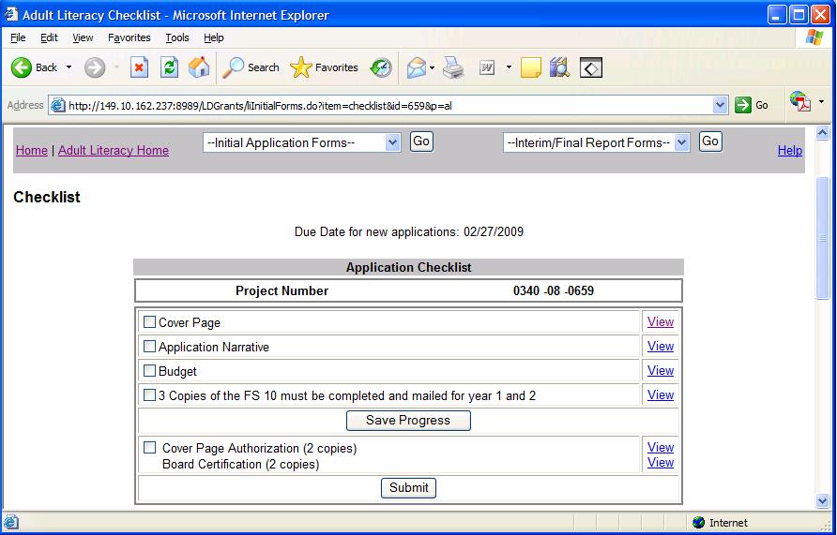

- Use the links on the Checklist page or the drop-down boxes on the top menu bar to navigate the application.

- If you have completed a section, you may check off the box next to the item and click Save Progress.

- The Literacy application due date is located on the Checklist page. You cannot submit the application after the due date. If the due date has passed, a warning message will appear on the Checklist page.

- The application is submitted by clicking on the Submit button. A warning message will display if you have not filled out the required Project Narratives. You will be asked to confirm submission of the application. The Project Manager will receive an automatically generated email indicating that the application was submitted. You will NOT be able to edit the application once you have submitted it. Please see the section on Submitting an Application.

- The bottom portion of the Checklist contains links to view application items in HTML or PDF formats. Both links open in a new window, and the PDF document can be printed or saved to your desktop.

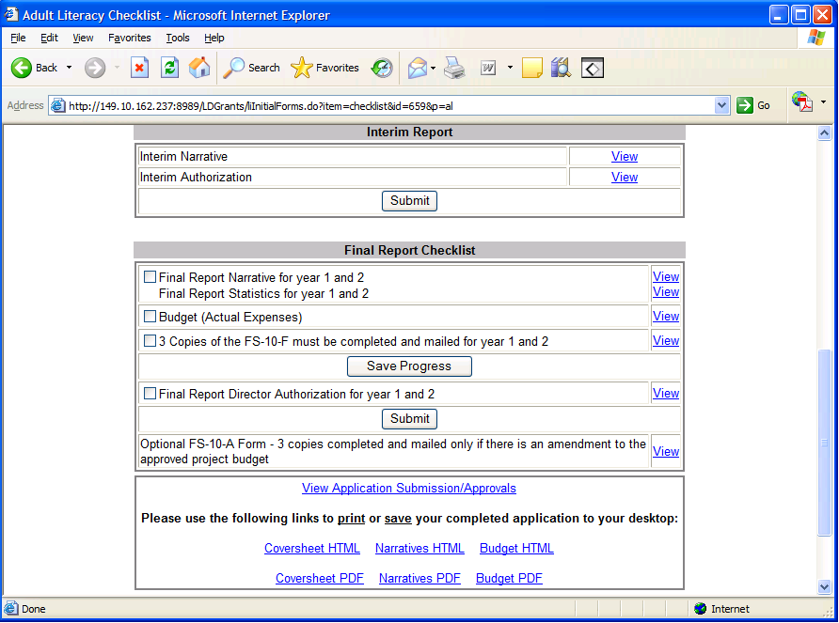

- The link to View Application Submissions/Approvals will display information on when the application was submitted, and the outcome of the Library Development Application Review process.

How to update the Cover Page

- The cover page contains information on the Institution, the Project Manager, and Participating Institutions. The Institution information (such as address, Director, senate, congressional districts) is supplied by an internal SEDREF database, and cannot be modified by applicants. If the information for your institution is not correct, please include the correct information when you mail in the Payee Information Form. The Payee Information Form will be sent to the Grants Finance office for approval, and only Grants Finance has the authority to update Institution and Director information.

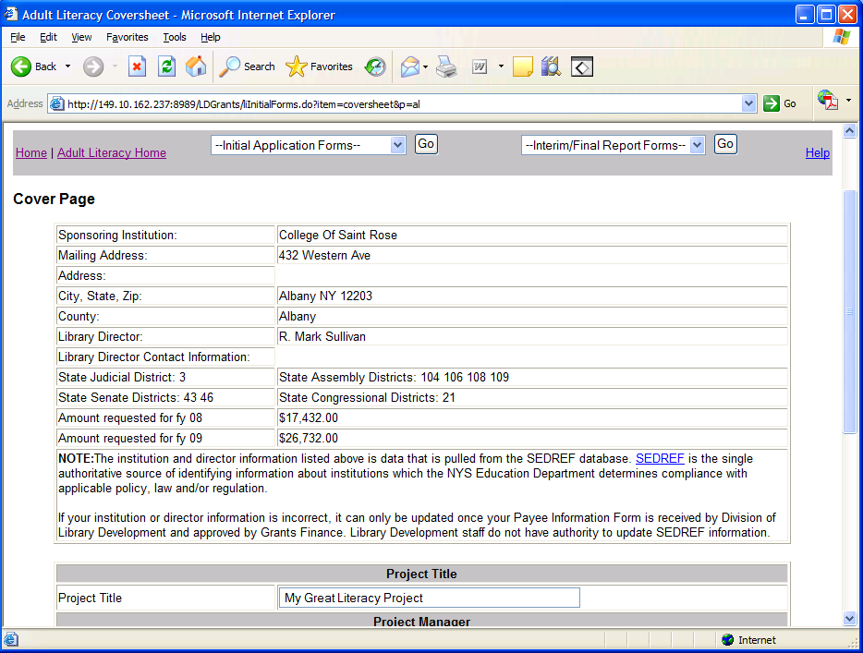

- The Amount Requested for fiscal year 1 and year 2 will display only after you have completed your budget pages.
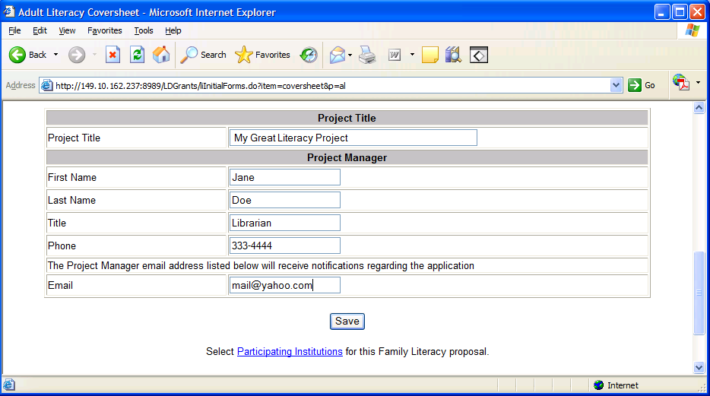

- Enter the information about the Project Manager, including name, title, and contact information. Also enter the title for this grant project. Then click the Save button to save all changes.

- To specify participating institutions cooperating in this grant project, click the link Participating Institutions located at the bottom of the Cover Page.
How to specify Participating Institutions

- To specify participating institutions cooperating in this grant project, click the link Participating Institutions located at the bottom of the Cover Page.

- Each Participating Institution added to the grant project will have read-only access to the online grant application.

- To search for an institution, type in the institution name and click the search button. A list of matching institution names will display.

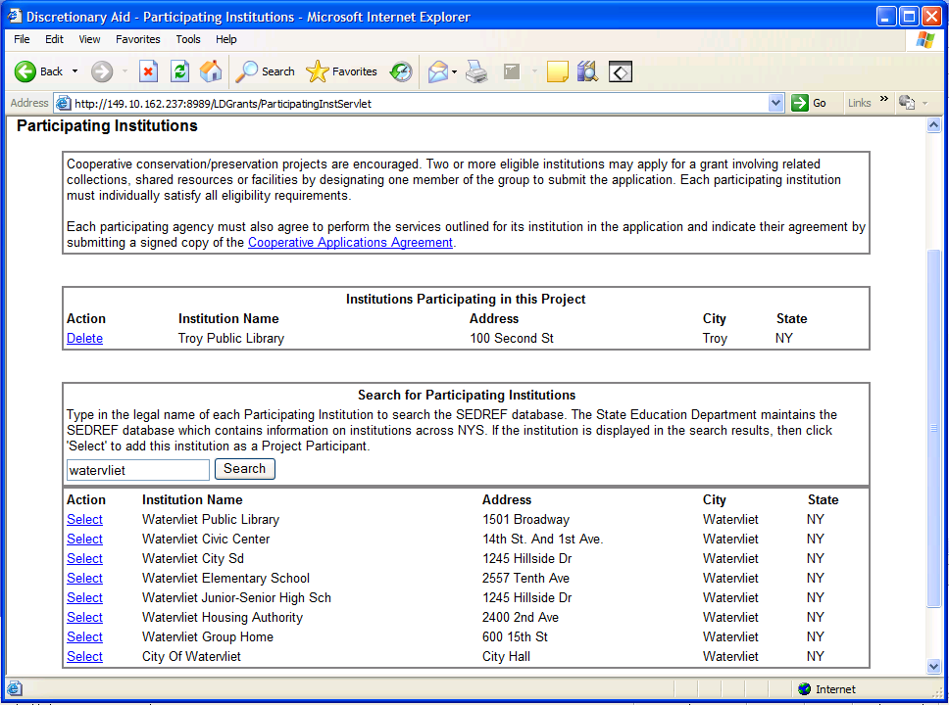

- If the participating institution is not listed in the search results, try searching another name. If the participating institution is not stored in the SED reference file, contact Library Development staff to add the institution to the SED reference file.

- If the participating institution is listed in the search results, click Select link, and the institution will be listed as a participant in this grant project.

- Additional Participating Institutions may be added by searching again, or existing participants deleted by using the Delete link for the corresponding institution.
Updating Application Narratives

- From the menu bar, choose Application Narratives in the Initial Application Forms drop-down box. This will display the first project narrative. Use the links on the left-hand side to access the remaining narratives.

- The instructions for each narrative are listed above the text area. Type the narrative in the text area or copy and paste from a Microsoft Word document. Click the Save button before moving on to the next narrative.

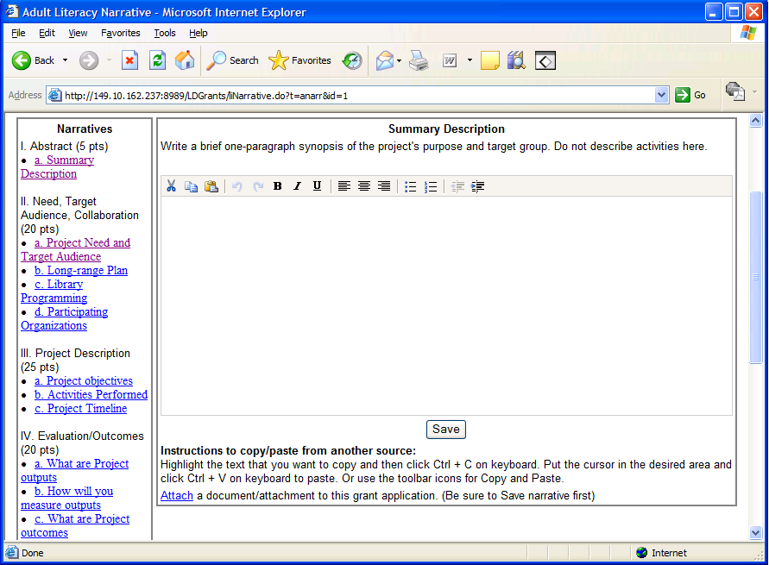

- The word editor at the top of the text area is only accessible if you have Javascript enabled. If your browser does not have Javascript enabled, you will NOT see the word editor, but can still type and save your narrative.

- To enable Javascript: From your browser click Tools -> Internet Options ->Security tab -> Custom Level button -> Scroll down to Active scripting and choose the Enable option.

- Once the application has been submitted, you will have read-only access to the narratives.
Attaching Documents to the application

- The top menu bar link ‘Attachments/Uploads’ in the Initial Application Forms drop-down will display all the documents that have been attached to this grant application.

- Items that can be attached to your application include letters of support, resumes, supporting data for purchased services, bids.

- Click the link ‘Delete’ next to a document to remove the document from this application. You will be asked to confirm the deletion first. Click the document name link to open or save the document on your desktop. You must have the appropriate software to open the document type, for example you must have Microsoft Excel in order to open an .xls document.

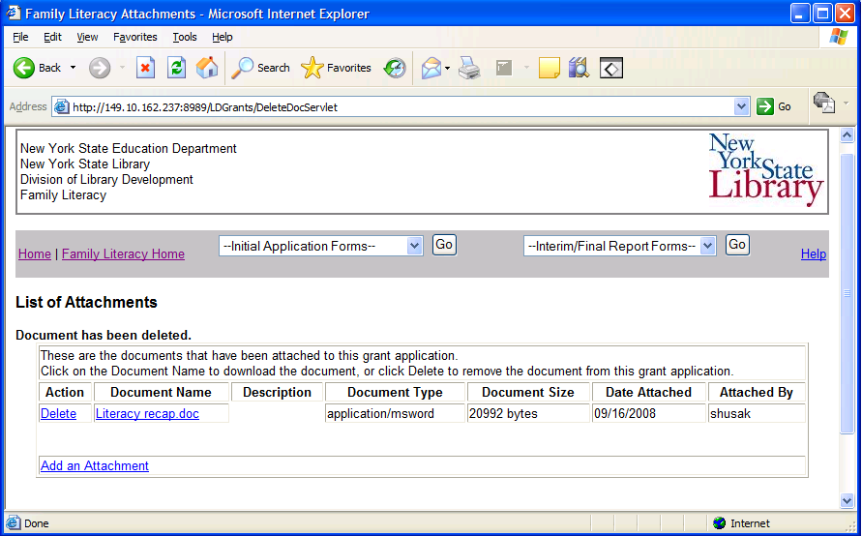

- Use the link at the bottom of the page to Add an Attachment to the application. You may add Microsoft Word, Excel files, text documents, pdf’s or picture files such as .jpg, .png, .bmp.

- On the Add Attachment page, click the Browse button to open a File window, and then navigate to the document on your own computer that you want to attach and click OK.

- Note: The name you see on the document will be the name saved to the database so please use a meaningful name for your document.

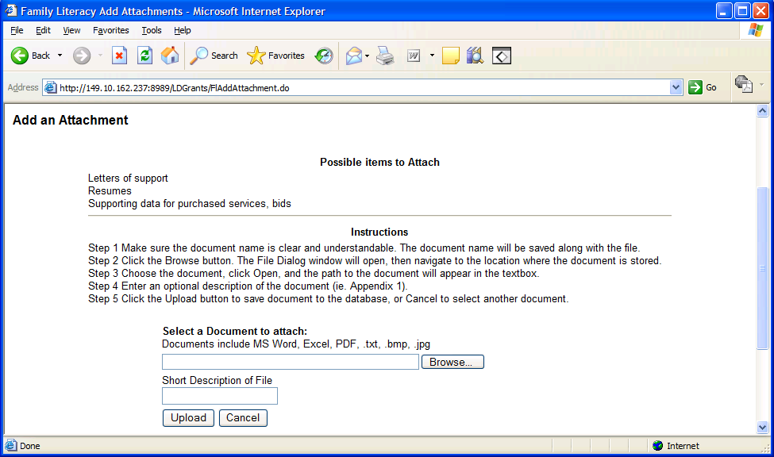

- Another option is to enter a short description of the document, and then click Attach button to save the document to the application. Click the Cancel button to reset the form without uploading.
Project Budget

- The link to Project Budget in the Initial Application Forms drop-down displays the first of five expense categories for the Project Budget. The expense categories are accessible using the tabbed links.

- The instructions for each expense category are listed at the top of the page, right above the expense category tabs.

- For each expense category pertaining to your project, click the Add button to add a blank record for year 1 or year 2 of the project.

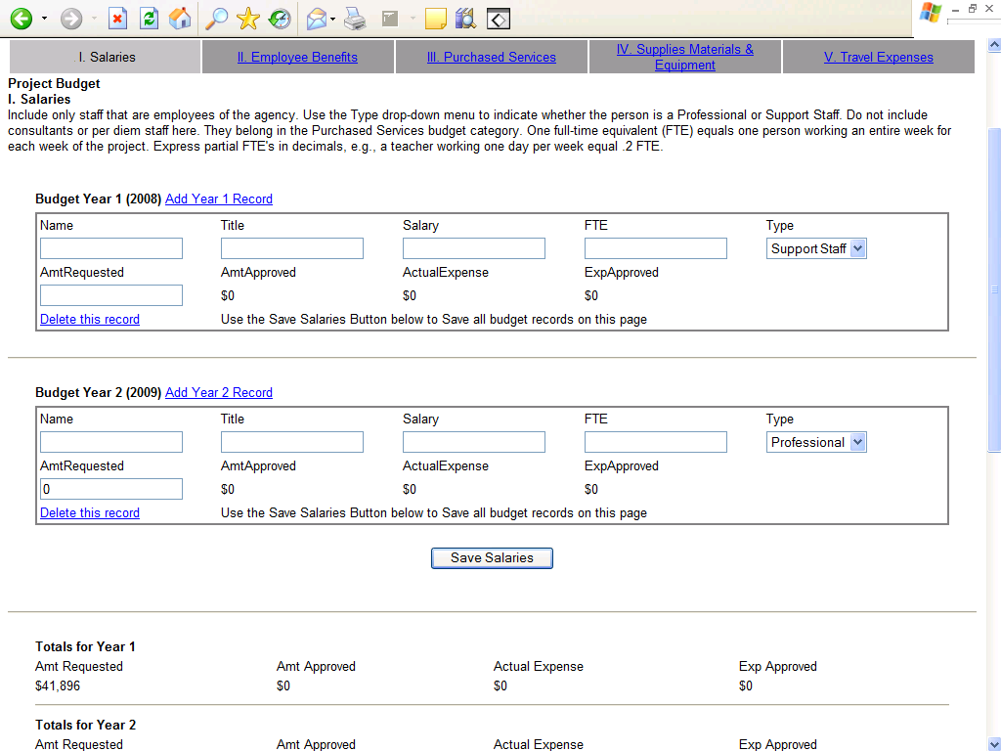

- Enter the required information for each budget record, and click the Save button at the bottom of the page. The gray text boxes are calculation boxes only – they are not saved to the database.

- If you have not entered all required data, an error message will warn you to enter all data before the form can be saved.

- If you need to delete an individual budget record, click the Delete link next to the record, and you will be asked to confirm deletion.

- The bottom of the page has the total amount requested for year 1 and year 2 of the project.

- Below the totals section, you must complete the budget narrative for each budget category. Explain how the items listed on the budget tab will support the project. Then click Save to save the narrative.
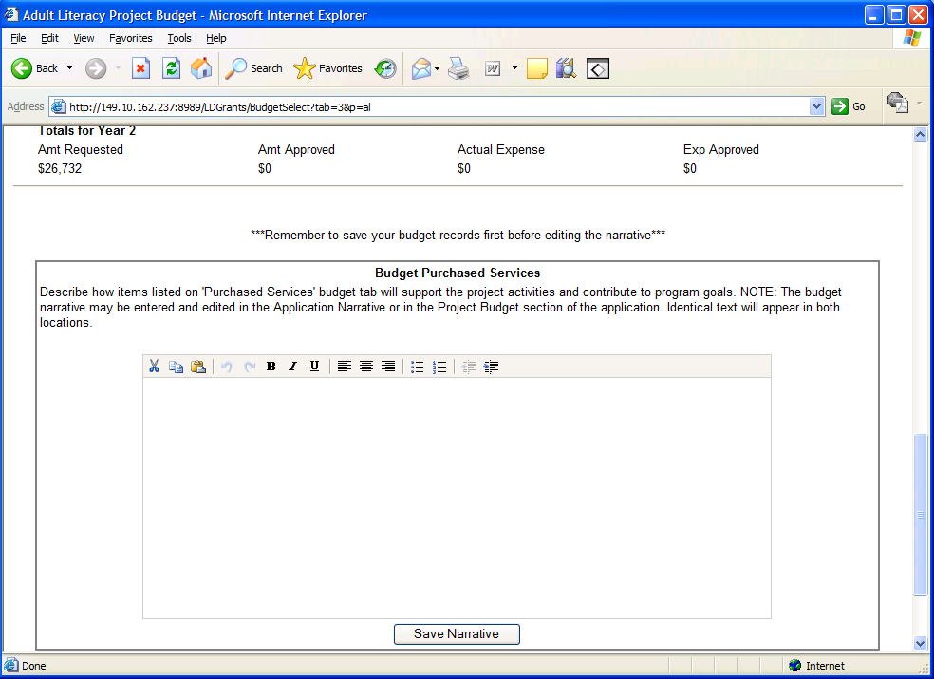

- After you submit the application, you cannot update the project budget records. If your grant project is approved, you will need to complete Budget Expenses. On the Budget Expense form, enter the expenses submitted for each of the budget records.

- Once the Project Budget pages are filled out, you may access the FS-10 form. The FS-10 form will be pre-filled with the information you save on the Project Budget pages. Please check the FS-10 form to make sure it is correct. This form will only show the funds you are requesting from the state.

Interim Narrative and Final Report Narrative

- Use the Interim/Final Application Forms drop-down will display the Final Report Narrative or Interim Narrative. You only need to complete the interim and final reports if your project is approved.

- Type the narrative in the text area or copy and paste from a Microsoft Word document. Click Save button to save changes to the database.

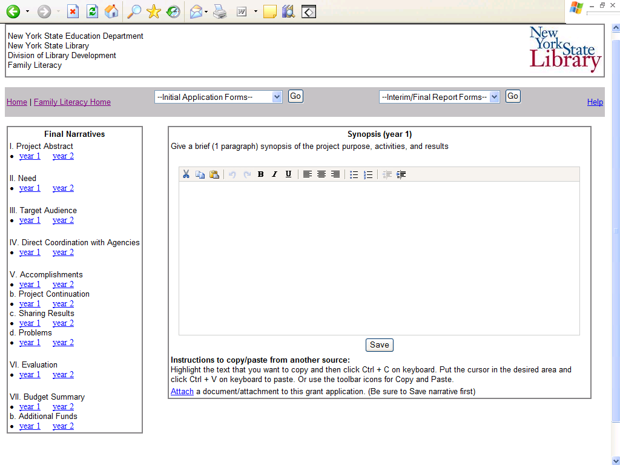
- Use the links on the left-hand side to access the remaining narratives. The narrative instructions will display above the text area.

- The word editor at the top of the text area is only accessible if you have Javascript enabled. If your browser does not have Javascript enabled, you will NOT see the word editor, but can still type and save your narrative.

- To enable Javascript: From your browser click Tools -> Internet Options ->Security tab -> Custom Level button -> Scroll down to Active Scripting and choose the Enable option.

How to Submit Authorization Sign-off Forms

- The Cover Page Authorization and Board Certification forms are accessible using the links on the Checklist page. Both forms must be submitted with your initial application. For approved projects only: the Interim Authorization must be submitted with your Interim Narratives and Final Report Director Authorization must be submitted with your Final Report.

- Print out two (2) copies of either the HTML form, or the PDF version of the form, then sign and date in blue ink. Mail the forms to the Division of Library Development address listed on the form.

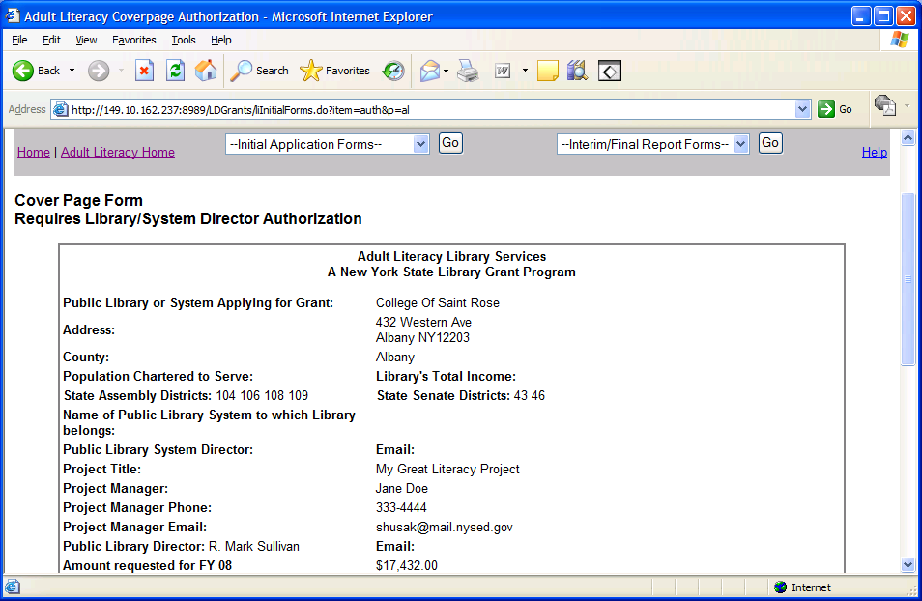

- Note: Failure to complete the Authorization sign-off forms may result in delay of reviewing the grant application.
How to submit the FS10, FS-10-F, FS-10-A

- The FS10 form must be signed and mailed to the Division of Library Development when submitting your initial application. The FS10 form is located using the FS Forms link of the Initial Application Forms drop-down box.

- Please make sure the FS-10 form is correct. The data on the FS-10 form comes from the data you entered on your Project Budget pages. The form will only show the amounts you are requesting from the state.

- Print and sign in blue ink three copies of the FS10 form and mail the forms to the Division of Library Development address specified on the form.

---------------------------------------------------------------------------------------------------------------------

- The FS-10-A form is optional and only needs to be completed if there is an amendment to your approved budget. The FS-10-A form is located using the FS Forms link of the Initial Application Forms drop-down box.

- Print three copies of the HTML or PDF version of the form, and clearly write the reason for amending the budget, and the budget amounts. Sign in blue ink and mail the FS-10-A forms to the Division of Library Development address specified on the form.

--------------------------------------------------------------------------------------------------------------------

- The FS-10-F form must be signed and mailed to the Division of Library Development when submitting your Final Report. The FS-10-F form is located using the FS Forms link of the Initial Application Forms drop-down box.

- Print and sign in blue ink three copies of the HTML or PDF version of the FS-10-F form. Mail the forms to the Division of Library Development address specified on the form.

How to Submit the Application

- On the Checklist page, click the Submit button to submit the Initial Application, Interim Report, or Final Report.

- Warning messages will display if you have not filled out all required application narratives. Please complete all narratives before submitting application. Then confirm application submission by clicking the Submit button.

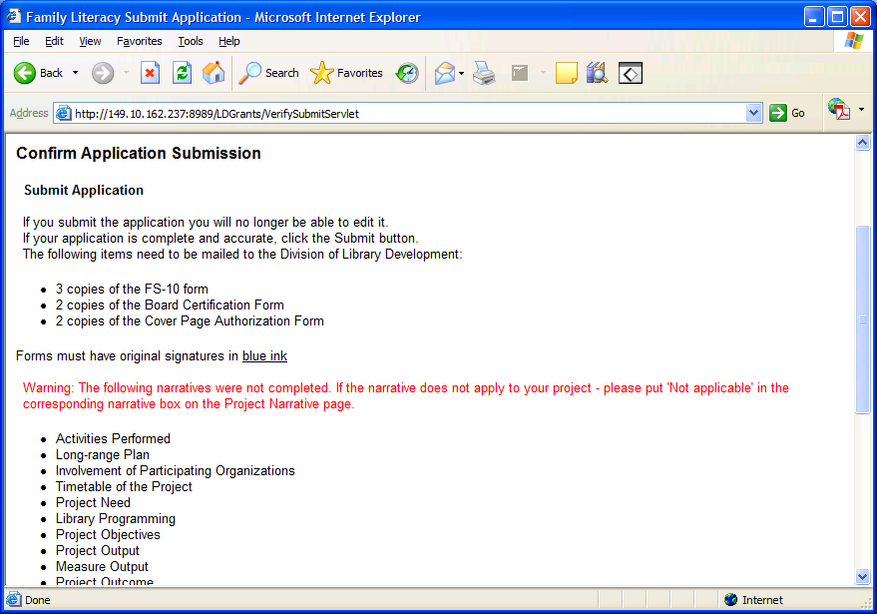

- Once the application is submitted, you will be redirected to the Literacy Home page. You cannot edit the submitted application.

- The Project Manager of the grant project will receive an email notification that the grant application has been submitted to the Division of Library Development.

- Remember to mail the FS-10 Form and Payee Information Form during Initial Application submission. The FS-10-F Form must be mailed during Final Report submission.
Status of the Application

- The bottom of the Checklist page contains a link to view application submissions/approvals. Data includes the date application was submitted, and date the Library Development Administrator reviewed or approved the application.

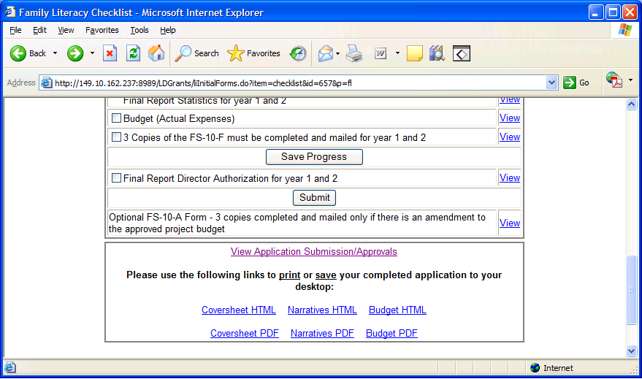

- There are also links to view, print, or save, a read only version of the coversheet, narratives, and budget.

- If an award is made for the grant project, the award amount will be listed on the Project Budget pages, under the Grand Totals section on each budget page. The Project Manager will receive an award email once approval has been made by the Division of Library Development.

Help with the Literacy application

- Click the menu bar link titled Help to access the Literacy help options.

- There are links to both HTML and PDF versions of this Applicant User Manual which has instructions on using the Division of Library Development Online Grant System. Also contains link to the Literacy Guidelines and Instructions document.

- To report error messages, problems, login issues, or questions regarding the Division of Library Development Online Grant System, contact LibDevGrants@nysed.gov. Please include any error message you received, along with a description of the steps you completed just prior to receiving the error message.

- For questions regarding the Adult/Family Literacy program please contact DLDLP@nysed.gov

