New York State Education Department
New York State Library
Division of Library Development

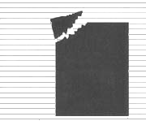 | Division of Library Development Online Grant System  Conservation/ Preservation Discretionary Aid and Coordinated Aid Reviewer  User Manual

Cultural Education Center
Division of Library Development
Albany NY 12203
(518) 474-7890

Stefanie Husak
April 28, 2008
Table of Contents

How to Login to Division of Library Development Online Grant System……………….…...3

How to fill out a Participation form………………………………………………………..….4
How to update a participation form………………………………………………..….5

How to update your contact information……………………………………………………...6

How to view grants assigned to you…………………………………………………….…….7

Reviewer Ratings
How to view the grant proposal………………………………………………………8
How to fill out a Rating Form/comments……….……………………………………9
How to submit a Rating Form.……………………………………………………….10

How to access documents regarding grant program………………………………………….11

How to get additional help……………………………………………………………………12

How to Login to Division of Library Development Online Grant System

- The URL to the system is https://eservices.nysed.gov/ldgrants To login to the Division of Library Development Online Grant System you must have an NYSDS username and password. If you do not have a NYSDS username and password, you must contact Library Development staff to create your account. Your username and password will be sent to you by email.

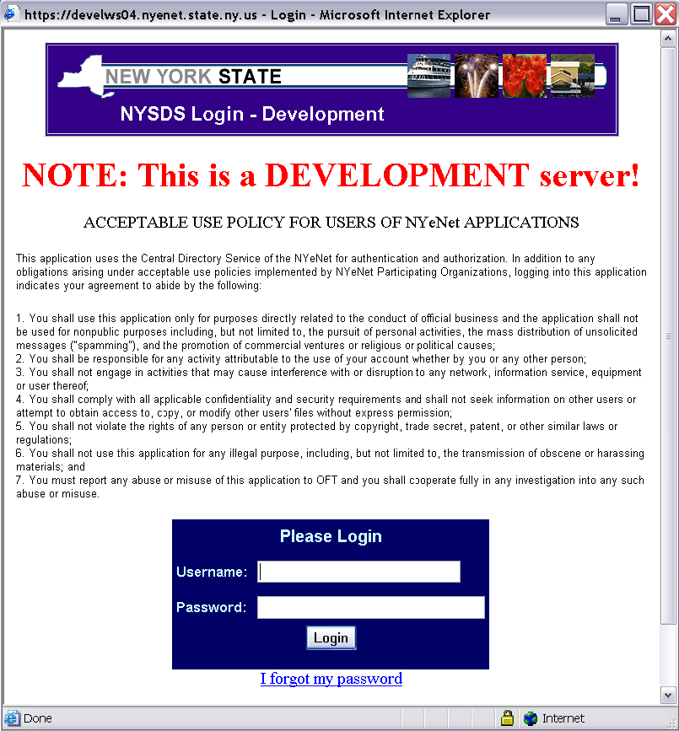

- Enter your username and password and click the Login button. Username is usually firstName.lastName (with a period between first and last names).

- If you are logging in for the first time, you may be asked to change your password and set up security questions. The questions will be used to reset your password in case you forget it. Password requirements are:
  - Must be at least 8 characters long; one of which must be a numeric character
  - Cannot be the same as your username or default password

- If you forget your password, click on the link labeled ‘I forgot my password’. You will need to answer your security question in order to reset the password.
How to fill out a Participation form

- Each year you will receive a Request for Participation email instructing you to login to the system and complete the participation form indicating how many grants you are willing to review for the next fiscal year.

- On the Reviewer Home page, click on the menu link labeled ‘Participation’. The screen will display your previous participation forms.

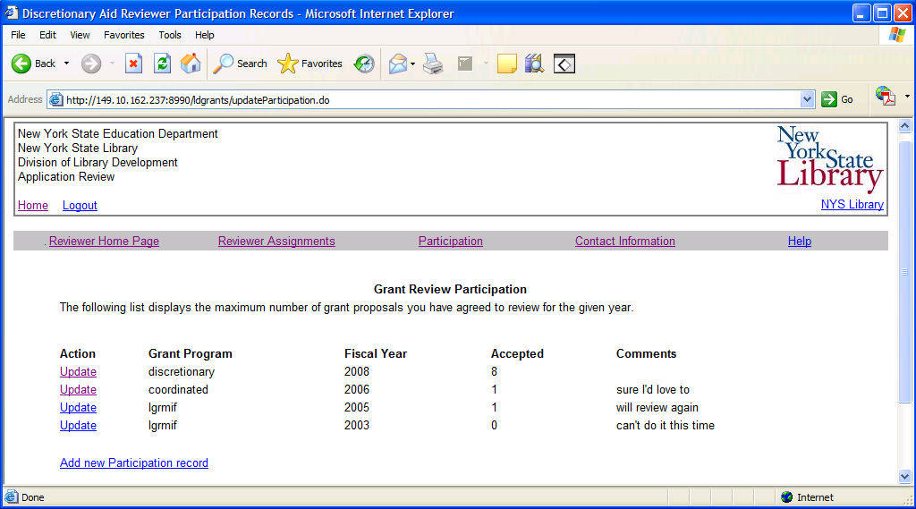

- To add a new Participation Form record, click the link labeled ‘Add new Participation record’. Enter the fiscal year, the grant program (C/P Coordinated or C/P Discretionary) and the maximum number of proposals you are able to review. If you cannot review for this fiscal year, enter a 0 in the space provided.

- Click the submit button to submit your participation form. If you will be reviewing more than one program for this fiscal year, then click the link ‘Add new Participation record’ to add another record for the next grant program.

- If you need to make corrections to a participation form that was submitted, click the link labeled ‘Update’ next to that participation record.
How to update a participation form

- From the Reviewer Home page, click on the link labeled ‘Participation’. The screen will display your previous participation forms.

- Click on the link ‘Update’ next to the participation record you need to change. The information about this participation record will be displayed, and you may add/edit the fields.

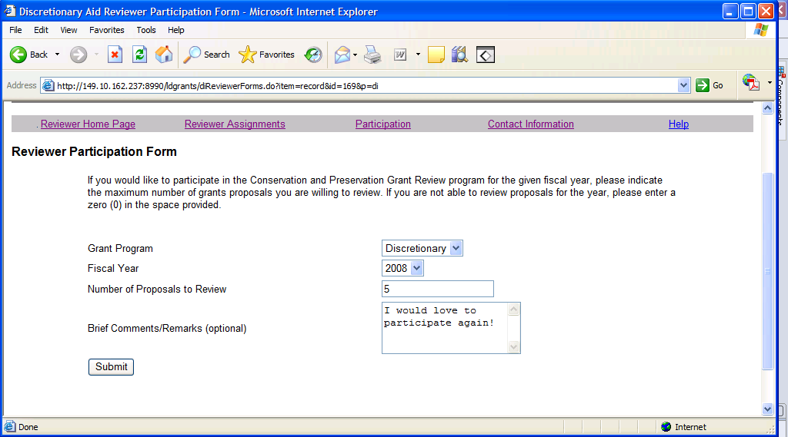

- The fiscal year, grant program, and maximum number of proposals to review are required fields. If you cannot review grant proposals for this fiscal year, enter a 0 in the space provided. Click the submit button to save the participation form.

How to update your contact information

- It is very important to keep your contact information up to date, as you will be receiving notifications to the email address and mailing address you provide.

- On the Reviewer home page, click on the menu link labeled ‘Update contact information’.

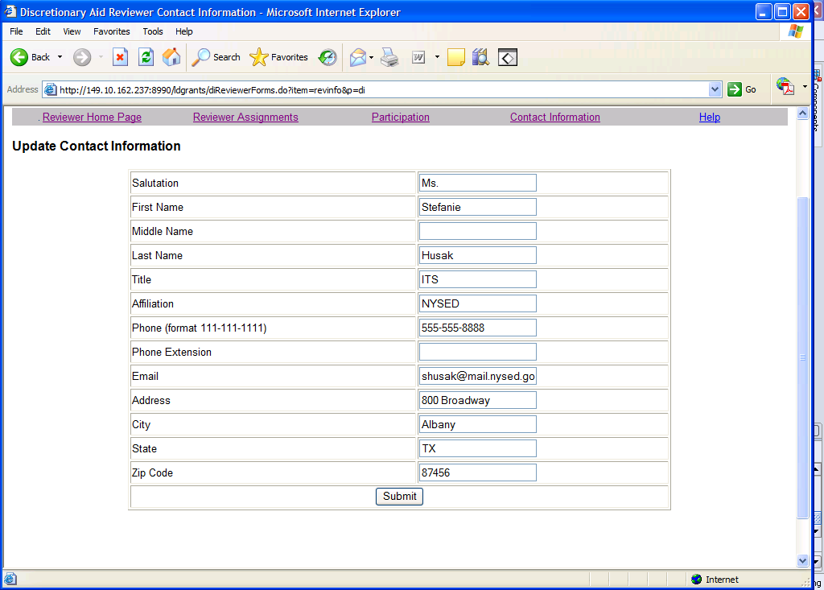

- If any of the fields are incorrect, enter the updated data. The email address is a required field, as the system will send notifications to the email address.

- Click the Submit button to save any changes.
How to view grants assigned to you

- If you completed a participation form for the fiscal year, the Conservation/Preservation Program Officer will assign reviewers to each submitted grant proposal. You will then receive an email with the grant proposal numbers you have been assigned.

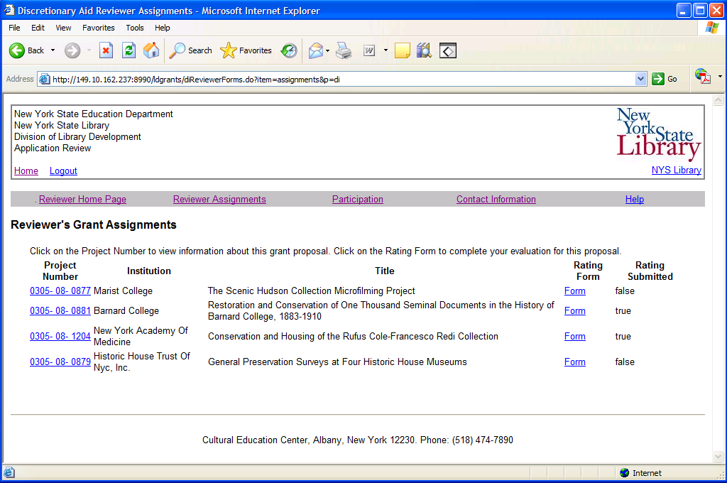

- On the Reviewer home page, click the menu link labeled ‘Reviewer Assignments’ to see a listing of all grant proposals that you have been assigned.

- To fill out an electronic rating form and comments, click on the link ‘Rating Form’ next to the corresponding grant proposal.

- To view the application information for a particular proposal, such as the budget or narratives, click on the project number link of the corresponding grant proposal.

- The column labeled ‘Rating Submitted’ will have a ‘Y’ if the rating form has been submitted to the Conservation/Preservation Program Office. You cannot update a rating form that has been submitted.

Reviewer Ratings – How to view the grant proposal

- On the Reviewer Home page, click on the menu link labeled ‘Reviewer Assignments’. Click on the project number link for the grant proposal you wish to view.

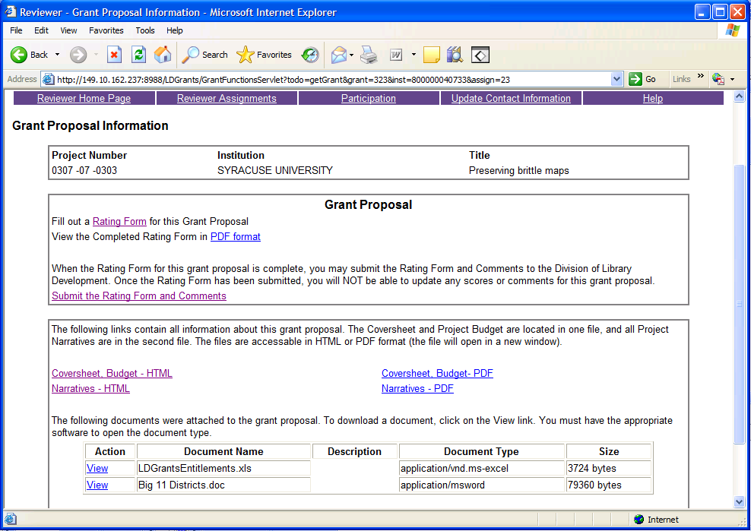

- The Grant Proposal Information page has links to complete and submit the Rating Form for this proposal, and view a PDF version of the Rating Form.

- The bottom section has HTML and PDF links to the three parts of the grant application: the Coversheet, Project Budget, and Project Narratives.

- There are also links to download documents that were attached to the grant application. Click the link labeled ‘View’ to open or save the document. The document type column will contain information on the type of document that was attached, such as Microsoft Word, Excel, etc. You must have the appropriate software in order to open the document type.
How to fill out a Rating Form/Comments

- On the Reviewer Assignments page, click on the link labeled ‘Rating Form’ to fill out the form for the corresponding grant proposal. You can also access the form from a link on the Grant Proposal Information page.

- Enter your score for each evaluation category. Coordinated proposals are based on a scale of 0-5, with 5 being the best score. Discretionary proposals are based on a scale of 0-3, with 3 being the best score. If a rating factor does not apply to this proposal, enter a zero in the box. You cannot enter ‘N/A’ in any of the boxes.

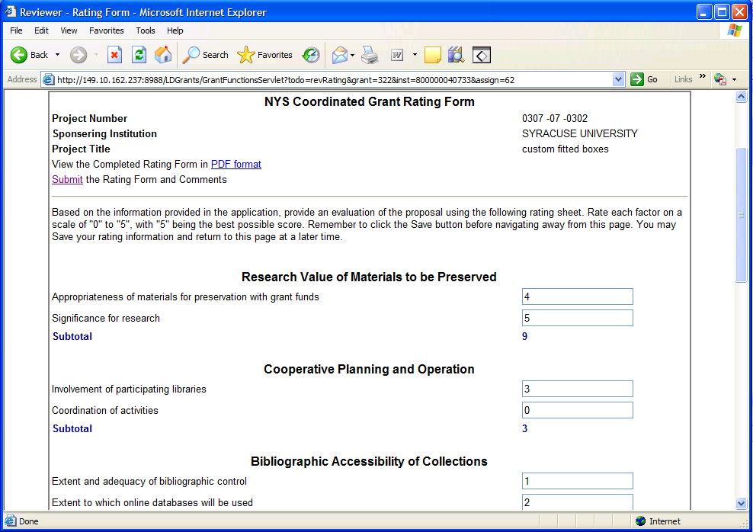

- The bottom of the Rating Form has a section for optional comments. These comments will be available to the Conservation/Preservation Program Officer and the applicant.

- Remember to click the Save button to save your ratings and comments before navigating away from this page. The totals for each category will be updated when you click Save. You can save your work and return to the form at a later date. But you cannot update a submitted Rating Form.
How to submit a Rating Form

- On the Reviewer Assignments Page click on the project number link of the grant proposal you need to submit. On the Grant Proposal Information page click the link ‘Submit the Rating Form and Comments’.

- You cannot update the Rating Form or comments after they are submitted. Click the button to confirm you want to submit the Rating Form.

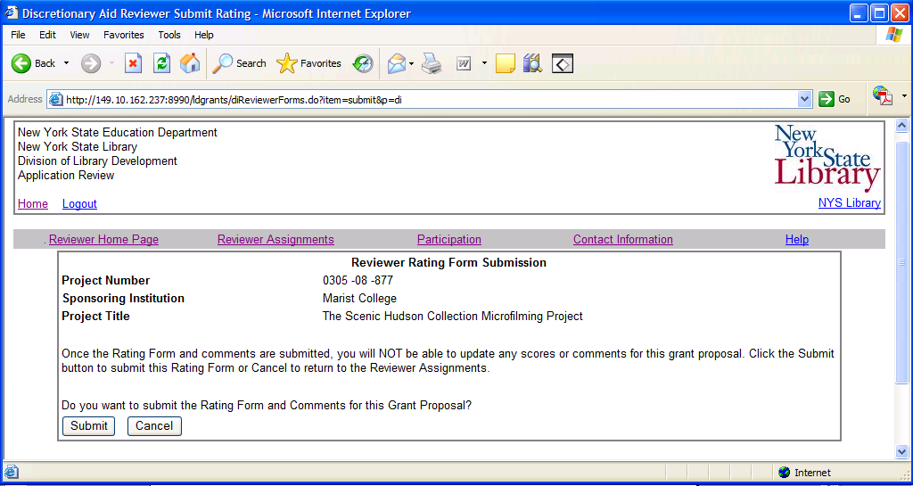

- You will receive an email from the system confirming that the Rating Form was received by the Conservation/Preservation Program Office. Please be sure your email address is current. You can update your contact information using the top menu link labeled ‘Update Contact Information’.

How to access documents regarding grant program

- The Reviewer Home Page and the Help page both contain links to documents regarding the C/P Coordinated Aid and C/P Discretionary Aid grant programs.

- The Conservation/Preservation Coordinated Aid Guidelines and the Conservation/Preservation Discretionary Aid Guidelines document describe the grant program and eligible projects for funding.

- The C/P Coordinated and Discretionary Rating Form document is a blank version of the Rating Form listing each of the rating factors and categories. You can print this out and write in scores as you review the grant proposal, then just type in the scores on the online Rating Form.

- The Reviewer Memo document contains information about changes to the grant program for this fiscal year, and any other relevant information for reviewing the proposals.

- The Help page also has a link to a Division of Library Development Online Grant System help manual. The manual has instructions and screenshots for reviewer pages.

How to get additional help

- For instructions on using the Division of Library Development Online Grant System, consult the Reviewer user manual on the Help page, or any of the other attached documents.

- If you have a question regarding the Coordinated Aid grant program, the Discretionary Aid grant program, the review process, types of eligible funding, etc. please contact the Conservation/Preservation Program Officer Barbara Lilley at barbara.lilley@nysed.gov

- If you need to report an error message, issue, or question regarding the Online Grant System, contact the system administrator at LibDevGrants@nysed.gov . Please include a description of which page you are viewing, the complete error message, or a screenshot of the page in question. To get a screenshot of the page, hold the Ctrl key and press Print Screen on your keyboard. Then just paste the image into Microsoft Word and send as an email attachment.

