**Task 1**

Create an RDS instance in your AWS account and upload the data to the RDS instance.

1. **Creating SQL Table to store NY Taxi Trip Details**

Creating a table in RDS instance.

Table name is ***ny_taxi_log***.

rowid is primary key of table and it is auto incremented.

To create a table code is present below:

CREATE TABLE ny_taxi_log

( rowid INT AUTO_INCREMENT PRIMARY KEY,

vendorid INT,

tpep_pickup_datetime TIMESTAMP,

tpep_dropoff_datetime TIMESTAMP,

passenger_count INT,

trip_distance DECIMAL(10,2),

ratecodeid INT,

store_and_fwd_flag CHAR(1),

pulocationid INT,

dolocationid INT,

payment_type INT,

fare_amount DOUBLE,

extra DOUBLE,

mta_tax DOUBLE,

tip_amount DOUBLE,

tolls_amount DOUBLE,

improvement_surcharge DOUBLE,

total_amount DOUBLE,

congestion_surcharge DOUBLE,

airport_fee DOUBLE);

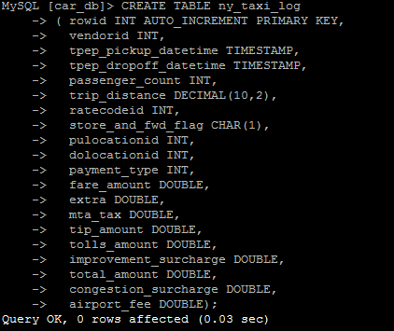

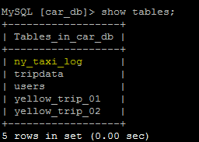

1. **Load data from csv files to SQL Table:**

**2.1 Load yellow_tripdata_2017-01.csv**

LOAD DATA LOCAL INFILE '/home/hadoop/dataset/yellow_tripdata_2017-01.csv'

INTO TABLE ny_taxi_log

FIELDS TERMINATED BY ','

LINES TERMINATED BY '\n'

IGNORE 1 LINES

(vendorid,tpep_pickup_datetime,tpep_dropoff_datetime,passenger_count,trip_distance,ratecodeid,store_and_fwd_flag,pulocationid,dolocationid,payment_type,fare_amount,extra,mta_tax,tip_amount,tolls_amount,improvement_surcharge,total_amount,congestion_surcharge,airport_fee);

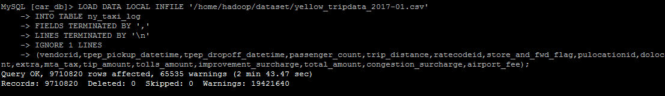

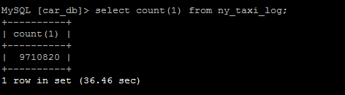

* 1. **Load yellow_tripdata_2017-02.csv**

LOAD DATA LOCAL INFILE '/home/hadoop/dataset/yellow_tripdata_2017-02.csv'

INTO TABLE ny_taxi_log

FIELDS TERMINATED BY ','

LINES TERMINATED BY '\n'

IGNORE 1 LINES

(vendorid,tpep_pickup_datetime,tpep_dropoff_datetime,passenger_count,trip_distance,ratecodeid,store_and_fwd_flag,pulocationid,dolocationid,payment_type,fare_amount,extra,mta_tax,tip_amount,tolls_amount,improvement_surcharge,total_amount,congestion_surcharge,airport_fee);

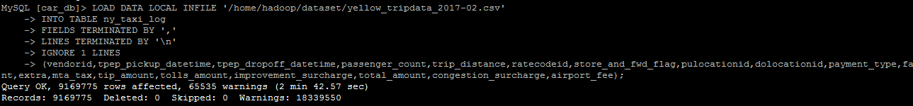

* 1. **Check Records in table after data load**

Total **18880595** records are present in table.

**2.3.1 Select 5 rows from table**

SELECT * FROM ny_taxi_log LIMIT 5;

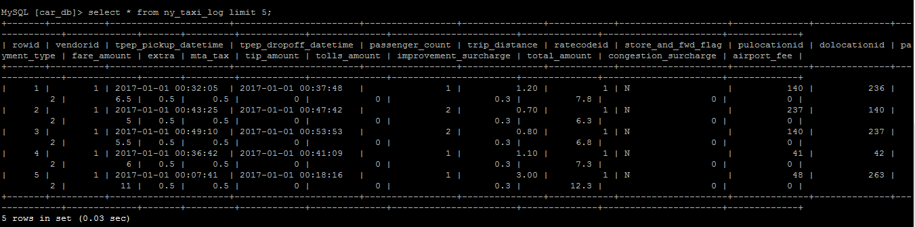

**2.3.2 Total table records count :**

SELECT COUNT(1) FROM ny_taxi_log;

