- Which vendors have the most trips, and what is the total revenue generated by that vendor?

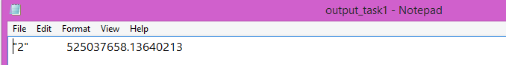

- Which pickup location generates the most revenue?

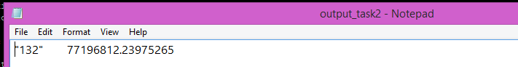

- What are the different payment types used by customers and their count? The final results should be in a sorted format.

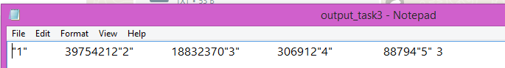

- What is the average trip time for different pickup locations?

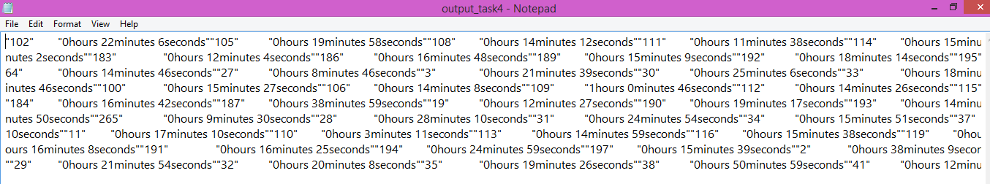

- Calculate the average tips to revenue ratio of the drivers for different pickup locations in sorted format.

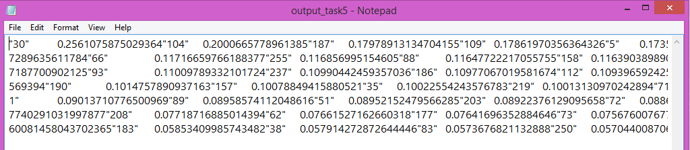

- How does revenue vary over time? Calculate the average trip revenue per month - analysing it by hour of the day (day vs night) and the day of the week (weekday vs weekend).
