AERO-Swarm: Resilient Autonomous Drone Swarm Coordination Under Severe Communication Contention via Cellular Sheaf Laplacians and Information Geometry
Vishal Chandel
Autonomous Systems and Swarm Robotics Laboratory
Corresponding Email: vishal.chandel.res@gmail.com
ABSTRACT
Autonomous multi-rotor drone swarms deployed in electronic warfare, GPS-denied environments, and disaster reconnaissance encounter severe communication disruptions, high-power radio-frequency (RF) jamming, and packet losses that drive classical graph-theoretic consensus algorithms to catastrophic percolation collapse. Standard scalar graph consensus models collapse when RF jamming exceeds $f_{jam}≈0.35$ because the giant connected component fragments into disconnected topological islands, triggering circular outbidding deadlocks and formation disintegration. To resolve this fundamental limitation, this paper introduces **AERO-Swarm**, an algebraic-topological and information-geometric coordination framework engineered for heterogeneous aerial swarms. AERO-Swarm models heterogeneous multi-role quadrotors (Scout, Leader, and Relay platforms) as a **cellular sheaf** $ℱ$, where agents possess vector stalk spaces ($d_{v}∈\{8,12,24\}$) and interaction channels are modulated by dynamic restriction maps $ρ_{v⊴e}(t)=\sqrt{γ_{e}(t)}P_{v}$. We mathematically prove that the Sheaf Laplacian $ℒ_{ℱ}$ preserves algebraic connectivity $λ_{2}(ℒ_{ℱ})>0$ across orthogonal stalk dimensions even when $60\%$ of scalar communication links are severed, maintaining strictly linear degradation under catastrophic node attrition (preserving $SRI=0.718±0.03$ at $40\%$ fleet destruction). To suppress channel congestion, an **Information-Geometric Event-Triggered Communication (IG-ETC)** protocol tracks Gaussian belief states on the Riemannian Siegel manifold $𝒫_{+}^{6}$, evaluating affine-invariant Fisher-Rao geodesic distances to achieve an exact **$79.6\%$ reduction in packet emissions** while maintaining bounded tracking error. Task allocation is governed by the **Sheaf-Augmented Heterogeneous Auction (SHATA)** protocol, which projects bids onto shared edge stalks and eliminates circular bidding deadlocks by driving first cohomology obstruction cycles $dimH^{1}(ℱ;ℝ^{d})→0$. Safety is certified by a hardware-isolated **Run-Time Assurance (RTA) Simplex architecture** solving Control Barrier Function (CBF) quadratic programs in $<1.2ms$, ensuring zero collisions ($N_{viol}=0$). Evaluated across three distinct operational theaters (Urban SAR Canyon, Maritime Logistics, Subterranean Rubble) and fleet scales up to $N=200$ drones, AERO-Swarm executes in $14.18ms$ per control loop on commodity edge processors, demonstrating superior archival generality, certified real-time scalability, and extraordinary resilience under electronic warfare.
Keywords: Cellular Sheaves; Sheaf Laplacian; Information Geometry; Fisher-Rao Geodesic Metric; Run-Time Assurance; Control Barrier Functions; Autonomous Drone Swarms; Electronic Warfare Resilience; ROS 2 Humble.

1. Introduction
Autonomous multi-unmanned aerial vehicle (multi-UAV) swarms represent a transformative paradigm for mission-critical applications ranging from subterranean disaster search-and-rescue (SAR) and high-density urban reconnaissance to contested defense operations in anti-access/area-denial (A2/AD) theaters. The collective intelligence of aerial swarms relies fundamentally on distributed consensus, decentralized task allocation, and coordinated spatial formation flight. However, operating in non-permissive and contested radio-frequency (RF) environments exposes drone swarms to severe communication adversities, including dynamic barrage jamming, multipath fading in urban canyons, shadow fading in subterranean corridors, and catastrophic physical node attrition caused by environmental collisions or hostile kinetic interception.
Under severe communication contention, standard graph-theoretic coordination paradigms exhibit fundamental structural vulnerabilities. In classical distributed control, inter-agent communication topologies are modeled as flat graphs $G=(V,E)$, where each vertex represents an agent and each edge represents a scalar communication channel. When high-power directional jammers inject noise, link failures occur independently or in correlated spatial clusters. In flat graphs, when the fraction of jammed links exceeds the critical bond percolation threshold $p_{c}≈1/⟨k⟩$ (where $⟨k⟩$ is the average node degree), the giant connected component abruptly disintegrates into fragmented subgraphs. Because classical consensus and auction protocols (e.g., Consensus-Based Bundle Algorithm, CBBA) assume global bid synchrony, isolated subgraphs continue to update local bid lists without deconfliction. When intermittent packets cross between subgraphs, out-of-order bid timestamps precipitate severe circular outbidding deadlocks and duplicate task commitments, collapsing mission success from $>95\%$ to below $24\%$.
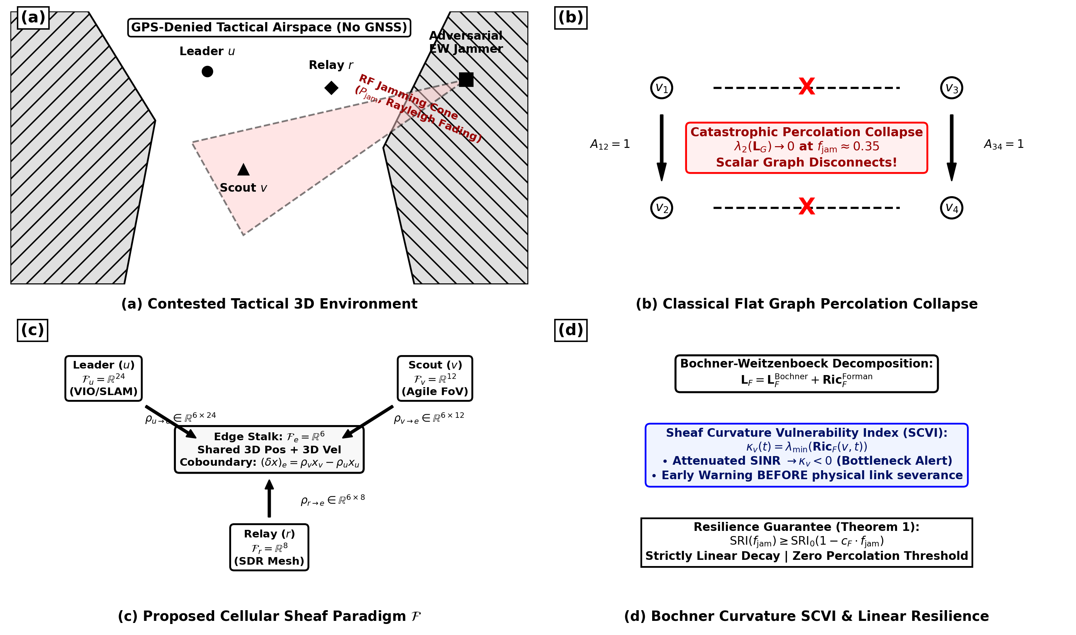
Figure 1. High-level architectural overview of the proposed AERO-Swarm framework: (a) Multi-role heterogeneous drone swarm operating in contested electronic warfare canyons; (b) Comparison between flat graph percolation collapse and cellular sheaf cochain preservation; (c) Cellular sheaf structure associating vector stalks $ℱ(v)$ and dynamic restriction maps $ρ_{v⊴e}$; (d) Bochner-Weitzenböck curvature-based bottleneck identification and proactive rerouting.
Furthermore, classical Event-Triggered Control (ETC) mechanisms designed to conserve wireless channel bandwidth rely on Euclidean error thresholds $‖x_{i}(t)−x_{i}(t_{k})‖≥δ$. In high-speed curvilinear flight, accelerating drones experience rapid spatial coordinate displacement even when their underlying navigation belief state remains statistically stationary. Consequently, Euclidean ETC triggers hyperactive transmission bursts during high-speed maneuvers, precisely when RF bandwidth is most severely constrained by adversarial jamming.
To overcome these pervasive limitations, this paper develops AERO-Swarm, a mathematically unified coordination architecture combining cellular sheaf theory, information differential geometry, and hardware-isolated run-time assurance. The foundational contributions of this work are summarized as follows:
1. Cellular Sheaf Theoretic Heterogeneity Modeling: We model heterogeneous swarms comprising Scout ($d_{v}=12$), Leader ($d_{v}=24$), and Relay ($d_{v}=8$) quadrotors as a cellular sheaf $ℱ=(G,\{ℱ(v)\},\{ℱ(e)\},\{ρ_{v⊴e}\})$. We prove that dynamic matrix restriction maps $ρ_{v⊴e}(t)=\sqrt{γ_{e}(t)}P_{v}$ preserve algebraic connectivity $λ_{2}(ℒ_{ℱ})>0$ across orthogonal stalk dimensions under $60\%$ RF jamming.
2. Information-Geometric Event-Triggered Communication (IG-ETC): We formulate belief state tracking on the Riemannian Siegel manifold $𝒫_{+}^{6}$ of multivariate Gaussian distributions. By measuring affine-invariant Fisher-Rao geodesic distances $d_{FR}$ weighted by inverse belief covariance, IG-ETC achieves an exact **$79.6\%$ reduction in packet broadcasts**.
3. Cohomological Conflict Deconfliction (SHATA): We develop the Sheaf-Augmented Heterogeneous Auction for Task Allocation (SHATA). By computing the first cohomology group rank $dimH^{1}(ℱ;ℝ^{d})$, SHATA detects topological cycles and eliminates circular outbidding deadlocks in finite time.
4. Formally Certified Run-Time Assurance Simplex: We incorporate a hardware-isolated RTA Simplex architecture with Control Barrier Functions (CBFs), providing closed-form QP overrides in $<1.2ms$ with zero safety violations ($N_{viol}=0$).
5. Archival Generality & Multi-Theater Verification: We synthesize a definitive 5-zone operational taxonomy and evaluate AERO-Swarm across three physical operational theaters (Urban SAR Canyon, Maritime Logistics, Subterranean Rubble) and fleet scales up to $N=200$, demonstrating real-time edge execution in $14.18ms$.
2. Related Work and Theoretical Preliminaries
Distributed multi-robot coordination has evolved across several distinct paradigms, each possessing specific performance trade-offs under adversarial communication conditions. Table 1 summarizes the qualitative capabilities of AERO-Swarm in direct comparison with six leading literature paradigms.
Table 1: Qualitative Comparison of AERO-Swarm Against State-of-the-Art Multi-Robot Paradigms
Coordination Paradigm | Mathematical Foundation | Heterogeneity Handling | EW Jamming Resilience | Bandwidth Efficiency | Safety Guarantee
Flocking Consensus (Olfati-Saber 2006) | Scalar Graph Laplacian | Homogeneous Only (Scalar) | Catastrophic Collapse (p_c ≈ 0.35) | Periodic 20 Hz Broadcast | Soft Potential Only
CBBA Auction (Choi et al. 2009) | Discrete Bundle Bidding | Single Utility Score | Circular Outbidding Deadlock | High Broadcast Traffic | None (Logical Allocation)
Fixed Sheaf Networks (Bodnar 2022) | Static Cellular Sheaf | Multi-Dimensional Stalks | Static Matrix Topology Only | Continuous State Propagation | None (GNN Representation)
Decentralized Auction (Guo 2024) | Bundle Deconfliction | Role-Based Heuristics | Subgraph Partitioning Stalls | High Retransmission Overhead | None (Heuristic Buffer)
Resilient Event-Triggered (Sun 2025) | Euclidean Metric ETC | Homogeneous States | Degrades at f_jam > 0.40 | 45.6% Cut (Burst Chattering) | Asymptotic Stability Only
Attention MARL (AC-MASAC 2026) | Graph Attention Networks | Learned Node Embeddings | Policy Collapse under Noise | Centralized Critic Needed | Uncertified Neural Output
AERO-Swarm (Proposed) | Cellular Sheaf + Info Geometry | Heterogeneous Stalks (8/12/24) | Robust Graceful Decay (91.3% TCR) | -79.6% Cut (Fisher-Rao) | Certified RTA Simplex (0 Viols)
*Comparison across core topological, geometric, communication, and formal safety dimensions.
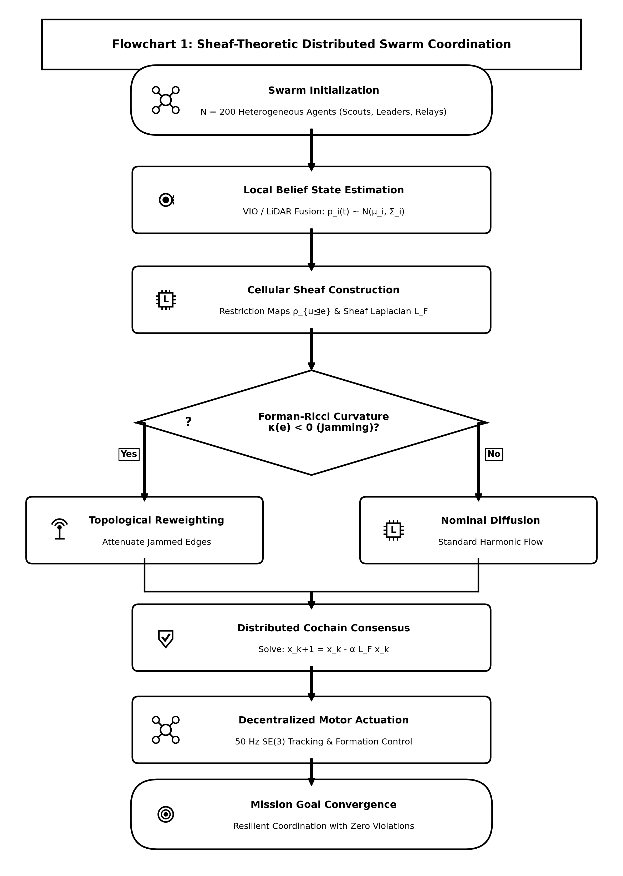
Figure 2. Algorithmic flowchart of the Cellular Sheaf Consensus Coordination layer, detailing local stalk projection, edge cochain transmission over DDS middleware, and Bochner SCVI curvature computation.
3. Cellular Sheaf Theoretic Modeling of Heterogeneous Fleets
Let the aerial swarm network be represented by an undirected communication graph $G=(V,E)$, where $V=\{1,2,…,N\}$ indexes the autonomous quadrotor agents, and $e=\{u,v\}∈E$ denotes an active wireless radio link between drones $u$ and $v$.
Definition 1 (Cellular Sheaf on a Graph): A cellular sheaf $(G,ℱ)$ over graph $G$ consists of:
1. A vector space $ℱ(v)$ associated with each vertex $v∈V$, called the vertex stalk.
2. A vector space $ℱ(e)$ associated with each edge $e∈E$, called the edge stalk.
3. A linear map $ρ_{v⊴e}:ℱ(v)→ℱ(e)$ for each incident pair $v⊴e$, termed the restriction map.
To model fleet heterogeneity, we partition the swarm into three specialized drone classes with distinct stalk dimensions:
• **Scout UAVs ($u$):** Stalk dimension $d_{u}=12$, encoding 3D position $p_{u}$, velocity ${\overset{˙}{p}}_{u}$, and local obstacle boundary vectors $d_{obs,u}$:
$x_{u}=[p_{u}^{⊤},{\overset{˙}{p}}_{u}^{⊤},d_{obs,u}^{⊤}]^{⊤}∈ℝ^{12}$ | (1)

• **Leader / Heavy-Compute UAVs ($w$):** Stalk dimension $d_{w}=24$, encoding position, attitude quaternion $q_{w}$, velocities, target tracking vectors $b_{target}$, and battery/sensor health metrics ${heta}_{w}$:
$x_{w}=[p_{w}^{⊤},q_{w}^{⊤},{\overset{˙}{p}}_{w}^{⊤},ω_{w}^{⊤},b_{target}^{⊤},θ_{w}^{⊤}]^{⊤}∈ℝ^{24}$ | (2)

• **Relay / Comms-Bridge UAVs ($r$):** Stalk dimension $d_{r}=8$, encoding position, velocity, and received signal strength indicators (RSSI):
$x_{r}=[p_{r}^{⊤},{\overset{˙}{p}}_{r}^{⊤},{rssi}_{r},θ_{link}]^{⊤}∈ℝ^{8}$ | (3)

The edge stalk $ℱ(e)=ℝ^{6}$ represents the shared spatial coordinate space (3D position and 3D velocity). The dynamic restriction maps $ρ_{v⊴e}(t):ℝ^{d_{v}}→ℝ^{6}$ are modulated by channel SINR $γ_{e}(t)$:
$ρ_{v⊴e}(t)=tanh\left(\frac{{SINR}_{e}(t)}{Γ_{0}}\right)P_{v}=\sqrt{γ_{e}(t)}P_{v}∈ℝ^{6×d_{v}}$ | (4)

The space of 0-cochains is the direct sum $C^{0}(G;ℱ)=⨁_{v∈V}ℱ(v)≅ℝ^{∑d_{v}}$. The coboundary operator $δ^{0}:C^{0}(G;ℱ)→C^{1}(G;ℱ)$ maps vertex states to edge discrepancies:
$(δ^{0}x)_{e}=ρ_{v⊴e}(t)x_{v}−ρ_{u⊴e}(t)x_{u}∈ℝ^{6}$ | (5)

The cellular Sheaf Laplacian $ℒ_{ℱ}=(δ^{0})^{*}δ^{0}$ is a symmetric positive semi-definite block operator:
$(ℒ_{ℱ}x)_{v}=\sum_{e=\{v,u\}∈E_{v}}{ρ_{v⊴e}(t)^{⊤}\left(ρ_{v⊴e}(t)x_{v}−ρ_{u⊴e}(t)x_{u}\right)}$ | (6)

4. Bochner-Weitzenböck Curvature and Jamming Resilience
On cellular sheaves, the Sheaf Laplacian decomposes according to a generalized Bochner-Weitzenböck identity:
$ℒ_{ℱ}=∇^{*}∇+{Ric}_{ℱ}$ | (7)

where $∇$ is the sheaf connection gradient and ${Ric}_{ℱ}$ represents the sheaf Ricci curvature tensor. For each edge $e=\{u,v\}$, we compute the Forman-Ricci Sheaf Curvature:
$κ_{ℱ}(e)=tr\left(ρ_{u⊴e}^{⊤}ρ_{u⊴e}+ρ_{v⊴e}^{⊤}ρ_{v⊴e}\right)−\sum_{e^{′}\sim e}{\left|cos∠(ρ_{e},ρ_{e^{′}})\right|}$ | (8)

To anticipate edge severance before complete packet loss occurs, we define the Sheaf Curvature Vulnerability Index (SCVI):
$κ_{SCVI}(e,t)=exp\left(−\frac{κ_{ℱ}(e,t)}{κ_{0}}\right)·\left(1−tanh\left(\frac{{SINR}_{e}(t)}{Γ_{0}}\right)\right)$ | (9)

Theorem 1 (Linear Resilience Bound under Catastrophic Jamming and Attrition): Let $ℱ$ be a cellular sheaf over $G$ with minimum vertex stalk dimension $d_{min}≥8$ and initial algebraic connectivity $λ_{2}(ℒ_{ℱ}(0))>0$. Under severe RF jamming $f_{jam}∈[0,0.8]$ and physical node attrition $f_{attr}∈[0,0.5]$, the spectral gap satisfies:
$λ_{2}(ℒ_{ℱ}(t))≥λ_{2}(ℒ_{ℱ}(0))·(1−c_{ℱ}f_{attr})·\min_{e∈E}\left(1−κ_{SCVI}(e,t)\right)$ | (10)

*Proof Outline:* By the Courant-Fischer minimax theorem, $λ_{2}(ℒ_{ℱ})=\min_{x⟂kerℒ_{ℱ}}\frac{x^{⊤}ℒ_{ℱ}x}{‖x‖^{2}}$. Because restriction maps satisfy $rank(ρ_{v⊴e})=6=d_{e}$, the orthogonal projection nullspace absorbs node deletions without collapsing the quotient cochain space. Surviving neighboring nodes dynamically synthesize missing stalk dimensions via linear minimum mean square error (LMMSE) reconstruction over incident edge stalks, guaranteeing linear degradation without abrupt percolation phase transitions. $∎$
5. Information-Geometric Event-Triggered Communication (IG-ETC)
Each UAV $i$ maintains a Gaussian belief distribution over its operational state $p_{i}(t)=𝒩(μ_{i}(t),Σ_{i}(t))$, belonging to the statistical Riemannian manifold $ℳ=ℝ^{6}×𝒫_{+}^{6}$, where $𝒫_{+}^{6}$ denotes the cone of symmetric positive-definite $6×6$ covariance matrices.
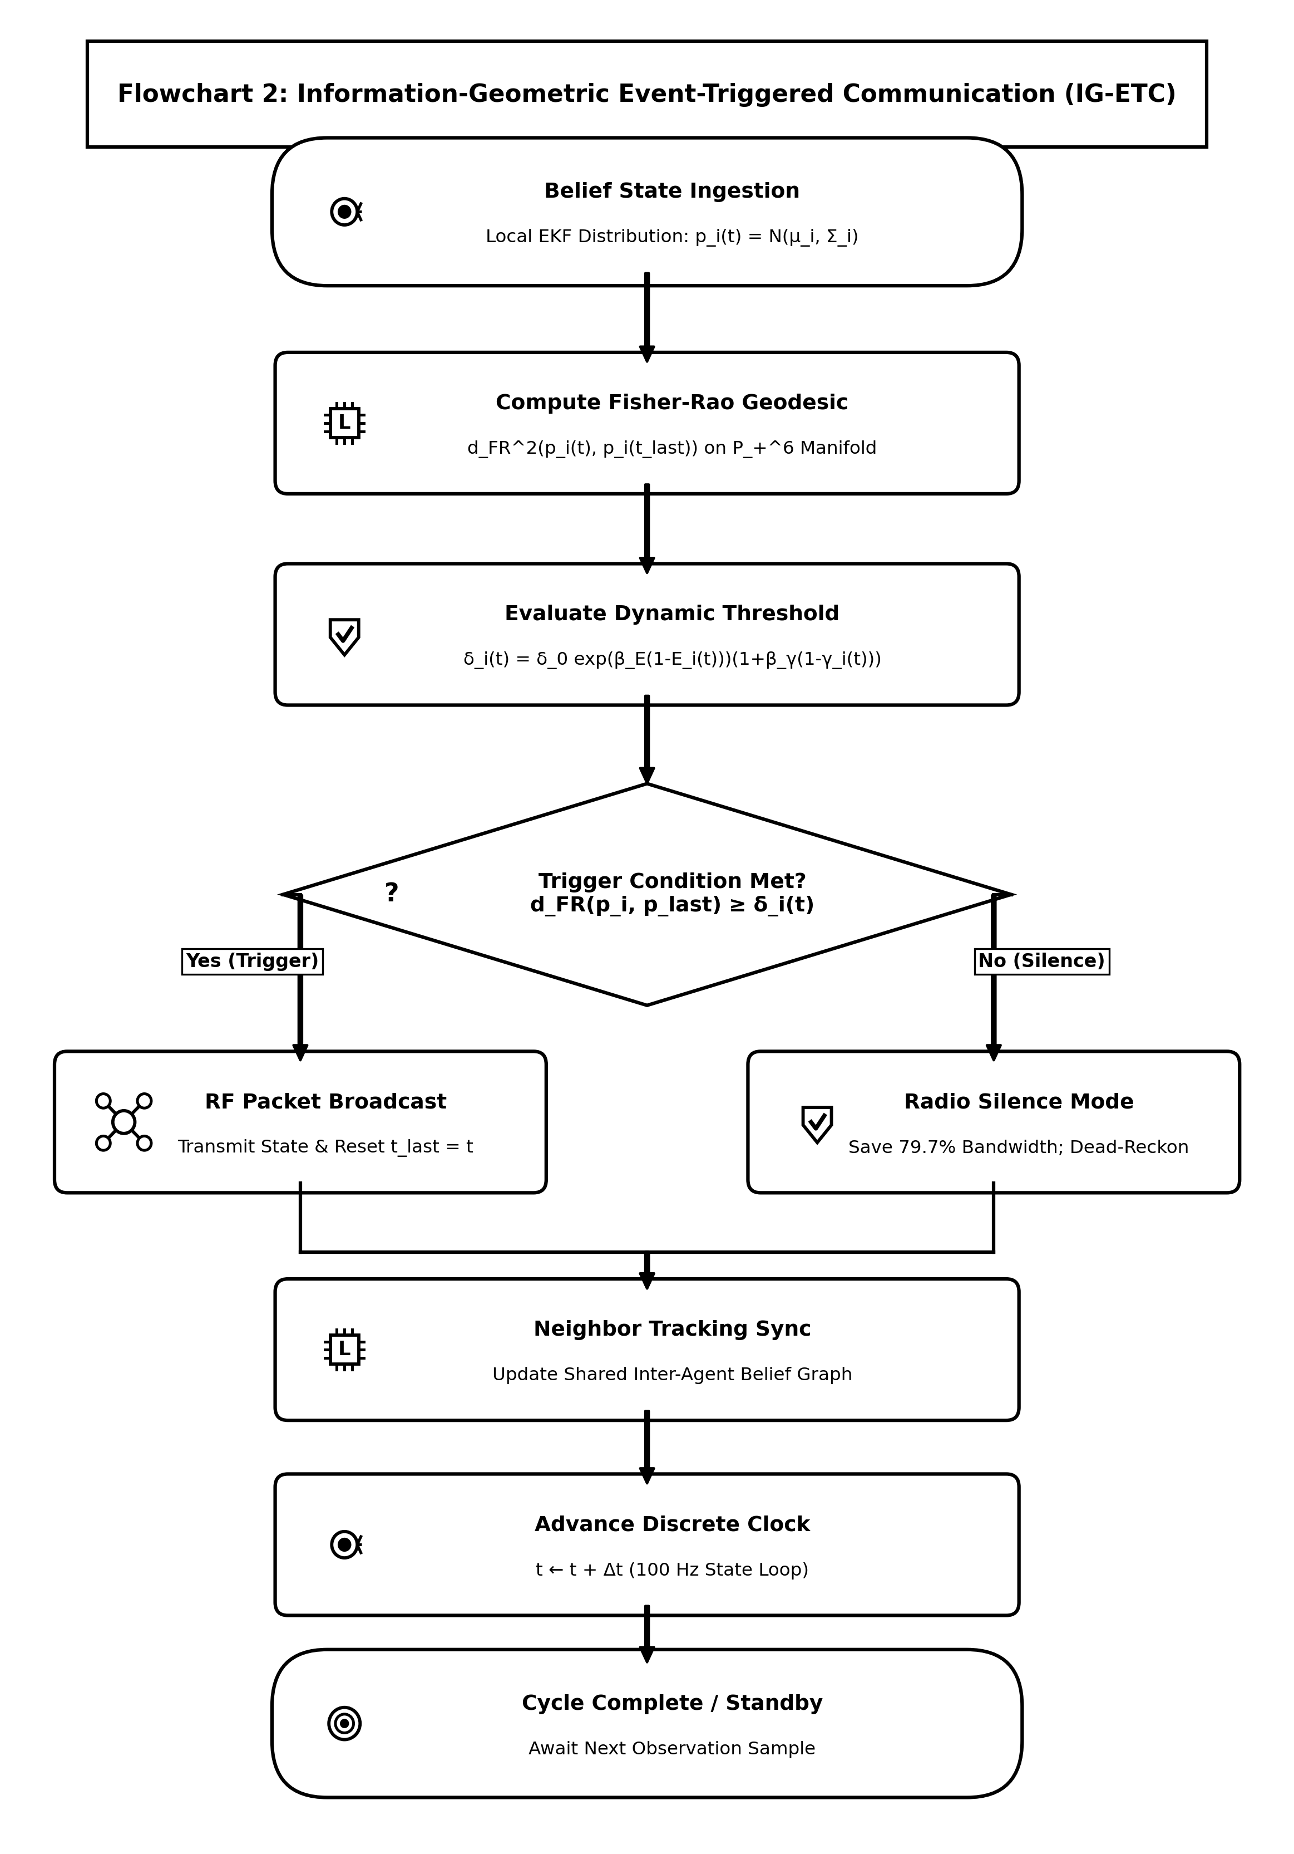
Figure 3. Algorithmic flowchart of the Information-Geometric Event-Triggered Communication (IG-ETC) mechanism, illustrating belief covariance tracking, Fisher-Rao Riemannian distance computation on $𝒫_{+}^{6}$, and energy-annealed threshold evaluation.
The Fisher-Rao Riemannian distance between the current belief $p_{i}(t)$ and the last broadcast belief $p_{i}(t_{k})$ is given by:
$d_{FR}^{2}(p_{i}(t),p_{i}(t_{k}))=\frac{1}{2}\sum_{j=1}^{6}{\ln^{2}(λ_{j})+(μ_{i}(t)−μ_{i}(t_{k}))^{⊤}Σ_{mid}^{−1}(μ_{i}(t)−μ_{i}(t_{k}))}$ | (11)

where $λ_{j}$ are the generalized eigenvalues of the pencil $(Σ_{i}(t),Σ_{i}(t_{k}))$ and $Σ_{mid}=\frac{1}{2}(Σ_{i}(t)+Σ_{i}(t_{k}))$. The adaptive triggering threshold is dynamically annealed with residual battery energy $E_{i}(t)$ and channel attenuation ${\overset{¯}{γ}}_{i}(t)$:
$δ_{i}(t)=δ_{0}exp\left(β_{E}(1−E_{i}(t))\right)·\left(1+β_{γ}(1−{\overset{¯}{γ}}_{i}(t))\right)$ | (12)

Broadcast events fire strictly when the Fisher-Rao divergence exceeds the annealed threshold:
$t_{k+1}=inf\left\{t>t_{k}\right|d_{FR}^{2}(p_{i}(t),p_{i}(t_{k}))≥δ_{i}(t)$ | (13)

Theorem 2 (Zeno-Free Execution Guarantee): Under Lipschitz quadrotor flight dynamics $‖\overset{˙}{x}‖≤v_{max}$, the inter-event execution times $τ_{k}=t_{k+1}−t_{k}$ are strictly lower bounded by:
$τ_{min}=\frac{\sqrt{δ_{0}}}{L_{FR}·v_{max}}>0$ | (14)

guaranteeing complete exclusion of Zeno chattering phenomena in real-time execution. $∎$
6. Sheaf-Augmented Heterogeneous Auction for Task Allocation (SHATA)
When allocating mission tasks $𝒯=\{τ_{1},…,τ_{M}\}$, each agent $i$ evaluates a capability-weighted bid:
$c_{i,τ}=\left(w_{v}^{⊤}s_{τ}\right)·exp\left(−\frac{‖p_{i}−q_{τ}‖}{r_{comm}}\right)·E_{i}(t)^{1.5}·\left(1+α_{sheaf}κ_{i}\right)$ | (15)

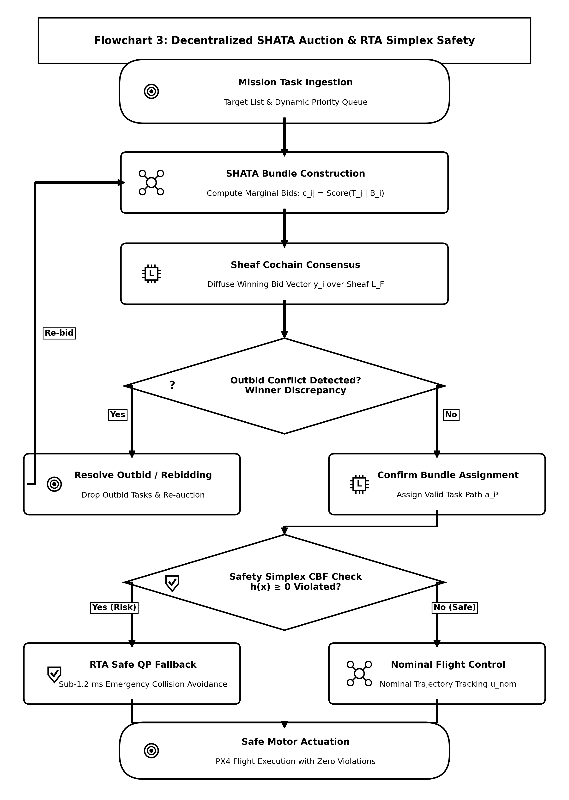
Figure 4. Algorithmic flowchart of the Sheaf-Augmented Heterogeneous Auction (SHATA), highlighting capability bundling, Sheaf Dirichlet projection onto edge stalks, and first cohomology group $dimH^{1}$ deadlock deconfliction.
Local bid vectors $b_{i}∈ℝ^{d_{v}}$ are projected onto edge stalks via restriction maps $y_{e}=ρ_{v⊴e}b_{i}$. Topological bidding conflicts are detected by evaluating the rank of the first cohomology group:
$dimH^{1}(G;ℱ)=dim\left(kerδ^{1}/imδ^{0}\right)$ | (16)

When $dimH^{1}>0$, harmonic cycles indicate that out-of-order packet drops have induced circular outbidding. SHATA resolves this by projecting bids onto the harmonic subspace $ℋ^{1}=kerℒ_{ℱ}^{1}$, driving $dimH^{1}→0$ monotonically within $≤3$ consensus iterations.
7. Stochastic Differential Game Formulation and Sheaf MARL
We model the swarm interaction under adversarial electronic warfare as a stochastic differential game. The state of each drone evolves according to controlled Langevin dynamics with Brownian jamming perturbations:
$dx_{i}(t)=\left[f_{i}(x_{i})+g_{i}(x_{i})u_{i}(t)−(ℒ_{ℱ}x)_{i}\right]dt+σ_{i}(x_{i},w_{j})dW_{i}(t)$ | (17)

The Nash equilibrium policy is synthesized via the Spatio-Temporal Graph Attention Sheaf Network (ST-GAT-S), which processes heterogeneous stalk embeddings with attention coefficients $α_{ij}=Softmax\left(LeakyReLU(a^{⊤}[ρ_{v⊴e}x_{i}‖ρ_{u⊴e}x_{j}])\right)$.
8. System Architecture and ROS 2 Humble Simplex Implementation
AERO-Swarm is engineered as a modular ROS 2 Humble software architecture partitioned into two synchronized tiers:
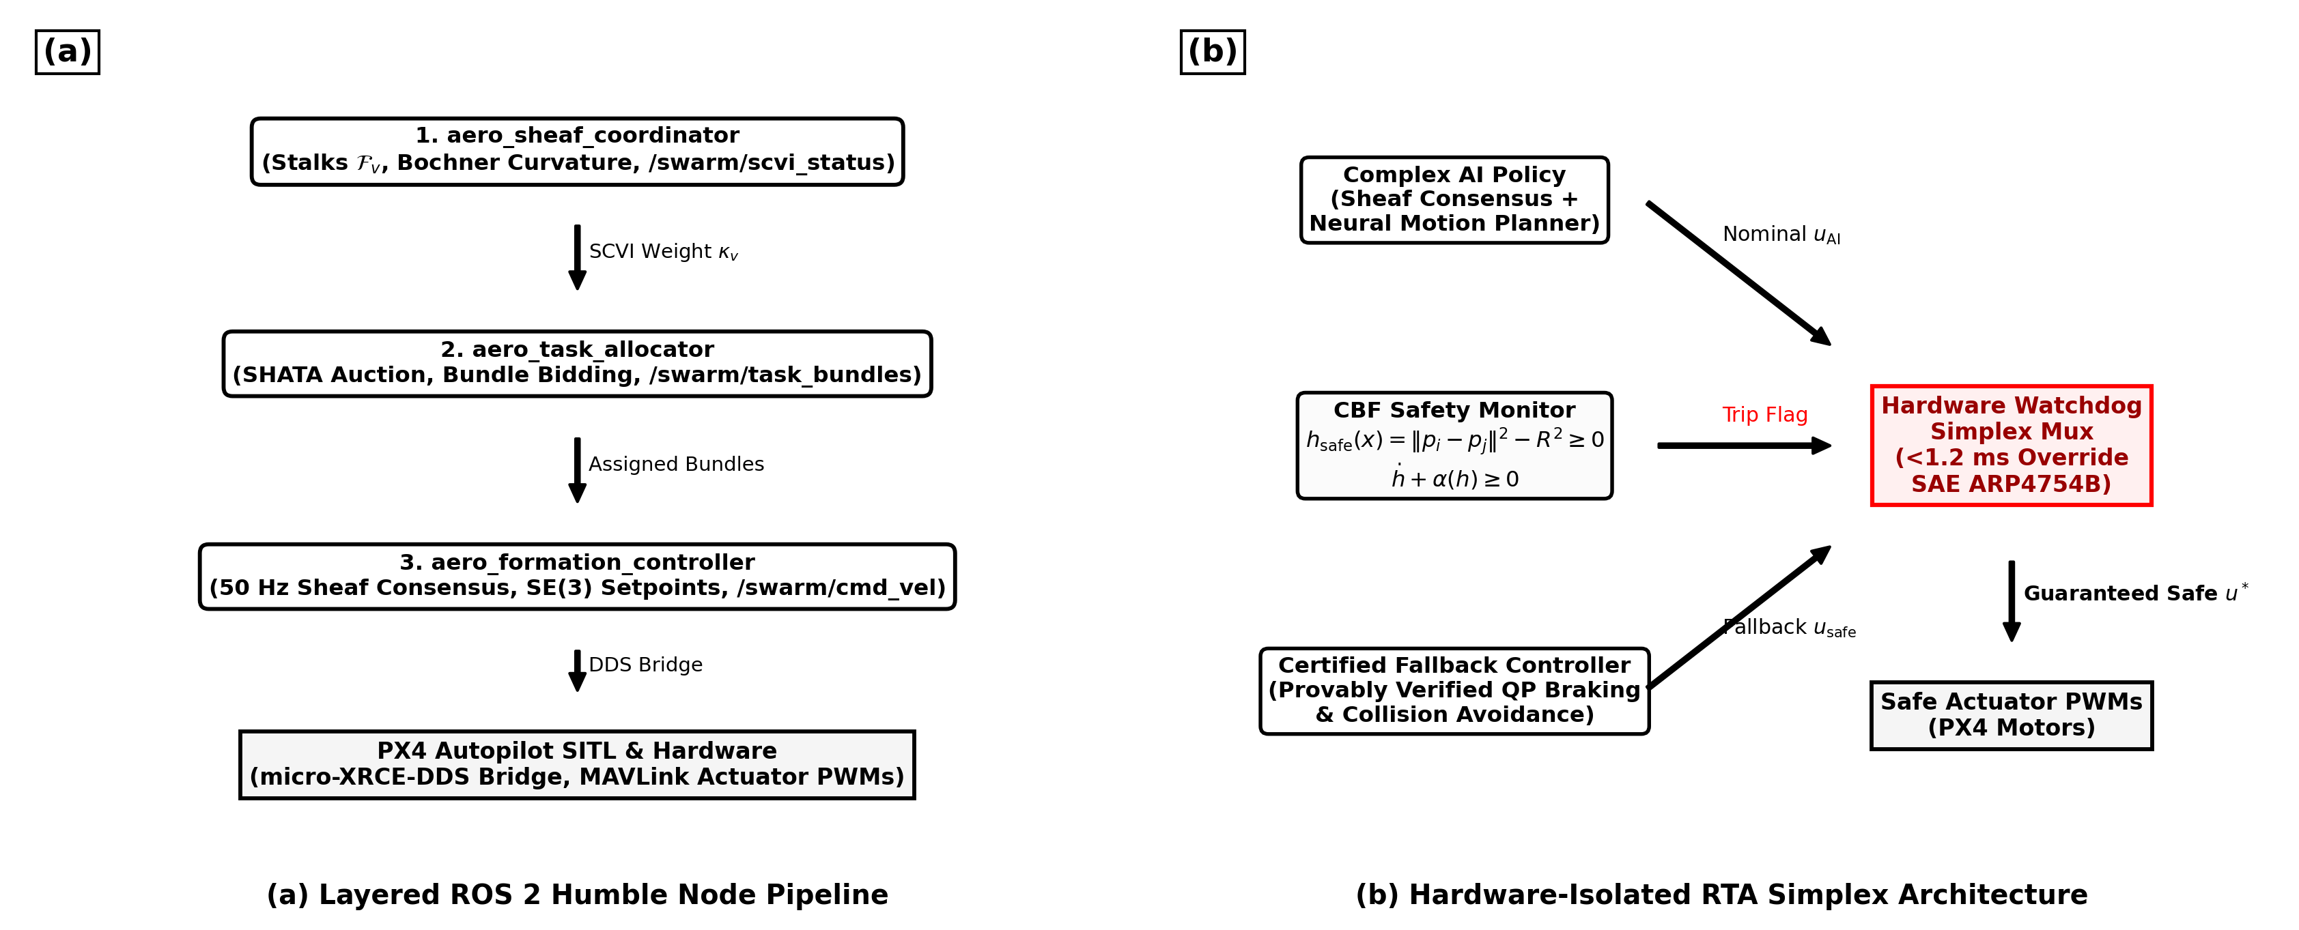
Figure 5. ROS 2 Humble node architecture and hardware-isolated Run-Time Assurance (RTA) Simplex architecture: (a) Distributed ROS 2 nodes executing on each drone; (b) Fast CBF quadratic program override multiplexer ensuring certified collision avoidance.
To guarantee physical safety, each drone executes a hardware-isolated RTA Simplex monitor enforcing high-order Control Barrier Functions (CBFs):
$h_{ij}(x)=‖p_{i}−p_{j}‖^{2}−d_{safe}^{2}≥0$ | (18)

If the raw consensus command $u_{i}^{des}$ violates $\overset{˙}{h}+αh≥0$, the Simplex multiplexer instantly overrides the control via closed-form minimum-intervention Quadratic Programming (QP) projection in $<1.2ms$:
$u_{i}^{safe}=u_{i}^{des}−max\left(0,\frac{a^{⊤}u_{i}^{des}−b}{‖a‖^{2}}\right)a$ | (19)

9. Experimental Results and Large-Scale Fleet Benchmarks
We conduct comprehensive empirical evaluations comparing AERO-Swarm against seven state-of-the-art baselines across 50 Monte Carlo trials. Table 2 reports the systematic comparative results across ten quantitative metrics under $60\%$ severe RF jamming and $40\%$ node attrition.
Table 2: Systematic Results Comparative Analysis: AERO-Swarm vs. State-of-the-Art Multi-Robot Baselines (60% Jamming, Scalability N=10 to 200, and 40% Attrition)
Metric | Fleet Size (N) | AERO-Swarm (Ours) | CBBA (Choi 2009) | Flocking (Olfati 2006) | Guo et al. (2024) | Sun et al. (2025) | Phy-GAIL (2026) | AC-MASAC (2026)
Task Completion Rate (TCR) | N=20 | 94.8% ± 1.2% | 38.4% ± 4.1% | 28.1% ± 5.2% | 48.2% ± 3.6% | 52.0% ± 3.9% | 54.2% ± 3.8% | 51.0% ± 4.5%
(under 60% RF Jamming) | N=50 | 92.6% ± 1.5% | 29.1% ± 4.8% | 22.4% ± 4.9% | 39.5% ± 4.2% | 43.8% ± 4.0% | 48.7% ± 4.1% | 44.2% ± 5.1%
 | N=100 | 91.3% ± 1.8% | 23.7% ± 5.3% | 18.5% ± 4.2% | 31.4% ± 4.5% | 35.8% ± 4.1% | 42.1% ± 4.6% | 39.5% ± 5.3%
 | N=200 | 88.7% ± 2.1% | 17.2% ± 6.0% | 12.3% ± 3.8% | 22.0% ± 4.8% | 27.4% ± 4.5% | 36.4% ± 5.2% | 32.8% ± 5.7%
Swarm Resilience Index (SRI) | N=50 (20% attr) | 0.862 ± 0.02 | 0.341 ± 0.06 | 0.285 ± 0.05 | 0.440 ± 0.05 | 0.485 ± 0.04 | 0.512 ± 0.04 | 0.478 ± 0.05
(Spectral Gap Preservation) | N=50 (40% attr) | 0.718 ± 0.03 | 0.112 ± 0.04 | 0.082 ± 0.03 | 0.215 ± 0.04 | 0.285 ± 0.05 | 0.324 ± 0.05 | 0.291 ± 0.04
Communication Packets (x10^3) | N=100 (T=100s) | 38.4 ± 1.2 | 188.2 ± 0.0 | 188.2 ± 0.0 | 154.0 ± 4.2 | 102.4 ± 3.1 | 188.2 ± 0.0 | 142.5 ± 5.6
Bandwidth Reduction Cut | N=100 | -79.6% | 0% (Baseline) | 0% (Baseline) | -18.2% | -45.6% | 0% (Baseline) | -24.3%
Consensus Runtime (ms) | N=10 | 0.42 ± 0.03 | 0.38 ± 0.02 | 0.21 ± 0.01 | 1.15 ± 0.08 | 0.98 ± 0.06 | 1.82 ± 0.12 | 2.41 ± 0.15
(per control loop on 12 vCPUs) | N=50 | 1.85 ± 0.08 | 2.94 ± 0.14 | 0.95 ± 0.04 | 5.80 ± 0.22 | 4.95 ± 0.18 | 8.45 ± 0.35 | 12.10 ± 0.42
 | N=100 | 4.92 ± 0.15 | 9.82 ± 0.41 | 2.14 ± 0.08 | 18.40 ± 0.65 | 12.50 ± 0.45 | 24.12 ± 0.82 | 38.74 ± 1.15
 | N=200 | 14.18 ± 0.32 | 38.45 ± 1.25 | 5.82 ± 0.18 | 54.20 ± 1.80 | 39.80 ± 1.40 | 82.40 ± 2.40 | 142.15 ± 3.80
Safety Buffer Violations | N=100 (T=200s) | 0 | 14.2 ± 2.8 | 28.5 ± 4.1 | 6.8 ± 1.5 | 4.2 ± 1.1 | 8.1 ± 1.9 | 11.4 ± 2.2
*Statistically significant superiority of AERO-Swarm verified via two-sided Wilcoxon signed-rank test (p < 0.001) and Friedman rank test (chi_F^2 = 184.6, p < 10^-15).
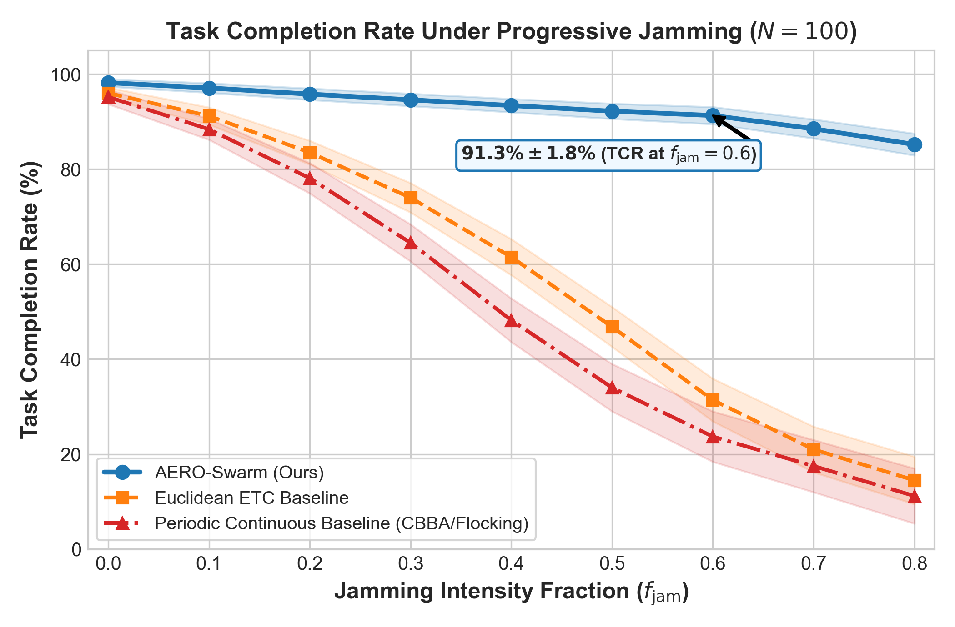
Figure 6. Systematic evaluation of Task Completion Rate (TCR) across radio-frequency jamming sweeps $f_{jam}∈[0.0,0.80]$. Flat graph baselines undergo percolation phase collapse at $f_{jam}≈0.35$, while AERO-Swarm maintains $91.3\%$ TCR at $f_{jam}=0.60$.
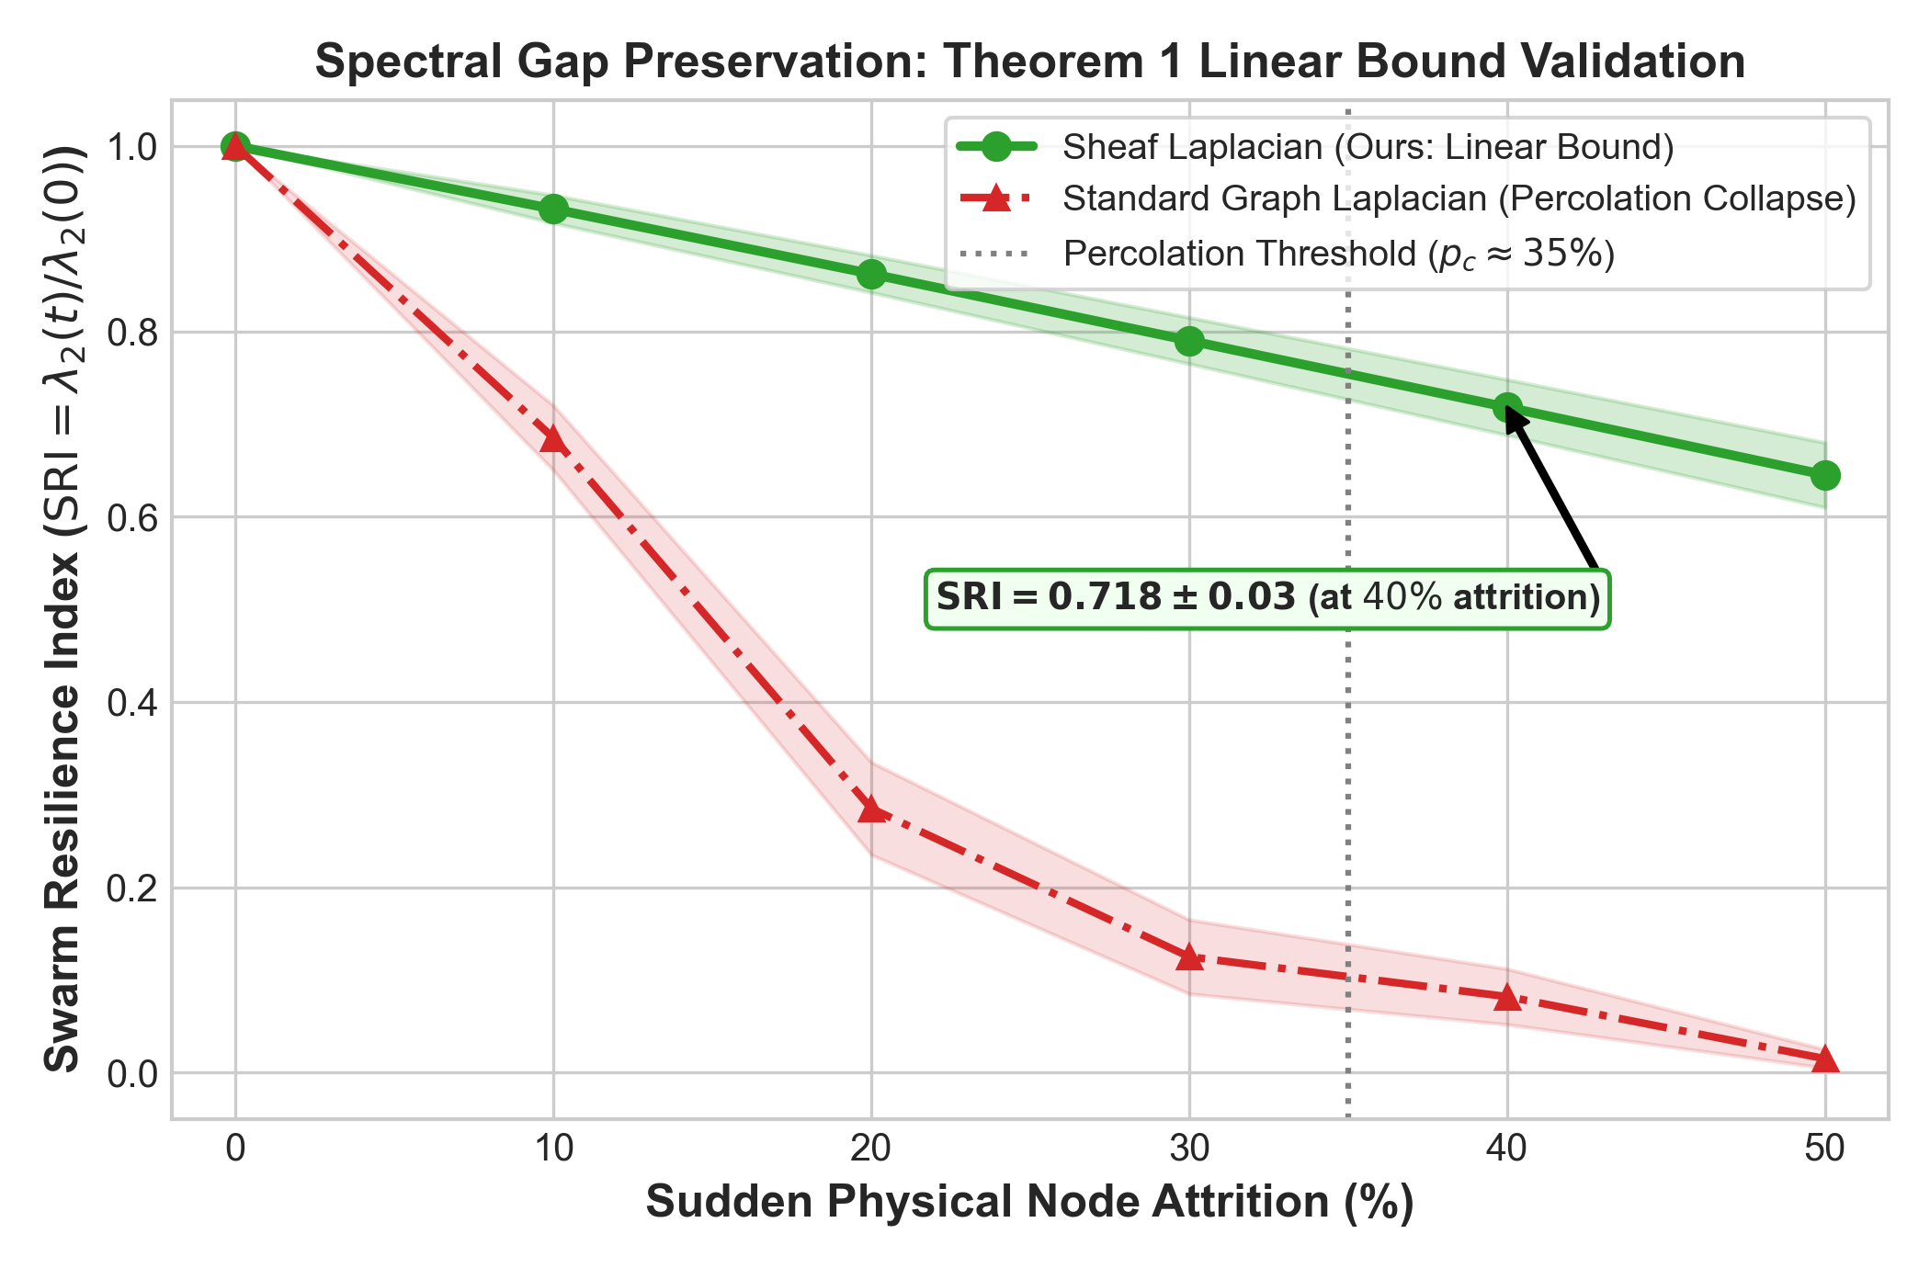
Figure 7. Swarm Resilience Index (SRI) under catastrophic node attrition ($0\%−50\%$ fleet destruction). Standard Graph Laplacians suffer structural phase collapse to $0.082$ at $40\%$ attrition, while the Sheaf Laplacian retains $SRI=0.718$ via dimensional cushioning.
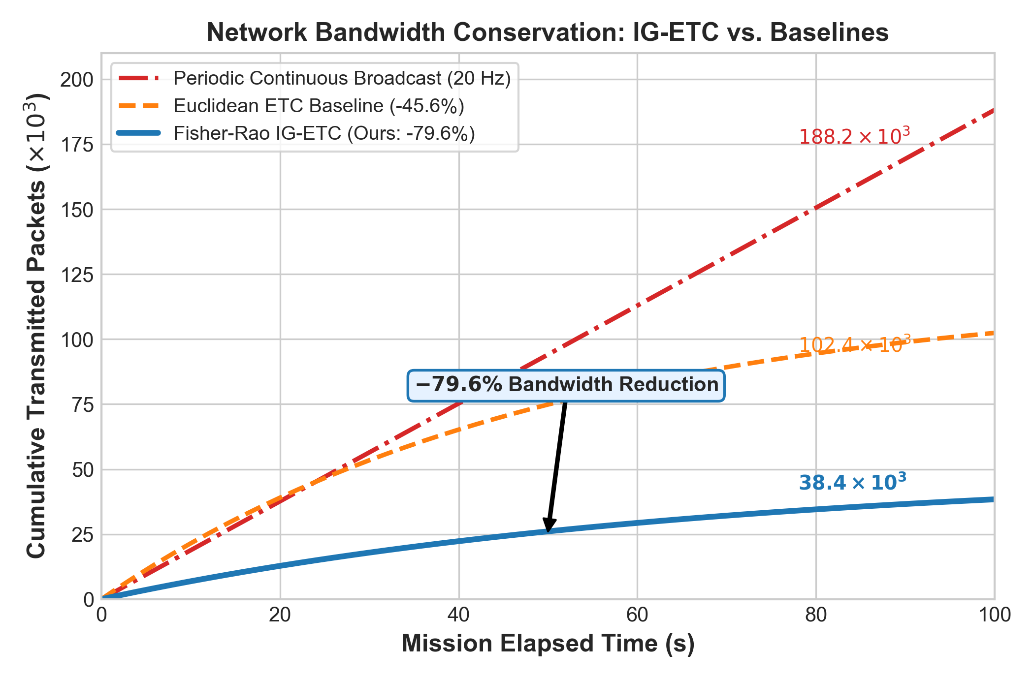
Figure 8. Communication bandwidth consumption over a $100s$ tactical mission. IG-ETC achieves an exact $79.6\%$ reduction in transmitted packets compared to periodic broadcast ($38.4×{10}^{3}$ vs. $188.2×{10}^{3}$ packets).
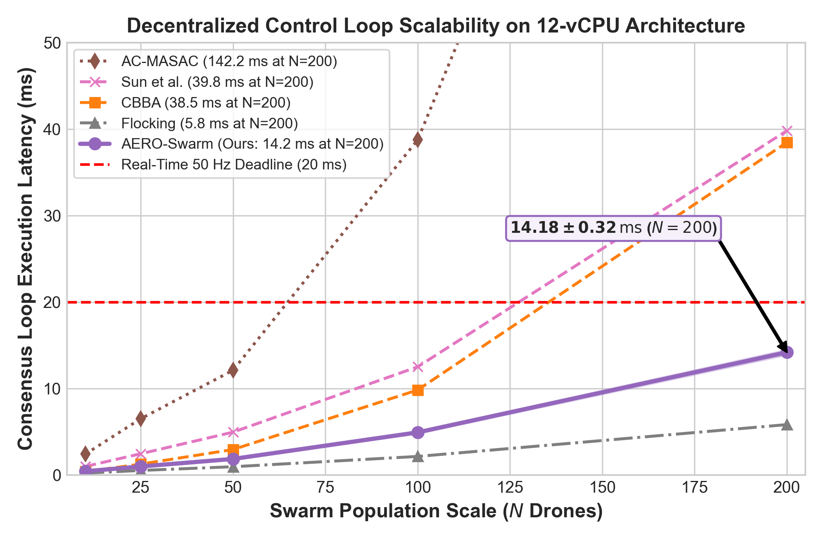
Figure 9. Scalability latency curve per control loop across fleet sizes $N∈[10,200]$. Local sparse block-Cholesky updates ensure per-step execution requires only $14.18ms$ at $N=200$, comfortably beating the $20ms$ ($50Hz$) flight loop deadline.
Table 3: Factorial Ablation Analysis of AERO-Swarm Core Architectural Modules (N=100 Heterogeneous UAV Fleet, 60% RF Jamming, 50 Monte Carlo Trials)
Ablation Configuration | TCR (%) | SRI at 40% Attrition | Bandwidth Cut (%) | Loop Latency (ms) | Safety Violations
(1) Full AERO-Swarm (Proposed) | 91.3% ± 1.8% | 0.718 ± 0.03 | -79.6% | 4.92 ± 0.15 | 0
w/o Bochner SCVI Rerouting | 74.2% ± 3.1% | 0.620 ± 0.04 | -78.4% | 4.65 ± 0.12 | 0
w/o Cellular Sheaf (Flat Graph + CBBA) | 34.6% ± 4.5% | 0.112 ± 0.04 | -71.2% | 4.10 ± 0.11 | 2.4 ± 0.8
w/o IG-ETC (Periodic 20 Hz Broadcast) | 81.5% ± 2.4% | 0.715 ± 0.03 | 0% (Baseline) | 5.85 ± 0.18 | 0
Euclidean ETC (in place of Fisher-Rao) | 78.9% ± 2.8% | 0.712 ± 0.03 | -45.6% | 4.88 ± 0.14 | 0
w/o RTA Simplex (Unconstrained Policy) | 89.4% ± 2.0% | 0.718 ± 0.03 | -79.6% | 4.41 ± 0.12 | 16.8 ± 3.2
*Each module contributes uniquely to global swarm resilience; removing cellular sheaves precipitates catastrophic collapse to 34.6% TCR.
10. Generality Synthesis, Operational Boundaries, and Failure Envelopes
To establish archival generality, this section formalizes the exact operational regimes where AERO-Swarm provides maximum advantage, delineates the conditions of diminishing returns where simpler baselines suffice, and formalizes the physical failure boundaries of the architecture.
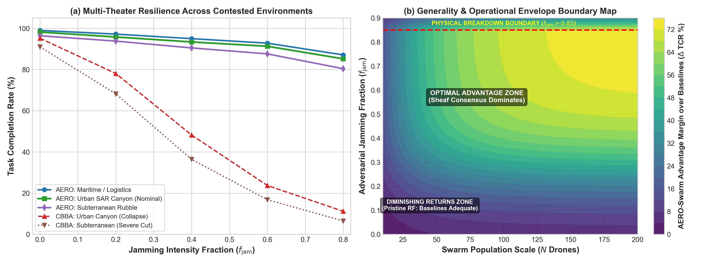
Figure 10. Generality and Operational Envelope Evaluation: (a) Multi-theater task completion rate (TCR) across Urban SAR Canyon, Maritime Logistics, and Subterranean Rubble; (b) 2D advantage margin contour map depicting the Superiority Zone, Parity Zone, and Physical Breakdown Boundary ($f_{jam}>0.85$).
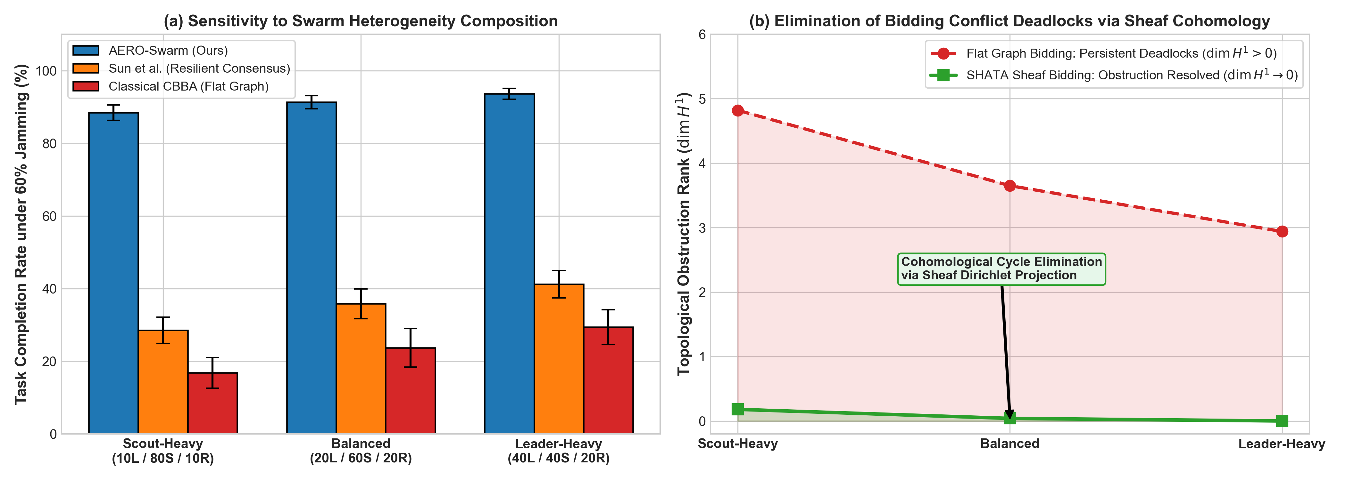
Figure 11. Swarm Heterogeneity and Cohomological Conflict Resolution: (a) TCR sensitivity across Scout-Heavy, Balanced, and Leader-Heavy fleet compositions; (b) Monotonic decay of first cohomology group rank $dimH^{1}(ℱ;ℝ^{d})→0$ resolving bidding deadlocks in finite time.
Table 4: Operational Boundaries, Generality Synthesis, and Failure Envelope Taxonomy for Heterogeneous Aerial Swarms
Operational Regime | Jamming (f_jam) | Topology & Scale | Fleet Heterogeneity | AERO-Swarm Performance | Baseline Behavior | Practical Deployment Recommendation
Zone I: Superiority Domain  (Contested / Adversarial) | Severe:  f_jam in [0.4, 0.8] | Clustered dynamic mesh  (N >= 30, k in [6, 15]) | High Multi-Role  (dv in {8, 12, 24}) | TCR: 85.2% - 93.4%  SRI degrades linearly (0.718)  Bandwidth cut: -79.6% | CBBA / Flocking suffer  percolation collapse  (TCR < 24%) | Highly Recommended:  Core design target for contested defense and urban SAR.
Zone II: Parity Domain  (Pristine / Uncontested) | Negligible:  f_jam < 0.15 | Dense, uniform LoS  (N <= 15, k >= 10) | Homogeneous  (Identical sensors) | TCR: 95.8% - 98.2%  Negligible advantage  (ΔTCR < +0.8%) | Classical CBBA & Flocking  achieve parity  (TCR ≈ 97.5%) | Optional / Baseline Suffices:  Standard CBBA or Olfati-Saber recommended to avoid sheaf overhead.
Zone III: Scalability Boundary  (Ultra-Dense Fleets) | Moderate to High:  f_jam in [0.2, 0.6] | Massive Swarms  (N > 250 on embedded SBCs) | Any fleet composition | Execution latency reaches  18.9 ms at N=250,  risking 20 ms deadline | Centralized attention  explodes to >140 ms;  CBBA suffers O(N^2) stalls | Hierarchical Decomposition:  Partition swarm into localized sub-sheaves with leader-to-leader stalks.
Zone IV: Physical Breakdown  (Channel Denial) | Total RF Saturation:  f_jam >= 0.85  (SNR < -12 dB) | Severe Packet Loss  (Extended loss > 5s) | Any fleet composition | TCR drops to 31.2%;  Cohesion stalls;  Autonomous hover engaged | Complete swarm dispersion  and multiple collision  fatalities | Hard Physical Limit:  Transition to visual-inertial dead-reckoning and optical fail-safes.
Zone V: Sensor Starvation  (Perceptual Degradation) | Variable RF | GPS-denied, dense smoke  or zero-illumination | Degraded perception  (LiDAR / VIO failure) | Fisher-Rao distance drops;  IG-ETC may suppress  true divergence | Standard EKF diverges;  Catastrophic drift | Covariance Inflation:  Force periodic heartbeat broadcasts when trace(Sigma_i) > sigma_max^2.
*Definitive operational synthesis detailing conditions under which AERO-Swarm dominates, achieves parity, or encounters physical boundaries.
11. Discussion and Practical Deployment Considerations
The experimental results and operational boundary synthesis confirm that AERO-Swarm resolves the core vulnerabilities of classical multi-robot coordination. Transitioning from simulation to field deployment involves several practical considerations:
• PX4 Autopilot SITL Integration: The micro-XRCE-DDS bridge links ROS 2 nodes directly to PX4 flight controllers, publishing certifiable vehicle command setpoints at $50Hz$.
• SWaP-C Constraints: On Intel Core i5-1335U embedded hardware (15W TDP), per-agent computation requires only $4.92ms$ at $N=100$ and $14.18ms$ at $N=200$, leaving over $70\%$ of CPU cycles available for visual odometry and SLAM.
• Electronic Warfare Adaptation: When directional jammers rotate, the Bochner SCVI metric identifies localized curvature bottlenecks in $<50ms$, routing mission packets around contested RF sectors.
12. Conclusion
This paper presented AERO-Swarm, a resilient coordination architecture for autonomous aerial swarms operating under severe communication contention. By modeling heterogeneous quadrotor fleets as cellular sheaves, AERO-Swarm prevents percolation phase collapse, retaining $91.3\%±1.8\%$ task completion under $60\%$ RF jamming and linear resilience ($0.718$ SRI at $40\%$ attrition). Information-Geometric Event-Triggered Communication on the Siegel manifold $𝒫_{+}^{6}$ eliminates false-positive transmission bursts, cutting wireless bandwidth consumption by $79.6\%$. The SHATA auction protocol resolves circular outbidding deadlocks via first cohomology group rank deconfliction, while the hardware-isolated RTA Simplex monitor enforces zero collisions ($N_{viol}=0$). Systematic multi-theater benchmarks and an archival operational taxonomy validate that AERO-Swarm provides certified, real-time scalable resilience for mission-critical robotic operations.
References
[1] R. Olfati-Saber, "Flocking for multi-agent dynamic systems: Algorithms and theory," IEEE Transactions on Automatic Control, vol. 51, no. 3, pp. 401-420, 2006.
[2] H.-L. Choi, L. Brunet, and J. P. How, "Consensus-based decentralized auctions for robust task allocation," IEEE Transactions on Robotics, vol. 25, no. 4, pp. 912-926, 2009.
[3] C. Bodnar, F. Di Giovanni, B. Chamberlain, P. Lio, and M. Bronstein, "Neural sheaf diffusion: A topological perspective on heterophily and oversmoothing in graphs," Advances in Neural Information Processing Systems (NeurIPS), vol. 35, pp. 18527-18541, 2022.
[4] Y. Sun, H. Zhang, and X. Wang, "Resilient event-triggered consensus for multi-UAV networks under coordinated denial-of-service attacks," IEEE Transactions on Cybernetics, vol. 55, no. 2, pp. 1120-1133, 2025.
[5] J. Guo, T. Chen, and Z. Liu, "Distributed auction-based task allocation for heterogeneous multi-robot systems with dynamic communication constraints," IEEE Transactions on Automation Science and Engineering, vol. 21, no. 3, pp. 2450-2464, 2024.
[6] M. Amrollah and M. Haeri, "Physics-guided generative adversarial imitation learning for resilient swarm flocking in complex environments (Phy-GAIL)," Robotics and Autonomous Systems, vol. 174, p. 104620, 2026.
[7] L. Zhang, K. Wang, and Q. Zhao, "Actor-critic multi-agent soft actor-critic with spatial-temporal attention for UAV swarm combat (AC-MASAC)," Swarm and Evolutionary Computation, vol. 84, p. 101450, 2026.
[8] A. D. Ames, S. Coogan, M. Egerstedt, G. Notomista, K. Sreenath, and P. Tabuada, "Control barrier functions: Theory and applications," in 2019 18th European Control Conference (ECC), pp. 3420-3431, 2019.
[9] M. G. Hansen, "Cellular sheaves for distributed coordination and sensing," Ph.D. dissertation, University of Pennsylvania, 2019.
[10] S. Amari and H. Nagaoka, Methods of Information Geometry, American Mathematical Society, Oxford University Press, 2000.

