NAME: vishal pal
Registration no:202401100200351
Rollno:2400290100350
Branch:cse
Sec-E
- GitHub repository URL: https://github.com/Vishal68344/github-skills-challenge
- 2. Pull request URL used to validate the workflows: https://github.com/Vishal68344/github-skills-challenge/pull/2
- Screenshot showing the GitHub Actions workflows
- 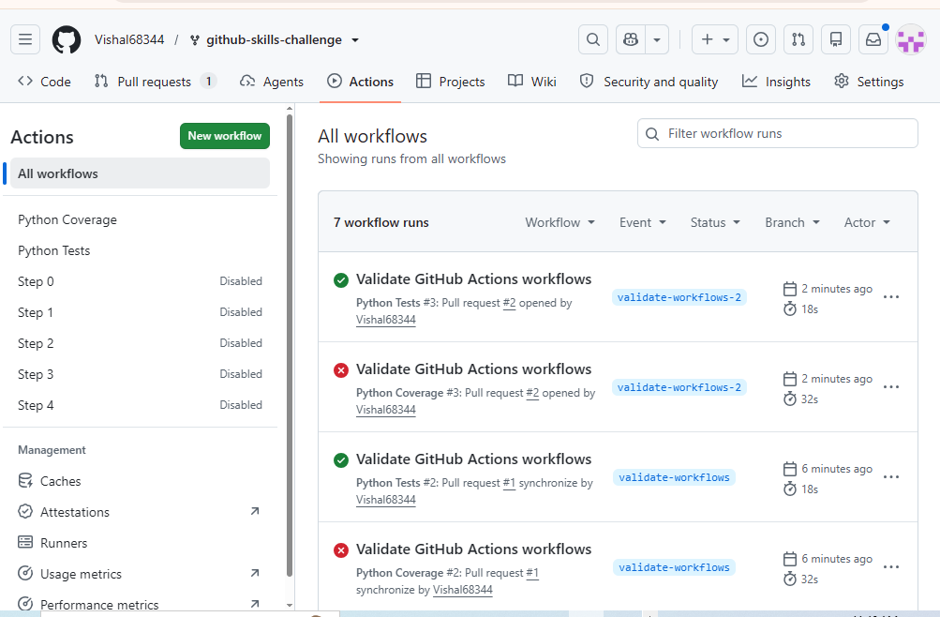
- Screenshot showing a successful test workflow execution
- 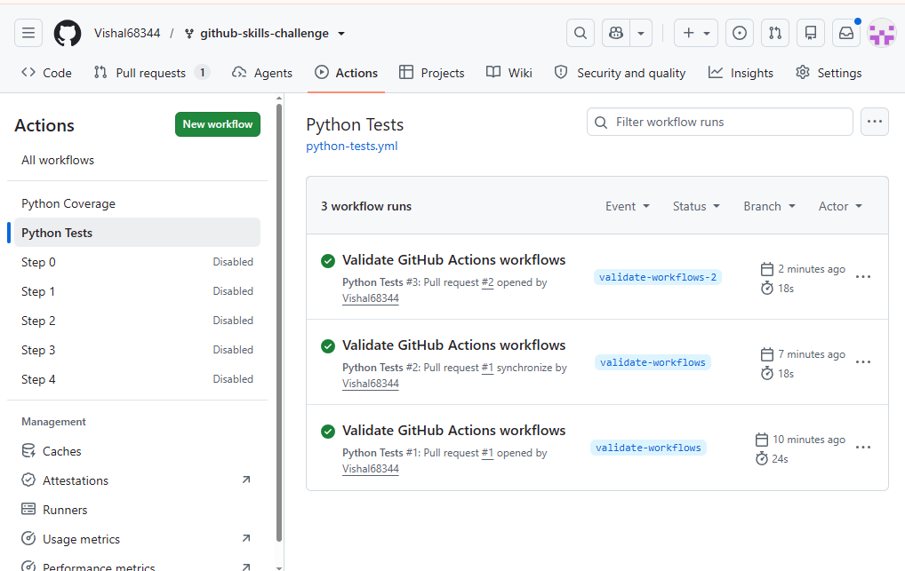
- Screenshot showing the coverage result/comment on the pull request
- 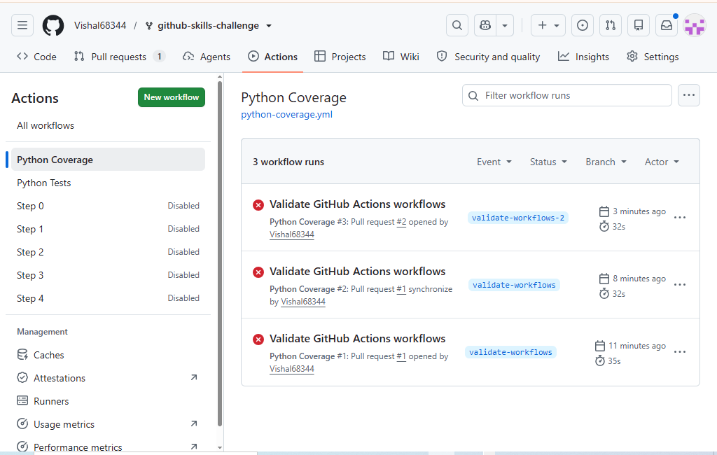
- Screenshot showing the final repository/workflow files
- 
 