Task - 4

Step 1:

Login to AWS Console

Go to S3 → Create bucket

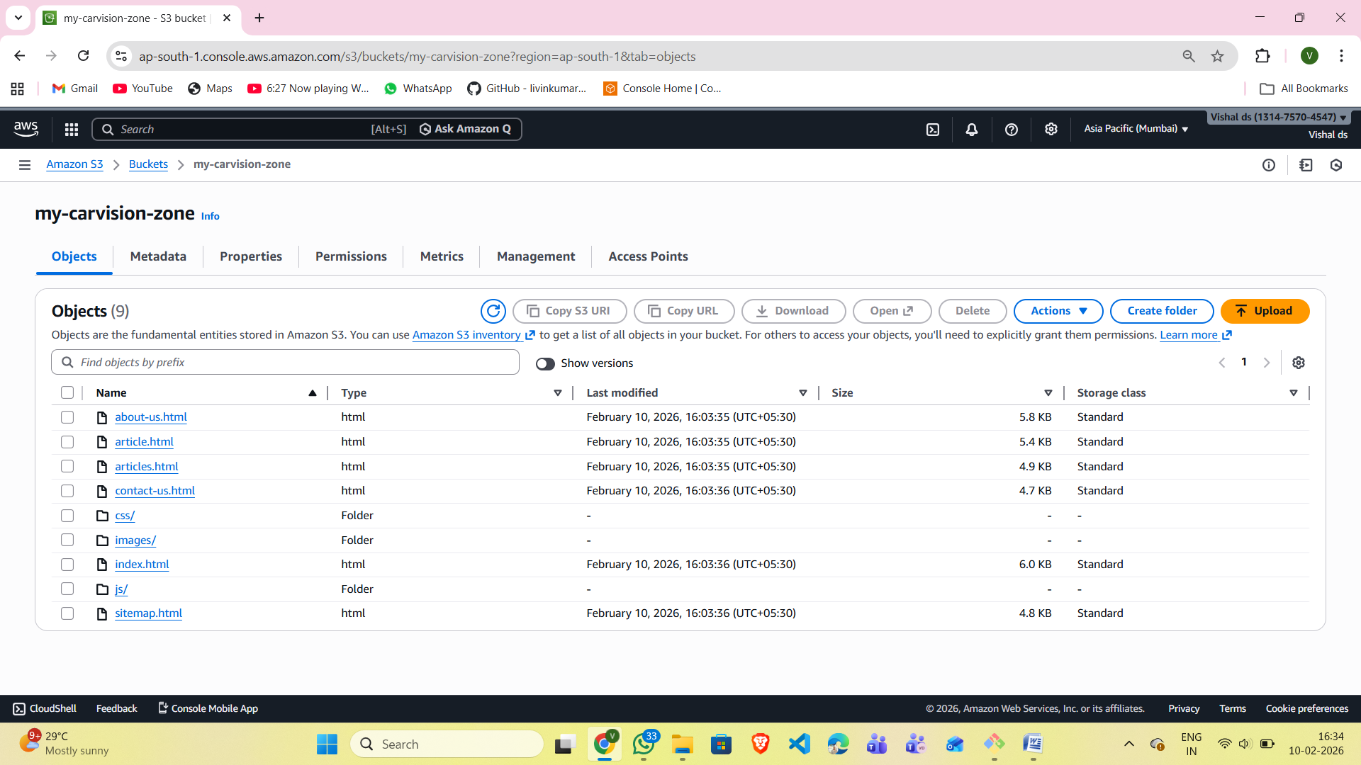

Step 2:

Open your S3 bucket Click Upload Upload all your files:

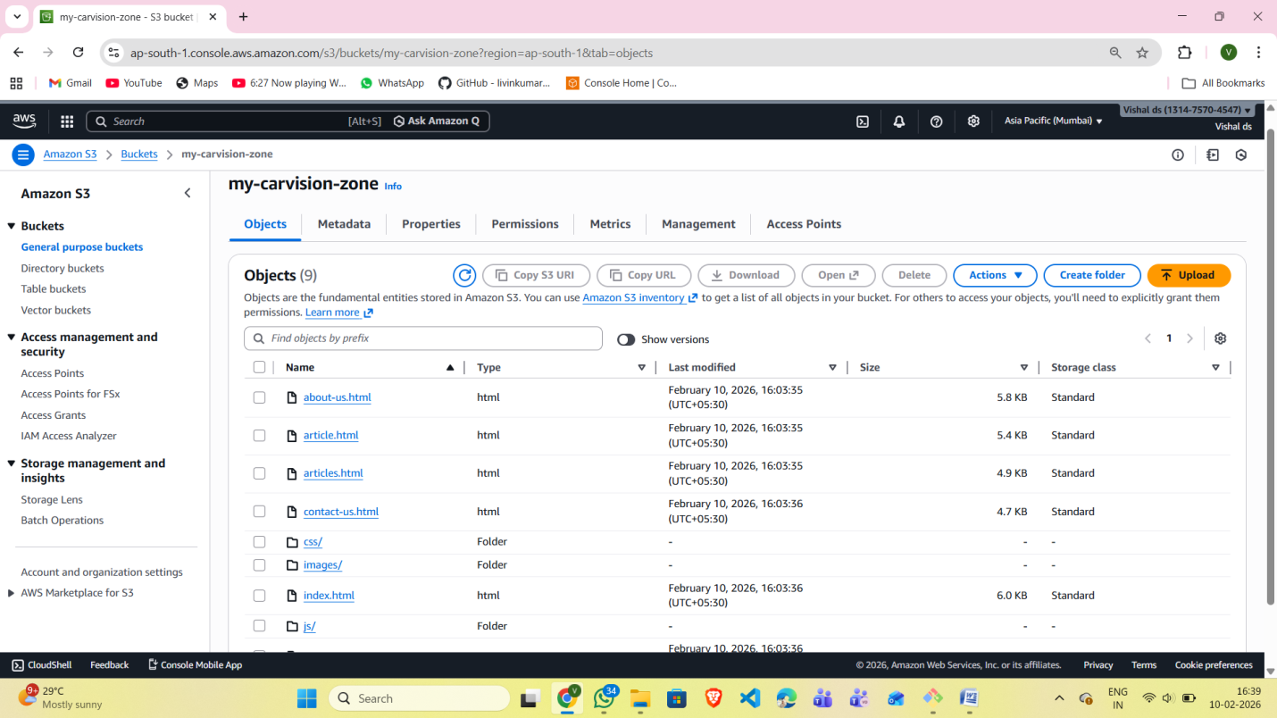

Step 3: Enable Static Website Hosting

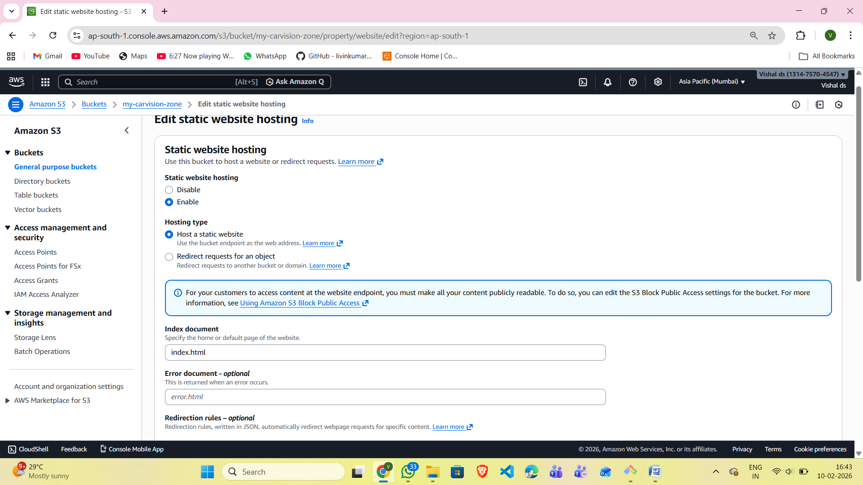

Step 4: Add Bucket Policy (Public Access)

Go to Permissions → Bucket policy

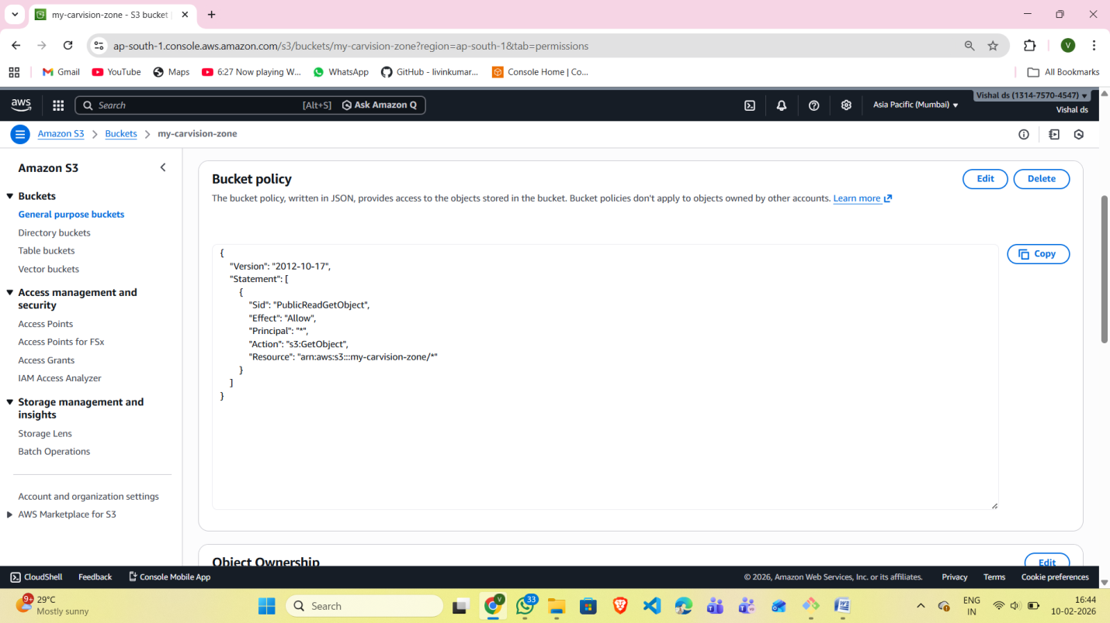

Step 5: Open in Browser Copy the S3 website URL and paste it in your browser.

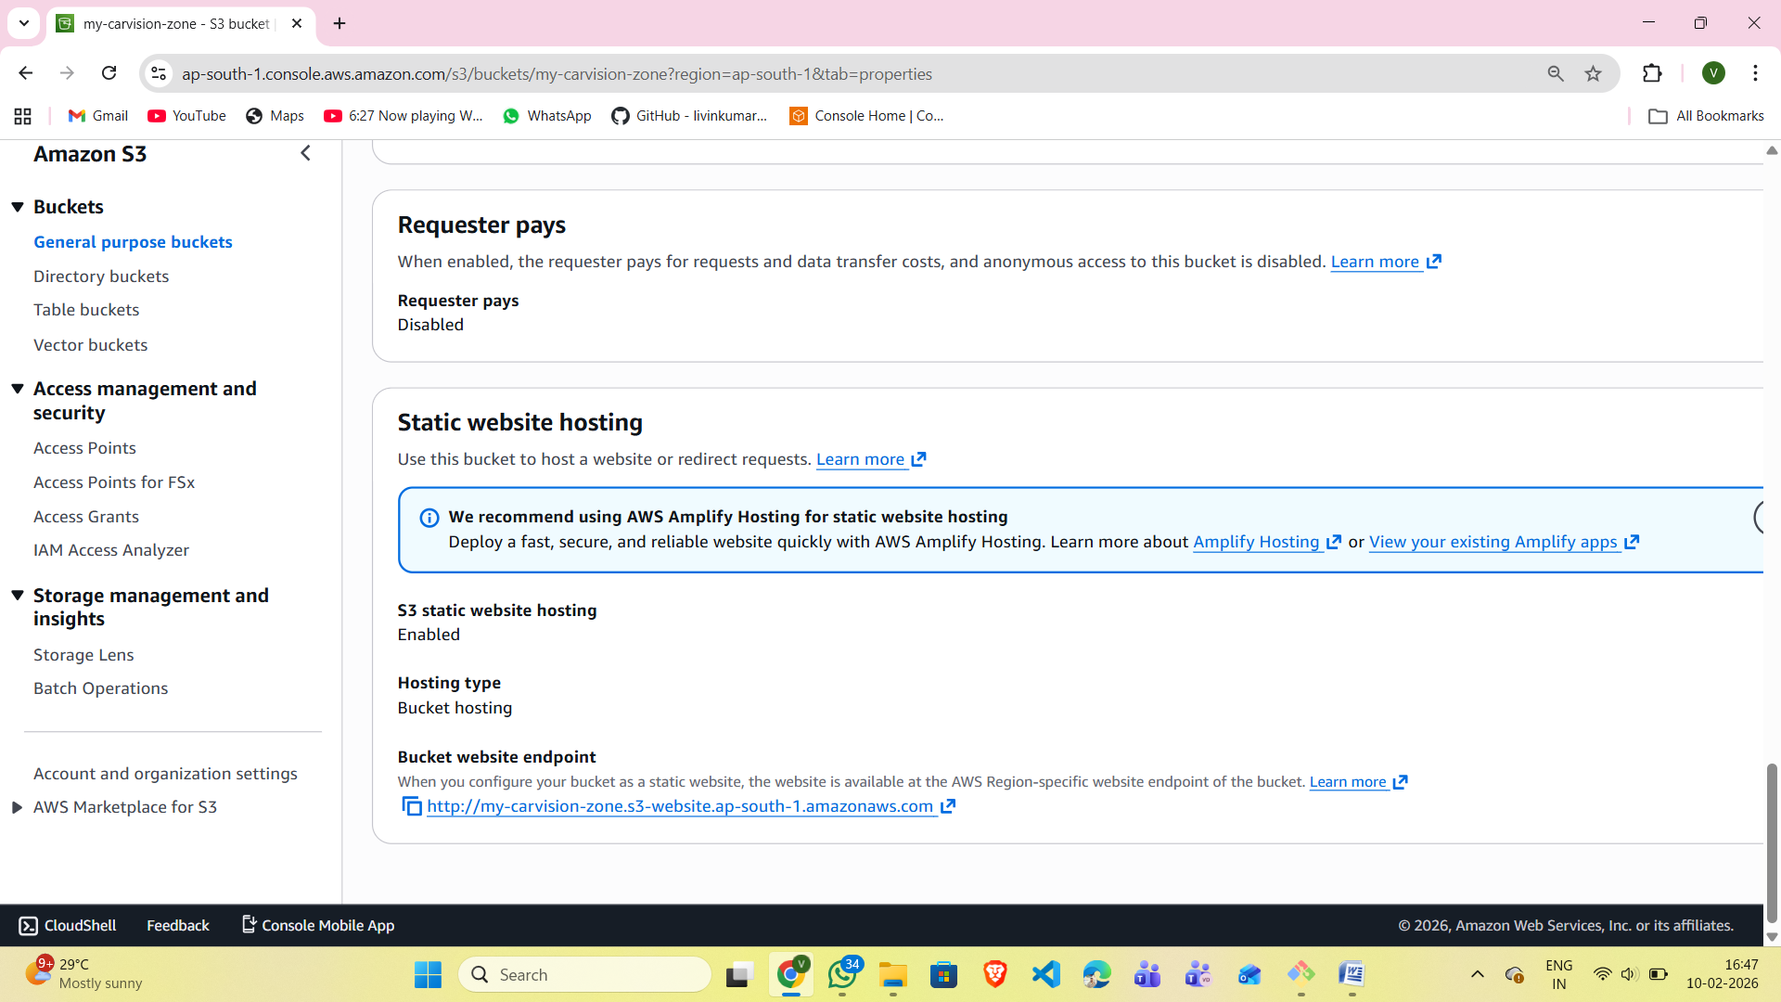

After Pasting in the browser , the website hosts successfully ..

