Predicting Concrete Compressive Strength Using Machine Learning

Vishal Anand M

1.Introduction

a.Overview

Concrete is a material used in construction that has great versatility and which is used across the globe. Concrete has several advantages, including good compressive strength, durability, workability, construction availability, and low cost. Determining accurate concrete strength is a major civil engineering problem. Test results of 28- day concrete cylinder represent the characteristic strength of the concrete that has been prepared and cast to form the concrete work. It is important to wait 28 days to ensure the quality control of the process, although it is very time consuming. Machine learning techniques are progressively used to simulate the characteristic of concrete materials.

b.Purpose

In this project, we are going to analyse concrete compressive strength dataset and build Machine Learning models to predict the compressive strength.

2.Literature Survey

a.Existing Problem

The recommended wait time for testing the concrete compressive strength is 28 days to ensure correct results. This consumes a lot of time and requires a lot of labour to prepare different prototypes and test them. Also, this method is prone to human error and one small mistake can cause the wait time to drastically increase.

b.Proposed Solution

One way of reducing the wait time and reducing the number of combinations to try is to make use of digital simulations, where we can provide information to the computer about what we know and the computer tries different combinations to predict the compressive strength. This way we can reduce the number of combinations we can try physically and reduce the amount of time for experimentation. But, to design such software we have to know the relations between all the raw materials and how one material affects the strength. It is possible to derive mathematical equations and run simulations based on these equations, but we cannot expect the relations to be same in real-world. Also, these tests have been performed for many numbers of times now and we have enough real-world data that can be used for predictive modelling.

3. Theoretical Analysis

a.Block Diagram

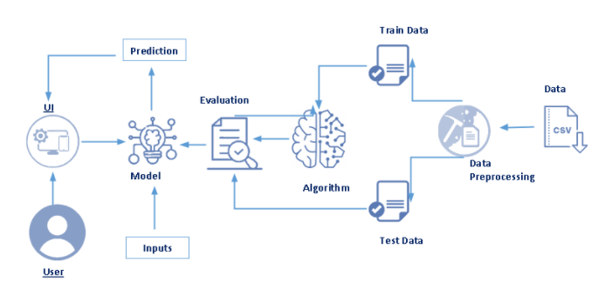

b.Hardware/Software Designing

The first step in any Data Science project is to understand the data and gain insights from the data before doing any modelling. This includes checking for any missing values, plotting the features with respect to the target variable, observing the distributions of all the features and so on. Let us import the data and start analysing.

We check the correlations between the input features, this will give an idea about how each variable is affecting all other variables. This can be done by calculating Pearson correlations between the features.

We can further use a pairplot in seaborn to plot pairwise relations between all the features and distributions of features along the diagonal.The pair plot gives a visual representation of correlations between all the features.

We plot scatter plots between CC_Strength and other features to see more complex relations.

Before we fit machine learning models on the data, we need to split the data into train, test splits. The features can be rescaled to have a mean of zero and a standard deviation of 1 i.e. all the features fall into the same range.

After preparing the data, we can fit different models on the training data and compare their performance to choose the algorithm with good performance. As this is a regression problem, we can use RMSE (Root Mean Square Error) and R2 score as evaluation metrics.

4.Experimental Observations

We can observe a high positive correlation between compressive Strength (CC_Strength) and Cement. this is true because strength concrete indeed increases with an increase in the amount of cement used in preparing it. Also, Age and Super Plasticizer are the other two factors influencing Compressive strength.

There are other strong correlations between the features:
- A strong negative correlation between Super Plasticizer and Water.
- positive correlations between Super Plasticizer and Fly Ash, Fine Aggregate.

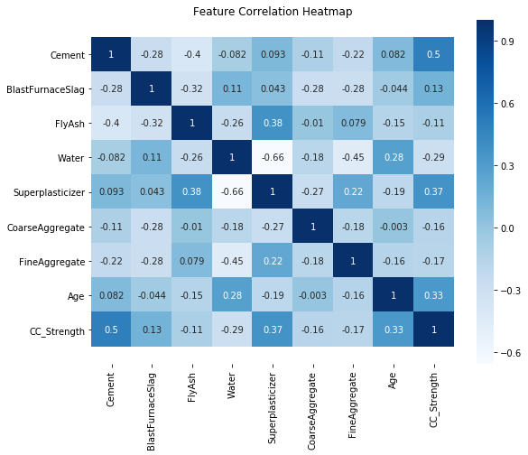
The observations we can make from the scatter plot CC_Strength vs (Cement, Age, Water):
- Compressive strength increases as the amount of cement increases, as the dots move up when we move towards right on the x-axis.
- Compressive strength increases with age (as the size of dots represents the age), this not the case always but can be up to an extent.
- Cement with less age requires more cement for higher strength, as the smaller dots are moving up when we move towards right on the x-axis.
- The older the cement is the more water it requires, can be confirmed by observing the colour of the dots. Larger dots with dark colour indicate high age and more water.
- Concrete strength increases when less water is used in preparing it since the dots on the lower side (y-axis) are darker and the dots on higher-end (y-axis) are brighter.
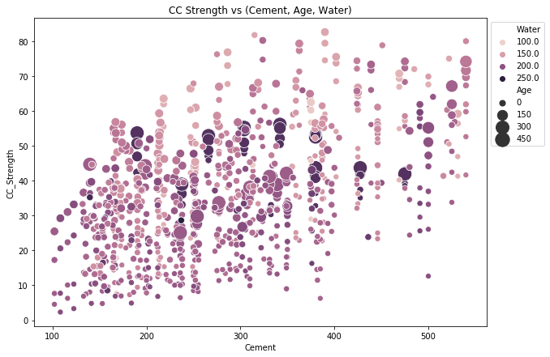
The observations we can make from the scatter plot CC Strength vs (Fine aggregate, Super Plasticizer, Fly Ash):
- Compressive strength decreases Fly ash increases, as darker dots are concentrated in the region representing low compressive strength.
- Compressive strength increases with Superplasticizer since larger the dot the higher they are in the plot.

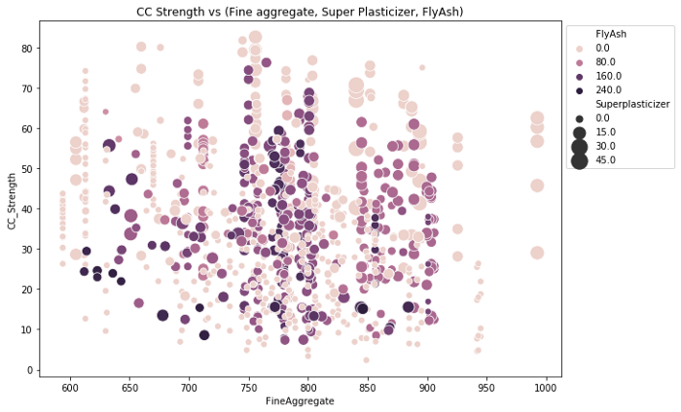

5.Flowchart


6.Results

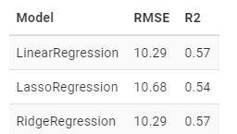

There is not much difference between the performance with these three algorithms.

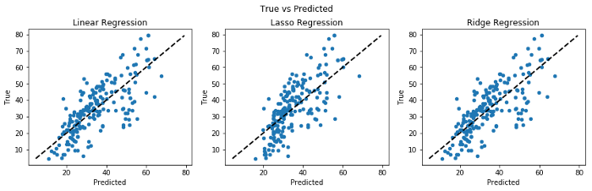

If the predicted values and the target values are equal, then the points on the scatter plot will lie on the straight line. As we can see here, none of the model predicts the Compressive Strength correctly.

A Decision Tree Algorithm represents the data with a tree-like structure, where each node represents a decision taken on a feature. This algorithm would give better performance in this case, since we have a lot of zeros in some of the input features.

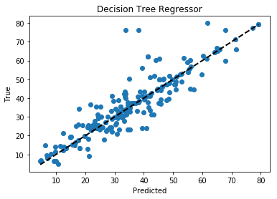

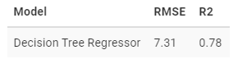

The Root Mean Squared Error (RMSE) has come down from 10.29 to 7.31, so the Decision Tree Regressor has improved the performance by a significant amount. This can be observed in the plot as well as more points are closer to the line.

Using a Decision Tree Regressor has improved our performance, we can further improve the performance by ensembling more trees. Random Forest Regressor trains randomly initialized trees with random subsets of data sampled from the training data, this will make our model more robust.

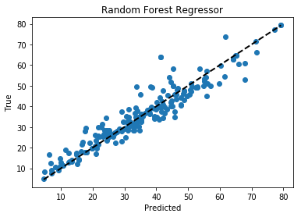

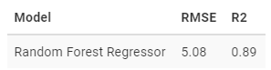

The RMSE has further reduced by ensembling multiple trees. We can plot the feature importance’s for tree-based models. The feature importance’s show how important a feature is for a model when making a prediction.

7.Advantages And Disadvantages

he simulation of concrete strength is strongly needed to better understand its behaviours under different conditions and loads. Since many studies predict the comprehensive strength of conventional concrete from hardened characteristics, based on the data points gathered from different experimental tests, empirical models have been developed and verified in the past years. Proposed models are more reliable if the numbers of tests increase and their repeatability increase as well. However, these models are designed for a specific range of concrete strengths. On the other hand, numerical models are more reliable since they are devised based on theoretical rules which could consider behaviours of concrete under different loading paths. But, the validation of these models is made by different loading paths with different configurations that result in costly experiments and both models use only principal stresses and strains in their formulation. Employing machine learning approaches instead of traditional models makes it possible to develop a better understanding of the compressive strength of concrete.

8.Applications

Compressive strength results are primarily used to determine that the concrete mixture as delivered on site meets the requirements of the specified strength, fc', in the job specification. Cylinders tested for acceptance and quality control are made and cured in accordance with procedures described for standard-cured specimens in ASTM C-31. For estimating the in place concrete strength, ASTM C-31 provides procedures for field-cured specimens. Cylindrical specimens are tested in accordance with ASTM C-39.

9.Conclusion

We have analysed the Compressive Strength Data and used Machine Learning to Predict the Compressive Strength of Concrete. We have used Linear Regression and its variations, Decision Trees and Random Forests to make predictions and compared their performance. Random Forest Regressor has the lowest RMSE and is a good choice for this problem. Also, we can further improve the performance of the algorithm by tuning the hyperparameters by performing a grid search or random search.

10.Future Scope

Further works can ivolve K-means clustering and C-means fuzzy clustering techniques along with the three regression techniques, namely, simple linear regression (SLR), logistic regression (LR), and least median of squares (LMS) and can be used to predict (estimate) the compressive strength of the concrete.

The proposed model can also be validated by selecting other standard datasets and comparisons can be made accordingly.

11.Bibliography

I-Cheng Yeh, “ Modeling of strength of high performance concrete using artificial neural networks,” Cement and Concrete Research, Vol. 28, №12, pp. 1797–1808 (1998).

Ahsanul Kabir, Md Monjurul Hasan, Khasro Miah, “ Strength Prediction Model for Concrete”, ACEE Int. J. on Civil and Environmental Engineering, Vol. 2, №1, Aug 2013.

12.Appendix

a.Source Code

html code

<!DOCTYPE html>
<html>

<style>
.navbar-text h1 {
color: #fff;
font-size: 40px;
align-content: center;
}

body {
background-color: grey;
}

form {
margin-top: 50px;
margin: auto;
width: 35%;
;
}

.result {
margin: auto;
width: 35%;
border: 1px solid #ccc;
background-color: grey;
color: #fff;
padding: 20px;
box-shadow: 0 4px 8px 0 rgba(0, 0, 0, 0.2);
transition: 0.3s;
;
}
</style>

<head>
<title>Compressive Strength Prediction</title>

<link rel="stylesheet" href="https://maxcdn.bootstrapcdn.com/bootstrap/4.0.0/css/bootstrap.min.css" integrity="sha384-Gn5384xqQ1aoWXA+058RXPxPg6fy4IWvTNh0E263XmFcJlSAwiGgFAW/dAiS6JXm" crossorigin="anonymous">
<link rel="stylesheet" href="style.css">
</head>

<body>

<nav class="navbar navbar-light bg-dark">
<span class="navbar-text">
<h1>Concrete Compressive Strength Predictor</h1>
</span>
</nav>

<form action="{{ url_for('main') }}" method="POST">
<div class="form-group">

<legend>Input Variables</legend>
<br>Cement(kg in a m^3 mixture):<br>

<input name="Cement" type="number" step="any" class="form-control" required>
<br>

<br> Blast Furnace Slag(kg in a m^3 mixture):<br>
<input name="BlastFurnaceSlag" type="number" step="any" class="form-control" required>
<br>

<br>Fly Ash(kg in a m^3 mixture):<br>
<input name="FlyAsh" type="number" step="any" class="form-control" required>
<br>

<br>Water(kg in a m^3 mixture):<br>
<input name="Water" type="number" step="any" class="form-control" required>
<br>

<br>Superplasticizer(kg in a m^3 mixture):<br>
<input name="Superplasticizer" type="number" step="any" class="form-control" required>
<br>

<br>Coarse Aggregate(kg in a m^3 mixture):<br>
<input name="CoarseAggregate" type="number" step="any" class="form-control" required>
<br>

<br>Fine Aggregate(kg in a m^3 mixture):<br>
<input name="FineAggregate" type="number" step="any" class="form-control" required>

<br>Age (day):<br>
<input name="Age" type="number" step="any" class="form-control" required>
<br>
<br>

<input type="submit" value="Submit" class="btn btn-primary">

</div>

</form>

<br>

<div class="result" align="center">
{% if result %} {% for variable, value in original_input.items() %}
<b>{{ variable }}</b> : {{ value }} {% endfor %}
<br>
<br>
<h1>Predicted Compressive Strength:</h1>
<p style="font-size:50px">{{ result }}</p>
{% endif %}
</div>

<script src="https://code.jquery.com/jquery-3.2.1.slim.min.js" integrity="sha384-KJ3o2DKtIkvYIK3UENzmM7KCkRr/rE9/Qpg6aAZGJwFDMVNA/GpGFF93hXpG5KkN" crossorigin="anonymous">
</script>
<script src="https://cdnjs.cloudflare.com/ajax/libs/popper.js/1.12.9/umd/popper.min.js" integrity="sha384-ApNbgh9B+Y1QKtv3Rn7W3mgPxhU9K/ScQsAP7hUibX39j7fakFPskvXusvfa0b4Q" crossorigin="anonymous">
</script>
<script src="https://maxcdn.bootstrapcdn.com/bootstrap/4.0.0/js/bootstrap.min.js" integrity="sha384-JZR6Spejh4U02d8jOt6vLEHfe/JQGiRRSQQxSfFWpi1MquVdAyjUar5+76PVCmYl" crossorigin="anonymous">
</script>
</body>

</html>

app.py code

import flask
import pandas as pd
from joblib import dump, load

with open(f'random.save', 'rb') as f:
model = load(f)

app = flask.Flask(__name__, template_folder='templates')

@app.route('/', methods=['GET', 'POST'])
def main():
if flask.request.method == 'GET':
return (flask.render_template('index.html'))

if flask.request.method == 'POST':
Cement = flask.request.form['Cement']
BlastFurnaceSlag = flask.request.form['BlastFurnaceSlag']
FlyAsh = flask.request.form['FlyAsh']
Water =flask.request.form['Water']
Superplasticizer = flask.request.form['Superplasticizer']
CoarseAggregate = flask.request.form['CoarseAggregate']
FineAggregate = flask.request.form['FineAggregate']
Age = flask.request.form['Age']

input_variables = pd.DataFrame([[Cement, BlastFurnaceSlag, FlyAsh, Water, Superplasticizer, CoarseAggregate,FineAggregate, Age]],
columns=['Cement', 'BlastFurnaceSlag', 'FlyAsh', 'Water', 'Superplasticizer',
'CoarseAggregate', 'FineAggregate', 'Age'],
dtype='float',
index=['input'])

predictions = model.predict(input_variables)[0]
print(predictions)

return flask.render_template('index.html', original_input={'Cement': Cement, 'BlastFurnaceSlag': BlastFurnaceSlag, 'FlyAsh': FlyAsh, 'Water': Water, 'Superplasticizer': Superplasticizer, 'CoarseAggregate': CoarseAggregate, 'FineAggregate': FineAggregate, 'Age': Age},
result=predictions)

if __name__ == '__main__':
app.run(debug=True)

b.UI output screenshot

The values are cleared after clicking submit button.

