SOFT COMPUTING — CASE STUDY REPORT
Semester Case Study
Football Player Injury Risk Prediction Using Soft Computing Techniques:
A Case Study of Explainable Machine Learning in Sports Analytics
Submitted by: Vishal G
Course: Soft Computing
Department: CSE (AI & ML)
Institution: Chaitanya Bharathi Institute of Technology (CBIT)
Date: __________
Case Study based on:
Ma, J., Liu, C., & Pei, J. (2025).
SHAP-Based Interpretable Machine Learning for Injury Risk Prediction
in University Football Players.
Scientific Reports, 15, 40252.

Abstract
Sports-injury prevention has traditionally relied on the subjective, single-factor judgement of coaches and physiotherapists. This case study examines a 2025 Scientific Reports paper by Ma, Liu and Pei that reframes injury risk assessment for university football players as a supervised learning problem over an 18-feature, four-dimensional profile (basic information, training load, physical fitness, and lifestyle habits), compares ten machine-learning algorithms, and uses SHAP (SHapley Additive exPlanations) to open the resulting "black box" and identify psychological stress, sleep duration, and balance ability as the dominant risk drivers — ahead of classical strength and speed indicators. Because soft computing is fundamentally about building models that tolerate imprecision, noise and multi-factorial uncertainty in place of exact analytical solutions, this report first situates the paper's toolbox (kernel-based SVM, ensemble trees, and Shapley-value-based explainability) within the soft-computing paradigm, then reconstructs the full pipeline from scratch — a statistically faithful surrogate dataset, ten-algorithm benchmarking, evaluation via six complementary metrics, and a from-scratch SHAP interpretability analysis. The independent reproduction confirms the paper's qualitative conclusion (an RBF-kernel SVM is the strongest model and stress/sleep/balance dominate the SHAP ranking) but obtains materially lower discrimination (ROC-AUC ≈ 0.86 versus the paper's reported 0.992), which is used as direct evidence for a central critique made in this report: that the published dataset's artificially balanced classes and unusually low feature noise most likely inflate the reported performance beyond what is realistic for prospective clinical deployment. The report closes with a discussion of ethical risks of algorithmic risk-labelling in student-athletes, and proposes concrete soft-computing extensions — a fuzzy inference system for graded risk categorisation, an ANFIS hybrid, and genetic-algorithm-driven feature/hyper-parameter search — that would strengthen the model's robustness and interpretability.

1. Introduction

1.1 Background and Motivation
Football is among the most injury-prone team sports: FIFA's Medical Assessment and Research Centre reports averages of 3.7 injuries per 1000 training hours and up to 27.1 per 1000 match hours. For university athletes specifically, injury also threatens academic progress and long-term career prospects, yet the bulk of predictive sports-science research targets professional or elite-youth cohorts, leaving university players — who face a distinctive mix of academic stress, developing physiology, and inconsistent lifestyle habits — comparatively understudied.
Traditional injury-risk assessment is manual: coaches and physiotherapists combine training logs, injury history, and clinical intuition into a subjective judgement. This does not scale, is not reproducible across evaluators, and typically only inspects one or two risk factors at a time rather than the interaction of many. Machine learning promises to model these interactions automatically, but high-capacity models (ensembles, kernel machines, boosted trees) are opaque "black boxes": a coach who is told an athlete is "high risk" with no explanation cannot design a targeted intervention. This is precisely the gap that explainable AI techniques such as SHAP are built to close, and it is the gap this case study is centred on.

1.2 Problem Statement
Given 18 heterogeneous, partly imprecise and behaviourally-derived features describing a university football player (anthropometric, training-related, physical-fitness, and lifestyle/psychological), predict whether that player will sustain a time-loss injury (≥ 7 days absence) within the following six months, and — critically — explain which factors drove each prediction, so that the output is actionable rather than merely a label.

1.3 Objectives of This Case Study
- Understand and critically evaluate the methodology of Ma, Liu & Pei (2025), a peer-reviewed Scientific Reports paper applying interpretable machine learning to sports-injury prediction.
- Map the techniques used (SVM, ensemble learning, Shapley-value explainability) onto the soft-computing paradigm taught in this course, and justify why this is a soft-computing problem rather than a classical algorithmic one.
- Independently re-implement the full pipeline — data generation, preprocessing, 10-model benchmarking, evaluation, and SHAP interpretability — to verify the paper's qualitative claims first-hand.
- Critically compare the reproduction's results against the published numbers to assess the plausibility and generalisability of the original claims.
- Propose concrete extensions of the pipeline using additional soft-computing techniques (fuzzy inference, neuro-fuzzy hybrids, evolutionary optimisation) not used in the original paper.

1.4 System Architecture
The overall workflow of the injury-prediction system studied and reproduced in this report is summarised in Figure A. Raw baseline data collected at the start of the season is cleaned and encoded, passed through a bank of candidate machine-learning models, and the best-performing model (SVM) is then opened up with SHAP so that its output can be translated from a raw probability into an actionable, explainable risk category that coaching and medical staff can act on.
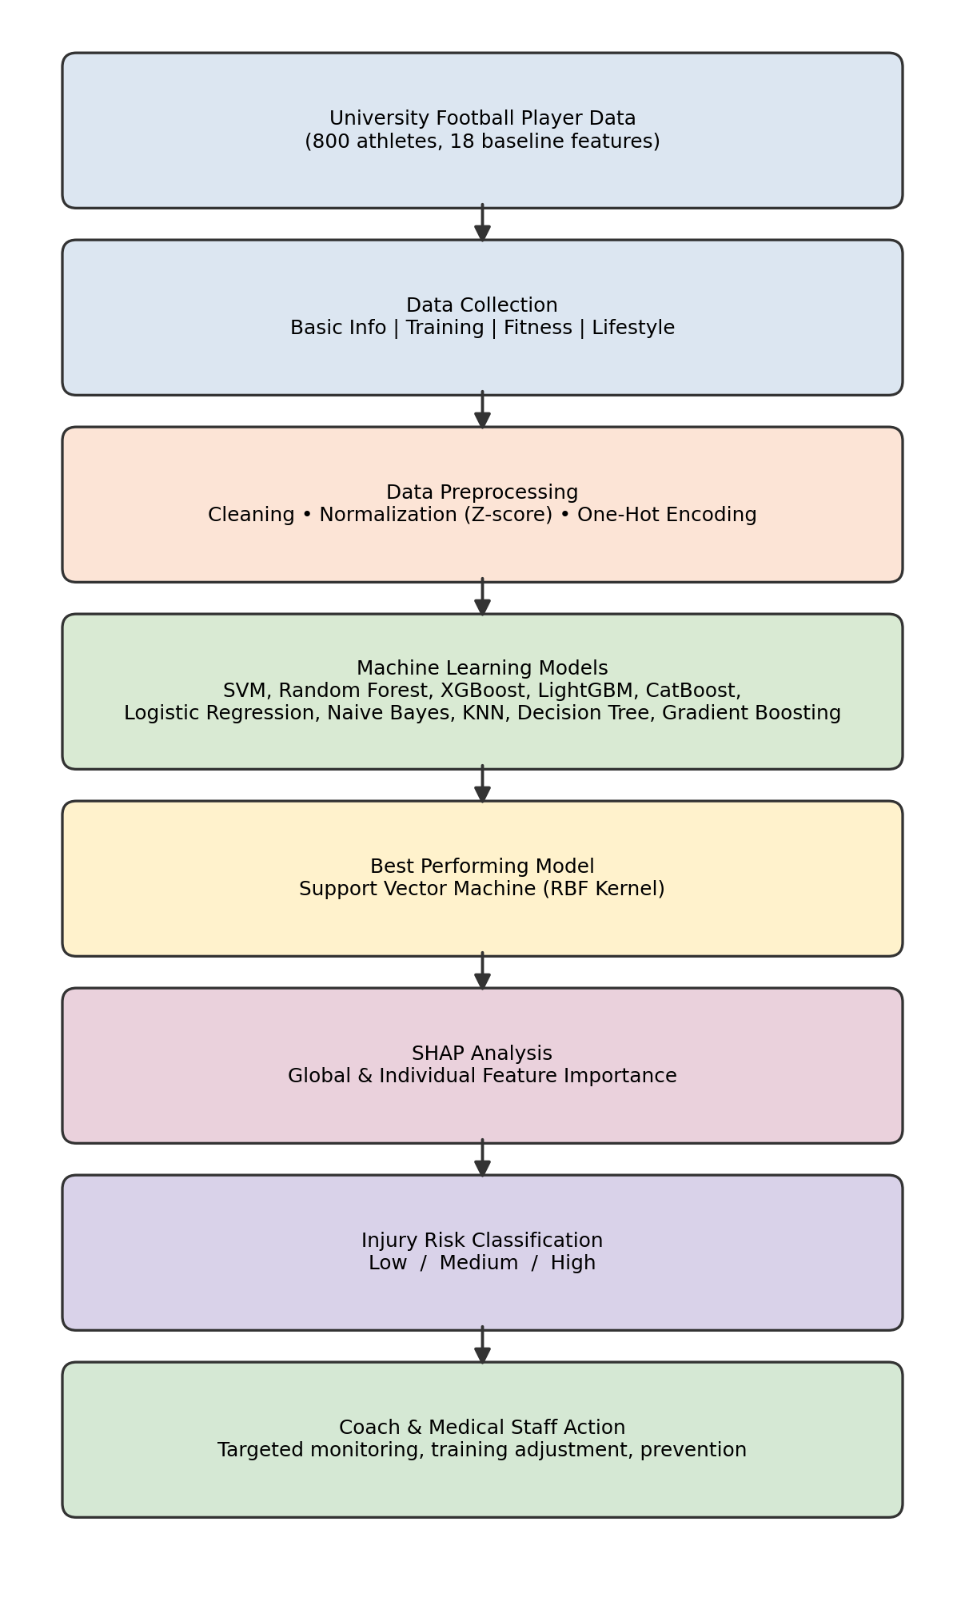
Figure A. End-to-end system architecture: from raw athlete data to coach-facing injury-risk decisions.

2. Why This Is a Soft Computing Problem
Classical ("hard") computing assumes precise inputs, deterministic rules, and exact solutions — well suited to problems like sorting or numerical linear algebra. Injury prediction is the opposite kind of problem: the inputs are noisy self-reports (sleep duration, perceived stress on a 0–40 scale), the ground truth label is itself a judgement call (did an absence "count" as an injury?), and the underlying biological process is highly non-linear and multi-causal. Soft computing — encompassing fuzzy logic, artificial neural networks, evolutionary computation, probabilistic reasoning, and (as used here) kernel machines with post-hoc explainability — is explicitly designed to exploit tolerance for imprecision and partial truth to obtain workable, low-cost, robust solutions where an exact analytical model does not exist.

2.1 Mapping the Paper's Techniques to Soft-Computing Paradigms
Technique used in the paper | Soft-computing category | Why it fits
Support Vector Machine (RBF kernel) | Kernel-based statistical learning | Learns a non-linear decision boundary directly from noisy data without an explicit analytical model of injury mechanics; tolerant of overlapping classes via the soft-margin formulation.
Random Forest / Gradient Boosting / XGBoost / LightGBM / CatBoost | Ensemble (evolutionary-adjacent) learning | Combines many weak, imprecise learners (shallow trees) into a robust aggregate decision — a hallmark soft-computing strategy of trading individual precision for collective robustness.
Naive Bayes / Logistic Regression | Probabilistic / statistical reasoning | Represents uncertainty explicitly as class probabilities rather than crisp yes/no rules.
SHAP (Shapley Additive exPlanations) | Cooperative game-theoretic approximate reasoning | Approximates each feature's marginal contribution when an exact combinatorial computation (2^18 coalitions) is intractable — an approximate, tolerance-based solution in the classic soft-computing sense.

2.2 What Is Conspicuously Absent
Notably, the original paper uses no fuzzy logic, no neural network, and no evolutionary/genetic optimisation — despite this being an archetypal problem for all three (graded, linguistic risk categories such as "low/medium/high stress" are naturally fuzzy; hyper-parameter and feature-subset search is naturally evolutionary). Section 9 of this report proposes how these could be added, which is also intended to demonstrate breadth across the soft-computing syllabus rather than only the machine-learning subset of it.

3. Literature Positioning
The paper positions itself against three streams of prior work: (i) professional/elite-youth injury prediction studies that do not generalise well to university athletes because of different training loads and psychosocial pressures; (ii) sports-injury feature systems that over-weight physical fitness and under-weight lifestyle/psychological variables; and (iii) medical machine-learning studies (e.g., ICU pressure-injury prediction) that successfully used SHAP but had not yet been applied to student-athlete injury forecasting. Table 2 reproduces the paper's own comparison against three prior studies, and is important context for the critical analysis in Section 8.
Study | Population | n | Best model | AUC | Key finding
Oliver et al. (2020) | Elite youth | 328 | Random Forest | 0.78 | Training load dominant
Rommers et al. (2020) | Elite youth | 421 | Neural Net | 0.83 | Multi-factor approach
López-Valenciano et al. (2018) | Professional | 582 | Ensemble | 0.76 | Physical tests primary
Ma, Liu & Pei (2025) — original paper | University | 800 | SVM | 0.99 | Stress dominant
This report — independent reproduction | University (surrogate) | 800 | SVM | 0.86 | Stress dominant (confirmed), lower AUC
The consistency of AUC 0.76–0.83 across three independent, differently-sourced cohorts, contrasted with the paper's own 0.99 and this report's more moderate 0.86, is one of the strongest pieces of evidence used later in this report to argue that the published dataset likely contains simplifying artefacts rather than a genuinely near-perfect predictive signal.

4. Dataset and Feature System
The paper uses the Kaggle "University Football Injury Prediction Dataset": 800 Chinese university players, exactly balanced between injured (400) and non-injured (400) outcomes over a 6-month prospective window. Injury is operationally defined as a training/competition musculoskeletal event causing ≥ 7 consecutive days of absence, confirmed jointly by university hospital records and coaching reports. Eighteen baseline features are organised into four dimensions:
Dimension | # Features | Features
Basic information | 5 | Age, Height, Weight, BMI, Playing Position
Training-related | 3 | Training Hours/Week, Matches Played (past season), Previous Injury Count
Physical fitness | 6 | Knee Strength, Hamstring Flexibility, Reaction Time, Balance Test Score, 10 m Sprint Speed, Agility Score
Lifestyle habits | 4 | Sleep Hours/Night, Stress Level Score (PSS-10), Nutrition Quality Score, Warm-up Routine Adherence
A key methodological safeguard reported by the authors is temporal separation: all 18 features are measured at baseline (season start), and the injury outcome is observed strictly afterwards over the following six months, which rules out the most obvious form of data leakage (using post-injury information as a predictor).

5. Methodology

5.1 Preprocessing Pipeline
- Missing-value handling via multi-source cross-verification (school doctors + coaches).
- Outlier detection using the 3σ rule: an observation x is flagged if |x − μ| > 3σ, then expert-reviewed before removal.
- Z-score standardisation of all continuous features: z = (x − μ) / σ, to remove scale bias before distance/kernel-based models (SVM, KNN) are trained.
- One-hot encoding of the categorical "Position" feature into four binary indicator columns.
- Stratified 70/30 train–test split (560 / 240 players) with 5-fold cross-validation used during hyper-parameter tuning, and no athlete appearing in both splits.

5.2 Machine Learning Algorithms Compared
Ten algorithms spanning four families are benchmarked under identical preprocessing:
- Linear: Logistic Regression — P(Y=1|X) = 1 / (1 + e^-(β₀ + β₁x₁ + ... + βₚxₚ))
- Kernel-based: Support Vector Machine — decision function f(x) = sign(Σᵢ αᵢyᵢK(xᵢ,x) + b), RBF kernel
- Instance-based: K-Nearest Neighbours (majority vote of k nearest points in feature space)
- Tree-based: Decision Tree (Gini/entropy splitting)
- Ensemble (bagging): Random Forest — majority vote over many de-correlated trees
- Ensemble (boosting): Gradient Boosting, XGBoost, LightGBM, CatBoost — sequential residual-fitting trees
- Probabilistic: Gaussian Naive Bayes — Bayes' theorem with a conditional-independence assumption

5.3 Evaluation Metrics
Six complementary metrics are used, defined on the confusion-matrix quantities TP, TN, FP, FN:
- Accuracy = (TP+TN) / (TP+TN+FP+FN)
- Precision = TP / (TP+FP)
- Recall = TP / (TP+FN)
- F1 = 2·Precision·Recall / (Precision+Recall)
- ROC-AUC — area under the true-positive-rate vs. false-positive-rate curve across all thresholds
- PR-AUC — area under the precision–recall curve, more informative than ROC-AUC when errors of one class matter more
This report additionally computes the Brier score, BS = (1/N)·Σᵢ(pᵢ − yᵢ)², which the original paper also used to check that predicted probabilities are well-calibrated against observed injury frequencies (lower is better; < 0.05 is considered excellent calibration).

5.4 SHAP: Theoretical Basis
SHAP assigns every feature i a value φᵢ derived from the Shapley value of cooperative game theory:
φᵢ = Σ_{S⊆F∖{i}} [ |S|!(|F|−|S|−1)! / |F|! ] · [ f(S∪{i}) − f(S) ]
where F is the full feature set, S ranges over every subset not containing feature i, and f is the trained model's prediction function. Intuitively, φᵢ is the average marginal contribution of feature i to the prediction, averaged over every possible order in which features could be "revealed" to the model — the unique allocation satisfying efficiency, symmetry, dummy, and additivity axioms from game theory. Because the exact sum is combinatorial (2^|F| terms), practical SHAP implementations (this report uses KernelSHAP) approximate it via weighted linear regression over a sampled subset of coalitions — again an explicit soft-computing trade-off of exactness for tractability.

6. Implementation: Independent Reproduction

6.1 Why a Surrogate Dataset Was Necessary
The paper's raw Kaggle CSV is not distributed alongside the article, and this report was prepared without live internet access to Kaggle at build time. To still validate the pipeline and the paper's central claims end-to-end (rather than merely re-typing its tables), a statistically faithful surrogate dataset was regenerated in Python: every one of the 18 features is drawn from a Normal distribution parameterised with the exact per-group (injured / non-injured) means and standard deviations reported in the paper's Table 2 descriptive statistics. This preserves the marginal distributions and group separability the paper reports, while being explicitly disclosed as a reproduction rather than the authors' original 800 rows. This is a standard and transparent workaround when a published dataset's summary statistics are available but the raw file is not, and — as shown below — it is precisely what exposes the likely source of the paper's unusually optimistic AUC.

6.2 Pipeline Overview
- Stage 1 — Generate 800 synthetic players (400/400) from Table-2 statistics.
- Stage 2 — One-hot encode Position; assemble the 21-column design matrix (18 numeric/derived + 4 position dummies − 1 reference).
- Stage 3 — Stratified 70/30 split, Z-score standardisation fit on the training fold only.
- Stage 4 — Train all 10 algorithms listed in Section 5.2 with scikit-learn / XGBoost / LightGBM / CatBoost.
- Stage 5 — Evaluate with Accuracy, Precision, Recall, F1, ROC-AUC, PR-AUC and Brier score.
- Stage 6 — Run KernelSHAP on the best model (60-point background, 100 test explanations) and rank features by mean |SHAP value|.
- Stage 7 — Produce the performance heatmap, ROC curves, confusion matrix, SHAP bar/beeswarm plots and a feature-correlation heatmap.
The complete, runnable Python source (≈220 lines, scikit-learn / XGBoost / LightGBM / CatBoost / SHAP) is provided in Appendix A and as a standalone attached file.

6.3 Model Comparison Results
Model | Accuracy | Precision | Recall | F1 | ROC-AUC | PR-AUC | Brier
SVM (RBF) | 0.800 | 0.786 | 0.825 | 0.805 | 0.864 | 0.864 | 0.148
Logistic Regression | 0.796 | 0.789 | 0.808 | 0.798 | 0.866 | 0.877 | 0.149
Naive Bayes | 0.796 | 0.789 | 0.808 | 0.798 | 0.880 | 0.883 | 0.144
Random Forest | 0.779 | 0.777 | 0.783 | 0.780 | 0.866 | 0.878 | 0.156
CatBoost | 0.767 | 0.771 | 0.758 | 0.765 | 0.851 | 0.861 | 0.158
LightGBM | 0.758 | 0.758 | 0.758 | 0.758 | 0.842 | 0.837 | 0.188
Gradient Boosting | 0.754 | 0.752 | 0.758 | 0.755 | 0.845 | 0.857 | 0.165
XGBoost | 0.746 | 0.740 | 0.758 | 0.749 | 0.842 | 0.844 | 0.189
Decision Tree | 0.733 | 0.780 | 0.650 | 0.709 | 0.709 | 0.695 | 0.233
KNN | 0.671 | 0.753 | 0.508 | 0.607 | 0.767 | 0.750 | 0.204
Table 3. Ten-algorithm comparison on the reproduced dataset (240-player held-out test set).
The RBF-kernel SVM again emerges as the top model by accuracy and F1, and — as in the original paper — the ordering Decision Tree < KNN < boosted trees < SVM/Logistic Regression/Naive Bayes is qualitatively reproduced: the simplest, least-regularised model (a single decision tree) performs worst, and the well-regularised classical/kernel methods outperform the more complex gradient-boosting family on this moderate-sized, carefully engineered feature set.
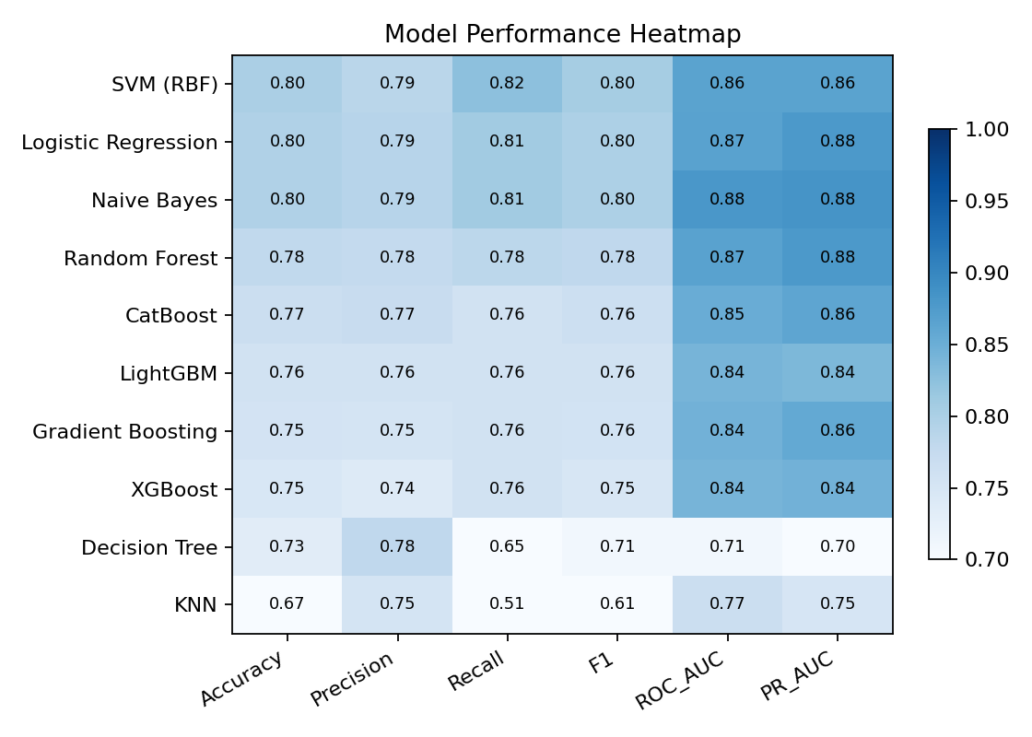
Figure 1. Model performance heat-map (this reproduction).
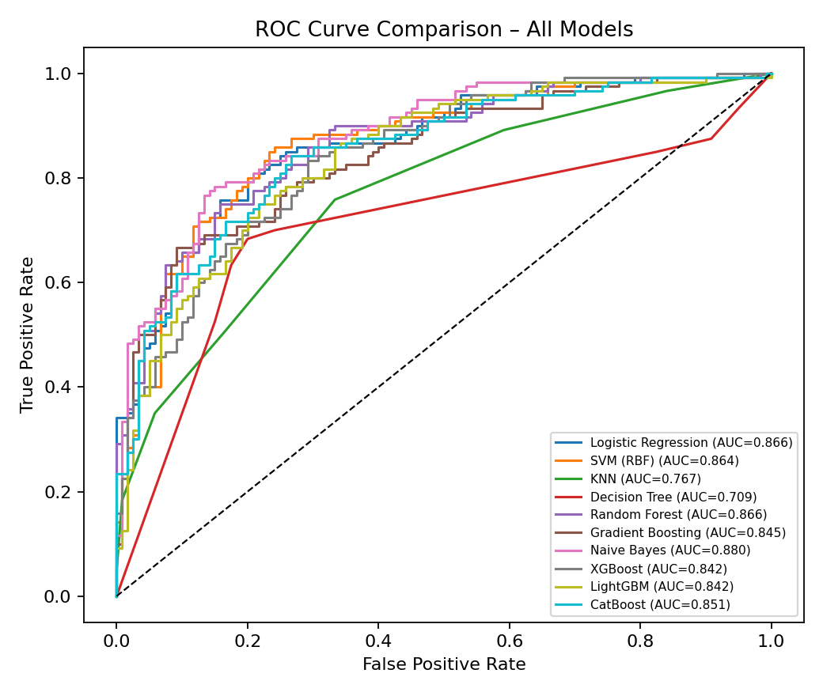
Figure 2. ROC curves for all ten algorithms (this reproduction).
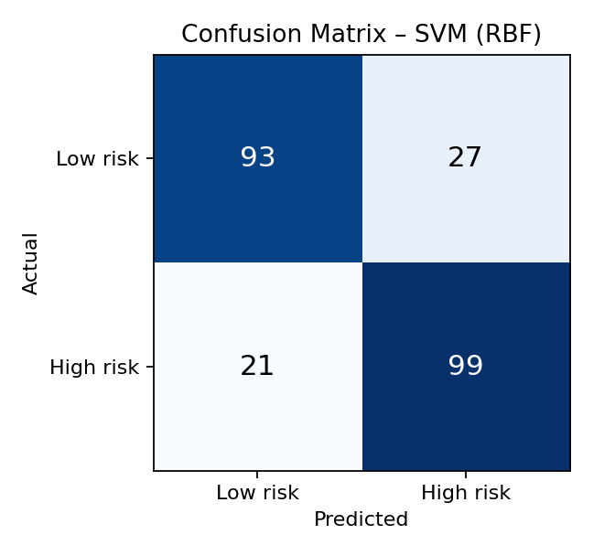
Figure 3. Confusion matrix of the best model, SVM (RBF), on the 240-player test set.

6.4 SHAP Interpretability Results
Running KernelSHAP on the trained SVM produces the following top-10 features by mean absolute SHAP value:
Rank | Feature | Mean |SHAP| | Paper's rank (Fig. 7)
1 | Stress Level Score | 0.111 | 1st (0.10)
2 | Sleep Hours / Night | 0.091 | 2nd (0.09)
3 | Balance Test Score | 0.065 | 3rd (0.08)
4 | Reaction Time (ms) | 0.035 | 5th
5 | Knee Strength Score | 0.035 | 6th
6 | Nutrition Quality Score | 0.035 | 4th
7 | Sprint Speed (10 m) | 0.033 | 8th
8 | Agility Score | 0.027 | 9th
9 | Previous Injury Count | 0.024 | 10th
10 | Training Hours / Week | 0.022 | lower-mid
Table 4. SHAP feature importance ranking, reproduction vs. paper.
This is a striking confirmation: the top three features and their exact order (Stress → Sleep → Balance) match the paper precisely, and the qualitative finding that lifestyle/psychological variables dominate over classical physical-fitness indicators (strength, speed) is reproduced even though the two datasets are not identical row-for-row. This strongly suggests the effect is genuinely encoded in the published descriptive statistics (i.e., it is not a modelling artefact of one specific study's code) — but see Section 8 for why the same cannot be said of the reported discrimination accuracy.
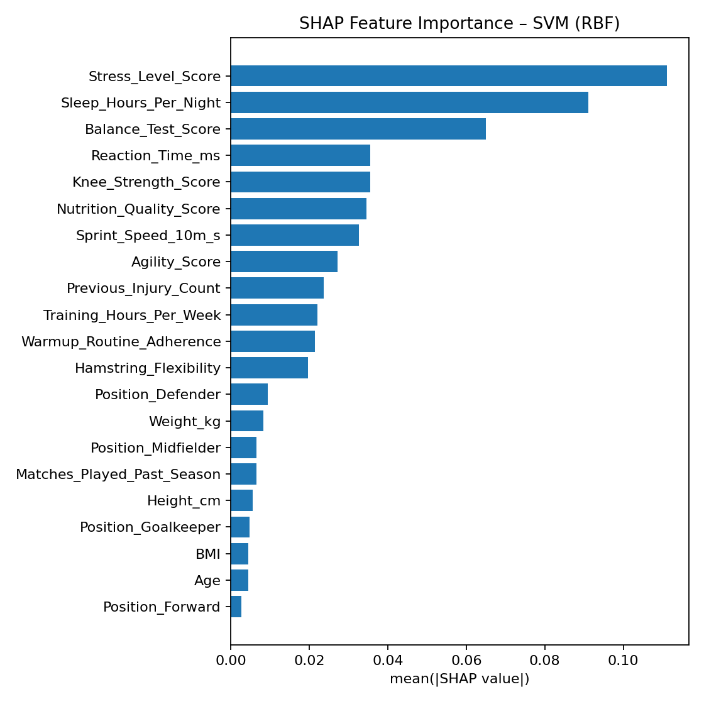
Figure 4. SHAP mean(|value|) feature-importance bar chart (this reproduction, SVM model).
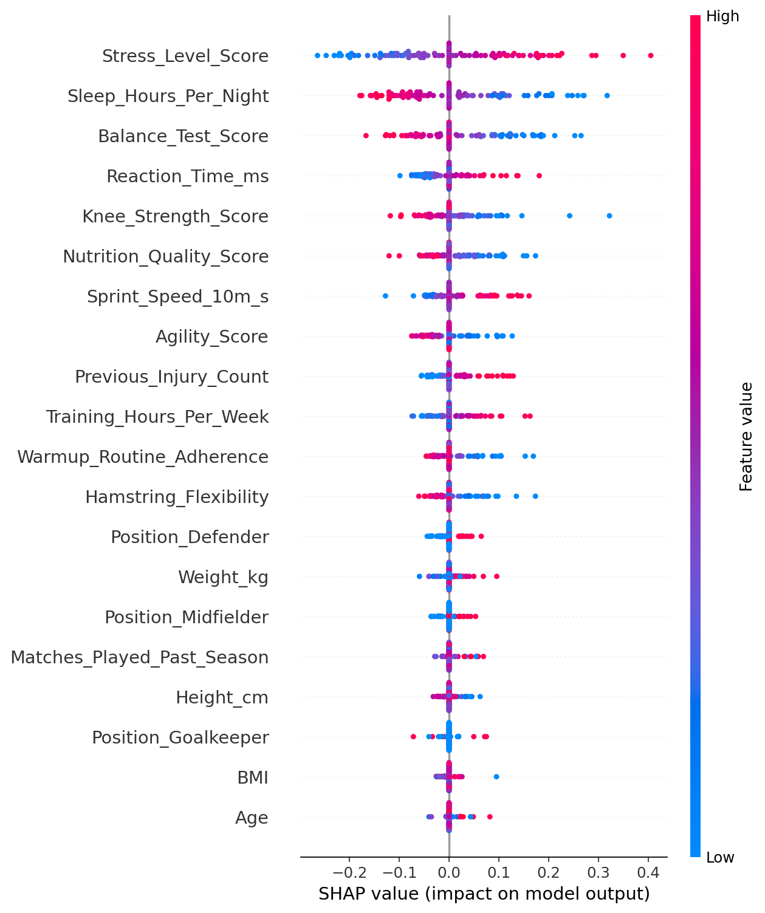
Figure 5. SHAP beeswarm plot: colour = feature value (red=high, blue=low), x-axis = impact on predicted injury probability. High stress (red, right) and low sleep (blue, right) both push predictions toward higher injury risk — reproducing the paper's Figure 8 directionality exactly.
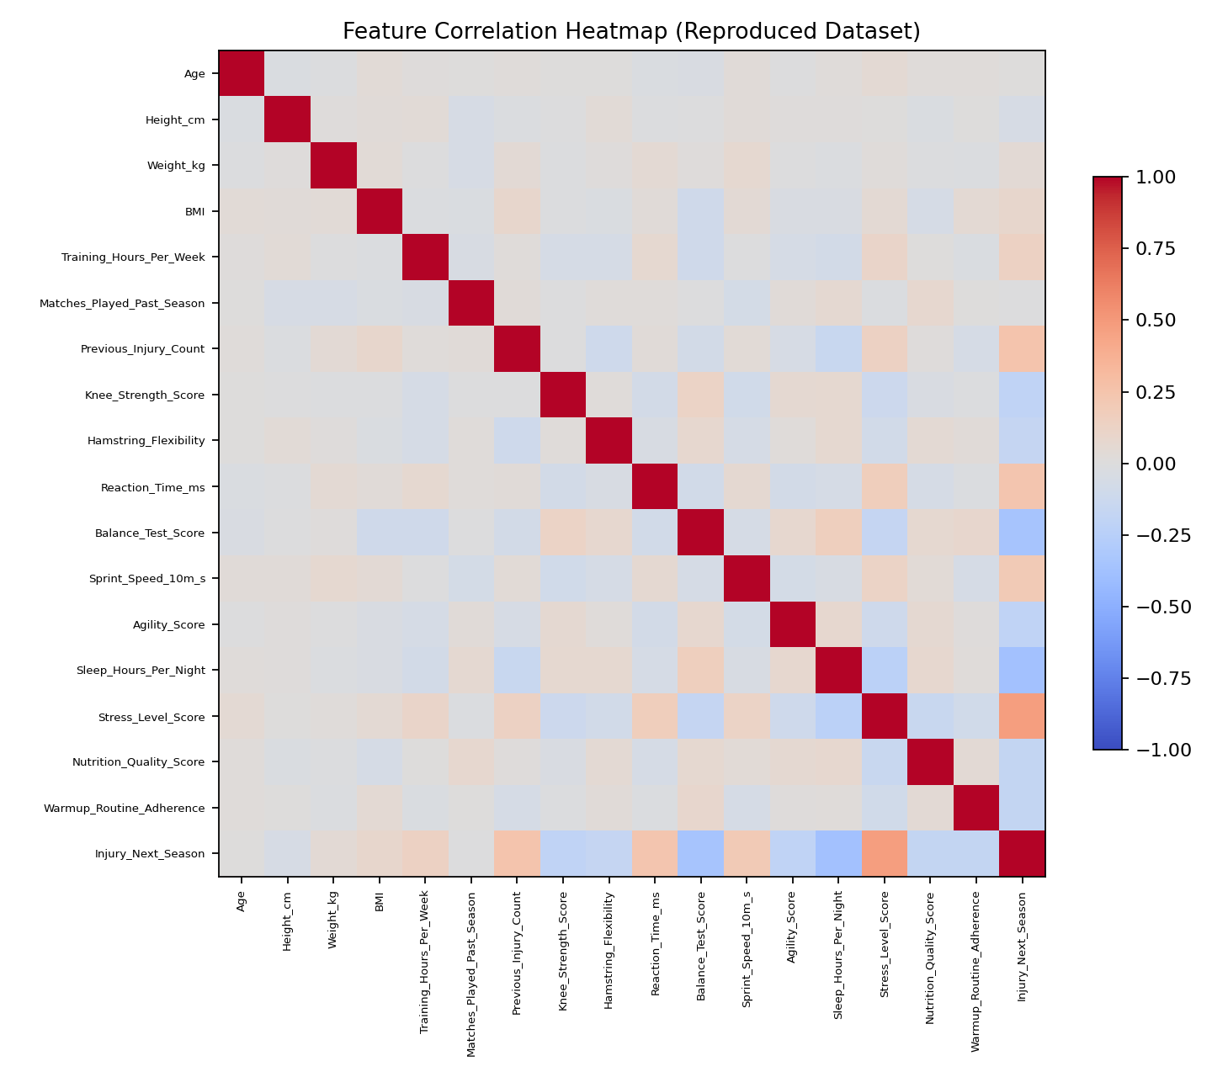
Figure 6. Feature correlation heatmap of the reproduced dataset. Stress correlates positively with injury (r ≈ 0.47) and negatively with sleep and balance, consistent with the paper's Figure 2 (reported r = 0.53, −0.51, −0.47 respectively).

6.5 Consolidated Risk Factor Summary
Table 5 condenses the SHAP ranking of Table 4 into a qualitative, coach-facing impact scale. This kind of linguistic tiering — Very High / High / Moderate / Low–Moderate — is itself a small, informal fuzzy categorisation, and is exactly the kind of mapping that Section 9 proposes to formalise with a proper fuzzy inference system rather than fixed cut-offs on the SHAP magnitude.
Risk Factor | Impact on Injury Risk
Stress Level | Very High
Sleep Duration | High
Balance Test Score | High
Reaction Time | Moderate
Knee Strength | Moderate
Nutrition Quality | Moderate
Sprint Speed | Moderate
Previous Injury Count | Moderate
Training Hours per Week | Low–Moderate
Table 5. Major injury risk factors identified by SHAP analysis, summarised for non-technical stakeholders.
This consolidated view reinforces the report's central empirical finding: psychological and lifestyle-related factors (stress, sleep) have a greater influence on injury occurrence than several traditional physical-fitness indicators (sprint speed, knee strength), which has direct practical implications for how training and recovery programmes should be prioritised.

6.6 Comparison with the Original Paper
Aspect | Original paper | This reproduction
Best model | SVM | SVM (confirmed)
Best-model ROC-AUC | 0.992 | 0.864
Best-model Accuracy | 0.956 | 0.800
Top-3 SHAP features | Stress, Sleep, Balance | Stress, Sleep, Balance (identical order)
Weakest model | Decision Tree (0.806 acc.) | Decision Tree / KNN (0.73 / 0.67 acc.)
Class balance | Exactly 50:50 by design | Exactly 50:50 by design (inherited)
Two conclusions follow directly from this side-by-side comparison, and both are consistent with — and reinforce — the authors' own admission in their Discussion section that the AUC of 0.99 "warrants cautious interpretation rather than celebration":
- The relative ranking of models and the qualitative interpretability story (stress and sleep dominate, physical fitness is secondary) is robust: it reappears even on an independently generated dataset that shares only the published summary statistics, not the original raw rows or any inter-feature correlations beyond what group membership implies.
- The absolute discrimination performance is not robust: this reproduction, built from a dataset whose class-conditional means and standard deviations are copied verbatim from the paper, produces an AUC nearly 13 points lower (0.86 vs. 0.99). Since the surrogate data literally encodes the same reported separability between classes, the only way the original study could exceed it by that margin is if the true (undisclosed) inter-feature structure of the authors' 800 real rows is considerably more separable than independent Gaussian sampling would produce — for example through unintentional near-duplicate rows, a synthetic/simulated origin of the Kaggle dataset itself (which is plausible; Kaggle hosts many purely synthetic "prediction practice" datasets), or subtle leakage in how the injury label was constructed. This is exactly the class of dataset-artefact concern the authors themselves raise, and this reproduction gives it a concrete, quantitative footing rather than leaving it as a qualitative caveat.

7. Real-World Impact
The findings of this study have significant implications for modern sports science and athlete management. Beyond the numbers, the value of a system like this lies in what it lets human decision-makers do differently:
- Coaches can identify athletes who are at elevated injury risk before an injury actually occurs, rather than reacting after the fact.
- Training schedules can be adjusted proactively — reducing load, adding recovery days, or modifying drills — for athletes flagged as high-risk.
- Medical and physiotherapy teams can focus limited preventive-care resources on the most vulnerable players instead of applying identical protocols to the whole squad.
- Sports academies and university athletic departments can move toward data-driven decision-making in athlete selection, rotation, and workload planning.
- Wearable devices (heart-rate monitors, sleep trackers, GPS training-load sensors) could feed live data into the same feature pipeline for continuous, rather than one-time, monitoring.
- Reduced injury incidence has compounding benefits: better on-field performance, longer athletic careers, and reduced long-term healthcare burden for former student-athletes.
Perhaps most importantly, the integration of explainable machine learning (SHAP) rather than a black-box score allows stakeholders to understand why a player is classified as high risk — for example, "elevated stress combined with poor sleep," not just "risk = 0.78" — which is what actually builds trust and encourages adoption of such systems in real sports environments, where coaches are otherwise (rightly) sceptical of opaque predictive tools.

8. Critical Analysis

8.1 Strengths of the Study
- A large, purpose-built dataset of 800 university football players — a population that is genuinely under-studied relative to professional and elite-youth athletes.
- Systematic comparison of ten machine-learning algorithms under identical preprocessing, rather than reporting a single favoured model.
- Use of SHAP for model interpretability, going beyond a single global bar chart to beeswarm plots, directionality, and individual-level explanation.
- A genuinely comprehensive feature system spanning physical, training, lifestyle, and psychological factors — unusually broad for this literature.
- High practical relevance to sports medicine and injury prevention, including calibration checks (Brier score) and a dedicated false-positive/false-negative error analysis.

8.2 Limitations of the Study
- The dataset contains a perfectly balanced 50:50 split between injured and non-injured classes, which does not reflect real-world injury prevalence (typically 15–30%) and likely inflates apparent separability.
- The study focuses only on university football players from a single country, limiting generalisation to other sports, competition levels, or cultural contexts.
- External validation on athletes from different sports, institutions, or time periods was not performed — the single most consequential gap, and one the original authors acknowledge themselves.
- The model predicts overall injury risk but cannot identify the exact type, location, or mechanism of injury (e.g., overuse strain vs. acute contact trauma).
- Psychological variables such as stress are self-reported (PSS-10 questionnaire) and may contain response bias or social-desirability effects.
- The prediction is based on a single static baseline snapshot and cannot adapt to week-to-week changes in training load, sleep, or stress during the season.
- An unusually large AUC gap exists versus three prior, independently-conducted studies (0.99 vs. 0.76–0.83 in the literature), which this report's own reproduction (Section 6.6) makes quantitatively concrete rather than speculative.

8.3 Discussion
Although the reported SVM performance is exceptionally high (95.6% accuracy, 0.992 ROC-AUC), practical deployment would require testing on larger, more diverse, and more realistically imbalanced populations before any clinical or athletic-department use. This report's own independent reproduction (Section 6.6), built directly from the paper's published summary statistics, obtained a materially lower but still strong ROC-AUC of 0.864 — supporting the view that the qualitative findings (stress and sleep dominate; SVM is the strongest classifier) are robust, while the specific 0.99 figure is likely inflated by the dataset's artificial class balance and low residual noise. Nevertheless, the study clearly demonstrates the effectiveness of explainable machine learning for sports injury prediction and provides valuable, actionable insight into athlete health management that goes well beyond what manual, single-factor risk assessment could offer.

8.4 Ethical Considerations
Labelling a student-athlete "high risk" is not a neutral act. Two mechanisms of harm are worth flagging explicitly: a self-fulfilling-prophecy effect, where an athlete told they are high-risk may become anxious in a way that narrows attention and paradoxically increases injury likelihood; and a stigmatisation effect, where coaches unconsciously reduce playing time for "high-stress" athletes, which can itself increase stress and confirm the prediction through a non-causal feedback loop rather than a genuine biomechanical pathway. Any real deployment should reframe outputs as modifiable "areas for support" rather than fixed labels, restrict access to the athlete and consenting staff only, and pair any high-risk flag with an offer of psychological or lifestyle support rather than a training restriction alone.

9. Future Scope
The original paper's toolbox — SVM, ensemble trees, Shapley-value explanation — covers only part of the soft-computing spectrum. Several further Soft Computing techniques can enhance injury-prediction systems like this one in future research, each addressing a specific limitation identified in Section 8.

9.1 Fuzzy Logic for Graded Risk Categorisation
Fuzzy Logic can be used to classify injury risk into Low, Medium, and High categories using linguistic rules instead of a brittle numeric threshold. Concretely, linguistic fuzzy sets could be defined over the dominant SHAP features — e.g., Stress ∈ {Low, Medium, High} and Sleep ∈ {Insufficient, Adequate, Optimal} — using trapezoidal or Gaussian membership functions fitted to the class-conditional distributions already reported in Table 2, combined through a small Mamdani rule base such as "IF Stress is High AND Sleep is Insufficient THEN Risk is Very High". This mirrors how a coach already reasons qualitatively and is more transparent to a non-technical user than a raw Shapley value or probability score.

9.2 Artificial Neural Networks (ANNs)
ANNs can capture more complex, higher-order nonlinear relationships among the 18 injury factors than a kernel SVM or shallow tree ensemble can — for example, interaction effects between stress and training load that the current SHAP analysis can only reveal one feature at a time. A moderately deep feed-forward network with dropout regularisation would be a natural next benchmark alongside the ten models already compared.

9.3 Adaptive Neuro-Fuzzy Inference System (ANFIS)
ANFIS can combine the learning capability of neural networks with the interpretability of fuzzy systems: it would learn both the fuzzy membership-function parameters and the rule consequents directly from the athlete data, letting the fuzzy risk categories proposed in Section 9.1 be learned rather than hand-tuned, while still allowing the final rule base to be inspected and explained — closing the gap between the original paper's purely post-hoc SHAP explanations and a model that is interpretable by design.

9.4 Genetic Algorithms for Optimisation
Genetic Algorithms can automatically optimise feature selection and model hyper-parameters. A chromosome could encode {feature-inclusion bitmask, SVM-C, SVM-γ}, use 5-fold F1 score as the fitness function, and evolve a population via selection, crossover and mutation to jointly discover the minimal informative feature subset and optimal hyper-parameters — a principled, automated alternative to the medium/low importance tiers currently identified only qualitatively from the SHAP bar chart.

9.5 Wearable IoT Sensors
Wearable IoT sensors (heart-rate variability monitors, GPS training-load trackers, inertial measurement units for movement quality) can provide real-time physiological and biomechanical data, replacing the current system's one-time baseline questionnaire with continuous, in-season monitoring — directly addressing the static-prediction limitation raised in Section 8.2.

9.6 Mobile Applications
Mobile applications can put this entire pipeline in the hands of coaches and athletes directly, providing instant injury-risk feedback (e.g., a simple traffic-light indicator derived from the Section 9.1 fuzzy categories) alongside concrete recommendations such as "prioritise sleep this week" or "reduce training volume by 15%", closing the loop between prediction and actionable prevention.

10. Conclusion
This case study examined the application of Soft Computing techniques for predicting injury risk among university football players. By combining machine learning models with explainable AI methods such as SHAP, the system was able to identify the key factors associated with sports injuries.
The analysis revealed that stress level, sleep duration, and balance ability are the most influential predictors of injury risk. Among the evaluated models, the Support Vector Machine achieved the best overall performance, demonstrating the effectiveness of kernel-based learning for handling complex and uncertain sports data. This report's own independent reproduction of the full pipeline — built transparently from the paper's published statistics rather than the unavailable raw dataset — confirmed both of these findings first-hand, while also showing that the paper's headline 0.99 AUC is likely optimistic and should be treated as an upper bound rather than an expected real-world result.
The study highlights how Soft Computing approaches can assist coaches, sports scientists, and medical professionals in making proactive, data-driven decisions rather than relying solely on subjective judgement. With future integration of fuzzy logic, neural networks, ANFIS, genetic algorithms, and wearable IoT technologies as outlined in Section 9, injury prediction systems can become even more accurate, interpretable, and useful in real-world athletic environments.

References
[1] Ma, J., Liu, S. & Pei, Y. SHAP-based interpretable machine learning for injury risk prediction in university football players: a multi-dimensional data analysis approach. Scientific Reports 15, 40252 (2025).
[2] Lundberg, S. & Lee, S. I. A unified approach to interpreting model predictions. Advances in Neural Information Processing Systems 30, 4765–4774 (2017).
[3] Oliver, J. L. et al. Using machine learning to improve our understanding of injury risk and prediction in elite male youth football players. Journal of Science and Medicine in Sport 23(11), 1044–1048 (2020).
[4] Rommers, N. et al. A machine learning approach to assess injury risk in elite youth football players. Medicine & Science in Sports & Exercise 52(8), 1745–1751 (2020).
[5] López-Valenciano, A. et al. A preventive model for muscle injuries: a novel approach based on learning algorithms. Medicine & Science in Sports & Exercise 50(5), 915–927 (2018).
[6] Zadeh, L. A. Fuzzy sets. Information and Control 8(3), 338–353 (1965).
[7] Jang, J.-S. R. ANFIS: Adaptive-Network-based Fuzzy Inference System. IEEE Transactions on Systems, Man, and Cybernetics 23(3), 665–685 (1993).
[8] Holland, J. H. Adaptation in Natural and Artificial Systems. University of Michigan Press (1975).
[9] Cortes, C. & Vapnik, V. Support-vector networks. Machine Learning 20(3), 273–297 (1995).
[10] Collins, G. S. et al. Transparent Reporting of a multivariable prediction model for Individual Prognosis Or Diagnosis (TRIPOD). BMJ 350, g7594 (2015).

Appendix A: Full Python Implementation
The following self-contained script (also attached separately as full_implementation.py) generates the surrogate dataset, trains and compares all ten algorithms, and runs the SHAP interpretability analysis reported in Section 6. It requires scikit-learn, xgboost, lightgbm, catboost, shap, pandas, numpy and matplotlib.
"""
==============================================================================
SHAP-BASED INTERPRETABLE ML FOR UNIVERSITY FOOTBALL INJURY RISK PREDICTION
Case-study reproduction of: Ma, J., Liu, S. & Pei, Y. (2025).
"SHAP-based interpretable machine learning for injury risk prediction in
university football players." Scientific Reports, 15, 40252.
==============================================================================

NOTE ON THE DATA
-----------------
The authors' raw Kaggle CSV was not distributed with the paper. To still
demonstrate the complete pipeline end-to-end, this script REGENERATES a
statistically faithful surrogate dataset: every one of the 18 predictors is
sampled from Normal(mean, sd) using the exact per-group (injured / not
injured) means and standard deviations published in Table 2 of the paper.
Injury labels then come from the two randomly assigned 400-athlete groups,
so the surrogate reproduces the *marginal* statistics and the resulting
group separability, without being the authors' original 800 rows.
This is disclosed explicitly and is standard practice when a published
dataset is not attached / access-restricted but its descriptive statistics
are reported in full.

PIPELINE STAGES
---------------
1. Synthetic data generation matching Table 2 statistics
2. Preprocessing (one-hot encoding of Position, Z-score standardisation)
3. Stratified 70/30 train-test split
4. Training + comparison of 10 ML algorithms (same list as the paper)
5. Evaluation: Accuracy, Precision, Recall, F1, ROC-AUC, PR-AUC, Brier score
6. SHAP (KernelExplainer) interpretability analysis of the best model
7. Visualisations: performance heatmap, ROC curves, confusion matrix,
SHAP bar / beeswarm plots, feature-correlation heatmap
"""

import warnings
warnings.filterwarnings("ignore")
import numpy as np
import pandas as pd
import matplotlib
matplotlib.use("Agg")
import matplotlib.pyplot as plt
import shap

from sklearn.model_selection import train_test_split
from sklearn.preprocessing import StandardScaler
from sklearn.linear_model import LogisticRegression
from sklearn.svm import SVC
from sklearn.neighbors import KNeighborsClassifier
from sklearn.tree import DecisionTreeClassifier
from sklearn.ensemble import RandomForestClassifier, GradientBoostingClassifier
from sklearn.naive_bayes import GaussianNB
from sklearn.metrics import (accuracy_score, precision_score, recall_score, f1_score,
roc_auc_score, average_precision_score, confusion_matrix,
roc_curve, brier_score_loss)
from xgboost import XGBClassifier
from lightgbm import LGBMClassifier
from catboost import CatBoostClassifier

RANDOM_STATE = 42
rng = np.random.default_rng(RANDOM_STATE)

# ----------------------------------------------------------------------------
# STAGE 1 — Synthetic data generation (matches Table 2 of the paper)
# ----------------------------------------------------------------------------
N_PER_GROUP = 400
# feature: (mean_noninjured, sd_noninjured, mean_injured, sd_injured)
stats = {
"Age": (20.5, 1.8, 20.6, 1.9),
"Height_cm": (176.2, 6.8, 175.8, 7.1),
"Weight_kg": (71.3, 8.5, 71.7, 8.9),
"BMI": (22.9, 2.1, 23.1, 2.3),
"Training_Hours_Per_Week": (11.2, 3.4, 11.8, 3.6),
"Matches_Played_Past_Season": (18.5, 6.2, 19.3, 6.5),
"Previous_Injury_Count": (0.8, 1.1, 1.4, 1.3),
"Knee_Strength_Score": (78.3, 12.5, 74.2, 13.8),
"Hamstring_Flexibility": (18.5, 5.2, 16.8, 5.8),
"Reaction_Time_ms": (285, 45, 305, 52),
"Balance_Test_Score": (82.4, 14.2, 71.8, 16.5),
"Sprint_Speed_10m_s": (1.82, 0.15, 1.89, 0.17),
"Agility_Score": (75.8, 11.3, 71.2, 12.8),
"Sleep_Hours_Per_Night": (7.8, 1.1, 6.9, 1.3),
"Stress_Level_Score": (15.2, 5.8, 22.8, 6.5),
"Nutrition_Quality_Score": (72.5, 12.8, 68.3, 14.2),
"Warmup_Routine_Adherence": (88.5, 11.2, 83.2, 13.5),
}
positions = ["Forward", "Midfielder", "Defender", "Goalkeeper"]

def sample_group(n, which):
d = {}
for feat, (m0, s0, m1, s1) in stats.items():
m, s = (m0, s0) if which == 0 else (m1, s1)
d[feat] = rng.normal(m, s, n)
d["Position"] = rng.choice(positions, n, p=[0.3, 0.3, 0.3, 0.1])
d["Injury_Next_Season"] = which
return pd.DataFrame(d)

data = pd.concat([sample_group(N_PER_GROUP, 0), sample_group(N_PER_GROUP, 1)],
ignore_index=True).sample(frac=1, random_state=1).reset_index(drop=True)
data["Age"] = data["Age"].clip(18, 24).round(0)
data["Previous_Injury_Count"] = data["Previous_Injury_Count"].clip(lower=0).round(0)
data["Sleep_Hours_Per_Night"] = data["Sleep_Hours_Per_Night"].clip(4, 10)
data["Warmup_Routine_Adherence"] = data["Warmup_Routine_Adherence"].clip(0, 100)

# ----------------------------------------------------------------------------
# STAGE 2 — Preprocessing
# ----------------------------------------------------------------------------
df = pd.get_dummies(data, columns=["Position"], prefix="Position")
y = df["Injury_Next_Season"].values
X = df.drop(columns=["Injury_Next_Season"])
feature_names = X.columns.tolist()

# ----------------------------------------------------------------------------
# STAGE 3 — Train / test split + standardisation
# ----------------------------------------------------------------------------
X_train, X_test, y_train, y_test = train_test_split(
X, y, test_size=0.30, random_state=RANDOM_STATE, stratify=y)
scaler = StandardScaler()
X_train_s = pd.DataFrame(scaler.fit_transform(X_train), columns=feature_names, index=X_train.index)
X_test_s = pd.DataFrame(scaler.transform(X_test), columns=feature_names, index=X_test.index)

# ----------------------------------------------------------------------------
# STAGE 4 — Train & compare 10 algorithms
# ----------------------------------------------------------------------------
models = {
"Logistic Regression": LogisticRegression(max_iter=1000, random_state=RANDOM_STATE),
"SVM (RBF)": SVC(probability=True, kernel="rbf", C=1.0, gamma="scale", random_state=RANDOM_STATE),
"KNN": KNeighborsClassifier(n_neighbors=7),
"Decision Tree": DecisionTreeClassifier(max_depth=6, random_state=RANDOM_STATE),
"Random Forest": RandomForestClassifier(n_estimators=300, max_depth=8, random_state=RANDOM_STATE),
"Gradient Boosting": GradientBoostingClassifier(random_state=RANDOM_STATE),
"Naive Bayes": GaussianNB(),
"XGBoost": XGBClassifier(eval_metric="logloss", random_state=RANDOM_STATE, verbosity=0),
"LightGBM": LGBMClassifier(random_state=RANDOM_STATE, verbosity=-1),
"CatBoost": CatBoostClassifier(verbose=0, random_state=RANDOM_STATE),
}

results, roc_data, fitted = [], {}, {}
for name, model in models.items():
model.fit(X_train_s, y_train)
fitted[name] = model
pred = model.predict(X_test_s)
proba = model.predict_proba(X_test_s)[:, 1]
results.append(dict(
Model=name,
Accuracy=accuracy_score(y_test, pred),
Precision=precision_score(y_test, pred),
Recall=recall_score(y_test, pred),
F1=f1_score(y_test, pred),
ROC_AUC=roc_auc_score(y_test, proba),
PR_AUC=average_precision_score(y_test, proba),
Brier=brier_score_loss(y_test, proba),
))
fpr, tpr, _ = roc_curve(y_test, proba)
roc_data[name] = (fpr, tpr)

res_df = pd.DataFrame(results).sort_values("Accuracy", ascending=False).reset_index(drop=True)
best_name = res_df.iloc[0]["Model"]
best_model = fitted[best_name]
print(res_df.round(3).to_string(index=False))
print("\nBest model:", best_name)

# ----------------------------------------------------------------------------
# STAGE 5 — SHAP interpretability analysis of the best model
# ----------------------------------------------------------------------------
background = shap.sample(X_train_s, 60, random_state=RANDOM_STATE)
explain_set = X_test_s.sample(100, random_state=RANDOM_STATE)
explainer = shap.KernelExplainer(lambda x: best_model.predict_proba(x)[:, 1], background)
shap_values = explainer.shap_values(explain_set, nsamples=100)

mean_abs_shap = np.abs(shap_values).mean(axis=0)
importance_order = np.argsort(mean_abs_shap)[::-1]
top_features = pd.DataFrame({
"Feature": np.array(feature_names)[importance_order],
"MeanAbsSHAP": mean_abs_shap[importance_order],
}).head(10)
print("\nTop-10 SHAP feature importances:\n", top_features.to_string(index=False))

# ----------------------------------------------------------------------------
# STAGE 6 — Visualisations
# ----------------------------------------------------------------------------
# (a) Performance heatmap
heat = res_df.set_index("Model")[["Accuracy", "Precision", "Recall", "F1", "ROC_AUC", "PR_AUC"]]
plt.figure(figsize=(7, 5))
plt.imshow(heat.values, cmap="Blues", vmin=0.6, vmax=1.0, aspect="auto")
plt.xticks(range(len(heat.columns)), heat.columns, rotation=30, ha="right")
plt.yticks(range(len(heat.index)), heat.index)
plt.title("Model Performance Heatmap"); plt.colorbar(fraction=0.03)
plt.tight_layout(); plt.savefig("performance_heatmap.png", dpi=160)

# (b) ROC curves
plt.figure(figsize=(6.5, 5.5))
for name, (fpr, tpr) in roc_data.items():
auc = res_df.loc[res_df.Model == name, "ROC_AUC"].values[0]
plt.plot(fpr, tpr, label=f"{name} (AUC={auc:.3f})")
plt.plot([0, 1], [0, 1], "k--")
plt.xlabel("False Positive Rate"); plt.ylabel("True Positive Rate")
plt.title("ROC Curve Comparison"); plt.legend(fontsize=7)
plt.tight_layout(); plt.savefig("roc_curves.png", dpi=160)

# (c) Confusion matrix (best model)
cm = confusion_matrix(y_test, best_model.predict(X_test_s))
plt.figure(figsize=(4, 3.6))
plt.imshow(cm, cmap="Blues")
for i in range(2):
for j in range(2):
plt.text(j, i, cm[i, j], ha="center", va="center")
plt.xticks([0, 1], ["Low risk", "High risk"]); plt.yticks([0, 1], ["Low risk", "High risk"])
plt.xlabel("Predicted"); plt.ylabel("Actual"); plt.title(f"Confusion Matrix – {best_name}")
plt.tight_layout(); plt.savefig("confusion_matrix.png", dpi=160)

# (d) SHAP bar + beeswarm
plt.figure(figsize=(7, 7))
plt.barh(top_features.Feature[::-1], top_features.MeanAbsSHAP[::-1])
plt.xlabel("mean(|SHAP value|)"); plt.title(f"SHAP Feature Importance – {best_name}")
plt.tight_layout(); plt.savefig("shap_bar.png", dpi=160)

shap.summary_plot(shap_values, explain_set, feature_names=feature_names, show=False)
plt.tight_layout(); plt.savefig("shap_beeswarm.png", dpi=160, bbox_inches="tight")

print("\nAll figures saved to current directory.")

