**APROJECT REPORT**

**ON**

**Goal Line technology**

SUBMITTED TO THE SAVITRIBAI PHULE PUNE UNIVERSITY

IN THE PARTIAL FULFILLMENT FOR THE AWARD OF THE DEGREE

**OF**

**THIRD YEAR OF ENGINEERING (SEM-2)**

**IN**

**ELECTRONICS AND TELECOMMUNICATION**

**BY**

**DIGAMBER GAVHANE EXAM NO. T151053008**

**VISHAL NIVANGUNE EXAM NO. T151053029**

**PANKAJ GHODKE EXAM NO. T151053009**

**UNDER THE GUIDANCE OF**

**Prof. S.P. DESHMUKH**



**DEPARTMENT OF ELECTRONICS AND TELECOMMUNICATIONENGG**

**STES’S**

**NBN SINHGAD SCHOOL OF ENGINEERING**

**AMBEGAON BK, OFF SINHGAD ROAD**

**PUNE 411041 2020-2021**



**CERTIFICATE**

This is to certify that the project report entitled

**"Goal Line Technology”**

**Submitted by**

**DIGAMBER GAVHANE. EXAM NO. T151053008**

**VISHAL NIVANGUNE EXAM NO. T151053029**

**PANKAJ GHODKE EXAM NO. T151053009**

Is a bonafide work carried out by them under the supervision of Prof. S.P. DESHMUKH and it is approved for the partial fulfillment of the requirement of University of Pune for the award of the Degree of Bachelor of Engineering (Electronics and Telecommunication).

This seminar report has not been earlier submitted to any other Institute or University for the award of any degree or diploma.

Prof. S.P. DESHMUKH Prof . M.M. JADHAV Dr .S.P.PATIL

Project Guide Head of Department Principal,

( E&T/C ) N.B.N.S.S.O.E, Pune-41

Place: Pune Date:

**ACKNOWLEDGEMENT**

It gives us an immense pleasure to express my sincere and heartiest gratitude towards my guide

**Prof . S.P. DESHMUKH** for his guidance, encouragement, moral support and affection through the course of my work. He has proven to be an excellent mentor and professor. We are especially appreciative to his willingness to listen and guide us to find the best solution, regardless of challenge.

Of greatest importance, we are also extremely grateful to Prof **Dr. M.M**

**JADHAV** Head of **E&TC**

Engineering Dept., for their motivation and support during the work from time to time. We are also thankful to our principal for his inspiration.

Lastly, my cordial thanks to all who have contributed intellectually and materially in words and deeds for completion of this work.

We express our gratitude to the **NBN SINHGAD SCHOOL OF ENGINEERING AMBEGAON, PUNE** for providing us with opportunity to do this project.

**Group Members -**

**DIGAMBER GAVHANE**

**VISHAL NIVANGUNE**

**PANKAJ GHODKE**

### CONTENTS

CERTIFICATE  *I* ACKNOWLEDGEMENT  *II*

|  |  |  |  |  |
| --- | --- | --- | --- | --- |
| **CHAPTER** | |  | **TITLE** | **PAGE NO.** |
| **1.** |  |  | **INTRODUCTION** |  |
|  |  |  |  |  |
|  | 1.1 |  | ABSTRACT…………………………...….…..... | 7 |
|  | 1.2 |  | INTRODUCTION.……………………………………….... | 8 |
|  | 1.3  1.4  1.5 |  | RELEVANCE….………  PROJECT UNDERTAKEN….………  ORGANISATION OF PROJECT….……… | 8  8 |
|  | 1.5.1 |  | SUMMARY | 9 |
|  |  |  |  |  |
| **2.**  **3.** | 2.1  2.2  2.3  2.4 |  | **LITERATURE AND SURVEY**  SURVEY NO 1………………………………………..  SURVEY NO 2……………………………………….  SURVEY NO 3……………………………………….  SURVEY NO 4……………………………………….  **DESIGN AND DRAWING** | 10  11 |
|  |  |  |  |  |
|  | 3.1 |  | INTRODUCTION…….……………………………. | 13 |
|  | 3.2  3.3 |  | BLOCK DIAGRAM…….…………………………….  DESCRIPTION OF COMPONENTS…….……………………………. | 14 |
|  |  | 3.3.1 | At Mega 16 Microcontroller…….……………………………. | 15 |
|  |  | 3.3.2 | Liquid Crystal Display …….……………………………. | 17 |
|  |  |  |  |  |
| **4.** |  |  | **CIRCUIT DIAGRAM** |  |
|  | 4.1  4.2 |  | INTRODUCTION…….…………………………….  CIRCUIT DIAGRAM…….……………………………. | 22 |
|  | 4.3 |  | PROTEUS CIRCUIT DIAGRAM………………………. | 23 |
|  |  |  |  |  |
|  |  |  |  |  |
|  |  |  |  |  |
|  |  |  |  |  |
|  |  |  |  |  |
| **5.** |  |  | **MANUFACTURING** | 24 |
|  |  |  |  |  |
|  | 5.1 |  | PCB LAYOUT AND ARTWORK…………………. | 25 |
|  | 5.2 |  | … | 27 |
|  |  | 5.2.1 | Soldering |  |
|  |  | 5.2.2 | PCB layout |  |
|  |  | 5.2.3 | Snapshot of simulation |  |
|  | 5.3  5.4 |  | PCB LAYOUT……………………………….  SNAPSHOT OF SIMULATION………………………………. | 30 |
|  |  |  |  | 31 |
|  |  |  |  |  |
| **6.** |  |  | **RESULTS AND DESCUSSION** | 33 |
|  |  |  |  |  |
|  | 6.1 |  | ADVANTAGES………………...……………………. | 34 |
|  | 6.2 |  | APPLICATIONS………..………………………… | 34 |
|  | 6.3 |  | CONCLUSIONS………………...…………………… | 34 |
|  | 6.4 |  | REFERENCES…………………….………………. | 35 |
|  |  |  |  |  |
|  |  |  |  |  |

**CHAPTER - 1**

**INTRODUCTION**

**1.1 ABSTRACT**

The goal-line technology is a method used to determine when the ball has slightly crossed the goal line with the assistance of electronic devices and at the same time assisting the referee in awarding a goal or not. Aim of goal- line technology is to assist the match officials in decision-making rather than replacing them. GLT must provide a evident indication that the ball has crossed the line so as to award or cancel the goal.The topic that we have chosen to discuss in our research paper is the emergence of the use of video technology in sports in recent years. During our lifetimes, information and computer technologies have significantly changed the world. The major technological revolution has had a very profound effect on contemporary sports over the last twenty years. Therefore, the use of different types of technology has become important in recent years due to the fact that sports contain moments in which there are mistakes made by referees and officials. The introduction of technology regarding these sports in recent years has helped to eradicate a number of these errors. The specific type of technology that is going to be discussed in this research paper is the use of video technology in relation to the potential introduction of goal line technology in football.First implemented at FIFA Club world cup 2012, and since then it has been implemented at multiple tournaments, like English Premier League, Liga BBVA, Bundesliga, etc and internationally it has been implemented at FIFA Confederations Cup 2013 and the FIFA world cup 2014, both in Brazil. GLT has been a success, since it has ameliorated the sport and given a helping hand to the match officials.Goal Line Technology makes use of GoalMinder, Cairos, GoalRef and the Hawk-eye system to assist in decision making. It has eliminated the missed events affecting the game as well as it uses magnetic fields and cameras to enhance the decision making ability of the referees.

**1.2 INTRODUCTION**

The objective of goal-line technology (GLT) is not to replace the role of the officials, but rather to support them in their decision-making. The technology must provide a clear indication as to whether the ball has fully crossed the line, and this information will serve to assist the referee in taking his final decision. As well as it ensures a fair play in sports such as football, hockey, hand-ball and also removes the human errors in umpiring and decision making. In football, there are some instances when the Ball hits the post, crosses the line but goes unnoticed due to human errors by referees. To avoid this situation, we introduce a circuit that will detect whether the ball crosses the line or not using the concept of a sensing and detecting. Apart from Football, this technology can be used in other sports as well. Also, with some modifications, it can be used in Traffic sensing and Home security, Vehicle counting on tollbooths as well as counting no of products on the assembly-line.

**1.3 RELEVANCE**

This system is relevant to human goal detection system. This project can be used to make current method more efficient. Human eye is not always accurate. This project solves the problems.

**1.4 PROJECT UNDERTAKEN**

The project undertaken is 'GOAL LINE TECHNOLOGY', based on embedded systems. This project aims at detecting goal with the help of IR sensor . For the purpose of display, (PIC 18F2420) microcontroller is used.

**1.5 ORGANISATION OF PROJECT REPORT**

**1.5.1 SUMMARY**

Goal-line technology has become the most upcoming technologies in the future, As it has a variety of uses in many sports. many sports organizations are going to implement it soon.

.

**CHAPTER 2**

**LITERATURE AND SURVEY**

* 1. **SURVEY NO 1**

In this paper, a real case study on a Goal Line Monitoring system is presented. The core of the paper is a refined ball detection algorithm that analyzes candidate ball regions to detect the ball. A decision making approach, by means of camera calibration, decides about the goal event occurrence. Differently from other similar approaches, the proposed one provides, as unquestionable proof, the image sequence that records the goal event under consideration. Moreover, it is non-invasive: it does not require any change in the typical football devices (ball, goal posts, and so on). Extensive experiments were performed on both real matches acquired during the Italian Serie A championship, and specific evaluation tests by means of an artificial impact wall and a shooting machine for shot simulation. The encouraging experimental results confirmed that the system could help humans in ambiguous goal line event detection.

* 1. **SURVEY NO 2**

In this paper, model-based approaches for real-time 3-D soccer ball tracking are proposed, using image sequences from multiple fixed cameras as input. The main challenges include filtering false alarms, tracking through missing observations, and estimating 3-D positions from single or multiple cameras. The key innovations are: 1. incorporating motion cues and temporal hysteresis thresholding in ball detection; 2. modeling each ball trajectory as curve segments in successive virtual vertical planes so that the 3-D position of the ball can be determined from a single camera view; and 3. introducing four motion phases (rolling, flying, in possession, and out of play) and employing phase-specific models to estimate ball trajectories which enables high-level semantics applied in low-level tracking. In addition, unreliable or missing ball observations are recovered using spatio-temporal constraints and temporal filtering. The system accuracy and robustness are evaluated by comparing the estimated ball positions and phases with manual ground-truth data of real soccer sequences.

* 1. **SURVEY NO 3**

In this paper, we investigate on the feasibility of multiple camera system for automatic offside detection. We propose six fixed cameras, properly placed on the two sides of the soccer field (three for each side) to reduce perspective and occlusion errors. The images acquired by the synchronized cameras are processed to detect the players' position and the ball position in real-time; a multiple view analysis is carried out to evaluate the offside event, considering the position of all the players in the field, determining the players who passed the ball, and determining if active offside condition occurred. The whole system has been validated using real-time images acquired during official soccer matches, and quantitative results on the system accuracy were obtained comparing the system responses with the ground truth data generated manually on a number of extracted significant sequences.

* 1. **SURVEY NO 4**

In this paper, model-based approaches for real-time 3-D soccer ball tracking are proposed, using image sequences from multiple fixed cameras as input. The main challenges include filtering false alarms, tracking through missing observations, and estimating 3-D positions from single or multiple cameras. The key innovations are: 1. incorporating motion cues and temporal hysteresis thresholding in ball detection; 2. modeling each ball trajectory as curve segments in successive virtual vertical planes so that the 3-D position of the ball can be determined from a single camera view; and 3. introducing four motion phases (rolling, flying, in possession, and out of play) and employing phase-specific models to estimate ball trajectories which enables high-level semantics applied in low-level tracking. In addition, unreliable or missing ball observations are recovered using spatio-temporal constraints and temporal filtering. The system accuracy and robustness are evaluated by comparing the estimated ball positions and phases with manual ground-truth data of real soccer sequences.

**CHAPTER-3**

**DESIGN AND DRAWING**

**3.1 INTRODUCTION**

1.Goalposts are fitted with the sensors such as IR sensors which detects the whether the ball has passed the goal or not.

2.The ball is an obstacle which activates the sensor when it passes the goal line. These sensors are accepted by FIFA(Federation International Football Association)and it doesn’t tamper the attributes of the ball.

3.If 50% of the ball passes the goal line the sensors on the goalpost detects the ball and then passes the data to the microcontroller.

**3.2 BLOCK DIAGRAM**

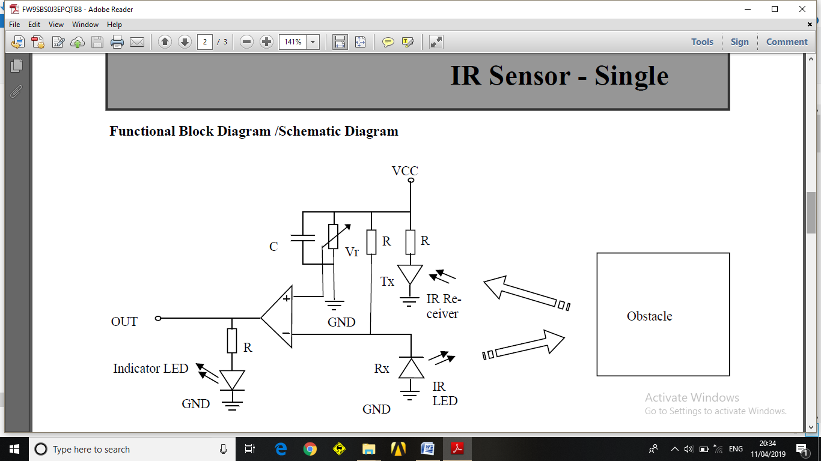

**3.3 DESCRIPTION OF COMPONENTS USED**

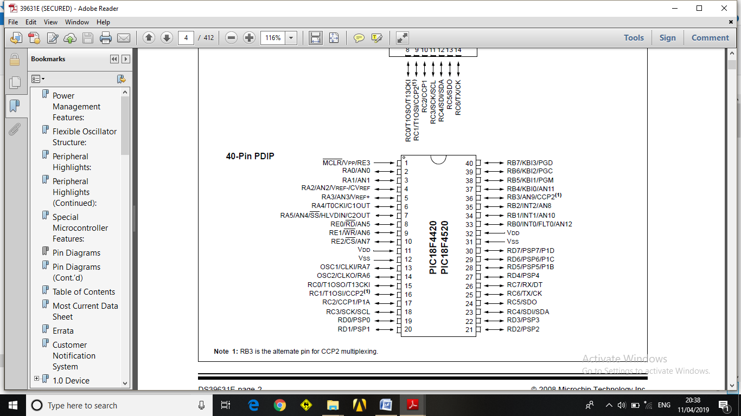

**Power Management Features:**

• Run: CPU on, Peripherals on

• Idle: CPU off, Peripherals on

• Sleep: CPU off, Peripherals off

• Ultra Low 50nA Input Leakage

• Run mode Currents Down to 11 ⎧A Typical

• Idle mode Currents Down to 2.5 ⎧A Typical

• Sleep mode Current Down to 100 nA Typical

• Timer1 Oscillator: 900 nA, 32 kHz, 2V

• Watchdog Timer: 1.4 ⎧A, 2V Typical

• Two-Speed Oscillator Start-up

**Flexible Oscillator Structure:**

• Four Crystal modes, up to 40 MHz

• 4x Phase Lock Loop (PLL) – Available for Crystal

and Internal Oscillators

• Two External RC modes, up to 4 MHz

• Two External Clock modes, up to 40 MHz

• Internal Oscillator Block:

- Fast wake from Sleep and Idle, 1 ⎧s typical

- 8 use-selectable frequencies, from 31 kHz to

8 MHz

- Provides a complete range of clock speeds

from 31 kHz to 32 MHz when used with PLL

- User-tunable to compensate for frequency drift

• Secondary Oscillator using Timer1 @ 32 kHz

• Fail-Safe Clock Monitor:

- Allows for safe shutdown if peripheral clock stops

**Peripheral Highlights:**

• High-Current Sink/Source 25 mA/25 mA

• Three Programmable External Interrupts

• Four Input Change Interrupts

• Up to 2 Capture/Compare/PWM (CCP) modules

• Master Synchronous Serial Port (MSSP) module

Supporting 3-Wire SPI (all 4 modes) and I2C™

Master and Slave modes

• Enhanced Addressable USART module:

- Supports RS-485, RS-232 and LIN/J2602

- RS-232 operation using internal oscillator

block (no external crystal required)

- Auto-wake-up on Start bit

- Auto-Baud Detect

• 10-Bit, up to 13-Channel Analog-to-Digital (A/D)

Converter module:

- Auto-acquisition capability

- Conversion available during Sleep

• Dual Analog Comparators with Input Multiplexing

• Programmable 16-Level High/Low-Voltage

Detection (HLVD) module:

- Supports interrupt on High/Low-Voltage Detection

**Special Microcontroller Features:**

• C Compiler Optimized Architecture:

- Optional extended instruction set designed to

optimize re-entrant code

• 100,000 Erase/Write Cycle Enhanced Flash

Program Memory Typical

• 1,000,000 Erase/Write Cycle Data EEPROM

Memory Typical

• Flash/Data EEPROM Retention: 100 Years Typical

• Self-Programmable under Software Control

• Priority Levels for Interrupts

• 8 x 8 Single-Cycle Hardware Multiplier

• Extended Watchdog Timer (WDT):

- Programmable period from 4 ms to 131s

• Single-Supply 5V In-Circuit Serial

Programming™ (ICSP™) via Two Pins

• In-Circuit Debug (ICD) via Two Pins

• Wide Operating Voltage Range: 2.0V to 5.5V

• Programmable Brown-out Reset (BOR) with software enable options.

**LIQUID CRYSTAL DISPLAY (16 X 2 LCD)**

**LIQUID CRYSTAL DISPLAY:**

**Introduction:**

Here I'll discuss how to interface LCD display to microcontrollers. There are different types of LCD display available in market, but the most commonly used character based LCD display is Hitachi's HD44780 controller or other which are compatible with HD44580.

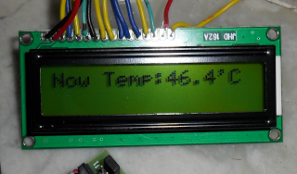

**Pins of LCD Display:**

This is a 16x2 LCD, means it has to lines and each line can display 16 characters. Most LCDs have 14 Pins and some LCDs have 2 controller has 16 Pins (two pins are extra in both for back-light  
LED connections). Pin description is shown:

[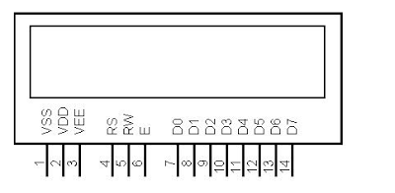](http://2.bp.blogspot.com/-Kw5RlLquJQM/T39KF25PSVI/AAAAAAAAAHI/Av0dcxzQDR4/s1600/lcd3.PNG)

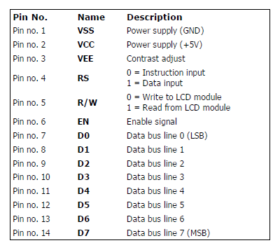

**Fixed voltage pins:**

           Pin1(Vss/Gnd), Pin2(Vcc), Pin3(Vee, connected to a pot) are dc lines, they are directly connected to voltage sources and to ground, they are not controlled by the microcontroller. Click here to see the diagram.

**Control Pins:**

         Pin4(RS), Pin5 (R/W), Pin6(EN) are control pins, I have connected these pins to PB0, PB1, PB2 respectively click here to see the diagram.

        EN: A negative edge of clock pulse must be given to this pin to make the LCD work each time you write a data port(Pin7 to Pin14). How you will give an negative edge of clock pulse here? First SET the pin then RESET the pin.

        For R/W and RS see above picture.

**Backlight Control Pins:**

         There are two extra pins (LED+ and LED-) to turn on the backlight of LCD display. Click here to see the diagram.

**Data Pins:**

         Pin7 to Pin14 are data pins. They are connected to portD of the microcontroller. Here Pin7 is LSB and Pin14 is MSB.

**Basic Instructions for LCD Display:**

|  |  |  |  |
| --- | --- | --- | --- |
| **No.** | **Instruction** | **Hex** | **Decimal** |
| 1 | Function Set: 8-bit, 1 Line, 5x7 Dots | 0x30 | 48 |
| 2 | Function Set: 8-bit, 2 Line, 5x7 Dots | 0x38 | 56 |
| 3 | Function Set: 4-bit, 1 Line, 5x7 Dots | 0x20 | 32 |
| 4 | Function Set: 4-bit, 2 Line, 5x7 Dots | 0x28 | 40 |
| 5 | Entry Mode | 0x06 | 6 |
| 6 | Display off Cursor off (clearing display without clearing DDRAM content) | 0x08 | 8 |
| 7 | Display on Cursor on | 0x0E | 14 |
| 8 | Display on Cursor off | 0x0C | 12 |
| 9 | Display on Cursor blinking | 0x0F | 15 |
| 10 | Shift entire display left | 0x18 | 24 |
| 12 | Shift entire display right | 0x1C | 30 |
| 13 | Move cursor left by one character | 0x10 | 16 |
| 14 | Move cursor right by one character | 0x14 | 20 |
| 15 | Clear Display (also clear DDRAM content) | 0x01 | 1 |
| 16 | Set DDRAM address or cursor position on display | 0x80+add | 128+add |
| 17 | Set CGRAM address or set pointer to CGRAM location | 0x40+add | 64+add |

**Sending Commands to LCD**

To send commands we simply need to select the command register. Following are the steps:

1. Move data to LCD port.
2. Select command register.
3. Select write operation.
4. Send enable signal.
5. Wait for LCD to process the command

**Sending Data to LCD**

1. Move data to LCD port.
2. Select data register.
3. Select write operation.
4. Send enable signal.
5. Wait for LCD to process the data

**CHAPTER-4**

**CIRCUIT DIAGRAM**

**4.1 INTRODUCTION:-**

The circuit consists of a microcontroller (PIC18F2024)on which hex file is loaded. The time of the match is set and the sensors are fitted to the goalsThe input is given by the LDR. We have three states:

* The first state gives us the score and the time of the match.
* The second state displays the GOAL whenever the sensor detects it.
* The third state updates the goal in the scoreboard.

**4.3 PROTEUS CIRCUIT DIAGRAM**

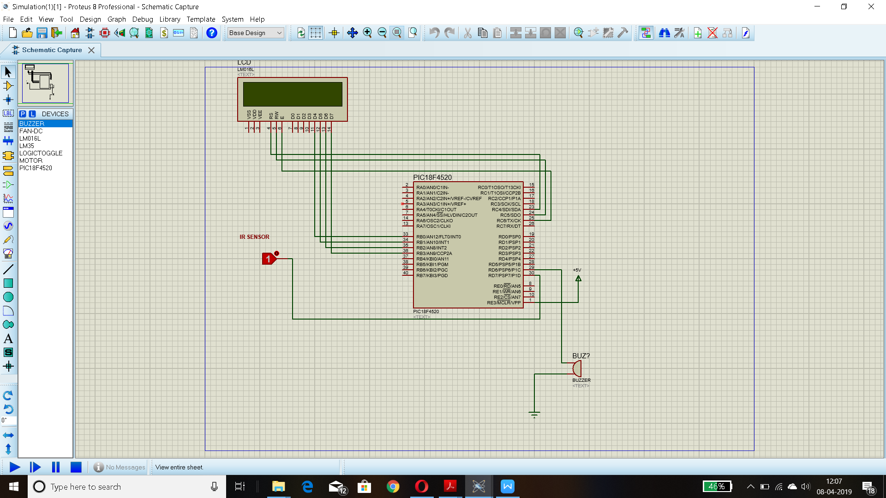

**4.4.1 SELECTION OF COMPONENTS:**

* **Availability:** Components for the projects are selected so that they are easily available in the market.

* **Size:** Depending upon the size components are selected to reduce the overall cost of the project.
* **Response time:** Components selected are digital to get the fast output and increase the accuracy of the circuit.

**CHAPTER NO.5**

**MANUFACTURING**

**5.1 PCB LAYOUT AND ARTWORK**

Layout basically means placing or arranging things in a specific order on the PCB. Layout means placing of components in an order. This placement is made such that the interconnection lengths are optimal .At the same time, it also aims at providing accessibility to the components for insertion testing and repair.

The PCB layout is the starting point for the final artwork preparation layout design should reflect the concept of final equipment.There are several factors, which we must keep in mind for placing the layout.

5.1.1. Schematic Diagram:

The schematic diagram forms main input document for preparation of the layout. For this purpose the software for PCB design, Express PCB was used.

5.1.2 Electrical and thermal requirement:

The PCB designer must be aware of the circuit performance in critical aspects of the same concerning electrical conditions and the environment to be used in.

5.1.3 Mechanical requirement:

The designer should have the information about physical size of the board, type of installation of board (vertical/horizontal). The method of cooling adopted, front panel operated components etc.

5.1.4 Component placing requirement:

All components are to be placed first in a configuration that demands only the minimum length for critical conductors. These key components are placed first and the others are grouped around like satellites**.**

5.1.5. Components mounting requirements:

All components must be placed parallel to one another as far as possible .i.e. in the same direction and orientation mechanical over stressing of solder should be avoided.

5.1.6 Layout Methodology:

For proper layout design minimal, steps to be followed are:

1. Get the final circuit diagram and component list.

2. Choose the board types, single sided / double sided / multilayered.

3. Identify the appropriate scale for layout.

4. Select suitable grid pattern.

5. Choose the correct board size keeping in view the constraints.

6. Select appropriate layout technique, manual / automated.

7. Document in the form of the layout scale.

5.1.7 Art Work:

Art work is accurately scaled configuration of the printed circuit from which the PCB tracks are made.

Art work rules:

Rules followed while selecting artwork symbol takes

1. Minimum spacing between conductor and pad should be 0 / 35 mm in 1:1 scale.

2. Minimum spacing between parallel conductors should be 0.4 mm in 1:1 scale.

3. The area of non-PTH solder pad should not be less than 5 sq.mm.

4. The width of current carrying conductors should be determined for max. temp.rise of 20C .

General Art Work Rules:

When there is higher conductor density assumes the conductors parallel to any one of the edge of the board.

When conductors have to be placed in other direction preference should be given to the 45ْ direction or to the 30ْ / 60ْ direction.

Whenever there is sufficient space available the conductors can be run in any direction so as to achieve sorted possible interconnection.

As far as possible, design and the conductor on the solder pad.

Conductor forming sharp internal angles must be avoided.

When a member of conductor has to run between two pads the conductor lines are run perpendicular w.r.t. the center-to-center line of pair of pads.

Equally distributed spacing is to be provided when three or more conductors run along a direction and / or between two pads.

Minimum spacing is provided when three or more lines run along a direction and / or between two pads.

The diameter of solder pad should be approximately 8 times the drilled hole diameter.

**5.2 IMPLEMENTATION**

The most important requirement of this project was to build a PCB with minimum weight and size. A zero PCB is a drilled board. Drilling process removes a lot of material from board and weight is reduced. Designing procedure is as follows:

Decide a proper place for components.

Actual placements of components from zero PCB

Connecting tracks with solid wires

Testing for continuity and Debugging

5.2.1 Soldering:

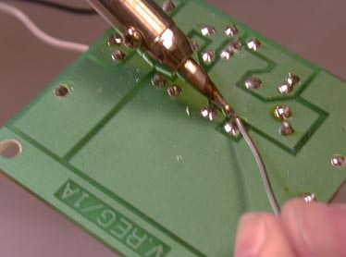

Soldering is a process in which two or more metal items are joined together by melting and flowing a filter metal(solder) into the joint, the filler metal having a lower melting point than the work piece. Soldering differs from welding in that soldering does not involve melting the work pieces.

5.2.2 Process

For hand soldering, the heat source tool should be selected to provide adequate heat for the size of joint to be complete. A 100 watt soldering iron may provide too much heat for printed circuit boards, while a 25 watt iron will not provide enough heat for large electrical connectors, joining copper roof flashing, or large stained- glass lead came. Using a tool with too high a temperature can damage sensitive components, but protracted heating by a tool that is too cool or under powered can also cause extensive heat damage.

Head -soldering techniques require a great deal of skill to use on what is known as fine pitch soldering of chip packages. In particular ball grid array (BGA) devices are notoriously difficult, if not impossible, to network by hand.

For attachment of electronic components to PCB, proper selection and use of flux helps prevent oxidation during soldering, which is essential for good wetting and heat transfer. The soldering iron tip must be clean and pre-tinned with solder to ensure rapid hat transfer.

Components which dissipate large amounts of heat during operation are sometimes elevated above the PCB to avoid PCB overheating .After inserting a through-hole mounted component, the excess lead is cut off, leaving a length of about the radius of the pad. Plastic or metal mounting clips or holders may be used with large devices to aid heat dissipation and reduces joint stresses.

5.2.3 Solder

Soldering filter materials are available in many different alloys or differing applications. In electronics assembly, the eutectic alloy of 63% tin 37% lead has been the alloy of choice.

Other alloys are used for plumbing, mechanical assembly, and other application. Some examples of soft-solder are tin-lead for general purpose, tin-zinc for joining aluminum, lead-silver for strength at higher then room temperature, cadmium-silver and tin-bismuth for electronics.

A eutectic formulation has advantage when applied to soldering the liquids and solidus temperature are the same, so there is no plastic phase, and it has the lowest possible melting point.

Having the lowest possible melting point minimizes heat stress on electronic components during soldering. And, having no plastic phase allows for quickly wetting as the solder heats up, and quicker setup as the solder cools.

5.2.4 Flux

The purpose of flux is to facilitate the soldering process. One of the obstacles to a successful solder joint is an impurity at the site of the joint. For example, dirt, oil, or oxidation. The impurities can be removed by mechanical cleaning or by chemical means, but the elevated temperatures required to melt the filter metal encourages the work piece to re-oxidize. This effect is accelerated as the soldering temperatures increases and can completely prevent the solder from joining to the work piece.

One of the earliest forms of flux was charcoal, which acts as a reducing agent and helps prevent oxidation during the soldering process. Some fluxes go beyond the simple prevention of oxidation and also provide some form of chemical cleaning.



**5.3 PCB LAYOUT:**

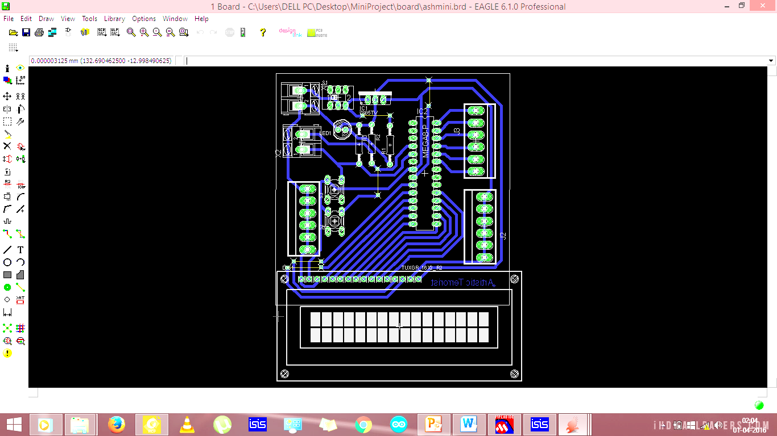

**5.4 SNAPSHOT OF SIMULATION:**

**1 .** When the sensor detects football , we will obtain Goal.



2.Then the score is automatically updated in the LCD screen .

**CHAPTER 6**

**RESULTS AND DISCUSSIONS**

**6.1 ADVANTAGES:**

1.Easy detection without Humanitarian errors.

2. Ensures fair play in sports.

3.Makes the work of referee easy.

4.Prevent controversies over goals

**6.2 APPLICATIONS:**

Apart from Football, this technology can be used in other sports such as hockey and basketball as well. Also, with some modifications, it can be used in Traffic sensing and Home security,vehicle counting on tollbooths as well as counting no of products on the assembly-line

**6.3 CONCLUSIONS:**

Goal-line technology has become the most upcoming technologies in the future.As it has a variety of uses in many sports,many sports organizations are going to implement it soon.

**6.4 REFERENCES:**

1. J. Ren, J. Orwell, G. Jones, and M. Xu. “Real-time modeling of 3-d soccer ball trajectories from multiple fixed cameras.” IEEE Transaction on Circuits and Systems for Video Technology, 18(3):350-362, 2008.
2. T. D'Orazio, M. Leo, P. Spagnolo, P. Mazzeo, M. Nitti, N. Mosca, and A. Distante. “An investigation into the feasibility of real-time soccer offside detection from a multiple camera system.” IEEE Transaction on Circuits and Systems for Video Technology, 19(12):1804-1817, 2009.
3. A. M. Fischler and R. C. Bolles. Random sample consensus. “A paradigm for model fitting with applications to image analysis and automated cartography.” Communication. ACM, 24(6):381-395, 1981.
4. X. Yu, H. Leong, C. Xu, and Q. Tian. “Trajectory-based ball detection and tracking in broadcast soccervideo.” IEEE Transaction on Multimedia, 8(6):1164-1178, 2006