Week 6 Baseline Model Report
Vishal Baboolal | CariSurg MedTech Pathways Programme 2026
AI-Assisted Emergency Department Triage
Verdict: The dataset contains useful predictive signal, but neither baseline is safe for clinical deployment because both miss most ESI Level 1 patients.

1. Dataset recap and modelling design
The cleaned dataset contains 55,121 emergency department encounters and 225 columns. The target is Emergency Severity Index (ESI), where Level 1 is most urgent and Level 5 is least urgent.
The model used 208 numeric clinical features available before or during triage. Post-triage leakage variables, administrative variables and fairness-sensitive demographic variables were excluded.
An 80/20 stratified split with random_state=42 produced 44,096 training records and 11,025 test records.

2. Baseline models
• Stratified random baseline - predicts classes according to their training prevalence.
• Logistic regression - scaled linear multi-class classifier.
• Decision tree - non-linear rule-based classifier capped at max_depth=12 to limit overfitting.

3. Benchmark table
Model | Accuracy | Macro F1 | Weighted F1 | ESI 1 recall | ESI 2 recall
Stratified random baseline | 0.375 | 0.204 | 0.375 | 0.000 | 0.327
Logistic regression | 0.667 | 0.492 | 0.661 | 0.250 | 0.608
Decision tree | 0.585 | 0.303 | 0.535 | 0.062 | 0.410
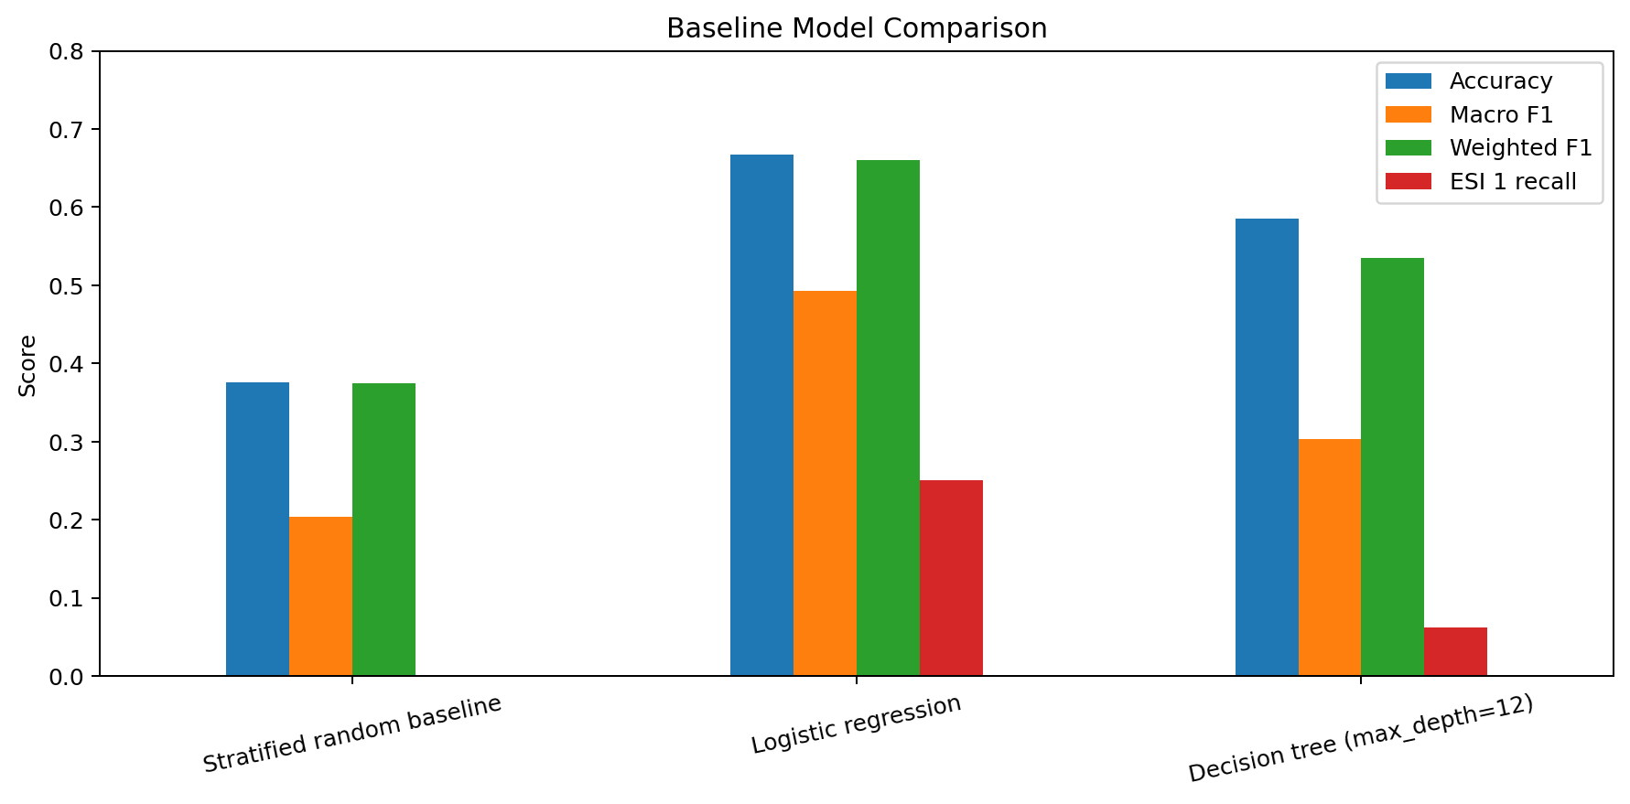
Figure 1. Comparison of the three baseline models.

4. Confusion matrices
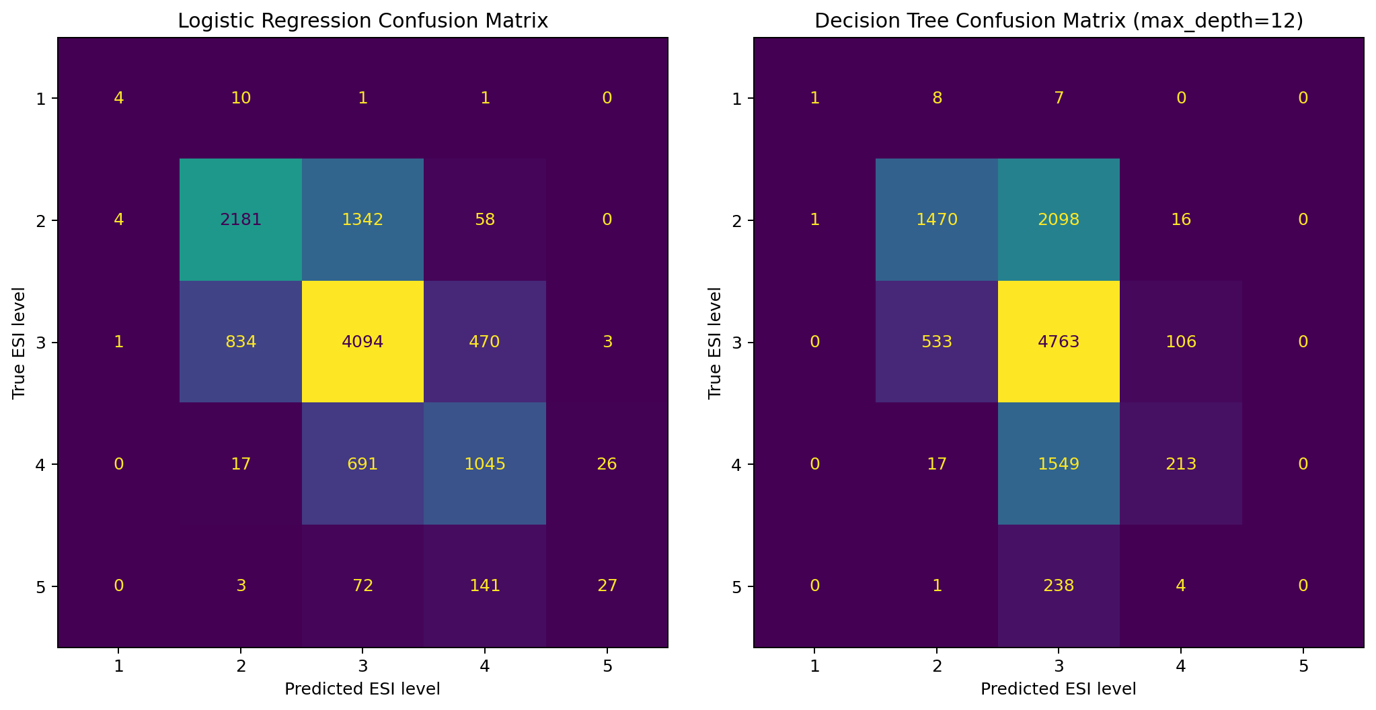
Figure 2. Rows are true ESI levels; columns are predicted levels.

5. Primary metric and clinical justification
The primary metric is ESI Level 1 recall: the proportion of truly Level 1 patients correctly identified. Accuracy is unsafe as the main measure because ESI Level 1 is extremely rare. A model could appear accurate while overlooking patients needing immediate life-saving care.
Logistic regression identified 4 of 16 Level 1 patients (25.0%) and missed 12. The decision tree identified 1 of 16 (6.2%) and missed 15. Neither result is clinically acceptable.

6. Macro versus weighted F1
Macro F1 gives every ESI class equal importance. Weighted F1 gives more influence to common classes. Logistic regression's macro F1 was 0.492, while its weighted F1 was 0.661. This gap shows that performance is substantially better on common ESI 2 and ESI 3 cases than on rare ESI 1 and ESI 5 cases.

7. Failure-mode reflection
The most serious failure is under-triage of critically ill patients. Logistic regression missed 12 of 16 ESI 1 cases, and the decision tree missed 15. A missed critical case could delay resuscitation, airway support, haemodynamic stabilisation or another urgent intervention.
The patients most at risk are those with subtle presentations or initially near-normal vital signs, where complaint context and clinical judgement may carry more urgency than the simple baseline captures.
The bounded decision tree also concentrated predictions in the common middle classes and did not correctly identify the least-urgent ESI 5 class. This shows that a single overall score would hide clinically important weaknesses.

8. Recommendation
Recommendation: retain both models as offline research baselines only. Logistic regression is the stronger overall reference model, but neither should influence patient care.

9. Next steps
• Address class imbalance using class weighting or carefully designed resampling.
• Tune models with cross-validation without using the held-out test set.
• Review de-identified summaries of missed ESI 1 and ESI 2 cases.
• Evaluate performance across demographic and operational subgroups.
• Assess calibration, alert burden and local transferability.
• Validate on Caribbean emergency department data before a silent pilot.

10. Reproducibility and governance
All models use the same stratified split and random_state=42. The patient-level CSV is excluded from the public repository. Only aggregate metrics, classification reports, figures and the executed notebook are committed.

