Week 5 Feasibility Memo: AI-Assisted Triage Data Exploration
Vishal Baboolal | CariSurg MedTech Pathways Programme | Dataset: yaleemmlc_admissionprediction_triage.csv

One-sentence verdict
Proceed with caveats: this dataset is suitable for building a baseline triage model because it has 55,121 adult ED records, complete ESI labels, vital signs and 200 chief-complaint flags, but it should only be used after leakage removal, outlier review, fairness checks and external/local validation.

Dataset summary
The dataset contains 55,121 patient records and 226 raw columns. After removing the original index column, the cleaned working file contains 225 columns. The target variable is ESI, where 1 is most urgent and 5 is least urgent. The dataset includes demographics, arrival details, vital signs, oxygen-device status, glucose, disposition variables and extensive one-hot encoded chief complaints.
Item | Finding
Age profile | 18-107 years; median 55; mean 55.3
Gender | 57.6% female; 42.4% male
Race/Ethnicity | 53.4% White/Caucasian; 29.0% Black/African American; 17.9% Hispanic/Latino
Arrival mode | 41.4% car; 33.7% ambulance
Missing/Duplicates | 0 missing values; 0 duplicate rows excluding index
Target balance | ESI 1: 0.14%, ESI 2: 32.5%, ESI 3: 49.0%, ESI 4: 16.1%, ESI 5: 2.2%
Figure 1. Core data quality dashboard
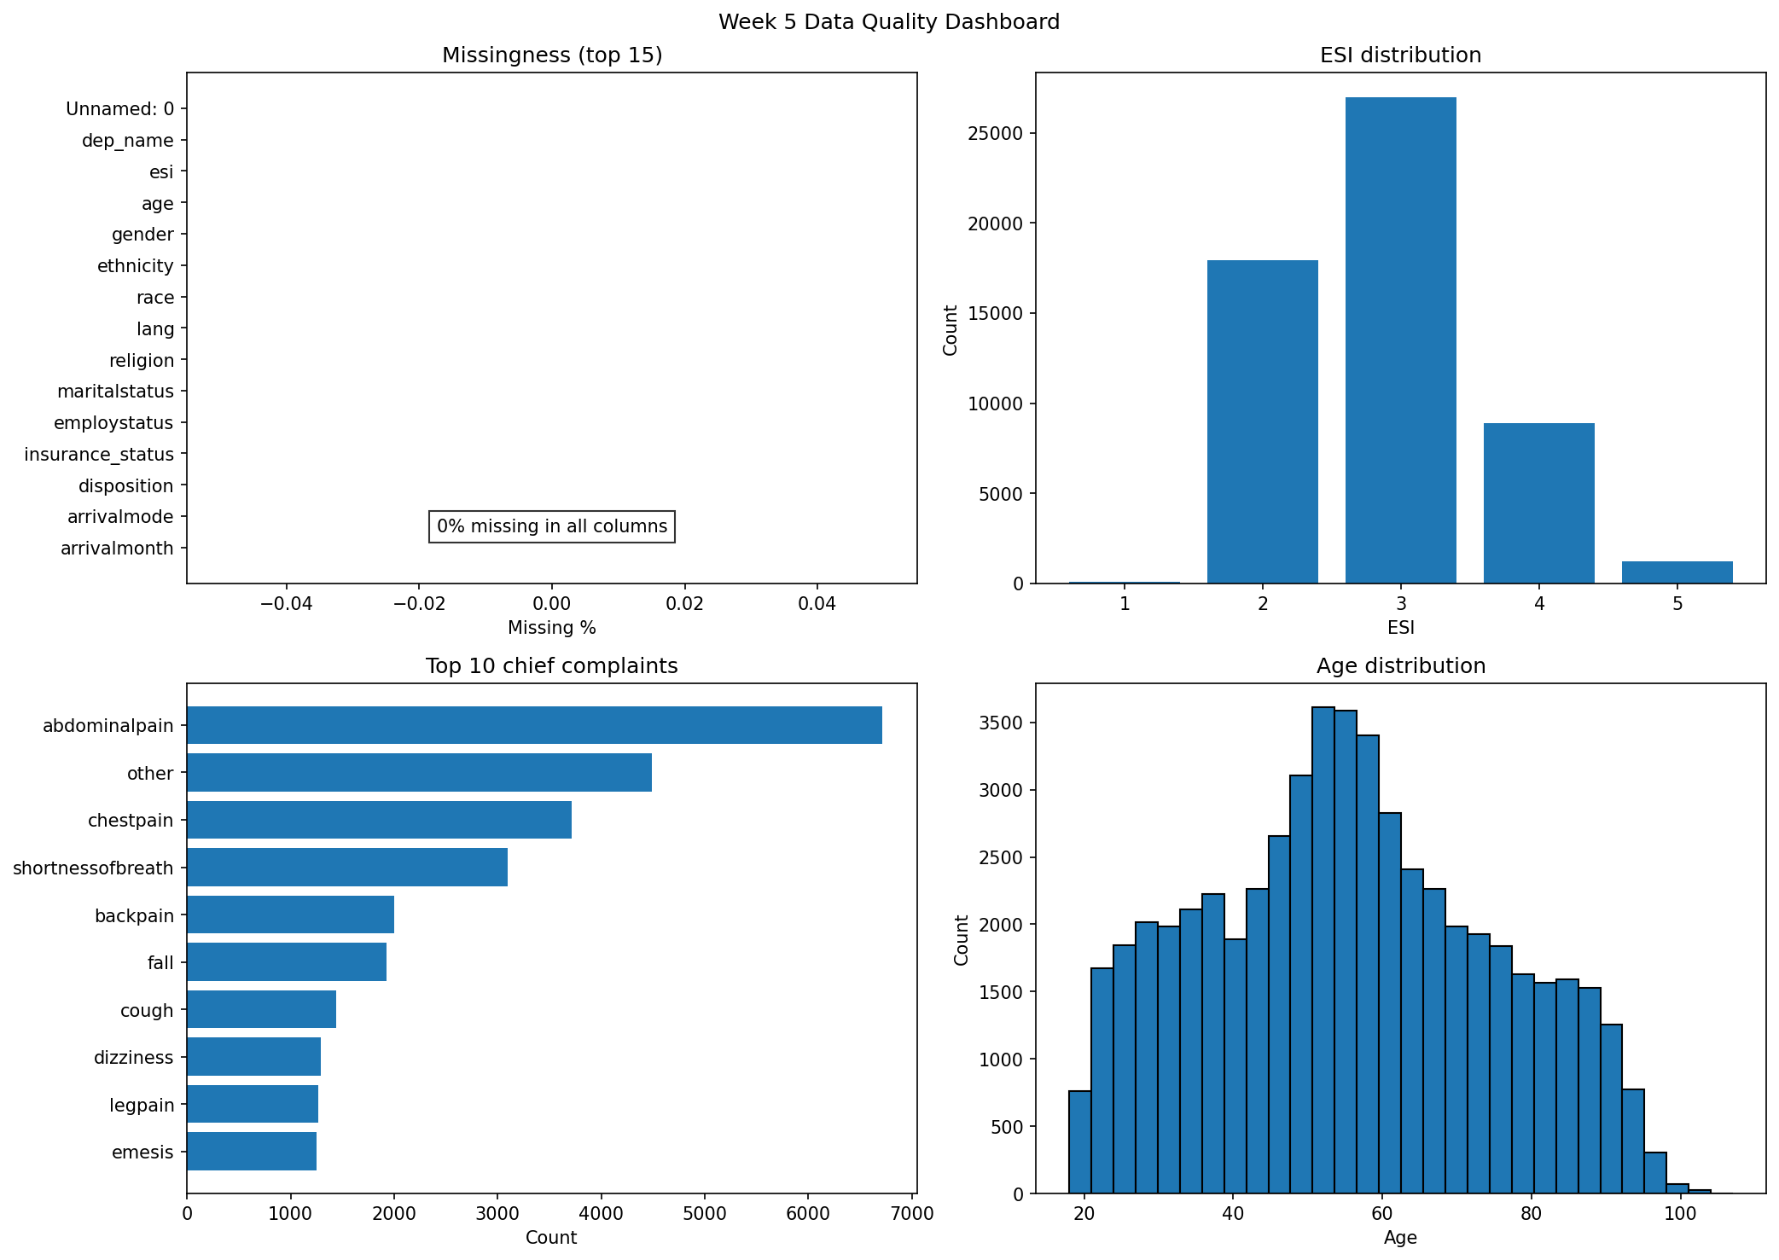

Top 3 data-quality concerns
1. Leakage risk from post-triage variables
The dataset includes disposition and previousdispo. Disposition occurs after ED assessment and treatment, so it must not be used as an input to a triage model. Excluding post-triage variables is essential to avoid artificially strong results.
2. Target imbalance
ESI 3 represents 49.0% of records and ESI 2 represents 32.5%, while ESI 1 is only 0.14%. A model could look accurate while missing rare but high-risk ESI 1 patients.
3. Extreme vital signs and transferability concerns
Vital signs are complete but include extreme values such as HR 221, systolic BP 266, respiratory rate 66, temperature 106 F and glucose 1066. Some may be true critical values, but they require audit. US-style insurance and arrival fields may not transfer cleanly to a Caribbean public hospital.

Top 3 reasons to proceed
1. Large sample size and complete labels
55,121 records with complete ESI labels support robust exploratory analysis and baseline modelling.
2. Clinically meaningful feature groups
Age, arrival mode, vital signs, oxygen-device status, glucose and chief complaints reflect information clinicians use during triage.
3. Rich complaint coverage
The 200 chief-complaint flags provide strong clinical context, including chest pain, shortness of breath, abdominal pain, altered mental status and suicidal ideation.
Figure 2. Target distribution and top complaints
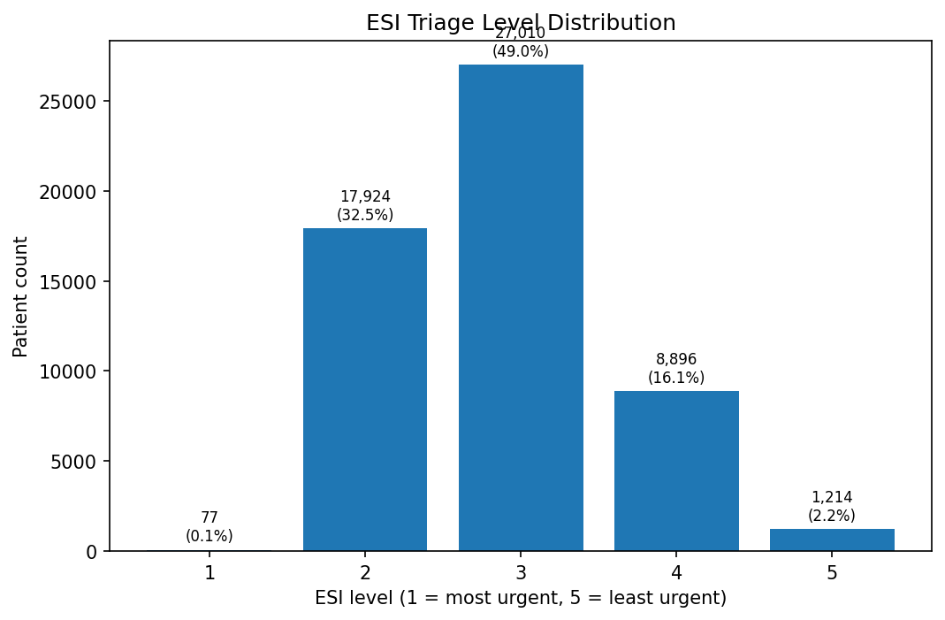
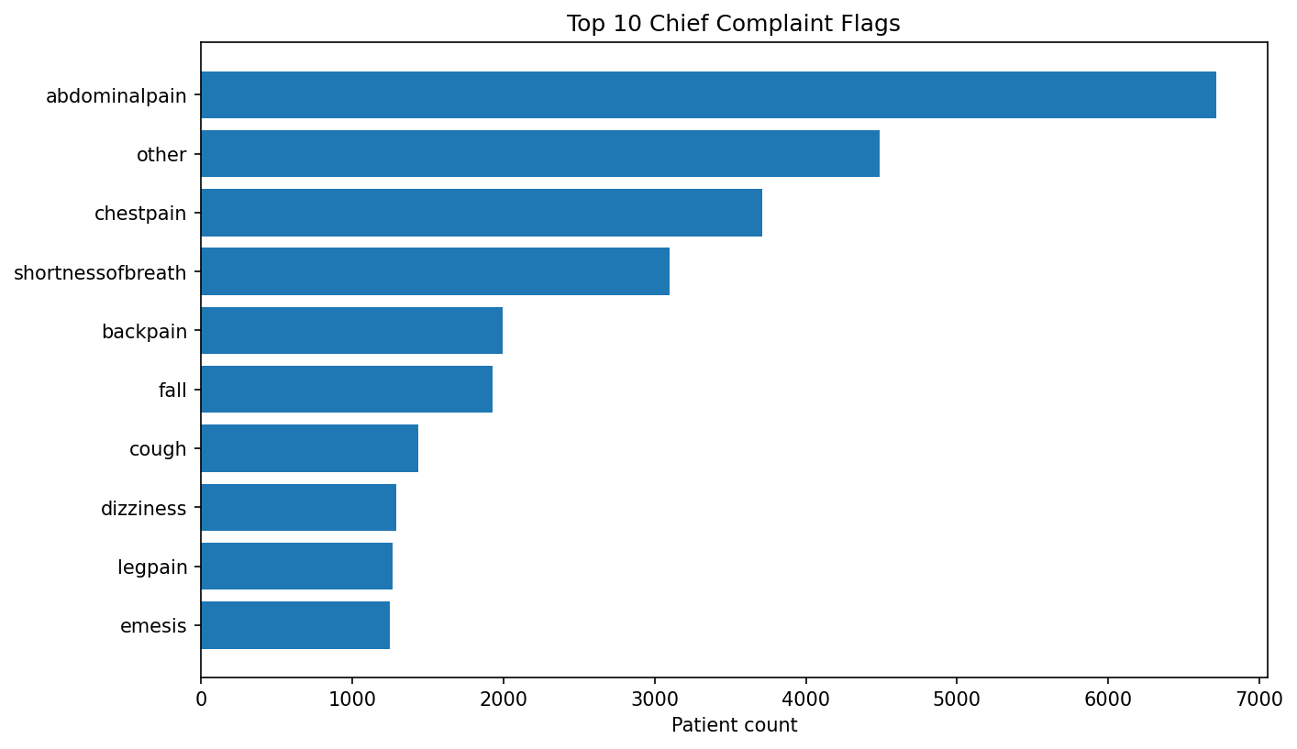

Top-10 feature shortlist
Rank | Feature | Assoc. | Clinical reasoning
1 | triage_vital_o2_device | -0.219 | Patients needing supplemental oxygen are more likely to require urgent review; it has one of the strongest associations with lower ESI acuity level.
2 | triage_vital_o2 | 0.159 | Low oxygen saturation directly signals hypoxia and respiratory compromise, which should influence triage urgency.
3 | age | -0.238 | Older adults have higher risk of deterioration and admission; age shows the strongest demographic association with ESI.
4 | cc_chestpain | -0.164 | Chest pain may represent acute coronary syndrome and is one of the most common high-acuity complaints.
5 | cc_shortnessofbreath | -0.15 | Shortness of breath can indicate respiratory failure, heart failure, asthma/COPD exacerbation or sepsis.
6 | triage_vital_hr | -0.073 | Tachycardia or bradycardia can indicate shock, arrhythmia, pain, fever or physiological stress.
7 | triage_glucose | -0.111 | Abnormal glucose can indicate diabetic emergencies or severe metabolic illness.
8 | cc_alteredmentalstatus | -0.132 | Altered mental status is clinically high risk and associated with urgent neurologic, toxicologic, septic or metabolic causes.
9 | triage_vital_rr | -0.056 | Respiratory rate is an early marker of deterioration and respiratory/metabolic stress.
10 | cc_suicidal | -0.143 | Suicidal ideation is a safety-critical presentation requiring urgent mental health risk assessment.
Note: Lower ESI means higher urgency. Negative associations indicate association with more urgent triage levels.

Caveats and recommendation
This dataset is good enough for baseline modelling and feasibility testing, but not for direct clinical deployment. Week 6 modelling should exclude leakage variables, use class-specific metrics, review high-acuity recall, and include subgroup checks across age, race, ethnicity, sex, language, insurance and arrival mode.
Recommended next step: build an offline baseline model using only variables available at or before triage; report confusion matrix, macro-F1, ESI 1/2 recall, calibration and subgroup performance. Any future clinical use should begin as a silent pilot before displaying AI output to triage staff.
Figure 3. Selected correlation heatmap
