

EZ Cart

Entity Relationship Diagram

Team: Team Evolution

Members:
Prasad Nair
Vishal Chothani

Date:18/03/2013

Purpose Of Entity Relation Diagram :

Purspose of Entity Relation Diagram is to shows the dependencies among the entities present in the database. It also shows relationship among the entries.It also shows all the table which are present in the database.

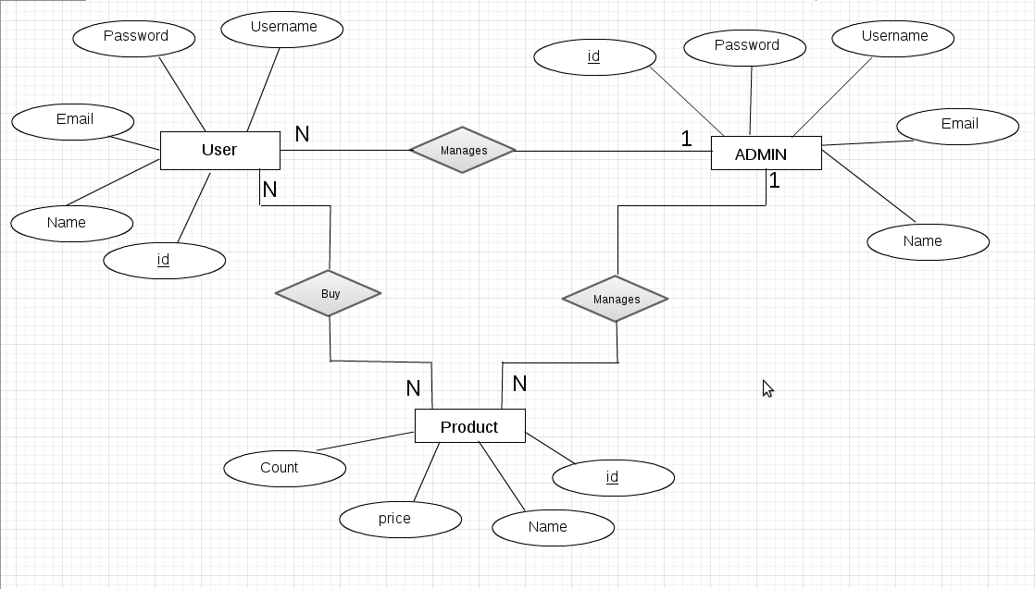

SIGN-OFF SHEET:

This document has been verified and approved by:

Project Manager : Mr Imran Loon

Sign :

Date :

