

EZ Cart

Software Requirement Specification

Team:Team Evolution

Members:
Vishal Chothani
Prasad Nair

Date:18/03/2013

Software Requirement Specification:

Table of Contents:

SNo | Title | Page No.
1. | Introduction | 3
2. | Overall Description | 4
3. | Functional Requirement | 5
4. | Non-Functional Requirement | 6
5. | Use Case Diagram | 7
6. | Data FLow Diagram (level 0) | 10

Chapter 1.Introduction:
This document is to provide the software requirement specification of the services provided by EZ Cart. It keeps track of the products in different categories and their details. It calculates the amount a registered user has to pay after the user selects some products to buy. It also displays and allows editing the cart at anytime for a registered user.
1.1 Purpose:
The main purpose of this application is to enable the easy shopping using the EZ Cart, It keeps tracks of the products, their categories, their details, the registered users, their cart contents and the calculations of the items selected by a user. Etc. Also provides an application with a consistent database for shopping cart operations.
1.2 Project Scope:
The application has the ability to keep a track on the user's cart and product details.
1.3 Benefits:
- Saves time
- Reduce human errors
- User-friendly
1.4 Overview:
The rest of this document gives an overview of the feature and functions of the EZ Cart along with the technical and non-technical details and the interfaces.

Chapter 2.Overall Description:
2.1. Product Perspective:
The “EZ Cart” is an application that remains to be independent.

2.1.1 System Interfaces:
The client user and administrator system must be able to save data properly in the database.

2.1.2 User Interfaces:
The screen formats and the menu structure is such that the user should find it easy to use the products according to their categories. The application should be user-friendly. The functionality provided by the system like displaying error messages should adapt itself to the different users of the application.

2.1.3 Operations:
The user can be a customer or an administrative manager. The user has to use a login to enter the application and then he/she can check different products and their details, also the user can add these products to his/her cart.
2.2. Product Functions:
The main functions are:
- User can search the particular item.
- User can add the item into his/her cart.
- Admin can add the new items in the application.
- Admin can edit the product details.

- Admin can view or manage all the user details.

2.3 Design Constraints:

1. There should necessarily be a menubar to navigate to different sections.

2. Registered User can edit only his own profile and no one elses.

3. Only Admin can add products to the database.

4. Only Registered User can add products to the cart.
Chapter 3.Functional Requirements:

Actor Admin:
1. Admin can add the new items in the application.
2. Admin can edit the item details.
3. Admin can delete the item details.
4. Admin can manage the user.

Actor User:
1. Can create new account.
2. Can then log into an account registered by him/her.
3. Can search the item.
4. User can get new password by clicking on forget password link.
5. User can add the items in the cart.
6. User can delete the items from the cart.
7. User can update the no of quantity of the items.
8. User can view the details of the items.
9. User can update his/her profile information.

Actor Guest:
1. Guest can search the details.
2. Guest can view the items and their details.

Chapter 4.Non Functional Requirements:

1. Software Requirements
2. Hardware Requirements
4.1 Software Requirements:
The two main software requirements for the Bank Management System are:

1. MySql
2. NetBeans

4.2 Hardware Requirements:
The system must basically support certain hardware and these must be an interface between them.

NAME OF THE ITEM | DESCRIPTION OF PURPOSE | SOURCE OF INPUT / DESCRIPTION OF OUTPUT
Keyboard | To get the details of from the user. | Source of input
Printer | To print the details of the account holder. | Destination of output
Mouse | To get the details of any item | Source of input

Chapter 5. Use Case Diagram:
Purpose:
To depict the relationships between all the actors and use case are represented.

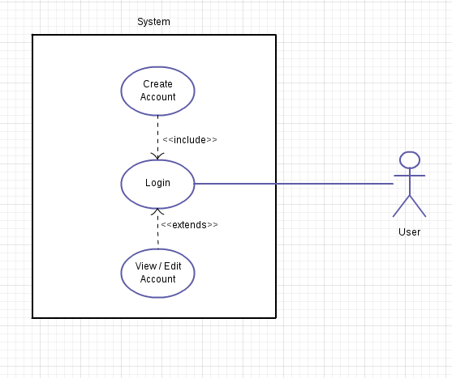

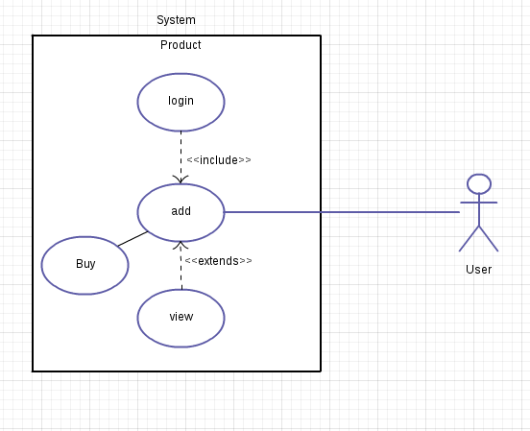

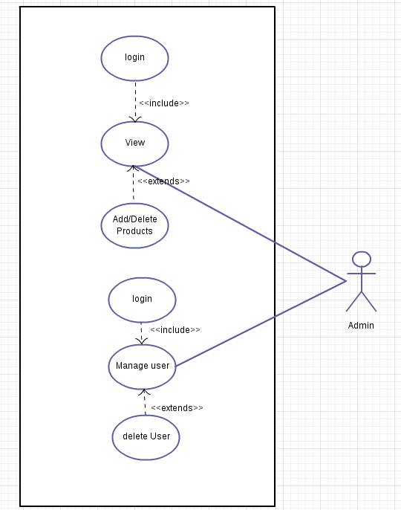
Chapter 6. Data Flow Diagram(Level 0):
Purpose:
To depict the flow of data through the system.

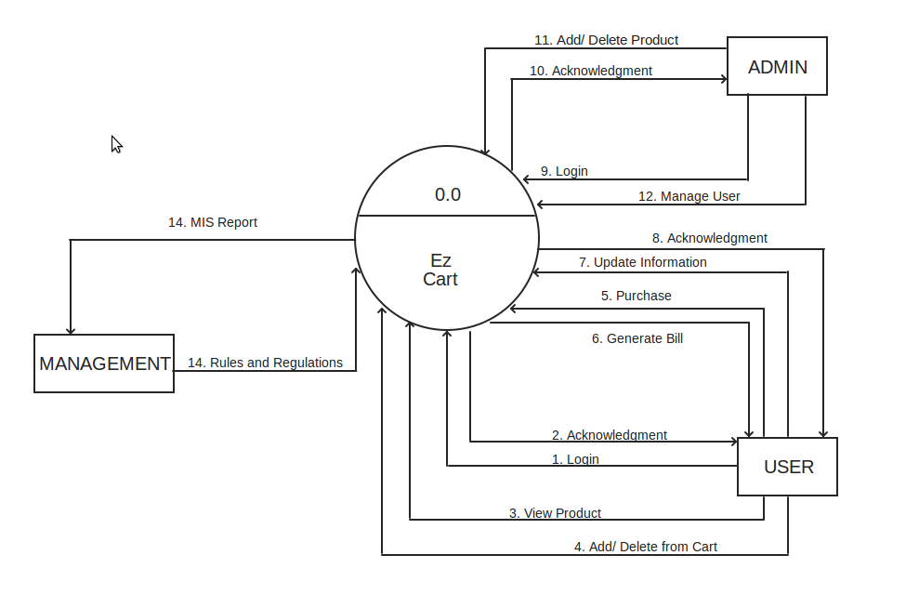
SIGN-OFF SHEET:

This document has been verified and approved by:

Project Manager : Mr Imran Loon

Sign :

Date :

