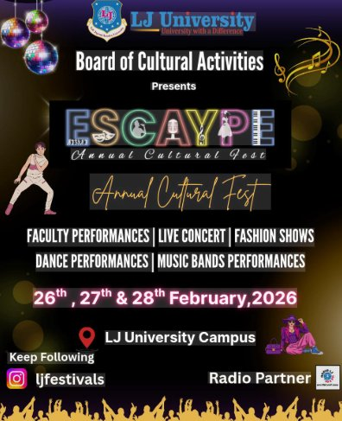

ESCAYPE 2026
Annual Cultural Fest
LJ University | Ahmedabad | 26th – 28th February, 2026

Event Report
Prepared by: Dixit Makwana | MCA Semester II
Roll No: B-15 | Enrollment No: 25004401110124
Subject: Communication and Technical Report Writing
University: LJ University, Ahmedabad
Date: March 2026

1. Introduction

ESCAYPE 2026 was a large-scale cultural and entertainment event organized by LJ University in Ahmedabad. The event aimed to provide a platform for students to showcase their talents, enhance social interaction, and promote creativity. It included various activities such as music performances, dance competitions, and technical events. This report highlights the planning, execution, and outcomes of the event.

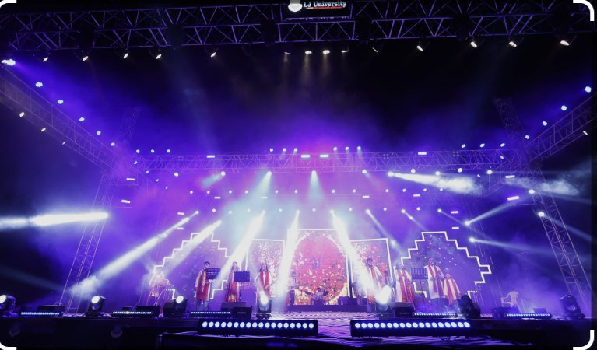

College festivals play an important role in the holistic development of students by encouraging participation beyond academics. ESCAYPE is one of the flagship annual fests of LJ University, attracting students from different colleges across Ahmedabad. The 2026 edition continued this tradition by organizing a multi-day event filled with cultural, technical, and entertainment activities.

2. Event Details

Event Name | ESCAYPE 2026 — Annual Cultural Fest
Organized By | Board of Cultural Activities, LJ University
Venue | LJ University Campus, Ahmedabad, Gujarat
Dates | 26th, 27th & 28th February, 2026

3. Planning & Preparation

The success of ESCAYPE 2026 was the result of detailed planning and teamwork. Key aspects included:

Organizing Committee Formation: Students and faculty members were divided into different teams such as event management, marketing

Campus-wide promotional campaigns through social media (@ljfestivals on Instagram) and physical posters

Coordination with the official Radio Partner for broadcast and promotion

4. Objective of Events

The main objectives of ESCAYPE 2026 were:

• To provide a platform for students to showcase their talents

• To encourage creativity, innovation, and teamwork

• To promote cultural diversity and interaction among students

• To enhance leadership and organizational skills

• To create a vibrant and enjoyable campus environment

5. Key Highlights

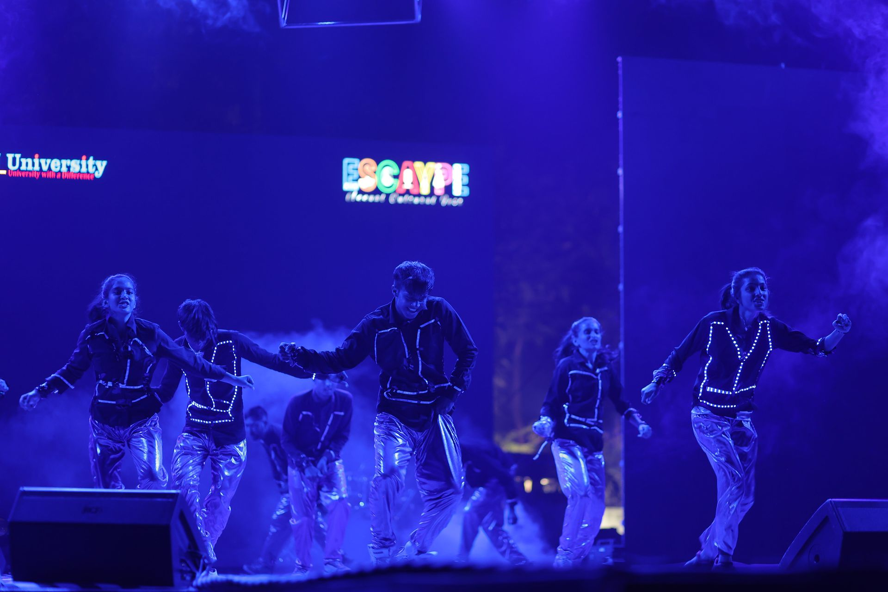

- 3 Days of non-stop cultural celebrations across multiple performance categories
- Spectacular stage production featuring LED walls, professional sound systems, and atmospheric lighting
- Headlining live concert that drew the largest crowd in recent ESCAYPE history
- A Fashion Show blending traditional Indian fashion with contemporary design sensibilities
- Student band performances showcasing original music and diverse genres
- Heartwarming Faculty Performances celebrating the human side of academia
- High social media engagement through @ljfestivals, amplifying reach beyond campus
- Seamless coordination between 100+ volunteers and organizing committee members

6. Observations
- High level of student participation and enthusiasm
- The production quality — including stage design, lighting, and sound engineering — matched industry standards and created a truly professional atmosphere
- Effective coordination among organizing teams
- Faculty engagement added a meaningful and joyful dimension to the festival, strengthening community bonds
- Security and crowd management were effectively organized, ensuring a safe environment for all attendees
- Positive audience engagement during performances
- The Radio Partnership enhanced reach and created an exciting buzz around performances and announcements
- Smooth execution of scheduled activities

7. Outcomes
outcomes:
- Enhanced student confidence and stage presence
- Over 200 students participated as performers across various acts — music, dance, fashion, and theatre
- Development of teamwork and leadership skills
- Increased visibility and reputation of LJ University
- Provided practical event management experience to organizers
- Thousands of students, faculty members, and guests attended all the three days, making it the most attended ESCAYPE edition till date
- Students gained experience in event management, and performance arts

8. Statistical Overview
Figure 1: Participant Count by Performance Category
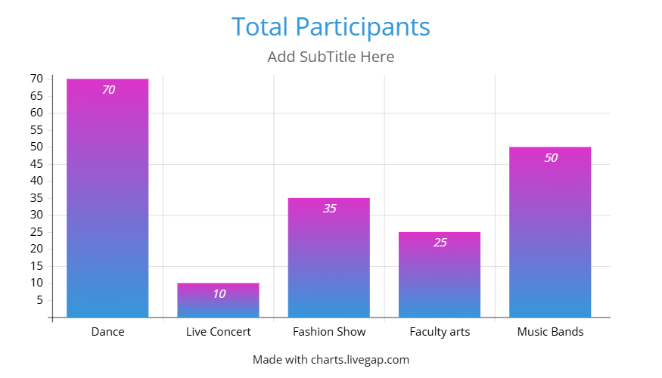
Figure 2: Estimated Daily Attendance Across 3 Days
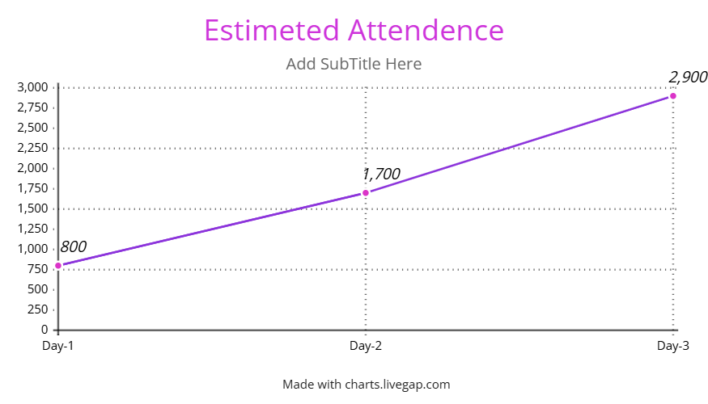

9. Conclusion

ESCAYPE 2026 was a successful and well-organized event that achieved its objectives of promoting talent, creativity, and collaboration among students. The event not only provided entertainment but also contributed to the personal and professional development of participants. Such events play a crucial role in enriching the overall educational experience and should continue to be encouraged in the future.

