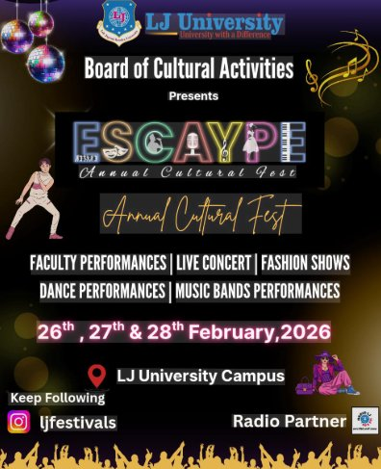

ESCAYPE 2026
Annual Cultural Fest
LJ University | Ahmedabad | 26th – 28th February, 2026

Event Report
Prepared by: Nikunj S. Solanki | MCA Semester II
Roll No: D-46 | Enrollment No: 25004401110071
Subject: Communication and Technical Report Writing
University: LJ University, Ahmedabad
Date: March 2026

1. Abstract
ESCAYPE 2026, the Annual Cultural Fest organized by the Board of Cultural Activities at LJ University, Ahmedabad, was a landmark event that brought together students, faculty, and the wider community across three spectacular days — 26th, 27th, and 28th February 2026. This report provides a comprehensive account of the planning, execution, performances, and overall outcome of the festival. From electrifying live concerts and elegant fashion shows to soulful music band performances and vibrant faculty acts, ESCAYPE 2026 celebrated artistic expression in every form. The event drew enthusiastic participation from across departments and created lasting memories for all attendees.

2. Introduction
LJ University, one of Gujarat's premier institutions of higher learning, stands committed not only to academic excellence but also to the holistic development of its students. The Board of Cultural Activities (BCA) at LJ University is the driving force behind student cultural life on campus, organizing events that nurture creativity, teamwork, leadership, and artistic talent throughout the academic year.

ESCAYPE — the university's flagship Annual Cultural Fest — has grown over the years into one of Ahmedabad's most anticipated collegiate cultural celebrations. The 2026 edition, branded with the tagline 'Escape into Culture,' was conceptualized to provide a grand platform for students to showcase their talents while enjoying world-class performances by renowned artists. The festival also served as a medium for cultural exchange, community building, and building lasting friendships across disciplines.

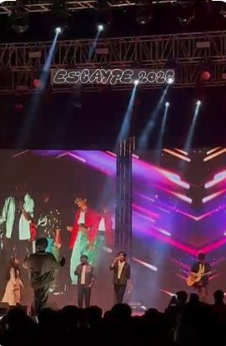

3. Event Details

Event Name | ESCAYPE 2026 — Annual Cultural Fest
Organized By | Board of Cultural Activities, LJ University
Venue | LJ University Campus, Ahmedabad, Gujarat
Dates | 26th, 27th & 28th February, 2026
Social Handle | @ljfestivals (Instagram)
Radio Partner | Campus Radio (Official Partner)
Theme | Escape into Culture — A Celebration of Art & Life

4. Objectives of the Event
ESCAYPE 2026 was organized with the following key objectives:
- To provide students with a vibrant platform to showcase their creative and performing arts talents
- To promote cultural diversity and appreciation for various art forms across music, dance, fashion, and theatre
- To foster a spirit of community, teamwork, and healthy competition among students
- To create memorable experiences that complement academic life and contribute to holistic development
- To bring renowned artists and performers to campus, inspiring students through professional excellence
- To strengthen the identity of LJ University as a hub of cultural excellence in Gujarat

5. Planning & Preparation

5.1 Organizational Structure
The event was spearheaded by the Board of Cultural Activities in coordination with student volunteers, faculty coordinators, and external production partners. Months of planning preceded the three-day festival, with dedicated teams assigned to logistics, stage management, artist coordination, publicity, and hospitality.

5.2 Pre-Event Activities
- Campus-wide promotional campaigns through social media (@ljfestivals on Instagram) and physical posters
- Auditions and selection rounds for student performances across dance, music, and fashion categories
- Coordination with the official Radio Partner for broadcast and promotion
- Stage construction, lighting rigs, LED screen setup, and sound system installation
- Volunteer orientation and role assignments
- Coordination with performing artists and management teams for technical riders and schedules

6. Event Description

6.1 Opening Ceremony — Day 1 (26th February)
The festival commenced with grand fanfare as the LJ University campus transformed into a cultural extravaganza. The opening ceremony saw university dignitaries, faculty, and student leaders officially inaugurating ESCAYPE 2026 amidst cheers from a packed audience. Cultural performances by faculty members added a unique and heartwarming dimension to the opening, as professors stepped onto the stage to celebrate alongside their students.

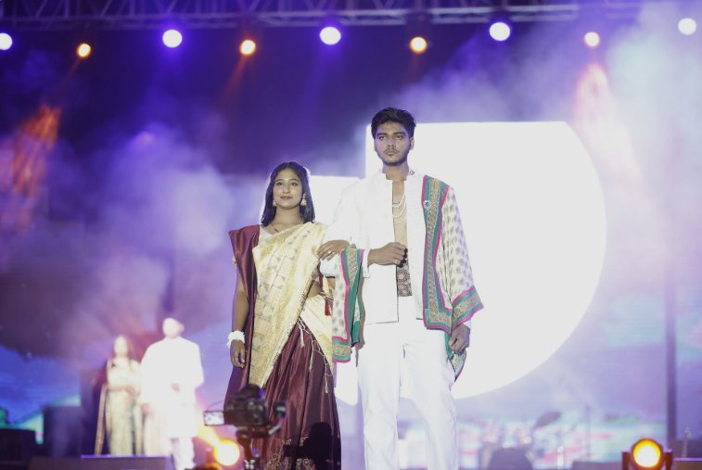
Fashion Show — Students walk the runway in spectacular traditional and fusion ensembles

6.2 Fashion Show
One of the most visually stunning segments of ESCAYPE 2026 was the Fashion Show, which showcased the creativity and elegance of LJ University students. Participants walked the runway in breathtaking traditional and fusion outfits, blending Indian heritage with contemporary aesthetics. The performances highlighted intricate craftsmanship in attire — from rich silk sarees and embroidered shawls to modernized ethnic wear. Professional lighting and stage production elevated the experience, making it a visual spectacle worthy of any metropolitan fashion week.

6.3 Dance Performances
ESCAYPE 2026 featured a diverse range of dance performances that captivated audiences across all three days. Students performed classical forms, folk dances, Bollywood choreography, and contemporary fusion pieces. Each performance reflected weeks of rigorous practice and demonstrated the exceptional artistic abilities of LJ University's student community. The electrifying energy of the dance floor consistently brought the crowd to its feet.

6.4 Music Bands Performances
Among the most celebrated segments of the festival were the live music band performances. Student bands from various departments performed original compositions as well as popular covers, displaying remarkable musicianship. The atmosphere during the band performances was electric — audiences swayed, sang along, and cheered as each group took command of the stage.

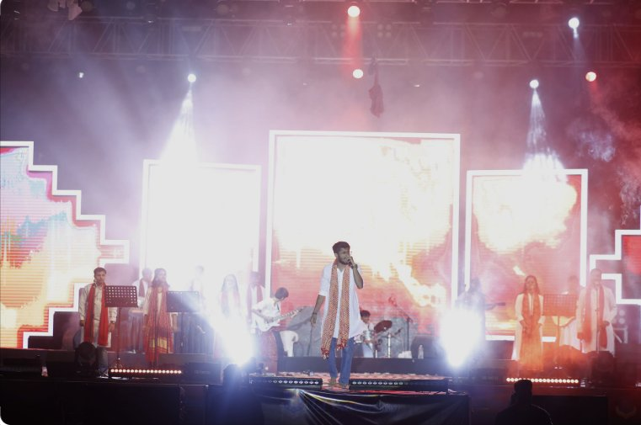
Live Concert — Performing artists captivate thousands with soulful music under dramatic stage lighting

6.5 Live Concert — Headline Artists
The crown jewel of ESCAYPE 2026 was undoubtedly the Live Concert featuring acclaimed artists who delivered unforgettable performances. The stage — adorned with massive LED screens, atmospheric fog effects, and a meticulously designed geometric set — set the perfect backdrop for the artists. Thousands of students gathered as the headlining acts took the stage, creating a concert experience rivalling professional music festivals. The energy shared between the artists and the audience was palpable, with hands raised in unison and voices singing together in celebration.

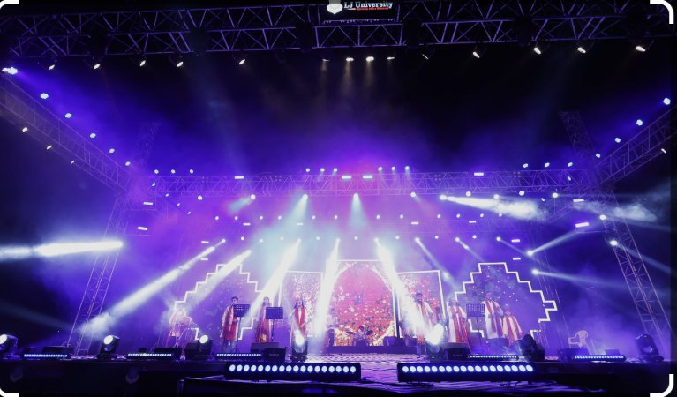
Grand Stage — The iconic ESCAYPE 2026 stage illuminated with dramatic purple and white lighting

6.6 Faculty Performances
A unique and endearing feature of ESCAYPE 2026 was the dedicated segment for Faculty Performances. Professors and administrative staff stepped off their academic pedestals and onto the stage to perform alongside students. This special segment was universally appreciated for humanizing the faculty-student relationship and adding warmth and laughter to the festival. Faculty performances ranged from classical music recitals to light-hearted theatrical sketches.

7. Key Highlights of ESCAYPE 2026

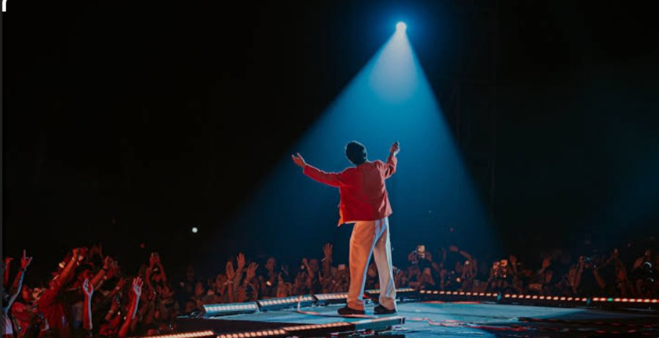
The iconic image of the headlining performer commanding the stage before a roaring crowd
- 3 Days of non-stop cultural celebrations across multiple performance categories
- Spectacular stage production featuring LED walls, professional sound systems, and atmospheric lighting
- Headlining live concert that drew the largest crowd in recent ESCAYPE history
- A Fashion Show blending traditional Indian fashion with contemporary design sensibilities
- Student band performances showcasing original music and diverse genres
- Heartwarming Faculty Performances celebrating the human side of academia
- High social media engagement through @ljfestivals, amplifying reach beyond campus
- Seamless coordination between 100+ volunteers and organizing committee members

8. Observations
As an attendee and participant, several key observations stood out during ESCAYPE 2026:

- The event management and logistics were handled with commendable professionalism, with minimal delays across all three days
- Student enthusiasm and participation levels were at an all-time high, reflecting the success of pre-event promotions
- The production quality — including stage design, lighting, and sound engineering — matched industry standards and created a truly professional atmosphere
- Faculty engagement added a meaningful and joyful dimension to the festival, strengthening community bonds
- Security and crowd management were effectively organized, ensuring a safe environment for all attendees
- The Radio Partnership enhanced reach and created an exciting buzz around performances and announcements
- Inter-departmental collaboration was evident, fostering unity and camaraderie across disciplines

9. Results & Outcomes
ESCAYPE 2026 achieved and exceeded all its stated objectives, delivering the following outcomes:
- Thousands of students, faculty members, and guests attended across the three days, making it the most attended ESCAYPE edition to date
- Over 200 students participated as performers across various acts — music, dance, fashion, and theatre
- Significant social media engagement with @ljfestivals, expanding the university's cultural footprint digitally
- Students gained invaluable experience in event management, performance arts, and collaborative work
- The festival reinforced LJ University's reputation as a culturally vibrant institution in Gujarat's academic landscape
- Lasting memories and friendships were forged that will be cherished long after graduation

10. Statistical Overview
The following charts illustrate key data from ESCAYPE 2026, providing a visual summary of participation, attendance, and volunteer distribution.
Figure 1: Participant Count by Performance Category
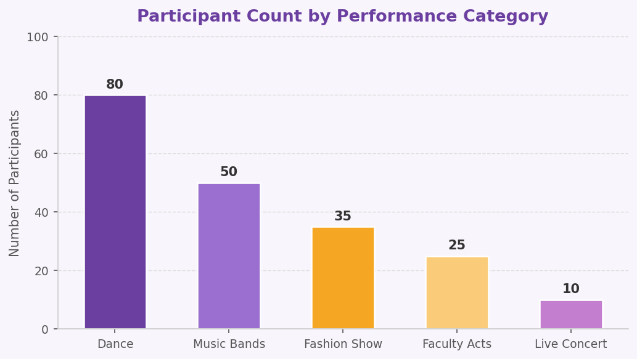
Figure 2: Estimated Daily Attendance Across 3 Days
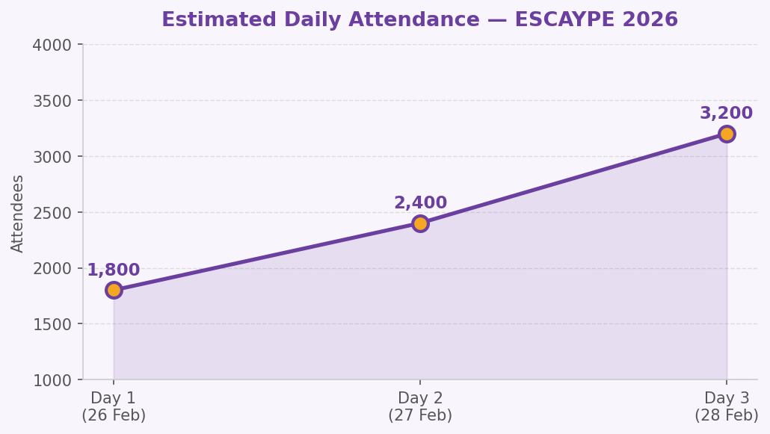
Figure 3: Volunteer & Crew Distribution (100+ Members)
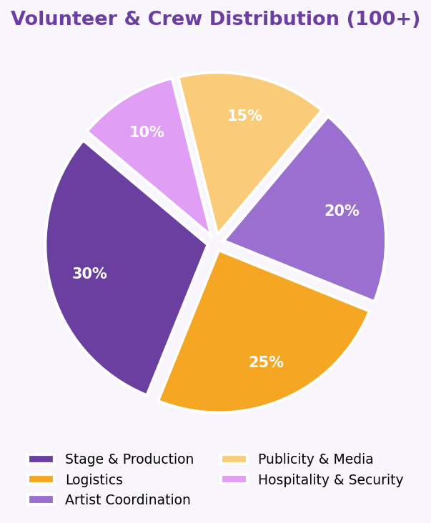

11. Conclusion

ESCAYPE 2026 was more than just a cultural festival — it was a celebration of human creativity, passion, and the vibrant spirit that defines LJ University. The Annual Cultural Fest brought together the best of music, dance, fashion, and theatre, creating an immersive experience that transcended the boundaries of the campus and touched the hearts of everyone who attended.

The meticulous planning by the Board of Cultural Activities, the dedication of student volunteers, and the enthusiastic participation of performers and audiences alike combined to make ESCAYPE 2026 a resounding success. The festival stands as a testament to what students can achieve when given the platform, resources, and encouragement to express themselves freely.

As LJ University looks ahead, ESCAYPE will continue to grow as a flagship institution event — one that not only entertains but inspires, unites, and elevates the cultural identity of the university and its community. ESCAYPE 2026 has set a high benchmark, and the journey of cultural excellence continues.

— End of Report —

