**Exploration of periodic activation functions in neural networks**

**1.Introduction**

**1.1 Background**

The Artificial neural network is one of the best tools for doing predictions and forecasting. Nowadays, Neural networks can be solving such complex problems which humans can’t even think of. However, the performance of these networks is highly dependent on the way these are trained. Since, last decade lots of research work has been done to enhance the performance of these models. All neural networks are dependent on the Activation function for learning the non-linear patterns of the data.

The goal of the project is to explore the ability of various conventional activation and to introduce a unique approach of using Sine as an activation function. To create a function which can map coordinates of the signals to its value, by using Sine waves as a non-linearity**.**

**1.2 Problem Statement.**

Inability of conventional activation functions to the represent function. Representing signals in an efficient manner has always been the most important task in a neural network. The most challenging task for any neural network is to learn the non-linearity of the data. While the other activation functions like ReLU and Maxout work well for most types of data for explicit neural networks but they lack in capture signal properties in cases of implicit representation of signals.

**1.3 Scope**

This scope of this project is very huge as neural networks are used in every field now.

**Within Scope:**

* Demonstrate implicit neural networks using SIRENs(sinusoidal representation networks) which can not only understand complex natural signals very well but their derivatives as well.
* Proposing a principle initialized scheme by analyzing the activation statistics of SIREN.
* Demonstration of images, sounds with their derivatives.
* Solving the boundary value problems like Helmholtz and Poisson equations using SIRENs.

**1.4 Document Overview**

The remaining of this document details the requirement, specialized methodology, anticipated outcomes, and the plan for project management. These segments will depict how to provide the better solution for problem statements and accomplish the designated scope for the semester.

**2 PRELIMINARY REQUIREMENTS**

Requirement 1: A detailed explanation of methods should be provided for representing the signals.

Requirement 2: The results should be based on experimental outcomes.

Requirement 3: The model should provide a satisfactory accuracy.

**3. TECHNICAL APPROACH**

**3.1 Analysis**

In order to implement and gain the good understanding of different activation functions for this project, various factors should be considered. Thorough research on behavior of various neural networks using different kinds of activation functions will be conducted.

Applying the various activation functions on the different types of signals would be the appropriate and most optimal way to understand the merits and demerits of these networks. All the factors like loss function and optimal initializing technique will be considered during the experiment.

**3.2 Requirements Development**

The requirement of the research will be divided into various categories of gathering the diverse data, operations and using various functions.

Various statistical methods will be used for determining the outcome of the model.

**3.3 Model Development**

Development iterations are expected to be based on modification of the feature set, algorithm selection, and algorithm parameters.

The foremost step of the research will be extraction of features from the signals as the input to the network. The signals will be analyzed for looking for features with their derivatives. The initialization of weights needs to be done in uniform fashion with the proper experimentation. Research iterations will be based on activation function selection, different features set and parameters of algorithms.

Python and some of its popular libraries will be used for analyzing the various networks. The Jupyter notebook should be more than for providing the suitable environment for analyzing the networks. The most difficult obstacle the model needs to overcome is to work with extremely small dataset. Moreover, if a model is unable to adjust and initialize weights properly it might result in skewed results. Another, most important thing is to consider appropriate loss function for proper learning of the network

**4. EXPECTED RESULTS:**

The research will result in two major deliverables:

* Efficient method developed to map the signal coordinates to its values. A detailed narrative of what functions are used, why and how they are chosen will be submitted.
* A functional model will be submitted for implicit neural representation of the different signals like images and videos.

**5 MANAGEMENT APPROACH**

The project is divided into five different tasks: Pre-study & research , Working of neural network , comparisons of activation functions , model creation and using it for different signals , final deliverable report. The timeline is shown in Figure 1. The Pre-study & research part includes the initial activities of the project like understanding the limitation of widely used activation functions and how stuff works. In phase 2 , the working of neural networks will be studied thoroughly by examining the various loss functions and ways to initialize the weights.

In phase 3, the study of the first two phases will be combined and results of various models will be analyzed to take the final model into the account.

In phase 4, the final model will be used on different types of data and its capabilities and demerits with various signals will be analysed.

Near the end of the semester in the last two weeks the final report and findings of the model will be summarised in the report.

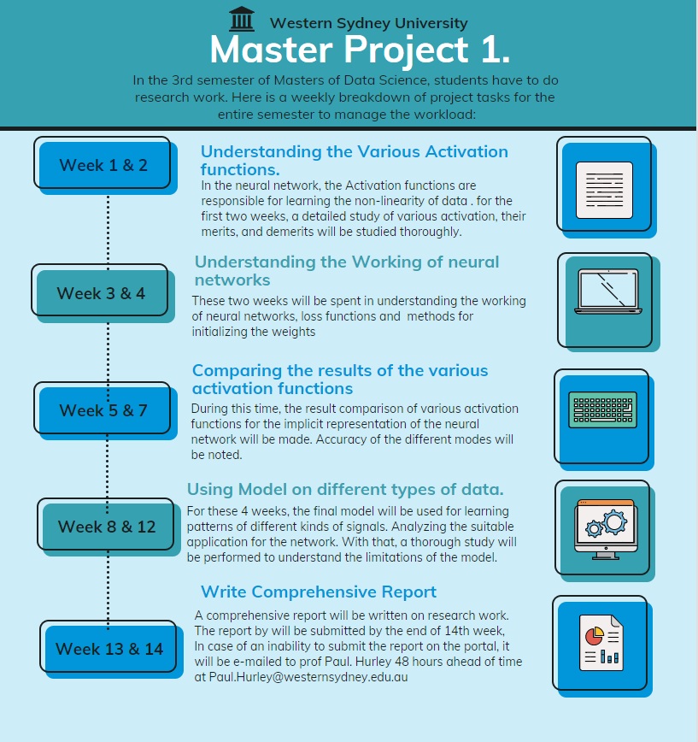

Fig : 1